User Acceptance Testing (UAT) Plan Template
(IEEE 829 Compliant)

Test Plan Identifier
TP-BOWLING-001 (bowling game UAT)

Introduction
This User Acceptance Test plan verifies that the Bowling game application meets business requirements and is ready for production release. Testing will focus on three key features:
1. Score calculation
2. Strike and spare
3. Final frame bonus rules
Purpose
The purpose of this document is to outline the scope, approach, resources, and schedule of the User Acceptance Testing (UAT) activities Bowling Game project. It identiﬁes the items to be tested, the features to be tested, the testing tasks, environmental needs, responsibilities, and criteria for success. This plan serves as a foundational document for all UAT-related eﬀorts, ensuring that the software product meets the user's expectations and business needs.

Scope
The scope of this UAT plan encompasses the testing of Bowling Game scoring system backend.
The testing will focus on:
1. Correct score calculation across 10 frames
2. Strike and spare bonus rules
3. Final frame bonus handling
4. Input validation
Out of Scope:
1. GUI (not implemented)
2. Database or file input

References
- Bowling Game Project Specification
- Course Assignment instructions
- Unit Test Code
- Source Code

Test Items
This section identiﬁes the software items that will be subjected to UAT. This includes the speciﬁc software builds, versions, and any associated hardware or environmental conﬁgurations.
- Software Product: Bowlin g game application
- Version: final version after fixing errors
- Components:
1.BowlingGame class
2.Scoring logic
3. Roll function
- Hardware: Standard desktop/laptop
- Operating Systems: Windows 10/11
- Browsers: not applicable
- Databases: not applicable
- Other Dependencies: python 3x

Features to Be Tested
- Score calculation:
system correctly calculates total score based on rolls
- Strike Handling:
system correctly applies bonus for strikes
- Spare Handling:
system correctly applies bonus for spares
- Final Frame Logic:
system allows extra rolls and calculates correct score
- Input Validation:
reject invalid inputs (negative or > 10 pins)

Features Not to Be Tested
- GUI interface
- Multiplayer functionality
- File/database input

Approach
I used python unittest framework to test the program.
Steps:
1. Execute unit test using python unittest
2 validate outputs against expected results
3 test edge cases such as:
perfect game 300 score
gutter game 0 score
4. Record results and identify defects
5.fixing issues
6. run test again

Pass/Fail Criteria
• Test Case Completion:
At least 95% of test cases must pass
• Defect Threshold:
No critical or major defects remain
• Business Requirements:
All scoring rules correctly implemented
• User Acceptance:
Tester confirms system behaves as expected

8. Suspension Criteria
- System crashes during scoring
- Incorrect score calculation for core scenarios
- Unable to execute tests

- 9. Resumption Criteria
- Critical bugs fixed
- System runs without crashing
- Tests can be executed successfully

Test Deliverables

The following items were produced during testing:
unit test:

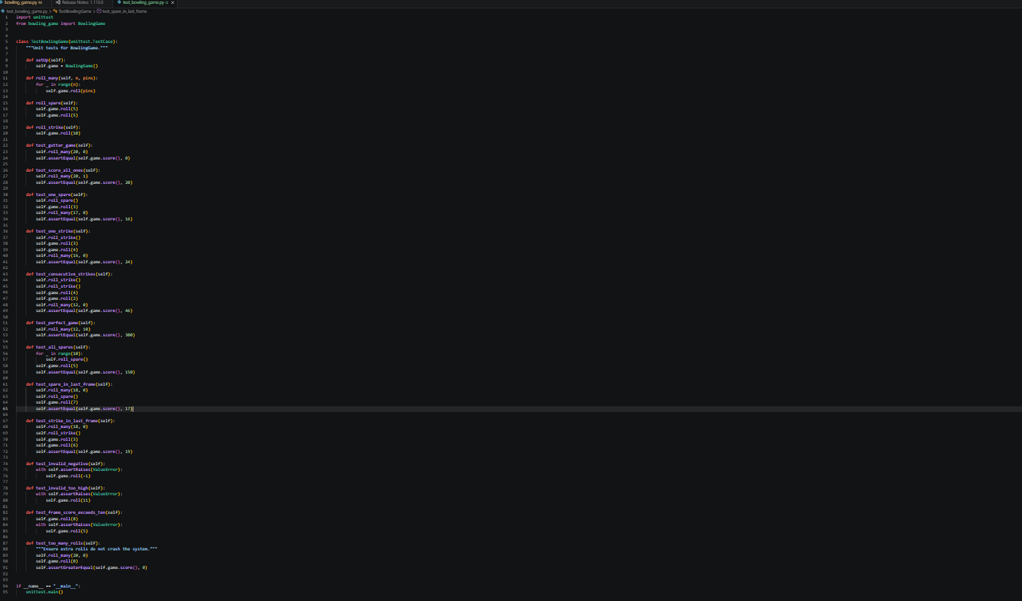

Bowling_game.py:

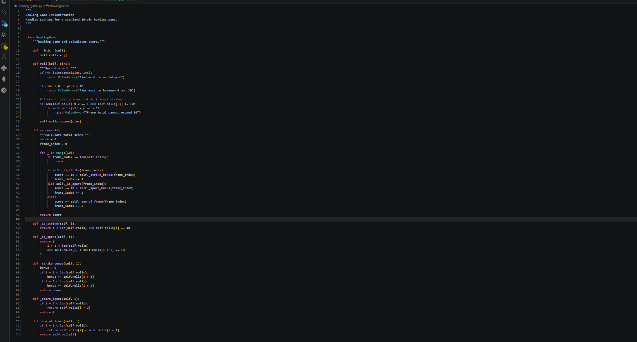

Test results:
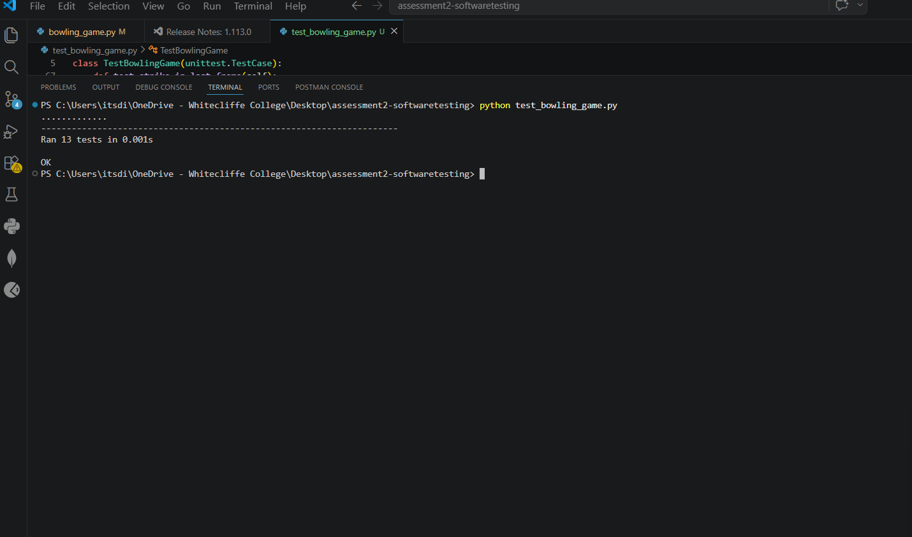

Errors faced:
