

CAPSTONE PROJECT REPORT
Report 3 – Software Requirement Specification

– Hanoi, Jan 2024 –
Table of Contents
I. Record of Changes 3
II. Software Requirement Specification 4
1. Overall Requirements 4
1.1 Context Diagram 4
1.2 Main Workflows 5
1.3 User Requirements 5
1.4 System Functionalities 7
1.5 Entity Relationship Diagram 7
2. Use Case Specifications 8
2.1 <<Feature Name1>> 8
2.2 Xyz Feature 10
3. Functional Requirements 11
3.1 Feature Name1 11
3.2 User Authentication 11
3.3 System Administration 12
4. Non-Functional Requirements 13
3.1 External Interfaces 13
3.2 Quality Attributes 13
5. Requirement Appendix 14
5.1 Business Rules 14
5.2 System Messages 14
5.3 Other Requirements… 15

I. Record of Changes
Date | A*  M, D | In charge | Change Description
*A - Added M - Modified D - Deleted

II. Software Requirement Specification

1. Overall Requirements

1.1 Context Diagram
The Healthcare Clinic Management System (HCMS) is a new software solution designed to replace current manual and telephone-based processes at a private paediatric clinic. The context diagram illustrates the external entities and system interfaces for the MVP version (v1.0), focusing on optimizing the data flow between parents, doctors, and the reception desk. The system is designed for a lean operational scale of 1-2 doctors and 1 receptionist, with the goal of eliminating administrative bottlenecks and fully digitizing electronic medical records (EMR). It is built upon a core data structure of 5 essential entities—Patient, Appointment, Visit, Prescription, and Billing—while strictly excluding complex features such as health insurance integration or advanced pharmacy inventory management to ensure rapid deployment.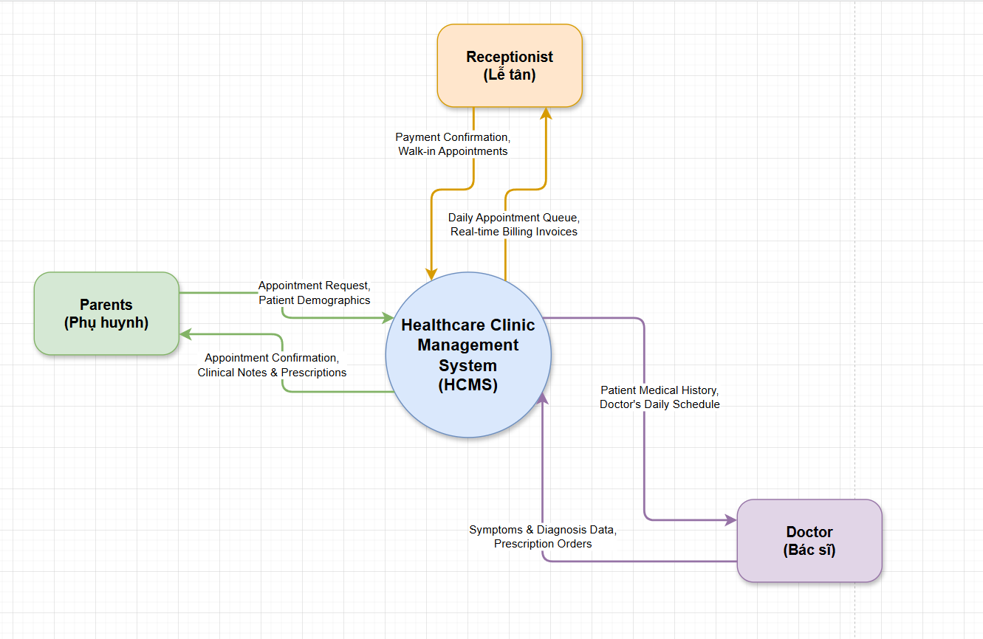

1.2 Main Workflows

1.2.1 Self-Service Booking
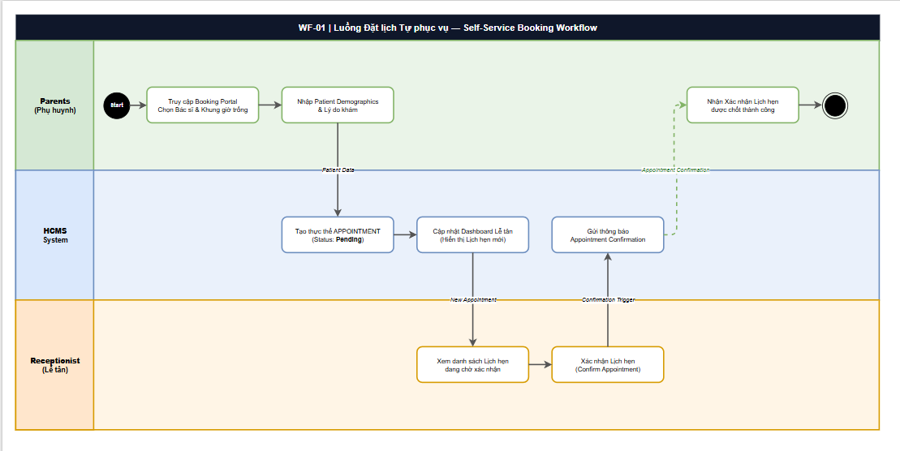

1.2.2 Clinical Consultation & EMR
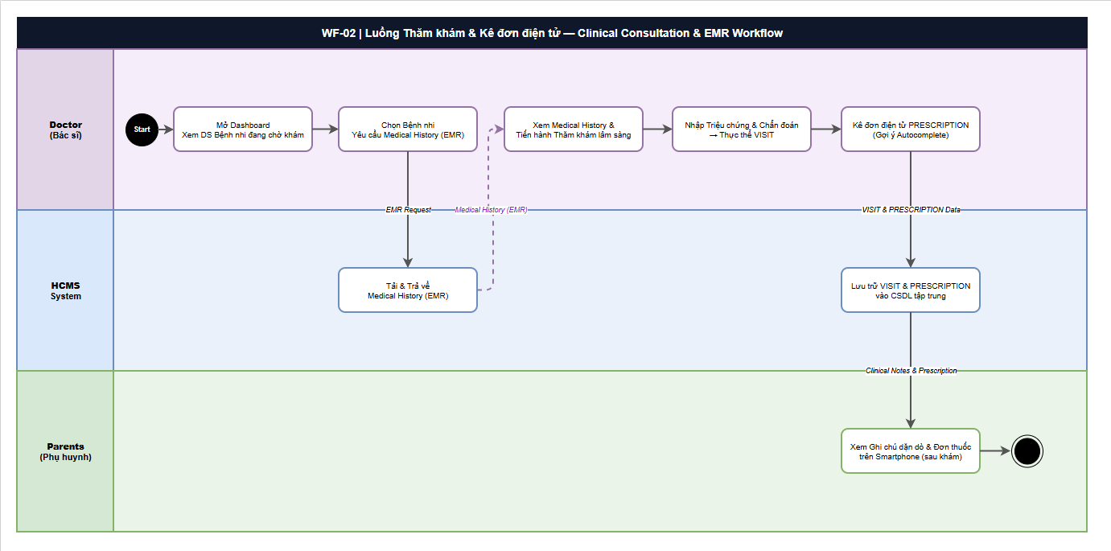

1.2.3 Streamlined 1-Click Checkout
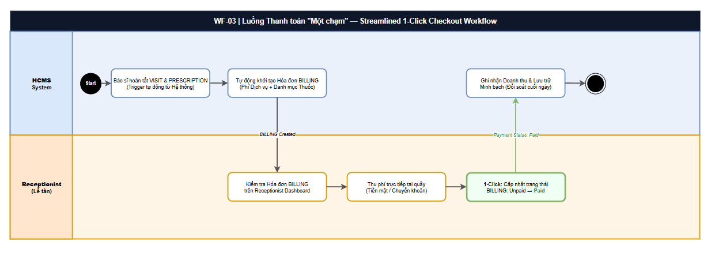

1.3 User Requirements

1.3.1 Actors

# | Actor | Description
1 | Parents  (Phụ huynh)  Human | External User | Parents or guardians of pediatric patients who interact with HCMS via the self-service Booking Portal (smartphone/web). They initiate appointment bookings, provide child's Patient Demographics, receive appointment confirmations, and view post-visit clinical notes & prescriptions on their device. They are outside the clinic and do not use the internal dashboard.
2 | Doctor  (Bác sĩ)  Human | Primary Internal User & System Sponsor | The lead physician (Dr. Minh) who acts as both project sponsor and the primary clinical user. Doctors interact with HCMS to access a real-time patient queue dashboard, retrieve full Medical History (EMR) for each patient, record clinical consultation outcomes into a VISIT entity, and issue electronic Prescriptions using the autocomplete drug-name feature. All Doctor interactions are within the clinic's internal network.
3 | Receptionist  (Lễ tân)  Human | Key Internal Operator | The front-desk operator (Chị Lan) responsible for administrative clinic operations. Receptionists interact with HCMS to view Appointment Dashboard, confirm or manually register appointments (including walk-ins), verify the auto-generated BILLING invoices, and execute the 1-Click Payment status update (Unpaid → Paid). She is a high-frequency user of the system.

1.3.2 Use Cases (UC)
ID | Use Case | Feature | Use Case Description
UC-01 | Book Appointment Online | Self-Service Booking Portal | Parents access the online Booking Portal, select a preferred Doctor (by name/specialty) and an available time slot from the real-time calendar. The system validates the slot and auto-creates an APPOINTMENT entity with status 'Pending'. The Receptionist is notified on her dashboard of the new pending booking.
UC-02 | Provide Patient Demographics | Self-Service Booking Portal | During an initial booking (or at check-in), Parents input the child's personal and medical data: full name, date of birth, parent phone/email, and primary medical notes. The system creates or updates the PATIENT entity linked to the APPOINTMENT record.
UC-03 | Receive Appointment Confirmation | Appointment Notification | After the Receptionist confirms a pending appointment, HCMS automatically sends an Appointment Confirmation notification (SMS/Email) to the Parent's registered contact, including appointment date, time, doctor name, and clinic address.
UC-04 | View Clinical Notes & Prescriptions | Patient EMR Portal | After a completed visit, Parents can log in to the portal to review the Doctor's clinical notes (VISIT record: diagnosis, symptoms, aftercare instructions) and the linked electronic PRESCRIPTION (medicine name, dosage, frequency, duration) on their smartphone.
UC-05 | View Appointment Dashboard | Appointment Management | The Receptionist views a live, sortable dashboard listing all upcoming appointments for the day: patient name, time slot, assigned Doctor, and current APPOINTMENT status (Pending / Confirmed / In-Progress / Completed). The dashboard auto-refreshes in real time.
UC-06 | Confirm Appointment | Appointment Management | Upon reviewing a Parent-submitted Pending appointment, the Receptionist validates the information and clicks 'Confirm'. The system updates the APPOINTMENT status from 'Pending' to 'Confirmed' and triggers the confirmation notification to the Parent (see UC-03).
UC-07 | Register Walk-in Appointment | Appointment Management | For patients who arrive at the clinic without a prior online booking, the Receptionist manually creates a new APPOINTMENT record by entering the patient info and selecting an available Doctor and time slot. The walk-in APPOINTMENT is created with status 'Confirmed'.
UC-08 | View Billing Invoice | Billing & Payment | Once the Doctor completes and saves a VISIT + PRESCRIPTION record, the HCMS system automatically generates a BILLING invoice summarizing: consultation fee, itemized prescription costs, and total amount due. The Receptionist can view this invoice on the dashboard with status 'Unpaid'.
UC-09 | Update Payment Status (1-Click Paid) | Billing & Payment | After collecting the payment from the Parent (cash or bank transfer at the counter), the Receptionist clicks a single 'Mark as Paid' button. The system instantly updates the BILLING status from 'Unpaid' to 'Paid', records the payment timestamp, and logs the transaction for the end-of-day revenue reconciliation report.
UC-10 | View Patient Queue | Clinical Dashboard | The Doctor opens their personal clinical dashboard to see the ordered list of patients waiting for examination: patient name, appointment time, and current status. The queue is auto-sorted by appointment time and updated in real time as Receptionists confirm arrivals.
UC-11 | Access Patient Medical History (EMR) | EMR – Medical History | Before or during an examination, the Doctor selects a patient from the queue and retrieves their complete Electronic Medical Record: full PATIENT profile, all previous VISIT records (past diagnoses, symptoms), and all past PRESCRIPTION records. This enables evidence-based, data-driven clinical decisions without paper records.
UC-12 | Record Clinical Consultation (VISIT) | EMR – Visit Management | During the physical examination, the Doctor enters the consultation outcome into a new VISIT record: observed symptoms, clinical diagnosis (ICD-coded), physical examination notes, and aftercare/follow-up instructions. The VISIT record is saved and linked to the patient's PATIENT entity and the originating APPOINTMENT.
UC-13 | Issue Electronic Prescription | EMR – Prescription Management | After completing the VISIT record, the Doctor creates a PRESCRIPTION record by specifying each medicine (drug name with autocomplete suggestion), dosage amount, frequency, administration route, and duration. The saved PRESCRIPTION is automatically linked to the VISIT and PATIENT entities, and is visible to the Parent via the portal (UC-04).
UC-14 | Manage Patient Profile | EMR – Patient Management | The Doctor can view and update supplementary medical information in the PATIENT profile: known allergies, blood type, chronic condition flags, and vaccination notes. This ensures the EMR remains accurate and up-to-date for future clinical decisions by the same or other doctors at the clinic.

1.3.2 Use Case Diagrams

1.3.2.1 UCs for Parents
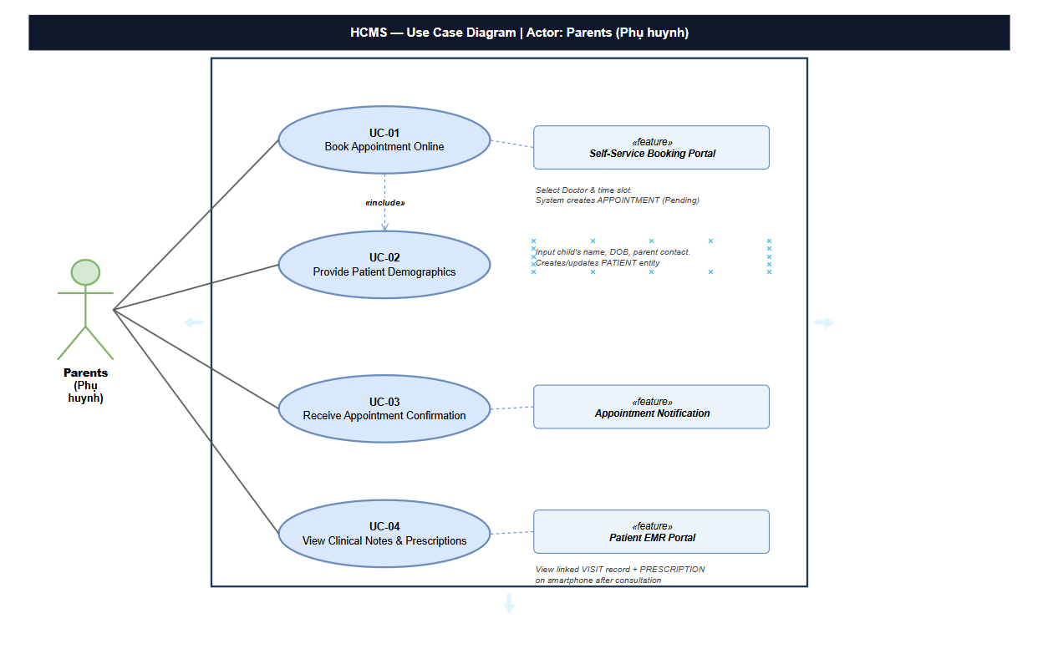

1.3.2.2 UCs for Receptionist
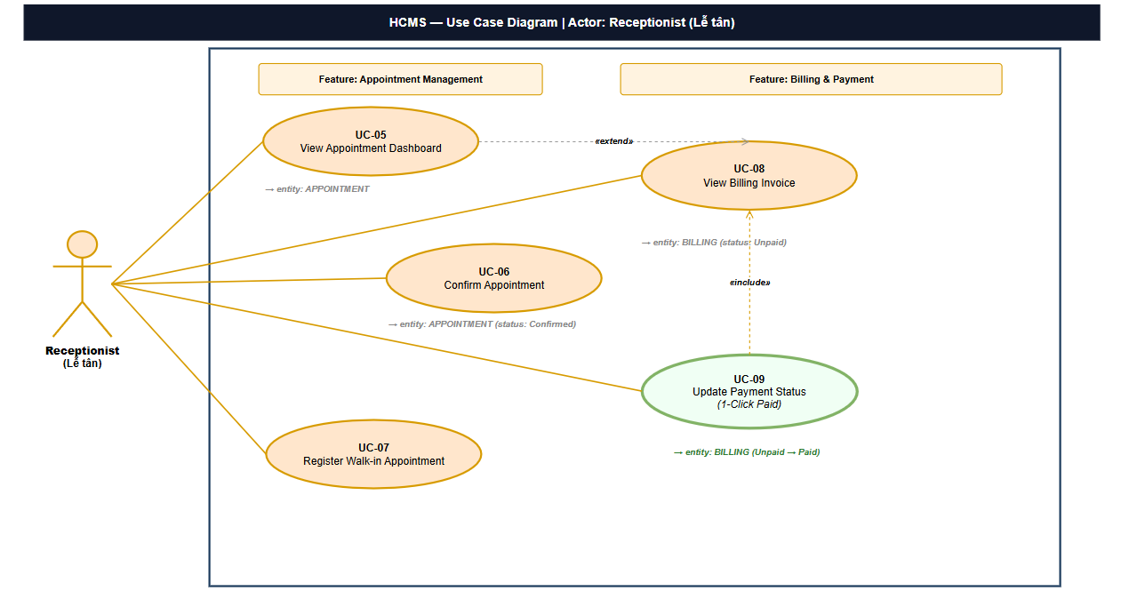

1.3.2.3 UCs for Doctors
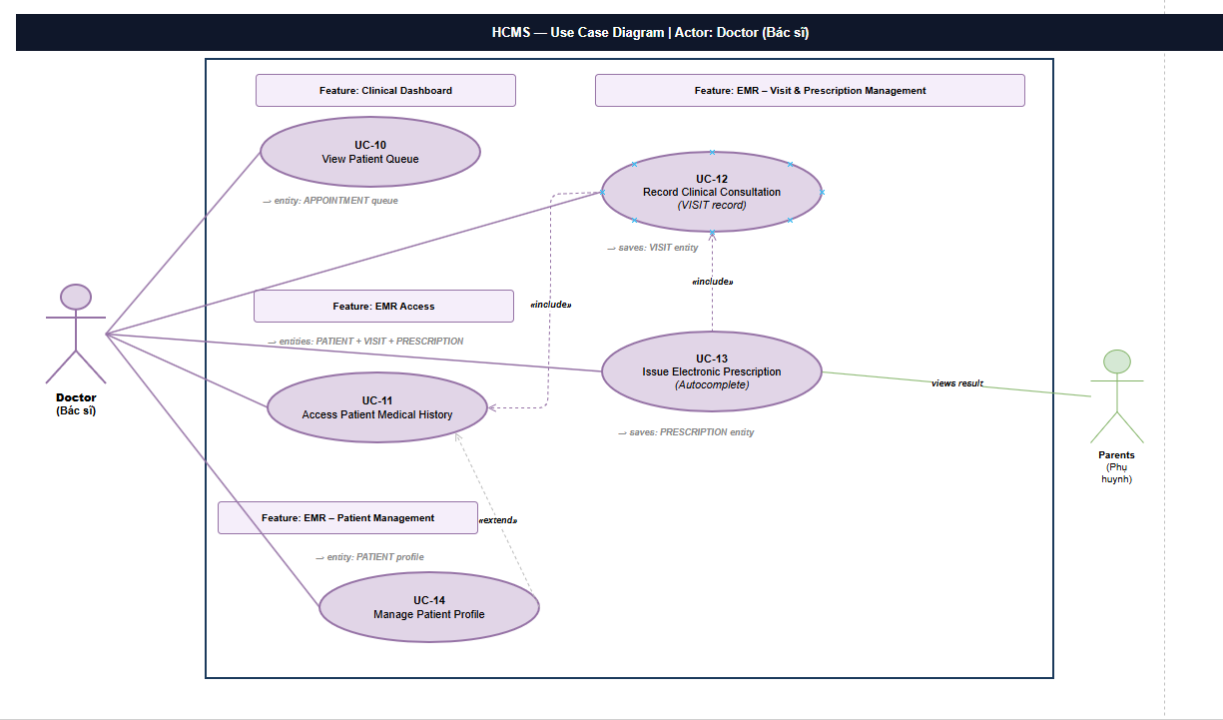

1.4 System Functionalities

1.4.1 Screens Flow
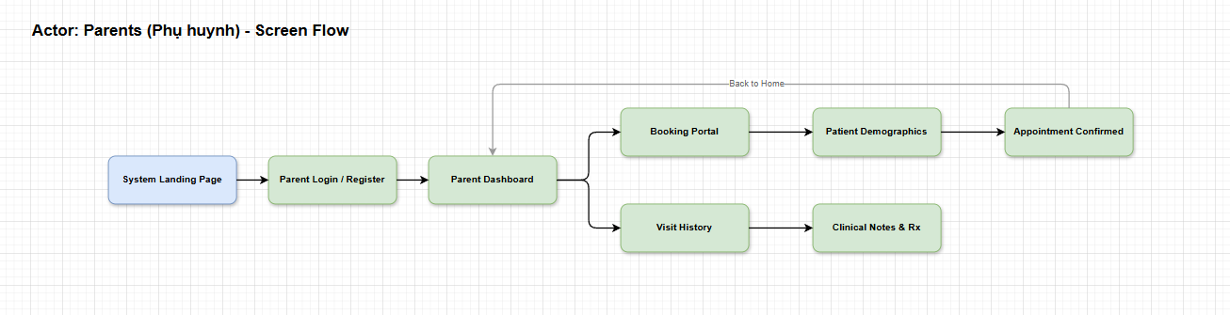
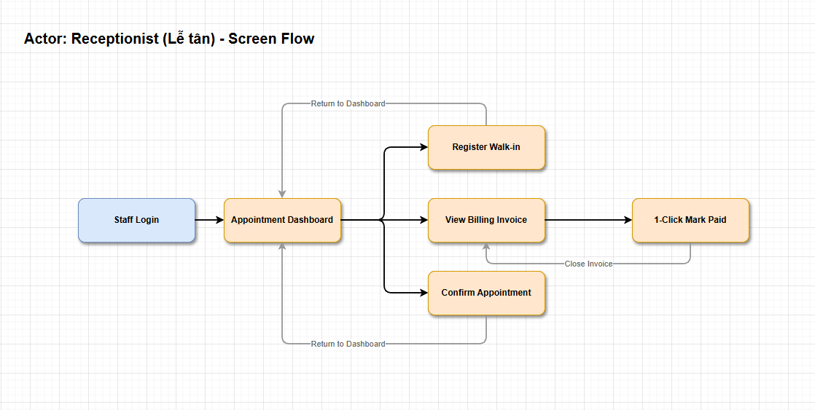
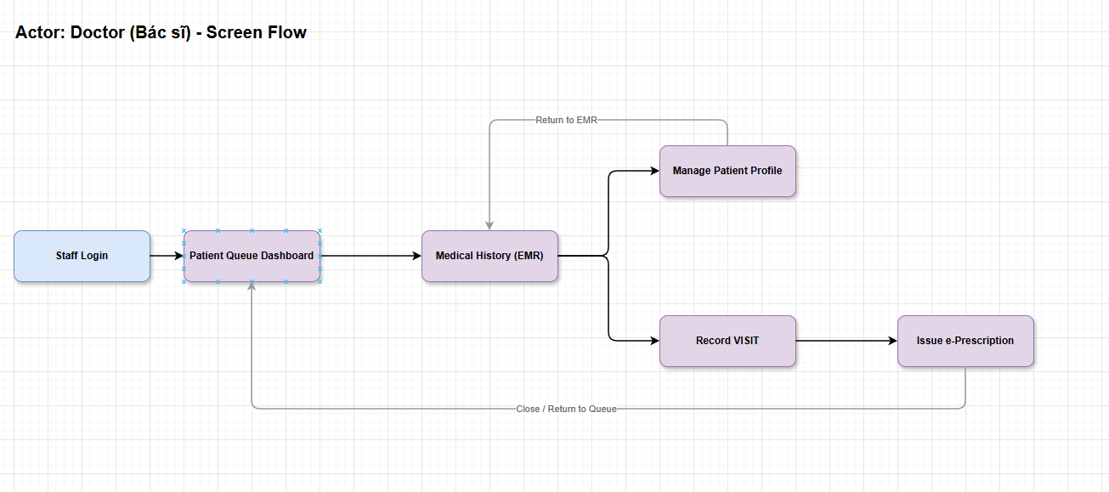

1.4.2 Screen Authorization
Screen | Role-Name1 | Role-Name2 | Role-Name3 | …
<<Screen Name1>> | X |  | X | X
<<Screen Name2>> |  | X
…

1.4.3 Non-UI Functions
[Provide the descriptions for the non-screen system functions, i.e batch/cron job, service, API, etc.]
# | Feature | System Function | Description
1 | <<Feature Name>> | <<Function Name1>> | <<Function Name1 Description>>
2 | …

1.5 Entity Relationship Diagram
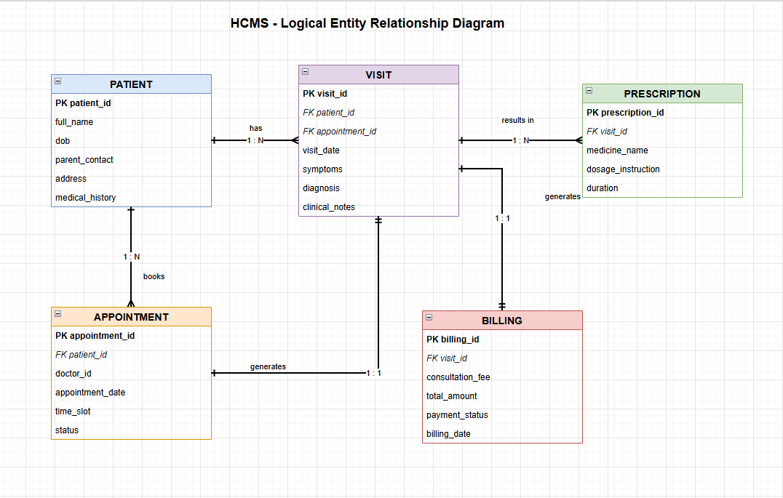
Entities Description
# | Entity | Description
1 | Patient | Cafeteria’s customer information
2 | Visit | …
3 | Prescription
4 | Billing
5 | Appointment

2. Use Case Specifications

2.1 Self-Service Booking Portal

2.1.1 UC-01 Book Appointment Online
Primary Actors | Parents | Secondary Actors | HCMS System
Description | As a parent, I want to view available doctors and time slots to book an appointment online so that I can save time and avoid waiting to call the clinic.
Preconditions | Parent accesses the Self-Service Booking Portal.
Postconditions | ● APPOINTMENT is tentatively held.  ● System proceeds to demographics screen.
Normal Sequence/Flow | Book Appointment  1. Parent accesses the Self-Service Booking Portal via web or mobile browser.  2. System displays available Doctors and time slots for the upcoming 7 days.  3. Parent selects a preferred Doctor and an available time slot.  4. Parent clicks the 'Continue' button.  5. System temporarily holds the selected time slot.  6. System directs Parent to the Patient Demographic screen (UC-02).
Alternative Sequences/Flows | Step 4_Time Slot Unavailable  1. System checks slot availability. If it was just booked by another user, System displays an error message (MSG01).  2. System refreshes available time slots.  3. Return to step 2 of normal flow.

2.1.2 UC-02 Provide Patient Demographics
Primary Actors | Parents | Secondary Actors | HCMS System
Description | As a parent, I want to enter my child's information so the clinic can properly identify the patient and confirm the booking.
Preconditions | Parent has successfully selected a time slot (UC-01).
Postconditions | ● PATIENT entity is updated/created.  ● APPOINTMENT entity is created with status 'Pending'.
Normal Sequence/Flow | Provide Demographics  1. System displays the Patient Demographic form.  2. Parent inputs the child's details (Full Name, Date of Birth, Gender) and parent contact (Phone Number, Email), along with Reason for Visit.  3. Parent clicks the 'Submit Booking' button.  4. System validates the inputted information (BR-01, BR-02).  5. System creates/updates the PATIENT record in the database.  6. System creates a new APPOINTMENT with status 'Pending' and links to the PATIENT.  7. System updates the Receptionist's Dashboard with the new APPOINTMENT.  8. System directs Parent to the Booking Success screen.
Alternative Sequences/Flows | Step 4_Validation Errors  1. Parent leaves mandatory fields blank (MSG02) or inputs invalid phone/email format (MSG03).  2. System highlights invalid fields with red text and displays error messages.  3. Return to step 2 of normal flow.

2.2 Appointment Notification

2.2.1 UC-03 Receive Appointment Confirmation
Primary Actors | Parents | Secondary Actors | Receptionist
Description | As a parent, I want to receive confirmation once the receptionist verifies my booking so I know my appointment is secured.
Preconditions | Receptionist confirmed the 'Pending' APPOINTMENT.
Postconditions | ● Parent receives a notification message.  ● Activity Log tracks the sent message.
Normal Sequence/Flow | Receive Confirmation  1. Receptionist changes the APPOINTMENT status to 'Confirmed'.  2. System generates an SMS/Email notification containing appointment details (Doctor, Time, Clinic Address).  3. System sends the notification to the Parent's registered contact info.  4. Parent receives and views the confirmation message on their device.
Alternative Sequences/Flows | Step 1.1_Appointment Rejected  1. Receptionist changes the APPOINTMENT status to 'Cancelled' (e.g., doctor unavailable).  2. System sends a cancellation notification with the corresponding reason to the Parent.

2.3 Patient EMR Portal

2.3.1 UC-04 View Clinical Notes & Prescriptions
Primary Actors | Parents | Secondary Actors | HCMS System
Description | As a parent, I want to view my child's consultation notes and medication dosage on my phone, to easily follow the doctor's instructions.
Preconditions | Consultation finalized (VISIT and PRESCRIPTION records exist).
Postconditions | ● Parent successfully authenticates via OTP and views records.
Normal Sequence/Flow | View Patient EMR  1. Parent accesses the EMR Portal via the secure link sent to their phone after the visit.  2. System requests OTP verification sent to parent's phone to authenticate access.  3. Parent inputs the OTP.  4. System validates the OTP.  5. System retrieves and displays the latest VISIT notes (Diagnosis, Doctor's advice) and PRESCRIPTION details (Medication name, dosage, frequency).  6. Parent reads the instructions.
Alternative Sequences/Flows | Step 4_OTP Invalid  1. Parent inputs an incorrect or expired OTP (MSG04).  2. System displays an error message and asks to re-enter OTP or request a new one.  3. Return to step 3 of normal flow.

2.4 Appointment Management

2.4.1 UC-05 View Appointment Dashboard
Primary Actors | Receptionist | Secondary Actors | HCMS System
Description | As a receptionist, I want to see an overview of all appointments for the day, to effectively coordinate patient flow.
Preconditions | Receptionist is securely logged into the system.
Postconditions | ● System displays current day's APPOINTMENT list.
Normal Sequence/Flow | View Dashboard  1. Receptionist clicks on the 'Dashboard' tab from the sidebar.  2. System queries the APPOINTMENT list for the current date.  3. System categorizes and displays the queue ('Pending', 'Confirmed', 'Checked-in', 'Completed').  4. Receptionist views the queue to monitor clinic traffic.
Alternative Sequences/Flows | None

2.4.2 UC-06 Confirm Appointment
Primary Actors | Receptionist | Secondary Actors | HCMS System
Description | As a receptionist, I want to confirm pending online bookings to ensure schedule accuracy and notify parents.
Preconditions | Dashboard displays a 'Pending' APPOINTMENT.
Postconditions | ● APPOINTMENT status becomes 'Confirmed'.
Normal Sequence/Flow | Confirm Booking  1. Receptionist reviews the 'Pending' APPOINTMENT details on the Dashboard.  2. Receptionist clicks the 'Confirm' button for that appointment.  3. System prompts for action confirmation.  4. Receptionist confirms the action.  5. System updates the APPOINTMENT status from 'Pending' to 'Confirmed'.  6. System automatically triggers UC-03 (Receive Appointment Confirmation).
Alternative Sequences/Flows | Step 2.1_Cancel Booking  1. Receptionist identifies a duplicate or invalid booking.  2. Receptionist clicks 'Cancel' and provides a reason.  3. System updates the APPOINTMENT status to 'Cancelled'.  4. Return to step 6 of normal flow (triggers Cancellation notification).

2.4.3 UC-07 Register Walk-in Appointment
Primary Actors | Receptionist | Secondary Actors | HCMS System
Description | As a receptionist, I want to register walk-in patients quickly at the desk to maintain accurate queues.
Preconditions | Parent arrives at the clinic without prior booking.
Postconditions | ● APPOINTMENT and PATIENT records are created.  ● APPOINTMENT status is 'Checked-in'.
Normal Sequence/Flow | Register Walk-in  1. Receptionist clicks 'New Walk-in' button on the Dashboard.  2. System displays the Walk-in Registration form.  3. Receptionist inputs new patient demographics (Name, DOB, Parent Contact).  4. Receptionist assigns the patient to an available Doctor queue.  5. Receptionist clicks 'Register'.  6. System saves a new PATIENT entity.  7. System creates a new APPOINTMENT with status 'Checked-in'.  8. System updates the Clinical Dashboard for the respective Doctor.
Alternative Sequences/Flows | Step 3.1_Patient Exists  1. Receptionist selects the 'Search Existing' option and search by phone number.  2. System displays existing patient details.  3. Receptionist selects the patient to autofill demographics.  4. Return to step 4 of normal flow.

2.5 Billing & Payment

2.5.1 UC-08 View Billing Invoice
Primary Actors | Receptionist | Secondary Actors | HCMS System
Description | As a receptionist, I want to view the auto-generated checkout invoice for a patient to collect payment securely.
Preconditions | Doctor finalized the VISIT, and System generated the BILLING record.
Postconditions | ● Invoice is displayed accurately to the Receptionist.
Normal Sequence/Flow | View Checkout  1. Receptionist navigates to the 'Billing' tab or selects the 'Ready for Checkout' appointment on the Dashboard.  2. System retrieves the corresponding BILLING and PRESCRIPTION data.  3. System displays the detailed invoice including consultation fee and medication costs.  4. Receptionist prints the invoice or communicates the total amount to the Parent.
Alternative Sequences/Flows | None

2.5.2 UC-09 Update Payment Status (1-Click Paid)
Primary Actors | Receptionist | Secondary Actors | Parents
Description | As a receptionist, I want to mark the bill as paid with 1-click to ensure fast checkout operations.
Preconditions | Receptionist views the 'Unpaid' invoice (UC-08).
Postconditions | ● BILLING status is updated to 'Paid'.  ● System logs checkout transaction.
Normal Sequence/Flow | Process Payment  1. Parent provides cash or completes a bank transfer for the total invoice amount.  2. Receptionist verifies the payment received.  3. Receptionist clicks the 'Mark as Paid' (1-Click) button on the system.  4. System updates the BILLING status from 'Unpaid' to 'Paid'.  5. System records the transaction for daily revenue tracking.
Alternative Sequences/Flows | Step 1.1_Payment Delayed/Failed  1. Parent does not have enough funds or bank transfer fails.  2. Receptionist leaves the invoice status as 'Unpaid'.  3. System keeps the invoice in the 'Pending Payment' list.

2.6 Clinical Dashboard

2.6.1 UC-10 View Patient Queue
Primary Actors | Doctor | Secondary Actors | HCMS System
Description | As a doctor, I want to view the queue of waiting patients assigned to me so I know who to examine next.
Preconditions | Doctor is logged in to the Clinical Dashboard.
Postconditions | ● System displays the queue of patients.
Normal Sequence/Flow | View Queue  1. Doctor opens the Clinical Dashboard screen.  2. System retrieves the daily APPOINTMENTs assigned to the currently logged in Doctor.  3. System displays the list categorized by 'Checked-in' (Waiting) and 'Completed'.  4. Doctor selects the next 'Checked-in' patient from the top of the queue to begin consultation.
Alternative Sequences/Flows | None

2.7 EMR Access

2.7.1 UC-11 Access Patient Medical History
Primary Actors | Doctor | Secondary Actors | HCMS System
Description | As a doctor, I want to review past visits, diagnoses, and allergies to make informed clinical decisions.
Preconditions | Doctor selects a patient from the queue.
Postconditions | ● System displays the EMR Summary.
Normal Sequence/Flow | View History  1. Doctor clicks on the Patient's name in the Clinical Dashboard queue.  2. System retrieves the patient's demographic profile, registered allergies, and past VISIT/PRESCRIPTION records.  3. System displays the historical summary in a structured timeline view.  4. Doctor reviews the information before proceeding to the current consultation notes.
Alternative Sequences/Flows | None

2.8 EMR – Visit & Prescription Management

2.8.1 UC-12 Record Clinical Consultation
Primary Actors | Doctor | Secondary Actors | HCMS System
Description | As a doctor, I want to type clinical notes and diagnoses directly into the EMR to eliminate paper files.
Preconditions | Doctor has reviewed the patient's history (UC-11).
Postconditions | ● VISIT entity is created and securely linked to the APPOINTMENT.
Normal Sequence/Flow | Enter Notes  1. Doctor clicks 'Start Consultation'.  2. System opens a new VISIT record form interface.  3. Doctor inputs Symptoms, Vital Signs, and Diagnosis.  4. Doctor clicks 'Save Consultation'.  5. System validates the inputs (e.g., diagnosis cannot be empty).  6. System securely stores the VISIT record into the database.
Alternative Sequences/Flows | Step 5_Validation Error  1. Doctor forgets to input the mandatory Diagnosis field (MSG05).  2. System highlights the missing required field and prevents saving.  3. Return to step 3 of normal flow.

2.8.2 UC-13 Issue Electronic Prescription
Primary Actors | Doctor | Secondary Actors | HCMS System
Description | As a doctor, I want to quickly add medications using autocomplete to save time when prescribing.
Preconditions | Doctor is in an active VISIT session.
Postconditions | ● PRESCRIPTION entity is created.  ● BILLING entity is automatically generated.
Normal Sequence/Flow | Create Prescription  1. Doctor clicks 'Add Prescription'.  2. Doctor types the first few letters of a medication name into the drug search field.  3. System displays a dropdown with Autocomplete suggestions from the drug dictionary.  4. Doctor selects the desired medication from the suggestions.  5. Doctor inputs dosage instructions (e.g., '2 times/day').  6. Doctor repeats steps 2-5 for other medications, then clicks 'Finalize Consultation'.  7. System saves the PRESCRIPTION linked to the active VISIT.  8. System automatically generates a BILLING invoice based on the consultation fee and medication costs.  9. System updates APPOINTMENT status to 'Completed'.
Alternative Sequences/Flows | Step 6.1_No Medication Needed  1. Doctor determines no medicine is needed for this patient.  2. Doctor clicks 'Finalize Consultation' without adding any drugs.  3. Return to step 8 of normal flow (System generates a Billing invoice containing consultation fee only).

2.9 EMR – Patient Management

2.9.1 UC-14 Manage Patient Profile
Primary Actors | Doctor | Secondary Actors | HCMS System
Description | As a doctor, I want to correct or update the core demographic and allergy information of the patient to ensure safety.
Preconditions | Doctor views the Patient Medical History (UC-11).
Postconditions | ● PATIENT entity is updated successfully.
Normal Sequence/Flow | Edit Profile  1. Doctor clicks 'Edit Profile' on the patient's information card.  2. System makes the data fields (Height, Weight, Allergies) editable.  3. Doctor types in the updated information (e.g., adding an allergy to Penicillin).  4. Doctor clicks 'Update'.  5. System saves the modified PATIENT record to the database.  6. System displays a success banner confirming the update.
Alternative Sequences/Flows | None

3. Functional Requirements
[Provide descriptions about the system’s functions/screens. The functions/screens are grouped by the system features, and even sub-features if needed. For the screens, you need to provide the screen layouts (mock-up screens) and relevant specifications if needed]

3.1 Feature Name1

3.1.1 SubFeature Name1.1

3.1.1.1 Screen/Function Name1
[Content #1: UI layout (Mockup screen prototype)]
[Content #2: brief descriptions of the screen/function, mapped to the relevant use cases]
[Content #3: provide further descriptions for the screen’s components/fields using table format below]
Field Name | Description
Field Name1 | Field description: data type min/max length or value, initial data, etc.
Field Name2 | …
Field Group-Name1
Field Name3 | …
Field Name4 | …
Field Group-Name2
… | …

3.1.1.2 Screen/Function Name2
…

3.1.2 SubFeature Name1.2
…
Field Name | Description
Test Field | Test Description
Field Name2 | …
Field Group-Name1
Field Name3 | …
Field Name4 | …
Field Group-Name2
… | …

3.2 User Authentication

3.2.1 User Register
…

3.2.2 User Login
…

3.2.3 Password Reset
…

3.3 System Administration

3.3.1 Master Data

3.3.1.1 Setting List
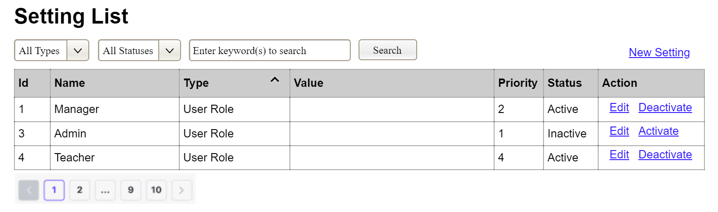
(3)
(2)
(1)
This screen allows the Administrator to:
- View Setting List: view list of current master data.
- Filter Setting List: filter master data by data types, statuses
- Search Settings: enter keyword(s) to search master data by their names or values
- Sort Setting List: sort mater data list (ascending, descending) by clicking column headers
On the screen, s/he can also
- Activate/Deactivate Setting: change status of a specific inactive/active master data
- Choose to go to the Setting Details screens for adding new or updating an existing master data by clicking the New Setting or Edit link.
Field Description
Field Name | Description
(1) | Initial values: all the active setting names with null or blank type  Hover the mouse to show the field name: “Setting Type”
(2) | Initial values: All Statuses, Active, Inactive (default value “All Status”)  Hover the mouse to show the field name: “Setting Status”
(3) | The change-status action is Activate or Deactivate depending on the current status of the relevant setting (Inactive or Active, respectively).

3.3.1.2 Setting Details
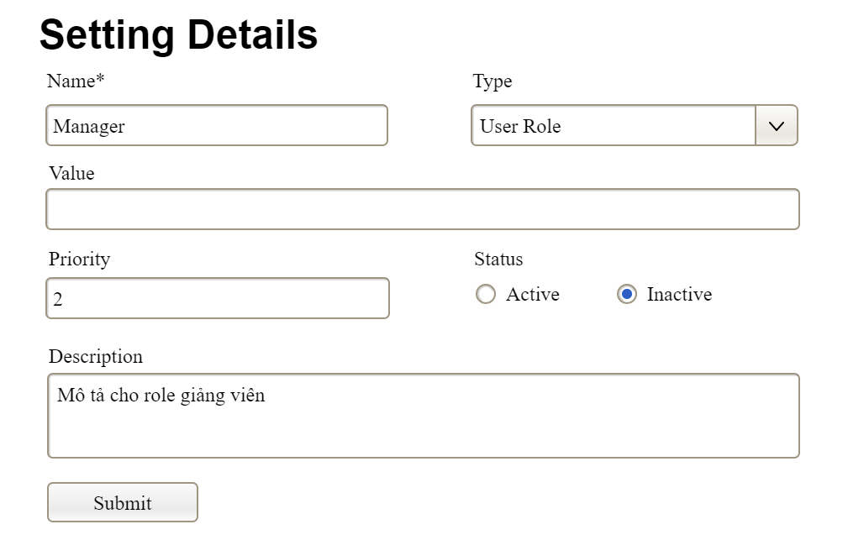

This screen allows the Administrator to:
- Add New Setting: add new master data.
- Update Setting Details: update details of a specific master data
Field Description
Field Name | Description
Name | Data type: non-digit string, max length of 20 characters
Type | Initial data values: all active setting names (with null or blank type)
Value | Data type: any string, max length of 100 characters
Priority | Data type: a positive integer
Description | Data type: any string, max length of 200 characters

3.3.2 User Management

3.3.2.1 User List
…

3.3.2.2 User Details
…

4. Non-Functional Requirements

3.1 External Interfaces
[This section provides information to ensure that the system will communicate properly with users and with external hardware or software/system elements.]

3.2 Quality Attributes
[List all the required system characteristics (quality attributes) specification. Some of the possible attributes are provided with the guide/descriptions are mentioned here]

3.2.1 Usability
[This section includes all those requirements that affect usability. For example, specify the required training time for a normal user and a power user to become productive at particular operations specify measurable task times for typical tasks or base the new system’s usability requirements on other systems that the users know and like specify requirement to conform to common usability standards, such as IBM’s CUA standards Microsoft’s GUI standards]

3.2.2 Performance
[The system’s performance characteristics are outlined in this section. Include specific response times. Where applicable, reference related Use Cases by name.
Response time for a transaction (average, maximum)
Throughput, for example, transactions per second
Capacity, for example, the number of customers or transactions the system can accommodate
Resource utilization, such as memory, disk, communications, and so forth.]

3.2.3 …

5. Requirement Appendix
[Provide business rules, common requirements, or other extra requirements information here]

5.1 Business Rules
[Provide common business rules that you must follow. The information can be provided in the table format as the sample below]
ID | Rule Definition
BR-01 | Delivery time windows are 15 minutes, beginning on each quarter hour.
BR-02 | Deliveries must be completed between 10:00 A.M. and 2:00 P.M. local time, inclusive.
BR-03 | All meals in a single order must be delivered to the same location.
BR-04 | All meals in a single order must be paid for by using the same payment method.
BR-11 | If an order is to be delivered, the patron must pay by payroll deduction.
BR-12 | Order price is calculated as the sum of each food item price times the quantity of that food item ordered, plus applicable sales tax, plus a delivery charge if a meal is delivered outside the free delivery zone.
BR-24 | Only cafeteria employees who are designated as Menu Managers by the Cafeteria Manager can create, modify, or delete cafeteria menus.
BR-33 | Network transmissions that involve financial information or personally identifiable information require 256-bit encryption.
BR-86 | Only regular employees can register for payroll deduction for any company purchase.
BR-88 | An employee can register for payroll deduction payment of cafeteria meals if no more than 40 percent of his gross pay is currently being deducted for other reasons.

5.2 System Messages
# | Message code | Message Type | Context | Content
1 | MSG01 | In line | There is not any search result | No search results.
2 | MSG02 | In red, under the text box | Input-required fields are empty | The * field is required.
3 | MSG03 | Toast message | Updating asset(s) information successfully | Update asset(s) successfully.
4 | MSG04 | Toast message | Adding new asset successfully | Add asset successfully.
5 | MSG05 | Toast message | Confirming email of asset hand-over is sent successfully | A confirmation email has been sent to {email_address}.
6 | MSG06 | Toast message | Resetting asset information successfully | Return asset(s) successfully.
7 | MSG07 | Toast message | Deleting asset information successfully | Delete asset(s) successfully.
8 | MSG08 | In red, under the text box | Input value length > max length | Exceed max length of {max_length}.
9 | MSG09 | In line | Username or password is not correct when clicking sign-in | Incorrrect user name or password. Please check again.
10 | ..

5.3 Other Requirements…

