

CAPSTONE PROJECT REPORT
Report 3 – Software Requirement Specification

– Hanoi, Jan 2024 –
Table of Contents
I. Record of Changes 3
II. Software Requirement Specification 4
1. Overall Requirements 4
1.1 Context Diagram 4
1.2 Main Workflows 5
1.3 User Requirements 5
1.4 System Functionalities 7
1.5 Entity Relationship Diagram 7
2. Use Case Specifications 8
2.1 <<Feature Name1>> 8
2.2 Xyz Feature 10
3. Functional Requirements 11
3.1 Feature Name1 11
3.2 User Authentication 11
3.3 System Administration 12
4. Non-Functional Requirements 13
3.1 External Interfaces 13
3.2 Quality Attributes 13
5. Requirement Appendix 14
5.1 Business Rules 14
5.2 System Messages 14
5.3 Other Requirements… 15

I. Record of Changes
Date | A*  M, D | In charge | Change Description
*A - Added M - Modified D - Deleted

II. Software Requirement Specification

1. Overall Requirements

1.1 Context Diagram
The Healthcare Clinic Management System (HCMS) is a new software solution designed to replace current manual and telephone-based processes at a private paediatric clinic. The context diagram illustrates the external entities and system interfaces for the MVP version (v1.0), focusing on optimizing the data flow between parents, doctors, and the reception desk. The system is designed for a lean operational scale of 1-2 doctors and 1 receptionist, with the goal of eliminating administrative bottlenecks and fully digitizing electronic medical records (EMR). It is built upon a core data structure of 5 essential entities—Patient, Appointment, Visit, Prescription, and Billing—while strictly excluding complex features such as health insurance integration or advanced pharmacy inventory management to ensure rapid deployment.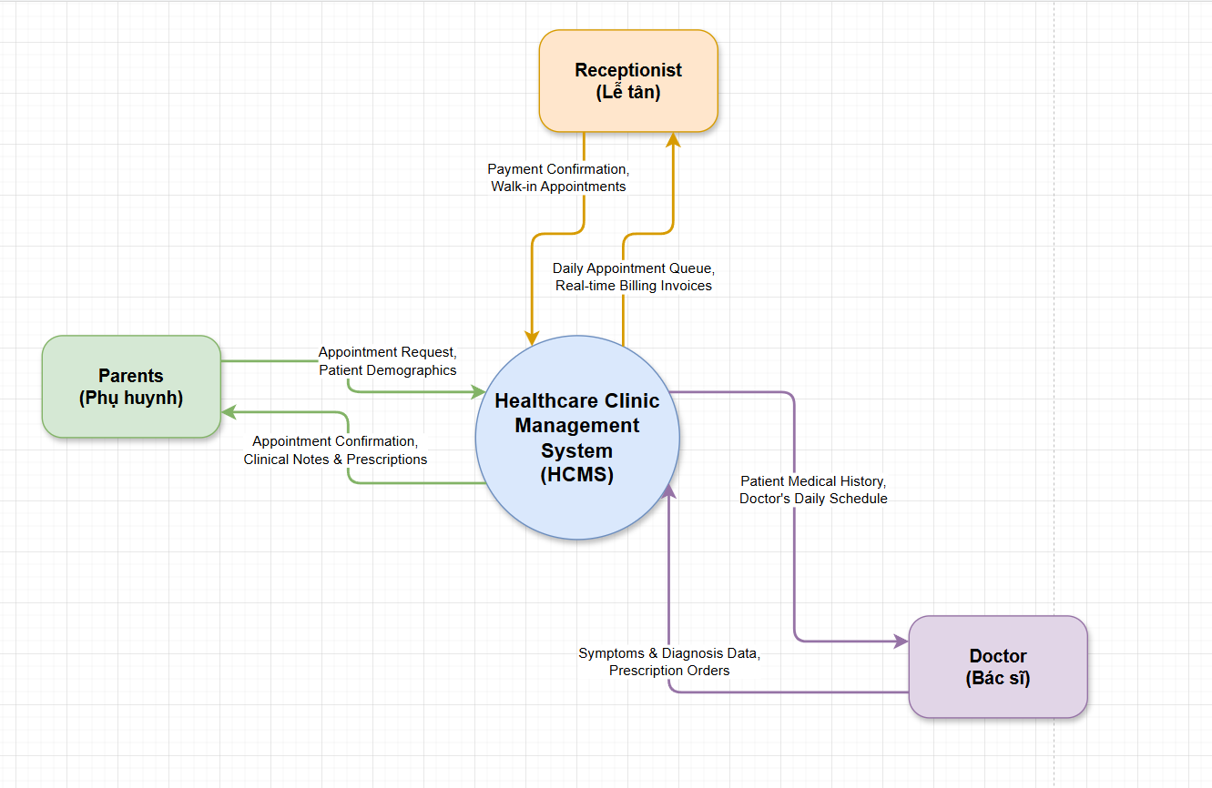

1.2 Main Workflows

1.2.1 Self-Service Booking
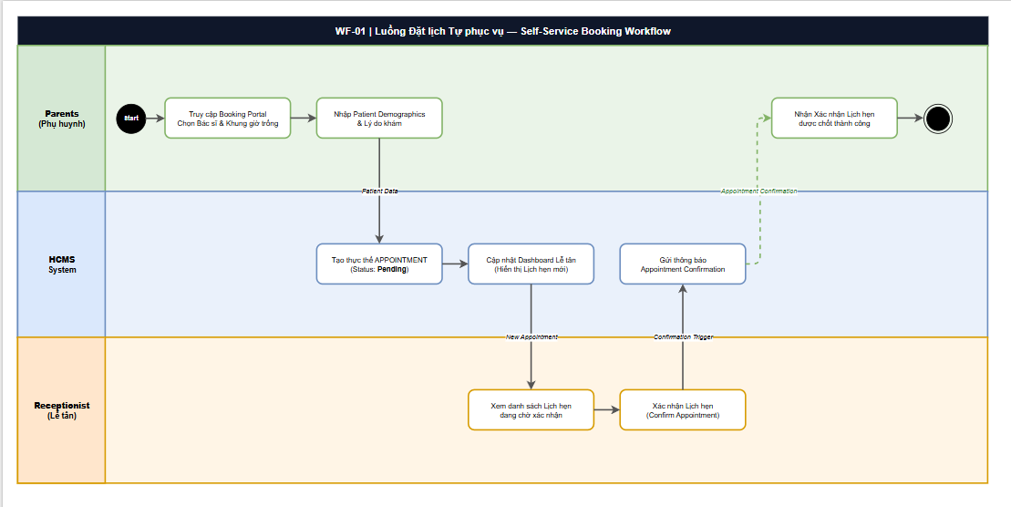

1.2.2 Clinical Consultation & EMR
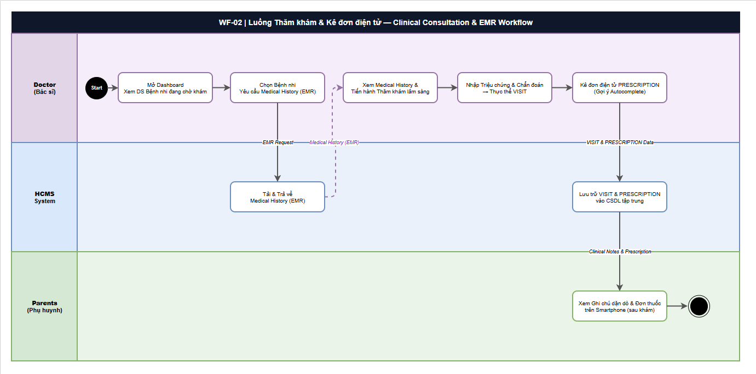

1.2.3 Streamlined 1-Click Checkout
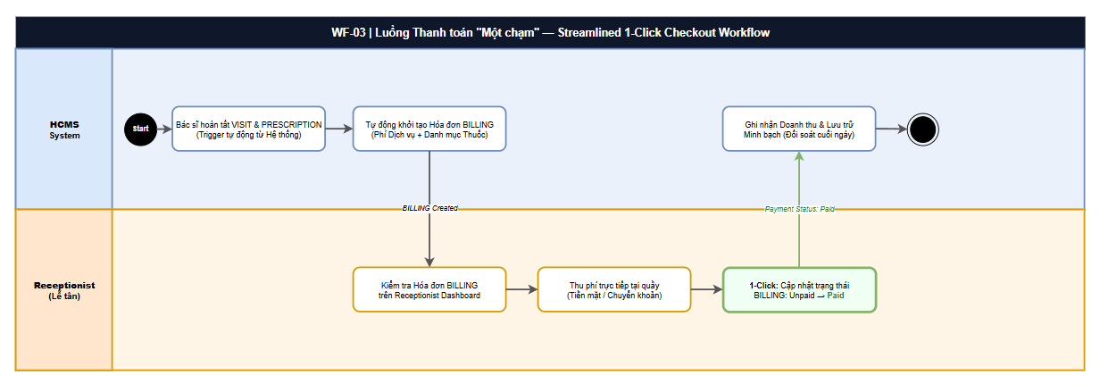

1.3 User Requirements

1.3.1 Actors

# | Actor | Description
1 | Parents  (Phụ huynh)  Human | External User | Parents or guardians of pediatric patients who interact with HCMS via the self-service Booking Portal (smartphone/web). They initiate appointment bookings, provide child's Patient Demographics, receive appointment confirmations, and view post-visit clinical notes & prescriptions on their device. They are outside the clinic and do not use the internal dashboard.
2 | Doctor  (Bác sĩ)  Human | Primary Internal User & System Sponsor | The lead physician (Dr. Minh) who acts as both project sponsor and the primary clinical user. Doctors interact with HCMS to access a real-time patient queue dashboard, retrieve full Medical History (EMR) for each patient, record clinical consultation outcomes into a VISIT entity, and issue electronic Prescriptions using the autocomplete drug-name feature. All Doctor interactions are within the clinic's internal network.
3 | Receptionist  (Lễ tân)  Human | Key Internal Operator | The front-desk operator (Chị Lan) responsible for administrative clinic operations. Receptionists interact with HCMS to view Appointment Dashboard, confirm or manually register appointments (including walk-ins), verify the auto-generated BILLING invoices, and execute the 1-Click Payment status update (Unpaid → Paid). She is a high-frequency user of the system.

1.3.2 Use Cases (UC)
ID | Use Case | Feature | Use Case Description
UC-01 | Book Appointment Online | Self-Service Booking Portal | Parents access the online Booking Portal, select a preferred Doctor (by name/specialty) and an available time slot from the real-time calendar. The system validates the slot and auto-creates an APPOINTMENT entity with status 'Pending'. The Receptionist is notified on her dashboard of the new pending booking.
UC-02 | Provide Patient Demographics | Self-Service Booking Portal | During an initial booking (or at check-in), Parents input the child's personal and medical data: full name, date of birth, parent phone/email, and primary medical notes. The system creates or updates the PATIENT entity linked to the APPOINTMENT record.
UC-03 | Receive Appointment Confirmation | Appointment Notification | After the Receptionist confirms a pending appointment, HCMS automatically sends an Appointment Confirmation notification (SMS/Email) to the Parent's registered contact, including appointment date, time, doctor name, and clinic address.
UC-04 | View Clinical Notes & Prescriptions | Patient EMR Portal | After a completed visit, Parents can log in to the portal to review the Doctor's clinical notes (VISIT record: diagnosis, symptoms, aftercare instructions) and the linked electronic PRESCRIPTION (medicine name, dosage, frequency, duration) on their smartphone.
UC-05 | View Appointment Dashboard | Appointment Management | The Receptionist views a live, sortable dashboard listing all upcoming appointments for the day: patient name, time slot, assigned Doctor, and current APPOINTMENT status (Pending / Confirmed / In-Progress / Completed). The dashboard auto-refreshes in real time.
UC-06 | Confirm Appointment | Appointment Management | Upon reviewing a Parent-submitted Pending appointment, the Receptionist validates the information and clicks 'Confirm'. The system updates the APPOINTMENT status from 'Pending' to 'Confirmed' and triggers the confirmation notification to the Parent (see UC-03).
UC-07 | Register Walk-in Appointment | Appointment Management | For patients who arrive at the clinic without a prior online booking, the Receptionist manually creates a new APPOINTMENT record by entering the patient info and selecting an available Doctor and time slot. The walk-in APPOINTMENT is created with status 'Confirmed'.
UC-08 | View Billing Invoice | Billing & Payment | Once the Doctor completes and saves a VISIT + PRESCRIPTION record, the HCMS system automatically generates a BILLING invoice summarizing: consultation fee, itemized prescription costs, and total amount due. The Receptionist can view this invoice on the dashboard with status 'Unpaid'.
UC-09 | Update Payment Status (1-Click Paid) | Billing & Payment | After collecting the payment from the Parent (cash or bank transfer at the counter), the Receptionist clicks a single 'Mark as Paid' button. The system instantly updates the BILLING status from 'Unpaid' to 'Paid', records the payment timestamp, and logs the transaction for the end-of-day revenue reconciliation report.
UC-10 | View Patient Queue | Clinical Dashboard | The Doctor opens their personal clinical dashboard to see the ordered list of patients waiting for examination: patient name, appointment time, and current status. The queue is auto-sorted by appointment time and updated in real time as Receptionists confirm arrivals.
UC-11 | Access Patient Medical History (EMR) | EMR – Medical History | Before or during an examination, the Doctor selects a patient from the queue and retrieves their complete Electronic Medical Record: full PATIENT profile, all previous VISIT records (past diagnoses, symptoms), and all past PRESCRIPTION records. This enables evidence-based, data-driven clinical decisions without paper records.
UC-12 | Record Clinical Consultation (VISIT) | EMR – Visit Management | During the physical examination, the Doctor enters the consultation outcome into a new VISIT record: observed symptoms, clinical diagnosis (ICD-coded), physical examination notes, and aftercare/follow-up instructions. The VISIT record is saved and linked to the patient's PATIENT entity and the originating APPOINTMENT.
UC-13 | Issue Electronic Prescription | EMR – Prescription Management | After completing the VISIT record, the Doctor creates a PRESCRIPTION record by specifying each medicine (drug name with autocomplete suggestion), dosage amount, frequency, administration route, and duration. The saved PRESCRIPTION is automatically linked to the VISIT and PATIENT entities, and is visible to the Parent via the portal (UC-04).
UC-14 | Manage Patient Profile | EMR – Patient Management | The Doctor can view and update supplementary medical information in the PATIENT profile: known allergies, blood type, chronic condition flags, and vaccination notes. This ensures the EMR remains accurate and up-to-date for future clinical decisions by the same or other doctors at the clinic.

1.3.2 Use Case Diagrams

1.3.2.1 UCs for Parents
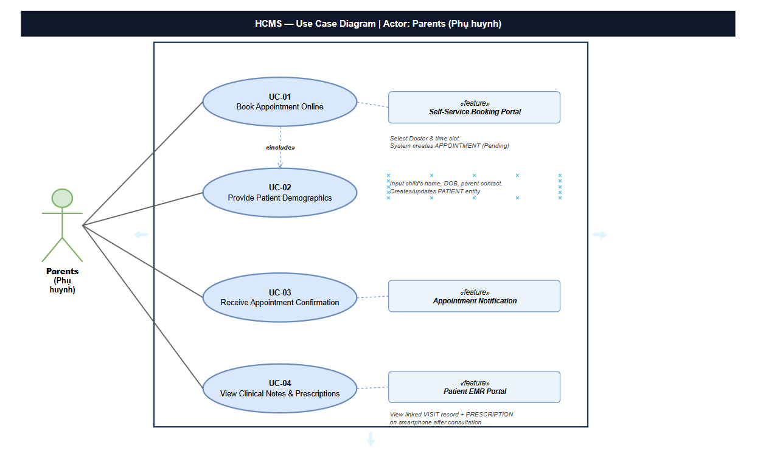

1.3.2.2 UCs for Receptionist
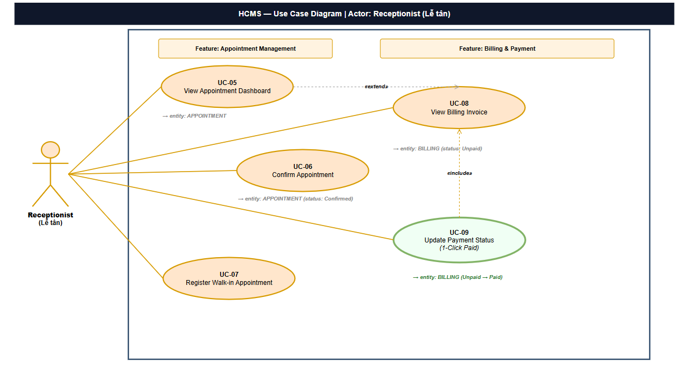

1.3.2.3 UCs for Doctors
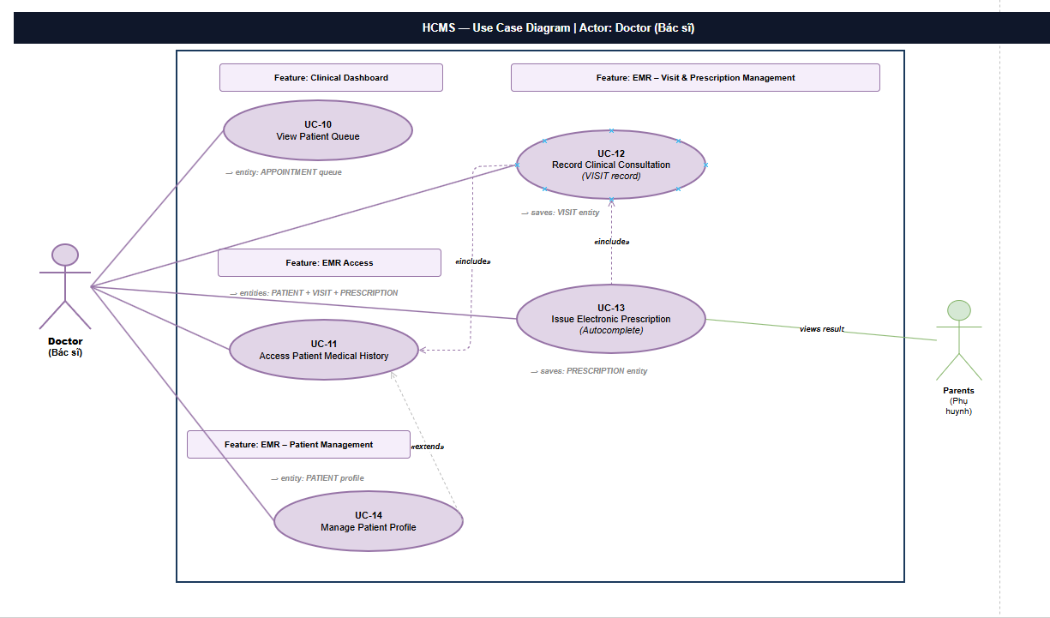

1.4 System Functionalities

1.4.1 Screens Flow
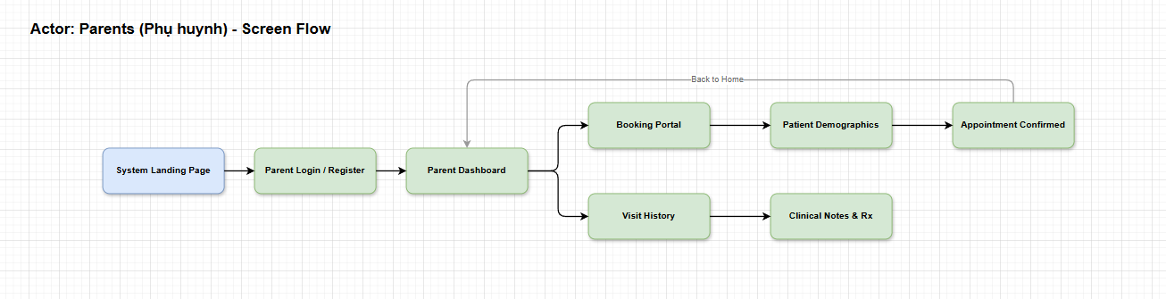
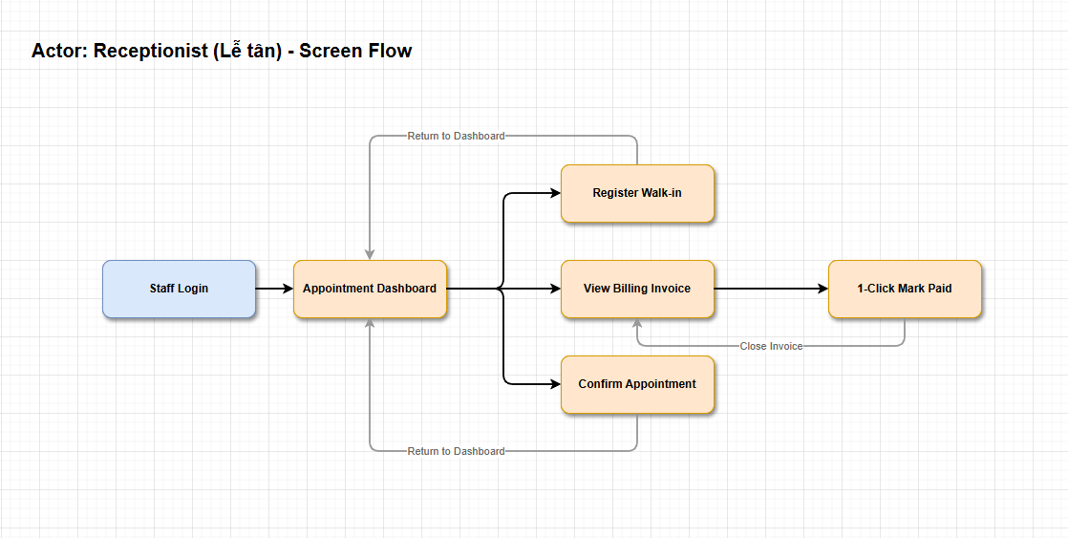
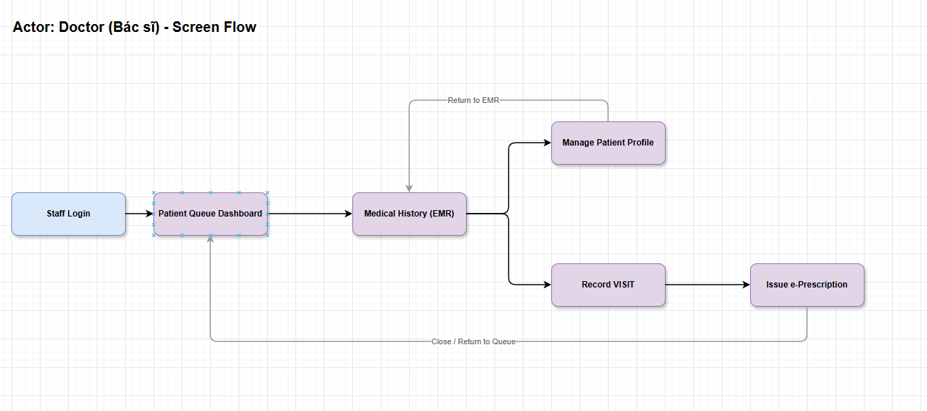

1.4.2 Screen Authorization
Screen | Role-Name1 | Role-Name2 | Role-Name3 | …
<<Screen Name1>> | X |  | X | X
<<Screen Name2>> |  | X
…

1.4.3 Non-UI Functions
[Provide the descriptions for the non-screen system functions, i.e batch/cron job, service, API, etc.]
# | Feature | System Function | Description
1 | <<Feature Name>> | <<Function Name1>> | <<Function Name1 Description>>
2 | …

1.5 Entity Relationship Diagram
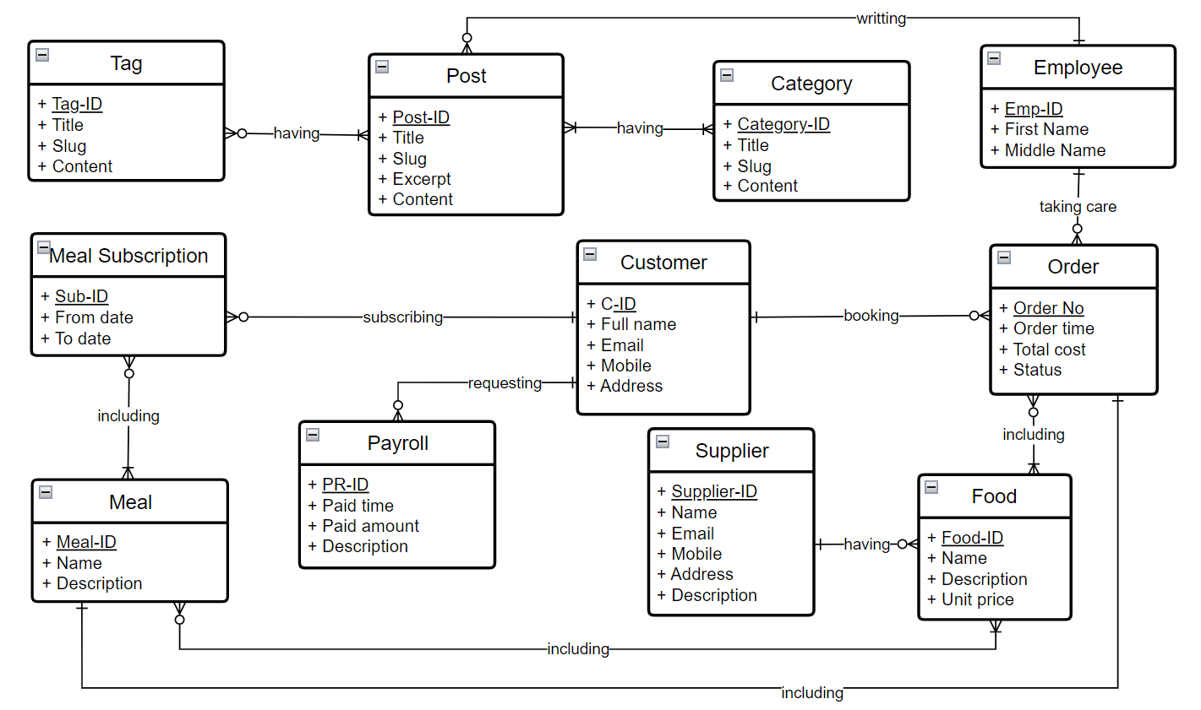
Entities Description
# | Entity | Description
1 | Patrol | Cafeteria’s customer information
2 | Meal | …
3 | …

2. Use Case Specifications
[Provide specifications for the use cases (UCs) those are covered in the system. The UCs are grouped by the system features and even sub features. You just need to provide UC specifications for complex UCs involving in the main workflows (business processes). Other UCs (i.e CRUD or data-viewing UCs) are simple, and you just need to refer the descriptions in the Functional Requirement (part 3) below)]

2.1 <<Feature Name1>>

2.1.1 UC Name1
Primary Actors |  | Secondary Actors
Description
Preconditions
Postconditions
Normal Sequence/Flow
Alternative Sequences/Flows

Primary and Secondary Actors
An actor is a person or other entity external to the software system being specified who interacts with the system and performs use cases to accomplish tasks. Name the primary actor that will be initiating this UC and any other secondary actors who will participate in completing execution of the UC.
Description
Provide a brief description of the reason for and outcome of this use case, or a high-level description of the sequence of actions and the outcome of executing the use case. The description can be in the form of a user story (As a <type of user>, I want <some goal> so that <some reasons>)
Preconditions
List any activities that must take place, or any conditions that must be true, before the use case can be started.
Postconditions
Describe the state of the system at the successful conclusion of the use case execution.
Normal Flow
Provide a description of the user actions and corresponding system responses that will take place during execution of the use case under normal, expected conditions.
Alternative Flows
Describe below two information if any:
- Other successful usage scenarios that can take place within this use case. State the alternative flow, and describe any differences in the sequence of steps that take place.
- Any anticipated error conditions that could occur during execution of the use case and how the system is to respond to those conditions.

2.1.2 Login System
Primary Actors | Customer | Secondary Actors | None
Description | As a user, I want to be able to log into the system so that I can use the system’s authenticated features and access my personalized account.
Preconditions | User account has been created & authorized
Postconditions | - User logs in the system successfully  - The system tracked successful login into the Activity Log
Normal Sequence/Flow | Login System  - User clicks Login button from the page header or accesses an authenticated feature (from a link or type the page URL directly into the address bar)  - System show the User Login screen  - User types in the login details (email, password)  - User clicks the Login button  - System validates the login details (BR-01, BR-02)  - System allows user to access  - System tracks user’s success login to the Activity Log  - System directs user to the Home Page (or the previous calling page if any)
Alternative Sequences/Flows | Step 2.1_Google Login  - User clicks Google Login button to login system using Google account  - System redirects the user to the Google’s Login screen  - User types in the Google account details and chooses to login  - Google validates user’s login information successfully and redirect him/her back to the system  - Return to step 5 of normal flow.  Step 4_System can’t authenticate the user  User can’t be authenticated & get relevant error message in one of below cases  - He/she leaves the Email and/or Password field blank (MSG10)  - Input Email or Password are incorrect (MSG09)  - Input Email/Password are correct but email has not been verified (MSG11)  - The user account is blocked / inactive (MSG12)  If user inputs wrong logging-in details 5 times continuously, system will lock his/her account in 30 minutes (with relevant warning message - MSG13)

2.1.3 UC Name2
…

2.2 Xyz Feature
…

3. Functional Requirements
[Provide descriptions about the system’s functions/screens. The functions/screens are grouped by the system features, and even sub-features if needed. For the screens, you need to provide the screen layouts (mock-up screens) and relevant specifications if needed]

3.1 Feature Name1

3.1.1 SubFeature Name1.1

3.1.1.1 Screen/Function Name1
[Content #1: UI layout (Mockup screen prototype)]
[Content #2: brief descriptions of the screen/function, mapped to the relevant use cases]
[Content #3: provide further descriptions for the screen’s components/fields using table format below]
Field Name | Description
Field Name1 | Field description: data type min/max length or value, initial data, etc.
Field Name2 | …
Field Group-Name1
Field Name3 | …
Field Name4 | …
Field Group-Name2
… | …

3.1.1.2 Screen/Function Name2
…

3.1.2 SubFeature Name1.2
…

3.2 User Authentication

3.2.1 User Register
…

3.2.2 User Login
…

3.2.3 Password Reset
…

3.3 System Administration

3.3.1 Master Data

3.3.1.1 Setting List
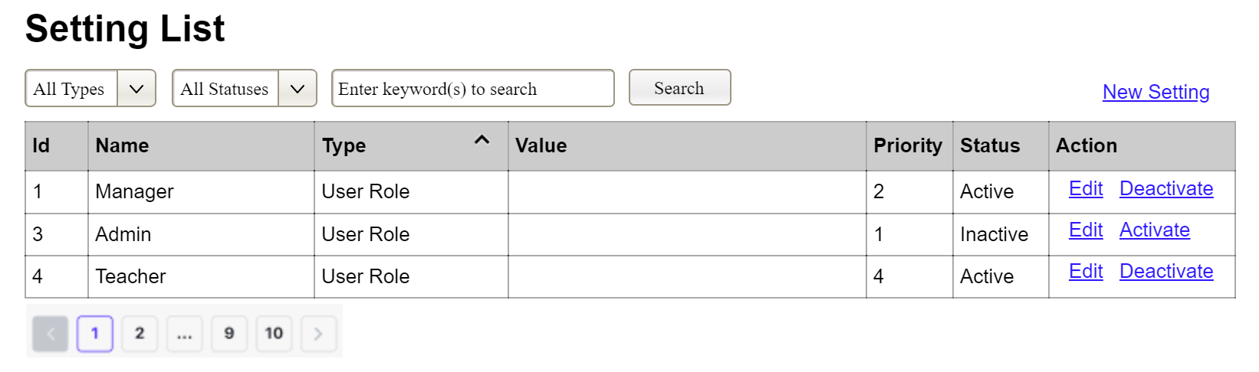
(3)
(2)
(1)
This screen allows the Administrator to:
- View Setting List: view list of current master data.
- Filter Setting List: filter master data by data types, statuses
- Search Settings: enter keyword(s) to search master data by their names or values
- Sort Setting List: sort mater data list (ascending, descending) by clicking column headers
On the screen, s/he can also
- Activate/Deactivate Setting: change status of a specific inactive/active master data
- Choose to go to the Setting Details screens for adding new or updating an existing master data by clicking the New Setting or Edit link.
Field Description
Field Name | Description
(1) | Initial values: all the active setting names with null or blank type  Hover the mouse to show the field name: “Setting Type”
(2) | Initial values: All Statuses, Active, Inactive (default value “All Status”)  Hover the mouse to show the field name: “Setting Status”
(3) | The change-status action is Activate or Deactivate depending on the current status of the relevant setting (Inactive or Active, respectively).

3.3.1.2 Setting Details
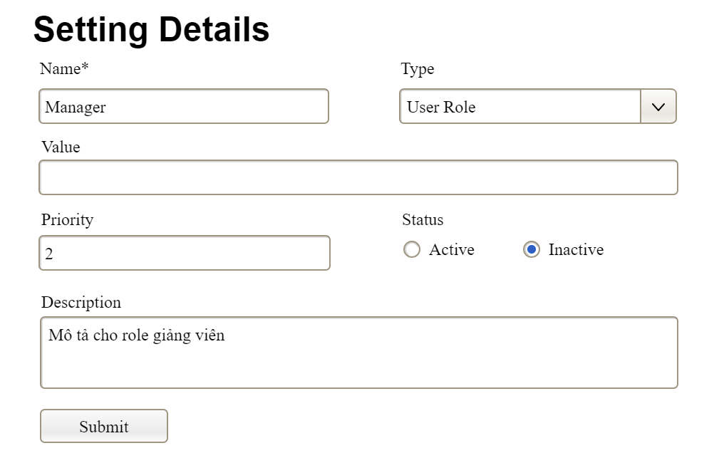

This screen allows the Administrator to:
- Add New Setting: add new master data.
- Update Setting Details: update details of a specific master data
Field Description
Field Name | Description
Name | Data type: non-digit string, max length of 20 characters
Type | Initial data values: all active setting names (with null or blank type)
Value | Data type: any string, max length of 100 characters
Priority | Data type: a positive integer
Description | Data type: any string, max length of 200 characters

3.3.2 User Management

3.3.2.1 User List
…

3.3.2.2 User Details
…

4. Non-Functional Requirements

3.1 External Interfaces
[This section provides information to ensure that the system will communicate properly with users and with external hardware or software/system elements.]

3.2 Quality Attributes
[List all the required system characteristics (quality attributes) specification. Some of the possible attributes are provided with the guide/descriptions are mentioned here]

3.2.1 Usability
[This section includes all those requirements that affect usability. For example, specify the required training time for a normal user and a power user to become productive at particular operations specify measurable task times for typical tasks or base the new system’s usability requirements on other systems that the users know and like specify requirement to conform to common usability standards, such as IBM’s CUA standards Microsoft’s GUI standards]

3.2.2 Performance
[The system’s performance characteristics are outlined in this section. Include specific response times. Where applicable, reference related Use Cases by name.
Response time for a transaction (average, maximum)
Throughput, for example, transactions per second
Capacity, for example, the number of customers or transactions the system can accommodate
Resource utilization, such as memory, disk, communications, and so forth.]

3.2.3 …

5. Requirement Appendix
[Provide business rules, common requirements, or other extra requirements information here]

5.1 Business Rules
[Provide common business rules that you must follow. The information can be provided in the table format as the sample below]
ID | Rule Definition
BR-01 | Delivery time windows are 15 minutes, beginning on each quarter hour.
BR-02 | Deliveries must be completed between 10:00 A.M. and 2:00 P.M. local time, inclusive.
BR-03 | All meals in a single order must be delivered to the same location.
BR-04 | All meals in a single order must be paid for by using the same payment method.
BR-11 | If an order is to be delivered, the patron must pay by payroll deduction.
BR-12 | Order price is calculated as the sum of each food item price times the quantity of that food item ordered, plus applicable sales tax, plus a delivery charge if a meal is delivered outside the free delivery zone.
BR-24 | Only cafeteria employees who are designated as Menu Managers by the Cafeteria Manager can create, modify, or delete cafeteria menus.
BR-33 | Network transmissions that involve financial information or personally identifiable information require 256-bit encryption.
BR-86 | Only regular employees can register for payroll deduction for any company purchase.
BR-88 | An employee can register for payroll deduction payment of cafeteria meals if no more than 40 percent of his gross pay is currently being deducted for other reasons.

5.2 System Messages
# | Message code | Message Type | Context | Content
1 | MSG01 | In line | There is not any search result | No search results.
2 | MSG02 | In red, under the text box | Input-required fields are empty | The * field is required.
3 | MSG03 | Toast message | Updating asset(s) information successfully | Update asset(s) successfully.
4 | MSG04 | Toast message | Adding new asset successfully | Add asset successfully.
5 | MSG05 | Toast message | Confirming email of asset hand-over is sent successfully | A confirmation email has been sent to {email_address}.
6 | MSG06 | Toast message | Resetting asset information successfully | Return asset(s) successfully.
7 | MSG07 | Toast message | Deleting asset information successfully | Delete asset(s) successfully.
8 | MSG08 | In red, under the text box | Input value length > max length | Exceed max length of {max_length}.
9 | MSG09 | In line | Username or password is not correct when clicking sign-in | Incorrrect user name or password. Please check again.
10 | ..

5.3 Other Requirements…

