LIEBHERR-HAUSGERÄTE

**Ochsenhausen GmbH**

Postfach 1161

88416 Ochsenhausen

**UserInterface Plattform 2021**

**04.10.2021**

**Inhaltsverzeichnis**

1 General Project Guidelines 4

1.1 Development Scope Abstract 4

1.2 Objective 4

1.3 Block and Principle Diagram 4

1.4 Development and Supply Scope 5

1.5 Quotation Scope 5

1.6 Schedule and Milestones 6

1.6.1 Milestones 6

1.6.2 Reviews 6

1.7 Prototype Statuses 6

1.7.1 A-Samples 6

1.7.2 B1 Samples 7

1.7.3 B2 Samples 7

1.7.4 C Samples 8

1.7.5 D Samples 8

1.8 Execution Regulations 9

1.8.1 General Development and Supply Scope 9

1.8.2 Labelling of Parts 9

1.8.3 Data Exchange Agreement 10

1.8.4 Tool for Specification 10

1.8.5 Bugtracking- / Change Management 10

1.8.6 Tools 10

1.8.7 Traceability 11

1.8.8 Hardware / Software development 11

1.8.9 Validation of the SW Development 11

1.8.10 Handling of Open Source SW 11

1.8.11 CAD Requirements 12

1.8.12 Test Management 12

1.8.13 Installation 12

1.8.14 Assembly Concept and Requirements from Production 12

1.8.15 Documentation 13

1.8.16 Component identification, packaging, delivery condition 14

2 Project Management and Organization 14

2.1 Responsibilities in the Project and Project Management Plan 14

2.2 Information Exchange 15

3 Quality Requirements 15

3.1 Quality and Reliability 15

3.2 Risk Management 15

3.2.1 Component FMEA 15

3.2.2 Design FMEA 15

3.2.3 Process FMEA 16

3.2.4 Second Source Components 16

4 System Architecture 16

4.1 Functional System Environment 16

4.2 Physical System Environment 17

4.2.1 Geometry and Tolerances 18

4.2.2 Earthing conditions 18

5 Technical Requirements 18

5.1 General Technical Requirements 18

5.1.1 Naming and Part lD No. 18

5.1.2 Climatic Requirements 19

5.1.3 Service Life 19

5.1.4 Conformity Requirements 20

5.1.5 Electronic assembly unit 20

5.1.6 PCB specifications 20

5.1.7 Additional PCB requirements for edge connector systems 21

5.1.8 General standard requirements for UL certification 21

5.1.9 General standard requirements for certification 21

5.1.10 Electromagnetic Compatibility 23

5.1.11 Electrostatic Discharge 23

5.2 Front Panel 24

5.2.1 Front Panel - Definition 24

5.2.2 Mechanical Requirements 27

5.2.3 Surface Area 27

5.2.4 Cover 28

5.2.5 Manufacturing process and raw material 28

5.2.6 Food conformity 28

5.2.7 Color 29

5.2.8 Scratch and scrub resistance 29

5.2.9 Light Fastness 29

5.2.10 Adhesion properties and chemical resistance of printing on fascias and components 30

5.3 User Interface Control Unit 30

5.3.1 User Interface Control Unit - Principle Diagram 30

5.3.2 Power supply 30

5.3.3 Graphic Display 30

5.3.4 Power Consumption 32

5.3.5 Controller 32

5.3.6 Connectors 33

5.3.7 Protocol Interface 33

5.3.8 Touch Control 34

5.3.9 Buzzer 34

5.3.10 Panel Light 34

5.3.11 Status Light 35

5.3.12 Ambient temperature measurement 35

5.3.13 Door sensor 36

5.3.14 Software Requirements 37

5.3.15 Test Requirements 39

5.3.16 Flashing 39

5.4 Connectivity 40

5.4.1 Connectivity Integration - Principle Diagram 40

5.4.2 Option 1: Connectivity integrated solution 40

5.4.3 Option 2: Connectivity Module 41

5.4.4 BLE Module 41

6 Testing and Validation 41

6.1 Environmental Tests 42

6.1.1 Coldness to DIN EN 60068-2-1 A 42

6.1.2 Dry heat to DIN EN 60068-2-2 B 42

6.1.3 Temperature change to DIN EN 60068-2-14 Na 42

6.1.4 Temperature change with humidity to DIN EN 60068-2-30 Db 44

6.1.5 Vibration, noise to DIN EN 60068-2-64 Fh 44

6.1.6 Sinusoidal vibration to DIN EN 680068-2-6 Fc 45

6.1.7 Shock to DIN EN 680068-2-27 45

6.1.8 Vibration stress on appliance during transportation 45

6.1.9 Shock impact on appliance during transportation 46

6.1.10 Shock impact in door 46

7 Change History 46

*ID* : UI_2021_2

# 1 General Project Guidelines

*ID* : UI_2021_3

## 1.1 Development Scope Abstract

This Specification defines the requirements and test procedures to be observed with regard to the product “User Interface Module” (referred to in the following as UI module) for LIEBHERR-HAUSGERÄTE GmbH which will be used for next generation of build-in and standalone- appliances. The serial production will start beginning of 2021.

The UI module is based on the requirements of the standards quoted below, where applicable.

In some cases the specification lays down stricter requirements for resistance criteria and degrees of testing accuracy. Empirical findings and physical considerations have shown that the normative tests are often set at too low a level. The technical inspection procedure described here serves to raise that level. This Technical Specification sets out a test procedure which is binding on manufacturers of this component.

*ID* : UI_2021_4

## 1.2 Objective

The target of the UI module is to develop a state of the art UserInterface for Fridge and Freezer appliances in the year 2021 for entry-level appliances and high end appliances for LIEBHERR-HAUSGERÄTE GmbH.

The goal is to get the lowest possible price on both display solutions. If some of the given requirements are blocking a real low cost solution please feel free to propose your changes to this specification.

*ID* : UI_2021_38

## 1.3 Block and Principle Diagram

The UI module consists of the Front panel and the electronic interfaces defined below. The specification incluedes 3 variants of "behind the door" UI modules and 2 variants of "in the door" UI modules. The dimensions of the UI module are defined by CAD data.

The positions of the Display, the connector between UI module and appliance, the door sensor and the touch buttons are fixed and mustn’t be changed. The concept how the UI module is finally realized is up to supplier. The concept should be cost efficency. The drawing and CAD data are just showing the outer dimensions of the UI module, indicate the different UI module's parts. The drawing just show one possible solution and is not mandatory to implement from supplier.

The development of the front panel and the discussions about the concepts shall be in direct contact with LIEBHERR.

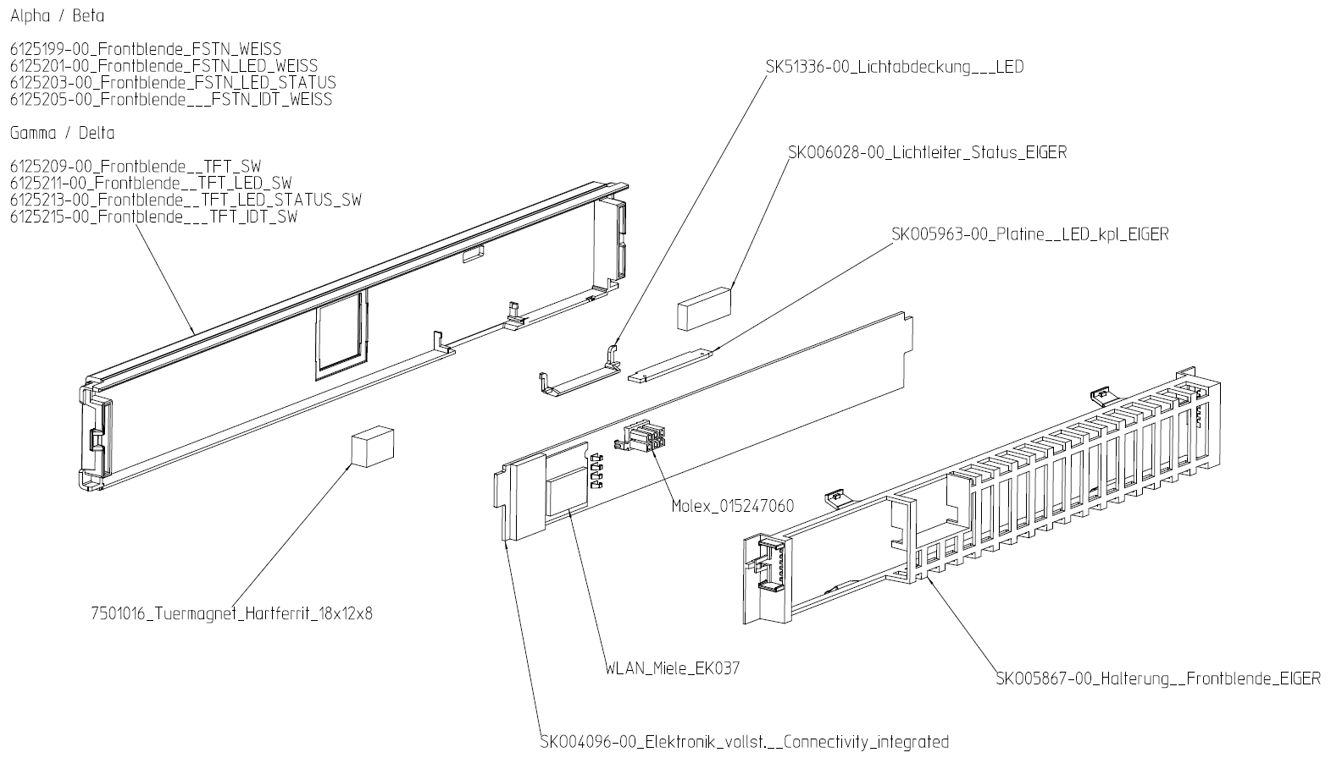

*ID* : UI_2021_7

## 1.4 Development and Supply Scope

The following development and supply scope for UI module apply:

- Hardware & Software Development of UI module

- Hardware documentation of Building Blocks that can be transferred to LHG systems

- Qualification and calculations of hardware

- Software architecture with specified interfaces requiring coordination with LIEBHERR

- In particular, the development has to be carried out in such a way that LIEBHERR is able to implement subsequent UI application's software independently in future

- Mechanical development and design in exchangeable data formats

- ESD conform delivery of tested and completely mounted assembly units

- Depending on the technology used to integrate the display in the front panel, safety tests may have to be carried out. These tests shall be agreed with LIEBHERR during project development phase

- Passing on the specification and drawing to third parties requires the approval of LIEBHERR

*ID* : UI_2021_8

## 1.5 Quotation Scope

The quotation scope of the UI module must include following documentation and information:

- Technical specification of the UserInterface concept (including CPU clock, memory size, micro Controller type etc...)

- Schematic with named parts

- Calculation of power consumption for different scenarios (see below)

- The costs of the top 10 expensive parts

- RC (recurring costs)

- NRC (non recurring costs)

- Detailed calculation of development-, tool- and production costs

- Time- / Project schedule

- Resource overview

- Production concept

- Name of the responsible project leader on supplier side

- Introduction of the development- and production location

- All mentioned certifications of the component

- Verification of certification and auditation

*ID* : UI_2021_11

## 1.6 Schedule and Milestones

*ID* : UI_2021_13

### 1.6.1 Milestones

Following Milestones apply:

A-Sample: 04/2019

B-Sample: 10/2019

C-Sample: 04/2020

D-Sample: 10/2020

SOP: 12/2020

*ID* : UI_2021_14

### 1.6.2 Reviews

Liebherr reserves the right to carry out reviews on specific topics

*ID* : UI_2021_15

## 1.7 Prototype Statuses

The number of prototypes required is coordinated with the supplier during the development phase.

The prototypes shall be developed and prepared according to the following criteria.

All prototypes need to be clearly marked with HW and SW revision which can be found in the delivered parts history sheet.

*ID* : UI_2021_177

### 1.7.1 A-Samples

**Production Type**

Testplatform - Functional sample

**Definition of Maturity Level**

- Not compatible to available installation space

- Can be built up of sample parts / sample material / supplier demo boards / PC emulation

- Customized parts not "off-tool"

- Assembly on series production equipment isn't necessary

- Hand modifications are acceptable

- Functional requirements partially fulfilled

- Environmental requirements not fulfilled

- Verification and qualification test depth only on laboratory level not based on formal procedures

- Not for field tests or customer usage

- Design-Documentation mainly available regarding content but not formally usable

**Software**

- Subset of features/Requirements, each with a defined readiness level (2c) Supplier Demo-Board with uC can be used Example ENA-HW1

- Design for Test: Support HW-Team for functional Basic Tests

**Hardware**

- Functional basic test of specified requirements

*ID* : UI_2021_178

### 1.7.2 B1 Samples

**Production Type**

Prototype - Engineering sample

**Definition of Maturity Level**

- Partly compatible to appropriate installation space

- Can be build up of sample parts / sample material

- Customized parts not "off-tool"

- Assembly on series production equipment isn't necessary

- Hand modifications are acceptable

- Functional requirements are mainly fulfilled

- Environmental requirements are partially fulfilled

- Verification and qualification test depth on engineering test level, procedure and report

baselines regarding content mainly available

- Not for field tests or customer usage

- Design-Documentation fully available regarding content and mainly formally usable

**Software**

All features/Requirements, each with a defined readiness level

- Diagnostic (Aftersales)

- Production (End of Line

- ....

**Hardware**

- Build up sample parts on eval board

- Partly design verification

*ID* : UI_2021_179

### 1.7.3 B2 Samples

**Production Type**

Prototype - Engineering sample

**Definition of Maturity Level**

- Fully compatible to appropriate installation space

- Can be build up partially of sample parts / sample material

- Customized parts partially "off-tool"

- Assembly is close to the serial manufacturing-process and mainly on serial production

equipment

- Hand modifications are acceptable

- Functional requirements are completely fulfilled

- Environmental requirements are mainly fulfilled

- Verification and qualification test depth on engineering test level, procedures and reports

regarding content complete available

- Not for field tests or customer usage

- Formal design documentation available

**Software**

- Configuration topics

- Bug-Fixes

- Production topic

**Hardware**

- Concept and design fully verified

- Design freeze

*ID* : UI_2021_180

### 1.7.4 C Samples

**Production Type**

Pre Series - Qualification Sample

**Definition of Maturity Level**

- Fully compatible to appropriate installation space

- Build up mainly of serial parts / serial material. Customized parts partially "off-tool" with EMPB

(accepted)

- Assembly is mainly under serial manufacturing conditions and on serial production equipment

- Functional requirements are completely fulfilled

- Environmental requirements are completely fulfilled

- Verification and qualification test depth on formal level, formal procedures and reports

available

- Measurements for serial release on customer application partially done and passed

- For field tests

- Formal design and qualification documentation available

- EMC requirements passed

**Software**

- Production topic

**Hardware**

- Product verification

*ID* : UI_2021_181

### 1.7.5 D Samples

**Production Type**

Zero Series - Series Qualification Sample

**Definition of Maturity Level**

- Fully compatible to appropriate installation space

- Units are ready for the final qualification and for the formal serial release After finished

qualification and serial release: D-samples = serial units

- Build up completely of serial parts / serial material

- Customized parts completely "off-tool" with EMPB (accepted)

- Full assembly under serial manufacturing conditions and on serial production equipment

- Functional requirements are completely fulfilled

- Environmental requirements are completely fulfilled

- Verification and qualification test depth on the serial level

- Measurements for serial release on customer application completely done and passed

- Customer usage

- Formal design and qualification documentation available

**Software**

- Production topic

**Hardware**

- Product validation

*ID* : UI_2021_6

## 1.8 Execution Regulations

*ID* : UI_2021_188

### 1.8.1 General Development and Supply Scope

Drawings: in English

Marking: name of supplier, LH part number, week of production

The drawings, article master data (order text) and this Specification form the basis for the manufacture of the products/components and for all characteristics to be tested. In addition, the quality-related requirements stated in the order and Specification must be met.

*ID* : UI_2021_191

### 1.8.2 Labelling of Parts

Parts, samples and prototypes (e.g. serial parts, EMC samples, AVS- samples, NS samples, etc.) shall be clearly labelled. The label should include all relevant information to assign the samples. All samples shall have a unique number.

- LHG article number

- hardware basis

- hardware version

- software version

- date of production

- etc.

Plastic parts heavier than 25 g and equipped with flame retardance are to be marked in accordance with DIN EN ISO 1043-4, as far as the size / geometry permits.

In the course of the survey of the ingredients for our material database, the quantity of flame-retardant (e. g. 18Gew% in article xxxx xxx-xx) and whether the flame retardant is added additive or reactive must be stated.

Sample marking

All samples need to be clearly marked with HW and SW revision which can be found in the delivered parts history sheet.

Electronic features such as e. g. software version, hardware version, ToD version etc. shall be readable electronically by external tool.

*ID* : UI_2021_184

### 1.8.3 Data Exchange Agreement

The tool Sharepoint serves as data exchange server. All relevant data are to be exchanged between LIEBHERR and the supplier via Sharepoint.

Data and Files shall be marked with corresponding labels to be able to filter the documents.

*ID* : UI_2021_183

### 1.8.4 Tool for Specification

LIEBHERR transmits specifications to the supplier by means of the tool DOORs. If DOORs is not used by the supplier, the provision of data must be agreed with LIEBHERR.

*ID* : UI_2021_185

### 1.8.5 Bugtracking- / Change Management

For Change Management and Bug Tracking issues the tool LIEBHERR JIRA shall be used.

In JIRA all changes and bugs shall be documented and tracked.

The LIEBHERR Workflow of the tracking system has to be discussed with LIEBHERR.

Both parties can launch change requests. Any change need to be accepted and released by the customer.

Also PCNs of component suppliers or cost down changes need to be agreed with the customer.

*ID* : UI_2021_198

### 1.8.6 Tools

**Jira:**

Jira (hosted at LIEBHERR) will be used for Issue-Management, Defect-Management, Feature-Maturity-Management, Risk-Management, Change-Management

**Office:**

Status Reports can be done with any Office Tool

**MS-Project:**

Detailed project schedules should be done with MS-Project, but this is not mandatory. Other equivalent tools could be used after agreement with the customer. As long as an other tool will be used, the customer need to be provided with a compatible reader tool.

*ID* : UI_2021_193

### 1.8.7 Traceability

A component-specific Determination of processes, procedures and data processing system that ensure the traceability of the different UI modules' parts shall be established

*ID* : UI_2021_186

### 1.8.8 Hardware / Software development

The development of the hardware and software must be carried out with LIEBHERR's involvement, so that LIEBHERR can continue to implement hardware and software fully or partly in future.

The interfaces of the hardware and software implementation shall be disclosed and must be agreed and discussed with LIEBHERR.

*ID* : UI_2021_22

### 1.8.9 Validation of the SW Development

For each software release, a new SW version has to be implemented.

The software version and corresponding changes of the new software version must be documented in a Version History File (Release Notes).

For each software version the relevant test documentation must be provided to LIEBHERR.

The source code must be provided on request.

With each delivery of an official software package, release notes must be provided to LIEBHERR.

For software implementation a release plan shall be implemented

For each state of the SW development process a review shall take place (requirement elicitation, concept, implementation and test)

A feature release plan shall be implemented. The status of feature implementation shall be evaluated for each SW-Release.

Electronic features such as e. g. software version, hardware version, ToD version etc. shall be readable electronically by external tool.

*ID* : UI_2021_189

### 1.8.10 Handling of Open Source SW

Any use of open source SW for the product need to be agreed with the customer. All relevant license information need to be provided to the customer, especially if there will be any requirements for any documentation in the users manual of the fridges.

*ID* : UI_2021_192

### 1.8.11 CAD Requirements

CAD Data must be exchanged by LIEBHERR interface. The interface has to be discussed with LIEBHERR construction department.

The file format should be IGES or STEP. If supplier is using the Tool Creo, the file format .prt and .asm could be used, too.

The Data structure must be discussed with LIEBHERR (structure, name, part number, SK-numbers, etc.)

Drawings of assembly parts and individual parts must be generated and permitted to LIEBHERR.

3D Data must be designed as volume model with accuracy of 1x10-6mm.

*ID* : UI_2021_194

### 1.8.12 Test Management

The compliance to the requirements must be done by appropriate tests. All tests that are used to provide evidence that the requirements have been met must be documented in such a manner that the purpose, design, implementation as well as the final evaluation by expert staff is understandable. The LIEBHERR technical specification traceability must be ensured.

*ID* : UI_2021_60

### 1.8.13 Installation

The supplier must specify the manufacturing process before series production. Quality-defining process steps must be documented by the supplier before series production.

*ID* : UI_2021_62

### 1.8.14 Assembly Concept and Requirements from Production

The assembly unit shall be designed so that it is suitable for factory assembly and that assembly is as simple as possible.

It is to be assumed that exposed cable ends connected to the assembly unit may be touched during the assembly process. An ESD-robust design of the control system is necessary.

The assembly unit is to be designed taking into consideration the customary LIEBHERR assembly and handling processes.

A uniform assembly concept and standard fastening elements are to be selected for assembly units in the same mounting locations.

No cables may run over the control system.

It shall be possible to dismantle the assembly unit without damaging it.

Safety requirements such as sound, water tests, clearances in the event of currents >0.2 A must be taken into account.

Operating elements located in the door are connected by a 5 -6-core cable run over the door hinge.

For appliances with display in the door a concept is necessary, which provide a connection point, in order to allow the end user to connect a cable for door change. Because of standardization a cable in the foam of the appliance is not possible.

*ID* : UI_2021_26

### 1.8.15 Documentation

**Product documentation**

From the orderer’s perspective, the characteristics and qualities set out are of special importance and significance for use. The supplier must provide drawings, detailed work instructions, inspection schedules and test specifications for these characteristics and qualities.

They must be tailored to the supplier’s manufacturing conditions with the aim of assuring quality during production.

The product documentation must be performed on the basis of LIEBHERR article numbers. The product documentation must make the version statuses of software, hardware and mechanical components clear. The software must be provided in such a manner that LIEBHERR is able to fully control the appliance.

System-related parameter set structures must also be provided.

Approval-, test certificates and other official certifications must be provided in accordance with the standard requirements.

All documentation must be promptly provided in electronic form in accordance with development progress.

*ID* : UI_2021_27

#### 1.8.15.1 Hardware Documentation

For each hardware release, a new HW version has to be implemented.

The hardware documentation must include the mechanical drawing, circuit diagram, component location plan, layout and parts list.

The hardware version and corresponding changes of the new hardware version must be documented in a Version History File.

For each hardware version the relevant test documentation must be provided to LIEBHERR.

With each delivery of an official hardware package, release notes must be provided to LIEBHERR.

*ID* : UI_2021_28

#### 1.8.15.2 Software Documentation

The software version and corresponding changes of the new software version shall be documented in a Version History File (Release Notes).

For each software version the relevant test documentation must be provided to LIEBHERR.

The source code must be provided on request.

With each delivery of an official software package, release notes must be provided to LIEBHERR.

*ID* : UI_2021_155

#### 1.8.15.3 Test documentation

All tests that are used to provide evidence that the requirements have been met must be documented in such a manner that the purpose, design, implementation as well as the final evaluation by expert staff is understandable. The LIEBHERR technical specification traceability must be ensured.

For each software release, a test documentation has to be provided.

The tests shall be automated to guarantee maximum possible faultless hardware/software.

*ID* : UI_2021_156

#### 1.8.15.4 Tool documentation

Tools that are developed for LIEBHERR or are provided to LIEBHERR must be documented in such a manner that expert staff are able to use them.

*ID* : UI_2021_130

### 1.8.16 Component identification, packaging, delivery condition

Assembly units have to be labelled as follows:

LHG part number and raw material labelling including recycling symbol for all parts

Date/Clock symbol

Assembly units: visible mark by label including part number+ date of production

Konstruktionsblatt 8.1.4 &[008001.pdf]&

Konstruktionsblatt 116.1.0 &[116001.pdf]& and &[2007-06-26 Liefer- und Verpackungsrichtlinien.pdf]&

Delivery conditions and transport protection must be discussed with LIEBHERR

*ID* : UI_2021_24

# 2 Project Management and Organization

*ID* : UI_2021_25

## 2.1 Responsibilities in the Project and Project Management Plan

The supplier shall name a responsible project manager

The supplier shall setup a detailed time schedule based on the given milestones of the supplier and track the progress against this plan

The supplier shall generate a weekly status report for the customer. The content and metrics of this report need to be aligned with the customer. Minimum content: achieved, next steps, risks, decisions/support, task and feature progress, defect status.

The supplier shall attend at weekly status meetings with the customer. This meetings can be done as Skype conference, but from time to time also on site meetings will be scheduled

The open issues of this regular meetings will be registered and followed in the LIEBHERR Jira system.

For escalation topics management meetings shall be invited on demand

Feature Release Plan

Based on the Integration Milestones and the high level content defined by the customer, the supplier shall generate a more detailed feature release plan which can be used for tracking of the progress and the feature maturity during the development phase.

Based on the integration schedule the supplier shall deliver SW for each defined integration step. In the final bug fixing phase a SW delivery in a bi weekly cycle shall be planned, so that the supplier and customer teams can test the SW in parallel.

*ID* : UI_2021_199

## 2.2 Information Exchange

For information exchange weekly status meetings including status reports shall be set.

A protocol shall be installed in LIEBHERR Jira, where all projects issues/tasks are documented.

*ID* : UI_2021_202

# 3 Quality Requirements

*ID* : UI_2021_19

## 3.1 Quality and Reliability

The supplier guarantees the characteristics, qualities and testing methods given as follows.

From the orderer’s perspective, the characteristics and qualities set out are of special importance and significance for use. The supplier must provide drawings, detailed work instructions, inspection schedules and test specifications for these characteristics and qualities.

They must be tailored to the supplier’s manufacturing conditions with the aim of assuring quality during production.

The requirements in accordance with the "QSV requirements" document apply.

*ID* : UI_2021_21

## 3.2 Risk Management

The supplier has to establish a transparent risk management for the component and the development process, which helps to avoid failures and problems in an early phase of the project.

The risk management concept must be discussed with LIEBHERR.

*ID* : UI_2021_115

### 3.2.1 Component FMEA

Under the responsibility of the development partner, a component FMEA is to be commissioned and conducted with the following objective.

- consideration of the individual circuit blocks (e.g. input wiring).

- analysis of the individual components in respect of their function(s), malfunction(s), failure(s) .

- assessment of impact on system function.

*ID* : UI_2021_116

### 3.2.2 Design FMEA

Under the responsibility of the development partner, a design FMEA is to commissioned in coordination with LIEBHERR and conducted with the following objective.

- assessment of circuit risks

- assessment of interactions/risks in connection with the software.

- assessment of supplier risks (for e.g. critical A parts)

*ID* : UI_2021_175

### 3.2.3 Process FMEA

*ID* : UI_2021_114

### 3.2.4 Second Source Components

Second source components must be listed and appropriately certified during development.

Assembly units with second source components are to be included in the tests.

Components for which there is no second source are to be specified.

*ID* : UI_2021_31

# 4 System Architecture

*ID* : UI_2021_32

## 4.1 Functional System Environment



The Ui module represents the interface between the customer and the appliance.

The functional system environment shows a block diagram of the functional range of the UI module.

The functional system features include the Front Panel, User Interface, WLAN option, Status Light and the Panel Light which were defined in below.

The bus interface is specified via single wire UART communication. The physical characteristics of the bus communication shall be coordinated with LIEBHERR.

*ID* : UI_2021_33

## 4.2 Physical System Environment



The user interface is located in the upper part of the appliance behind the door (named hdT).

For in the door solution there is the basic PCB in the space of UI Module and the Display is located in the door (named idT)

For door detection, a door magnet is installed in the door while the door sensor is placed on the UI module.

The communication between PowerBoard and the UserInterface is realized by means of single wire communication.

The UI module consists of Front panel, User Interface, WLAN option (optionally), Panel light, Status Light, Buzzer and Door Sensor.

In the door display (idT) and behind the door display (hdT) have the same functional scope. The User interaction and design is similar to hdT version.

*ID* : UI_2021_63

### 4.2.1 Geometry and Tolerances

The space for the assembly unit, the geometry, the connector between UI Module and appliance, the position of the SDB contacts and the position of the door sensor are defined by CAD data &[SKO00860_Einbauverhaeltnisse_UI_low]&

The realization of the geometry of UI module shall be in direct contact with LIEBHERR.

The CAD data are the first prototype CAD data and could be modified partly in project development

The permissible tolerance ranges shall be agreed with LIEBHERR.

*ID* : UI_2021_172

### 4.2.2 Earthing conditions

The compressor and tubing are grounded.

Grounding of all other metal parts cannot be taken for granted.

Some appliances contain frame heaters that are also part of the refrigeration circuit and as such are earthed. Frame heaters are located in the area of the door gasket below insertion openings and on side walls.

If control elements are built into the door, a resistance of less than 1 ohm can be assumed between the metal of the door and the metal of the side wall.

*ID* : UI_2021_36

# 5 Technical Requirements

*ID* : UI_2021_203

## 5.1 General Technical Requirements

*ID* : UI_2021_37

### 5.1.1 Naming and Part lD No.

The assembly unit consist of following parts:

- Front Panel

- User Interface

- Status Light

- Panel Light

- Connectivity function

- BLE Module

Following configurations of the UI Module shall be offered:

UserInterface behind the Door

1: UI Module FSTN 128px x 128px Matrix display: Basic functionality + Connectivity prepared

2: UI Module TFT 2,0" - 2,2" display: Basic functionality + Connectivity prepared

3: UI Module no display: Basic functionality + Connectivity prepared

UserInterface in the Door

1: UI Module FSTN 128px x 128px Matrix display: Basic functionality + Connectivity prepared (behind the door) + 100mm x 100mm Display Panel in the door

2: UI Module TFT 2,0" - 2,2" display: Basic functionality + Connectivity prepared (behind the door) + 100mm x 100mm Display Panel in the door

Following options shall be included in the offer

1: WLAN option integrated on PCB

2: Front Panel Light (GT - Light)

3: Status Light

4: Front Panel - transparent and colored printed (black/white) in the back

5: Display with longer service life for idT solution (if hdT display doesn't keep the required service life)

6: Rear cover of the Front Panel

7: BLE Module (Bluetooth)

8: Price of glass window for idT display instead of acryl glass

The connectivity module including the adaptation circuit is specified by Liebherr and will be provided to the supplier. The integration of the connectivity Module (integrated option) shall be discussed together with LIEBHERR

*ID* : UI_2021_92

### 5.1.2 Climatic Requirements

Storage temperature range:

- 30 °C to + 60 °C

Operating temperature range:

0 °C to + 43 °C

extended operating temperature range in the freezer area

- 40 °C to + 43 °C

extended operating temperature range in the refrigerator area

- 5 °C to + 43°C

Humidity storage area:

20%rH to 95%rH

Humidity operating area:

20%rH – 95%rH

extended operating humidity range in the freezer / refrigerator area

20%rH to 100%

The specified temperature ranges are the ambient conditions of the appliances.

Self-heat due to the appliance's built-in situation must be taken into account.

The extended thermal stress applies in addition to the standard thermal stress.

The component shall be able to withstand a reduced air pressure of up to 1500 m above sea level

*ID* : UI_2021_87

### 5.1.3 Service Life

The assembly unit "UI module" must be designed according to following demands:

- The UI module shall be designed for a life cycle of 15 years.

- Life time tests shall be done considering the welding process of the display window and the printing process of the label. The approval process has to be designed and discussed with LHG.

For this purpose

- Each component must first be calculated separately (especially ELCO capacitors). Provided the calculation model envisages it, calculation includes environmental conditions, temperature, electrical load and load duration. The failure rate of the entire assembly unit is the sum total of the failure rates of the individual components in the relevant assembly unit.

- a result must be calculated for the various ambient temperatures of 0°C, 25°C, 43°C. In addition to these ambient temperatures the respective self-heating of the components, determined on the basis of a temperature test (e.g. thermography) must be taken into account.

- each part result in the calculation must be verifiable.

*ID* : UI_2021_29

### 5.1.4 Conformity Requirements

The following conformity requirements must be met by the component:

- Compliance with the RoHS Directive 2011/65/EU and other substance restrictions and bans such as REACH. This must be documented by confirming the delivery specification LS 1110500 "Prohibition of Substances" (at least version -04). External document &[1110500-04_en.pdf]

- In order to prove RoHS conformity, the supplier must submit a complete RoHS analysis upon delivery of the first item with series production status.*

- LIEBHERR Hausgeräte must be informed immediately if substances from the ECHA candidate list or Annex XIV of Regulation (EC) No. 1907/2006 "REACH" are used.

- Flame retardant (see also 4.7): Printed circuit boards may contain only reactive TBB (P)A in quantities less than 0.1 % by weight. This means that they must not contain additive TBB (P)A or other halogenated organic compounds. Inorganic flame retardants are permitted

*ID* : UI_2021_173

### 5.1.5 Electronic assembly unit

The requirements in accordance with the "Technical Delivery Specification TL 1110041" document apply.

External document &[1110041-01.pdf]

*ID* : UI_2021_147

### 5.1.6 PCB specifications

- Creep resistance:

Positioning in the appliance interior: >= 250 CTI

Positioning outside: >= 175 CTI

- Flame retardants:

PCBs may only contain reactive TBB(P)A. This means that they may not contain additive TBB(P)A or other halogenated organic compounds. With the exception of antimony trioxide, inorganic flame retardants are permitted, e.g. phosphorous, halogen-free flame retardances such as RDP and BDP, red phosphorus (microencapsulated), melamines, (-cyanurates and -phosphates), metal phosphinates, organic phosphinates, DOPO / aluminium hydroxide, metal phosphinates/DOPO/silicon dioxide, polymer phosphonates and flame-retardant thermoplastic plastics. Size / geometry permitting, parts containing flame-retardants are to be labelled or sent for labelling in accordance with DIN.

- PCB material: PCBs with UL listing only

- PCB Type: FR4

- The circuit path thickness must be at least 35μm Cu. It must be ensured that the circuit paths can carry the maximum occurring current. The relevant confirmation must be submitted to LIEBHERR.

- Varistors without internal back-up fuse (or respectively separate current sensitivecut-out) are not permitted.

- IPC-A-610: The UI module is to be manufactured according to IPC-A-610 Class2. Confirmation of compliance with IPC-A-610 is to be submitted to LIEBHERR

- New developments are to be developed in accordance with IEC 61000-3-2 Class D. Compliance with the standard for the development of components is to be agreed in consultation with LIEBHERR.

- Connection points like contacts with external modules must have a secure connection. Gold-plating of contacts may be necessary. This is to be defined in the course of the project and shall be discussed with LIEBHERR

*ID* : UI_2021_148

### 5.1.7 Additional PCB requirements for edge connector systems

If used, the faces of the edge connector systems must not have sharp edges.

One phase must be provided to avoid damage to the connector or contact material wear during the connection process.

Appropriate measures must be taken to ensure that the coating on the contact surface provides a live metallic connection to the Cu / Ni printed circuit.

The contact surface must be clean, smooth (IPC A 600 C) and free of solder mask paint and flux residue.

In the case of edge connector systems a suitable PCB design must be selected for connector systems.

The requirements specified in Konstruktionsblatt 133.1.0 &[133001.pdf]& must be respected

*ID* : UI_2021_171

### 5.1.8 General standard requirements for UL certification

A UL certificate for the usage in fridges or freezers with flammable refrigerant for USA- or Kanada-appliances is necessary.

*ID* : UI_2021_168

### 5.1.9 General standard requirements for certification

Following standard requirements for IEC certification apply:

3 months before the start of series production, the following certificates must be made available (latest version including all amendments):

1. Test certificate according to:

- EN 60730-1

- EN 60730-2-9

- EN 60335-1

- EN 60335-2-24

- EN 62031 only for LED lamps and if a separate power supply unit is available

2. CB Certificate incl. complete test report

- IEC 60730-1

- IEC 60730-2-9

- IEC 60335-1

- IEC 60335-2-24

- IEC 62031 only for LED lamps and if a separate power supply unit is available

- IEC 62471 only for LED illumination

The following requirements shall be taken into account in the certification test:

- Each circuit board must be marked with the type of approval. Changes that are not relevant to approval must not have any effect on the type designation (for example, use placeholders).

- Ambient temperature = 43°C + self-heating under most unfavorable conditions

- Use of flammable refrigerants, i. e. consideration of IEC/EN 60335-2-24 Appendix CC

- Worst case analysis of all inputs and outputs:

Short Circuit

Interruption

Most unfavorable operating condition

- PEC

Must be avoided and marked accordingly in the certificate (e. g. specification of no use of a PEC)

If a PEC is used, this must be evaluated during development with LHG ALE

- Definition of the nominal data of all inputs and outputs

Voltage range

Current range

Frequency range

Power range

- Changes relevant to certification

Must be re-certified by the license holder.

Before the respective change, information must be sent to LIEBHERR approbation department

Updated certificates must be made available to LIEBHERR approbation department

For capacitors, transformers, coils, connectors (part of the power supply unit or input filter) the data sheets and approval certificates must be

provided to LIEBHERR approbation department.

- When R600 is used, the maximum temperature in normal operation and improper operation must not exceed 272°C (R600a = 360°C).

Normal operation:

All operating conditions at RT = 43°C (i. e. in the housing, 43°C + self-heating)

Improper operation:

Short circuit (components and distances smaller than IEC 60335) and interruption.

One-time short overruns (principle of fuse) are permissible

Before commissioning the approvals, a coordination meeting must take place between the electronics supplier, the testing institute and LIEBHERR approbation department. The organization is carried out by the electronics supplier, who is also the holder of the licence

*ID* : UI_2021_90

### 5.1.10 Electromagnetic Compatibility

The requirements in accordance with the "SysReq001-01 LIEBHERR EMV-Anforderungen" document apply.

External document &[SysReq001-01 LIEBHERR EMV-Anforderungen]&

During the development process, in-development measurements must be conducted on appropriate test set-ups with the UserInterface.

Measurements must be completed and submitted along with the first prototypes.

Reference appliances are provided by LIEBHERR for development purposes at various intervals. The provision times for the reference appliances by LIEBHERR as well the provision of the final release-stage hardware status must be indicated in the schedule.

Reference appliances 1 are for preliminary tests and may be modified.

Reference appliances 2 are intended as an acceptance reference for development and only the developed components may be added to them. Modification is not permissible without the consent of LIEBHERR. Appliances from "A pilot series" or "pilot series" are usually used for this purpose. The final hardware status must be achieved 6 weeks after receipt of these appliances.

The required scope and time to achieve the project objectives is determined based on the supplier's suggestion in coordination with LIEBHERR.

*ID* : UI_2021_91

### 5.1.11 Electrostatic Discharge

For all connections which were connected with the cable harness, the following ESD tests shall be passed.

*ID* : UI_2021_118

#### 5.1.11.1 ESD test in insulated condition

**Test setup**

The assembly unit to be tested is positioned in an insulated state 30 mm above a metal plate mounted on a table. The assembly unit is tested without current and without connecting wiring.

The metal plate must extend beyond the assembly unit on all sides by at least 30 cm. Connect the metal plate to the ground potential of the ESD generator.

**Execution**

The charging voltage of the ESD generator (relay discharge according to EN 61000-4-2) is set to 5 kV.

Perform 3 discharges in sequence on the individual plug contacts and the exposed assembly unit components (e.g. refrigeration unit, conductive display frame).

After every discharge, a high-ohm discharge (1 M) to the ground potential is performed in order to prevent charge accumulation on the assembly unit.

The test is subsequently repeated in the same way with changed polarity of the ESD test voltage.

**Evaluation**

The test is followed by a function test on the assembly unit. The ESD handling test is passed if no permanent function impacts or function-relevant previous damage were found.

*ID* : UI_2021_119

#### 5.1.11.2 ESD test in grounded state

**Test setup**

The assembly unit to be tested is positioned in an insulated state 30 mm above a metal plate mounted on a table. The assembly unit is tested without current and without connecting wiring.

The metal plate must extend beyond the assembly unit on all sides by at least 30 cm. Connect the metal plate to the ground potential of the ESD generator.

For components with a mains connection, connect L, N and, if present Ground, to the ground potential.

For components with DC connection, connect the DC supply connections with Ground.

**Execution**

The charging voltage of the ESD generator (relay discharge according to EN 61000-4-2) is set to 5 kV.

Perform 3 discharges in sequence on the individual plug contacts and the exposed assembly unit components (e.g. refrigeration unit, conductive display frame).

After every discharge, a high-ohm discharge (1 M) to the ground potential is performed in order to prevent charge accumulation on the assembly unit.

The test is subsequently repeated in the same way with changed polarity of the ESD test voltage.

**Evaluation**

The test is followed by a function test on the assembly unit. The ESD handling test is passed if no permanent function impacts or function-relevant previous damage were found.

*ID* : UI_2021_204

## 5.2 Front Panel

*ID* : UI_2021_207

### 5.2.1 Front Panel - Definition

The front panel contains the basic functionality of the user interface which were defined in below. Simultaneously it serves as an interface between the customer and the device. The different variants of the front panels are defined as follows:

*ID* : UI_2021_211

#### 5.2.1.1 Variant 1: Front panel for hdT alpha / beta appliances

**Interaction concept alpha / beta hdT**

- Interaction with UI Module by 3 Touch buttons beside the display

- No Touch on Display functionality

- Black background, white font

- Use the arrow keys to move through the menu carousel with the individual functions

- Press the confirm button to select and confirm.

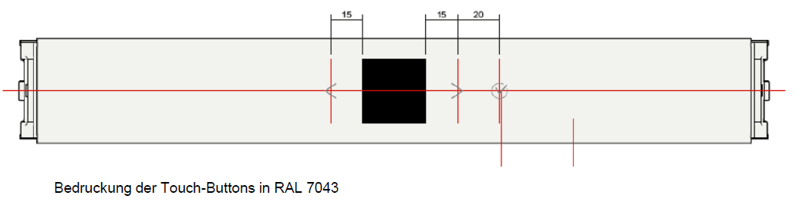

*ID* : UI_2021_212

#### 5.2.1.2 Variant 2: Front panel for hdT gamma / delta appliances

**Interaction concept gamma / delta hdT**

- Interaction with UI Module by Touch&Slide on display

- Only Touch on Display functionality

- Black background, white font

- horizontal sliding through the menu carousel with the individual functions

- Touch the display for selection and confirmation

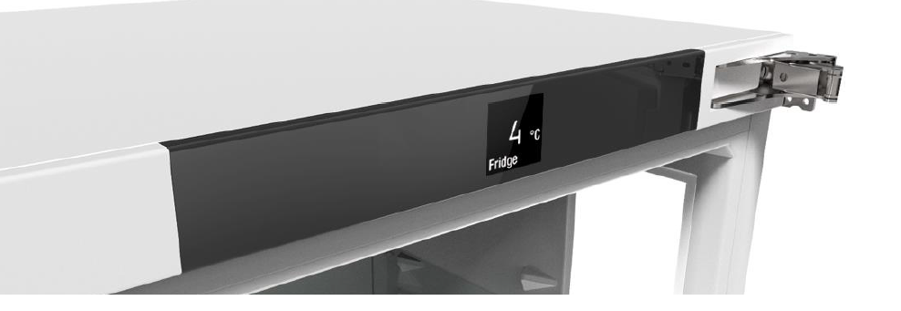

*ID* : UI_2021_213

#### 5.2.1.3 Variant 3: Front panel for idT alpha / beta appliances

**Interaction concept alpha / beta idT**

- dimension: 100mm x 100mm

- pane: acrylic glass

- Interaction with UI Module by 3 Touch buttons beside the display

- No Touch on Display functionality

- Black background, white font

- Use the arrow keys to move through the menu carousel with the individual functions

- Press the confirm button to select and confirm.

- Navigation and Interaction design similar to hdT Version

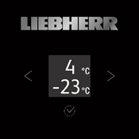

For idT Appliances the Basic Functionality like door sensor, buzzer, ambient temperature and light is located at the front panel behind the door. By Y-connector, the idT Display is connected to the Front Panel.

If the door side has to be changed the customer can change the door opening side for devices with idT display by Y-connection.

*ID* : UI_2021_214

#### 5.2.1.4 Variant 4: Front panel for idT gamma / delta appliances

**Interaction concept gamma / delta idT**

- dimension: 100mm x 100mm

- pane: acrylic glass => alternative glass

- Interaction with UI Module by Touch&Slide on display

- Only Touch on Display functionality

- Black background, white font

- horizontal sliding through the menu carousel with the individual functions

- Touch the display for selection and confirmation

- Navigation and Interaction design similar to hdT Version

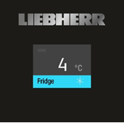

For idT Appliances the Basic Functionality like door sensor, buzzer, ambient temperature and light is located at the front panel behind the door. By Y-connector,the idT Display is connected to the Front Panel.

If the door side has to be changed the customer can change the door opening side for devices with idT display by Y-connection.

*ID* : UI_2021_215

#### 5.2.1.5 Variant 5: Front panel for idT appliances

For all idT appliances a Front panel without display is needed. The basic funtionality like door sensor, buzzer, ambient temperature sensor, lights and the connectivity are located on the Front panel behind the door. The idT communicates and is supplied by bus system. Door change is realized by Y-connection.

*ID* : UI_2021_81

### 5.2.2 Mechanical Requirements

The mechanics must be verified by supplier according to EN 60730 based on IEC 60335-1 and -2-24

Requirements from Konstruktionsblatt 3.1.7 (&[003001.pdf]& und &[003001_ALE_Leitfaden_2010-05-06.pdf]&) are valid. These requirements are just a extract from standards mentioned above supplemented by LHG internal requirements.

Test tools are mentioned in Konstruktionsblatt 113.1.1 &[113001.pdf]&

All 3D drawings which were mentioned in below are principle drawings and shall be discussed in detail with LIEBHERR while development phase.

*ID* : UI_2021_123

### 5.2.3 Surface Area

Visible surfaces shall be produced free of pores and burrs and may contain no sink marks, tool marks, scratches, streaks or flaws.

The Control Panel Housing / Front Housing delivery specification LHG 111033-1 &[1110033_01.pdf]& shall be observed.

Visible surfaces shall be manufactured with a high gloss polish finish (unless otherwise notes, e.g. etching structure)

The front panel for alpha and beta shall include a continuous line with cut out and welded window for UI display. The window shall be integrated in that way that the gap on the front panel is as less as possible. The document &[Eiger Displayblende.pptx]& show a design prototype of front panel. The window can be rasted or glued. The requirements regarding the spilling water test do not apply because of safety low voltage.

The front panel for gamma and delta shall include a continuous line with transparent window without gap for UI display. The window shall be printed on back side with defined colors, not to create a gap on the front panel. The document &[Eiger Displayblende.pptx]& show a design prototype of front panel. This version shall be offered as an option. The standard quotation for gamma/delta shall be assumed as alpha/beta.

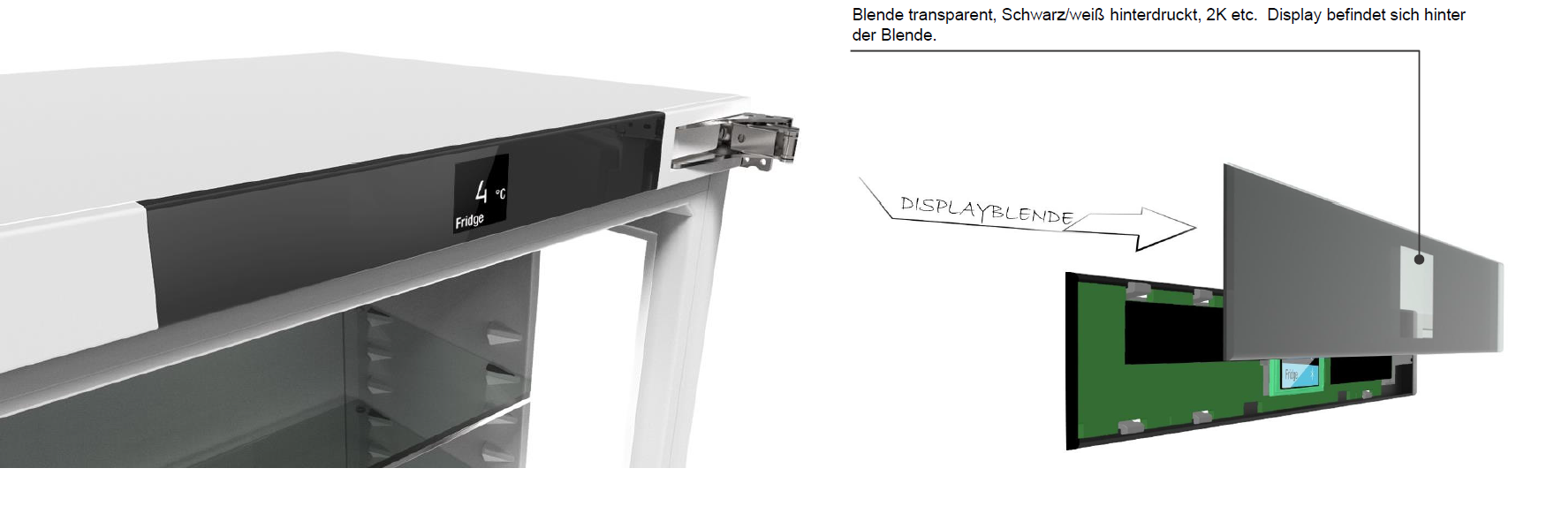

Based on prototypes, all surfaces shall be discussed and released by LIEBHERR before production process.

*ID* : UI_2021_125

### 5.2.4 Cover

It shall be possible to securely and tightly lock the side cover parts into place. Transport attempts in an installed condition must be successfully completed.

It shall be possible to dismantle the covers without damaging them.

For devices with standard WLAN functionality the Front panel shall be designed in this way that the rear cover to avoid ESD demage can be omitted.

For devices without standard WLAN functionality, a rear cover is required to avoid ESD damage due to the customer's requirement for retrofitting the WLAN Solution.

The price for the rear cover shall be listed separately.

*ID* : UI_2021_126

### 5.2.5 Manufacturing process and raw material

The manufacturing methods and materials for the affected parts shall be determined individually while taking the required properties into consideration.

Terluran GP 35 front panel material

Safety-relevant material tests in accordance with the Design Data Sheet 101.1.1 &[101001.pdf]& as well as MWN 2014 &[MWN2014-T1-02_2008-08.pdf]& may need to be performed (existing materials are an exception to this. Coordination with Mr. Weller (ALE) is required here)

*ID* : UI_2021_122

### 5.2.6 Food conformity

Electronic housings with directly contact to food shall be developed according to delivery specification 1110501 &[LS-1110501_02-dt+engl.pdf]&

Food conformity is required for all housings which are assembled inside the appliance, even if they do not have food contact directly.

*ID* : UI_2021_124

### 5.2.7 Color

**Color LIEBHERR surface black**

RAL DESIGN 24 02 005

**Color LIEBHERR surface** **white 744**

Color samples with measurement report will be delivered if necessary

**Color LIEBHERR printing**

Edelstahlfarben Peterlack VPAA10603,

Fa. Peter Lacke Artikelnummer: P949053, PEHABIN HYDRO-Einschichtbronze silver (VPAA10603, SS)

**Color Miele surface** **white 744**

Color samples with measurement report will be delivered if necessary

**Color Miele gray surface**

RAL Design 5000

**Color Miele printing**

NCS S 3500-N

**Permissible Color deviation**

General Deviation dE = 0,8

The maximum possible deviation of each color axis is 0,5

**Color authenticity**

The color authenticity is defined by reference- and boundary parts. These parts must be defined together with LIEBHERR QM.

**Color Resistance**

Following specification concerning Color resistance of the surface must be fulfilled:

Miele Technische Prüfanweisung OE/LA/024/11 &[OE LA 024-11_2011-03.pdf]&

Prüfanweisung PA 436-001 LWL &[PA 436-001 LWL.PDF]&

*ID* : UI_2021_127

### 5.2.8 Scratch and scrub resistance

Following requirements regarding scratch and scrub characteristics must be fulfilled:

Miele Technische Prüfanweisung OE/LA/025/08 &[OE LA 025-09_2011-07.pdf]&

Prüfanweisung PA 436-004 LWL &[PA 436-004 LWL.PDF]&

*ID* : UI_2021_128

### 5.2.9 Light Fastness

The assessment of the light fastness must be done under artificial illumination followed by thermal treatment

Miele Werknorm MWN 3037 &[MWN 3037-00-E_2002-02.pdf]&

*ID* : UI_2021_129

### 5.2.10 Adhesion properties and chemical resistance of printing on fascias and components

Following requirements regarding Adhesion properties and chemical resistance of printing on fascias and components must be fulfilled:

Miele Werknorm MWN 2016/01 &[MWN2016-01_1999-05.pdf]& and &[MWN2016-01_1999-05_en.pdf]&

*ID* : UI_2021_205

## 5.3 User Interface Control Unit

*ID* : UI_2021_208

### 5.3.1 User Interface Control Unit - Principle Diagram



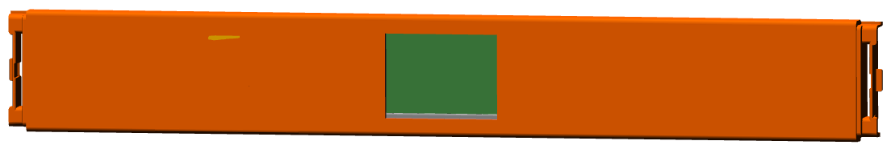

*ID* : UI_2021_174

### 5.3.2 Power supply

The power supply for UI module is provided by PowerBoard.

The power supply of all relevant PowerBoards is realized with SELV (safety low voltage).

The supply voltage of UI module is specified as followed:

13 V DC-Out from PB: 13,1 V ± 0.5 V (Voltage range maximum: 11V to 13,6V), Ripple ≤2 Vpp, Ri≤1 Ω, Pmax=13 W, Imax= 1 A

The UI module shall handle this power supply characteristics safely.

Disturbances and Interruptions of the power supply shall be taken into account.

*ID* : UI_2021_143

### 5.3.3 Graphic Display

**Display characteristics LCD Matrix Display:**

- Viewing Area: ~ 30mm x 30mm

- LCD Matrix resolution: 128px x 128px

- Technology: LCD, FSTN, negative, ~ 40cd/m²

- Backlight: White

- Viewing angle: 6h

alternative 12h

- Dimming: possible

- Operating hours: 5.500 hours (15 years - 1h /day - behind the door display)

132.000 hours (15 years - in the door display)

**Display characteristics TFT Matrix Display:**

- Viewing Area: ~ 2,0" to 2,2" (the maximum possible size which fits to front panel shall be used; Standard format not customized)

- LCD Matrix resolution: 320px x 240px (resolution depending on final display selection)

- Technology: TFT color

- Backlight: White

- Dimming: possible

- Operating hours: 5.500 hours (15 years - 1h /day - behind the door display)

132.000 hours (15 years - in the door display)

Color definition and color tolerances shall be coordinated with LIEBHERR.

It shall be possible to alter the display brightness to at least 5 gradations via the software. Brightness must comply with the following minimum requirements.

Maximum brightness level: >40cd/m2 (average irradiance)

Minimum brightness level: >4cd/m2 (average irradiance)

After 132,000 operating hours, the maximum brightness level of displays that are visible when the door is closed shall demonstrate at least the minimum brightness level at the point of delivery in terms of irradiance.

After 5,500 operating hours, the maximum brightness level of displays that are not visible when the door is closed shall demonstrate at least the minimum brightness level at the point of delivery in terms of irradiance.

Where necessary, the software shall offer the option of 10 contrast settings for graphic displays.

Using static charging to produce black is not permissible.

A contrast diagram for the display shall be provided.

The display quality shall be as followed:

- Maximum amount bright dots: <=2

- Maximum amount dark dots: <= 2

- Maximum amount defect dots: <= 2

(1 dot = 1 subpixel // 3 subpixel = 1 dot)

It shall be considered that display will be used for in the door appliances (=> display continuously on) and behind the door appliances (=> display on when door open). The service life time of 15 years must be considered. It shall be taken into consideration that for behind the door another display need to be used like for in the door appliances because of cost efficiency.

The display samples are released after final inspection by LIEBHERR on basis of display samples.

*ID* : UI_2021_144

### 5.3.4 Power Consumption

It is necessary to pay attention on the power consumption of the UI module.

For the evaluation of the power consumption all doors are assumed to be closed, i. e. display- and control panels can be switched off, if they are not visible when the door is closed.

The power consumption of the control must be named in the quote. Especially for idT appliances a low power consumption is necessary because of continuous display operation.

Following Energy consumption should be reached under specified conditions:

- Standby Mode < 5 mW

Display off

Controller low power mode => Wake up every 100ms to 200ms to check reed input, touch

sensor and bus information

- Low power Mode:

Backlight dimmed (level has to be tested on a sample)

Controller low power mode => Wake up every 100ms to 200ms to check reed input, touch

sensor and bus information

- Normal operation: < 70mW

Display on, full background brightness

Controller in normal operation

*ID* : UI_2021_145

### 5.3.5 Controller

The controller of the UI module shall be implemented according to following requirements:

ROM:

- The size of the controller shall be calculated by the supplier. Basis for calculation is the interaction design and the feature scope of the UI simulation. For future features and modifications additional space of 40% shall be foreseen at the controller.

I/Os:

- LC Display

- Input:

- Touch on Display

- magnetic door sensor

- Ambient temperature sensor

Output:

- Buzzer; Buzzer must be placed on UI module

- Option: Additional light output: 13V / 2W PWM controlled

- Option: Status Light

Data:

- single wire UART

Power supply

- 13V DC (provided by central power board)

*ID* : UI_2021_146

### 5.3.6 Connectors

Following Connector shall be implemented on UI module. The position of the connector is specified by CAD data &[SKO00860_Einbauverhaeltnisse_UI_low]&

**Interface Ui module <=> Appliance:**

- Connector type: Molex MiniFit 6 pos

pin1: GND

pin2: Data UI (bus single wire)

pin3: + 13,1V

pin4: GND

pin5: +24V

pin6: GND (24V)

**Interface Ui module <=> Connectivity Module:**

- Connector type: gold spring contacts / PCB pads

pin1: GND

pin2: Data UI (bus single wire)

pin3: + 13,1V

pin4: GND

**Interface UI-module <=> door hinge (Y-connection)**

- Connector type: RAST 2,5 edge Connector / alternative socket connector

pin1: GND

pin2: Data UI (bus single wire)

pin3: + 13,1V

pin4: GND

pin5: +24V

pin6: GND (24V)

The Y connection shall be foreseen for all types of UI module. The Y connection serves as an interface to connect idT Display, Ambilight or automatic door opening system.

If another pinning is more efficient, the pinning could be changed.

Before implementation of the HW, the pinning shall be discussed with LIEBHERR.

*ID* : UI_2021_197

### 5.3.7 Protocol Interface

The communication between the UI module and the PowerBoard shall be realized by SingleWire communication. The requirements in accordance with document [Liebherr Singlewire Communication 20180926.docx] apply. Detailed specification of the bus shall be discussed with LIEBHERR in project phase.

For future implementation the software architecture shall be modular, that components (e.g. Singlewire Protocol, SingleWire Physical Layer) can be exchanged easily.

*ID* : UI_2021_131

### 5.3.8 Touch Control

General Touch characteristics:

Haptic feedback characteristics shall be coordinated with LIEBHERR.

Push button function is tested by means of a "GOOD/BAD test finger".   
The switching function shall always be activated in the test with the GOOD test finger.  
The switching function shall fail to be activated in the test with the BAD test finger.  
In both tests, a force of 2 - 10 N must be applied to the touch surface of the test finger.

The wipe functionality to clean the User Interface must be taken into consideration. While wiping the display, no interaction on UI should happen.

A detailed specification how the touch screen must be handled for assembly and which tolerances are acceptable between the touch and the display window shall be provided to LIEBHERR.

*ID* : UI_2021_152

### 5.3.9 Buzzer

**Alarms**:

An acoustic pressure Lp > 60 dB(A) shall be achieved in assembled condition with a closed door.

Measurement point in relation to the left front edge of the appliance:

x: 0.7m parallel to the front edge of the appliance

y: 0.7 m vertical to the front edge of the appliance

z: 1.7 m height

A solution with 4 kHz as well as a solution in the frequency range from 1kHz to 1.5kHz must be shown.

**Signals:**

The definition of the different signals is done in the UI control concept.

The tone with the following control parameters serves as reference.

Frequency: 4 kHz  
 Pulse length: 1 ms  
 Duty cycle: 50:50

No. of periods: 4

The buzzer sounds shall be evaluated by prototypes together with LIEBHERR

*ID* : UI_2021_160

### 5.3.10 Panel Light

>> Drawing Panel Light

For appliances like e.g. Freezers it is not possible to integrate the light into the housing of the appliance. For these appliances the light shall be integrated in the front panel. The panel light shall be offered as an option and shall be placed on the left side of the UI Module where the basic functionality is located.

There shall be the possibility to integrate a light output with 13V / 2W PWM controlled into the front panel. The panel light is not needed for all appliances, so it shall be possible to handle the light as an option. There shall be the possibility to deliver front panel with and without panel light. The light shall be integrated on the front panel PCB in a cost efficient way. The light solution shall be discussed together with LIEBHERR.

If lamps are delivered, following color specification shall be fulfilled:

   x                       y

0,3055              0,3177

0,3041              0,3240

0,3210              0,3408

0,3216              0,3334

Voltage: 13V

The current regulator is integrated on the LED interior light.

A gentle increase in brightness within 1 to 2 seconds is to be achieved.

The function is to be designed so that the increase in brightness is perceived to be smooth and even.

End state is 100% interior light control.

The interior light can be switched off immediately.

Panel Light shall be optional functionality which can be assembled or not by UI variant

*ID* : UI_2021_210

### 5.3.11 Status Light

The Status Light is a optional functionality for Freestanding Freezer Appliances

The Status Light show the status of the appliance through the door in red and blue color. LEDs with window through the Front Panel shall be included in UI module.

The Lightguide which guides the Light through the door is developed by LIEBHERR and is not part of the offer.

Luminance of the LED:

- average luminance red LED> 2500cd / m²  
- average luminance blue LED approx. 1000cd / m²  
- Deviation from a measuring point should be the ratio of minimum to mean ≥ 0.6.

*ID* : UI_2021_149

### 5.3.12 Ambient temperature measurement

On UI module an ambient temperature sensor shall be implemented.

The placement of the sensor and the thermal coupling shall be selected so that no direct influence is exercised on the measured values by component heating.

**Measuring Loop**

Accuracy requirement for the entire measurement chain (electronic system incl. sensors):

Absolute temperatures: +/- 1.0 K

Temperature difference: +/- 0.5 K

The resolution of the AD converter in the relevant temperature range must be at least 0.25 K.

Temperature ranges:

Ambience:

+ 10 °C to + 43 °C

The specified accuracy must be valid for following temperature range of -50°C to 50°C

**Measuring system without sensor**

Accuracy requirement of the measuring system without sensor:

Absolute temperatures:

+/- 0.5 K

Temperature differences:

+/- 0.5 K

*ID* : UI_2021_150

### 5.3.13 Door sensor

The sensors shall be adjusted to the electronic and door sensor systems.

Detection of open and closed doors shall be possible within a range of 22 mm to 40 mm, measured from the front edge of the side wall to the metal edge of the door on the side with the gasket.

A side offset of +/-5 mm and height reduction of -5 mm due to production reasons shall be taken into account.

The door sensors are to be located on the UI module.

Exception: Door sensors on the bottom door on combinations. In this case, an appropriate connection to control system is to be provided.

The proposal is to be coordinated with LIEBHERR.

It shall be assumed that the door will be opened and closed 300,000 times throughout the appliance's life cycle.

The extended temperature and humidity ranges apply when the sensor is located in the freezer compartment interior.

In the developing process of the door sensor the mechanical requirements of Konstruktionsdatenblatt 130.1.1 Türsensorik &[130001.pdf]& and the datasheet of the door magnet &[173103.pdf]& und &[Datenblatt LIEBHERR HF.pdf]& must be taken into account.

The door detection shall compensate any aging effects of the system e.g. less sensitivity of the sensor over life time, less magnetic field of the magnet over life time, changed signal because of mechanical changes in the system (for example changed door connection from right to left with slightly different position of door/ magnet).

After the beginning of door opening, the interior light must go on after 300 ms at the latest.

*ID* : UI_2021_151

#### 5.3.13.1 Door Sensor - System Realization

**Hardware:**

- Use of Hall sensor

**Signals:**

stateDoorSwitchChange: 1 = already changed / 0 = no change

valueHallSensorLimitOpen: Limit in LPF in percent

valueHallSensorLimitClosed: Limit in LPF in percent

valueHallSensor1: Opening Value (counts)

valueHallSensor2: Maximal sensor value (MAX; maximal counts in door closed position, set point for 100 %)

**Sensor:**

The two Hall Sensor outputs are connected direct to the UI μController.

The controller is activating the sensor and tracks both outputs every 1ms.

The measurement takes about 20μs time. Afterwards the sensor is switched off for the next 980μsec.

Without magnet the resistive Hall bridge is symmetrically and both analog inputs are measuring VDD/2 (512).

The signal which is used for the door detection is the difference of both analog measurements.

For the open door (no magnet) this difference is near to 0x00.

If the door is closed the magnet will unbalance the magnet resistive Hall sensor.

The UI writes into the PowerBoard "valueHallSensor1" the actual difference value and to "valueHallSensor2" the actual MAX value (for 'Door Closed').

These both values are only for information, to read from external the door values.

During the production of the fridge/freezer the values "valueHallSensorLimitOpen" and "valueHallSensorLimitClosed" are written into the ToD as non volatile values.

**Calibration:**

Into calibration period a closed door value (zero adjustment) will be initiated. After this there is a regularly adjustment of this value. After Power up Calibration period starts for one hour

First value is initial value for "MAX value".

Measurement cycle is 100 ms. "MAX value" of Limit will change only one digit per cycle (100 ms).

If the Calibration period ends and the actual MAX value is still in the fix 'DoorOpen' range, this period gets restarted. Otherwise the second period will be started.

The limits "valueHallSensorLimitOpen" and "valueHallSensorLimitClosed" are used as percentage value. The digit value for MAX has to be defined online from the software.

After a reset the MAX value is fix set to a very low value which is sure lower than a signal for a closed door.

After the door is closed, this "max value" is increased to the real measured value of the system

During this period the MAX value gets updated to a HIGHER actual value.

If a new MAX value gets detected, the 'DoorClosed' and 'DoorOpen' limits of all depending zones gets re-calculated.

If the door was closed during reset it is handled in the same way. First initialization with an very low value. Direct overwriting max value after first measurement of door sensor value.

**Adjustment:**

Adjustment function runs only if door are closed. If door are opened measurement is postponed into next 5 minutes period.

After calibration period the software will adapt this "MAX value" every 5 min by one digit, if the actual measured value is higher or lower than the actual defined "MAX value"

The system should have the same behavior when LPF defines "valueHallSensorLimitOpen" and "valueHallSensorLimitClosed" and eliminates tolerances of the system.

*ID* : UI_2021_161

### 5.3.14 Software Requirements

***General software requirements***

The logical data structure of the software shall be discussed with LIEBHERR.

Transmission protocols shall be agreed with LIEBHERR.

The software shall be designed in a way, that the zone controls and the total appliance control can be included into a PC program without modifying the source code.

The software and the corresponding interface concept shall be designed in a way, that it is possible to include external software moduls without changing the source code of these modules.

***Software and process quality assurance***

A software process comparable with SPICE Level 0 is to be aimed at.

The conditions and the realization of the SPICE Level shall be discussed with LIEBHERR

***Condition function requirements***

Aside from the requirements according to the operating specifications, test and service functions are to be implemented in coordination with LHG.

***Change History***

A change history sheet for SW functionality has to be implemented

***Software Architecture***

The software architecture of the UI Module's software shall be discussed with LIEBHERR.

The software architecture shall be designed to allow transparent access to the UI. There shall be an interface which allows to separate the BSP and the application functionality.

For future use, there shall be the possibility to implement the application software by LIEBHERR and to use BSP of supplier.

*ID* : UI_2021_43

#### 5.3.14.1 Operating Concept and MMI

The UI simulation specifies the UI interaction design and the current functionality of the UI module. The simulation is illustrating the current functional scope of the project, future amendments could be possible and shall be considered by controller size. The development of the UI interaction design and the functionality scope shall be done in coordination with LIEBHERR.

The current functional scope and flows are summarized by separate document

&[UI_flow_FSTN_LIEBHERR_280928.pdf]&

The current functional scope and flows are summarized by separate document

&[UI_flow_TFT_LIEBHERR_280928.pdf]&

The navigation and functional scope is similat to FSTN Version. The screens are in color. Final simulation and draft will be sent after offer.

The Miele functional scope and flows are summarized by separate document

&[K70000_UI Low_Konzept_v1.pdf]&

The Miele functional scope and flows are summarized by separate document

&[K70000_UI High-Konzept_v1.pdf]&

It shall be considered that additional OEM UI interaction design could be implemented and handled.

*ID* : UI_2021_162

#### 5.3.14.2 Software - Transparent Access

For test purposes direct memory access to all controllers and system memories is to be furnished. All controllers of external components shall be accessible.

EEPROM, Flash and RAM memories shall be modifiable.

The structure can be used for any internal data exchange.

Access shall be uniformly possible via all existing external interfaces.

Mapping of memory content to the LHG nomenclature of variables and parameters shall be executed in a xml file. Definition to be performed jointly with LHG.

Read and write options shall be available for bit, byte, word and block accesses.

*ID* : UI_2021_163

#### 5.3.14.3 Controller monitor and reset function

All system controllers involved in controlling the appliance shall be monitored. If a problem occurs on a controller, a forced reset shall be performed.

This requirement also applies to components connected to the internal bus system that are involved in controlling the appliance.

*ID* : UI_2021_167

### 5.3.15 Test Requirements

The compliance with the requirements shall be done by appropriate tests.

For software the test requirements according to DIN/IEC 15504: 2011-7 (SPICE) are valid.

*ID* : UI_2021_51

### 5.3.16 Flashing

*ID* : UI_2021_157

#### 5.3.16.1 Programming in an uninstalled state

In order to reduce stocks of spare parts, a uniform programming option shall be created for all printed circuit boards.

The programming of the controller and the UI shall be possible via a uniform interface. The UI shall be programmable in the mounted state via the control unit.

For programming, it need not be necessary for the control unit to be supplied with mains voltage.

It shall be possible to program parameter sets as well as the software functionality

Programming at spare parts level shall be possible.

*ID* : UI_2021_158

#### 5.3.16.2 Programming in Service Case

Via the interface to the SDB box, a low voltage supply shall be available for the control unit so that programming and parameterization is possible without mains voltage connection.

*ID* : UI_2021_164

#### 5.3.16.3 Bootloader

The software of all controllers contained in the system shall be able to be updated via any external interface.

*ID* : UI_2021_165

#### 5.3.16.4 Programming equipment

It shall be possible to program all control systems in the development area. The necessary adapters and programming tools shall be provided for this purpose.  
The latter shall be provided along with the first prototype control systems to all factories in which the respective control system is to be implemented.

*ID* : UI_2021_206

## 5.4 Connectivity

*ID* : UI_2021_209

### 5.4.1 Connectivity Integration - Principle Diagram

Two connectivity variants for the UI Module shall be offered:

1: "Connectivity integrated" on UI Module => Connectivity module + Adaption circuit are soldered on UI module PCB

2: "Connectivity module" as retrofit solution => Connectivity and Adaption circuit are implemented but not equipped on PCB; Connection by gold springs for connectivity module on UI module shall be foreseen

The connectivity module and the peripheral circuit will be defined by LIEBHERR. The detailed delivery process of the connectivity module shall be discuss with LIEBHERR in project phase.

The connectivity module / connectivity access also serves as service access to the appliance

*ID* : UI_2021_154

### 5.4.2 Option 1: Connectivity integrated solution

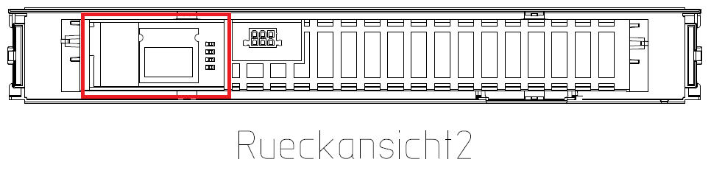

The integrated solution shall be used for all appliances where the connectivity is set as a standard.

The connectivity module and the peripheral circuit for adaption of the data to Liebherr ToD shall be soldered directly on UI module PCB.

For appliances without standard connectivity module, the circuit is not equipped - just foreseen.

Depending on the constructive UI concept it shall be checked if the rear cover is not needed for assembly process

The orientation and radiation characteristics of the connectivity module shall be defined during the project in order to achieve the best possible radiation characteristics.

*ID* : UI_2021_159

### 5.4.3 Option 2: Connectivity Module

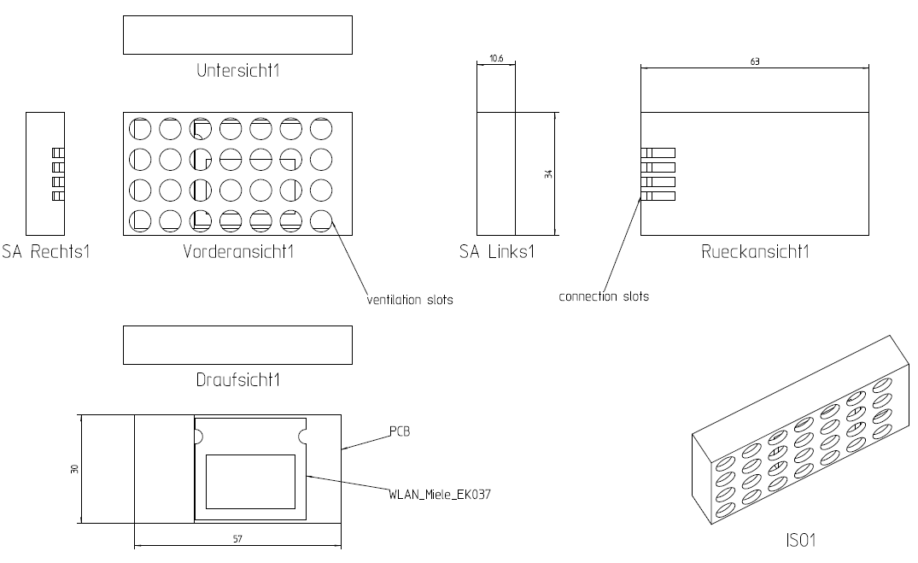

For retrofit solution a Connectivity module shall be integrated in the rear cover of the UI module

The connection of connectivity module is realized by gold springs. On UI PCB the springs for connection shall be implemented. If the pins need to be gold plated has to be discussed in development phase.

A Guidance and fixation of the connectivity module against shifting is necessary in the rear cover of the UI module.

The two different dimensions of the connectivity module shall be considered

Drawing see external document &[SKO04095_Anfrage_20180928.pdf]&

*ID* : UI_2021_217

### 5.4.4 BLE Module

On the front panel there shall be foreseen assembly space for a BLE module (Bluetooth), which allows a modular extension by a BLE module + antenna + adaption circuit to LIEBHERR Bus (~ 35mm x 35mm), not to create additional effort in plastic parts later on.

The BLE Module shall be connected to appliance electronic via the LIEBHERR bus.

For future use the BLE module shall be soldered on UI PCB independently of the connectivity module

The space to place the BLE module is up to the supplier.

The supplier shall propose a concept to implement the BLE module.

*ID* : UI_2021_98

# 6 Testing and Validation

*ID* : UI_2021_132

## 6.1 Environmental Tests

*ID* : UI_2021_133

### 6.1.1 Coldness to DIN EN 60068-2-1 A

The purpose of the coldness test is to assess assembly unit suitability for operation or storage at low temperatures. Assembly units are cooled down to the minimum temperature of their steady state. The assembly units are then kept at the test temperature for the test period. Prior to and on conclusion of the test period visual checks and a function test are conducted on the assembly units. Electronic assembly units are operated at under-voltage and their function monitored. The assembly unit is only switched on once it has reached its steady state.

Test parameters:

Test duration: min. 500 h

Test temperature: minimum assembly unit temperature, however not warmer than 0°C

*ID* : UI_2021_134

### 6.1.2 Dry heat to DIN EN 60068-2-2 B

The purpose of the dry heat test is to assess assembly unit suitability for operation or storage at a higher temperature. The assembly units are heated to the maximum temperature of their steady state. The assembly units are then kept at the test temperature for the test period. Prior to and on conclusion of the test period visual checks and a function test are conducted on the assembly units. Electronic assembly units are operated at over-voltage and their function monitored.

Test parameters:

Test duration: min. 500 h

Test temperature: maximum assembly unit temperature

*ID* : UI_2021_135

### 6.1.3 Temperature change to DIN EN 60068-2-14 Na

**Rapid temperature change with fixed transition period**

This test is used to assess the resistance of mechanical and electronic components and assembly units, materials, material combinations and their connection systems when exposed to rapid changes in temperature. The necessary test temperatures and dwelling times depend on the specimen properties. Prior to and on conclusion of the test period visual checks and a function test are conducted on the assembly units. Intermediate tests can be conducted during the test. Function must be monitored during the test.

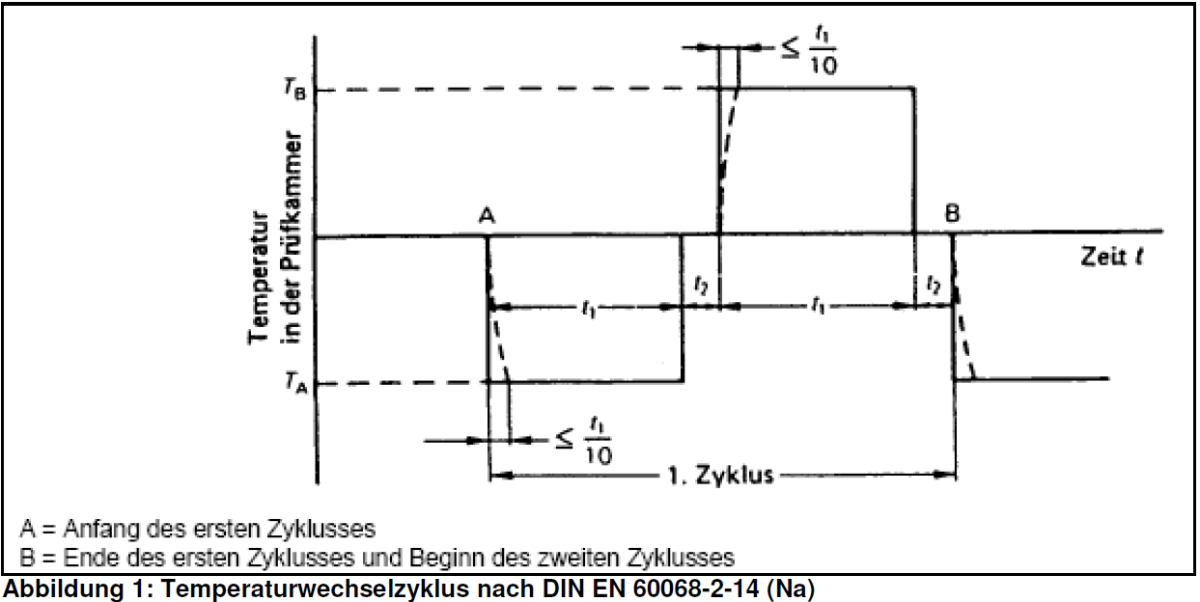

[Fig. 1: temperature change cycle acc. to DIN EN 60068-2-14 (Na)

A= beginning of the first cycle

B= end of the first cycle and beginning of the second cycle

X-Axis: Temperature in the test chamber

Time: 1st cycle]

Test parameters:

upper test temperature: depending on the maximum temperature of the assembly unit.

Lower test temperature: depending on the minimum temperature of the assembly unit.

Dwelling time t1: 15 min

t2: 0 min

No. of cycles: 3000

**Temperature change with fixed change speed**

This test is used to assess the resistance of assembly units to temperature changes in the air as they may occur during operation, storage and transportation. The test temperatures are generally based on the maximum temperature thresholds of the assembly unit. Prior to and on conclusion of the test period visual checks and a function test are conducted on the assembly units. Function must be monitored during the test.

Test parameters (case study):

Upper test temperature: depending on the maximum temperature of the assembly unit.

Lower test temperature: depending on the minimum temperature of the assembly unit.

Dwelling time: 10 min

Rate of change: 2 K/min

No. of cycles: 3000

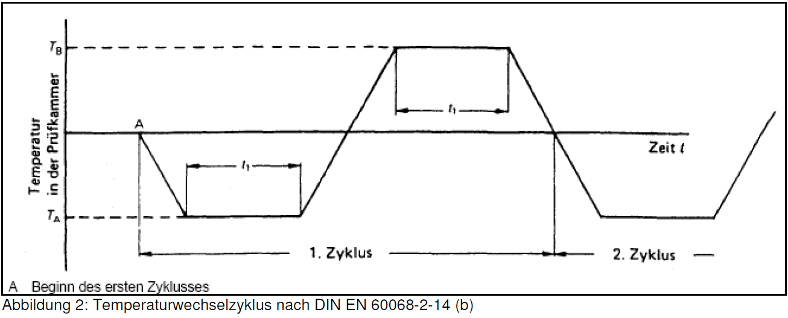

[Fig. 2: temperature change cycle acc. to DIN EN 60068-2-14 (b)

A Beginning of the first cycle

X-Axis: Temperature in the test chamber

Time: 1st cycle // 2nd cycle]

*ID* : UI_2021_136

### 6.1.4 Temperature change with humidity to DIN EN 60068-2-30 Db

***Temperature change with fixed rate of change***

This test is used to assess the resistance of assembly units to temperature changes in the air as they may occur during operation, storage and transportation. The test temperatures are generally based on the maximum temperature thresholds of the assembly unit. Prior to and on conclusion of the test period visual checks and a function test are conducted on the assembly units. Function must be monitored during the test.

Test parameters:

upper test temperature: 60°C / 95% rel. humidity

Lower test temperature: -30°C

Dwelling time: 12 h / 12 h

No. of cycles: 50

*ID* : UI_2021_137

### 6.1.5 Vibration, noise to DIN EN 60068-2-64 Fh

The test is used to locate mechanical weaknesses. The test should be conducted in the original built-in conditions of the assembly unit. Prior to and on conclusion of the test period visual checks and a function test are conducted on the assembly units.

Test parameters:

Test period in the built-in location: 24 h

Test period in the other two locations: 8 h respectively

Test spectrum:

5Hz >> 0.005 g2/Hz

10Hz >> 0.01 g2/Hz

20Hz >> 0.01 g2/Hz

50Hz >> 0.01 g2/Hz

100Hz >> 0.01 g2/Hz

200Hz >> 0.01 g2/Hz

500Hz >> 0.0015 g2/Hz

*ID* : UI_2021_138

### 6.1.6 Sinusoidal vibration to DIN EN 680068-2-6 Fc

The test is used to locate mechanical weaknesses. The test should be conducted in the original built-in conditions of the assembly unit. Prior to and on conclusion of the test period visual checks and a function test are conducted on the assembly units.

Test parameters:

Frequency: 5Hz - 500Hz - 5Hz 1 octave/minute

Frequency cycles: 10

Amplitude/acceleration:

5Hz to 8 Hz /3.5mm

8Hz to 500Hz /1g

*ID* : UI_2021_139

### 6.1.7 Shock to DIN EN 680068-2-27

The test is used to locate mechanical weaknesses. The test must be conducted in the original built-in situation of the assembly unit. The built-in situation must include the mechanical interface to the appliance. Prior to and on conclusion of the test period visual checks and a function test are conducted on the assembly units.

Test parameters:

Shock type: semi-sinusoidal

Acceleration: 30G

Impact time: 11 ms

No. of shocks 3 shocks per axis and direction

Axes: X, Y, Z

*ID* : UI_2021_140

### 6.1.8 Vibration stress on appliance during transportation

Appliances are tested at LHG.

After testing the specimen must be in perfect working order.

Power density spectrum to ASTM 4169 Truck Level 1.

Frequency; spectral power density

1 Hz ; 0.001 G2/Hz

4 Hz ; 0.02 G2/Hz

16 Hz ; 0.02 G2/Hz

40 Hz ; 0.002 G2/Hz

80 Hz ; 0.002G2/Hz

200 Hz ; 0.00001 G2/Hz

Acceleration: 0.833 gRMS

Test duration: 30 minutes

*ID* : UI_2021_141

### 6.1.9 Shock impact on appliance during transportation

Shock resistance to foreseeable shock impact must be afforded.

Appliances are tested at LHG.

Unbroken fall of appliance from a height of up to 0.52 m onto solid ground.

*ID* : UI_2021_142

### 6.1.10 Shock impact in door

The shock impact on components built into the door caused by opening and closing is to be taken into account.

It is to be assumed that the door will be opened and closed 350,000 times during the appliance's life cycle.

*ID* : UI_2021_112

# 7 Change History

02.11.2017: Maximum Temperature Limits by use of R600 (ID UI_LOW_168)

29.08.2018: Update complete User Interface Specification according display decision August 2018