**Environment and Firm Leverage**

Xiqiao Ouyang, Yubing Tang

## Abstract

We test the stakeholder theory of capital structure from the perspective of the firm’s environmental performances. The paper found out that the company with a good awareness of environmental-friendly(recycling and green sources) have low debt ratios.

## Introduction

Several studies analyzed the significance effect from stakeholders including customers, suppliers, and workers on capital structure decisions. The result shows that the company with good relations with their employees have low debt ratios (Bae, Kang, and Wang, 2010). Because there is an increasing number of corporate social responsibility supporters provide that environmental performance is not only the right thing to do but also incorporate social and environmental criteria incorporate practices (Xphetoe, 2014). Therefore, we want to investigate whether the firm’s environmental awareness affect leverage and their relation and figure out their relation.

There are some potential arguments for why the level of a firm’s environmental awareness should be related to its capital structure. The first explanation is that

Another argument is that managers with higher free cash flow may invest in environmental-friendly services or products than firms with lower free cash flow.

For analyzing the relationship between their green resources and its financial policy, a firm-level measure data is needed. We used data from the KLD Research & Analytics, Inc. (hereafter, KLD) SOCRATED database. It gives comprehensive information on the ratings given to firm environmental performances. Base on the database, we create an index, which we call the Environment Index, to measure the extent of environmental friendliness of the firm.

Using a sample of 4291 firm-year observations for which KLD ratings are available for the period 2003-2010, we find that firms with a higher score on Environment Index influence a little on lower leverage.

The paper is organized as follows. In part 2, we show the data used in paper and provide summary statistics. In the later section, we present regression results for the relation between the Environment Index and market/book leverage.

## Data

This part we describe how we select our sample.

Measurement of a firm’s environmental awareness

For measuring the firm’s environmental awareness, we looking into their green resources actions. We obtain environment measure from the KLD SOCRATES database. It provides extensive data on the ratings of the firm’s environmental actions. Analysts rating the social performance using negative or positive indicators once KLD gets the data. Below, we summarize how they evaluate strengths in five categories of environmental performance:

1. Beneficial Products and Services - whether or not the company provided environmental-friendly products and services.

2. Pollution Prevention - whether or not the company has taken protection procedures for the environment beforehand operating.

3. Recycling - whether or not the company rational use of resources through recycling the resources.

4. Clean Energy - whether or not the company encourages high-quality energy like solar energy.

5. Other Strength- other strengths relate to environmental-friendly actions.

KLD determine those five categories and assigns with 0 or 1 rating corresponding. Then we can create our Environment Index by summing up all those indicator variables. This Index should between zero and five. Therefore, higher Index regard as more environmental-friendly.

Sample selection

Our initial sample from KLD SOCRATES database between 2003 and 2010 consist of more than 10,000 firm-year observations with ratings on the environment. Then we merge these observations with the Compustat industry annual file for more firm characteristics. Next, we exclude firms for which information on total asset and not headquartered in the United States.

We also exclude regulated industries with standard industrial classification (SIC) codes between 6,000 and 6,999 and between 4,900 and 4,999 followed by Bae (2010), we got 13,358 observations.

During creating the new variables, there is a large amount of missing value generating, for example, 1448 missing value in environment index and 7000 missing value in sales growth (3 years). After excluding those missing value in target variables and replace by 0 in some variables like R&D expenses, restrictions result in a final sample of 4804 firm-year observations. There exists around 11.1% positive score of Environment Index on our sample. A further breakdown of that 11.1% includes that 7.7%, %, 2.3%,1.0% and 0.2% of the sample has a score of one, two, three, and four respectively (Graph 1). There is no observations level in five scores of Environment Index.

|  |  |
| --- | --- |
| envindex | Freq. |
| 0 | 4,270 |
| 1 | 369 |
| 2 | 111 |
| 3 | 46 |
| 4 | 8 |

## Summary statistics

We summarize our statistics about our sample firm in Table 1. We present a summary statistic in compare leverage, control variables and other firm characteristics of all sample firms, and also compare all those characteristics by two groups. One with a positive Environment Index score, another group is the matching firms with the zero Environment Index score. As we can see in Graph 1, there are just 534 firms with a positive Environment Index. Therefore, for each of these 534 firms need a matching firm with similar asset size using the first two digits of the SIC code.

There are some features should be mentioned and noticed. Initially, we find that those positive Environment Index’s firm has a lower leverage ratio than those firms with zero Environment Index amount. The mean of market long-term debt ratios for positive and zero Environment Index is 12.8% and 13.7% respectively. Secondly, fixed assets to total assets, R&D expenditures to total assets are significantly higher for positive index firms than matching firms. Moreover, selling, general and administrative expenses to total assets for firms with positive environment index is much higher than firms with zero environment index score. However, our sample with small number shows lower total assets and total sales for positive environment index firms. We think it is because the small sample we get after dropping a lot of missing value, and this is also the limitation that we get a small number of sample.

**Results**

In Table 2, we present the result of the regression. To test the relationship between leverage and environment index, we run six models in total on the panel dataset. Following are the variables selection.

|  |  |  |  |  |
| --- | --- | --- | --- | --- |
|  | Dependent Variables | Independent Variables | | |
| Model # |  | Environment Index | Lagged Leverage Ratio | Control Variables |
| 1 | market leverage ratio | N | Y | Y |
| 2 | market leverage ratio | Y | Y | Y |
| 3 | book leverage ratio | Y | Y | Y |
| 4 | market leverage ratio | N | N | Y |
| 5 | market leverage ratio | Y | N | Y |
| 6 | book leverage ratio | Y | N | Y |

According to Table, the coefficient estimate from all models shows that the environment index is negative. However, is not statistically significant.

Model 3(with Lagged Leverage Ratio and Environment Index shows the highest R square, which means both of these two variables contribute to the predict of the book leverage ratio.

Even most of the coefficient shows the negative relationship between environment index and leverage, the difference is not distinguishable and not obviously in our data.

## Appendix

Table 1

Summary statistics on firm characteristics

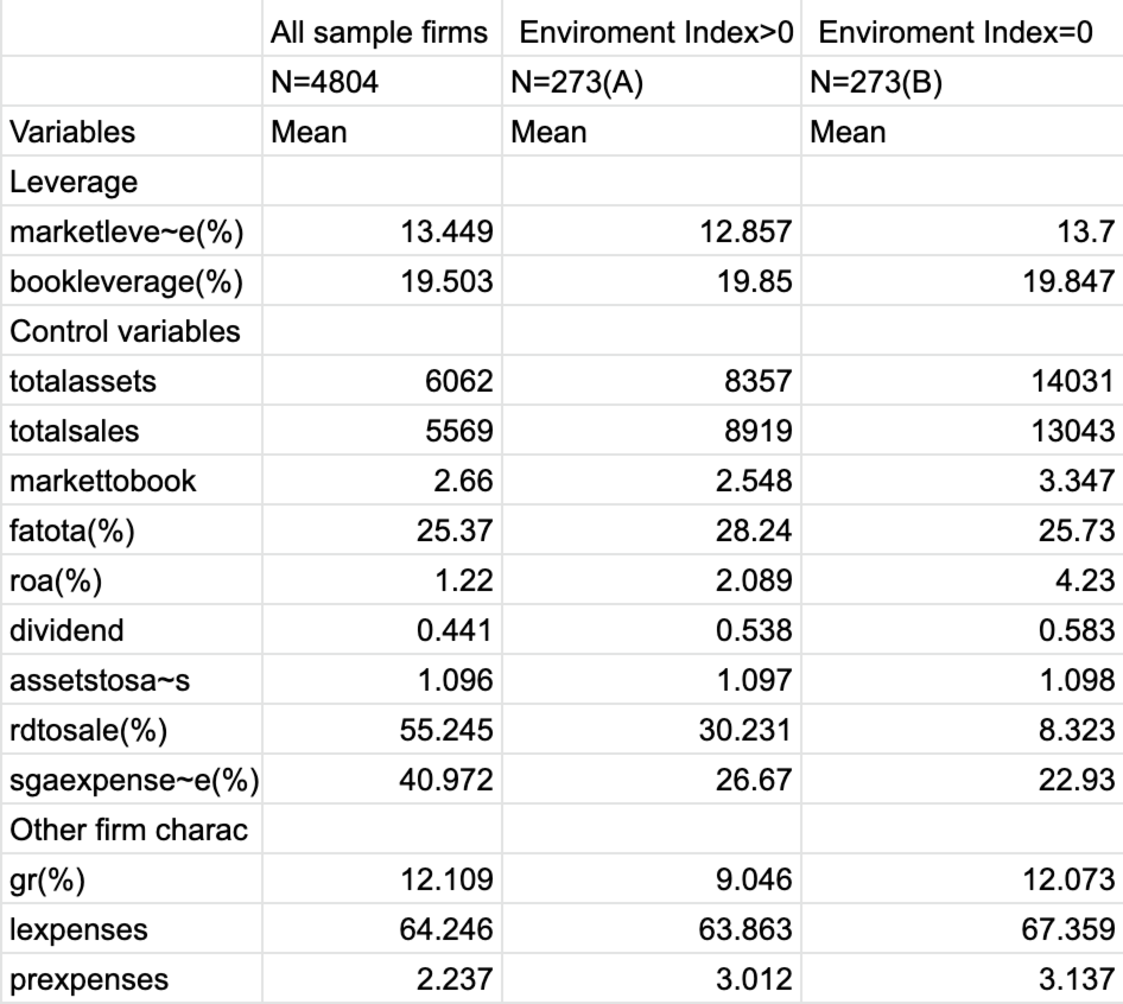

Table 2

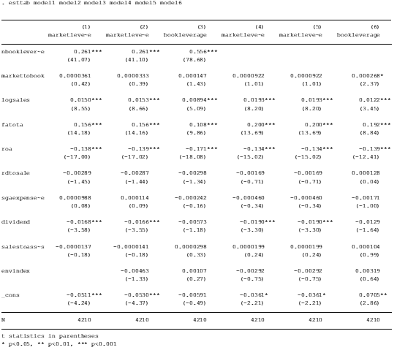

Table 3

|  |  |
| --- | --- |
| Model # | Overall R-sq |
| 1 | 0.5555 |
| 2 | 0.5567 |
| 3 | 0.7939 |
| 4 | 0.1663 |
| 5 | 0.1663 |
| 6 | 0.1169 |

## References

*Bae,K., Kang,J.,Wang, J, 2010. Employee treatment and firm leverage: Atest of the stakeholder theory of capital structure. Journal of Financial Economics 100 (2011) 130-153.*

*Xphetoe,Π., 2014.Environmental performance and corporate capital structure. Retrieved from**<http://dione.lib.unipi.gr/xmlui/bitstream/handle/unipi/8739/Papageorgopoulos_Christos.pdf?sequence=1&isAllowed=y>*