Chinese New Year cookie feast
- Introduction
Our project is an interactive 3D 1st POV eating food animation created using OpenSCAD and Three.js. The main food object is a Chinese style almond pastry inspired by traditional festive cookies and mooncakes. Three almond pastries are arranged on a ceramic plate,then a pair of chopsticks enter the scene, picks up the top pastry , moves it towards the viewer and does a two-bite eating animation. To explore beyond a single material type,a crystal osmanthus cake is also presented, being served inside a bamboo steamer. (The 2 foods were designed to behave differently;the almond pastry is rough and brittle-looking while the crystal cake is translucent, soft and wobbly.) After the almond cookie was eaten, the plate moves to the left and the almond cookie enters from the right, the chopsticks pick up and, after shaking it to display its wobbly response, does another two-bite animation similar to the first.

- Approach
- Modeling
Taking reference from these pictures and models(see figure1-4), the food geometry was procedurally modeled in OpenSCAD and exported as STL files for use in Three.js.
Several related models were exported from the same procedural coordinate system(mainly for showing the whole/bitten states of the almond cookie and the cake.
A bamboo steamer was built using cylindrical walls, binding bands and door slats，while models of chopsticks and a ceramic plate was also created.

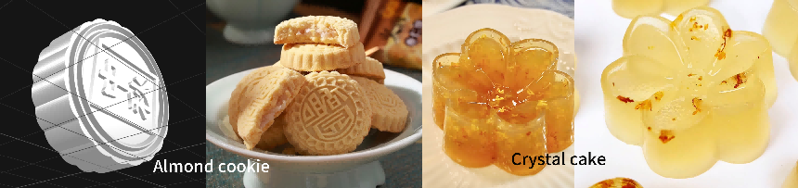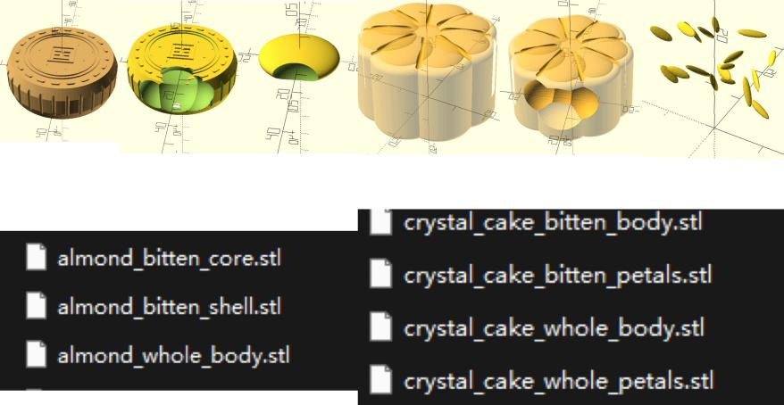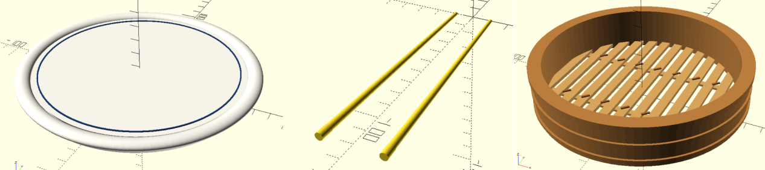
In order to prevent the model from shifting(creating visual jumps) when switching from one state to another(Because OpenSCAD uses a Z-up coordinate system while Three.js uses Y-up), the imported STL models are rotated by:
The whole and bitten versions are also aligned using the same reference center.
- Texture mapping and almond pastry shader
The STL geometry does not contain useful UV coordinates, so the almond pastry was mapped using a triplanar texture mapping instead of a conventional UV texture workflow.
The texture is sampled from three directions：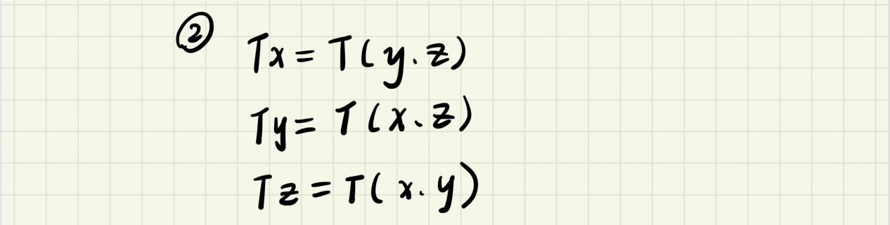
The shader calculates blending weights from the surface normal:
The final surface color is then approximately：
This allows the texture to wrap over the top, sides, grooves.etc without manually UV-unwrapping the STL model and produces no visible UV seams.
Separate texture maps were used for shell surface color& roughness, side ridge surface color&roughness, crumb color&roughness and filling color&roughness.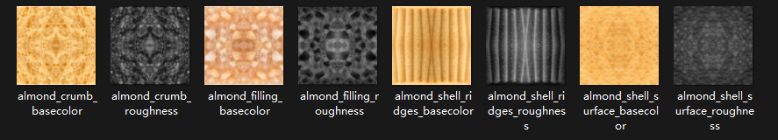

The geometry was slightly softened before rendering so that the outer edges appeared more like baked food than a sharp CAD object.(this step was achieved with the help of generative AI).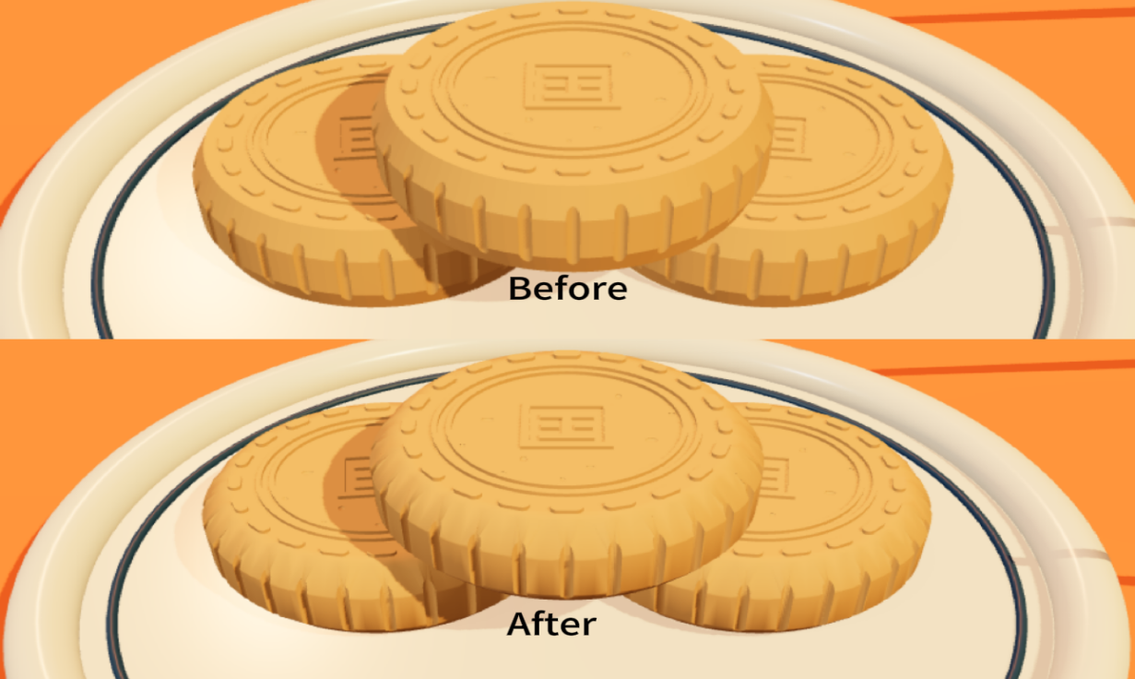
- Crystal cake material and wobble effect
The crystal cake uses a physically based translucent material.Its appearance combines transmission, transparency, index of refraction, clearcoat, as well as low surface roughness, creating a wet, translucent appearance of gelatin.
The material was combined with a custom vertex shader , several sine and cosine waves deform the model in different directions(A =wobble energy, t=animation time, h=height-dependent weighting value):
The bottom of the cake is more strongly anchored due to the height weighting while the upper deforms more freely, this makes the cake appear to sit on the steamer instead of floating.
After an external movement stops, the wobble does not stop immediately, its energy decays exponentially.(This equation creates delayed secondary motion, especially when the steamer stops or when the chopsticks shake the cake.)
- Animation
The complete animation is implemented as a state based sequence in Three.js.
For the almond pastries, the main states include:
Approach
→ Grip
→ Lift
→ First Bite
→ Reveal
→ Second Bite
→ Exit
The first bite switches the visible geometry from the whole model to the bitten shell and filling, crumb particles are released at the same time.
For the crystal cake,the animation includes:
Steamer Entrance
→ Chopstick Rotation
→ Grip
→ Lift
→ Move Toward Camera
→ Shake
→ First Bite
→ Cross-section Reveal
→ Second Bite
→ Exit
Object movement uses cubic easing.(This produces smooth acceleration and deceleration. ):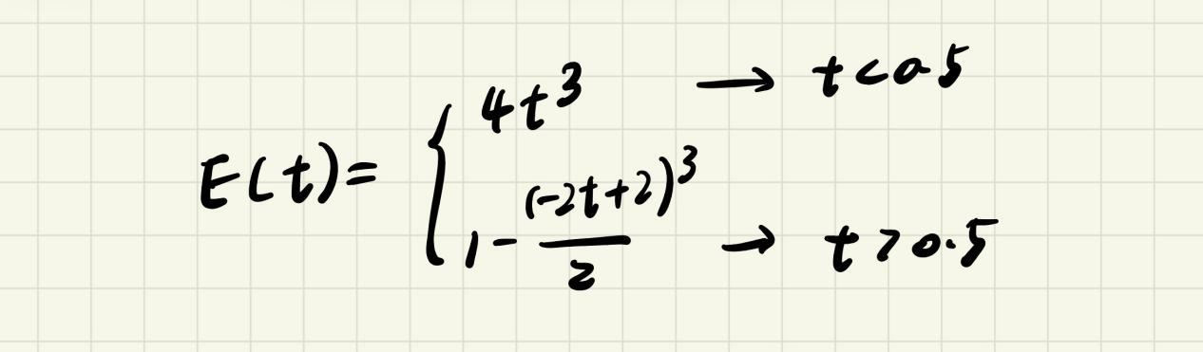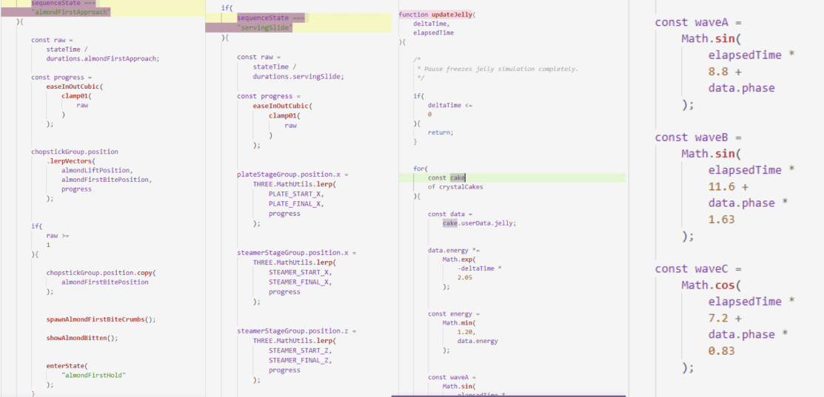
- Lighting and rendering(this step was achieved with the help of generative AI)
The lighting was aimed to create a warm food-photography appearance while clearly revealing the different material properties of the two desserts.
The scene combines ambient and hemisphere lighting with a strong directional key light, a softer fill light, a warm rim light, and a front accent light. The key light defines the main form and produces shadows, while the fill light prevents the darker areas from losing detail.
The rim and front lights are especially important for the crystal cake because they create bright edge highlights that make its transmission, transparency, and clearcoat easier to perceive.
PCF soft shadows and ACES Filmic tone mapping were also used to produce smoother shadows and better control over bright highlights.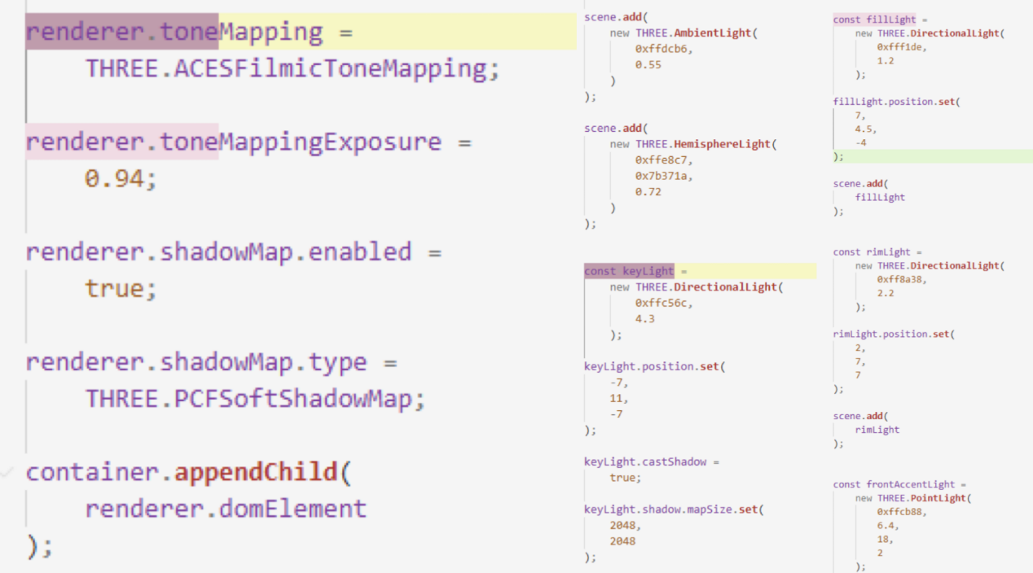

3.Results:
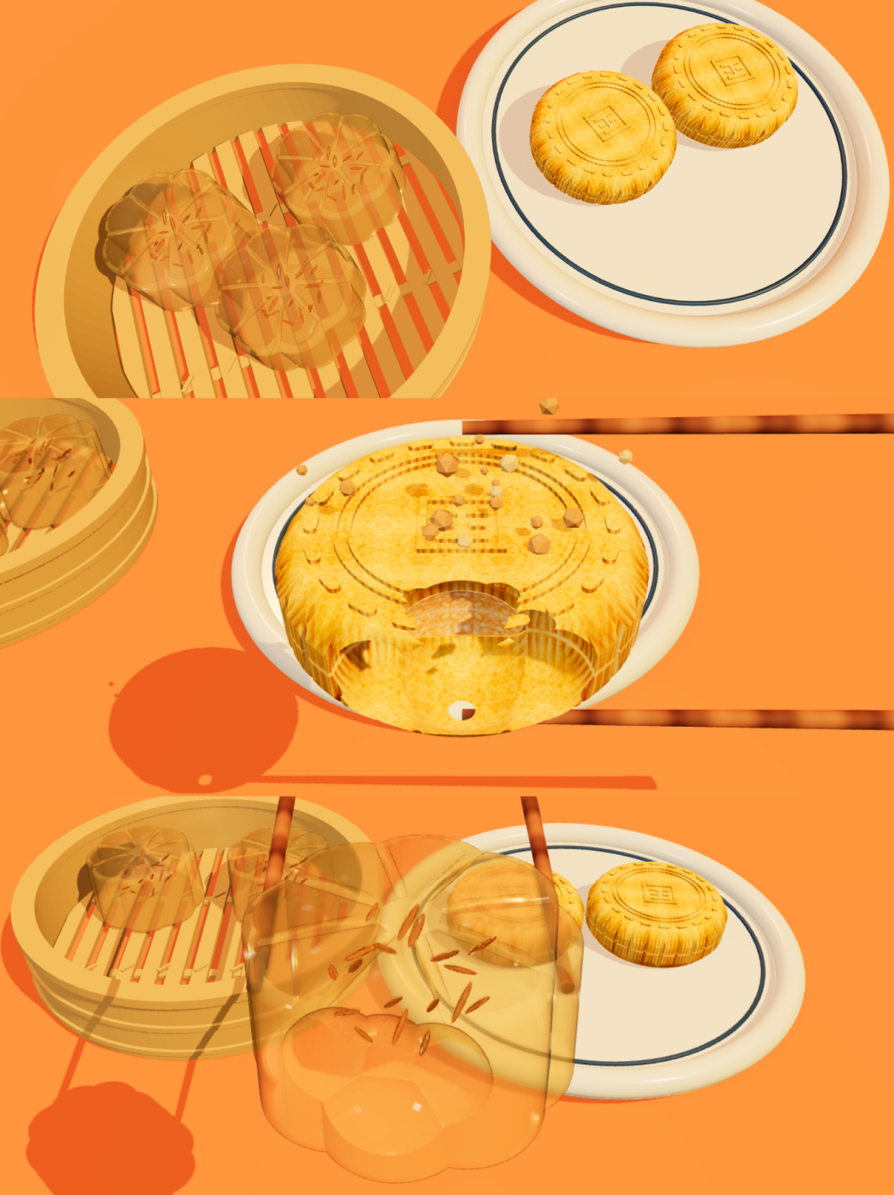
- Problems and solutions
- In an early version of the scene, the three almond pastries were positioned using manually chosen offsets. Because the offset did not accurately account for the final scaled dimensions of the STL model, the pastries intersected with one another when arranged on the plate.(figure1)

Solution:Instead of positioning the pastries using arbitrary values, the placement from the actual bounding box dimensions of the imported whole pastry was calculated.
After the source model was scaled, its diameter and height were calculated as: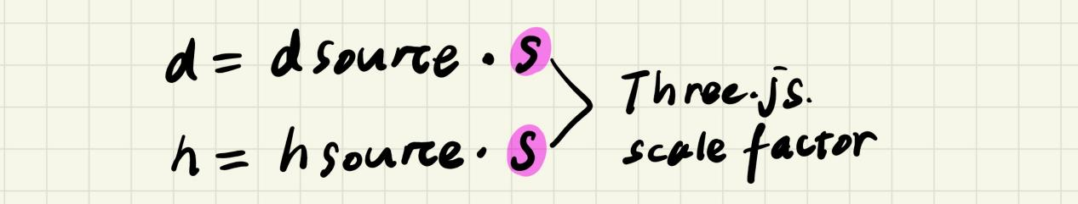
The horizontal offset of the 2 lower pastries was then based on their actual diameter:
The lower pastries’ height was calculated from the plate surface:
and the upper pastry was raised according to the actual pastry thickness:
As a result, the pastries remain visually close enough to appear stacked while avoiding obvious mesh interactions(figure2)
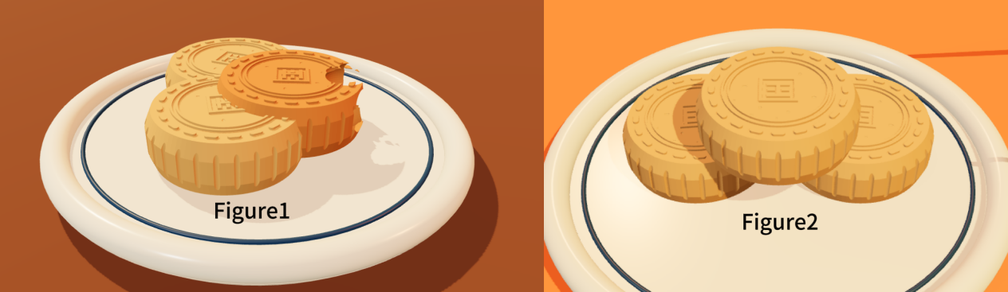

- When the bamboo steamer was first added to the second half of the animation, only the steamer itself moved into the scene.Because the ceramic plate remained close to the center, the large circular steamer moved into the same area and visually intersected with the plate and the remaining almond pastries.(figure1)
Solution:The transition was changed so that both serving objects move simultaneously.
The plate and 2 remaining almond pastries were placed in one parent group:plateStageGroup, while the steamer and its 3 crystal cakes were in steamerStageGroup.
During the transition, the plate moves from the center toward the left: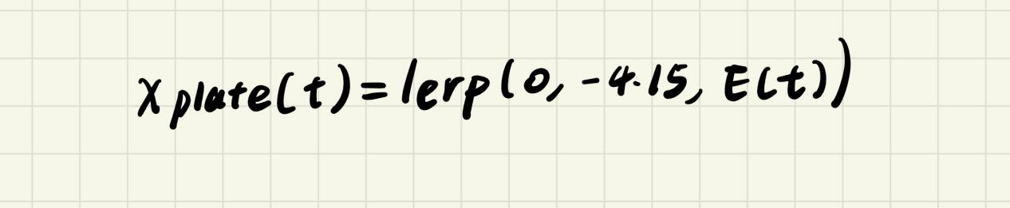
While the steamer moves from outside the right side of the scene:
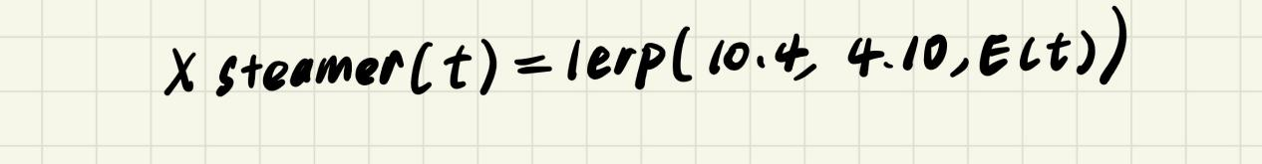Both movements use the same easing function, which makes the change in composition feel coordinated rather than like two unrelated movements. The remaining almond pastries also receive small secondary offsets while the plate is moving. This creates the impression that the pastries have inertia instead of being attached to the plate. At the same time, the crystal cakes wobble as the steamer enters and continue moving briefly after it stops.
The result is shown in Figure2: the ceramic plate occupies the right half of the final composition while the bamboo steamer occupies the left half,no longer intersecting.
