**Creating the AWS instance**

Once you have your account working, you will need to create an instance.

We want to stay within the free tier, so select the Amazon Linux tier.

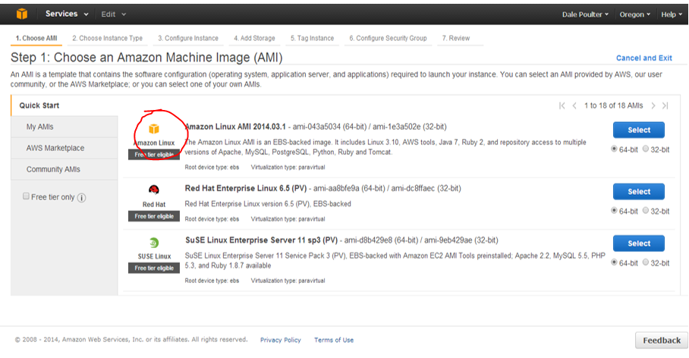

Again, select the free tier option. This will work well for our instance. If needed you can change the type in the future.

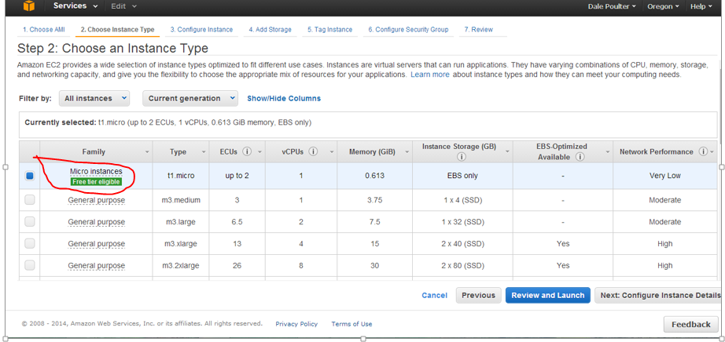

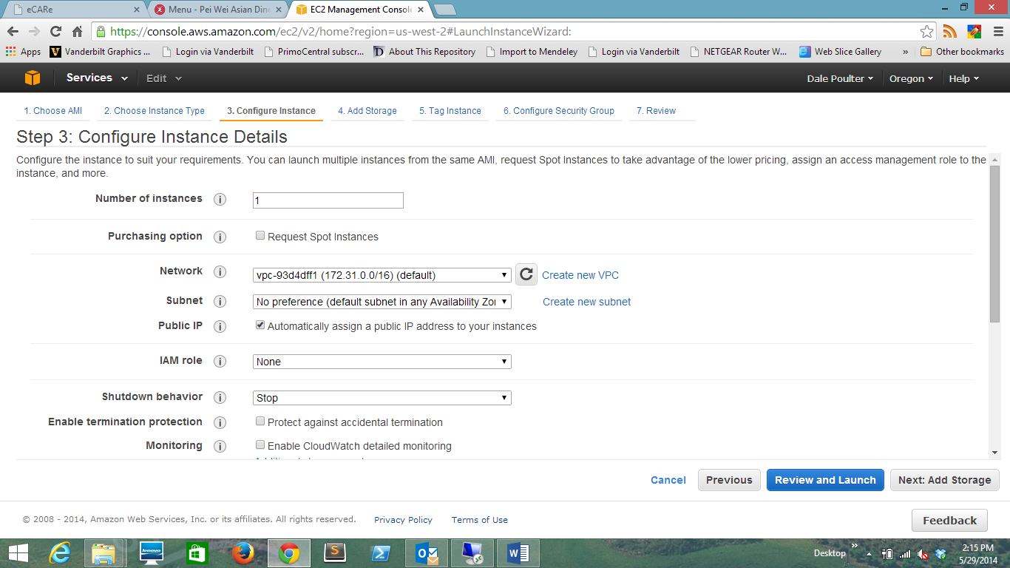

Storage: Be careful here. Unless you need additional space do not add it at this time.

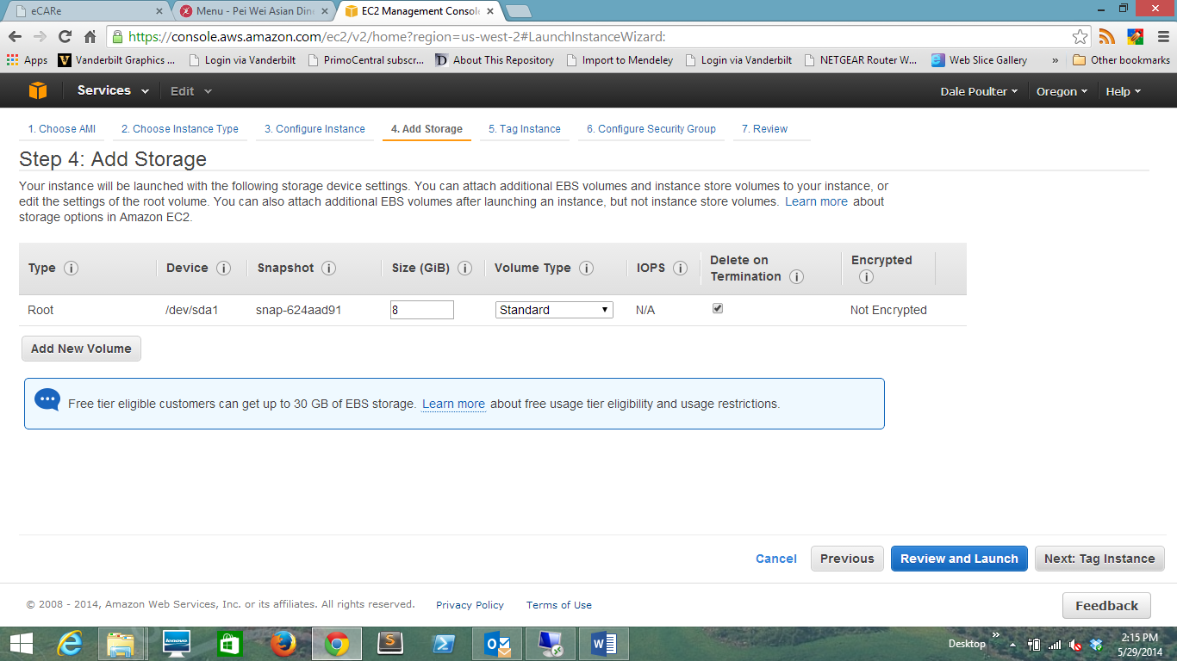

The tagging is for your personal use, you can add a tag, use an existing tag or skip this step completely.

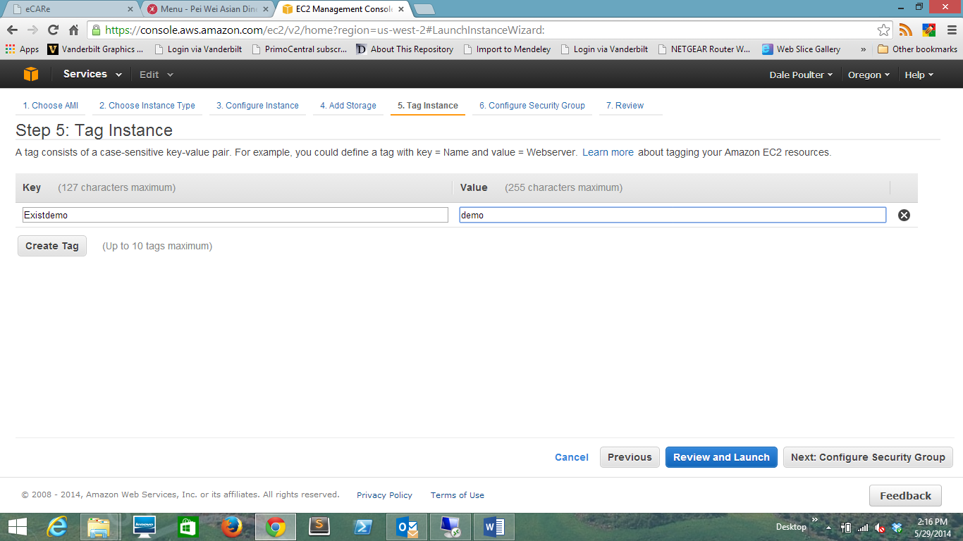

Unless you will have a system ready for users to access quickly or are aware of a limited number of ips you want to allow in, I would recommend leaving only ssh access at this time. If we wanted to be extra careful (which is not always bad) we would limit the ssh access to a single ip. However, in this case I recommend accepting the default settings. We will adjust this later.

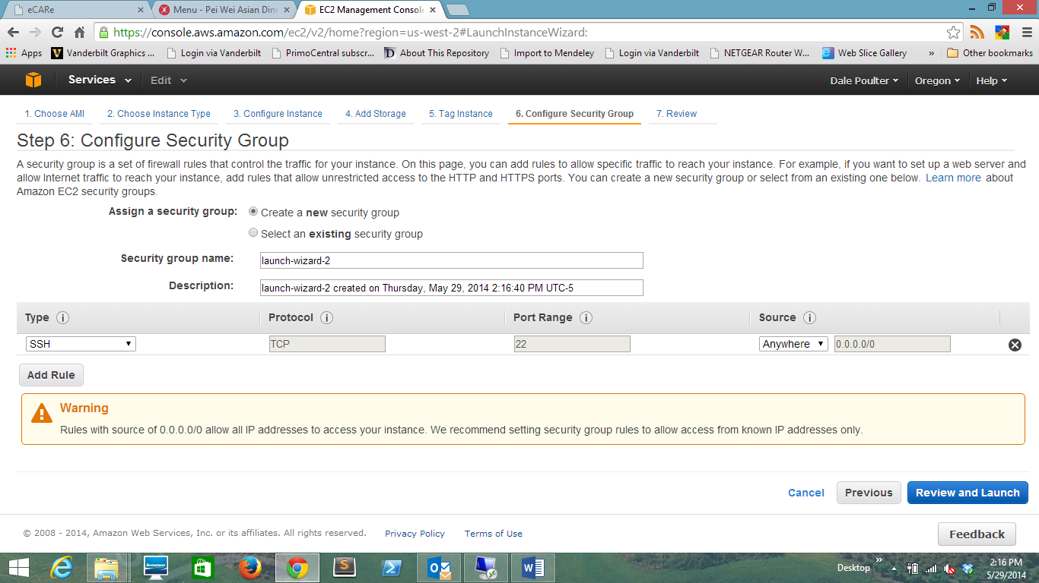

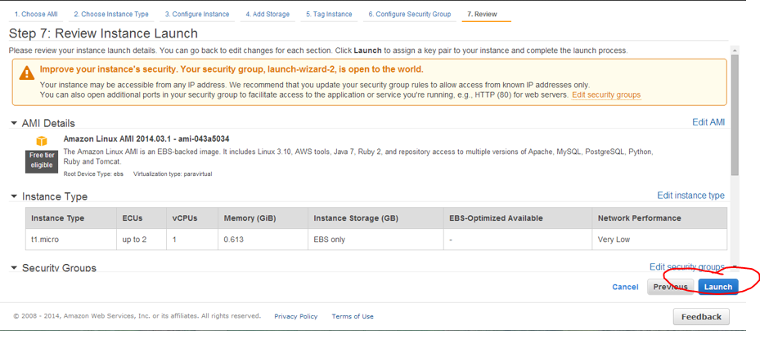

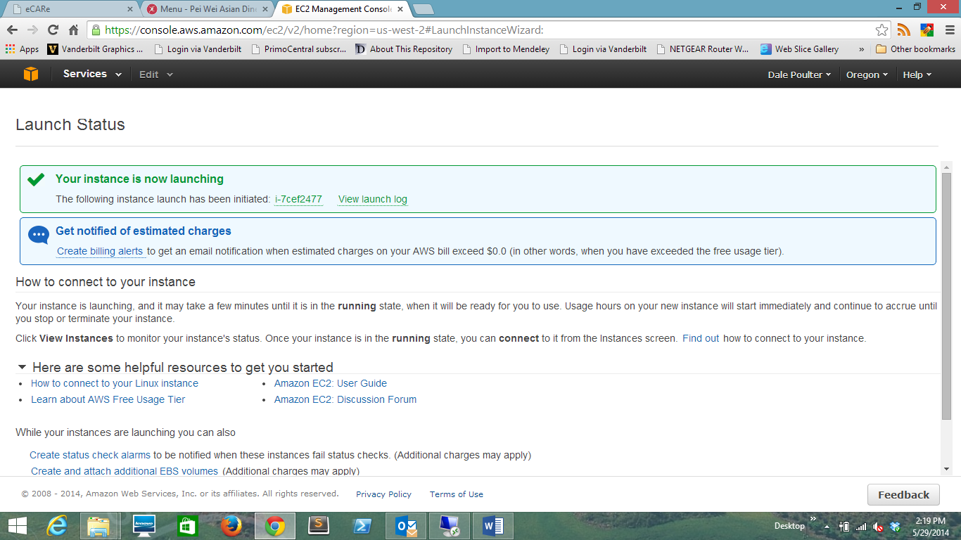

Create your Key Pair for SSH access

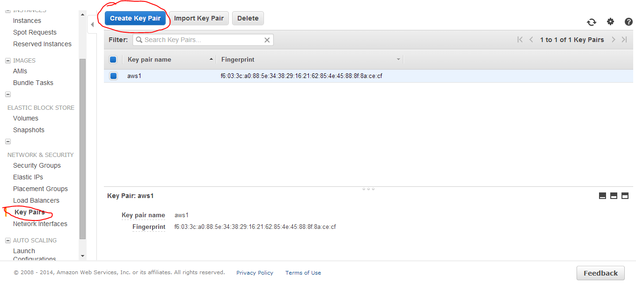

Choose a name of your choice, but remember the name so you can load it later.

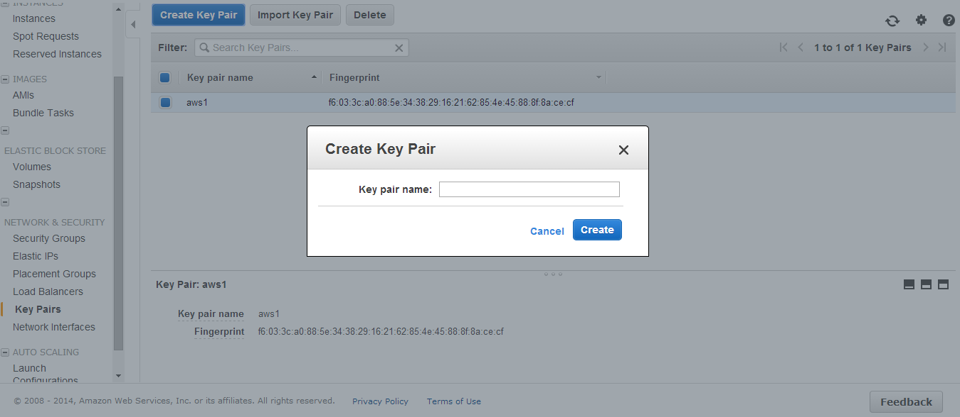

Putty

Create a new session – your ip address in the AWS instance will change.

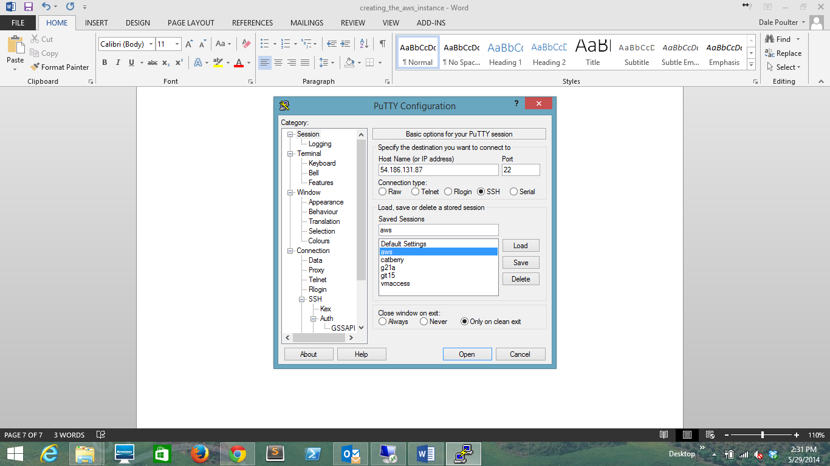

Select and load your key

