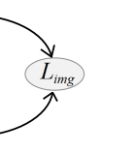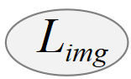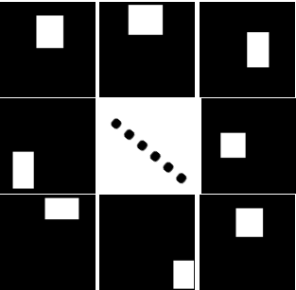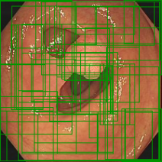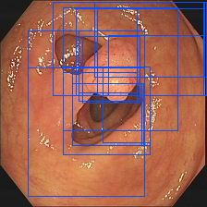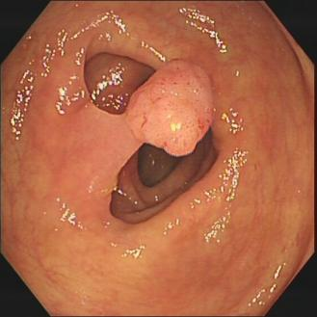

**...**

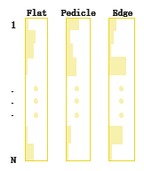

FC

FC

FC

Softmax_d

**Multiple instance branch**

Test

Train

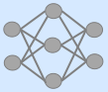

Pseudo Segementaion

Network

Proposals masks **B**

Trained Proposal

Featurex

Original Proposals

Selective

search



Pseudo segmentation map **P**

Input Image **I**

Backbone

(VGG 16)

**RoI Pooling**

**Cross-referenced module**



**...**

Conv_cls

Softmax_c

**Space category module**

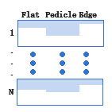

GAP



**Dual-threshold Postprocessing Strategy**

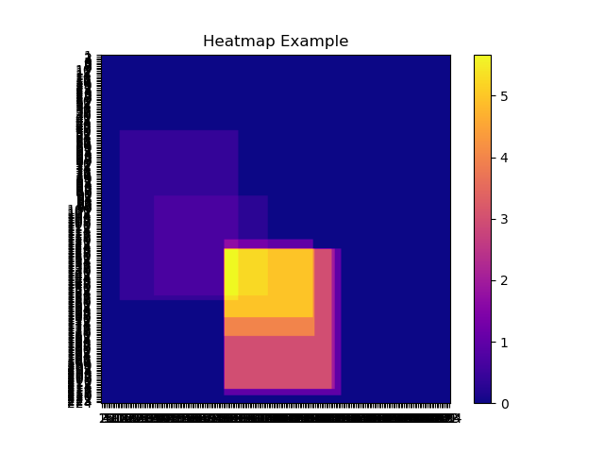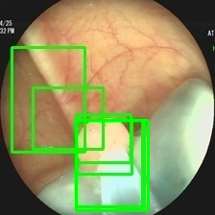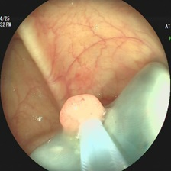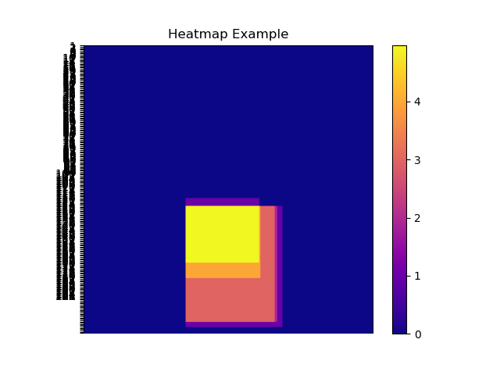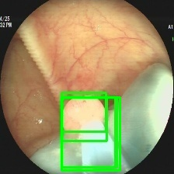

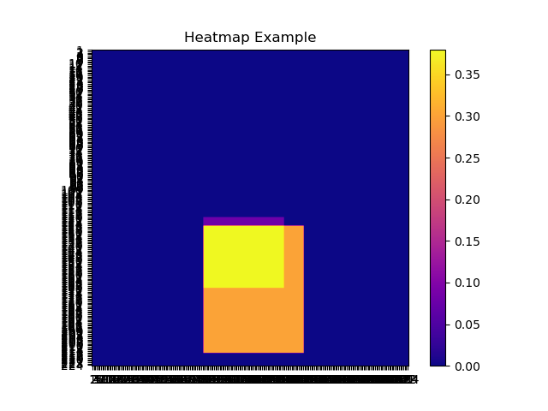

WSPD

Network



Certainty map

( )

Original boxes

(N0)

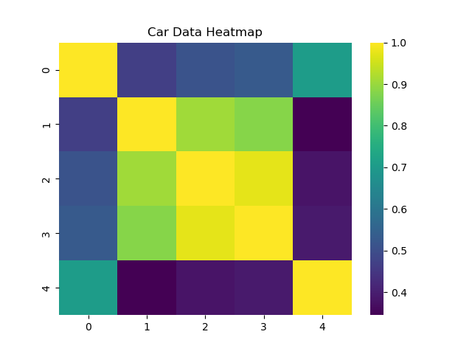

Filter by nms

(N2)

Refined prediction

Pseudo prediction

refinement

Region-certainty

map( )

Original boxes nms filter

Overlap map

(N1×N1)

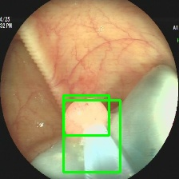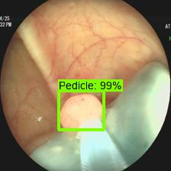

Image

(I)



High-certainty

map

Filter by class

(N1)

