**SAR目标识别**

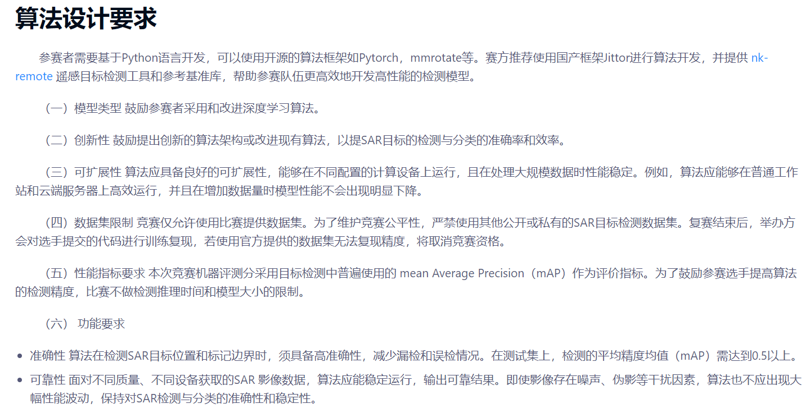

1. **目标检测框架相关文章：**
2. Jittor：官网版

[NK-JittorCV/nk-remote (github.com)](https://github.com/NK-JittorCV/nk-remote)

2.Pytorch: zzy 走远了 走深了

3. mmrotate：

<https://www.bilibili.com/video/BV1N94y1A7DZ?spm_id_from=333.788.videopod.episodes&vd_source=646a1b13f31b7b456c7deceda4266e0e&p=3>

[open-mmlab/mmrotate: OpenMMLab Rotated Object Detection Toolbox and Benchmark (github.com)](https://github.com/open-mmlab/mmrotate)

1. **某一框架下可能运行的模型架构：**

1．Faster R-CNN：

<https://blog.csdn.net/weixin_42310154/article/details/119889682>

2. YOLOv10＋神经架构搜索 (NAS)：（目前YOLO系列最优）

[SAR-NAS：基于神经架构搜索的轻量级 SAR 目标检测 --- SAR-NAS: Lightweight SAR Object Detection with Neural Architecture Search (arxiv.org)](https://arxiv.org/html/2509.01279?_immersive_translate_auto_translate=1)

**三．路径方法：**

**1.YOLOv10仓库：**

[**https://github.com/THU-MIG/yolov10**](https://github.com/THU-MIG/yolov10)

**2.zzy仓库：（AI给的代码）**Jittor+ Faster R-CNN[**https://github.com/Zzzzzzy3/Day3_1/blob/main/SAR_1/deepseek_generate1.py**](https://github.com/Zzzzzzy3/Day3_1/blob/main/SAR_1/deepseek_generate1.py)

**四．相关知识：**

mAP是什么？