Formatting with Writer and Organon

About Organon's Method:
Organon separates your main document into sub documents. For each file or folder in Organon's tree a new sub document will be created. (You can find the sub documents in your project folder under Files/odt) These sub documents are linked into the main document by using text sections. That causes consequences for the formatting:
Overall formatting can only be done by using templates.
('Select All' selects all of the text of the current section you are working on. It doesn't work for the whole document.)

Select a Template:
a) You can use the writer default template of OO/LO. The format is modified in
Format/Styles and Formatting (F11). Select by right-click the default template and select 'modify'.
Or click on the icon on the left of the templates.
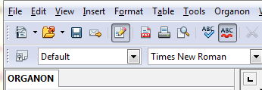

b) You can also use your own template. Important: Organon doesn't import all of the paragraph styles of the template. Only the paragraph style the cursor is in when the template is opened will be imported and used.

Create Template from Selection
Creates a new template from the selection.
(This function is more or less useless at the moment.)

Links
More infos on how to work with templates and styles can be found at::
Templates_and_Styles

PDFs:
WorkingWithTemplatesInWriter.pdf
StylesAndTemplates.pdf

