摘要
第一段：写论文解决什么问题
1． 问题的重述
a. 介绍重点词开头：
例1：“Hand move” irrigation, a cheap but labor-intensive system used on small farms, consists of a movable pipe with sprinkler on top that can be attached to a stationary main.
例2:……is a real-life common phenomenon with many complexities.
例3：An (effective plan) is crucial to………
b. 直接指出问题：
例 1：We find the optimal number of tollbooths in a highway toll-plaza for a given number of highway lanes: the number of tollbooths that minimizes average delay experienced by cars.
例2：A brand-new university needs to balance the cost of information technology security measures with the potential cost of attacks on its systems.
例3：We determine the number of sprinklers to use by analyzing the energy and motion of water in the pipe and examining the engineering parameters of sprinklers available in the market.
例4: After mathematically analyzing the …… problem, our modeling group would like to present our conclusions, strategies, (and recommendations )to the …….
例5：Our goal is... that (minimizes the time )……….

2． 解决这个问题的伟大意义
反面说明。如果没有……
Without implementing defensive measure, the university is exposed to an expected loss of $8.9 million per year.
3． 总的解决概述
a．通过什么方法解决什么问题
例：We address the problem of optimizing amusement park enjoyment through distributing Quick Passes (QP), reservation slips that ideally allow an individual to spend less time waiting in line.
b．实际问题转化为数学模型
例1 We formulate the problem as a network flow in which vertices are the locations of escorts and wheelchair passengers.
例2 : A naïve strategy would be to employ the minimum number of escorts to guarantee that all passengers reach their gates on time.
c.将问题分阶段考虑
例3：We divide the jump into three phases: flying through the air, punching through the stack, and landing on the ground.
第二、三段：具体分析
1．在什么模型中/ 建立了什么模型
a. 主流模型
例1：We formulate a differential model to account for the rates of change of these uses, and how this change would affect the overall consumption of water within the studied region.
例2:We examined the mathematical effects of……. We developed a detailed …… (simulation methodology) to test our ideas and to quantify the differences between (among) different …… (strategies).
例3：Based on (write your basis .such as the theory of supply and demand), we establish a model (such as differential equation system that includes demand, supply).
例4：To (write the aims), we establish a criterion (write the criterion).
b. 模型非主流
例5：We build a model to determine how to lay out the pipe each time the equipment is moved.
例6：We determine …………
例7：We build a model to determine……….
例8：We formulate a model for………By analyzing …and examining…..

2．分析模型（使用什么数据，怎么做，一般三句话）
a. 写历史数据
例1：Using historical data from the United States, we determine initial conditions for our model.
b. 写计算机模拟
例1：this model leads to a computer simulation of catch-can tests of the irrigation system and ……
例2:Software packing reaches………by calculating and comparing………..
c. 运用数据模拟
例1：to ground this model in reality, we incorporate extensive demographic data and run……
例2：We fit the modified model to data (such as 1970-2003.). We conclude that (write the last conclude).
d. 讲详细分析
例1：We physically characterize the system that…
例2：We provide a strategy (write the logical strategy).
例3：The …model is (efficient, intuitive, and flexible) and could be applied to…
例4：To meet the needs of people today without, we establish a criterion of rational(合理的标准) oil allocation(分配).
3．总结该模型的结果/得到什么结论
a. 说明不是最优但能产生作用
例：We show that this strategy is not optimal but can be improved by assigning different numbers……
b. 说明如果用这个模型，结果如何
例1：If Delta Airlines were to utilize the naïve strategy at Atlanta International Airport, the cost would be ……
例2：We modify the model to reflect (some trend such as exponentially increasing……) and generalize the model to (other field).
例3：Our results are summarized in the formula for the optimal number Bof tollbooths for
c．通过其上情况的列举得到的结论
例：For various situations, we propose an optimal solution.
d. 得出了结论
例1：we elicit that a conclusion.
例2：We conclude with a series of recommendations for how best to…
e.进一步说明其他因素对模型的影响
例：In addition to the model, we also discuss policies for …..
f.用真实数据检验模型
例:To demonstrate how our model works, we apply it to ………..
最后一段：写总的结论
a. 说明结论的可行性
例：Our suggested solution, which is easy to implement, includes a detailed timetable and the arrangement of pipes.
b.说明算法的广泛性
例1：Our algorithm is broad enough to accommodate various airport concourses, flight schedules, and flight delays.
例2：Our analysis began by determining what factor impact……, Our conclusions are presented……
c.说明模型可用于其他领域
例：Since our model is based on…… it can be applied to (other domain).
其他（承上启下的连接词/常用词组）
例:In addition to the model, we also discuss……
引言部分
（1）回顾研究背景，常用词汇有review, summarize, present, outline, describe等
（2）说明写作目的，常用词汇有purpose, attempt, aim等，另外还可以用动词不定式充当目的状语来表达
（3）介绍论文的重点内容或研究范围，常用词汇有study, present, include, focus, emphasize, emphasis, attention等
方法部分
（1）介绍研究或试验过程，常用词汇有test study, investigate, examine, experiment, discuss, consider, analyze, analysis等
（2）说明研究或试验方法，常用词汇有measure, estimate, calculate等
（3）介绍应用、用途，常用词汇有等
结果部分
（1）展示研究结果，常用词汇有show, result, present等
（2）介绍结论，常用词汇有summary, introduce, conclude等
讨论部分
（1）陈述论文的论点和作者的观点，常用词汇有suggest, repot, present, expect, describe等
（2）说明论证，常用词汇有等support, provide, indicate, identify, find, demonstrate, confirm, clarify
（3）推荐和建议，常用词汇有suggest, suggestion, recommend, recommendation, propose, necessity, necessary, expect等。
摘要中常用的词语汇：
critical 至关重要的
algorithm 运算法则
a method of evaluating 评价方法
appropriate 近似的
consider 考虑
configurations 布局
optimal 统一的
maximize 使…最大化
strategy 策略
parameter 参数，主要的决定因素
accuracy 精确性
strengths and weaknesses 优点和缺点
contact 相关的
contract 建立，构造
calculate 计算
establish 建立
formula 公式
modify 改进
rational 合理的
countermeasure 对策
criterion 标准，准则

Assumptions
引出：
We make the following assumptions about……process in this paper.
- 不考虑因素
例1：We do not take into account interactions between factors.
例2：The influence of …can be neglected
例3：…is “ideal” in …, …can be neglected.
- 为了简化模型，之后反驳不正确，但是合理。
例1：In fact （in reality）factors effect each others, but in order to simplify the model ,we ignore the interactions between factors.
例2：In fact in reality factors effect each others, but in order to simplify the model ,we ignore the interactions between factors.
c. 近似
例1：……can be approximated as a liner function of ….
例2： …are assumed to be the same. In practice, there is a slight difference.
例3：……can be approximated as a liner function of ….
d. 细致考虑（可附原因）
例1：An airport consists of 1 to 10 concourses, each of with consists of 2 to 50 gates. Gates in the same concourse are generally located close to one another, while the travel time between concourses can be quite lengthy. Hence, we assume that inter-concourse travel is much lengthier than intra-concourse travel.
例2：A average fast walking speed is 250ft/min(3mph), but average speed when arms are immobilized (as when pushing a wheelchair) is only 180 ft/min (2 mph) [Gross and Shi 2001]. We assume that an escort walks at these speeds.
例3：An escort can operate only one wheelchair at a time. U.S. Dept. of transportation guidelines discourages leaving WPs unattended. Hence, the escort takes a WP to the connecting flight and remains until the flight leaves.
e.直接定义(假设)：
例1：To measure the……,we define……
例2：Yearly industry statistics can be used valid.
例3：Sth may be represented by
例4：….are independent and randomly distributed
总结：
Additional assumptions are made to simplify analysis for individual sections. These assumptions will be discussed at the appropriate locations.

公式

由假设得到公式
1．We assume laminar flow and use Bernoulli’s equation:（由假设得到的公式）
公式
Where
符号解释
According to the assumptions, at every junction we have （由于假设）
公式

由原因得到公式
2．Because our field is flat, we have公式, so the height of our source relative to our sprinklers does not affect the exit speed v2 （由原因得到的公式）；
公式
Since the fluid is incompressible(由于液体是不可压缩的), we have
公式
Where
公式

用原来的公式推出公式
3．Plugging v1 into the equation for v2 ,we obtain （将公式1代入公式2中得到）
公式
11．Putting these together(把公式放在一起), because of the law of conservation of energy, yields：
公式
12．Therefore, from (2),(3),(5), we have the ith junction（由前几个公式得）
公式
Putting (1)-(5) together, we can obtain pup at every junction . in fact, at the last junction, we have
公式
Putting these into (1) ,we get（把这些公式代入1中）
公式
Which means that the
Commonly, h is about
From these equations, （从这个公式中我们知道）we know that ………

引出约束条件
4．Using pressure and discharge data from Rain Bird 结果,
We find the attenuation factor （得到衰减因子，常数，系数） to be
公式

计算结果
6．To find the new pressure ,we use the ( 0 0),which states that the volume of water flowing in equals the volume of water flowing out : （为了找到新值，我们用什么方程）
公式
Where
() is ;;
7．Solving for VN we obtain (公式的解)
公式
Where n is the …..
8．We have the following differential equations for speeds in the x- and y- directions:
公式
Whose solutions are （解）
公式
9．We use the following initial conditions ( 使用初值 ) to determine the drag constant:
公式

根据原有公式
10．We apply the law of conservation of energy（根据能量守恒定律）. The work done by the forces is
公式
The decrease in potential energy is （势能的减少）
公式
The increase in kinetic energy is (动能的增加)
公式
Drug acts directly against velocity, so the acceleration vector from drag can be found Newton’s law F=ma as : (牛顿第二定律)
Where a is the acceleration vector and m is mass
Using the Newton’s Second Law, we have that F/m=a and
公式
So that
公式
Setting the two expressions for t1/t2 equal and cross-multiplying gives
公式
22．We approximate the binomial distribution of contenders with a normal distribution:
公式
Where x is the cumulative distribution function of the standard normal distribution. Clearing denominators and solving the resulting quadratic in B gives
公式
As an analytic approximation to . for k=1, we get B=c
26．Integrating, （使结合）we get PVT=constant, where
公式
The main composition of the air is nitrogen and oxygen, so i=5 and r=1.4, so
23．According to First Law of Thermodynamics, we get
公式
Where ( ) . we also then have
公式
Where P is the pressure of the gas and V is the volume. We put them into the Ideal Gas Internal Formula:
公式
Where

对公式变形
13．Define A=nlw to be the ( )（定义）; rearranging (1) produces （将公式变形得到）
公式
We maximize E for each layer, subject to the constraint (2). The calculations are easier if we minimize 1/E.（为了得到最大值，求他倒数的最小值） Neglecting constant factors （忽略常数）, we minimize
公式

使服从约束条件
14．Subject to the constraint （使服从约束条件）
公式
Where B is constant defined in (2). However, as long as we are obeying this constraint, we can write （根据约束条件我们得到）
公式
And thus f depends only on h , the function f is minimized at （求最小值）
公式
At this value of h, the constraint reduces to
公式

结果说明
15．This implies（暗示） that the harmonic mean of l and w should be
公式
So , in the optimal situation. ………
5．This value shows very little loss due to friction.（结果说明） The escape speed with friction is
公式
16． We use a similar process to find the position of the droplet, resulting in
公式
With t=0.0001 s, error from the approximation is virtually zero.

17．We calculated its trajectory(轨道) using
公式
18．For that case, using the same expansion for e as above,
公式
19．Solving for t and equating it to the earlier expression for t, we get
公式
20．Recalling that in this equality only n is a function of f, we substitute for n and solve for f. the result is
公式
As v=…, this equation becomes singular (单数的).

由语句得到公式
21．The revenue generated by the flight is
公式
24．Then we have
公式
We differentiate the ideal-gas state equation
公式
Getting
公式
25．We eliminate dT from the last two equations to get （排除因素得到）
公式
22．We fist examine the path that the motorcycle follows. Taking the air resistance into account, we get two differential equations
公式
Where P is the relative pressure. We must first find the speed v1 of water at our source: （找初值）
公式

图
引用的文献数据所画的图：
1、分阶段图的引入：
First we study the …… (文献)，showing …… under the situation.
分阶段图的引出：
The compression process is divided into three(数字) phases, as shown in the figure:
The first phase: …… deformation, according to ……; the second phase: …… deformation. The compression grows more slowly and reaches the maximum. The third phase: ……deformation: After compression reaches the maximum, the rate of deformation starts to fall. The unrecoverable deformation goes on increasing. (2003—65)
2、引用已有的模型图：
A model of flow rate for instant total failure is right triangular 【U.S. Army Corps of Engineers 1997】. (see Figure 1)(2005—53\54)
3、通过历史数据作图：
We validate our model by examining historical HIV rates from prenatal clinics in South Africa between 1995 and 2005(Figure 1). (2006—244)
4、拟合的图形：
Figure 1 shows the number of bags still left for the EDS to process at airport A after each minute in airport B, the results are similar. (2003—260)
自己根据计算所画的图：
1、为了…….(目的)，我们作了…….图。
To demonstrate better the change in flow rate with time when the breach begins t form, we plot over a shorter range of time in Figure 5. (2005—55)
We plot 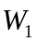for values of from 6 to 13, in steps of 0.25, together with the best-fit quartic, in Figure 2 (2005—92)
2、根据数据拟合的图：
Fitting (式子) to the data in (表), we get the curve in Figure 1, for the function (公式). (2005—211)
We use the graph in Figure 1 to simulate the arrival of passengers. (2003—201)
The simulation model also generates system characteristics for the ETD machines at airport A. These results are shown in Figure 3. (2003—232)
3、根据取值不同画图：
We take 2001as the starting point, when total remaining oil was 1.1178bbl.We calculate the time to oil exhaustion under different cases: GDP growing at 10%, 5%, 3%,and 1%.(Figure 3)
For 10%, ...... ; for 5%,……;for 3%,……;for 1%,……. (2005—213\233)
4、用软件（如MATLAB）画图：
To solve the differential equations in our model, we use (the ODE45 numerical integrator) in MATLAB on (式子) to find the results in Figure 3.(2005—232)
5、图形的改进：
Generally speaking, the shape of the target is not too irregular, so we choose five typical shapes of the targets in different sizes. In Figure 3a, we illustrate the maximum section of a typical bean-shaped target, whose maximum dimension is 35mm. Using the skeleton generation algorithm, we get corresponding skeleton shown in Figure 3b. Then we apply the GA-based shot placement algorithm, resulting in three shots for the target: one 14 mm helmet and two 8 mm helmets. The locations and sizes of the helmets in 2D are indicated in Figure 3c, while 3D shot placements are shown in Figure 4. (2003—130)
6、画示意图：
The irrigation order and position of sprinklers are presented in Figure 4. (2006—127)
This algorithm can be viewed in the flowchart in Figure 3.We define some of the objects found in the chart. (2006—164\165)

表
表的格式：表头在上 注：红字标记代表可通用的句子
- 在表前对表的来源和数据进行说明
- In Table 1, we summarize the minimum number of escorts needed to reach each service level
表的解释部分
For each airport, the difference between the Good and Adequate service levels is roughly a factor of two, with slightly increasing returns to scale; with larger scales, the staff are spread more uniformly, so it is less likely that a job will crop up with nobody close enough to take it.
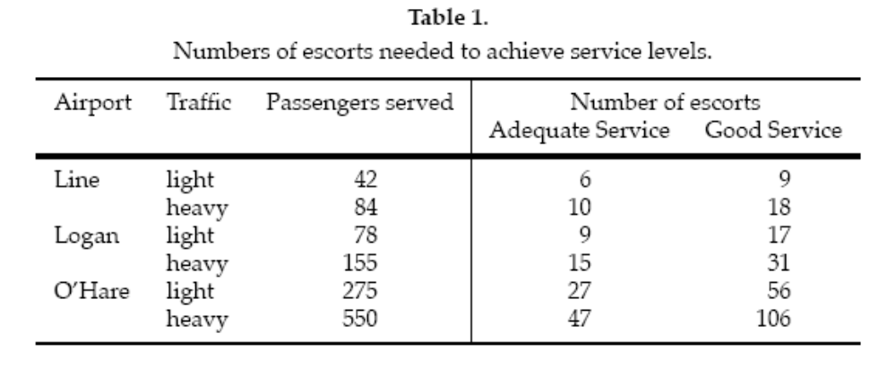
例2
表的解释部分
（前面的说出数据的来源，然后筛选出比较代表性的数据进行说明）。
We determined absolute and relative criticality values for each country for which all the data used in computing parameters was available (108 countries). We then used relative criticality in selecting our most critical countries, by continent. Had we used absolute criticality it would have given precedence to large nations, despite relatively mild HIV/AIDS situations.
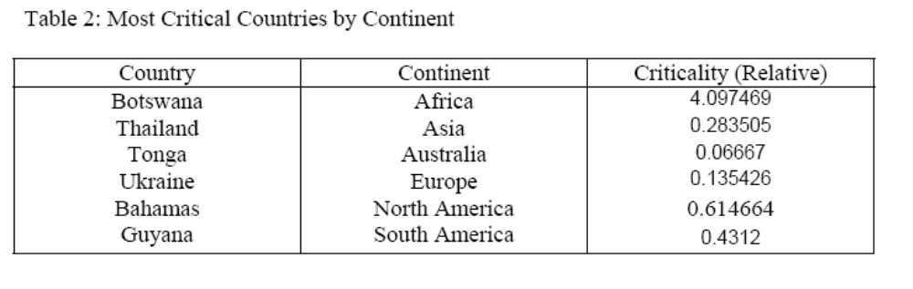
例3
The table below is the generated irrigation schedule for the repositioning of the sprinklers, given 12-hour work day for a rancher. Each pipe is set in place for 5 hours.
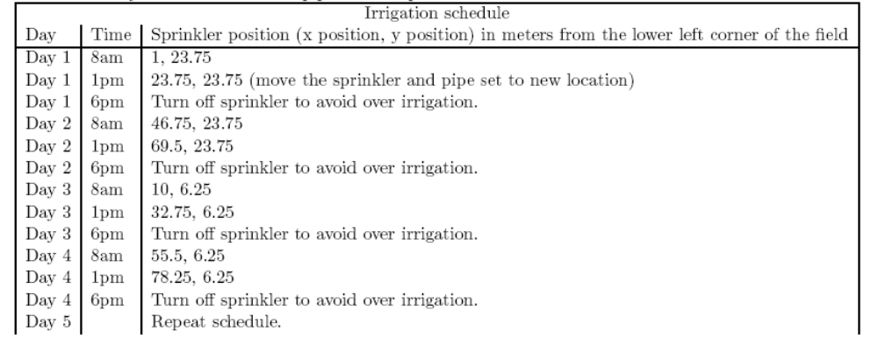
例4
And some data processing we can get the relevant statistical data information of patient and donor characteristics for the simulation.
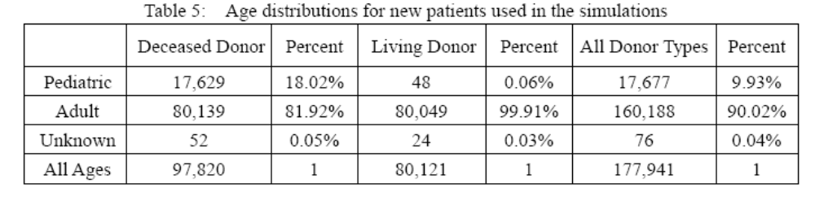
例5
The graft survival rates show in the following UNOS data for kidney transplants in the U.S (based on OPTN data as of 2006):
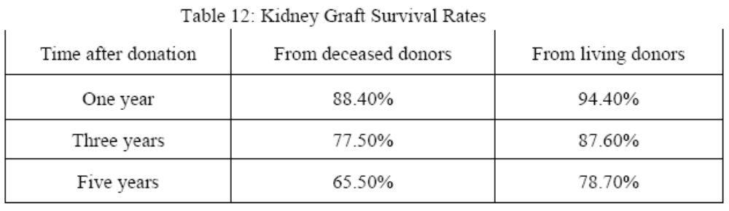
2、在表后对表的内容进行说明
例1
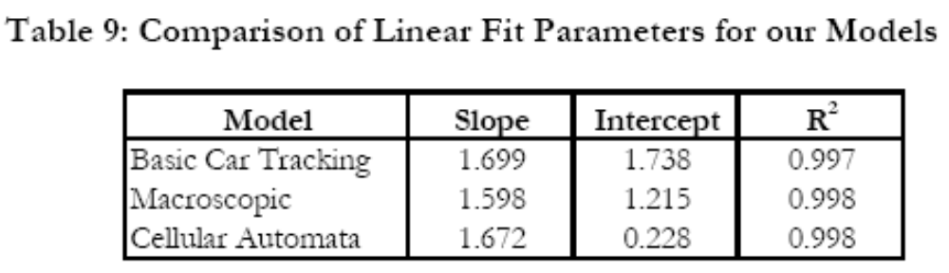
Table 9 shows linear fit parameters for all three models. Note that all three models are well described by a linear equation.
例2
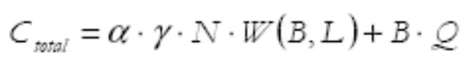
Using the cellular automata model, we compute waiting time as a function of both the number of lanes and the number of tollbooths. For a fixed L, we compare all values of Ctotal and choose the lowest one. The results of this method are presented in Table6.
例3
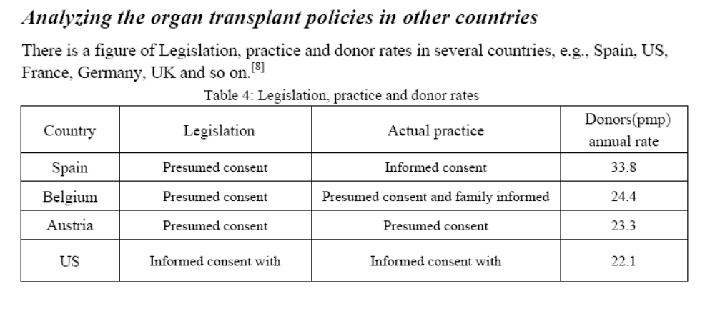
According to the above data, we can see that many of the European countries have the high rates of the donor, particularly in Spain. This phenomenon shows that the organ transplant is also hot in Europe. Although the relevant policies and statutes in these countries are less comprehensive than that in U.S, there still a lot what U.S could learn from. Here, we mainly analyze the organ transplant policies in Spain, U.K and Korea this three countries.
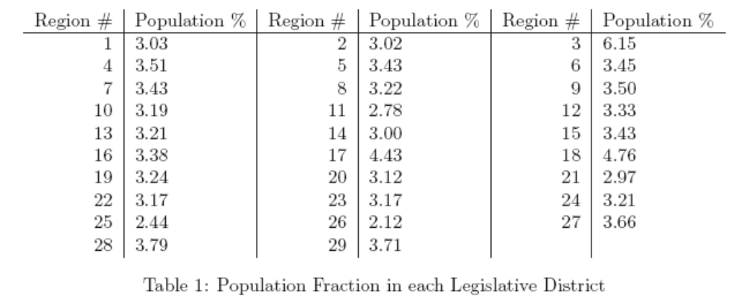
……The population contained in each region is summarized in table 1.（在表后对数据的内容进行总结）
例4
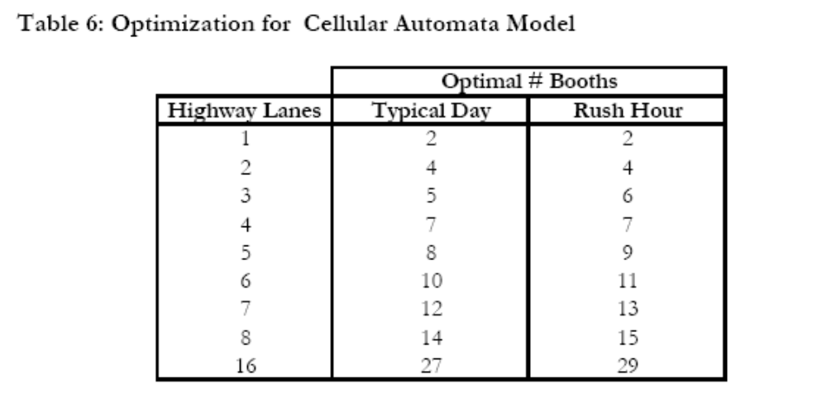
图表的解释部分
As indicated in Table 6, there is fairly good agreement between the recommended number of booths for a typical day and for peak hours. However, we note that the optimal booth number for a typical day never exceeds that for rush hour. Rush hour seems to require slightly more booths than a typical day in order for the plaza to operate most efficiently.
Each value in Table 6 is representative of approximately 20 trials. Through these trials, we noted a remarkable stability in our model. Despite the stochastic nature of our algorithm, each number of lanes was almost always optimized to the same number of tollbooths. There were a handful of exceptions; they occurred exclusively for small numbers of highway lanes (< 3 lanes). Integer values are presented in Table 6 only because fractional tollbooths have no physical meaning.
3、表前表后有引入引出 ，且中间对两表之间进行比较
例1
表的解释部分
We can obtain the data which is involved with the status of the American Organ
Transplant from the data banks. We have collected the demand of the various organs in United States to date, the annual donors，transplants and the demand (Here taking the kidney for example, by years 1995-2006)
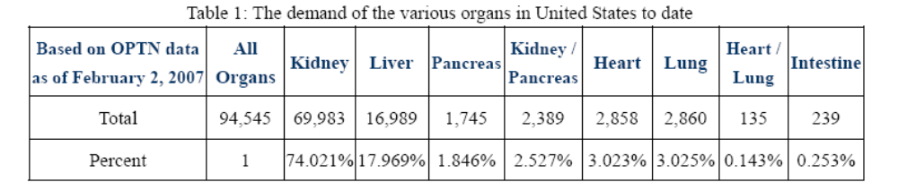
From the above table1, we can see that the kidney accounts for 73% in the
total of the organ transplants. It accounts for a very large proportion as a most important organ which can be transplanted. Therefore, we only need to discuss the status of the kidney transplant here, being able to achieve the analysis and research on the organ transplant.
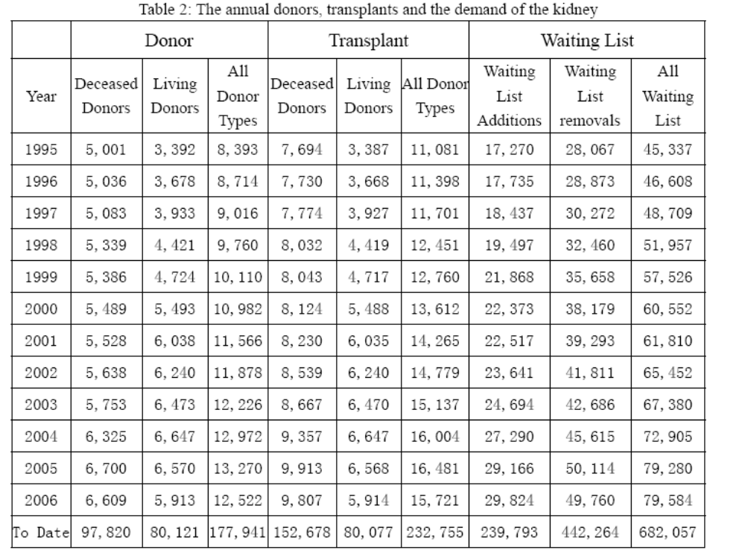
According to the above data, we can get the figures as follow:
例2
So after many times simulation under the conditions discussed above, we obtain statistic results as follow:
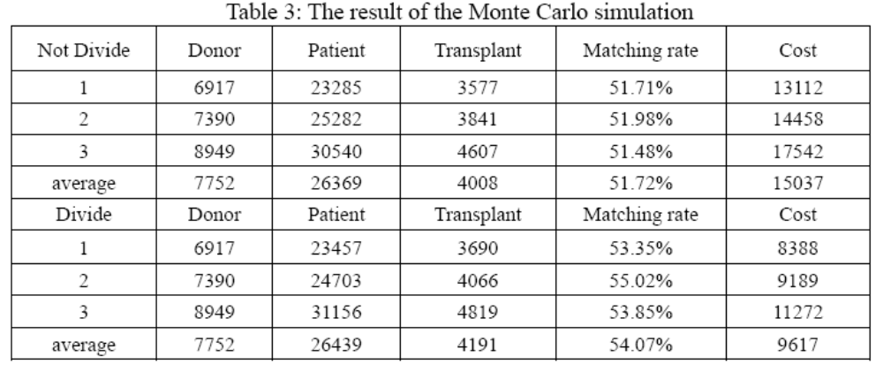
表的解释部分
By analyzing the above result, we can find: When there are more donors (more
resources), the number of transplant will increase obviously, and the matching rate changes only a little; When the network is divided into 11 regions (small networks), the costs of the transport and preservation of the organ will be reduced greatly.

例3
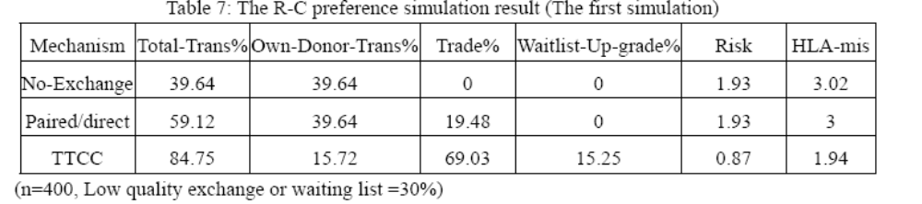
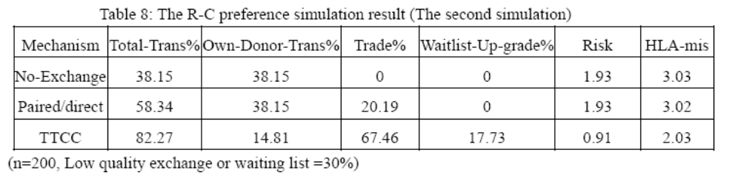
Table 7 reports the general patient statistics under each regime in the columns. The first column in these tables reports the total live donor transplants as percentage of the population size, which is the sum of next two columns, transplants from own compatible donor and transplants from trades. The forth column is the percentage of patients upgraded to the top of the waitlist as heads of w-chains. The fifth and sixth columns report the quality of matches in the live donor transplants: the risk of graft failure relative to the risk under no-exchange mechanism with population size n=400 is reported in the fifth column and the number of HLA mismatches for an average transplant is reported in the sixth column. In the table 8, we change the n into 200.
表与表之间的比较
By comparison, we can found that the matching proportion become little and the matching quality will get worse as the total number of the patients decrease. The result is consistent with the reality. The 30% probability of the waiting list or low quality exchange is an adjustable parameter.
例4
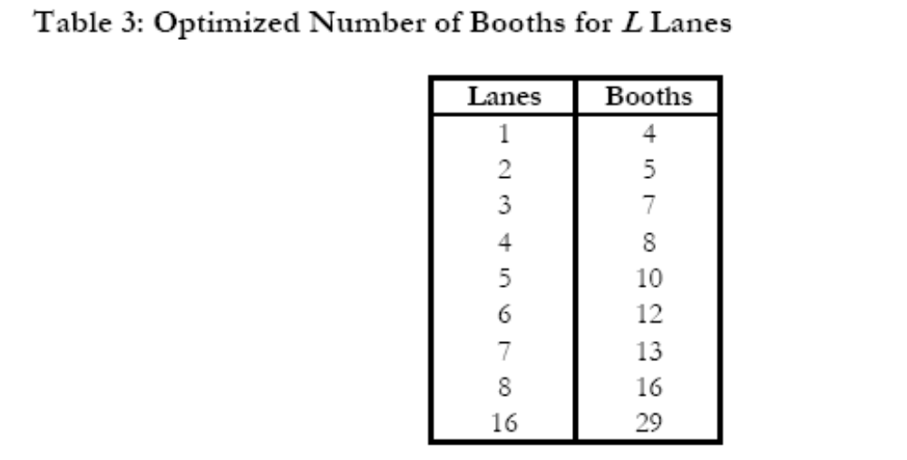
表与表的比较
Also, we wish to explore the situation in which there is one lane per booth:
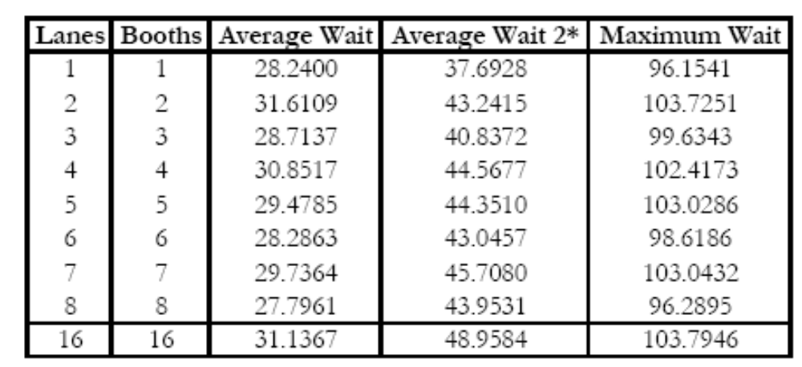
例5
The parameters we choose to modify are p (probability of advancement), ‘delay’ (number of time steps required to serve a vehicle in a tollbooth), and q (the probability that a flagged vehicle opts to attempt a turn). The results of this analysis are presented in Table 7. Since we have used six lanes as our standard test case, we continue with this choice here.
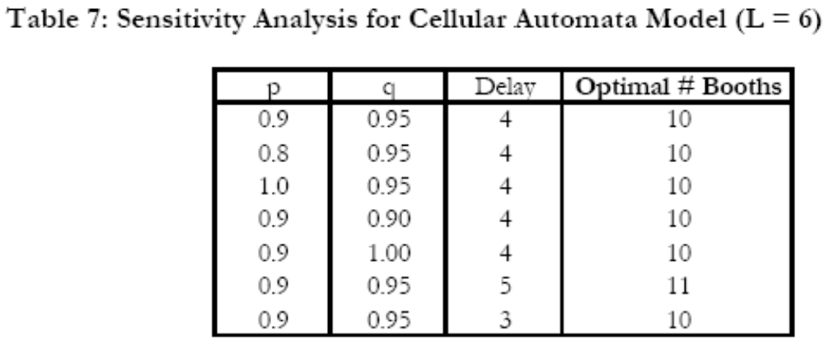
As indicated in Table 7, our cellular automata model is relatively insensitive to both p and q. Changes of ± 11% and ± 5.2% in p and q, respectively, had no effect on the optimal number of tollbooths for a six lane highway. On the other hand, increasing the delay time by 25% shifted the optimal number of booths from 10 to 11 (10%). Decreasing the delay by 25% had no effect on the solution. Perhaps additional work could lead to an elucidation of the relation between delay and optimal booth number that could help stabilize the cellular automata model.

优缺点
Evaluations of solutions
Strengths
- Our main model's strength is its enormous edibility. For instance,……..Including all these factors into a single, robust framework, our model enables
- We developed a theoretical line formation model which agrees without rough data. Our computer model agrees with both despite working on different principles, implying it behaves as we want.
- This allows us to make substantive conclusions about
- Finally, our model is strong because of
- The Monte Carlo simulation has been perfectly used in our models, and the simulation results are consistent with the reality.
- We introduced …… in order to improve the exchange quality. The chain rules can also modified in a degree.
- The models used in our paper is promotional, in view of different consideration,
- we can modify our models conveniently.
- the model is independent of the site simulated( )…
- the( )model is .intuitive
- the algorithm is efficient ::
- a corresponding strength of our model is that it would be relatively easy to include a parameter for probability of ……
- Our model is particularly appropriate for simulation of ……, a problem that naturally lends itself to such discrete modeling.
- The fundamental strengths of our model are…
- The model is independent of…
- Processor-based model has few input parameters, leading to good robustness and sensitivity.
- Uses a variety of modeling techniques in an integrated, holistic model.
- Our model effectively achieved all of the goals we set initially. It was fast and could handle large quantities of data, but also had the flexibility we desired. Though we did not test all possibilities, we showed that our model optimizes state districts for any of a number of variables. If we had chosen to input income, poverty, crime or education data into our interest function, we could have produced high-quality results with virtually no added difficulty. As well, our method was robust.
- Our main model's strength is its enormous flexibility. For instance
- This allows us to make substantive conclusions about policy issues, even without extensive data sets. By varying parameters, allocation rules, and our program's objective function——all quite feasible within the structure——we can examine the guts of policymaking: the ethical principles underlying a policy, the implementation rules designed to fulfill them, and the sometimes nebulous numbers that govern the results.
- Finally, our model is strong because of its discrete setup.
- The fundamental strengths of our model are its robustness and flexibility. All of the data is fully parameterized, so the model can be applied to……
Weaknesses
- Some special data can’t be found, and it makes that we have to do some proper assumption before the solution of our models. A more abundant data resource can guarantee a better result in our models. Current line length is not taken into account by the line formation model. In real life……
- Weaknesses of the model included assumptions made for simplicity that likely do not hold. For instance, in most runs of our model on(sides……), cases (impact/conclusion) to…… This feature is likely a result of our assumption that /The primary weakness of this model is the( ), It should be possible to eliminate this, another weakness that could be corrected with more analysis is ( )`
- The primary weakness of this model is the…
Another weakness that could be corrected with more analysis is …
- Parameters have to be derived from physical occurrences.
- The other primary weakness of our model is our lack of metrics for comparison.
- Although we list the model's comprehensive, discrete simulation as a strength, it is
- (Paradoxically) also the most notable weakness. Our results lack clear….Second ,our model demands great attention to….While its general structure and methodology are valid, the specific figures embedded in its code are not airtight.
- Although we list the model's comprehensive, …… as a strength, it is (paradoxically) also the most notable weakness. Our results lack clear illustrative power; data manipulated through a computer program cannot achieve the same effect as ……
- Indeed, there is a fundamental tradeoff here between realism and elegance, and our model arguably veers toward over realism.

总结
Conclusions
- As our team set out to come up with a strategy on what would be the most efficient way to
我们提出了一种最有效的方法去解决……
- The first aspect that we took into major consideration was…….
Other important findings through research made it apparent that the standard
首先我们考虑到……，其他重要的是我们通过研究使
4、We have used mathematical modeling in a……to analyze some of the factors associated with such an activity。
为了分析这类问题的一些因素，我们运用数学模型……
5、This “cannon problem” has been used in many forms in many differential equations courses in the Department of Mathematical Sciences for several years.
这些年这些问题已经以不同的微分方程形式运用于自然科学部门。
6、In conclusion our team is very certain that the methods we came up with in
总之，我们很确定我们提出的方法
7、We already know how well our results worked for……
我们已经知道我们结果对……
8、Now that the problem areas have been defined, we offer some ways to reduce the effect of these problems.
既然已经定义了结果，我们提出一些方法减少对问题的影响。
9、There are many methods in existence for……Furthermore each is mostly successful in what is sets out to do. However, all of these seem to
有许多的方法研究……，因此最好的是我们要作的，然而，所有的这些好像……
10、While our approaches and models were effective and produced results, there remain several types of model weaknesses:
我们的方法和模型很有效对结果进行延伸，我们的模型也存在些缺点。
11、We next developed a detailed simulation engine to perform simulations. Our simulations allowed us to ……
我们接下来研究计算，我们的模拟允许我们……
12、We have reached several valuable conclusions about the nature of……and some of the possible policy solutions that can be implemented to make it more effective ，Most importantly, we believe in the absolute necessity of implementing
我们得到关于这类问题的结果，一些可能的政策结果使它很有效，最重要的是，我们认为……相当有必要性。
13、We use …to …
14、Thus, we recommend…
15、Considering the…
16、In this paper, we examine the results of some fundamental avaricious in structure:……
17、We also wish to tie our exploration of sensitive……
18、we suspect that such system are in general less effective than simpler ones

