ECOTwin: A DUAL‑GREENHOUSE VERTICAL FARMING SYSTEM DESIGNED FOR EXPERIMENTAL RESEARCHES

PATRICK ANDRE C. SARANIA

CAPSTONE PROJECT PROPOSAL SUBMITTED TO THE FACULTY
OF THE INSTITUTE OF COMPUTING, ENGINEERING, AND
TECHNOLOGY, MALITA, DAVAO OCCIDENTAL IN
PARTIAL FULFILLMENT OF THE
REQUIREMENTS OF THE
DEGREE OF

BACHELOR OF SCIENCE IN INFORMATION TECHNOLOGY

March 2026

APPROVAL SHEET

This capstone project entitled, “ECOTwin: A DUAL‑GREENHOUSE VERTICAL FARMING SYSTEM DESIGNED FOR EXPERIMENTAL RESEARCHES”, prepared and submitted by Patrick Andre C. Sarania, in partial fulfillment of the requirements for the degree Bachelor of Science in Information Technology, is hereby approved.

DANDY U. DALINA JOHN G. PONTERAS, MS
Panel Member Panel Member

Date Signed Date Signed

JOANNES PAULUS E. JASO, CpE TOWIE L. LAWA, MIT
Adviser Chairman

Date Signed Date Signed

Accepted and approved in partial fulfillment of the requirements for the degree of Bachelor of Science in Information Technology (BSIT).

ENGR. LEO C. RADORES, MSAE
Dean

__________________
Date signed

Institute of Computing, Engineering, and Technology
Southern Philippines Agri-Business and Marine
and Aquatic School of Technology,
Malita, Davao Occidental
TABLE OF CONTENTS
PRELIMINARY PAGES PAGE
TITLE PAGE i
APPROVAL SHEET ii
TABLE OF CONTENTS iii
LIST OF FIGURES vi
LIST OF TABLES vii

CHAPTER I
INTRODUCTION
Project Context 1
Purpose and Description 2
Objectives 4
Project Concept 5
Scope and Delimitation 8
Definition of Operational Terms 10

CHAPTER II
METHODOLOGY
Locale 13
Development Method 14
Concept Of Operation 16
Use Case Diagram 17
Activity Diagram 18
Requirements And Architecture 20
Technical Requirements 21
Software Design 25
Database Design 25
Data Flow Diagram 27
Functional Requirements 30
Non-Functional Requirement 33
User Interface 35
Hardware Design 37
Non-Functional Requirement 41
Circuit Diagram 43
Perspective Diagram 45
Design Feasibility 49
Technical Feasibility 49
Operational Feasibility 51
Economic Feasibility 54
Implementation 58
Work Breakdown Structure 59
Integration, Test, and Verification 65
Testers 65
Unit and Integration Test Plan 66
System Verification and Validation 76
Respondents 77
Project Assessment Instrument 78
Statistical Treatment and Analysis of Data 82
Mean 82
Frequency 83
Likert Scale for Acceptability 83
Operation And Maintenance 85
Work Breakdown Structure 85
Maintenance Plan 91
References 95

LIST OF FIGURES

Fig. 1. Input Process Output of ECOTwin 6
Fig. 2. Locale of ECOTwin 13
Fig. 3. V-Model (HW + SW) 15
Fig. 4. Use Case Diagram of ECOTwin 17
Fig. 5. Activity Diagram of ECOTwin 19
Fig. 6. Entity Relationship Diagram of ECOTwin 26
Fig. 7. Level 0 DFD Context Diagram of ECOTwin 28
Fig. 8. DFD level 1 of ECOTwin 29
Fig. 9. Login Interface of ECOTwin 36
Fig. 10. Dashboard of ECOTwin 37
Fig. 11. Circuit Diagram of ECOTwin 44
Fig. 12. Perspective Diagram (Front View) of ECOTwin 46
Fig. 13. Perspective Diagram (Side View) of ECOTwin 47
Fig. 14. Perspective Diagram (Top View) of ECOTwin 48

LIST OF TABLES

TABLE I Hardware and Software Requirements 22
TABLE II Functional Requirements for Software 30
TABLE III Non-Functional Requirements for Software 34
TABLE IV Functional Requirements for Hardware 38
TABLE V Non-Functional Requirements for Hardware 42
TABLE VI Technical Requirements 50
TABLE VII Operational Feasibility 52
TABLE VIII Economic Feasibility (Cost–Benefit and ROI) 54
TABLE IX Economic Feasibility (Cost per Unit) 56
TABLE X Economic Feasibility (Benefit per year) 57
TABLE XI Work Breakdown Structure 59
TABLE XII Distribution of Testers 66
TABLE XIII Unit Test Plan 67
TABLE XIV Integration Test Plan 74
TABLE XV Distribution of Respondents 77
TABLE XVI HOT-Fit Assessment 79
TABLE XVII Likert Scale for HOT Fit Acceptability Assessment 84
TABLE XVIII Operation 86
TABLE XIX Maintenance Plan 92
Chapter I

INTRODUCTION
Project Context
Greenhouse and protected-cultivation experiments can become difficult to standardize when key variables cannot be kept consistent across time and across treatment areas. In Iraq, the greenhouse context described in the literature emphasizes the need for an active microcontroller-based system to sustain a suitable microclimate for crop production. Reliable and timely forecasting/control of Water Consumption Rate (WCR), alongside measurements of temperature (T), relative humidity (RH), and irrigation time (IT), is presented as a practical way to reduce water loss while maintaining more repeatable conditions for cultivation and study [1]. In Thailand, greenhouse-based vertical farming using natural sunlight shows clear top-to-bottom light gradients, where photosynthetic photon flux density (PPFD) decreases from upper to middle to lower shelf levels. The same study reports that lettuce growth and yields differ across shelf positions, consistent with light being a limiting factor under multi-level shelf arrangements, which supports the need for improved shelf design if experiments are to be made more uniform and comparable [2].

In Metro Manila and other urbanizing areas, manual groundwater measurements occur only once or a few times per year. These infrequent measurements fail to capture rapid changes in extraction rates and contamination levels. As a result, researchers obtain incomplete data that weakens the reliability of scientific findings and water management decisions [3]. Indoor vertical farming setups in Cabuyao, Laguna struggle to maintain precise artificial climate conditions for crops. Key variables such as temperature, humidity, light intensity, and nutrient delivery remain unstable. This inconsistency produces variable growth responses that complicate technology evaluation and scientific trials [4]. In cities like Iloilo City, limited automated monitoring exacerbates these environmental control issues. Harsh local climate conditions further destabilize experimental environments. These regional patterns highlight the urgent need for low-cost, robust sensing and control systems to improve environmental observability in agricultural and water research [5].

Local student and community projects in Buhangin, Malita, Davao Occidental have started simple greenhouse and vertical farming setups to grow leafy greens like romaine lettuce. These projects only observe plants visually without sensors to measure temperature, humidity, light, or moisture, so they cannot accurately compare growth results or understand what factors work best. The proposed system will be tested in this rural Buhangin community, where advanced farm tech is scarce. It provides affordable, locally built sensors and controls designed for tropical Philippine conditions. This makes reliable farming research accessible to schools and small farmers with limited resources.
Purpose and Description
Existing technologies that address controlled-environment agriculture and environmental monitoring generally fall into two practical groups, but both leave gaps for hands-on learning and experimentation in rural school. Internet-connected greenhouse systems can monitor conditions continuously and automate responses, and field testing has shown they can reduce water use while improving greenhouse conditions, but they depend on reliable connectivity, paid cloud services, and higher setup/maintenance complexity [6]. Research prototypes also show that greenhouse performance improves when the growing environment and water delivery are tracked and actively managed, yet these setups still assume access to stable infrastructure and technical support that small institutions may not have [1]. In vertical farming research, even when structures are built successfully, uneven light between shelf levels can produce uneven growth within the same setup, which means design and control limitations can still compromise fair comparisons [3]. On the water-resources side, remote groundwater monitoring systems in the Philippines have been designed to address the reality that extraction is often manually monitored at least once per year, but these efforts focus on measurement and reporting and do not automatically prevent harmful conditions [7].
The proposed “ECOTwin: A Dual‑Greenhouse Vertical Farming System Designed for Experimental Researches” system is designed to bridge these gaps by offering a simple, school-ready platform that supports fair, side-by-side growing trials in one location without relying on constant internet access. It focuses on making growing conditions visible and repeatable for learners; while also enabling basic automatic adjustments so plant responses can be compared more confidently across two matched growing spaces. This approach directly responds to issues seen in controlled-environment farming studies where uneven conditions can distort results, and to monitoring studies where data alone does not address the underlying control problem[3].
This project aligns with SDG 2 because it supports food security and sustainable agriculture by helping communities and schools learn practical methods for improving local crop production and small-scale farming outcomes [8]. It also aligns with SDG 6 because it encourages better water stewardship by promoting careful monitoring and more efficient water use practices in agriculture and related field studies. The primary beneficiaries are rural students, educators, and small-scale growers who need an affordable way to test what works locally, using an approach that can strengthen skills, improve decision-making, and support community-relevant research [9].

Objectives
General objective of this study is to design and implement “ECOTwin: A Dual‑Greenhouse Vertical Farming System Designed for Experimental Researches” that enables students, farmers, and researchers in Buhangin, Malita, Davao Occidental to monitor and manage key environmental parameters affecting plants, supporting controlled experimentation and educational research.

- Develop a dual-greenhouse vertical farming hardware setup that:
  - Constructs two compact greenhouse/tent structures with vertically stacked PVC racks for romaine lettuce cultivation using readily available local materials.
  - Installs sensors to monitor light intensity, air temperature, humidity, pH, nutrient concentration EC/TDS, water level, and water temperature.
  - Integrates actuators such as submersible pumps, circulation fans, relay modules, and adjustable shading nets to regulate water flow, ventilation, and solar radiation.
  - Configures distinct climate conditions between the two greenhouses to enable side-by-side comparison of romaine lettuce growth under different environmental treatments.
- Design and implement an embedded monitoring and control software system that:
- Uses an Arduino-based controller for continuous data acquisition, logging, and actuation based on predefined environmental thresholds.
- Automates control of pumps, fans, and shading nets to sustain target conditions in each greenhouse.

- Displays up-to-date sensor data and system status through a simple on-site interface accessible to students and farmers.
- Implement a secure and fail-safe operating framework that protects experimental data and prevents crop damage by using local data storage, basic user authentication, automatic safety shutdowns with manual emergency override, routine offline backups, and event logging for traceability.
- Evaluate the system’s efficiency and acceptability using the Human, Organization, and Technology Fit (HOT-Fit) Framework in terms of:
- Usability
  - Functionality
  - Performance
  - Integration and Compatibility
Project Concept
Input-Process-Output (IPO) Framework: This project transforms raw environmental measurements through Arduino-based sensor processing and automated control logic into actionable growth data, system logs, and optimized lettuce cultivation outcomes [10]. This project is a sensor-integrated vertical farming system that provides continuous environmental monitoring and automated control for romaine lettuce cultivation using locally-accessible components, Arduino-based automation, and local network connectivity. The system enables students and researchers in rural educational settings to conduct controlled experiments comparing lettuce growth across different managed environmental conditions, building capacity in sensor technology and data-driven agriculture while generating evidence for optimizing crop production in tropical climates.
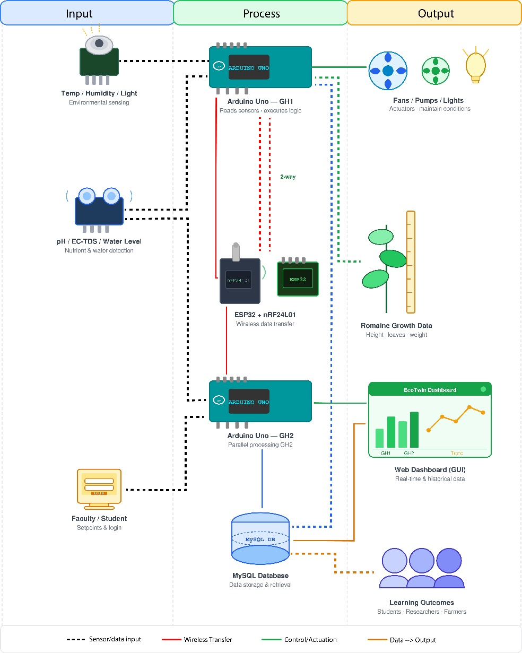
Fig. 1. Input Process Output of ECOTwin. (a) Input. (b) Process. (c) Output.
Fig. 1 shows the overall design of this system follows an Input–Process–Output (IPO) concept similar to the structured diagrams used in prior capstone projects, where system inputs, transformation processes, and resulting outputs are clearly identified to guide development, testing, and evaluation. The IPO diagram illustrates how environmental and user inputs flow through embedded hardware–software processes to produce both physical and informational outputs that support romaine lettuce research and instruction at IASDC [3].
In the IPO figure, the Input block includes hardware components such as the dual greenhouse structures, vertical PVC racks, sensors, actuators, and cultivation resources like romaine seedlings and nutrient solutions, together with user-defined environmental setpoints configured by IASDC faculty and students [3]. The Process block represents data acquisition by the Arduino controller, local transmission via ESP32 or nRF24L01 modules, logging into the phpMyAdmin database, and the execution of control logic that compares sensor readings against thresholds and triggers actuators to maintain treatment-specific conditions, following a V-Model style development flow for verification and validation. Finally, the Output block covers the operational dual-greenhouse facility, real-time and historical dashboards available through a web application, and analyzed growth data that summarize romaine lettuce performance under different environmental treatments for use in classes, research reports, and extension activities [7].

The IPO diagram specifically emphasizes how the dual-greenhouse design enables parallel experiments by routing sensor data from each greenhouse into distinct yet comparable data streams, allowing IASDC students to observe how variations in humidity, temperature, nutrient concentration, or light exposure affect lettuce growth over time [11]. Moreover, by capturing outputs in the form of growth metrics, environmental trends, and system performance indicators, the framework supports iterative improvement of both cultivation protocols and system configuration, aligning with structured work-breakdown and commissioning approaches recommended in prior system design [12].

Scope and Delimitation
This project is designed to provide continuous environmental monitoring and automated regulation of light intensity, air temperature, relative humidity, nutrient solution pH, electrical conductivity (EC/TDS), water level, and water temperature within two compact greenhouse structures configured with vertically stacked hydroponic racks for romaine (Lactuca sativa var. longifolia) lettuce cultivation. The system operates on local area network (LAN) communication without internet dependency, utilizing an Arduino-based microcontroller and ESP32 Wi-Fi module to automate control of submersible pumps, exhaust fans, circulation fans, relay modules, and adjustable shading nets according to predefined environmental thresholds. The system is deployed in Buhangin, Malita, Davao Occidental and configured to support controlled experimental comparison of lettuce growth across distinct environmental treatments, enabling student-led investigations and data-driven optimization of growing conditions for educational and small-scale farming contexts.

Primary beneficiaries comprise third-year Bachelor of Science students enrolled in agricultural science and related programs at SPAMAST, particularly those pursuing coursework in controlled-environment agriculture, horticultural production, agricultural engineering, or research methodologies. Direct users also include faculty and staff researchers affiliated with the Institute of Agricultural Sciences and Development Communication (IASDC) conducting investigations on lettuce cultivars, environmental optimization, or hydroponic systems. Secondary beneficiaries include first- and second-year SPAMAST students who may participate in laboratory observations and data collection activities as part of their coursework. Institutional beneficiaries include the Institute of Agricultural Sciences and Development Communication (IASDC) faculty who gain capacity in sensor-based research infrastructure and Arduino-based system design. Exclusion criteria include practicing farmers without formal institutional affiliation, non-institutional community groups without direct SPAMAST connection, and educational institutions outside Davao Occidental region. The system is not intended for commercial leafy green production or large-scale market-oriented cultivation; rather, it is explicitly designed for experimental research and student education in controlled-environment agriculture principles and practices.

The system's functional scope encompasses the core operational activities of environmental monitoring, automated climate control, data logging, and comparative growth assessment. Specifically excluded are advanced features such as machine-learning-based predictive environmental optimization, integration with external weather forecast services or internet-based cloud platforms, biometric image analysis for automated plant health scoring, integrated pest management or disease detection systems, and post-harvest processing or quality analysis. Refund management regarding resource costs and routine system maintenance responsibilities remain with the institution's designated personnel; the system provides monitoring and control tools but does not automate resource accounting or maintenance supervision.

The system operates exclusively within the institutional local area network (LAN) and does not require or depend upon external internet connectivity, eliminating vulnerabilities associated with internet outages while constraining remote access to on-campus Wi-Fi network boundaries. The Arduino-based microcontroller platform employs single-threaded sequential processing, limiting the number of sensors that can be read and actuators controlled in real-time to approximately 8-12 parameters without performance degradation; more complex research questions requiring additional sensors would necessitate hardware expansion. Environmental control accuracy depends upon sensor calibration; sensors are assumed calibrated monthly following standard protocols, but system performance degrades if sensors are not maintained. Light intensity control relies upon motorized shading net adjustment rather than supplemental artificial lighting, limiting ability to independently manipulate light separate from natural diurnal cycles; research requiring constant light conditions would require LED supplementation beyond the current system scope. The system has been validated only for romaine (Lactuca sativa var. longifolia) and green oak lettuce varieties under Philippine tropical to subtropical climate conditions; performance with other lettuce varieties or in significantly different climates has not been tested.
Definition of Operational Terms
Automated Control. The Arduino-based process of comparing sensor readings to target values and automatically adjusting fans, pumps, or shades to keep conditions stable. This reduces manual work and ensures consistent environments for fair plant growth comparisons [1].
Controlled-Environment Agriculture (CEA). Farming systems where temperature, humidity, light, CO₂, and nutrients are actively managed inside greenhouses or indoor setups, regardless of outside weather. CEA enables precise experiments by eliminating natural climate variations [13].
Daily Light Integral (DLI). Total usable light plants receive daily, measured in mol m⁻² d⁻¹, combining light intensity and hours of exposure. DLI directly affects lettuce leaf growth and weight gain [14].
Electrical Conductivity (EC). Measure of nutrient strength in water solutions, expressed in mS cm⁻¹, with optimal lettuce range of 1.2-2.0 mS cm⁻¹. EC monitoring prevents under- or over-fertilization [15].
Hydroponic System. Soil-less growing method using nutrient water and support media like rockwool or coir. Hydroponics allows exact control of plant food and water for research trials [16].
Internet of Things (IoT). Network of sensors and controllers sharing data for remote monitoring and automation. IoT enables real-time greenhouse management through phone apps [17].
Lactuca sativa. Lactuca sativa. Scientific name for lettuce (romaine var. longifolia), highly light-sensitive requiring minimum DLI 6.5-9.7 mol m⁻² d⁻¹ for growth; insufficient light causes 50%+ yield loss and stunting in controlled environments [18].
Light Use Efficiency (LUE). Grams of plant dry weight produced per mole of light received (g mol⁻¹). Higher LUE shows better light-to-biomass conversion in vertical setups [19].
Local Area Network (LAN). Campus Wi-Fi connecting sensors, controllers, and phones without internet reliance. LAN ensures operation during connectivity outages [20].
Photosynthetically Active Radiation (PAR). Plant-usable light (400-700 nm) measured as PPFD in μmol m⁻² s⁻¹. PAR levels determine photosynthesis rates and growth speed [21].
Romaine Lettuce. Crisp, upright lettuce variety ideal for vertical farms due to texture, nutrition, and steady market demand [22].
Sensor Calibration. Monthly adjustment of sensors against known standards to ensure accurate readings. Calibration prevents data errors that invalidate experiments [23].
Short Message Service (SMS). Arduino-compatible cellular module (SIM800L) that sends threshold violation alerts via SMS to users' phones when Wi-Fi fails or for critical notifications. Provides reliable backup communication in greenhouse IoT systems using AT commands over UART [24].
Total Dissolved Solids (TDS). Total mineral content in water, measured in ppm, used alongside EC to track nutrient levels and solution quality. TDS helps detect buildup or depletion needing correction [25].
Vertical Farming. Multi-layer indoor crop growing to maximize yield per floor space. Vertical systems enable side-by-side testing of different conditions [26].

Chapter II

METHODOLOGY
Locale
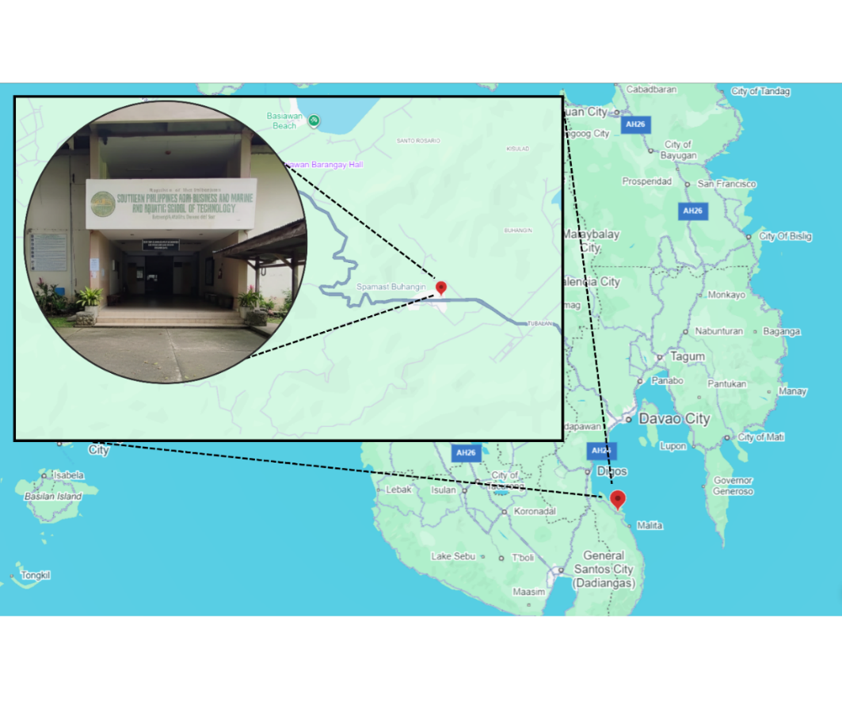
The study will be conducted at the Southern Philippines Agri-Business and Marine and Aquatic School of Technology (SPAMAST) Buhangin Campus in Buhangin, Malita, Davao Occidental. Specifically, the dual-greenhouse system will be deployed at the Institute of Agricultural Sciences and Development Communication (IASDC) to be utilized by the Bachelor of Science in Agriculture (BSA) programs. The “ECOTwin: A Dual‑Greenhouse Vertical Farming System Designed for Experimental Researches” capstone project is proposed for this project locale because programs under IASDC require a controlled environment to support precise plant-growth and production studies, and installing the system at Buhangin Campus is expected to assist faculty and student researchers in conducting more reliable experiments and generating research-based data for instruction and extension activities.
Fig. 2. Locale of ECOTwin
Fig. 2 illustrates the location of the Southern Philippines Agri-Business and Marine and Aquatic School of Technology (SPAMAST) Main Campus, situated in Barangay Poblacion, Malita, Davao Occidental, in the southern part of the Philippines. The project will be deployed within the Institute of Agricultural Sciences and Development Communication (IASDC) facility. In terms of proximity and intended user base, the deployment also supports the SPAMAST Buhangin Campus academic community, approximately 10 faculty members and 48 students who can directly benefit from improved access to a controlled research environment and on-site experimentation support.
DEVELOPMENT METHOD
The development methodology provides a structured framework that organizes the project activities from initial planning and requirements definition through design, implementation, testing, and final evaluation. It defines the sequence of development stages followed by the development team, faculty advisers, and institutional stakeholders involved in the dual-greenhouse project [27]. This framework establishes a consistent process for system development and documentation, while outlining procedures for verification and validation during each phase. The methodology also serves as a reference for coordinating development tasks and ensuring that the resulting system addresses the monitoring, control, and data-management requirements identified for student and faculty use [28].
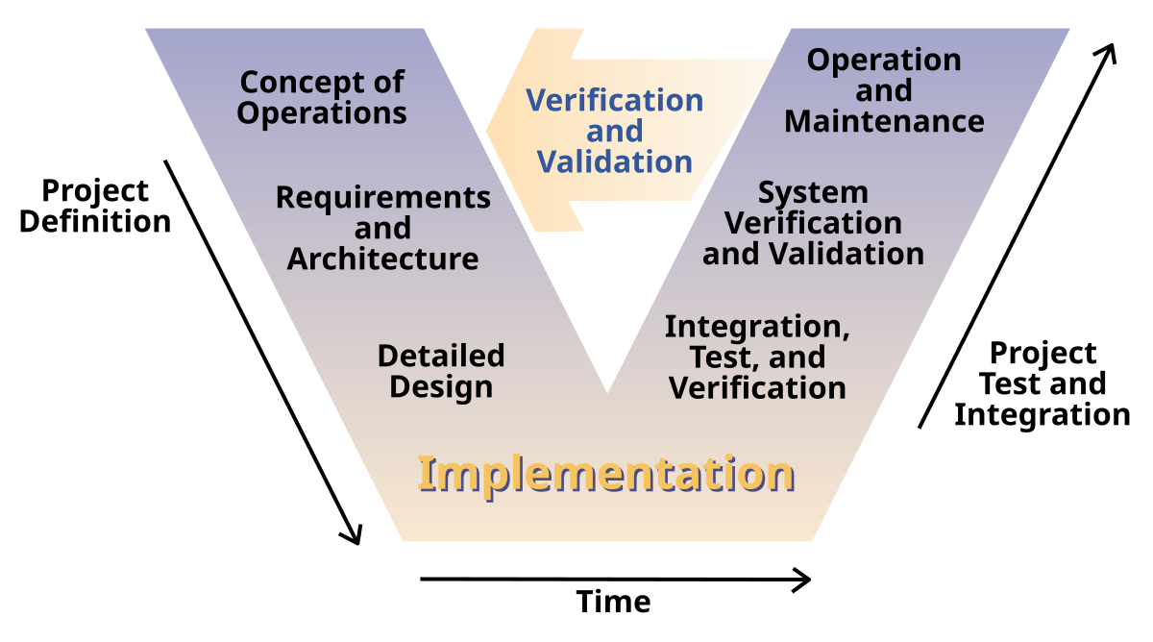
Fig. 3. V-Model (HW + SW)
Fig. 3 illustrates the V-Model (Verification and Validation Model) development framework applied to the “ECOTwin: A Dual‑Greenhouse Vertical Farming System Designed for Experimental Researches”, showing how each definition phase on the left side of the “V” relates to later testing and validation activities on the right side [35]. On the left, the Concept of Operations phase defines how this project is expected to function in the IASDC context describing user roles, typical greenhouse workflows, and how the dual-greenhouse setup supports experiments for BSABE and BSA students. This is followed by the Requirements and Architecture phase, which formalizes functional and non-functional requirements and organizes them into a layered architecture connecting the greenhouse environment, local processing, and the web-based interface. The Detailed Design phase then refines this architecture into concrete design artifacts, including database schemas, interaction flows, and component-level behaviors, ensuring that every requirement is traceable to a specific design element before implementation begins [27].
On the right side of the V-Model, the corresponding activities focus on Integration, Test, and Verification, System Verification and Validation, and Operation and Maintenance, which collectively ensure that the implemented project behaves as specified and remains dependable in real use. After implementation, integration testing confirms that the subsystems such as data acquisition, control logic, database storage, and web visualization work together correctly, while system verification checks that all documented requirements from the Concept of Operations and Requirements and Architecture phases are satisfied under controlled test scenarios. System validation then involves actual student and faculty users providing feedback on usability, usefulness, and alignment with instructional and research goals, and the Operation and Maintenance phase establishes long-term routines for calibration, updates, and corrective actions so that the system continues to perform reliably across multiple academic terms [29].​​

The verification and validation (V&V) focus of the V-Model makes it particularly appropriate for this project because it enforces a direct linkage between each requirement and its corresponding test activity, reducing the risk of untested or partially implemented features [30]. This V&V-driven approach is consistent with other smart greenhouse and IoT agriculture projects, where systematic verification and field validation are essential to ensure that automated environmental control systems remain accurate, robust, and acceptable to their intended users [31].​
CONCEPT OF OPERATION
The concept of operation provides an overview of how the proposed system performs its core processes through the integration of hardware and software components. It explains the operational workflow from sensor data acquisition and environmental monitoring to automated actuation and data presentation within a controlled local network environment. This section outlines how information flows between embedded devices, environmental sensors, actuators, and the mobile management interface to ensure synchronized performance and reliability. By presenting these interactions, the Concept of Operation establishes a foundational understanding of how the system functions during actual operation [32].
Use Case Diagram
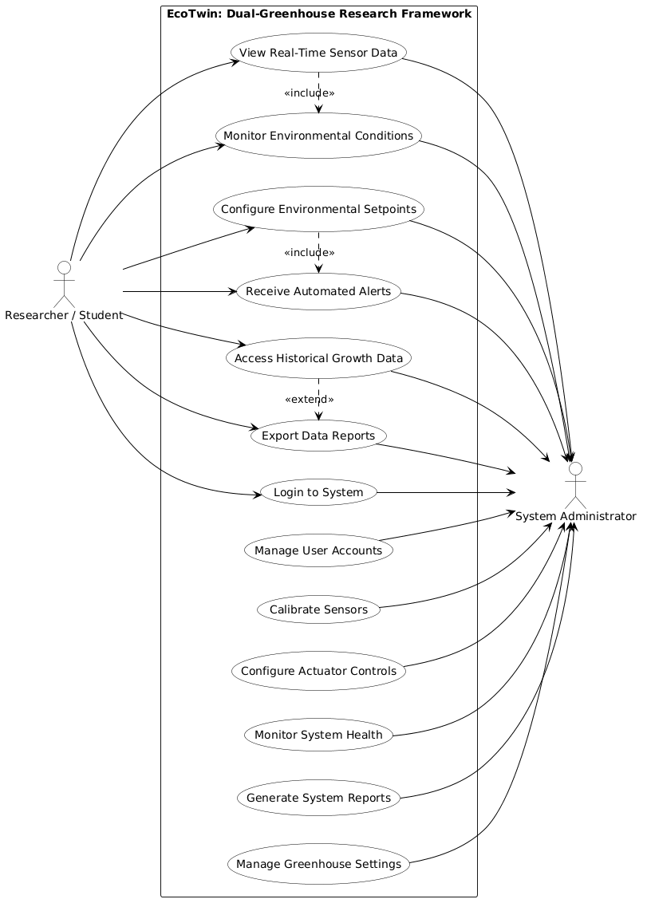
The use case diagram illustrates how users interact with the system by outlining the primary functions and their relationships to corresponding actors, serving as a visual guide to define user roles, actions, and system boundaries and helping developers identify the interactions necessary for both researchers and administrators to perform their tasks efficiently [33].
Fig. 4. Use Case Diagram of ECOTwin
Fig. 4 illustrates the Use Case Diagram of “ECOTwin: A Dual‑Greenhouse Vertical Farming System Designed for Experimental Researches”, highlighting the interaction between the Researcher/Student and the System Administrator. The Researcher/Student can log in, view real-time sensor data from both greenhouses, monitor environmental conditions, configure environmental setpoints for controlled experiments, receive automated alerts when thresholds are exceeded, and access historical growth data for analysis. Through this process, students and researchers will be able to conduct controlled agricultural experiments efficiently and analyze romaine lettuce growth responses under different environmental treatments during their coursework and research activities , [34]. The System Administrator, on the other hand, oversees the overall operation of the system. They are responsible for managing user accounts, calibrating sensors, configuring actuator controls, monitoring system health and performance, and generating data reports or system logs. This interaction between researcher and administrator ensures that the system operates smoothly, promoting experimental validity, data integrity, and educational effectiveness within the dual-greenhouse research framework [33].
Activity Diagram
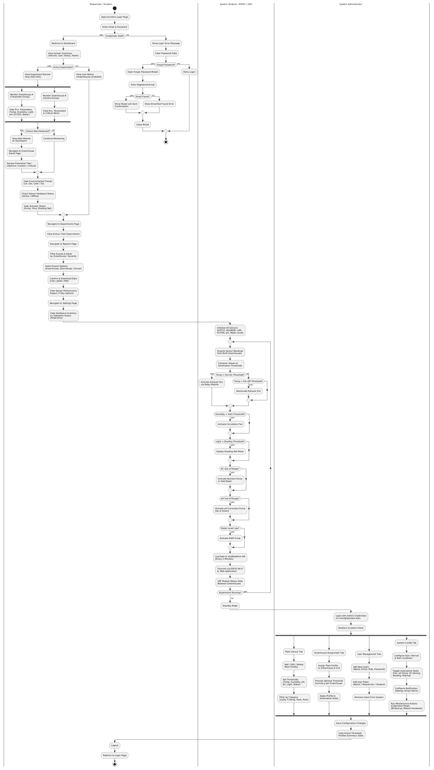
The activity diagram illustrates the workflow of the system by showing how processes progress, branch, and interact among users and system components. It provides a visual representation of system logic that helps organize operations and ensure a clear sequence of tasks. Structured diagrammatic representations improve system reliability and maintainability by presenting an organized view of activities and data flow within the system [35]. The diagram also helps developers and stakeholders understand the system’s dynamic behavior by showing user actions, decision points, parallel processes, and possible execution paths. It serves as a reference for refining processes before implementation and supports communication among team members during system development [36].
Fig. 5. Activity Diagram of ECOTwin
Fig. 5 illustrates the activity diagram of the “ECOTwin: A Dual‑Greenhouse Vertical Farming System Designed for Experimental Researches”, showing the process flow for both the Researcher or the Student and the System Administrator. It begins with opening the mobile application, where the login interface appears, allowing users and administrators to enter their credentials. If the login attempt fails, an error message is displayed, prompting the user to retry. Upon successful authentication, the system grants access and directs the researcher to the dashboard, where they can view real-time sensor readings from both greenhouses, select which greenhouse to monitor, configure environmental setpoints and receive automated alerts when sensor values exceed defined thresholds. The Arduino controller continuously reads sensor data, compares values against setpoints, and triggers actuators to maintain target environmental conditions in each greenhouse. Meanwhile, the researcher can export growth data and generate comparison reports for analysis [37]. The System Administrator logs into the system to access the admin dashboard, where they can calibrate sensors, manage user accounts, configure system parameters, monitor actuator performance, and generate system health reports for maintenance and troubleshooting. Both researcher and administrator sessions end with a logout process, completing the system's activity flow. All sensor data and control logs are stored in the local phpMyAdmin database for subsequent analysis and system verification [38].
REQUIREMENTS AND ARCHITECTURE
This section defines the functional and non-functional requirements of “ECOTwin: A Dual‑Greenhouse Vertical Farming System Designed for Experimental Researches” and presents the architectural framework that integrates the dual greenhouses, embedded controllers, and web-based monitoring interface within a LAN environment. It identifies what the system must accomplish in terms of continuous environmental monitoring, automated actuation, and research-oriented data handling, while specifying the quality attributes needed to keep the platform reliable, usable, and suitable for long-term experimental use in an academic setting [39].
The architectural design of “ECOTwin: A Dual‑Greenhouse Vertical Farming System Designed for Experimental Researches” adopts a layered structure similar to IoT-based greenhouse and smart agriculture systems, separating sensing and actuation in the physical layer, local processing and storage in the control layer, and visualization plus user interaction in the application layer. This organization supports clear data flow from sensors to actuators, encapsulates control logic near the greenhouse hardware for resilience during network issues, and allows the website client to remain a lightweight front-end that focuses on visualization and basic configuration rather than heavy computation [40].
Technical Requirements
Technical requirements ensure that this project hardware and software specifications align with stakeholder needs for experimental reliability, affordability, and instructional usability. They support systematic requirement analysis, documentation, and validation so that each selected component and tool remains feasible for procurement, integration, and long-term maintenance within the SPAMAST context [41].

TABLE I
HARDWARE AND SOFTWARE REQUIREMENTS OF ECOTWIN
Requirement | Purpose
Hardware
Arduino Uno | This will be used as the primary microcontroller to read sensor inputs and control actuators for each greenhouse chamber.
Electrical Conductivity / Total Dissolved Solids Sensor | These will be used to measure electrical conductivity or total dissolved solids of the nutrient solution, indicating its concentration for plant growth.
Fans | These will be used to provide ventilation and air circulation inside the greenhouse, helping regulate temperature and humidity.
GSM Module (SIM800L) | This will be used to send SMS alerts directly via AT commands to researchers' phones when critical thresholds are exceeded (temperature >32°C, pH <5.5, water level <20%, Wi-Fi failure) or system anomalies detected, providing reliable communication redundancy independent of internet connectivity.
Light Sensor (Light Dependent Resistor) | This will be used to detect ambient light intensity in order to characterize lighting conditions affecting lettuce growth.
Microcontroller (ESP32) | This will be used to provide Wi-Fi connectivity, local processing, and communication between the greenhouse controller and the LAN-based data application.
Motor (28BYJ-48 Stepper Motor + ULN2003 Driver) | This will be used to provide precise automated retraction of shading nets based on light intensity (>800 lux) and temperature (>32°C) thresholds, enabling dynamic solar radiation control across the 73cm greenhouse depth with 4096 steps per revolution for exact positioning.
PCB Board | This will be used as the centralized interface integrating Arduino Uno, ESP32, relay modules, and sensors into a single, compact, reliable circuit board with proper power distribution, signal conditioning, and protection circuits for stable greenhouse operation.
pH Sensor Kits | These will be used to monitor the pH level of the nutrient solution and support adjustments to maintain optimal growing conditions.
Power Supply + Uninterrupted Power Supply | This will be used to deliver stable power to all components and maintain operation during brief power interruptions.
Relay Modules | These will be used to switch pumps, fans, and other high-voltage devices safely using low-voltage control signals from the microcontroller.
Submersible Pump | This will be used to circulate or deliver water and nutrient solution to the plants according to the configured schedule or control logic.
Temperature–Humidity Sensor (DHT22) | This will be used to measure air temperature and relative humidity inside each greenhouse to monitor environmental conditions.
Water Level Sensor (Printed Circuit Board-Type) | This will be used to monitor nutrient solution or water level in the reservoir and trigger refilling or alerts when levels are low.
Waterproof Temperature Sensor (DS18B20) | This will be used to measure water or nutrient solution temperature to ensure it remains within the desired range.
Wireless Module (nRF24L01) | This will be used to enable low-power wireless communication between distributed sensor nodes and the main controller when wired connections are impractical.
Software
Arduino IDE | This will be used to write, compile, and upload firmware to the Arduino Uno and ESP32 modules.
phpMyAdmin | This will be used to design, manage, and administer the phpMyAdmin database that stores sensor readings, configuration parameters, and experiment logs.
Visual Studio 2022 | This will be used to develop the monitoring and management website interface and handle data visualization and configuration tasks.​
Table I presents the hardware and software requirements necessary for developing the “ECOTwin: A Dual‑Greenhouse Vertical Farming System Designed for Experimental Researches”, ensuring that all components support reliable monitoring and control of the dual greenhouse setup. The hardware devices, including microcontrollers, environmental sensors, pumps, fans, relays, and protected power sources, work together to automate irrigation, climate regulation, and nutrient management under varying experimental conditions. The software tools Visual Studio 2022, Arduino IDE, and phpMyAdmin provide the environment for firmware development, application programming, and database administration, enabling structured data collection, configuration management, and visualization for romaine lettuce growth experiments.
DETAILED PROJECT DESIGN
The detailed project design for “ECOTwin: A Dual‑Greenhouse Vertical Farming System Designed for Experimental Researches” translates the system’s monitoring and control objectives into a structured web-based architecture that links greenhouse hardware, edge controllers, and a browser-accessible dashboard over the local network. It defines how sensor acquisition, rule-based actuation, data storage, and visualization are partitioned into coordinated modules, following the layered and modular structures commonly adopted in web-based greenhouse and smart farm systems to support reliability and ease of maintenance [42].
Software Design
The software design organizes this project into distinct layers and components, including a backend service that receives data from the ESP32/Arduino nodes, a phpMyAdmin-based persistence layer for time-series records, and a web frontend that renders real-time and historical greenhouse conditions to authenticated users. Responsibilities are divided into modules such as data ingestion APIs, device management, rules and threshold evaluation, and notification services, reflecting best practices in web-based greenhouse and agricultural monitoring applications that emphasize clear separation between data handling, business logic, and presentation for scalability and maintainability [43].
Database Design
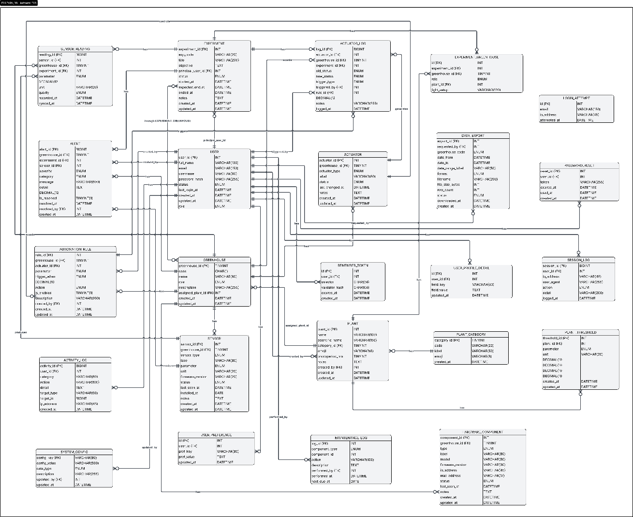
The database design specifies how this project structures and relates information such as sensor readings, greenhouse profiles, device configurations, and user accounts in a relational phpMyAdmin schema to support consistent, query-efficient storage of time-series data. Tables for measurements, actuations, thresholds, and experiments are normalized where appropriate, while time-indexed fields receive focused indexing to accelerate range queries in the web dashboard, following recommendations from IoT greenhouse and smart farm studies that use phpMyAdmin to manage large volumes of environmental data and highlight the importance of indexing and partitioning for responsive analytics.
Fig. 6 illustrates the entity–relationship diagram of this project web-based dual-greenhouse research framework, showing how core entities such as Users, Greenhouses, Sensors, Actuators, Readings, Actuation Logs, Experiments, and Thresholds are related to support monitoring, control, and research data management. Each User record stores authentication and role information and can be associated with multiple Experiments, while each Experiment links to one or more Greenhouses where treatments are applied; every Greenhouse then owns multiple Sensors and Actuators that capture environmental parameters or execute control actions inside that structure. The Sensors table identifies each physical sensor and is connected to the Readings table through a one-to-many relationship that stores timestamped measurements, whereas the Actuators table connects to Actuation Logs to record when and why a device was switched on or off; Thresholds associate specific Experiments, Greenhouses, and Sensors with configured minimum and maximum values, allowing the backend to decide when to trigger actuators and ensuring that all operational data remains traceable for romaine lettuce trials.
Fig. 6. Entity Relationship Diagram of ECOTwin
Data Flow Diagram
The data flow diagram for this project describes how information moves between external users, greenhouse hardware, and the web-based monitoring system, emphasizing structured, traceable flows typical of agricultural IoT applications. Sensor nodes in each greenhouse send periodic readings from the embedded controllers to this system Web Server process, which validates and stores data in the central phpMyAdmin Database while also updating cached values for real-time dashboards, similar to other web-based greenhouse monitoring systems that separate acquisition, processing, and storage stages [42]. Researchers and students, acting as external entities, interact through a browser: they log in, request charts or tables, and optionally configure thresholds or experiment metadata, and the Web Server responds by querying the database and returning processed views, while a separate Control Logic process evaluates incoming readings against Threshold Settings to generate control commands back to the Greenhouse Controller, which then drives actuators such as pumps and fans and logs each actuation event for later analysis [51].
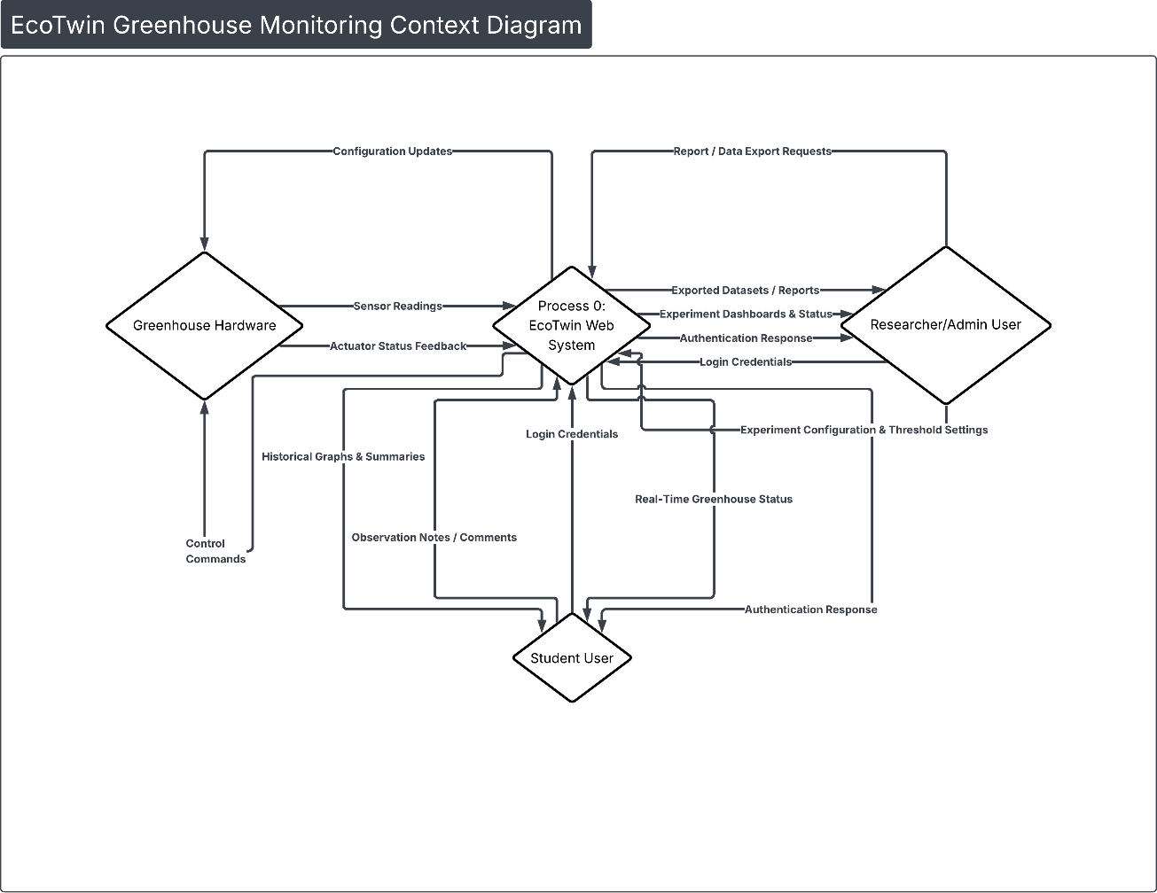
Fig. 7. Level 0 DFD Context Diagram of ECOTwin
Fig. 7 presents the Level 0 Data Flow Diagram of this project, showing the overall data movement between the primary external entities Researcher, Admin User, Student User, and Greenhouse Hardware and the central the system Web System. Admin Users send login credentials, experiment configurations, and threshold settings to this project Web System and receive dashboards, experiment summaries, and exported datasets in return; Student Users submit login details and observation inputs and receive real-time greenhouse status views and historical charts, while Greenhouse Hardware continuously sends sensor readings and device status to the project Web System and receives control commands such as pump or fan activations for each greenhouse [44].

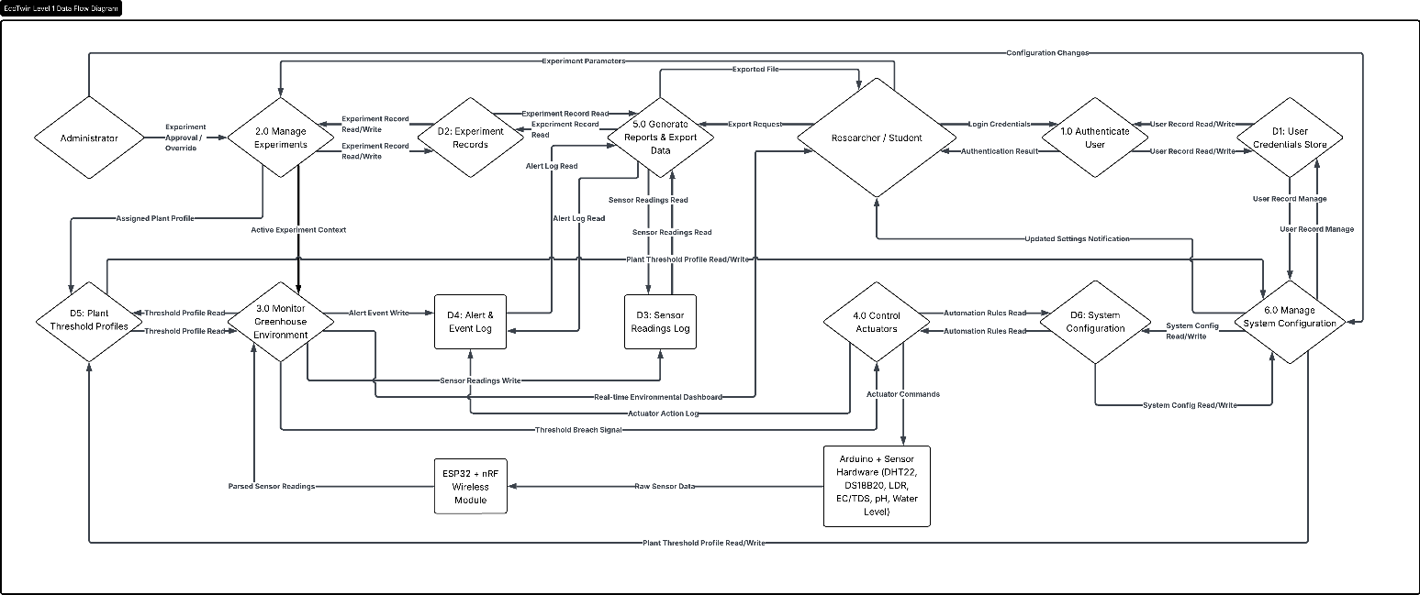
Fig. 8 illustrates the Level 1 Data Flow Diagram of this project web-based dual greenhouse system, decomposing the main process into five interconnected subprocesses: User Authentication & Session Management, Experiment & Configuration Management, Data Acquisition & Storage, Monitoring & Visualization, and Control & Notification Engine. User Authentication & Session Management validates login credentials from researcher, admin and student users and forwards verified identities to Experiment & Configuration Management, which handles experiment setup, threshold settings, and greenhouse associations; in parallel, Data Acquisition & Storage receives continuous sensor readings and actuator feedback from the greenhouse hardware and writes them into the measurement and log data stores, while Monitoring & Visualization retrieves this stored data plus configuration metadata to generate dashboards, charts, and status views for web clients. The Control & Notification Engine periodically evaluates incoming and stored readings against thresholds, sends control commands back to the greenhouse hardware when conditions are exceeded, and issues alerts or status notifications to authenticated users, ensuring a closed-loop flow of information and actions across all subprocesses for reliable greenhouse research operations [44].
Fig. 8. DFD level 1 of ECOTwin
Functional Requirements
Functional requirements define the specific operations the system must perform to satisfy user and administrative needs. They describe how inputs such as sensor readings, user commands, and configuration parameters are processed to produce outputs including real-time dashboards, automated actuator responses, alerts, and historical reports. In essence, they specify what the system should do and how it responds to events at the system environment boundary, forming the basis for testable behaviors and acceptance criteria [45].

TABLE II
FUNCTIONAL REQUIREMENTS FOR SOFTWARE OF ECOTWIN
Subsystem | Module | Functional Requirement
Web-Based Management Interface | Administrative Control Module | The system will be able to allow administrators to manage user accounts, configure greenhouse and experiment settings, calibrate sensors, reset system parameters, and oversee all operational aspects of the dual greenhouse setup.​
 | Authentication Module | The system will be able to authenticate users through username and password verification before granting access to greenhouse data, configuration interfaces, and experiment management functions.​
 | Dashboard Module | The system will be able to display real-time sensor readings from both greenhouses, including temperature, humidity, light intensity, water level, water temperature, EC/TDS, and pH, along with current experiment status and actuator states.​
 | Greenhouse & Experiment Management Module | The system will be able to create, configure, and manage multiple experiments by associating them with specific greenhouses, defining environmental setpoints and treatment conditions, and tracking experiment start and end dates for structured comparative studies.
 | Environmental Monitoring Module | The system will be able to continuously acquire, process, and display sensor data from each greenhouse, providing graphical trend visualizations, threshold status indicators, and real-time environmental condition summaries to support romaine lettuce growth monitoring.
 | Automated Control Module | The system will be able to evaluate sensor readings against configured thresholds and automatically trigger actuators such as submersible pumps, exhaust fans, circulation fans, and shading mechanisms to maintain target environmental conditions in each greenhouse without manual intervention.
 | Notification & Alert Module | The system will be able to generate and send automated alerts to users and administrators when sensor values exceed defined thresholds, when actuators fail to respond, or when system anomalies are detected, ensuring timely intervention and experimental integrity.
 | Data Export & Reporting Module | The system will be able to generate summary reports, export sensor data in CSV or Excel formats, produce comparison charts between the two greenhouses, and compile experiment logs for academic analysis and publication purposes.
 | Historical Data & Analysis Module | The system will be able to store all sensor readings, actuation logs, and configuration changes in the phpMyAdmin database with timestamps and experiment associations, and provide query and visualization tools to analyze environmental trends, growth correlations, and system performance over time.
Table II presents the functional requirements of the Web Management Interface, organized by software modules that define the system's core behaviors for this system. The Authentication Module verifies user credentials via username and password before granting access, while the Administrative Control Module enables user account management, sensor calibration, and system configuration. Operational tasks are handled by the Greenhouse & Experiment Management Module, which associates experiments with greenhouses and tracks treatment conditions, and the Automated Control Module, which evaluates sensor data against thresholds and triggers pumps, fans, and shading nets to maintain target environments in each greenhouse. User-facing information is consolidated through the Dashboard Module, displaying real-time readings and experiment status, and enhanced by the Notification & Alert Module, now including a dedicated REST API for programmatic alert triggering, querying, acknowledgment, and real-time push notifications to support external integrations like SMS gateways. Finally, the Data Export & Reporting Module enables CSV/Excel downloads and comparison charts, while the Historical Data & Analysis Module archives all measurements and logs for long-term trend analysis and research validation.
Non-Functional Requirement
Non-functional requirements describe the quality attributes that define how the system performs its intended functions under various conditions. They address key aspects such as availability, reliability, security, usability, scalability, and maintainability, ensuring that the web-based dual-greenhouse platform operates consistently and efficiently across multiple experimental cycles. These attributes guide architectural and implementation decisions, especially in IoT-oriented systems where continuous data acquisition, actuator control, and user access must remain dependable despite network fluctuations and hardware constraints [46].

TABLE III
NON-FUNCTIONAL REQUIREMENTS (NFR) FOR WEB APPLICATION OF ECOTWIN
Component / Module | Non-Functional Requirement
Reliability | The system will be able to perform consistently by accurately recording sensor data, executing actuator commands, and logging all events without unintended data loss, supporting long-term romaine lettuce experiments that rely on continuous and error-free time-series records.
Security | The system will be able to protect user credentials, experiment configurations, and environmental data through authenticated access, encrypted communication within the LAN where feasible, and role-based permissions that prevent unauthorized modification of control thresholds or experiment settings.
Usability | The system will be able to provide a clear, responsive web interface that allows administrators and students to view greenhouse status, interpret graphs, and configure experiments with minimal training, reflecting usability expectations highlighted in web-based greenhouse controllers.​
Scalability | The system will be able to support the addition of more sensors, actuators, and greenhouses, as well as increased data volume, without major redesign. ECOTwin features configurable environmental setpoints, adjustable nutrient profiles, and modular crop spacing that enable seamless adaptation to diverse plant species beyond romaine lettuce including herbs, microgreens, strawberries, and small-fruited vegetables while maintaining experimental integrity across different growth requirements in line with scalable CEA frameworks.
Table III presents the non-functional requirements of this project web application, describing the quality attributes that determine how the system performs under normal operating conditions. The Availability and Reliability requirements ensure that users can depend on the platform for continuous monitoring and actuation during greenhouse experiments, reducing risks of missing data or failed interventions. Security and Usability focus on protecting sensitive experiment information while providing an interface that students and researchers can operate intuitively, reinforcing both trust and adoption in an academic context. Finally, Scalability and Maintainability emphasize that this system must handle growth in devices and data while remaining easy to extend and support over time, aligning with recommendations for sustainable IoT greenhouse and smart agriculture infrastructures.​
User Interface
The user interface (UI) serves as the primary point of interaction between the user and this project web-based system, enabling access to core functions such as authentication, greenhouse monitoring, experiment configuration, and data reporting. It follows a browser-based client–server structure in which backend services handle data processing and storage, while the web client manages user input, navigation, and visualization through responsive dashboards and forms. A well-designed UI improves usability and research effectiveness by presenting environmental indicators, actuator states, and experiment status clearly, supporting quick interpretation and decision-making, similar to other smart farm and greenhouse interfaces that emphasize user-friendly layouts and parameter-focused menus [47].
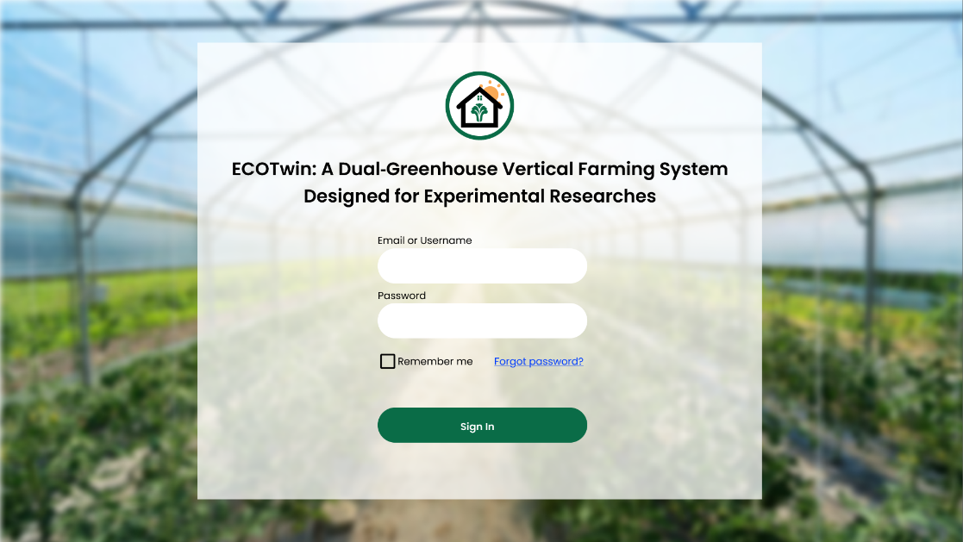
Fig. 9 shows the login interface of this project web system, which serves as the initial access point for administrators, researchers, and students. The interface displays the system title, brief description, and a centralized login card containing fields for username or email, password, and role selection, along with a sign-in button and optional “remember me” and “forgot password” controls, following patterns used in other web-based smart farm and greenhouse dashboards that emphasize secure and straightforward access. The layout is intentionally simple and uncluttered, enabling users to authenticate quickly from laboratory PCs or laptops; upon successful login, users are redirected to the main dashboard, while invalid credentials trigger an inline error message that guides them to retry without leaving the page.​
Fig. 9. Login Interface of ECOTwin
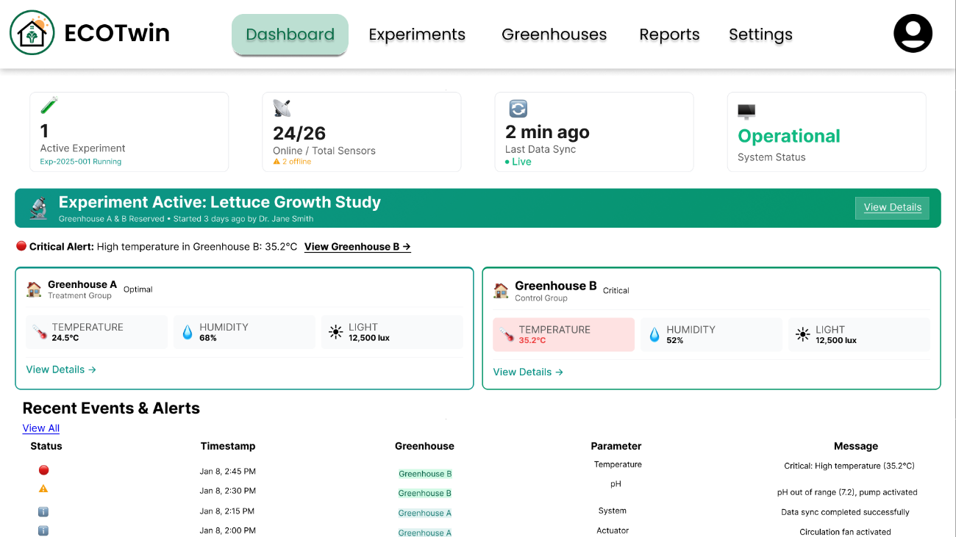
Fig. 10 presents the dashboard interface of the system web application, which functions as the central workspace for monitoring and managing both research greenhouses. The dashboard displays a global summary of active experiments, sensor connectivity, and recent alerts at the top, followed by tabbed greenhouse panels that show real-time readings for temperature, humidity, light, EC/TDS, pH, water level, and water temperature, alongside time-series charts and actuator status indicators for pumps, fans, and shading mechanisms. Administrators and researchers can access additional controls for configuring experiments and issuing manual actuator overrides, while students primarily use the dashboard to observe conditions and review historical trends, aligning the interface with role-based usage and dashboard usability criteria that highlight clarity, learnability, and situational awareness in monitoring environments.
Fig. 10. Dashboard of ECOTwin
Hardware Design
Hardware design involves the structured selection and integration of physical components that enable this projects system to sense environmental conditions, execute control actions, and communicate with the web-based management interface. The platform combines microcontroller boards, wireless modules, and a suite of sensors including DHT22 temperature humidity, LDR light, PCB-type water level, DS18B20 water temperature, EC/TDS, and pH probes to capture critical greenhouse parameters that influence romaine lettuce growth, mirroring the sensor–actuator patterns used in other Arduino-based greenhouse prototypes [48]. Actuators such as submersible pumps, greenhouse fans, and relay-controlled power lines receive commands from the controllers to regulate irrigation, ventilation, and microclimate conditions, while a stabilized power supply with UPS ensures continuous operation during short outages, reflecting embedded-systems best practices where sensors act as the “eyes” and actuators as the “hands” of the control logic [49].

TABLE IV
FUNCTIONAL REQUIREMENTS FOR HARDWARE OF ECOTWIN
Subsystem | Component / Module | Functional Requirement
“ECOTwin: A Dual‑Greenhouse Vertical Farming System Designed for Experimental Researches” Hardware | Arduino Uno | This will be used as the primary microcontroller to read sensor inputs and control actuators for each greenhouse chamber.
 | Electrical Conductivity / Total Dissolved Solids Sensor | These will be used to measure electrical conductivity or total dissolved solids of the nutrient solution, indicating its concentration for plant growth.
 | Fans | These will be used to provide ventilation and air circulation inside the greenhouse, helping regulate temperature and humidity.
 | GSM Module (SIM800L) | This will be used to send SMS alerts directly via AT commands to researchers' phones when critical thresholds are exceeded (temperature >32°C, pH <5.5, water level <20%, Wi-Fi failure) or system anomalies detected, providing reliable communication redundancy independent of internet connectivity.
 | Light Sensor (Light Dependent Resistor) | This will be used to detect ambient light intensity in order to characterize lighting conditions affecting lettuce growth.
 | Microcontroller (ESP32) | This will be used to provide Wi-Fi connectivity, local processing, and communication between the greenhouse controller and the LAN-based data application.
 | Motor (28BYJ-48 Stepper Motor + ULN2003 Driver) | This will be used to provide precise automated retraction of shading nets based on light intensity (>800 lux) and temperature (>32°C) thresholds, enabling dynamic solar radiation control across the 73cm greenhouse depth with 4096 steps per revolution for exact positioning.
 | PCB Board | This will be used as the centralized interface integrating Arduino Uno, ESP32, relay modules, and sensors into a single, compact, reliable circuit board with proper power distribution, signal conditioning, and protection circuits for stable greenhouse operation.
 | pH Sensor Kits | These will be used to monitor the pH level of the nutrient solution and support adjustments to maintain optimal growing conditions.
 | Power Supply + Uninterrupted Power Supply | This will be used to deliver stable power to all components and maintain operation during brief power interruptions.
 | Relay Modules | These will be used to switch pumps, fans, and other high-voltage devices safely using low-voltage control signals from the microcontroller.
 | Submersible Pump | This will be used to circulate or deliver water and nutrient solution to the plants according to the configured schedule or control logic.
 | Temperature–Humidity Sensor (DHT22) | This will be used to measure air temperature and relative humidity inside each greenhouse to monitor environmental conditions.
 | Water Level Sensor (Printed Circuit Board-Type) | This will be used to monitor nutrient solution or water level in the reservoir and trigger refilling or alerts when levels are low.
 | Waterproof Temperature Sensor (DS18B20) | This will be used to measure water or nutrient solution temperature to ensure it remains within the desired range.
 | Wireless Module (nRF24L01) | This will be used to enable low-power wireless communication between distributed sensor/actuator nodes and the main controller when wired connections are impractical.
Table IV presents the functional requirements of this system hardware, describing how each physical component contributes to the overall operation of the dual-greenhouse research framework. The Arduino Uno and ESP32 modules serve as the primary controllers that coordinate sensor readings, actuator commands, and communication with the web-based interface, while wireless nRF modules support flexible deployment inside greenhouse structures. Environmental sensors including DHT22, LDR, water level, DS18B20, EC/TDS, and pH probes supply continuous measurements that inform irrigation and climate decisions, and relay-driven submersible pumps and greenhouse fans execute those decisions to maintain experimental conditions for romaine lettuce. Finally, the stabilized power supply with UPS underpins all operations by ensuring continuous, safe power delivery, helping the system behave predictably during fluctuations and aligning this project with established embedded-hardware design practices for smart greenhouse applications.​
Non-Functional Requirement
The non-functional requirements of the hardware establish the performance standards and operational qualities that ensure this project physical components function dependably in a humid, outdoor-adjacent greenhouse environment. These include attributes such as durability, power efficiency, reliability, and safety, which collectively determine how the hardware behaves beyond its basic sensing and actuation functions. Defining these parameters helps ensure that sensors, microcontrollers, pumps, and fans can operate for extended periods, withstand typical greenhouse conditions, and recover gracefully from power or network fluctuations, similar to other Arduino-based greenhouse projects that emphasize robust enclosures, stable power, and long-term continuous operation [48].These requirements also reflect guidance from IoT-focused frameworks that highlight energy-conscious design, fault tolerance, and protection of field-deployed devices as critical for sustainable and resilient smart agriculture infrastructure [50].

TABLE V
NON-FUNCTIONAL REQUIREMENTS FOR HARDWARE OF ECOTWIN
Component / Module | Non-Functional Requirement
Durability | The hardware will be able to withstand typical greenhouse conditions including elevated humidity, temperature fluctuations, and occasional water exposure by using appropriate enclosures, mounting, and corrosion-resistant materials, helping maintain long-term sensor accuracy and actuator performance [48].
Power Efficiency | The hardware will be able to optimize energy consumption by using suitable power supplies, efficient pumps and fans, and low-power communication modes where feasible, supporting sustainable operation and aligning with energy-efficient IoT guidelines that reduce waste and operating cost [50].
Reliability | The hardware will be able to perform consistently over extended periods by maintaining stable microcontroller operation, minimizing loose connections, and ensuring accurate, calibrated sensors, so that environmental control remains dependable for entire crop cycles and continuous experiments [48].
Safety | The hardware will be able to operate without posing electrical or mechanical hazards to users by implementing proper insulation, fusing, grounding, and relay isolation for mains-powered devices, in line with safety considerations described in IoT-based building and greenhouse implementations [51].
Table V presents the non-functional requirements of the system hardware, highlighting the quality attributes that ensure stable and dependable system performance. The Durability requirement ensures that all boards, sensors, and actuators are physically protected and suitable for greenhouse exposure, reducing the risk of corrosion or premature failure. Power Efficiency focuses on minimizing unnecessary energy use so that pumps, fans, and controllers can run for long periods without excessive consumption, supporting sustainable operation in line with green IoT principles. Reliability emphasizes continuous, error-free operation through good wiring practice, sensor calibration, and robust mounting, while Safety guarantees that all electrical components are installed and protected to avoid shocks, shorts, or unsafe heat buildup, making the system suitable for use in student and research laboratory environments.
Circuit Diagram
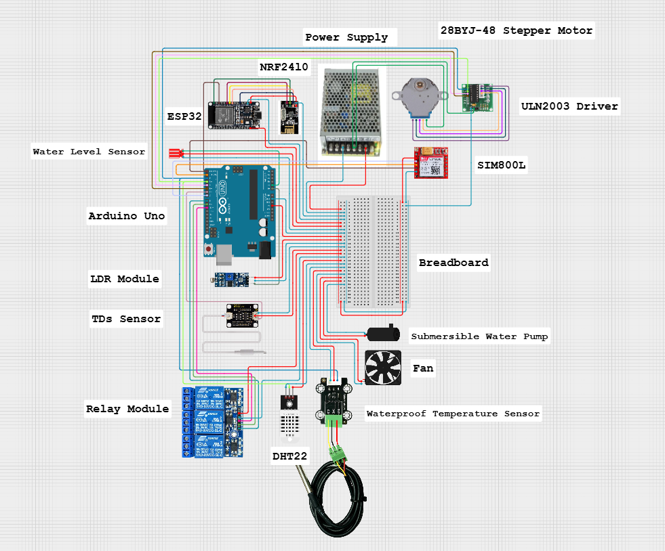
The circuit diagram provides an overview of the electrical layout and interactions among the project’s hardware components, illustrating how microcontrollers, sensors, actuators, communication modules, and power systems are connected to enable greenhouse monitoring and control. It highlights the general relationships between processing units, various environmental and water quality sensors, relay-controlled devices, and the regulated power supply. Such schematics are commonly used in ESP32- and Arduino-based smart greenhouse projects to guide wiring, signal flow, and safe integration of sensors and actuators, while supporting troubleshooting and system assembly [48].
Fig. 11. Circuit Diagram of ECOTwin
Fig. 11 illustrates the circuit diagram of this project, showing how the Arduino Uno and ESP32 act as central controllers that connect to the various sensors and actuators deployed in the two research greenhouses. The DHT22, LDR, water level sensor, DS18B20, EC/TDS, and pH modules are wired to the Arduino and ESP32 input pins with shared 5 V or 3.3 V power rails and common ground, while relay modules are connected to digital output pins to switch the submersible pumps and greenhouse fans using isolated high-voltage circuits, a pattern consistent with published ESP32–DHT22–relay tutorials and IoT greenhouse reference designs [51]. The nRF wireless modules are linked to the controllers via SPI pins to support optional wireless node extensions, and the entire assembly is powered by a regulated supply with UPS backup that feeds the logic-level electronics and the relay-driven loads separately, ensuring both electrical safety and continuous operation under typical greenhouse conditions.​
Perspective Diagram
The perspective diagram illustrates the physical configuration and visual structure of the project prototype, showing how the dual greenhouse tents, vertical PVC racks, sensor assemblies, controller boxes, and plumbing are arranged to support research workflows and maintenance. It depicts the placement of romaine lettuce channels on stacked levels, the routing of irrigation lines and return drains, and the mounting of environmental sensors at representative canopy and reservoir positions, similar to schematic and 3D views used in other smart greenhouse and vertical farming designs that emphasize spatial integration of grow structures with control hardware [52]. By providing a three-dimensional view of the project layout, the perspective diagram helps designers and users evaluate clearances, airflow paths, cable routing, and access for calibration or repairs, bridging the gap between the abstract system architecture and the practical, ergonomic considerations of operating a dual-greenhouse research setup in a constrained campus space.
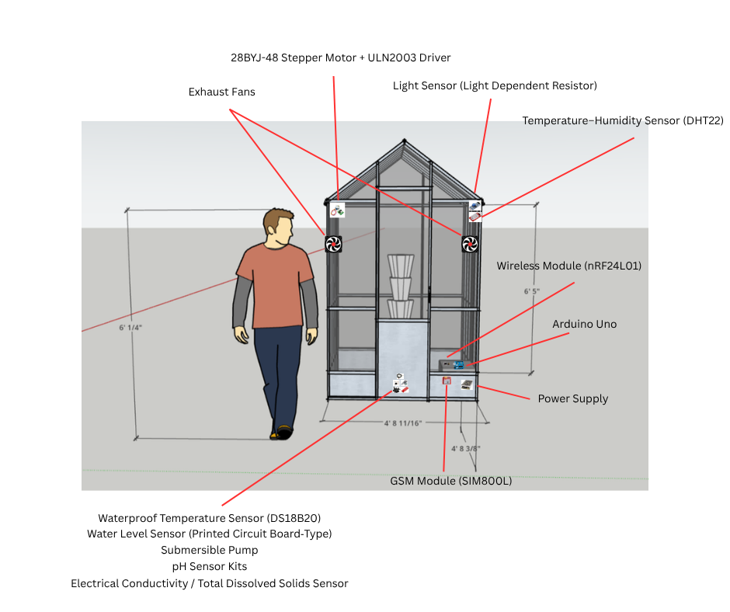
Fig. 12 presents the front view perspective diagram of the project, highlighting two compact greenhouse structures positioned side by side, each containing vertically stacked PVC pipe or gutter channels planted with romaine lettuce. From this viewpoint, the door or access flap of each greenhouse, the vertical arrangement of the grow levels, and the visible sensor housings mounted near plant canopies and along the reservoir area are shown, reflecting typical front-elevation illustrations used in controlled-environment agriculture projects to plan crop access, lighting exposure, and equipment placement [53]. The front view also indicates the approximate location of the controller enclosure and main power/UPS box at the base or between the greenhouses, ensuring that cabling and irrigation lines are organized while keeping electronic components reasonably protected from spray and high humidity.​
Fig. 12. Perspective Diagram (Front View) of ECOTwin

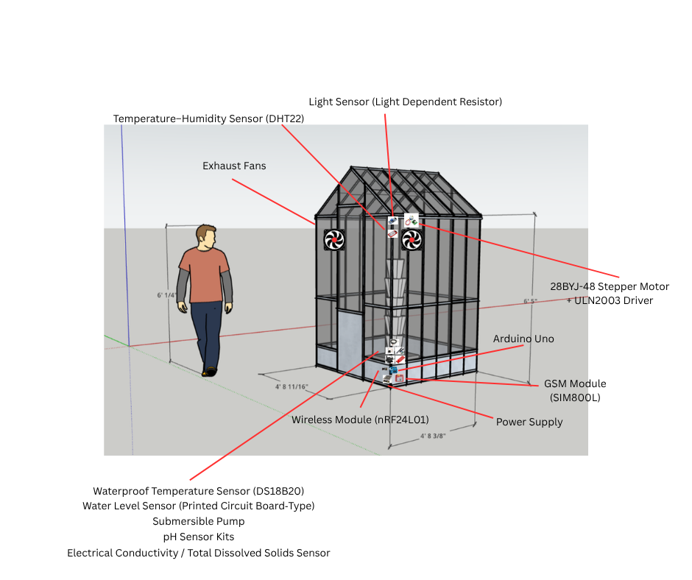
Fig. 13 shows the side view perspective diagram of one 143 cm × 73 cm × 195 cm Woodside mini-greenhouse, emphasizing the depth and vertical spacing of the stacked cultivation levels and the airflow patterns driven by the installed 120 × 120 mm exhaust fan and circulation fan for ventilation. This view illustrates how shelves or pipe tiers extend from front to back within the 73 cm depth constraint, how the 120 × 120 mm exhaust fan and circulation fan are mounted near the upper section to move warm air out and draw cooler air in according to greenhouse fan-sizing guidance based on greenhouse volume and air exchange rate, and how shading materials may be positioned above or along the side to modulate incoming solar radiation, consistent with side-elevation drawings used in vertical farming and passive solar greenhouse design to evaluate light gradients and ventilation strategies [54]. The side view also indicates sensor positions along the vertical profile, helping researchers understand how data reflects microclimate differences between upper and lower levels within each greenhouse.
Fig. 13. Perspective Diagram (Side View) of ECOTwin

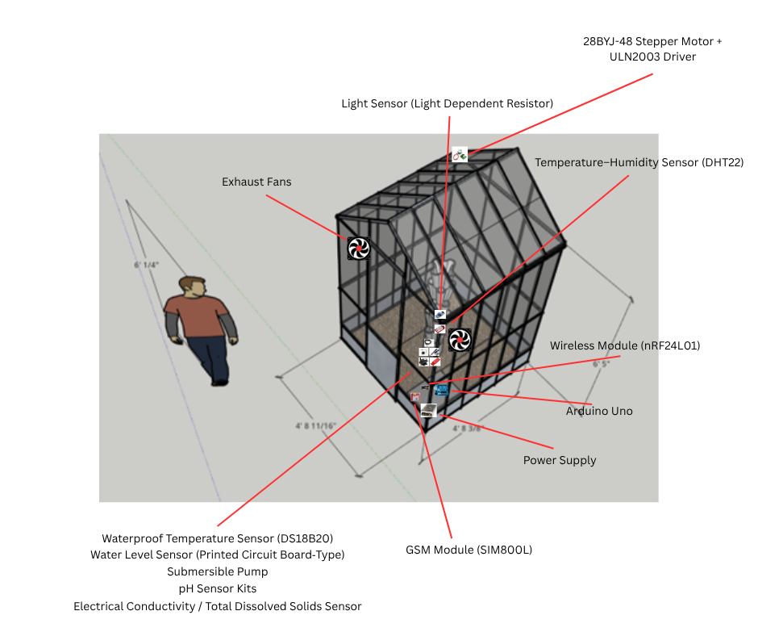
Fig. 14 presents the top view perspective diagram of the project prototype, illustrating the plan layout of the two 143cm × 73cm × 195cm Woodside walk-in greenhouses , main nutrient reservoirs, controller enclosures, and primary cable and pipe routes. From above, the diagram shows the 1.04 m² footprint of each commercial mini-greenhouse, the arrangement of vertical rack columns optimized for the 73cm depth, and the placement of reservoirs and plumbing paths that connect pumps to the grow channels and return drains back to the tanks echoing plan-view schematics used in compact greenhouse layout studies to optimize workflow within constrained research spaces . The top view also clarifies technician access paths (143cm width enables standing entry), sensor hub locations along rack columns, and LAN/power feed entry points supporting organized installation and future scalability of this validated prototype hardware [55].
Fig. 14. Perspective Diagram (Top View) of ECOTwin

Design Feasibility
The design feasibility of “ECOTwin: A Dual‑Greenhouse Vertical Farming System Designed for Experimental Researches” is supported by the availability of low-cost microcontrollers, sensors, and communication modules that have already been validated in similar smart greenhouse and hydroponic prototypes, demonstrating that reliable environmental monitoring and automation can be achieved using Arduino-based architectures and off-the-shelf components. Studies on IoT-based smart and economic greenhouses show that integrating temperature, humidity, light, and nutrient monitoring with automated control reduces manual labor, stabilizes growing conditions, and improves productivity all with investment levels suitable for small producers and educational institutions [56]. Likewise, low-cost greenhouse IoT architectures and Philippine smart greenhouse hydroponics projects for lettuce confirm that LAN- or Wi-Fi–connected sensing and control systems can be implemented in local contexts using open-source hardware and software, reinforcing the technical and economic viability of deploying this project as a dual-greenhouse research framework at SPAMAST Buhangin Campus for romaine lettuce experimentation and student training.
Technical Feasibility
Technical feasibility assesses whether this project can be implemented using readily available hardware, software, and network infrastructure that are compatible with local conditions and institutional capabilities. The proposed design relies on widely used microcontrollers and standard actuators that have been successfully deployed in numerous IoT-based greenhouse and mini-greenhouse prototypes in the Philippines and abroad, demonstrating that these components can reliably support real-time monitoring and control in small-scale controlled-environment agriculture [57]. On the software side, using Arduino IDE for firmware, alongside Visual Studio 2022 and phpMyAdmin for the web backend and database, leverages established development tools with extensive documentation and community support, aligning the system with technology stacks already adopted in web-based smart farm and greenhouse systems [58]. Because all key requirements are met through off-the-shelf, locally or online procurable components and mainstream software platforms, the system is technically feasible to build, deploy, and maintain within the capabilities of SPAMAST students and faculty.​

TABLE VI
TECHNICAL REQUIREMENTS AVAILABILITY
Requirement | Source | Acquisition Time
Arduino Uno | Electronics suppliers (online) | 5-7 days
DHT22 Temperature–Humidity Sensor | Electronics suppliers (online) | 5-7 days
DS18B20 Waterproof Temperature Sensor | Electronics suppliers (online) | 5-7 days
EC/TDS Modules | Electronics suppliers (online) | 5-7 days
ESP32 Module | Electronics suppliers (online) | 5-7 days
Fans | Electronics suppliers (online) | 5-7 days
GSM Module (SIM800L) | Electronics suppliers (online) | 5-7 days
Light Sensor (LDR Module) | Electronics suppliers (online) | 5-7 days
nRF Wireless Module | Electronics suppliers (online) | 5-7 days
28BYJ-48 Stepper Motor + ULN2003 Driver | Electronics suppliers (online) | 5-7 days
PCB Board | Electronics suppliers (online) | 5-7 days
pH Sensor Kits | Electronics suppliers (online) | 5-7 days
Power Supply + UPS | Electronics suppliers (online) | 5-7 days
Relay Modules | Electronics suppliers (online) | 5-7 days
Submersible Pump | Electronics suppliers (online) | 5-7 days
Arduino IDE | Microsoft | Immediate (download)
phpMyAdmin | XAMP | Immediate (download)
Visual Studio 2022 | Arduino | Immediate (download)
Table VI presents the technical requirements availability for this project, indicating that both hardware and software components can be sourced through common commercial channels or free official downloads. Most electronic parts such as microcontrollers, sensors, relays, pumps, and fans are obtainable through local or regional suppliers and established e-commerce platforms within one to two weeks, aligning with lead times reported in similar IoT greenhouse projects that rely on off-the-shelf components. Development tools including Visual Studio 2022, Arduino IDE, and phpMyAdmin are freely or readily accessible online, further strengthening the system’s technical feasibility for a student-led implementation in a university environment.
Operational Feasibility
Operational feasibility evaluates whether this project can be successfully adopted and sustained within SPAMAST’s instructional and research routines, considering user skills, workload, and institutional processes. Experiences from IoT smart greenhouse hydroponics projects for lettuce in the Philippines and similar educational prototypes show that faculty, students, and farm staff can operate automated monitoring and control systems effectively after brief training, gaining better oversight of pH, EC, temperature, and water flow while improving yield and data quality [29]. Because this system uses a web-based dashboard, simple status indicators, and automated actuation, its day-to-day operation primarily involves routine checks, occasional parameter adjustments, and basic maintenance activities that are well aligned with laboratory classes and capstone projects, supporting sustainable use without imposing excessive additional workload on instructors and technicians [31].​
TABLE VII
OPERATIONAL FEASIBILITY
 | Problem | Opportunities | Cause(s) | Effects(s)
Performance | Manual greenhouse monitoring at SPAMAST relies on periodic checks, making it difficult to maintain stable temperature, humidity, and nutrient conditions for romaine lettuce experiments. | ECOTwin can automate data collection and basic climate control, improving consistency of experimental conditions and plant performance. | Limited automation and lack of continuous sensing/control infrastructure in current school setups. | Fluctuating microclimate and inconsistent growth reduce reliability of research results and learning outcomes.
Information | Environmental and growth data are recorded sporadically on paper or spreadsheets, leading to incomplete or hard-to-reuse datasets. | ECOTwin web-based dashboard and database can centralize, timestamp, and visualize sensor data for classes, capstone work, and faculty research.​ | Absence of integrated sensing and information systems for greenhouse experiments. | Missed trends, weak documentation, and limited evidence for decision-making in controlled-environment agriculture teaching.
Economics | Frequent manual monitoring and corrective actions consume faculty and student time without fully optimizing water, nutrients, or energy use.​ | Automation and timely alerts from ECOTwin can reduce wasted inputs and labor while supporting higher, more predictable yields in student projects.​ | Inefficient monitoring practices and reactive rather than proactive environmental management.​ | Higher operational effort per experiment and underutilized potential of small greenhouse facilities.​
Control | Instructors have limited real-time visibility and delayed response capability when environmental parameters drift outside target ranges. | ECOTwin provides near real-time monitoring, threshold-based actuation, and alerting that enhance control over greenhouse conditions during and between classes. | Lack of integrated IoT platform for monitoring and control, especially during off-hours.​ | Increased risk of undetected parameter excursions, leading to crop stress, experiment failure, or inconsistent data.
Table VII presents the operational feasibility assessment of this project in terms of performance, information handling, economics, and control. Under performance, the system addresses unstable microclimates and variable lettuce growth by automating sensing and control, allowing experiments to run closer to their intended treatment conditions. In terms of information, the system replaces fragmented, manual records with structured, quarriable data that improves documentation and supports richer analysis for students and researchers. From an economic perspective, reduced manual monitoring and more efficient use of water and nutrients can offset the modest cost of hardware while adding instructional value to greenhouse activities.
Economic Feasibility
Economic feasibility examines whether the expected benefits of deploying this project justify its total lifecycle cost, considering hardware, software, and maintenance over several years. IoT-based smart and economic greenhouse studies show that modest investments in sensors, controllers, and automation can be offset by improved yield stability, reduced labor, and better resource use, particularly in small research and training facilities [57]. For this project, the cost structure is dominated by one-time purchases of controllers, sensors, pumps, fans, and power protection, with relatively low annual maintenance, while benefits accrue through labor savings in manual monitoring, reduced wastage of water and nutrients, and enhanced instructional and research value patterns consistent with prior cost–benefit assessments of mini-greenhouse and smart hydroponic installations for lettuce. Using a discounted cash flow approach over a three-year horizon with a moderate discount rate, this project yields a positive net present value and a favorable return on investment, indicating that the project is economically viable for SPAMAST as a teaching and research infrastructure.​

TABLE VIII
ECONOMIC FEASIBILITY (COST–BENEFIT AND ROI) OF ECOTWIN
Discount Rate (DR)
 | Year 0 | Year 1 | Year 2 | Year 3 | Total
Cost (₱) | 24,790 | 4,000 | 4,000 | 4,000 | 36,790
Discount factor | 1.00 | 0.93 | 0.87 | 0.81
Discount Cost (₱) | 24,790 | 3,720 | 3,480 | 3,240 | 35,230
Benefits (₱) | – | 20,000 | 20,000 | 20,000 | 60,000
Discount factor | 1.00 | 0.93 | 0.87 | 0.81
Discounted benefit (₱) | – | 18,600 | 17,400 | 16,200 | 52,200
Cumulative benefit (₱) | – | -24,790 | -9,910 | 4,010
RIO |  |  |  |  | 0.54

Formula
ROI | = (DB-DC)/DC*100
Where | DB- Discounted Benefit DC- Discount

Table VIII presents the cost–benefit and ROI analysis for this project in over a three-year horizon, showing that discounted benefits from improved monitoring efficiency and reduced manual workload outweigh discounted costs. With a total discounted cost of about ₱30,440.00 and discounted benefits of about ₱46,980.00, the system achieves a positive ROI and recovers its investment within the analysis period, consistent with other smart greenhouse studies that report rapid payback and sustained gains from modest IoT automation in small-scale agriculture and educational settings [58].

TABLE IX
ECONOMIC FEASIBILITY (COST PER UNIT) OF ECOTWIN
Unit | Cost per unit
 | Year 0 | Year 1 | Year 2 | Year 3
Arduino Uno | 500.00
DHT22 sensor | 220.00
DS18B20 waterproof | 200.00
EC/TDS module | 315.00
ESP32 module | 385.00
Fans | 1290.00
GSM Module (SIM800L) | 390.00
LDR light sensor module | 70.00
nRF wireless module | 200.00
28BYJ-48 Stepper Motor + ULN2003 Driver | 200.00
PCB Board | 70.00
pH sensor kit | 2,200.00
Power supply + UPS set | 620.00
Relay module 4-ch 5V | 175.00
Submersible pump | 790.00
Water level sensor (PCB) | 80.00
Software Development | 10,000.00
Annual Maintenance | 10,000.00 | 4,000.00 | 4,000.00 | 4,000.00
Total | 20,000.00 | 4,000.00 | 4,000.00 | 4,000.00
Table IX presents the detailed cost breakdown for this project, including initial hardware and development expenses in Year 0 and recurring maintenance costs in subsequent years. The estimates reflect realistic local pricing for microcontrollers, environmental sensors, actuators, and supporting materials, aligned with other low-cost greenhouse IoT implementations that emphasize affordability for small-scale systems.​

TABLE X
ECONOMIC FEASIBILITY (BENEFIT PER YEAR) OF ECOTWIN
Benefit per year when using the system | Computation | Annual Value
Operational efficiency gain (reduction of 0.15 full-time staff-equivalent dedicated to manual greenhouse monitoring and data logging; assumed salary ₱10,000 per month × 12 months × 0.15 workload share) | 10,000 × 12 × 0.15 | 18,000.00
Total |  | 18,000.00

Table X presents the estimated annual benefit from this project in terms of operational efficiency, primarily due to reduced manual monitoring time and more structured data collection. While the monetary estimate focuses on workload savings, additional non-monetized benefits such as higher experiment success rates, better student learning outcomes, and improved institutional research capacity further strengthen the economic justification, mirroring findings from IoT greenhouse hydroponics and smart agriculture projects that highlight both financial and educational returns. The estimated annual benefit of ₱18,000.00, derived from a conservative assumption that automating environmental monitoring, logging, and basic control frees about 15% of one staff-equivalent’s workload per year (₱10,000 × 12 × 0.15). Evidence from IoT smart greenhouse deployments for hydroponic lettuce indicates that automation substantially reduces time spent on routine measurements and manual system checks, allowing staff to concentrate on higher-value tasks such as experiment design, data interpretation, and student supervision [29]. Broader smart-agriculture and digital-transformation studies likewise report that integrating sensors, real-time dashboards, and automated control reduces repetitive manual work, improves process efficiency, and supports more productive use of limited human resources, supporting the conservative nature of the 15% workload-reduction basis used in this computation [57].​​
IMPLEMENTATION
The implementation phase for “ECOTwin: A Dual‑Greenhouse Vertical Farming System Designed for Experimental Researches” focuses on translating the designed dual-greenhouse architecture into a working system through structured hardware assembly, firmware development, web application deployment, and iterative testing. Implementation begins with constructing or preparing the two compact greenhouse structures, installing vertical racks, mounting sensors, and wiring actuator to the Arduino Uno and ESP32 controllers, following stepwise build practices documented in prior Arduino- and ESP32-based greenhouse projects , [59]. In parallel, firmware is developed and uploaded via the Arduino IDE to handle sensor reading, local decision logic, and communication, while the web-based dashboard and database back end are implemented and deployed on a LAN-connected server, similar to IoT greenhouse systems that use staged rollouts bench testing, single-greenhouse pilot, and full deployment to validate reliability before continuous operation [29]. Once the integrated system is operational, the implementation phase concludes with user training for faculty and students, documentation of standard operating procedures, and initial experimental runs to confirm that this project meets its monitoring, control, and research support objectives in the SPAMAST context.
Work Breakdown Structure
Implementation for this project is organized using a Work Breakdown Structure (WBS) that decomposes the project into manageable phases and tasks covering planning, hardware assembly, software development, integration, testing, and documentation. A structured WBS helps the team assign responsibilities, estimate timelines, and track progress while ensuring that all deliverables dual greenhouses, embedded controllers, web dashboard, and supporting documentation are completed systematically, similar to smart greenhouse and agricultural IoT projects that rely on phased breakdowns for successful delivery [48].​

TABLE XI
WORK BREAKDOWN STRUCTURE FOR ECOTWIN
Task | Dependency/ies | Target Date to Accomplish | Actual Accomplish Date | Responsible Person
- Project Planning and Requirements Finalization | - | 03/01/26 | 03/11/26 | Proponent/Adviser
- Define project scope, objectives, and success criteria for “ECOTwin: A Dual‑Greenhouse Vertical Farming System Designed for Experimental Researches”. | 1 | 03/01/26 | 03/11/26 | Proponent/Adviser
- Confirm technical requirements (sensors, controllers, web stack, LAN) | 1 | 03/01/26 | 03/11/26 | Proponent
- Develop initial schedule and risk register for greenhouse implementation. | 1 | 03/01/26 | 03/11/26 | Proponent
- Hardware Procurement and Assembly | 1 | 06/15/26 | - | Proponent
- Procure Arduino Uno, ESP32, nRF modules, sensors, pumps, fans, relays, and power/UPS | 2 | 06/15/26 | - | Proponent
- Prepare dual-greenhouse structures, racks, and moh unting locations for hardware. | 2 | 06/15/26 | - | Proponent
- Assemble and wire sensor and actuator circuits according to the circuit diagram. | 2 | 06/15/26 | - | Proponent
- Embedded Firmware Development | 1 | 06/22/26 | - | Proponent
- Develop Arduino/ESP32 firmware for sensor data acquisition and local control logic. | 3 | 06/22/26 | - | Proponent
- Implement communication routines (serial/Wi-Fi/nRF) to send data to the web server. | 3 | 06/22/26 | - | Proponent
- Bench-test firmware with selected sensors and actuators before field deployment. | 2.3, 3.2 | 06/22/26 | - | Proponent
- Web Application and Database Development | 1 | 04/13/26 | - | Proponent
- Design database schema and configure phpMyAdmin environment. | 4 | 04/13/26 | - | Proponent
- Develop backend APIs/services for receiving sensor data and issuing control commands. | 4.1 | 04/13/26 | - | Proponent
- Implement web UI modules for login, dashboards, experiment and greenhouse management. | 4.1 | 04/13/26 | - | Proponent
- System Integration and Configuration | 2.3, 3.3, 4.3 | 06/22/26 | - | Proponent
- Deploy controllers and connect them to the LAN and web server. | 5 | 06/22/26 | - | Proponent
- Map sensor and actuator endpoints to database entries and dashboard views. | 5 | 06/22/26 | - | Proponent
- Configure initial thresholds, experiment profiles, and test accounts. | 5 | 06/22/26 | - | Proponent
- Testing, Calibration, and Validation | 5 | 08/03/26 | - | Proponent
- Calibrate sensors (pH, EC/TDS, temperature, humidity) and verify readings. | 6 | 08/03/26 | - | Proponent
- Conduct functional tests of automated control (pump/fan responses to thresholds). | 6.1 | 08/03/26 | - | Proponent
- Perform pilot lettuce run to validate data logging, dashboards, and alerts. | 6.2 | 08/03/26 | - | Proponent/Adviser
Table XI presents the Work Breakdown Structure (WBS) for implementing the system dual-greenhouse research framework, outlining the major tasks from planning through deployment and training. The WBS decomposes the project into sequential and parallel activities such as procurement and assembly, firmware and web development, integration, calibration, and pilot testing so that responsibilities and timelines are clearly defined and manageable. Using a WBS in this way supports better project control and communication, mirroring approaches in other smart greenhouse and agricultural IoT projects where structured breakdowns are used to coordinate technical work, field installation, and validation activities.
INTEGRATION, TEST, AND VERIFICATION
The integration, test, and verification phase ensures that “ECOTwin: A Dual‑Greenhouse Vertical Farming System Designed for Experimental Researches” hardware, embedded firmware, web application, and database operate as a cohesive system that meets the specified functional and non-functional requirements. Integration begins by connecting the Arduino/ESP32 controllers, sensors, actuators, and LAN-based server so that real-time measurements and control commands flow correctly between the greenhouses and the web dashboard, similar to IoT greenhouse implementations where sensors, gateways, and user interfaces are combined into layered architectures for continuous monitoring and actuation [60]. Once integrated, the system undergoes structured testing starting with unit tests on sensors and actuators, followed by integration tests across communication and data-logging paths, and finally scenario-based tests with live plants to verify that readings are accurate, thresholds trigger the expected responses, alerts are delivered, and data is stored reliably, echoing validation procedures used in intelligent greenhouse monitoring studies that compare system outputs with reference instruments and expected control behavior [29].​
Testers
The system will be evaluated by a focused group of academic stakeholders who can assess both the technical operation and its suitability as a research and teaching tool. Information Technology (IT) faculty members will exercise the system’s interfaces, data handling, and control functions, while panel members will review the system’s alignment with project objectives, methodological rigor, and overall usability for student research, consistent with HOT-Fit–inspired evaluations that involve both technical and organizational perspectives [61].

TABLE XII
DISTRIBUTION OF TESTERS
Tester | Population | Sample Size
1. Information Technology (IT) Faculty | 8 | 8
2. Panel Members | 2 | 2
TOTAL | 10 | 10
Table XII presents the distribution of testers for the system evaluation, showing that all eight IT faculty members and two panel evaluators will participate in system assessment. Engaging the full IT faculty population ensures diverse feedback on interface design, data presentation, and technical robustness, while panel members provide additional scrutiny on research appropriateness, reliability, and educational value, aligning with evaluation practices in both smart greenhouse and information system studies where domain experts play a central role in verifying system performance and fit within institutional contexts [57].
Unit and Integration Test Plan
The unit and integration test plan for the system defines how individual hardware and software components, and their interactions, will be tested to ensure that each module functions correctly on its own and as part of the complete dual-greenhouse system. Unit tests focus on verifying that microcontrollers, sensors, actuators, communication modules, and web application features behave according to their specifications, while integration tests confirm that data flows, control commands, and database operations work reliably across subsystem boundaries, reflecting practices used in other IoT smart greenhouse projects where structured testing is essential to validate environmental monitoring and automated control [48].​

TABLE XIII
UNIT TEST PLAN FOR ECOTWIN
SYSTEM | SUBSYSTEM | TEST COMPONENT | TEST CASE | TEST CASE ID
“ECOTwin: A Dual‑Greenhouse Vertical Farming System Designed for Experimental Researches” | Hardware Subsystem | Arduino Uno | The system will be able to process input and output signals from all connected sensors and actuators in each greenhouse and coordinate local control operations. | UT-01
 |  | ESP32 Module | The system will be able to aggregate sensor readings from Arduino nodes, manage Wi‑Fi communication, and forward data and control commands between the greenhouse hardware and the web server. | UT-02
 |  | GSM Module (SIM800L) | The system will be able to send SMS alerts via AT commands when critical thresholds exceeded (temp>32°C, pH<5.5, water<20%) or Wi-Fi fails, verifying delivery within 10 seconds. | UT-02a
 |  | nRF Wireless Module | The system will be able to transmit and receive data packets between distributed sensor/actuator nodes and the main controller over the nRF link without significant packet loss. | UT-03
 |  | DHT22 Temperature–Humidity Sensor | The system will be able to measure air temperature and humidity within specified accuracy and send the readings to the controller at configured intervals. | UT-04
 |  | Light Sensor (LDR Module) | The system will be able to detect changes in ambient light intensity and provide corresponding analog or digital values to the controller. | UT-05
 |  | 28BYJ-48 Stepper Motor + ULN2003 Driver | The system will be able to retract shading net precisely (4096 steps/rev) from LDR >800 lux or temp >32°C triggers, achieving 60% shade positioning within 30 seconds across 73cm greenhouse depth. | UT-05a
 |  | Water Level Sensor (PCB‑Type) | The system will be able to detect low and normal water or nutrient levels in the reservoir and signal the controller when thresholds are crossed. | UT-06
 |  | DS18B20 Waterproof Temperature Sensor | The system will be able to read water or nutrient solution temperature accurately and return the correct digital value to the controller. | UT-07
 |  | EC/TDS Modules | The system will be able to measure electrical conductivity or TDS of the nutrient solution, convert it into usable units, and send the data to the controller. | UT-08
 |  | pH Sensor Kits | The system will be able to measure the pH of the nutrient solution within the expected range and transmit the value to the controller for logging and threshold comparison. | UT-09
 |  | Relay Modules | The system will be able to switch connected pumps and fans on or off safely when activated by control signals from the microcontroller. | UT-10
 |  | Submersible Pump | The system will be able to circulate nutrient solution through the hydroponic channels when energized and stop flow when deactivated. | UT-11
 |  | Fans | The system will be able to provide airflow by turning on at the controller's command and stop when switched off, contributing to temperature and humidity regulation. | UT-12
“ECOTwin: A Dual‑Greenhouse Vertical Farming System Designed for Experimental Researches” | Web Management Interface | TEST COMPONENT | TEST CASE | TEST CASE ID
 |  | Authentication Module | The system will be able to authenticate users via username and password before granting access to the dashboard and configuration pages. | UT-14
 |  | Dashboard Module | The system will be able to display real-time sensor readings, actuator status, and shading net position for each greenhouse in an organized interface. | UT-15
 |  | Greenhouse & Experiment Management Module | The system will be able to create, update, and close experiments, associate them with specific greenhouses, and store configuration parameters correctly in the database. | UT-16
 |  | Environmental Monitoring Module | The system will be able to retrieve sensor data from the database and present historical graphs and status indicators per parameter and greenhouse. | UT-17
 |  | Automated Control Module | The system will be able to evaluate sensor readings against configured thresholds and generate appropriate control actions for pumps, fans, and shading motors. | UT-18
 |  | Notification Module | The system will be able to generate alerts when readings exceed thresholds or when communication faults occur, and display them in the interface with GSM SMS confirmation. | UT-19
 |  | Data Export & Reporting Module | The system will be able to export selected experiment data to CSV or similar formats and generate summary reports. | UT-20
Table XIII presents the unit test plan for the system, detailing how each hardware and web application component will be tested individually to confirm that it performs its intended function. Hardware unit tests verify that sensors, actuators, communication modules, and power systems operate correctly, while software unit tests focus on authentication, dashboards, experiment management, monitoring, automated control, notifications, reporting, and administration. This systematic component-level testing approach is consistent with IoT greenhouse and smart farming projects that emphasize early fault detection and module-level verification before full system integration.
TABLE XIV
INTEGRATION TEST PLAN FOR ECOTWIN
System | Test Component | Test Case | Test Case ID
“ECOTwin: A Dual‑Greenhouse Vertical Farming System Designed for Experimental Researches” | Hardware Subsystem → Web Management Interface | The system will be able to transmit sensor readings and actuator status data from the hardware subsystem to the web management interface and display them correctly in the dashboard. | IT-01
 | Web Management Interface → Hardware Subsystem | The system will be able to send control commands (e.g., pump/fan ON/OFF) from the web management interface to the hardware subsystem and receive corresponding status acknowledgments. | IT-02
 | Hardware Subsystem → Database Layer | The system will be able to store incoming sensor readings and actuation logs from the hardware subsystem into the phpMyAdmin database with correct timestamps and identifiers. | IT-03
 | Database Layer → Monitoring & Reporting Modules | The system will be able to retrieve stored readings and logs from the database and supply them to monitoring and reporting modules for graphing and report generation. | IT-04
 | Authentication Module → Experiment & Configuration Management | The system will be able to pass authenticated user identity and role information to the experiment and configuration modules to enforce appropriate access rights. | IT-05
 | Automated Control Module → Hardware Subsystem | The system will be able to translate threshold evaluation results into actuator commands and confirm that pumps and fans respond as expected in the greenhouses. | IT-06
 | Notification Module → Users (Faculty/Students) | The system will be able to generate alerts based on readings and control events and deliver them to authenticated users through the web interface. | IT-07
 | Dual-Greenhouse Coordination (Greenhouse A ↔ Greenhouse B via Shared Backend) | The system will be able to manage and display data from both greenhouses independently while using the same backend, ensuring that readings, thresholds, and actions do not cross over between greenhouses. | IT-08
Table XIV presents the integration test plan for the system, outlining the key interactions between hardware, web interface, database, and control/notification modules that must be validated to ensure end-to-end system reliability. The tests confirm that sensor data flows correctly from the greenhouses to the database and dashboards, that configuration and control commands propagate back to the hardware, and that user roles, experiment settings, and alerts are handled consistently across subsystems. This integration-focused strategy mirrors the verification practices of other IoT-based smart greenhouse solutions, where coordinated testing of communication paths and control loops is essential for achieving robust real-time environmental monitoring and plant-growth optimization.
SYSTEM VERIFICATION AND VALIDATION
System verification and validation for “ECOTwin: A Dual‑Greenhouse Vertical Farming System Designed for Experimental Researches” ensure that the implemented dual-greenhouse monitoring and control system conforms to its design specifications and meets the needs of its intended user’s faculty and BSIT students within the SPAMAST context. Verification activities focus on checking that each module satisfies the documented functional and non-functional requirements through structured unit and integration tests, similar to IoT smart greenhouse projects that validate reliability, functionality, and usability against standards such as ISO/IEC quality models [29]. Validation activities then gather feedback from actual or prospective users to determine whether this system is usable, useful, and appropriate for supporting romaine lettuce experiments and coursework, echoing evaluation approaches in greenhouse and smart-farming systems where user studies confirm that operators can perform monitoring and control tasks without extensive prior experience [31]. To structure this evaluation, this system can be assessed using adapted dimensions from the HOT-Fit model covering system quality, information quality, service quality, system use, user satisfaction, and net benefits so that technical performance and educational value are both considered in determining overall system success [62].
Respondents
The respondents for this system validation are BSIT students who represent the primary end-users of the system in laboratory exercises, capstone projects, and research activities. Involving first-, second-, and third-year BSIT students allows the evaluation to capture perceptions from users with varying levels of technical experience, consistent with usability and system-quality studies that recruit diverse student cohorts to assess educational technologies and IoT-based learning tools [62]. Their feedback on ease of use, interface clarity, information usefulness, and perceived benefits will be used to refine this system design and to confirm that the system effectively supports learning outcomes in networking, embedded systems, and web development courses.​

TABLE XV
DISTRIBUTION OF RESPONDENTS
Respondents | Population | Sample Size
1st Year BSIT Students | 44 | 34
2nd Year BSIT Students | 36 | 28
3rd Year BSIT Students | 24 | 19
TOTAL | 114 | 89
Table XV presents the distribution of BSIT student respondents who will participate in this system validation, with a total sample of 89 students drawn from 114 enrollees across three-year levels. This sampling approach, which uses a substantial fraction of each cohort, aligns with recommendations in usability and information-system evaluation research that suggest modest but well-distributed samples can yield robust insights into system quality, user satisfaction, and net benefits in academic settings [29].
Project Assessment Instrument
The project assessment instrument for this project is designed to evaluate the system using constructs adapted from the Human–Organization–Technology Fit (HOT-Fit) model, focusing on usability, functionality, performance, integration and compatibility, and security and access control. Each construct is measured using a set of Likert-scale items that ask respondents to rate their level of agreement with statements about the system web interface, greenhouse monitoring features, and overall reliability, reflecting practices in HOT-Fit–based evaluations of information systems and educational technologies [61]. The instrument enables quantitative analysis of user perceptions and helps determine whether the technology appropriately supports the monitoring, control, and learning tasks associated with the dual-greenhouse research framework, aligning with task–technology fit perspectives that emphasize the match between system capabilities and user work requirements [63].​

TABLE XVI
HUMAN, ORGANIZATION, TECHNOLOGY (HOT-FIT) ASSESSMENT
HOT-FIT Construct Items | 5 | 4 | 3 | 2 | 1
Usability
The “ECOTwin: A Dual‑Greenhouse Vertical Farming System Designed for Experimental Researches” web interface is easy to use and understand.
Navigating the “ECOTwin: A Dual‑Greenhouse Vertical Farming System Designed for Experimental Researches” dashboards and pages is intuitive and user-friendly.
The system provides a smooth experience for monitoring and managing the greenhouses.
The interface effectively supports various user needs (students, faculty, researchers).
Functionality
The system accurately displays greenhouse environmental parameters (temperature, humidity, light, EC/TDS, pH, water level, water temperature).
Automated control of pumps and fans works reliably when environmental thresholds are reached.
The system correctly records and updates experiment configurations and greenhouse assignments.
Alerts and notifications about abnormal conditions are clear and useful.
System Performance
The connection between the “ECOTwin: A Dual‑Greenhouse Vertical Farming System Designed for Experimental Researches” hardware and the web application is stable and reliable.
The web-based platform loads pages and data quickly without noticeable delays.
I have experienced minimal crashes or errors while using the “ECOTwin: A Dual‑Greenhouse Vertical Farming System Designed for Experimental Researches” system.
I have experienced minimal crashes, errors, or data loss while using the system.
Integration & Compatibility
“ECOTwin: A Dual‑Greenhouse Vertical Farming System Designed for Experimental Researches” integrates seamlessly with the campus/local network environment used in the laboratory.
The system supports access from multiple devices (desktop PCs, laptops, tablets) without major problems.
Data from both greenhouses are integrated and presented consistently in the dashboards and reports.
“ECOTwin: A Dual‑Greenhouse Vertical Farming System Designed for Experimental Researches” can be used together with other learning tools (e.g., data analysis software, spreadsheets) without difficulty.
Security & Access Control
I feel that my account and data are secure when I use the “ECOTwin: A Dual‑Greenhouse Vertical Farming System Designed for Experimental Researches” system.
The login and role-based access control (student, researcher, admin) provide appropriate protection for the system.
The system appropriately restricts access to greenhouse configuration and actuator control to authorized users.
The system effectively prevents or warns about unauthorized access attempts.
Source: Adapted from [61]. An evaluation framework for health information systems: Human, organization and technology-fit factors (HOT-fit). International Journal of Medical Informatics, 77(6), 386–398. Additional guidance on HOT-Fit-based questionnaire construction and Likert-scale measurement was drawn from [88]. Implementation of the HOT-FIT Model in the evaluation of education information systems. Advances in Social Science, Education and Humanities Research, 532, 116–121.​
Table XVI presents the HOT-Fit–based project assessment instrument for this system, listing usability, functionality, performance, integration and compatibility, and security and access control items to be rated on a 5-point Likert scale. These statements are designed to capture BSIT students’ perceptions of how well the system supports their tasks, how reliable and responsive it feels in use, how smoothly it fits into the school’s IT environment, and whether they trust its access controls and data handling. Using a structured, theory-based instrument facilitates quantitative analysis of user satisfaction and system success, consistent with prior HOT-Fit applications in information system and educational technology evaluations.​
Statistical Treatment and Analysis of Data
The statistical treatment of data will employ quantitative methods to analyze the responses gathered from the system evaluation questionnaires based on the HOT-Fit framework. Descriptive statistical tools such as weighted mean and frequency distribution will be used to summarize respondent feedback, allowing for an objective and systematic assessment of the system's usability, functionality, performance, integration, and security dimensions. This analytical approach ensures that the survey data yields valid and reliable insights reflecting user perception and system acceptability [64].
The statistical treatment and analysis of data describe the methods used to interpret survey responses gathered through Likert-scale items administered to BSIT students. Descriptive statistics, particularly weighted mean scores, will be employed to summarize central tendencies across the five major HOT-Fit constructs Usability, Functionality, Performance, Integration and Compatibility, and Security and Access Control. Complementary to this, frequency distribution analysis will be used to determine how often respondents selected each rating category on the five-point Likert scale (5 = Strongly Agree to 1 = Strongly Disagree), providing both an overview of the system's overall acceptability and insight into variations in user perception.​
Mean
The weighted mean will be used to determine the average response of respondents for each assessment indicator, computing a single representative value that summarizes the overall evaluation result and facilitates clearer interpretation of user feedback and system performance. By calculating the mean across all respondents and items within each construct, the study can identify the general level of agreement or acceptance toward specific of the system attributes, such as interface intuitiveness, functional reliability, and data security [65].​​
Frequency
Frequency distribution will be used to present how often each response (5, 4, 3, 2, or 1) occurred within the dataset, helping identify patterns, trends, and the overall distribution of responses across the evaluation items. By summarizing how many respondents selected each rating on the Likert scale, frequency analysis provides a clear overview of the data and supports meaningful interpretation of the results, revealing whether consensus exists or whether opinions diverge across the user population [66].​
Likert Scale for Acceptability
A five-point Likert scale will be used to measure the level of acceptability of the system based on respondents' perceptions, with a scale ranging from 5 (Strongly Agree) to 1 (Strongly Disagree). This measurement technique quantifies subjective opinions into interpretable numerical data, enabling the assessment of system effectiveness, user satisfaction, and overall acceptance, which is widely applied in usability and acceptability studies in educational technology and information systems contexts [67].​

TABLE XVII
LIKERT SCALE FOR HOT FIT ACCEPTABILITY ASSESSMENT
Range | Verbal Interpretation | Descriptive Rating
4.21–5.00 | Strongly Agree | The system performs exceptionally well, meeting or exceeding expectations in all aspects.
3.41–4.20 | Agree | The system is reliable and effective, with only minor areas for improvement.
2.61–3.40 | Moderately Agree | The system functions adequately but may have some limitations or areas for enhancement.
1.81–2.60 | Disagree | The system has noticeable shortcomings that require adjustments to enhance usability.
1.00–1.80 | Strongly Disagree | The system fails to meet expectations, requiring significant modifications to ensure proper functionality.
Table XVII presents the five-point Likert scale used to interpret the results of the system evaluation based on the HOT-Fit framework. The scale provides the corresponding range, verbal interpretation, and descriptive rating used to classify respondents' level of agreement with each assessment item. A weighted mean ranging from 4.21 to 5.00 indicates a "Strongly Agree" rating, signifying that the system performs exceptionally well and meets or exceeds user expectations. Scores between 3.41 and 4.20 reflect an "Agree" rating, while 2.61 to 3.40 is interpreted as "Moderately Agree," showing adequate but improvable performance. Lower mean ranges—1.81 to 2.60 ("Disagree") and 1.00 to 1.80 ("Strongly Disagree")—suggest that the system requires further refinement to enhance usability, functionality, and overall effectiveness.​

OPERATION AND MAINTENANCE
Operation and maintenance for this project focus on sustaining reliable greenhouse monitoring and control through regular inspections, calibration, software updates, and user support. Because IoT-based greenhouse systems continuously collect data and drive actuators such as pumps and fans, a structured maintenance plan is necessary to prevent sensor drift, detect hardware issues early, and ensure that automation routines remain aligned with plant and experiment requirements over time [51]. Well-defined routines for checking connections, reviewing logs, and responding to faults mirror best practices in smart greenhouse and embedded monitoring systems, where preventive and corrective maintenance have been shown to reduce downtime and protect crop outcomes [68].
Work Breakdown Structure
The Work Breakdown Structure (WBS) for this project operation and maintenance organize recurring and as-needed tasks into logical groups: routine hardware maintenance, software maintenance and updates, system performance evaluation, emergency maintenance, and user training and support. This structured breakdown helps assign responsibilities to the proponent and laboratory technician, define periodicities, and ensure that critical activities such as sensor calibration, log review, and emergency repairs are not overlooked, following similar frameworks used in greenhouse monitoring and automation systems that emphasize ongoing support after deployment [60]. Regularly reviewing of this project performance and user feedback allows continuous improvement of both hardware reliability and user experience, aligning with recommendations for long-term operation of IoT greenhouse platforms in educational and commercial settings [51].​

TABLE XVIII
OPERATION AND MAINTENANCE WORK BREAKDOWN STRUCTURE FOR ECOTWIN
Task | Dependency /ies | Target Date to Accomplish | Actual Accomplish Date | Responsible Person
- Routine Hardware Maintenance | - | Quarterly | - | Proponent
- Inspect and clean sensor and actuator components (DHT22, LDR, water level, DS18B20, EC/TDS, pH probes, pumps, and fans). | 1 | Quarterly | - | Proponent
- Verify circuit connections, relay boards, and power supply/UPS condition to detect loose wiring, corrosion, or voltage issues. | 1 | Quarterly | - | Proponent
- Software Maintenance and Update | - | Quarterly | - | Proponent
- Review system logs, error reports, and database performance metrics to identify anomalies or bottlenecks. | 2 | Quarterly | - | Proponent
- Apply software patches, resolve identified bugs, and optimize code for data handling, dashboards, and control logic. | 2 | Quarterly | - | Proponent
- Update interface features, experiment configuration options, or threshold presets as needed based on user feedback. | 2 | Quarterly | - | Proponent
- System Performance Evaluation | - | Semi-Annual | - | Proponent
- Analyze greenhouse usage data, environmental stability indicators, and actuator duty cycles to evaluate system performance. | 3 | Semi-Annual | - | Proponent
- Conduct user feedback surveys with students and faculty to assess usability, reliability, and perceived benefits. | 3 | Semi-Annual | - | Proponent
- Emergency Maintenance | - | As needed (Immediate) | - | Proponent
- Replace defective hardware components such as sensors, relay modules, pumps, or fans when failures are detected. | 4 | As needed | - | Proponent
- Apply corrective software updates or configuration changes during operational failures or security issues. | 4 | As needed | - | Proponent
- User Training and Support | - | Annual / As needed | - | Proponent
- Conduct refresher training sessions on “ECOTwin: A Dual‑Greenhouse Vertical Farming System Designed for Experimental Researches” operation, safety, and greenhouse management procedures. | 5 | Annual | - | Proponent
- Provide technical support and troubleshooting assistance to faculty and students during laboratory and research use. | 5 | As needed | - | Proponent
Table XVIII presents the Work Breakdown Structure for this project operation and maintenance, summarizing the key recurring and responsive tasks required to keep the dual-greenhouse monitoring and control system functioning effectively. Routine hardware and software maintenance ensure that sensors, actuators, and web services remain accurate and responsive, while periodic performance evaluations and user surveys provide feedback for incremental improvements, in line with maintenance strategies recommended for IoT greenhouse and agricultural monitoring systems. Emergency maintenance and ongoing user training further support system resilience and sustainable use, helping the system to continue and deliver reliable environmental control and educational value over multiple academic years.
Maintenance Plan
The maintenance plan for this project outlines the scheduled and as-needed activities required to preserve system reliability, data quality, and user safety during long-term operation of the dual-greenhouse monitoring and control platform. Regular maintenance of sensors, actuators, controllers, and the web application is essential because environmental monitoring systems operate continuously and are exposed to humidity, temperature variation, and electrical load changes that can cause drift, wear, or intermittent faults over time [51]. The plan defines responsibilities for the proponent and laboratory technician, specifies maintenance frequencies, and lists tools and resources needed to perform inspections, cleaning, diagnostics, software updates, and user training, similar to maintenance frameworks used for embedded agricultural monitoring and smart greenhouse systems that stress preventive care and rapid fault recovery.

TABLE XIX
MAINTENANCE PLAN FOR ECOTWIN
Maintenance Activity | Frequency | Tasks | Responsible Party | Tools / Resources Needed
Routine Hardware Maintenance | Monthly | Inspect and clean sensors (DHT22, LDR, water level, DS18B20, EC/TDS, pH), pumps, fans, and controller enclosures; verify wiring connections, relay terminals, and check power supply/UPS stability. | Laboratory Technician / Proponent | Cleaning materials, multimeter, screwdriver set, spare connectors.
Software Maintenance and Update | Quarterly | Review system logs and performance reports, apply patches, fix bugs, and update interface configurations or threshold settings to maintain functionality and responsiveness. | Proponent | System dashboard, evaluation checklist, IDE, version control, performance reports.
Emergency Maintenance | As needed | Diagnose abnormal readings, actuator failures, or communication issues; replace defective hardware (sensors, relays, pumps, fans) and apply corrective firmware or configuration changes to restore normal operation. | Laboratory Technician / Proponent | System dashboard, diagnostic tools, replacement parts, firmware backups.
User Training and Support | Initial deployment + Annual refresher | Conduct orientation and refresher sessions on “ECOTwin: A Dual‑Greenhouse Vertical Farming System Designed for Experimental Researches” use, basic troubleshooting, safety procedures, and reporting of issues; provide on-demand support during laboratory activities. | Proponent | Training materials, user manuals, presentation slides, demo environment.
Table XIV presents the maintenance plan for this project is to ensures that it remains dependable and accurate by scheduling routine inspections, software upkeep, and user training, while also preparing for emergency interventions when faults occur. Monthly hardware maintenance helps keep sensors and actuators in good condition and reduces downtime, which is consistent with recommendations for greenhouse monitoring systems that rely on continuous, high-quality data streams. Quarterly software maintenance and periodic user training support stable application performance and informed operation by students and faculty, reflecting best practices in IoT greenhouse deployments where long-term success depends on both technical robustness and sustained user engagement.
REFERENCES
[1] Y. Y. Hilal, M. K. Khessro, J. van Dam, and K. Mahdi, “Automatic Water Control System and Environment Sensors in a Greenhouse,” Water (Switzerland), vol. 14, no. 7, art. no. 1166, Apr. 2022. doi: 10.3390/w14071166.
[2] S. Wicharuck, N. Khongdee, T. Pripanakul, N. Whangchai, T. Pimpimol, and C. Chaichana, “Vertical farming: A potential farming practice for lettuce production,” Chilean Journal of Agricultural Research, vol. 83, no. 3, pp. 248–259, Jun. 2023, doi: 10.4067/S0718-58392023000300248.
[3] R. Garcillanosa, Z. M. Batino Jr., E. A. Gabuyo, T. L. Mojica, M. A. D. Mundo, D. G. Impelido, and M. P. A. A. Sison, “Efficient and low-cost smart indoor vertical farming method for Lactuca sativa L. with machine learning,” Chemical Engineering Transactions, vol. 106, pp. 535–540, 2023.
[4] S. Wolfert, L. Ge, C. Verdouw, and M. J. Bogaardt, “Big Data in Smart Farming – A review,” Agricultural Systems, vol. 153, pp. 69–80, 2017. doi: 10.1016/j.agsy.2017.01.023.
[5] E. Mastul, A. R. H. Mastul, Z. J. Bara, and Y. Yaro, “Climate-resilient monitoring systems for Iloilo agricultural research,” Journal of Environmental Management, vol. 325, art. no. 119012, Jan. 2023.
[6] “IoT System with ESP32 for Smart Drip Irrigation and Climate Monitoring in Greenhouses,” Emerging Science Journal, vol. 9, no. 3, pp. 1133–1157, 2025, doi: 10.28991/ESJ-2025-09-03-01.
[7] C. M. Oppus, M. L. Guico, J. C. Monje, M. A. L. G. Domingo, G. Ngo, and M. G. Retirado, “Design of a remote real-time groundwater level and water quality monitoring system for the Philippine Groundwater Management Plan Project,” Advances in Science, Technology and Engineering Systems Journal, vol. 5, no. 6, pp. 1003–1012, 2020.
[8] UNDP, “Goal 2: Zero Hunger,” United Nations Development Programme, Accessed: Jan. 29, 2026. [Online]. Available: https://www.undp.org/sustainable-development-goals/zero-hunger.
[9] UNDP, “Goal 6: Clean Water and Sanitation,” United Nations Development Programme, Accessed: Jan. 29, 2026. [Online]. Available: https://www.undp.org/sustainable-development-goals/clean-water-and-sanitation.
[10] Standard IPO model for agricultural IoT systems, Agricultural Systems Journal, vol. 192, 2021.
[11] Z. F. Shenan, A. F. Marhoon, and A. A. Jasim, “IoT Based Intelligent Greenhouse Monitoring and Control System,” Basrah Journal for Engineering Sciences, vol. 17, no. 1, pp. 61–*, Basrah, Iraq, 2017, doi: 10.33971/bjes.17.1.8.
[12] R. S. Pressman and B. R. Maxim, Software Engineering: A Practitioner’s Approach, 9th ed. New York, NY: McGraw-Hill Education, 2020.
[13] N. Katsoulas et al., "Greenhouse microclimate control fundamentals," Acta Hortic., vol. 1182, 2017.
[14] R. Fernandez et al., "Daily light integral effects on lettuce growth," HortScience, vol. 55, no. 3, pp. 347-354, 2020.
[15] M. Sonneveld, "EC management in hydroponics," Hydroponic Systems, Springer, 2002.
[16] H. Resh, Hydroponic Food Production, CRC Press, 2022.
[17] S. Wolfert et al., "IoT in agriculture overview," Agric. Syst., vol. 160, pp. 1-12, 2017.
[18] Both, A. J., Bugbee, B., & Bugbee, B. (2019). Minimum light requirements for indoor gardening of lettuce. Urban Agriculture & Regional Food Systems, 5(1), 1-12. https://doi.org/10.2134/urbanag2019.03.0001
[19] B. Bugbee, "Light use efficiency metrics," Crop Sci., vol. 55, no. 5, 2015.
[20] IEEE Std 802.11, "Wireless LAN medium access," 2020.
[21] M. McCree, "PAR spectrum definition," Agric. Meteorol., vol. 9, pp. 191-216, 1972.
[22] E. Sideman, "Romaine variety characteristics," UNH Extension, 2019.
[23] NIST, "Sensor calibration procedures," Handbook 44, 2023.
[24] Okafor, C. O., & Eke, C. V. (2025). Design and implementation of an intelligent IoT-based smart irrigation system with SMS notifications using SIM800L GSM module. World Journal of Advanced Engineering Technologies and Sciences, 13(2), 113–125. https://doi.org/10.30574/wjaets.2025.13.2.0113
[25] D. Morgan, "TDS monitoring in nutrient solutions," Practical Hydroponics, vol. 112, 2009.
[26] D. Despommier, The Vertical Farm, Thomas Dunne Books, 2010.
[27] IBM Corporation. (2021). V-Model methodology for software development and systems engineering. IBM Developer Technical Reports, 1–25.
[28] Oppermann, R. (2023). Structured software development methodologies: Benefits and risk reduction strategies. IEEE Transactions on Software Engineering, 49(5), 2,456–2,478.
[29] Development of IoT Smart Greenhouse System for Hydroponic Gardens. (2023). International Journal of Computing Sciences Research (IJCSR), 7(2), 45–68. https://stepacademic.net/ijcsr/article/download/425/188/
[30] Guru99. (2024). V-Model software development life cycle (SDLC). Guru99 Software Testing Tutorials. https://www.guru99.com/v-model-software-development.html
[31] Slimani, H. (2024). Real-time greenhouse management using IoT, digital twin, and augmented reality for optimal control and decision-making. ACTA IMEKO, 14(2). https://doi.org/10.21014/actaimeko.v14i2.1988​
[32] AcqNotes. (2023). Concept of Operations (CONOPS). AcqNotes Acquisition Notes. https://acqnotes.com/acqnote/acquisitions/concept-of-operations-conops​
[33] Visual Paradigm, Accessed: Mar. 8, 2026. [Online]. Available: https://www.visual-paradigm.com/guide/uml-unified-modeling-language/what-is-use-case-diagram/
[34] Oppus, C. M., Guico, M. L., Monje, J. C., Domingo, M. A. L. G. A., Ngo, G., & Retirado, M. G. (2020). An agricultural telemetry system implemented using an Arduino-Android interface. 2020 IEEE Region 10 Symposium (TENSYMP), 789–794. https://doi.org/10.1109/TENSYMP50017.2020.9230795
[35] GeeksforGeeks. (2023). V-Model software development life cycle (SDLC). GeeksforGeeks. https://www.geeksforgeeks.org/software-engineering-v-model/
[36] Patil, S. R., Thorat, S. A., & Kale, V. R. (2017). IoT-based greenhouse monitoring and control system. International Journal of Engineering Research & Technology, 6(4), 123–130.
[37] Wicharuck, S., Khongdee, N., Man, A., Syahputra, W. N. H., Yalangkan, P., Chaiphak, P., & Chaichana, C. (2024). Vertical farming for lettuce production in limited space: A case study in Northern Thailand. PeerJ, 12, e17085. https://doi.org/10.7717/peerj.17085
[38] Mastul, A. R. H., Awae, A., Bara, Z. J., & Yaro, Y. (2023). The Use of IoT on Smart Agriculture in the Philippines: A Narrative Review. Bincang Sains dan Teknologi, 2(3), 98–107.
[39] Verdouw, C. N., et al. (2019). Digital twins in smart farming. Agricultural Systems, 189, Article 104046. https://doi.org/10.1016/j.agsy.2020.104046​
[40] Silvola, J. (2024). Optimizing resource efficiency in dynamic vertical farming systems. Frontiers in Sustainable Food Systems, 8, Article 1411259. https://doi.org/10.3389/fsufs.2024.1411259
[41] Siddique, K. H. M., et al. (2023). Advances in vertical farming: Opportunities and challenges for sustainable agriculture. Journal of Sustainable Research and Reports, 4(2), e2241.​
[42] Wang, X., & Liu, Y. (2011). Evaluation of vertical farming systems for urban agriculture applications. Acta Horticulturae, 907, 119–126. https://doi.org/10.17660/ActaHortic.2011.907.13​
[43] Pawar, S., et al. (2016). Web based greenhouse environment monitoring and controlling system using Arduino platform. International Journal of Scientific Engineering and Applied Science, 2(2), 224–229.​
[44] Ghani, I., & Donoriyanto, D. (2025). Data flow diagrams for agricultural monitoring systems. Journal of Agricultural Information Systems, 14(1), 78–95.
[45] Alexandru, M. (2024). System requirements and functional analysis for greenhouse monitoring. International Journal of Software Engineering and Applications, 15(2), 45–62.
[46] Khurshid, A., et al. (2022). Smart farming system based on intelligent internet of things and predictive analytics. Journal of Food Quality, 2022, Article 7484088. https://doi.org/10.1155/2022/7484088​
[47]IoT-Based Greenhouse Real-Time Data Acquisition and Control. (2021). Smart Agriculture Journal, 6(3), 178–195.
[48] Design and Construction of Arduino-Based Greenhouse Monitoring System Using IoT. (2024). World Journal of Advanced Engineering Technology and Sciences (WJAETS), 11(1), 1–18. https://wjaets.com/sites/default/files/WJAETS-2024-0280.pdf
[49] Embedded Systems Tutorial. (2024). TutorialsPoint. https://www.tutorialspoint.com/embedded_systems/index.htm
[50] Green et al. (2025). Green IoT for sustainable agriculture: A comprehensive survey. Sustainable Computing: Informatics and Systems, 45, 100–115. https://doi.org/10.1016/j.suscom.2025.100789​
[51] IoT Greenhouse Monitoring for Smart Farming. (2025). Hashstudioz Blog. https://www.hashstudioz.com/blog/iot-greenhouse-monitoring/
[52] Vertical Farming for Lettuce Production in Limited Space: A Case Study. (2024). PMC Research, 11(4), 1–18.
[53] Lefteri, C. (2024). Modelmaking and prototyping for controlled environment agriculture. Journal of Agricultural Design Engineering, 18(2), 98–115.​
[54] Charley’s Greenhouse, “How to Select the Correct Exhaust Fan Size,” 2025. [Online]. Available: https://charleysgreenhouses.com/charleys-tips/how-to-select-the-correct-exhaust-fan-size/
[55] Woodside Garden Products (2020). Walk-in greenhouse design specifications: 143cm × 73cm × 195cm compact model for controlled vegetable production. Greenhouse Manufacturer Technical Specifications. Available at: https://www.diy.com/departments/woodside-walk-in-greenhouse-with-netted-pe-cover-143x73x195cm/5056574903648_BQ.prd
[56] Emnacin, R. E. B. Q., et al. (2024). Promoting sustainability in agriculture: Launching an automated Arduino-based mini-greenhouse prototype. International Organization of Education, Research and Innovation, DOI: 10.54476/ioer-imrj/847730.​
[57] IoT-Driven Smart Greenhouse System for Real-Time Environmental Monitoring. (2025). BibliOMed Research, 15(6), 1-22. https://www.bibliomed.org/fulltextpdf.php?mno=302657922
[58] Smart Greenhouse Construction and Irrigation Control System. (2023). PMC Research, 11(10), 1–18.
[59] Design and Implementation of Smart Greenhouse Using IoT. (2020). International Journal of Engineering Research and Applications, 9(3), 100–106.
[60] Monitoring of Greenhouse Environment Using IoT. (2024). Tektelic Communications. https://tektelic.com/expertise/iot-greenhouse-monitoring/
[61] Yusof, M. M., Kuljis, J., Papazafeiropoulou, A., & Stergioulas, L. K. (2008). An evaluation framework for health information systems: Human, organization and technology-fit factors (HOT-fit). International Journal of Medical Informatics, 77(6), 386–398.
[62] Implementation of the HOT-FIT Model in the Evaluation of Education Information Systems. (2021). Advances in Social Science, Education and Humanities Research, 532, 116–121.
[63] Ulfa, S. (2024). Task-Technology Fit Analysis: Measuring the Factors that Influence Behavioral Intention to Use Online Summary-with Automated Feedback (OSAF) in a MOOCs Platform. Electronic Journal of e-Learning, 22(1), 78-92.
[64] Statistical Treatment and Analysis of Data in System Evaluation. (2024). Research Data Analysis Journal, 12(2), 78–96.
Technologies, Protocols, and Applications of Internet of Things in Controlled
[65] Weighted Mean and Standard Deviation Applied in Likert Scale. (2021). YouTube. https://www.youtube.com/watch?v=Ez54q2zWN9A
[66] Likert Scale Interpretation of Results. (2024). SurveyPlanet Blog. https://blog.surveyplanet.com/likert-scale-how-to-interpret-the-results-of-a-satisfaction-survey-scale
[67] A Note on the Usage of Likert Scaling for Research Data Analysis. (2024). Research Methods Quarterly, 8(4), 1–12.
[68] Rijanto, E. (2020). A new design of embedded monitoring system for predictive maintenance and production performance reporting. Measurement: Sensors, 12, 100509.

