Answer the following questions.
- The phases of a complier for statement “b=a+i*2” are described in the following figure 1. Please give the meanings of A, B, C, D, E in the Figure 1.
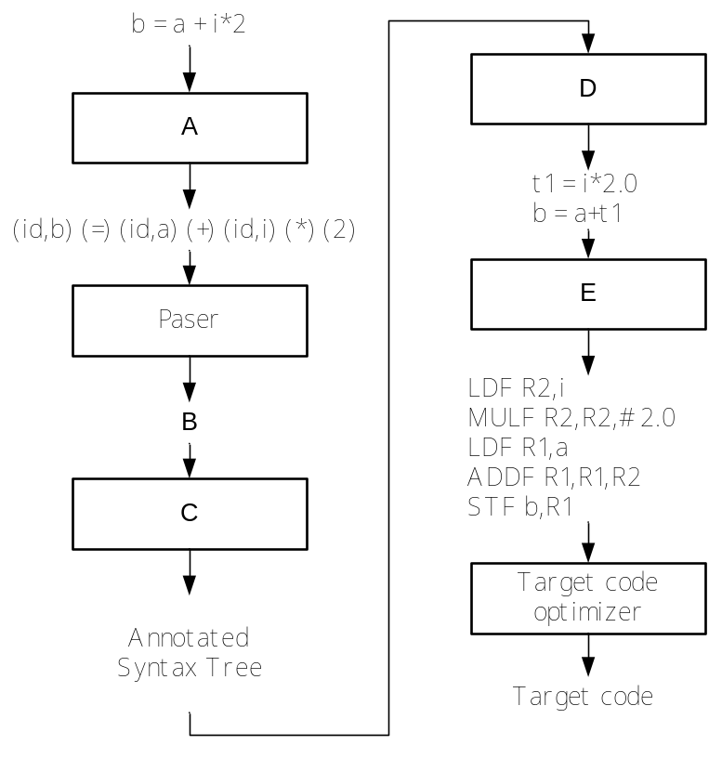
Figure 1
- Alphabet∑={a,b}, write a regular expression that will generates the set of all strings over this alphabet that contain an even number of a’s.
- Rewrite the following grammar G(S) to remove left recursion and left factor.
A → bAbB | bABb | aB
B → BaA | ab | ba
- Consider the following grammar for Boolean expressions:
E→T+E| T-E|T, T→1|2|3|4|5|6|7|8|9|0
Write a rightmost derivation for the string: 2+3-4
- Given grammar G[E]:
E→E+E | T
T→T*F | F
F→i | (E)
Write out the handle of the sentential form T*F+i

Construct minimum-state DFA for the following regular expression: a(b|ab)*, which includes：
- Convert the regular express into NFA first
- Convert the NFA into DFA
- Minimize the state of DFA

For-statement has the usual form:
for i:= initial to final do S
the meaning of for-statement can be illustrated as:
t1 = newtemp();||t2=newtemp();||
t1:=initial;
t2:=final;
if t1≤t2 then
begin
v:=t1;
S;
while v≠t2 do
begin
v:=v+1;
S;
end
end
- Give the attribute grammar for “while E do S”
- Given the three-address code corresponding to the for-statement: for v:=1 to 10 do x:=x+1.

Consider the following grammar G[S]:
S→(L)|aS’
S’→S|ε
L→SL’
L’→SL’|ε
- Please explain the grammar is LL(1) grammar.
- Construct the LL(1) parsing table

Consider the following grammar G[A]:
A → aAd | aAb | ε
- Construct the DFA of LR(0) items for this grammar
- Is this grammar the LR(0) or SLR(1) grammar ? Give your reason. If so, Construct the SLR(1) parsing table
- Show the parsing stack and the action of SLR(1) parser for the input string abd.

1.
(1)
A: Scanner
B:
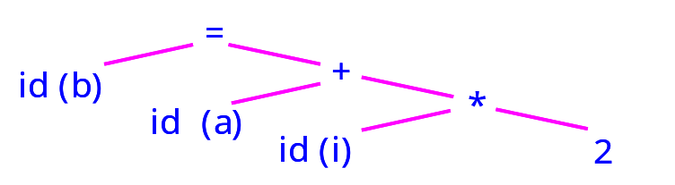
C: Semantic analyzer
D: IR Generation
E: Code generator
(2)
R.E.: ((ab*a)|b)*
(3) the rewritten grammer
A → bAbB | bABb | aB
B → BaA | ab | ba
A → bAA’ | aB
A’ →bB|Bb
B →abB’ | baB’
B’ →aAB’|ε
(4)
E→T+E| T-E|T, T→1|2|3|4|5|6|7|8|9|0
E ⇒ T+E ⇒ T+T-E⇒ T+T- T⇒ T+T- 4⇒ T+3- 4⇒ 2+3-4
(5)
T*F
2
- turn the regular expression to NFA

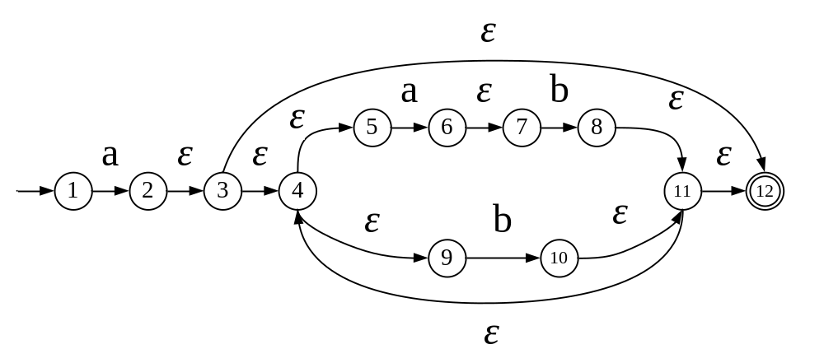
- turn this NFA into DFA using the table
I |  | I_{a} | I_{b}
{1} | 0 | {2,3,4,5,9,12}
{2,3,4,5,9,12} | 1 | {6,7} | {4,5,9,10,11,12}
{6,7} | 2 |  | {4,5,8,9,11,12}
{4,5,9,10,11,12} | 3 | {6,7} | {4,5,9,10,11,12}
{4,5,8,9,11,12} | 4 | {6,7} | {4,5,9,10,11,12}

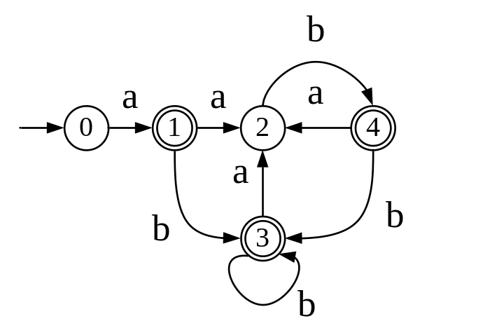

- minimize the DFA and give the reason

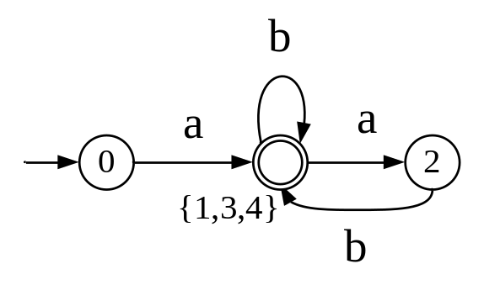
3 Solution:
- The attribute grammar is
S’ →while E do S

S’.begin=newlabel;
E.true=newlabel;
E.false=S’.next;
S.next=S’.begin;
S’.code=Label S’.begin || E.code || Label E.true || S.code ||goto S’.begin
- The Three Code is (符合逻辑的三地址码算正确)
参考：
t1=1  t2=10  if t1 ≤ t2 goto L1  goto L2  label L1  v=t1 t3=x+1 x=t3  label L4 | if v ≠ t2 goto L3  goto L2  Label L3  v=v+1 t4=x+1 x=t4  goto L4  label L2  halt

4
- Please explain the rewritten grammar is LL(1) grammar.
- S→(L)|aS’
- S’→S|ε
- L→SL’
- L’→SL’|ε

Nullable nonterminal：{S’, L’}

Productions | First sets | First(α) sets | Follow sets
 | First(S)={(, a}  First(S’)={ (,a,ε}  First(L)={ (, a }  First(L’)={(,a, ε}  First(() = {(}  First(a) ={a} | First((L))={(}  First(aS’)={a}  First(S) ={(,a}  First(SL’)={ (,a } | Follow(S)={$,(,a}  Follow(S’)={$,(,a}  Follow(L)={ ) }  Follow(L’)={ ) }
Reason:
S’→S|ε : ε in First(S’), and First(S’) ∩ Follow(S’)≠Φ, So the grammar is not LL(1)
- Construct the LL(1) parsing table
 | ( | ) | a | $
S | S→(L) |  | S→aS’
S’ | S’→S  S’→ε |  | S’→S  S’→ε | S’→ε
L | L→SL’ |  | L→SL’
L’ | L’→SL’ | L’→ε | L’→SL’
5.
1) Rewrite the grammar and Draw the DFA:
G’[A]:
(1) S’ → A
(2) A → aAd
(3) A → aAb
(4) A → ε
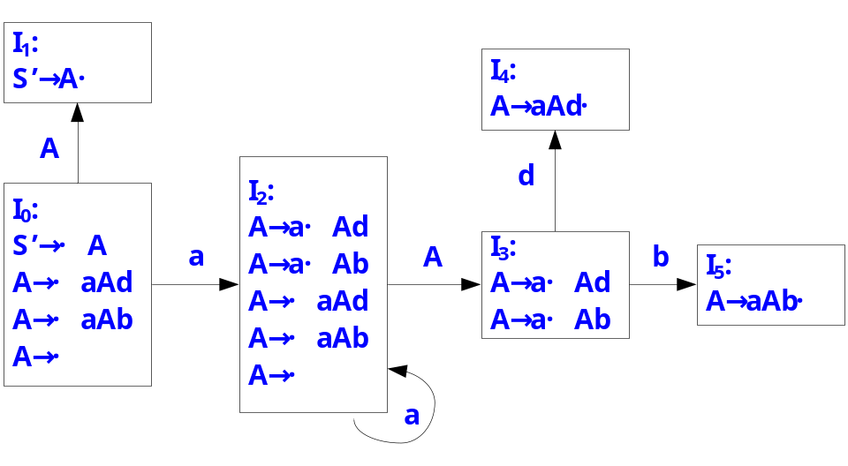
2) : Is it LR(0) or SLR(1), why?
In I₀ and I₂, there exist shift-reduce confliction.
Follow(A) ∩ {a} = {d,b,$} ∩ {a} =Φ, so G[A] is a SLR(1) grammar.

 | ACTION |  |  |  | GOTO
 | a | d | b | $ | A
0 | S₂ | r3 | r3 | r3 | 1
1 |  |  |  | acc
2 | S₂ | r3 | r3 | r3 | 3
3 |  | S₄ | S₅
4 |  | r1 | r1 | r1
5 |  | r2 | r2 | r2
3) Solution:
 | Stack | Input | ACTION | GOTO
1 | $0 | abd$ | Shift | 2
2 | $0a2 | bd$ | r3 | 3
3 | $0aA3 | bd$ | Shift | 5
4 | $0aA3b5 | d$ | r2 | 1
5 | $0A1 | d$ | err

