Fiat

Mini

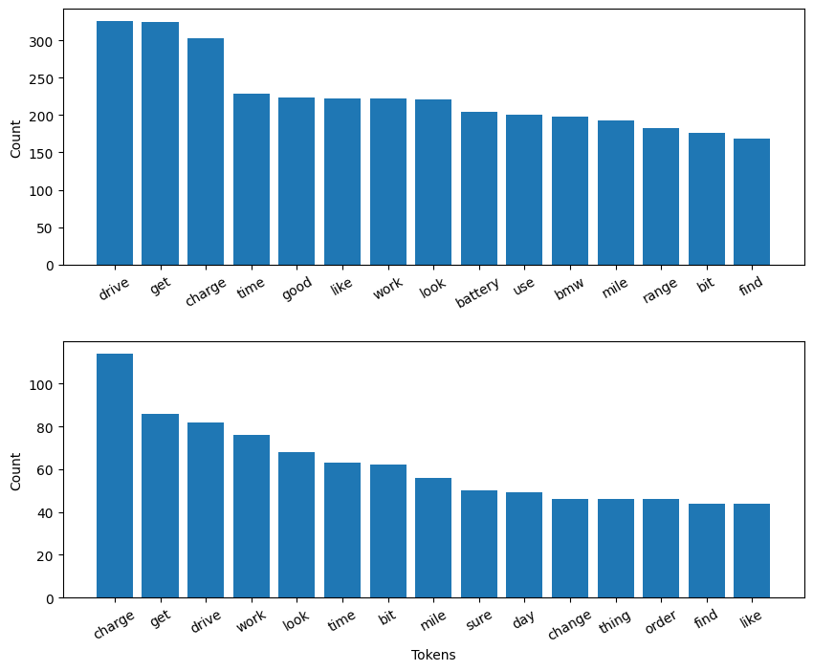

VW

Pg

Tesla

