**Fiat**

**T0: General driving experience**

range, drive, uk, dealer, cable, new, m, month, wheel, order

**T1: Charging & Facilities**

charge, charger, good, get, plug, try, work, seat, new, time

**T2: Range & Battery**

look, battery, like, range, drive, mile, good, get, app, set

**

**Experience**

**Charging**

**Range**

**Mini**

**T0: Charging (battery and range)**

charge, cable, get, charger, look, cost, work, time, use, drive

**T1: Purchase and appearance**

order, get, standard, pack, look, spec, option, good, add, black

**T2: Purchase (dealer and range)**

range, day, get, dealer, phev, mile, week, drive, order, bmw

**T3: Service (dealer)**

work, service, dealer, set, use, get, want, find, time, year

**T4: General Discussion (performance and features)**

drive, battery, mile, range, try, good, mpg, bit, brake, like

**??Driving**

**Car Spec**

**Experience**

**Battery**

**??Charging**

**VW**

**T0: Intelligent System & App**

app, work, gte, phone, time, use, drive, try, net, like

**T1: Charging & Dealer**

charge, get, dealer, try, work, look, battery, charger, week, point

**T2: Car Comparison**

like, electric, tesla, year, big, sell, battery, diesel, model, well

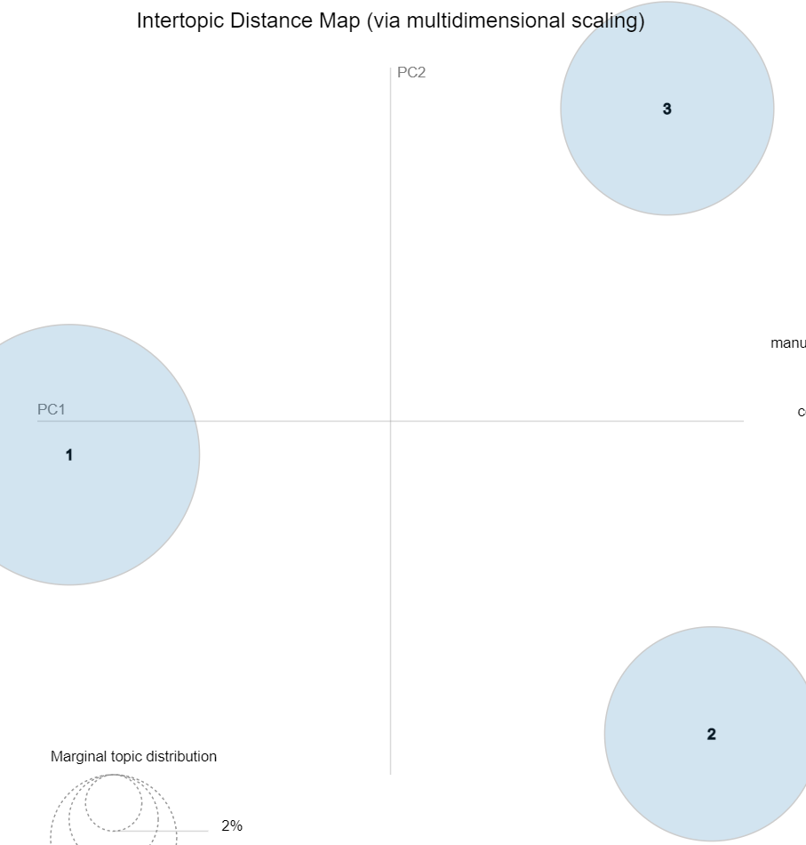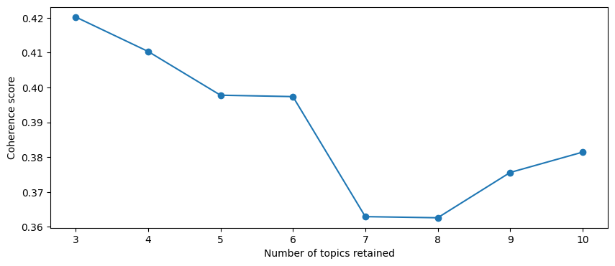

**Car Spec / Comparing**

**Battery, Charging**

**Experience**

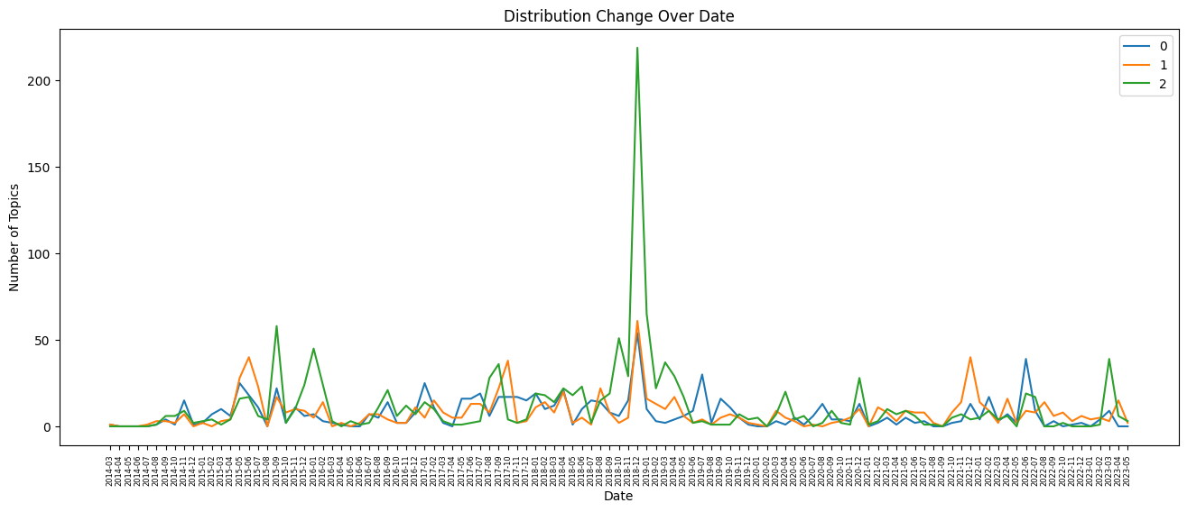

**Pg**

**T0: Maintenance & Repair**

battery, work, voltage, problem, try, ion, start, charge, issue, pin

**T1: Charging (battery and range)**

charge, battery, range, charger, drive, use, good, get, mile, work

**T2: Purchase (price & dealer)**

price, look, buy, sell, cell, year, pack, dealer, vehicle, tapatalk

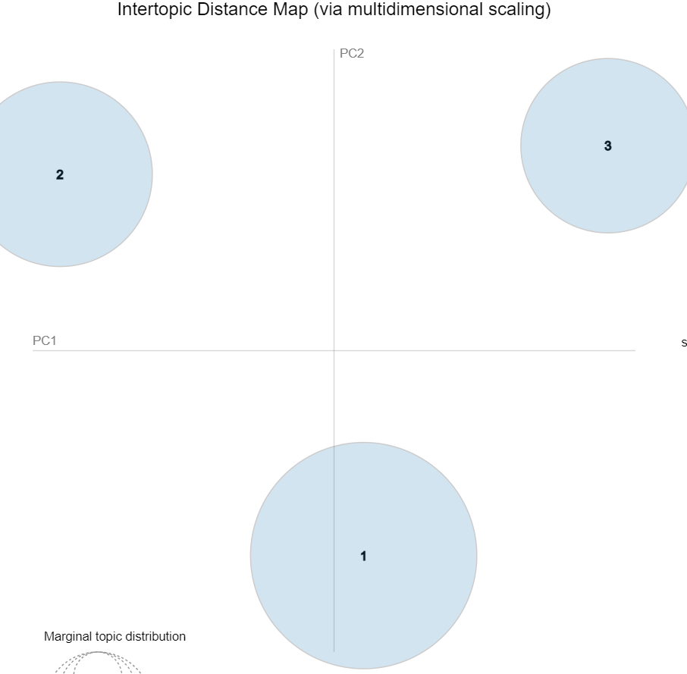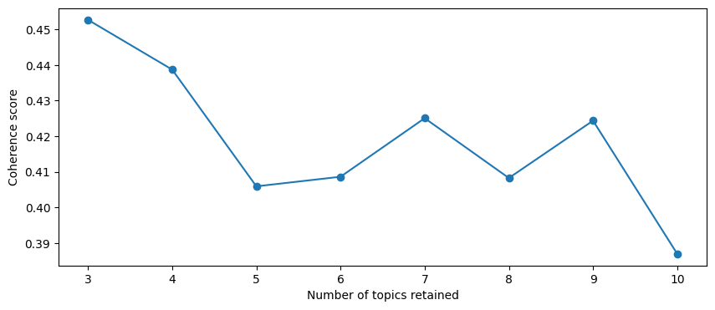

**Maintenance / Battery data**

**Charging VS Range**

**Electrical / battery problem**

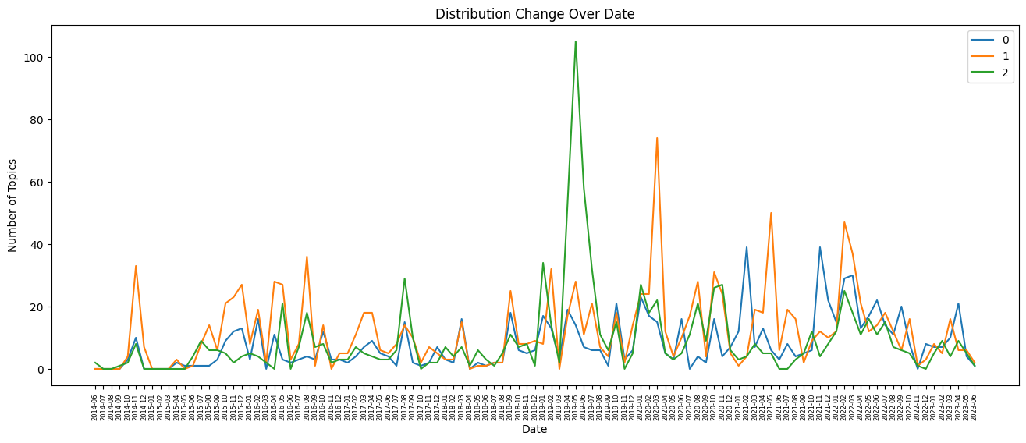

**Tesla**

**T0:** **General Discussion (Automation and others)**

drive, like, time, thing, look, driver, good, road, work, way

**T1:** **Purchase (price)**

year, model, buy, model_s, like, price, cost, market, new, sell

**T2:** **Charging & Battery**

charge, supercharger, use, charger, time, work, battery, site, get, uk

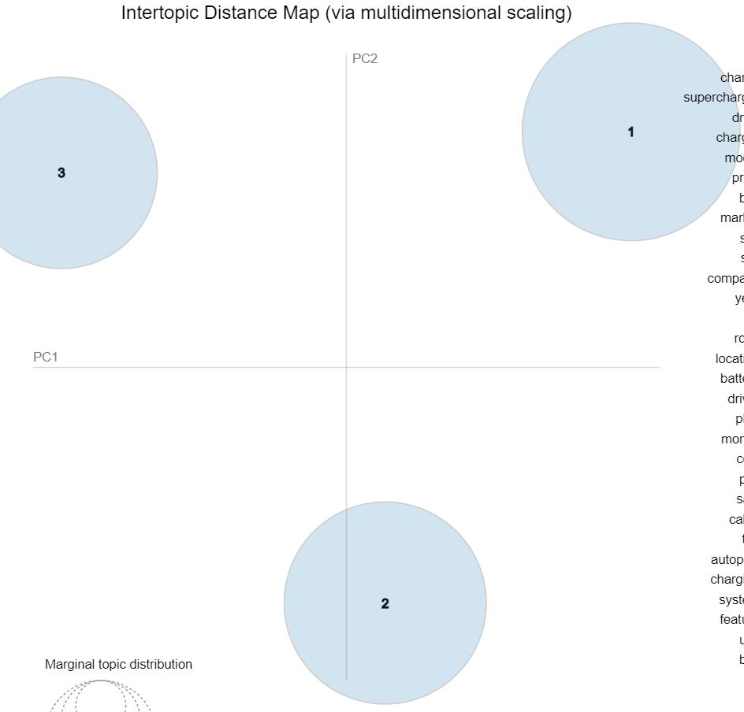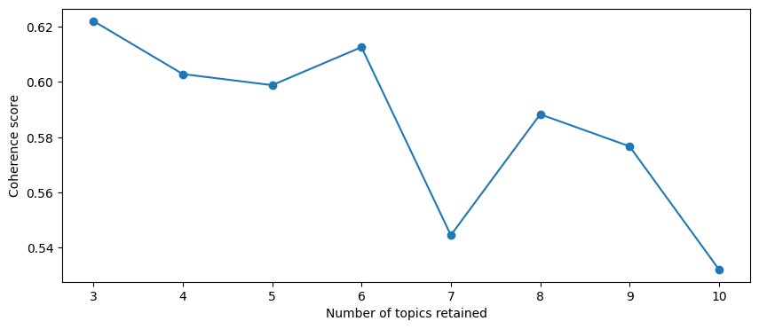

**Experience**

**Market**

**Battery, Charging**

