characteristics of photos in facebook:

* write once, read often, never modified, barely delete

the bottleneck: read the metadata(inode) of photos from disk to memory

the requirement of haystack:

* high throughput low latency
* fault toletent
* cost effective
* disk

## design pattern

* typical design

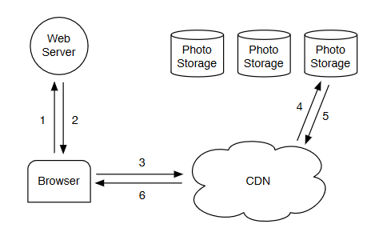

* NFS-based design

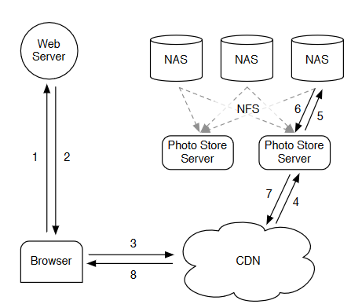

cache problem: cache has limited improvement for long tail requests

solution: reduce the metadata size for photos so that the metadata can be all cached-> store multiple photos in a large file.

