## Introduction

the definition of monitor: a set of resource and the procedures to allocate the resources.

the mechanism: at one time only one procedure can get access to the monitor.

wait: cause the calling program to be delayed; (and after that, the resource must be released)

singal: cause one of the waiting programs to be resumed; (after that, the resource must be assigned to a waiting program)

condition variable - control the wait and the signal - **reasons for waiting**

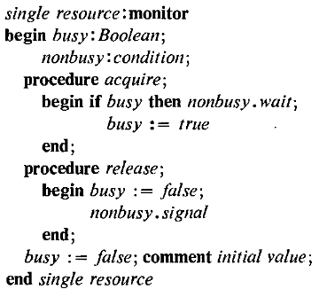

the condition variable and its wait and signal can be implemented by the semaphore. To increase the efficiency, try to use *hardware*.

## bounded buffer example

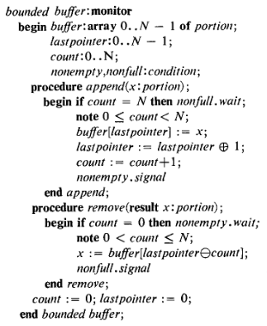

## the waiting schedule strategy

usual: FIFO

special: weighted

## the samples

* buffer allocation
* disk head scheduler
* reader && writer

## problems

* the interaction among different monitors to get more information to make optimization decisions
* critical regions on the procedures.