Pilot is designed for the personal computing environment, single language and single user.

no need for security protection, no need for sharing resources, no need for right check.

single address: like embedded.

\tip: problems of hints: security damage

## pilot interfaces

a software system: program modules && definition modules

definition modules: interfaces(public, private)

*File and Volumn*: get access to a file -> map it to a section of virtual memory

file attributes: size, type, permanence, immutability

\tip: permanence: like temporary file, lose it when you reboot the system.

permanence to solve “lost object problem”

immutability means read-only.

virtual memory: each page with three flags.

space interface: allocation entity, mapping entity, swapping entity.

pilot stream facility: transducer and the filter

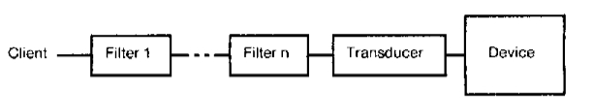

the communication methods:

* shared-memory for tightly coupled processes
* communications facility for loosely coupled processes(on different machines) using packet communication protocols.

packets are transferred in the Internet

network address <-> socket <-> machine

network address: 16-bit network number, 32-bit processor ID, 16-bit socket number

package level:

level 0: requirements for the communication medium

level 1: the format of the internetwork packet

level 2: special kinds of packages, such as error packet, connection-oriented sequenced packet etc.(its like the stream)

\tip: above: like TCP.

## implementation

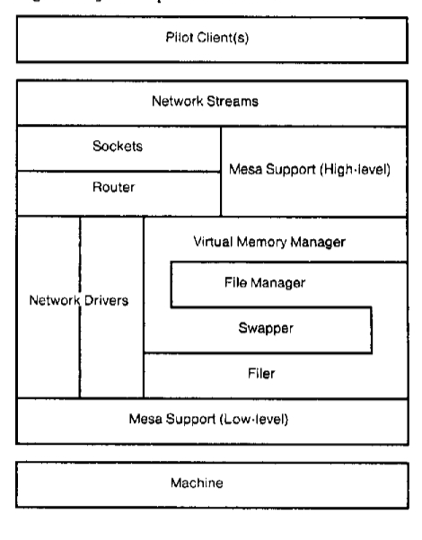

storage system: a small body of code permanently in primary memory; storage facility to significantly ease the implementation of the remainder;