sprite: network operating system

trends: networks, large memories, multiprocessors.

three additional facilities:

transparent network file system

sharing writable memory between processes on a single workstation

migrating processes between workstations

## application interface

**sharing** - all the disks and I/Os among machines are shared

* physical memory sharing
* process migration **proc_migrate**: move the process at any time, even if it has begun

transparency for the file systems

the sharing between processes: shared fork -> the child process can share the data of write-read rights with its parent. **proc_fork**

## basic kernel structure

* multi-threading
  + single-threaded UNIX kernel: only one system call can enter the kernel for the same time so there is no synchronization problem.
* RPC

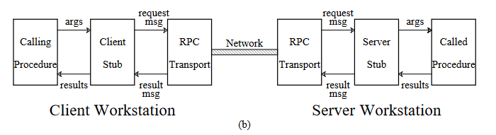

use fragmentation to ship large blocks of data in a single remote operation

the file system in Pirate: domains with prefix tables.

locating a file -> two kinds of paths -> absolute && relative path

make a new prefix table entry: broadcast

reconfiguration: client request timeout -> invalid the entry and rebroadcast -> the new entry re-respond.

### file cache

delayed-write policy: 30seconds for ellipse.

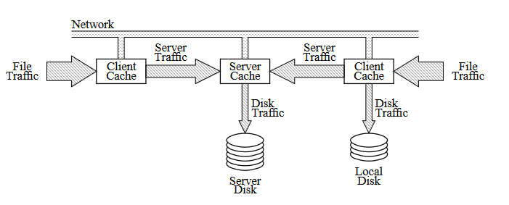

cache consistency is ensured in pirate through **fs_read**.

sequential write-sharing: version number

concurrent write-sharing: disable the client cache

consistency and synchronization difference

sticky segments: the code pages of a program are kept in the memory after the program exits.

the negotiation between file system and the virtual memory.