BOGA LEGABA
Guest House & Conference Centre
Website User Guide
A plain-English handbook for guests and for staff
Mahikeng, North West Province, South Africa
www.bogalegaba.co.za · info@bogalegaba.co.za · +27 82 875 7018

Version 1.0 · Prepared 3 August 2026

What is in this guide
This guide is written for two kinds of reader. If you are a guest booking a room, you only need Sections 1 to 3. If you work at Boga Legaba and manage the website, you will also need Sections 4 onwards.
Section | What it covers
1. Welcome | What the website is for, and what you can do on it
2. Getting started | Opening the site, finding your way around, digital check-in (Steps 1–5)
3. Guest guide | Browsing, searching, booking, paying, confirming, changing a booking, getting help (Steps 6–15)
4. Staff guide | Signing in, the dashboard, bookings, rooms, photos, reviews, reports (Steps 16–25)
5. Quick reference | The ten things people do most often, on one page
6. Picture index | Every screenshot in this guide, listed in order
7. Troubleshooting | Eighteen common problems and how to fix them
8. Glossary | Every unfamiliar word on the screen, explained simply
9. Contact & support | Who to call, and what to tell them

TIP: You do not need to read this from cover to cover
Use the table above to jump to the part you need. Every instruction is numbered, and every screen you will see has a picture next to it.

1. Welcome

What this website is for
The Boga Legaba website lets guests see which rooms are genuinely free on the dates they want, book one, and pay for it — without phoning anyone. It also gives Boga Legaba staff a private area for seeing every booking, managing room photos, and checking that bookings have reached the reservation system correctly.
Boga Legaba is not a single building. Rooms are spread across separate properties at different street addresses in Mahikeng. This matters when you arrive, so the website shows the property name on every room.
Property | Where it is
Chababa | 8 Interlaken Avenue, Riviera Park, Mahikeng, 2745
Interlaken A | 6 Interlaken Avenue, Riviera Park, Mahikeng
Lantana | 10 Lantana Street, Mahikeng — also the conference venue
Transnet Portfolio | Additional rooms; the address is confirmed when you book

IMPORTANT: Always check your arrival address
Because the properties are on different streets, the address on your booking confirmation is the one to drive to. Do not assume every booking is at the same place.

What a guest can do
- See live room availability for chosen dates — the list is fed directly from the reservation system, so it is accurate at the moment you look at it.
- Compare room types, bed configurations, bathroom types and nightly rates.
- Choose a meal plan: Room Only, Bed & Breakfast, or Dinner, Bed & Breakfast.
- Book and pay by card or EFT in one sitting.
- Complete a digital check-in form before arrival, to save time at reception.
- Send an enquiry by WhatsApp, phone or the contact form.

What a staff member can do
- See every booking, filtered by who is arriving, who is in-house, and who is leaving.
- See bookings made on the website, and whether the guest's payment succeeded.
- Spot a paid booking that has not reached the reservation system, and push it through again.
- Add a booking manually on behalf of a guest who phoned in.
- Upload and remove room photographs.
- Read guest registration (digital check-in) submissions.
- Refresh the guest reviews shown on the home page.

2. Getting started

Step 1: Opening the website
1. Open your web browser — Chrome, Safari, Edge or Firefox all work.
2. Click into the address bar at the very top of the browser window.
3. Type www.bogalegaba.co.za and press Enter.
4. The home page opens. You do not need to sign in, and you do not need an account, to look at rooms or to book one.
TIP: The site works on a phone too
Every screen in this guide also works on a mobile phone. On a small screen the menu across the top collapses into a button with three lines — tap it to see the same list of pages.

Step 2: Understanding the home page
The home page introduces the guest house and gives you the quickest routes to the things people want most: seeing rooms, and making a booking.
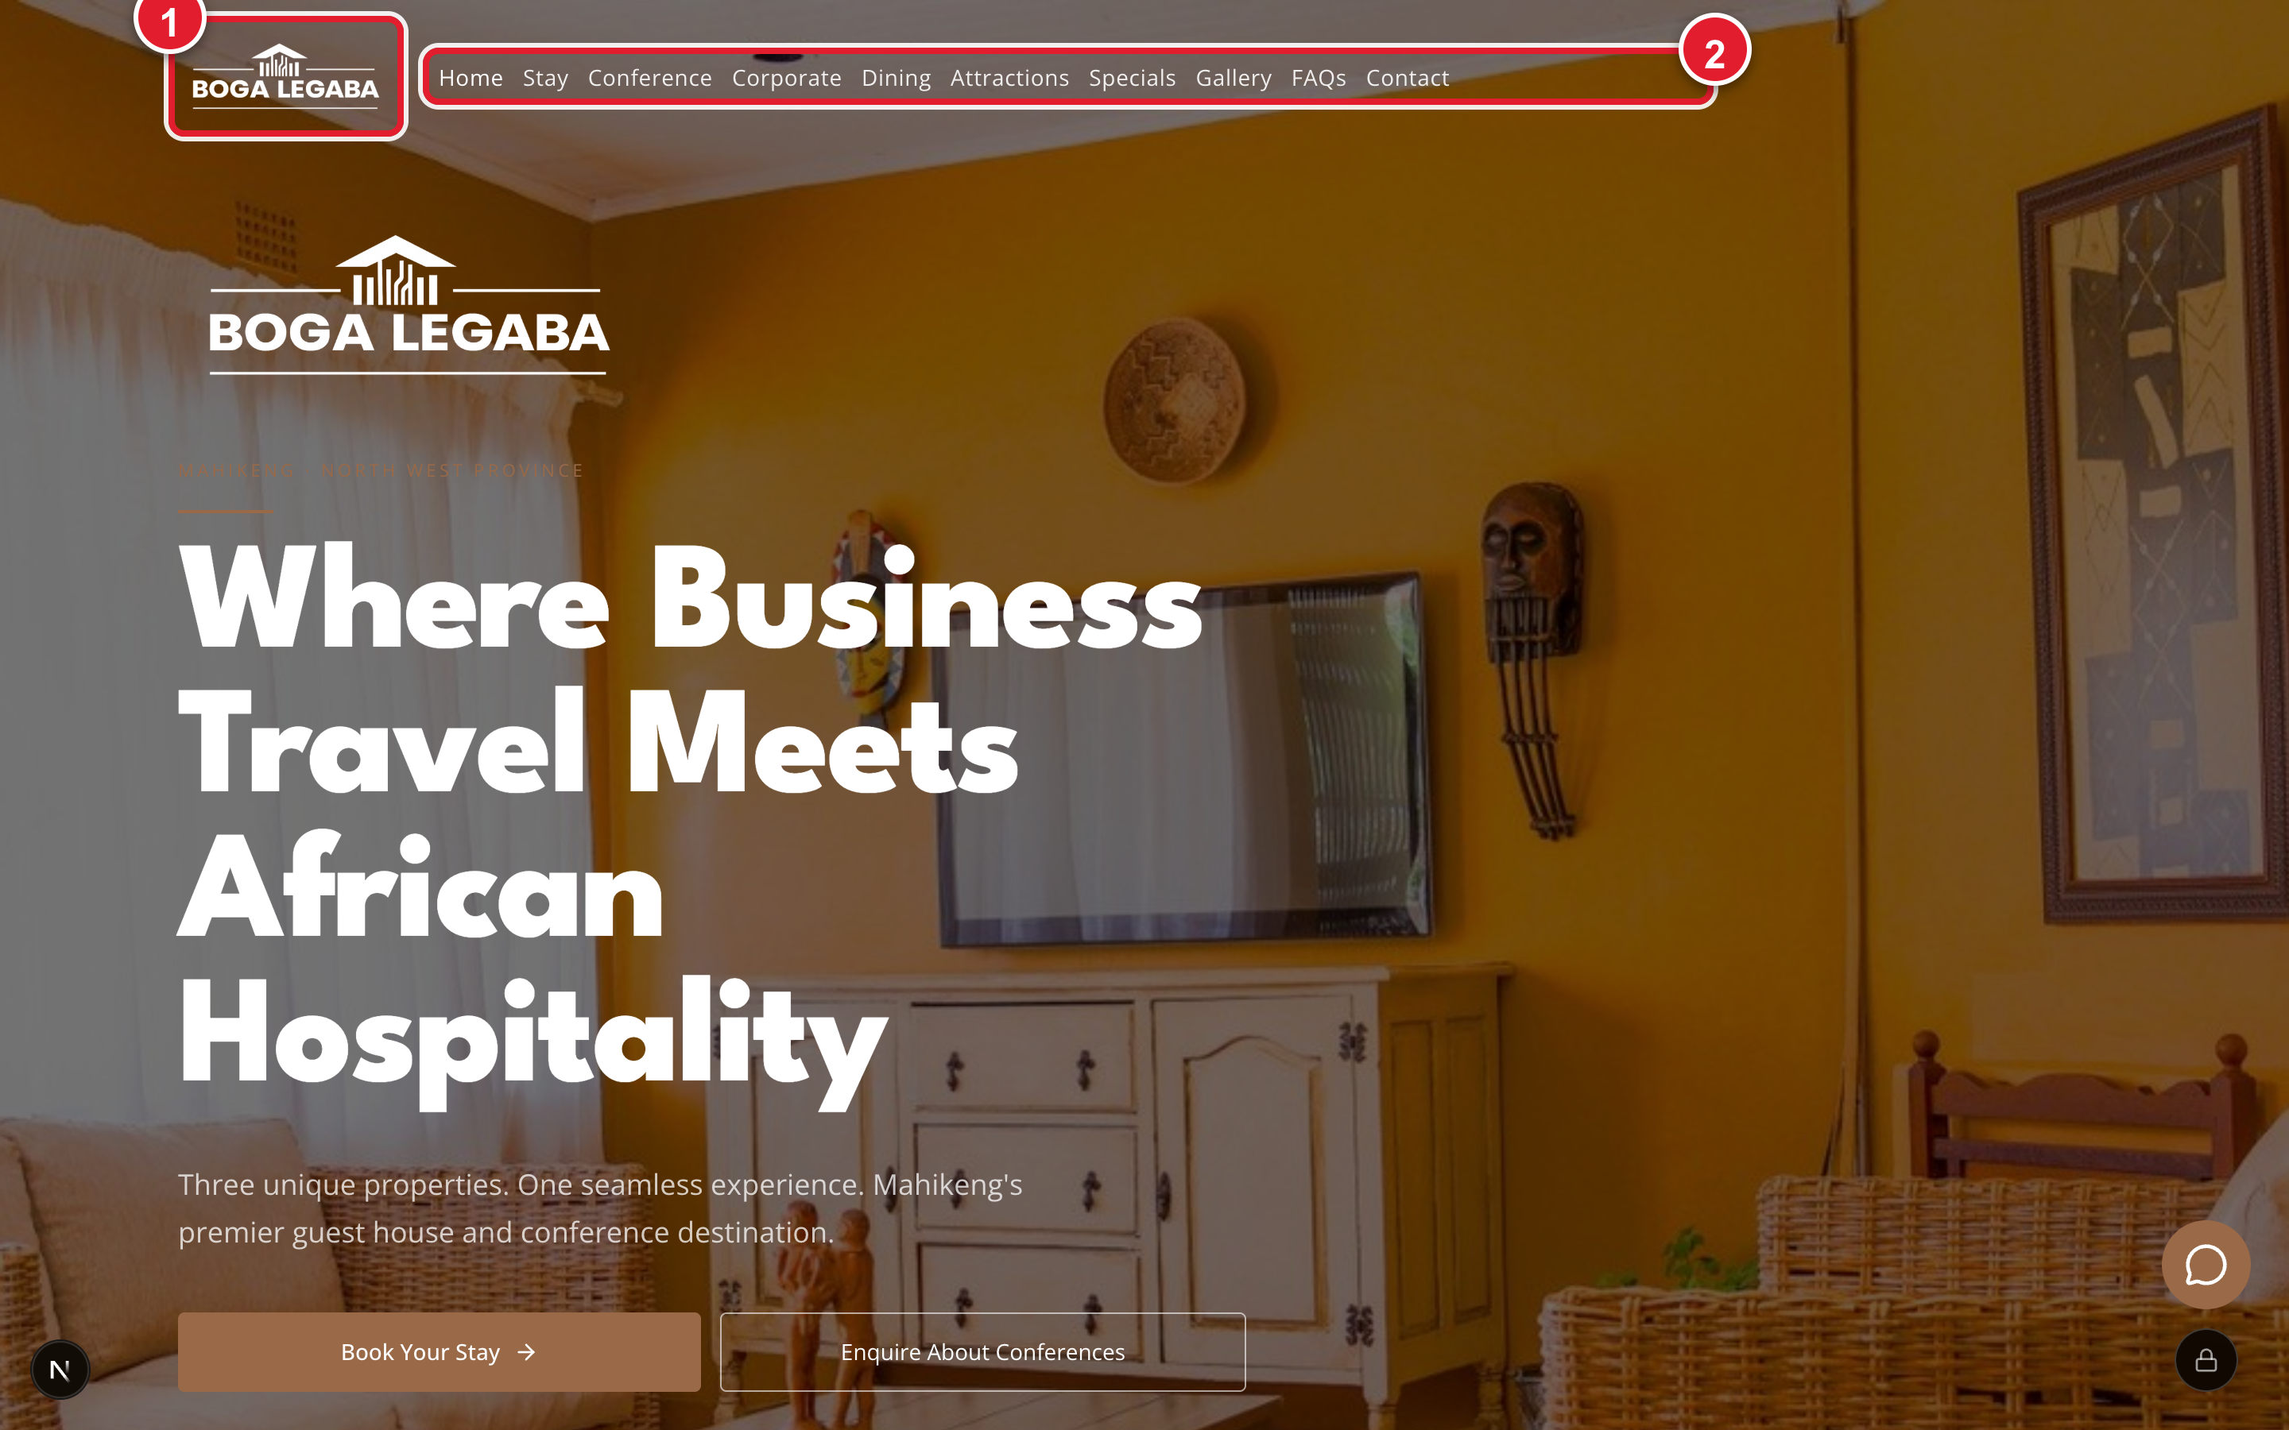
Fig. 1.1 The home page, with the two things you use most marked
This is the first screen you see. Marker 1 is the Boga Legaba logo — clicking it always brings you back here. Marker 2 is the main menu.

Step 3: Using the main menu
The menu runs across the top of every page. It never changes, so you can move between sections from anywhere on the site.
Menu item | What you will find there
Home | The main welcome page
Stay | Every room, with photographs, bed types and a search box
Conference | The conference venue, seating layouts and equipment
Corporate | Business and government accommodation, invoicing and purchase orders
Dining | Meals and breakfast arrangements
Attractions | Things to see and do near Mahikeng
Specials | Current offers and packages
Gallery | Photographs of the properties
FAQs | Answers to the questions guests ask most
Contact | Phone number, email address, a map, and a message form

TIP: The quickest way to book
From any page, click Stay in the menu, then use the Book This Room button on the room you want. You never need to go back to the home page first.

Step 4: Completing your digital check-in
Boga Legaba asks guests to fill in their arrival details before they get there. This is the digital check-in, and it saves you filling in a paper register at reception. It is separate from booking — you can do it any time before you arrive.
1. Go to www.bogalegaba.co.za/register in your browser.
2. Fill in your Full name. This is the only field you must complete.
3. Add your Email and Phone so reception can reach you.
4. Fill in Home / residential address, Nationality and ID / Passport number. Foreign guests must give a passport number.
5. Add your Vehicle registration if you are driving — this is used for parking and security.
6. Enter the Number of guests and the Names of all guests staying, separated by commas.
7. Give an Emergency contact name and Emergency contact phone.
8. Click the submit button at the bottom of the form.
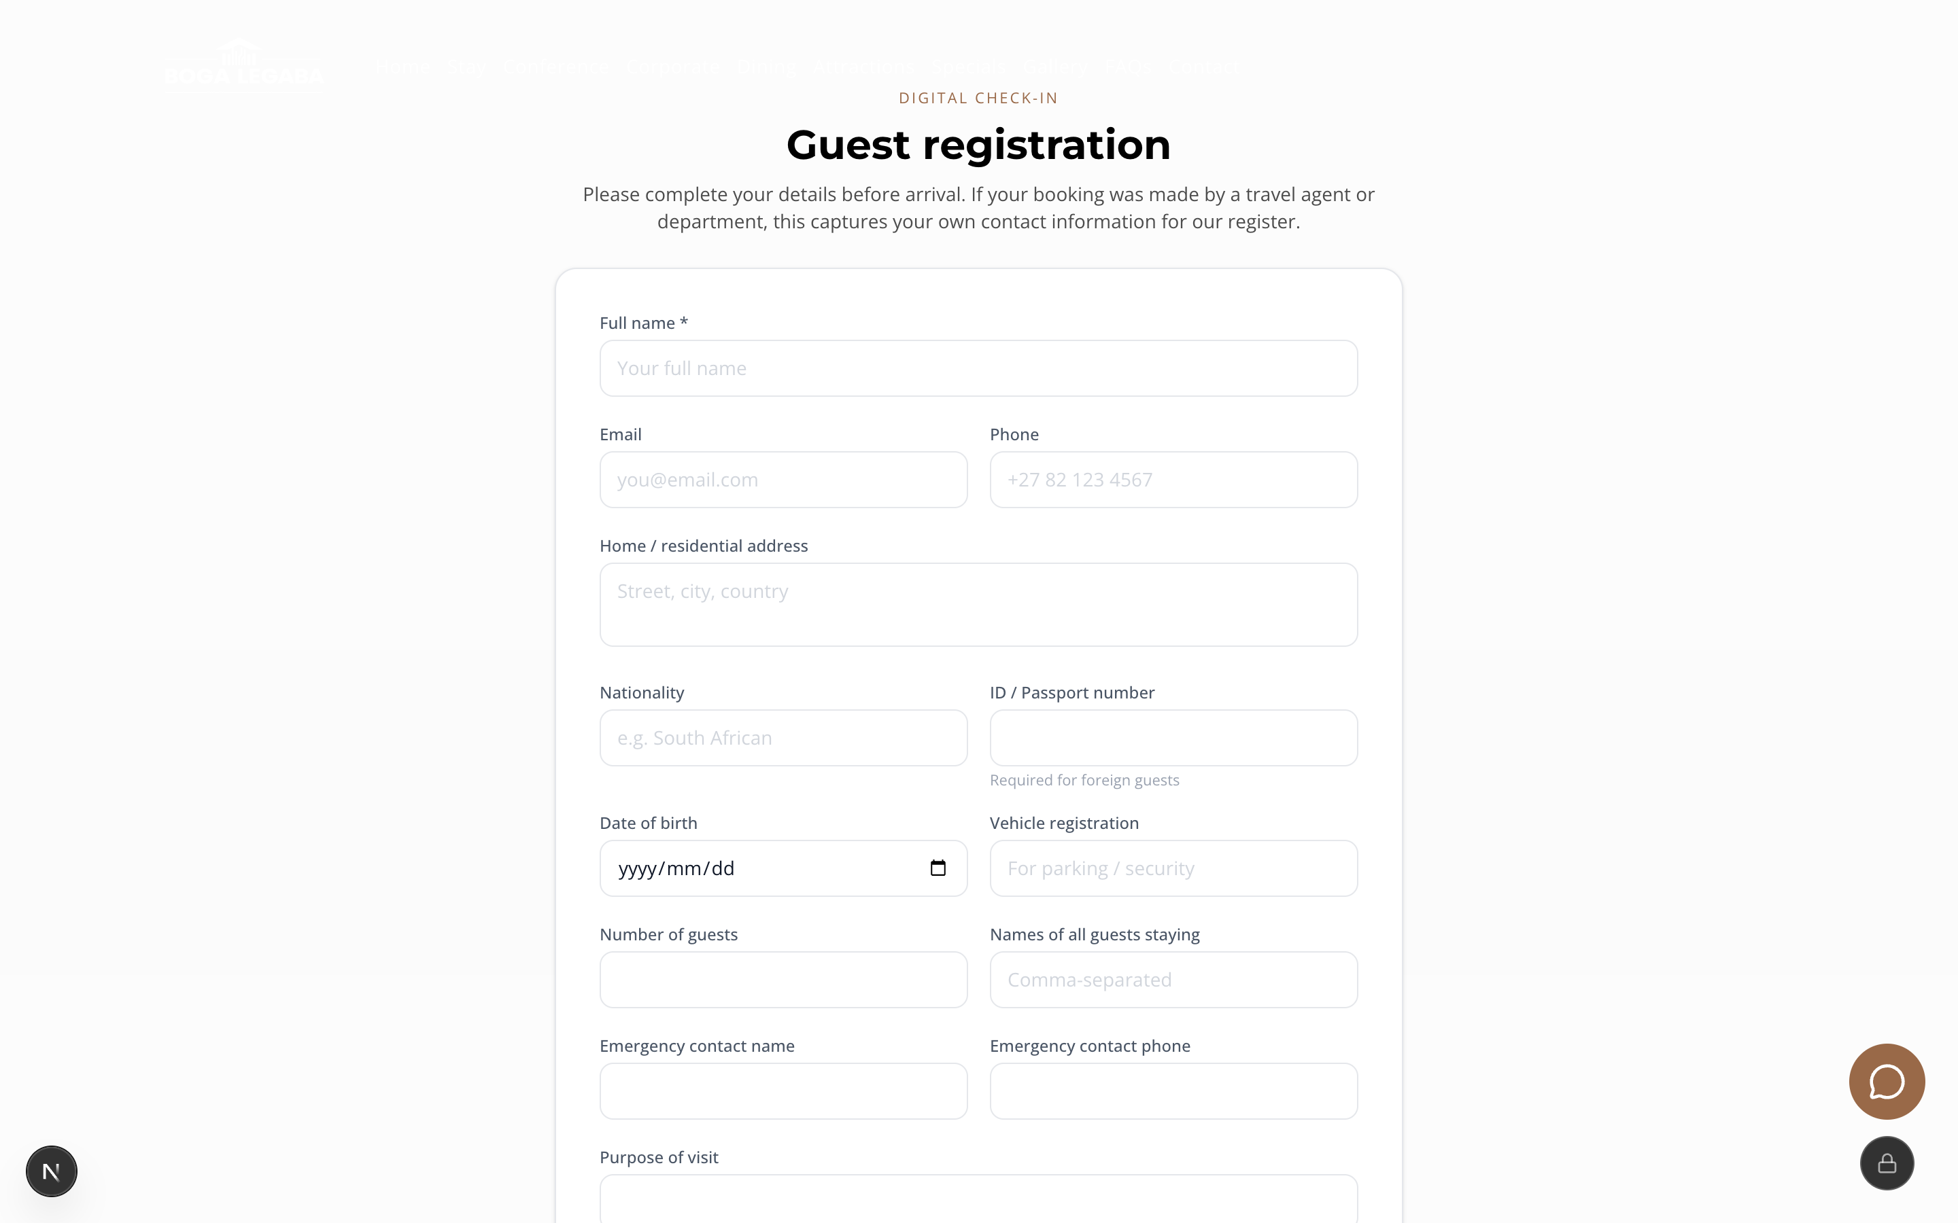
Fig. 2.1 The digital check-in form
This is the Guest registration screen. Only Full name is compulsory, but the more you complete, the faster your arrival will be.

Step 5: Signing in
SUCCESS: Guests do not need an account
There is no guest login on this website, and no password for you to remember. You can browse, book and pay without ever creating an account. Your booking is identified by a booking reference instead.
Only Boga Legaba staff sign in, and only to reach the private management area. If you are a staff member, that is covered in Step 16.

3. Guide for guests

Step 6: Browsing available rooms
1. Click Stay in the menu at the top of any page.
2. Scroll down. Rooms are grouped under the property they belong to — Chababa first, then the other properties.
3. Read each room card. A green AVAILABLE badge means the room can be booked.
4. The small grey tags on each card tell you the property, the bed type (for example DOUBLE or TWIN) and the bathroom (BATH ONLY, SHOWER, or BATH & SHOWER).
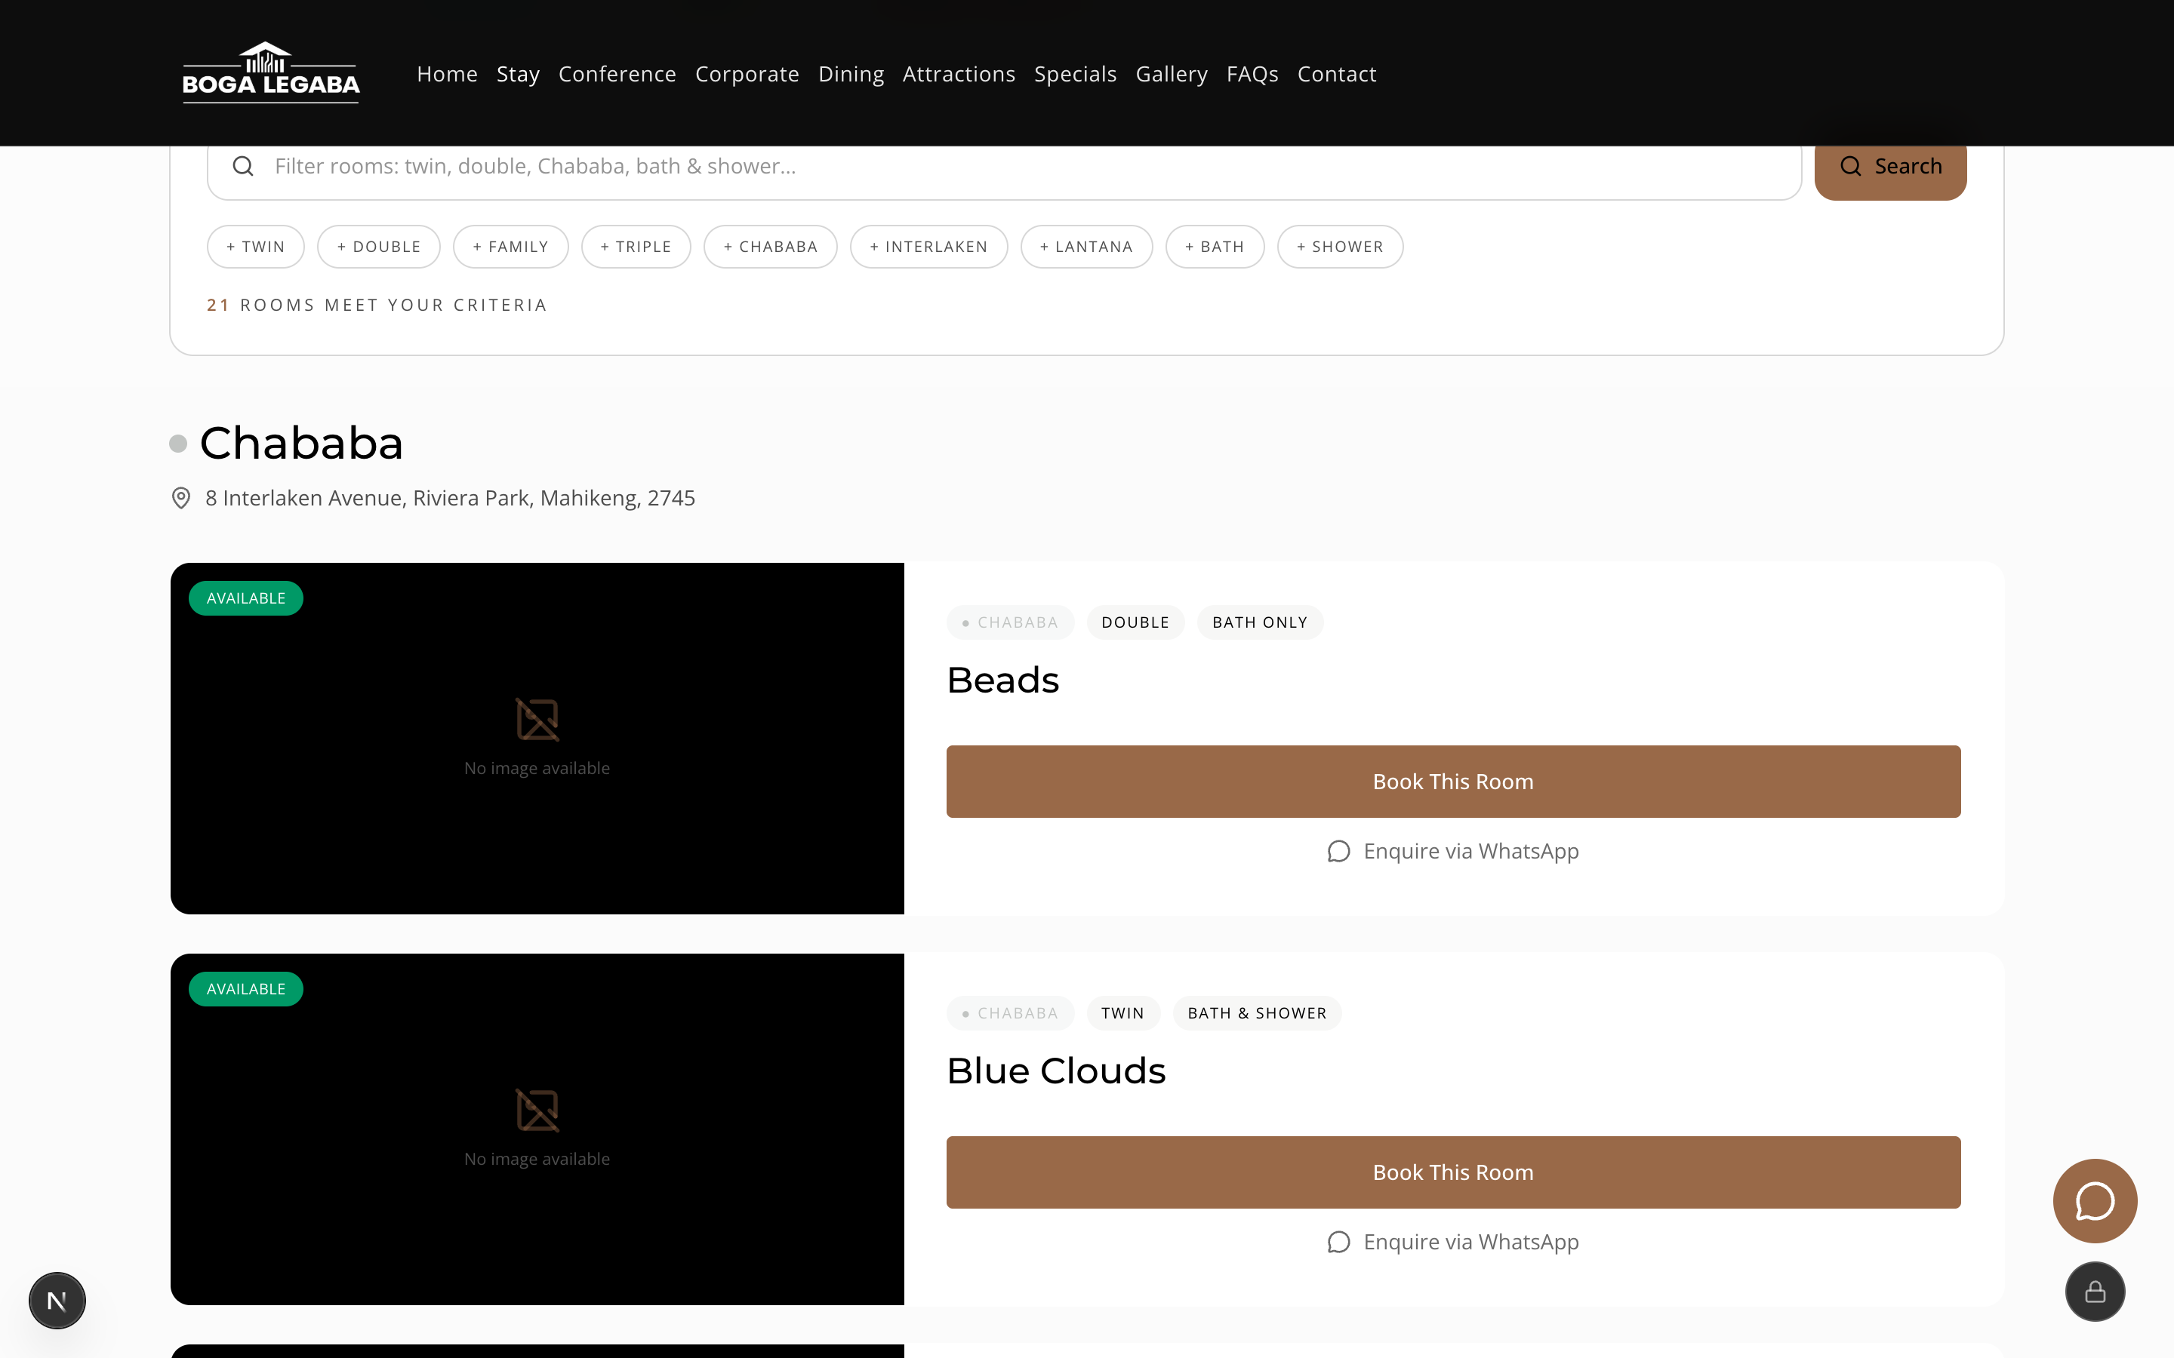
Fig. 3.1 The Stay page, showing rooms grouped by property
Each room is one card. The green AVAILABLE badge, the room name, and the Book This Room button are the three things to look at.
IMPORTANT: Some rooms have no photograph yet
If a room shows a grey box reading “No image available”, the photograph simply has not been uploaded yet. The room is still real and still bookable — ask for pictures on WhatsApp if you want to see it first.

Step 7: Searching and filtering rooms
If you already know what you want, use the search box instead of scrolling.
1. On the Stay page, click into the box that reads “Filter rooms: twin, double, Chababa, bath & shower…”.
2. Type what you are looking for — a bed type, a property name, or a bathroom type.
3. Click the brown Search button, or simply press Enter.
4. Alternatively, click one of the grey filter buttons below the box: + TWIN, + DOUBLE, + FAMILY, + TRIPLE, + CHABABA, + INTERLAKEN, + LANTANA, + BATH or + SHOWER.
5. You can click several filters at once — for example + TWIN and + CHABABA to see only twin rooms at Chababa.
6. Watch the line that reads “N ROOMS MEET YOUR CRITERIA”. That number tells you how many rooms match.
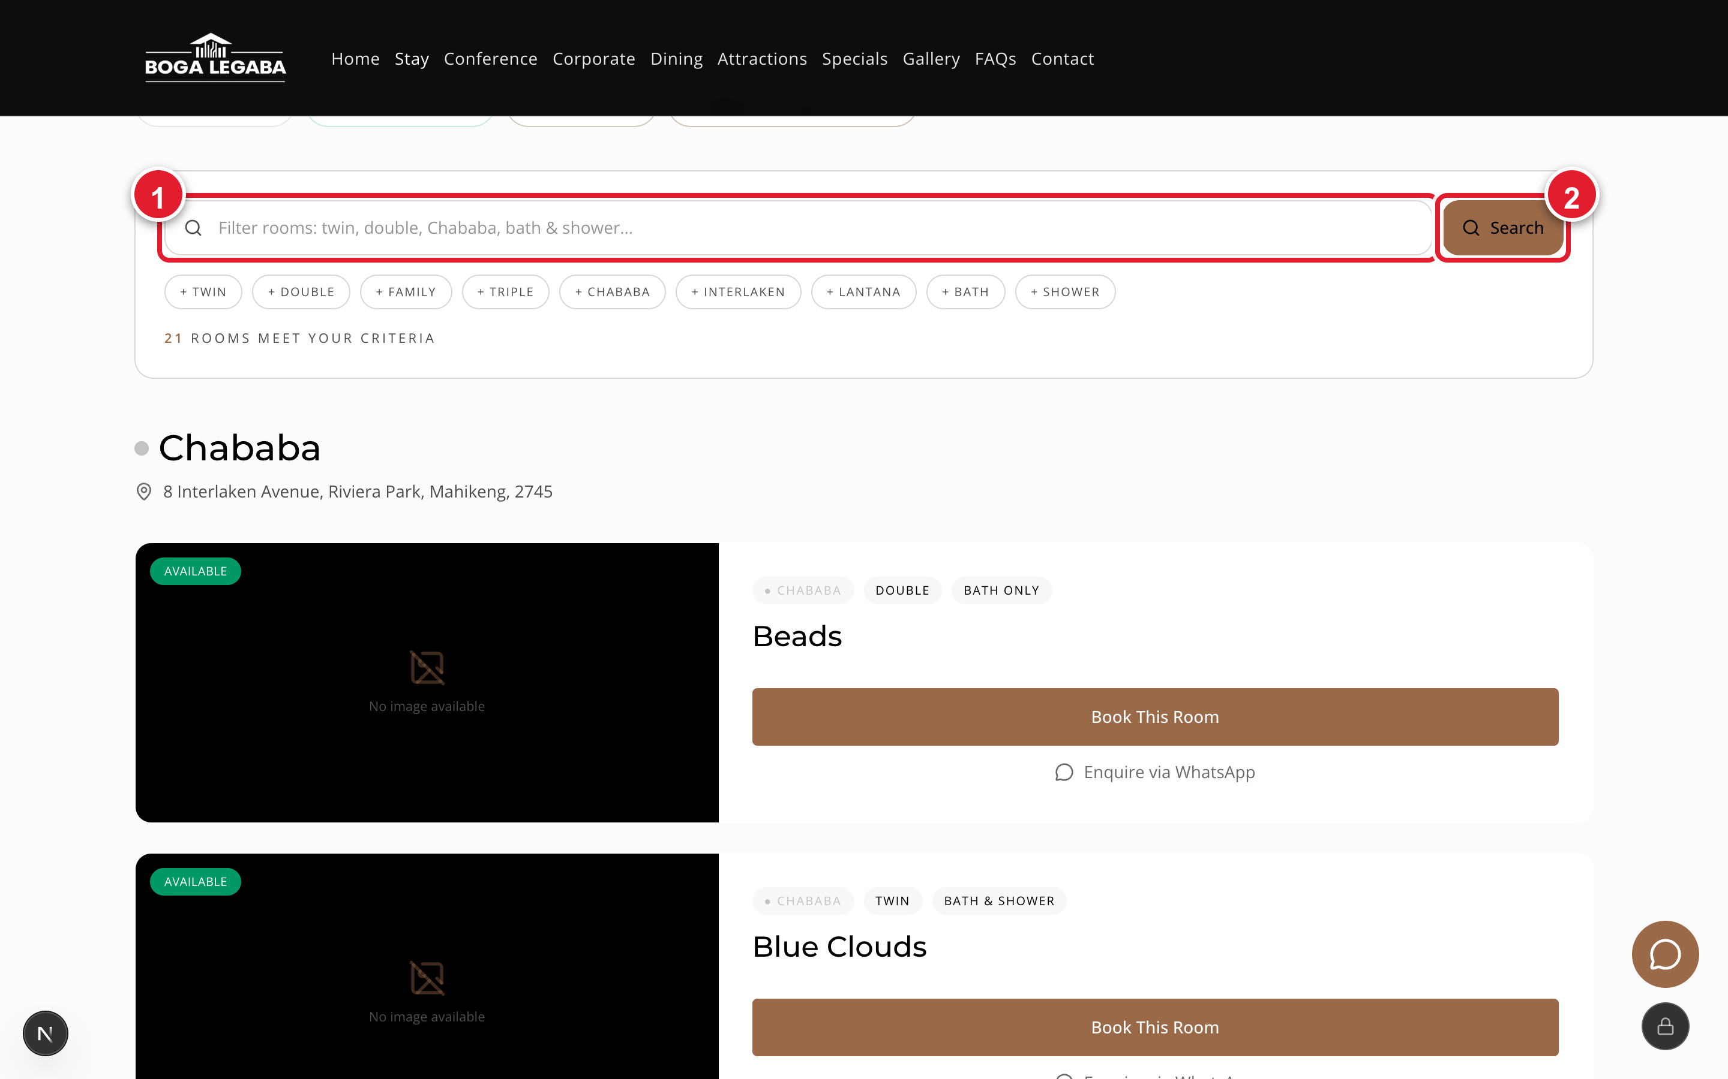
Fig. 3.2 The room search box and filter buttons
Marker 1 is where you type. Marker 2 is the Search button. The filter buttons underneath do the same job with one click.
TIP: If nothing matches
If the count drops to zero, you have probably chosen filters that cannot exist together. Click the filters again to switch them off, and start with just one.

Step 8: Viewing the details of one room
Before booking, open the room to see exactly what you are paying for.
1. Click Book This Room on the room card, or View & Book in the availability list.
2. At the top you will see a large photograph, the room name, the size in square metres, the bed, and the maximum number of adults.
3. Read About this room for a written description.
4. Look at Room facts for the size, bed, guest limit, tier, type and whether the room is non-smoking.
5. Look at Room amenities, grouped as In-Room, Bathroom and Kitchen.
6. On the right, the green Available panel confirms the room is free for your dates, and Rate options · per night shows the price for each meal plan, for one adult and for two adults.
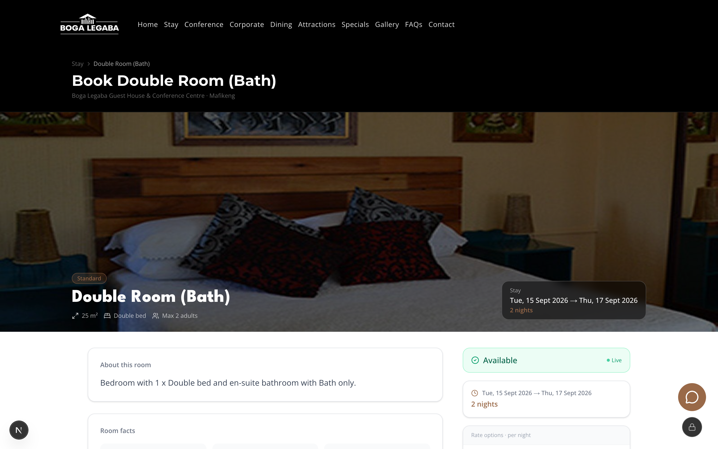
Fig. 3.3 The top of a room's own page
The photograph, the room name, and a green Available panel confirming the room is free for the dates shown.
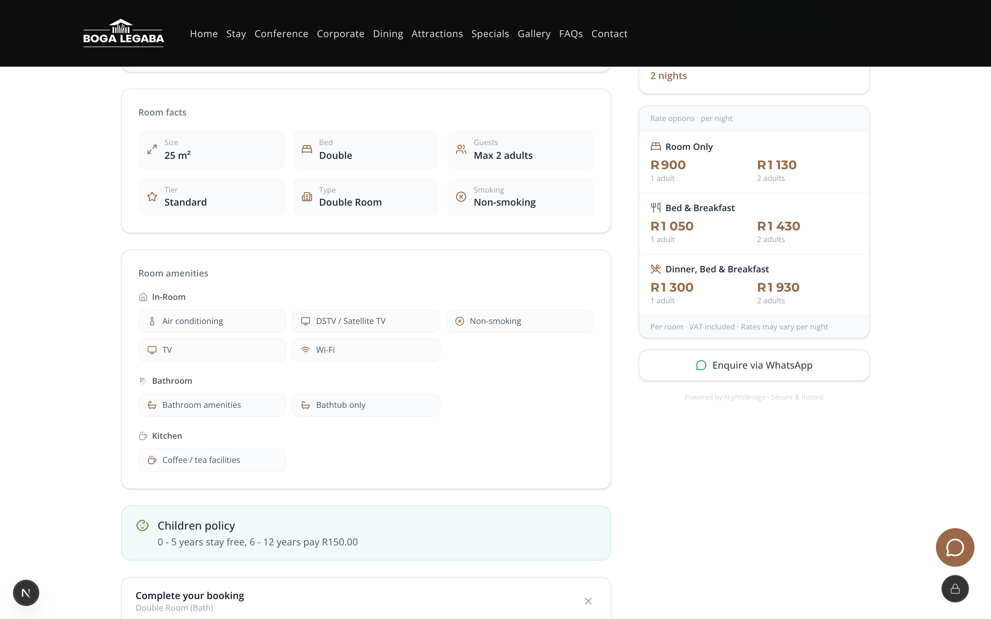
Fig. 3.4 Room facts, amenities and the nightly rates
Room facts and Room amenities are on the left. The rate for each meal plan, for one and for two adults, is on the right.
TIP: Prices are per room, per night, and include VAT
The rates panel says “Per room · VAT included · Rates may vary per night”. If your stay crosses a weekend or a busy period, the nightly rate can differ from night to night.

Step 9: Making a booking
Booking happens on one screen. You choose your dates, check the room is free, then fill in one form.
1. Click Stay, then Book Now, or go straight to the Book a room page.
2. Check the dates shown at the top of the availability panel — for example “Tue, 15 Sept 2026 → Thu, 17 Sept 2026”, with the number of nights beside them.
3. Read down the Available rooms table. Each line shows the room type, how many guests it sleeps, the price for 1 adult per night, the price for 2 adults per night, and a Status.
4. A green Available in the Status column means you can book it.
5. Click the brown View & Book button on the line you want.
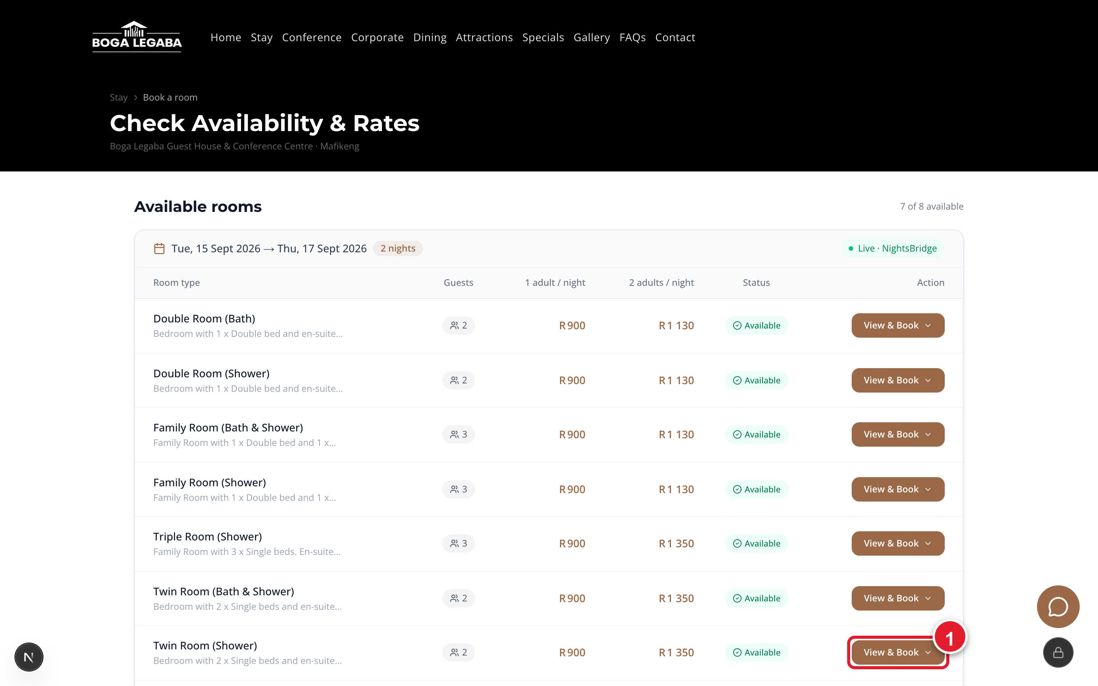
Fig. 3.5 The Check Availability & Rates screen
Marker 1 is the View & Book button. The green “Live · NightsBridge” tag means these rooms are free right now, not a stale list.
SUCCESS: “Live” means exactly that
The availability you see is read from the reservation system at the moment the page loads. If a room shows as Available, it genuinely is — although a very popular room can still be taken by someone else while you are filling in the form.

Step 10: Entering your personal and payment details
Clicking Book This Room opens a panel headed Complete your booking. Work down it in order.
1. Under MEAL PLAN, choose one: Room Only, Bed & Breakfast, or Dinner, Bed & Breakfast. The price beside each option updates the total.
2. Under GUESTS, set the number of Adults using the − and + buttons.
3. Set Children 0-5 and Children 6-12 if you are travelling with children.
4. Under PERSONAL INFORMATION, fill in First name and Surname. Both are required.
5. Enter your Phone number including the country code — for example +27 82 555 0134.
6. Enter your Email, then type it again in Re-type email. These must match exactly, because your confirmation is sent there.
7. Optionally add your Approx. arrival time, and your Airline and Flight no. if you are flying in.
8. Use Special requests for anything else — a ground-floor room, a late arrival, dietary needs.
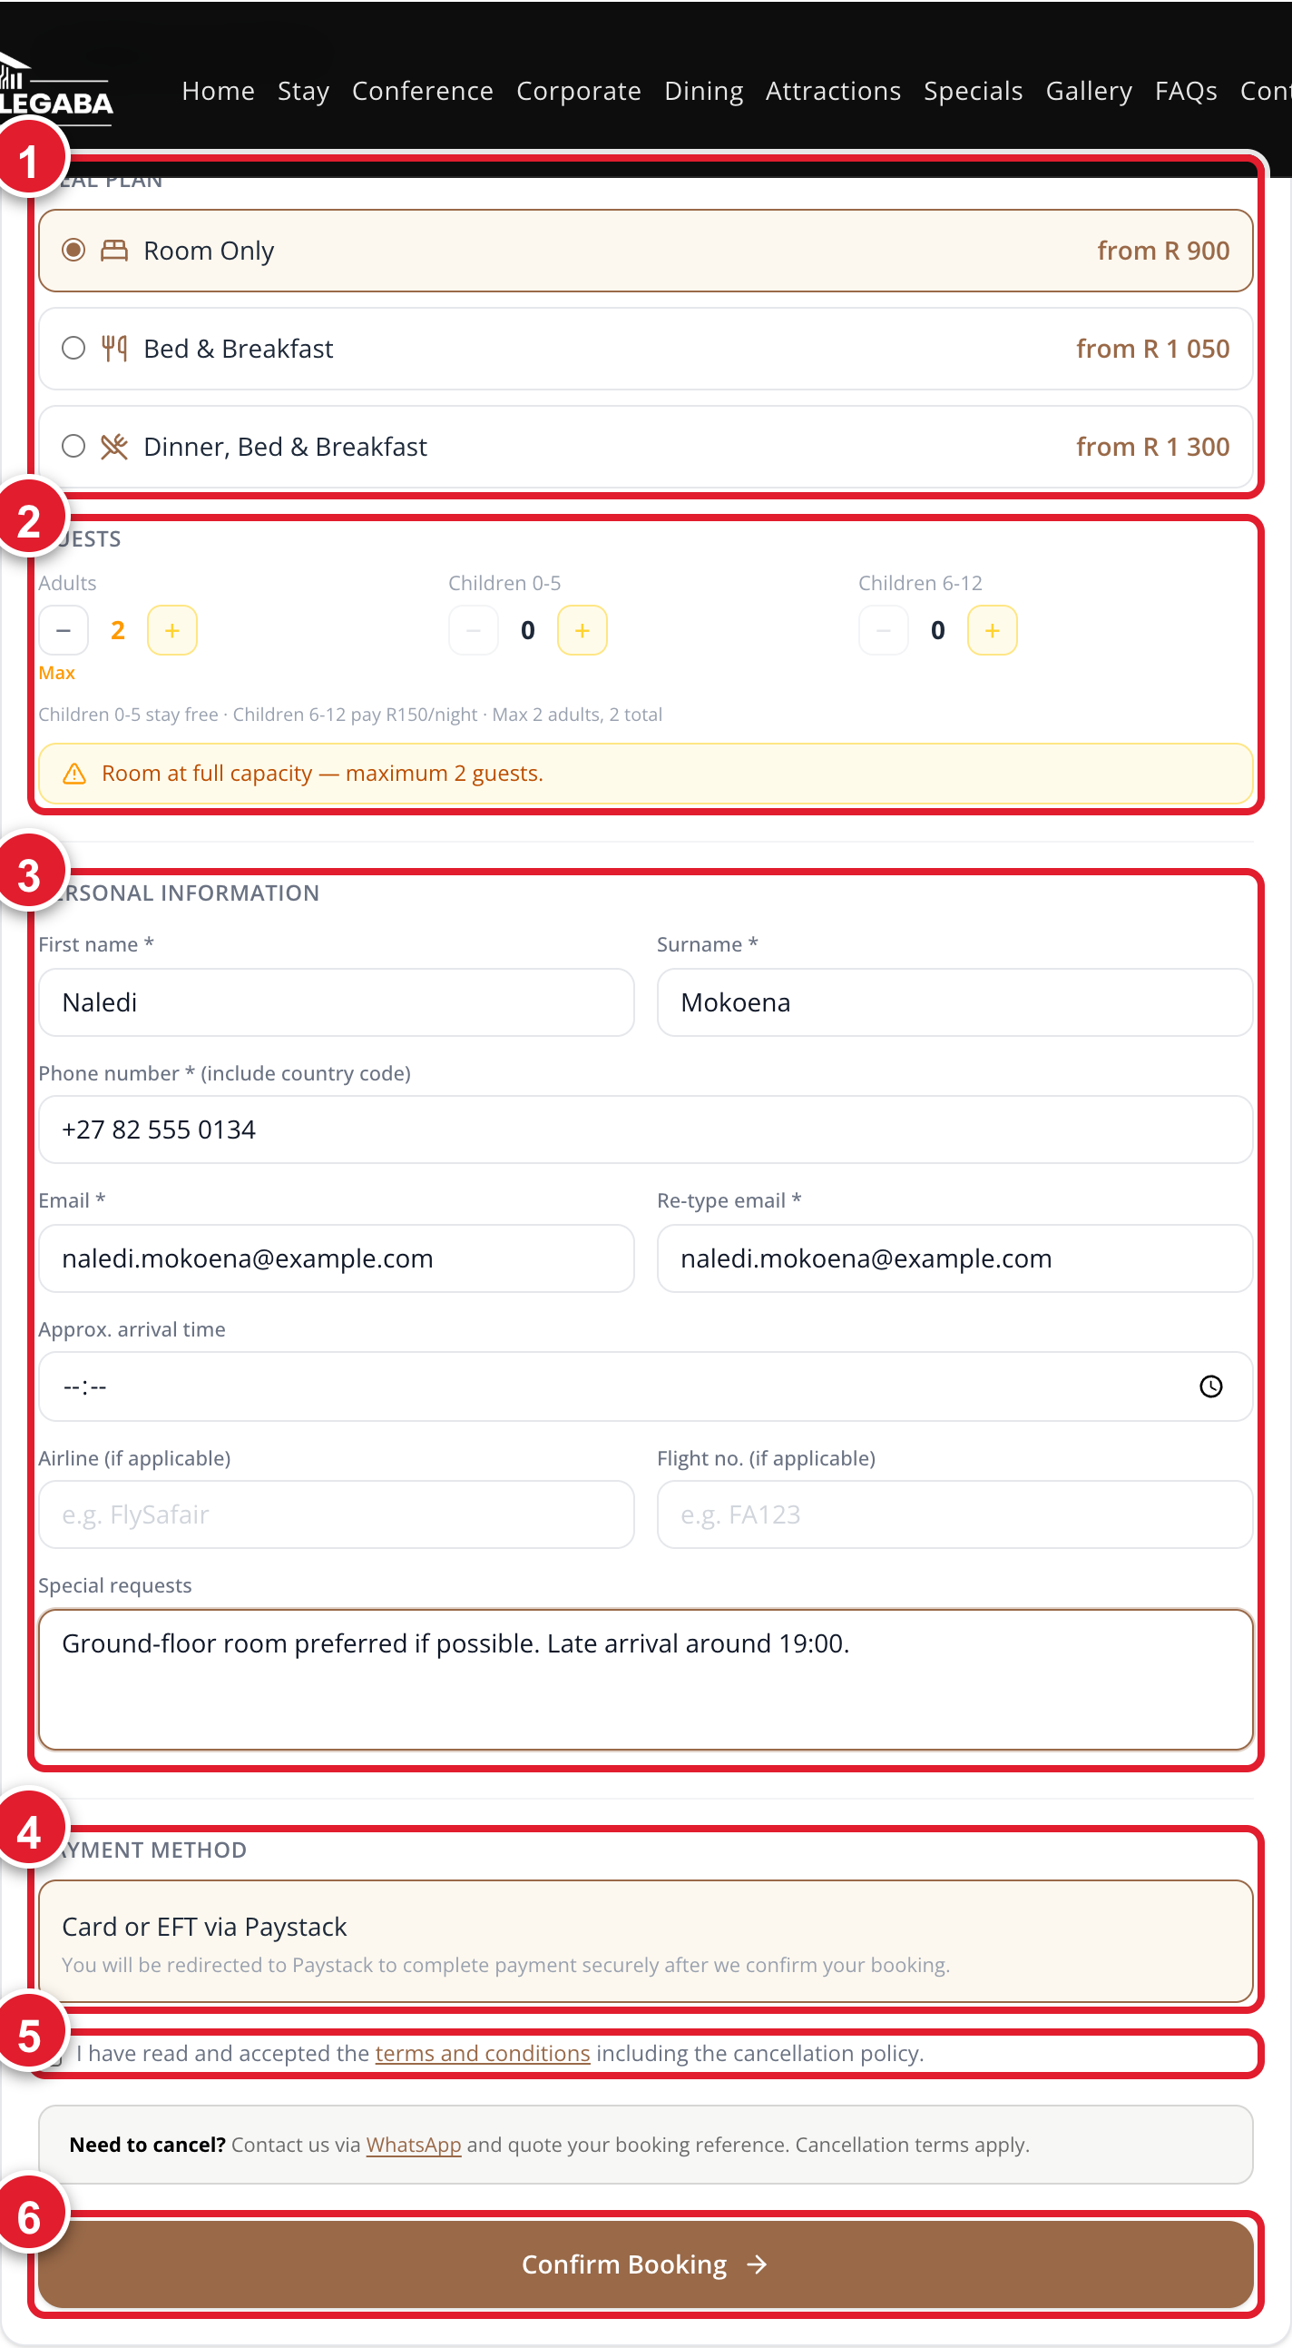
Fig. 3.6 The complete booking form, with every section numbered
1 Meal plan · 2 Guests · 3 Your personal details · 4 Payment method · 5 Terms and conditions · 6 the Confirm Booking button.
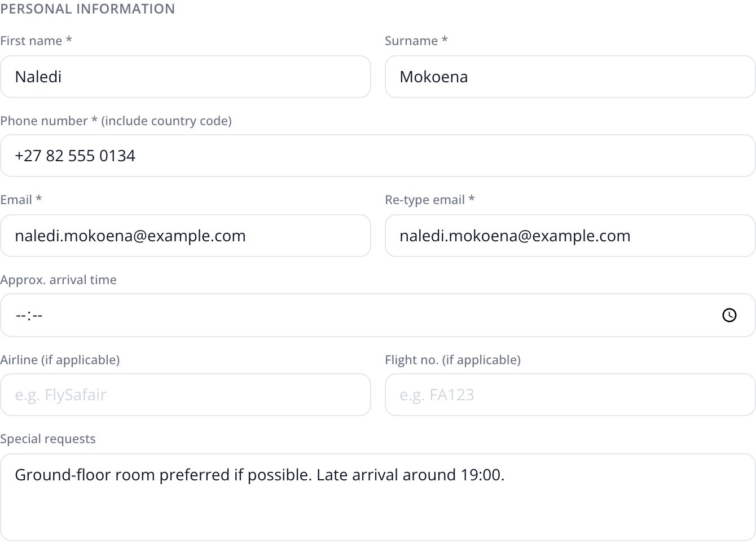
Fig. 3.7 A closer look at the personal details section
The two starred fields — First name and Surname — plus Phone number and both Email boxes, must be completed.
IMPORTANT: Children are charged differently
The form states the rule underneath the guest counters: children aged 0 to 5 stay free, and children aged 6 to 12 are charged R150 per night. Children still count towards the room's maximum occupancy.
IF SOMETHING GOES WRONG: “Room at full capacity — maximum 2 guests”
This yellow message appears when you have added more people than the room sleeps. Reduce the number of adults or children, or go back and choose a Family or Triple room instead.

Step 11: Reviewing and confirming your booking
1. Check the PAYMENT METHOD box. It reads “Card or EFT via Paystack”. This is the only payment method on the website.
2. Read the terms line and tick the box beside “I have read and accepted the terms and conditions including the cancellation policy”. You cannot continue without ticking it.
3. Read the grey Need to cancel? note. It tells you to contact Boga Legaba on WhatsApp and quote your booking reference.
4. Check your dates, room, meal plan and guest numbers one last time.
5. Click the brown Confirm Booking button.
6. A screen appears reading “Reserving your room…”. Wait — do not close the tab and do not press the back button.
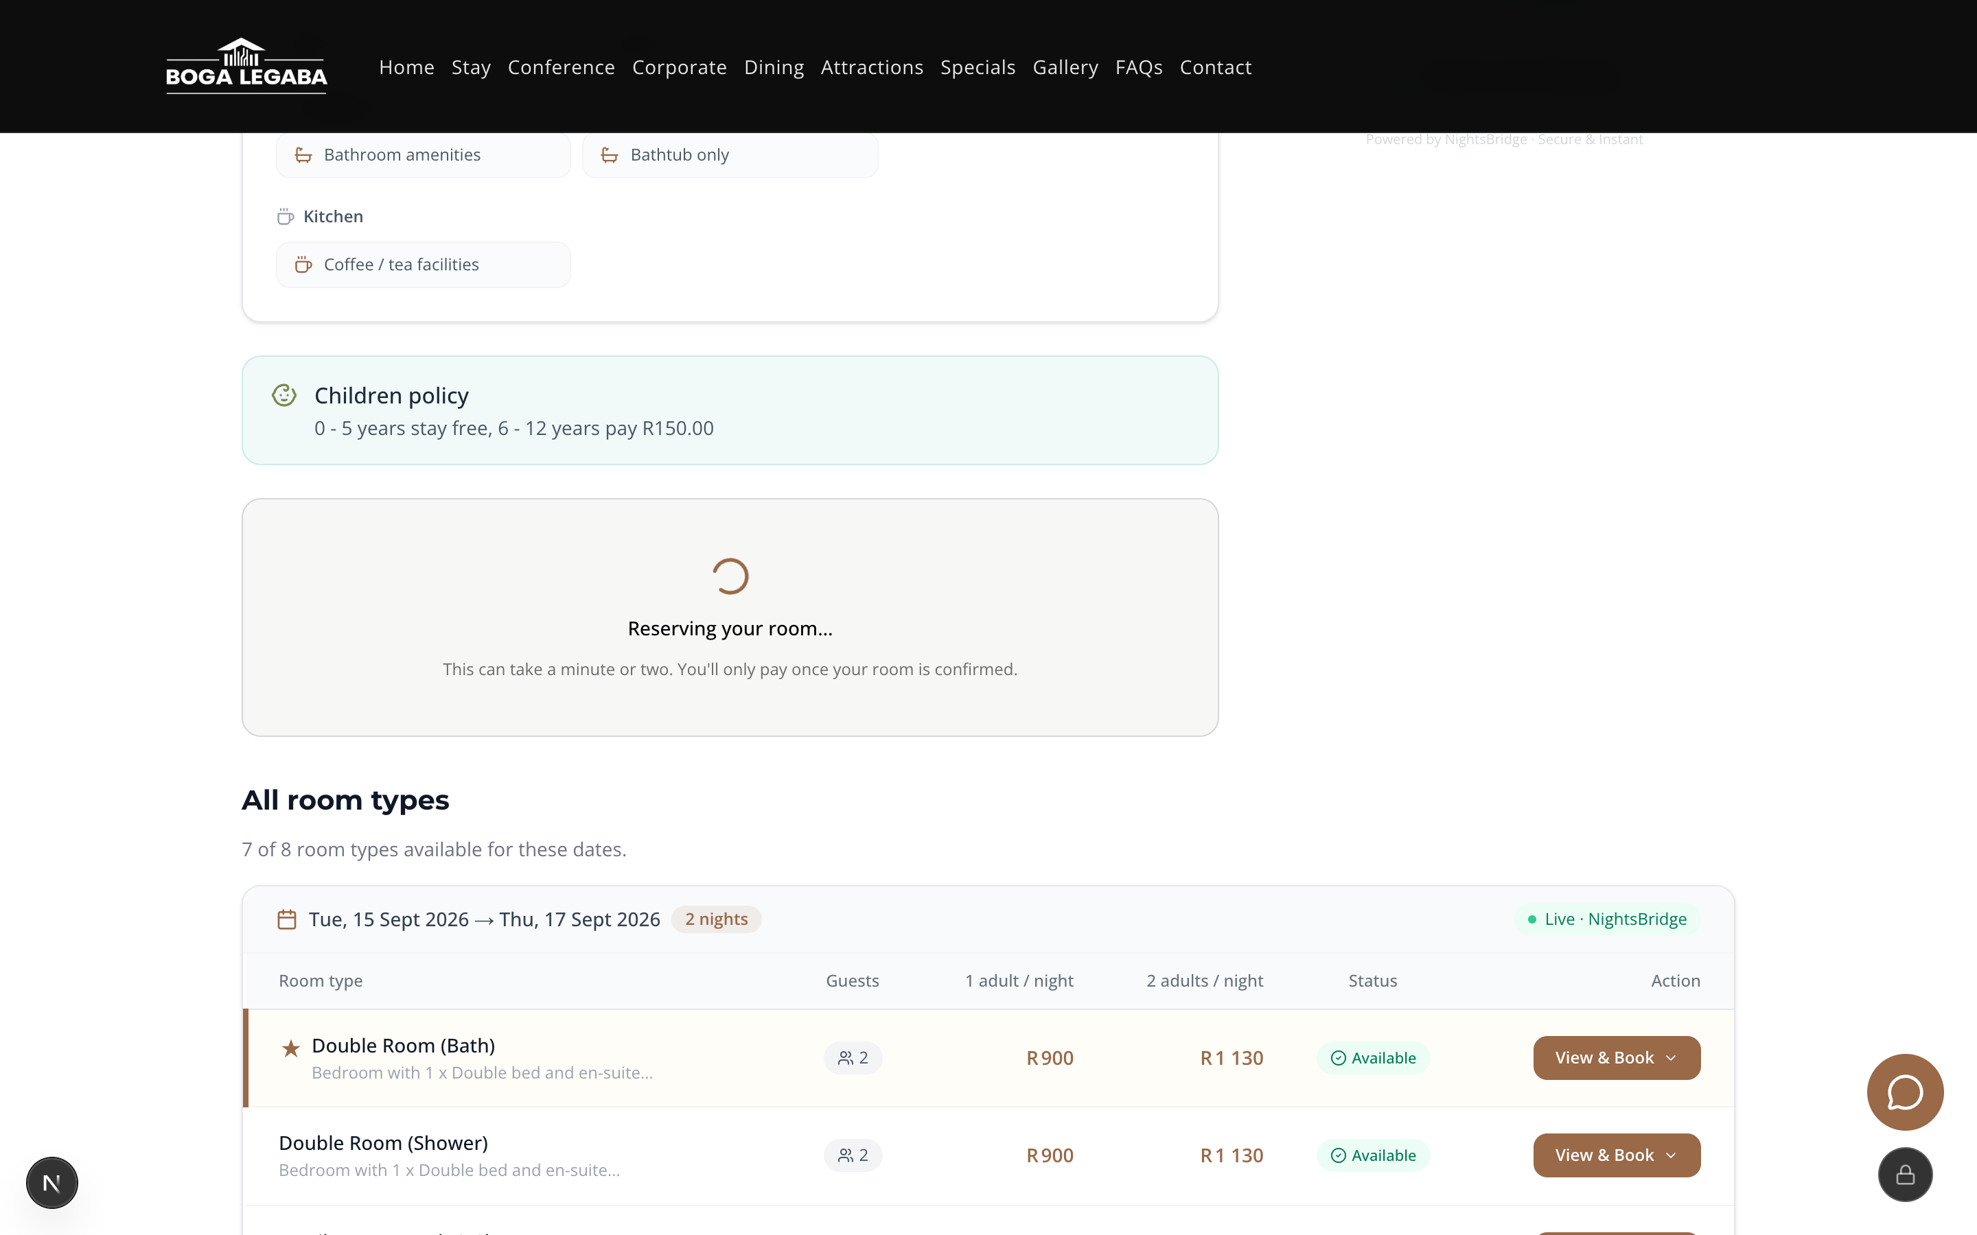
Fig. 3.8 The screen while your room is being held
This step can take a minute or two. The message confirms you will only be asked to pay once the room is secured.
SUCCESS: You are not charged until the room is confirmed
The website reserves the room first and only then sends you to payment. The wording on screen says it plainly: “You'll only pay once your room is confirmed.”
7. When the room is secured, the website hands you to Paystack, South Africa's payment provider, to pay by card or EFT.
8. Enter your payment details on the Paystack screen and complete the payment there.
IMPORTANT: Boga Legaba never sees your card number
Card details are typed on Paystack's own secure screen, not on the Boga Legaba website. No one at the guest house can see them.

Step 12: Receiving and understanding your confirmation
When payment succeeds you are returned to the Boga Legaba website.
1. Look for the heading Payment Confirmed with a tick above it.
2. Read the line “Your stay at Boga Legaba is fully confirmed.”
3. A green message also appears near the bottom reading “Payment confirmed — Your stay at Boga Legaba is fully booked.”
4. Check your email inbox. A confirmation email with all the details is sent automatically.
5. Click Back to Home to return to the website.
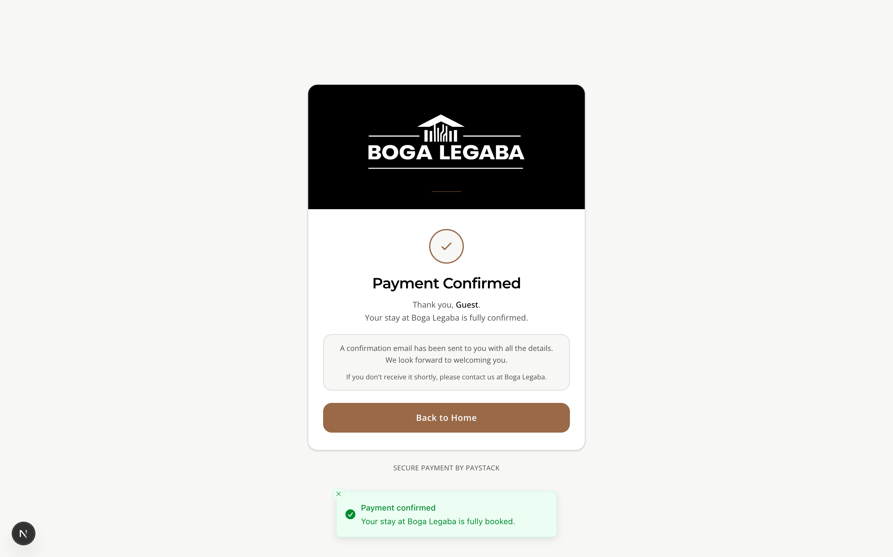
Fig. 4.1 The Payment Confirmed screen
This is what a successful booking looks like. If you see this, your room is booked and paid for.
IF SOMETHING GOES WRONG: If the confirmation email does not arrive
Check your spam or junk folder first. If it is not there after about fifteen minutes, phone +27 82 875 7018 or message the same number on WhatsApp. Your room is still booked — only the email is missing.
IMPORTANT: Keep your booking reference
The booking reference is the number Boga Legaba uses to find your booking. It is in your confirmation email. You will be asked for it if you want to change or cancel anything.

Step 13: Viewing, changing or cancelling a booking
IMPORTANT: This is done by talking to the guest house, not on the website
There is no self-service area where you can log in and change your own booking. Every change goes through Boga Legaba directly. This is deliberate — it means a person confirms the change with you.
1. Find your booking reference in your confirmation email.
2. Choose how to reach Boga Legaba: WhatsApp on +27 82 875 7018, a phone call to the same number, or email to info@bogalegaba.co.za.
3. Give your booking reference, your full name, and your arrival date.
4. Say clearly what you want: new dates, a different room, more or fewer guests, or a cancellation.
5. Wait for written confirmation of the change before you travel. Do not assume a request has been actioned.
IF SOMETHING GOES WRONG: Cancellation charges may apply
Cancellation terms depend on the rate and the season, and are set out when you book. Ask what the charge will be before you confirm a cancellation.

Step 14: Leaving a review
Guest reviews shown on the Boga Legaba home page are collected from Google, not typed into this website.
1. Open Google and search for “Boga Legaba Guest House Mahikeng”, or open Google Maps and find the guest house.
2. Scroll to the Reviews section of the Google listing.
3. Click Write a review and choose a star rating.
4. Write your comments and post the review.
5. Your review will appear on the Boga Legaba home page after staff refresh the review list — usually within a day.
TIP: Mention which property you stayed at
Because Boga Legaba has several properties, saying whether you stayed at Chababa, Interlaken A or Lantana makes your review far more useful to the next guest.

Step 15: Contacting support
1. Click Contact in the menu at the top of any page.
2. To phone, call +27 82 875 7018. Reception is staffed 24 hours a day.
3. To email, write to info@bogalegaba.co.za.
4. To use the form on the page, fill in Name, Email and Message. Name, Email and Message are required; Phone is optional.
5. Choose a Subject from the dropdown list so your message reaches the right person.
6. Click the send button below the form.
7. For an instant reply, use the green WhatsApp button that floats at the bottom-right of every page.
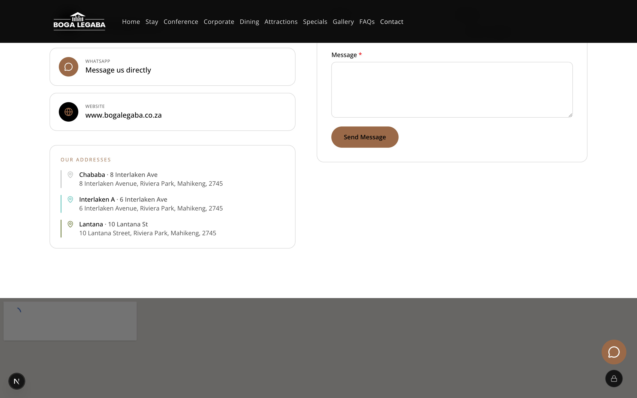
Fig. 4.2 The contact form
Name, Email and Message must be filled in. Choosing a Subject helps route your message to the right person.
TIP: WhatsApp is usually fastest
Each property has its own WhatsApp desk. The floating green button follows you around the site, so you can ask a question without losing the page you were reading.

4. Guide for Boga Legaba staff
IMPORTANT: This section is for staff only
The management area shows real guests' names, telephone numbers, email addresses and payment status. Do not open it on a shared or public computer, and do not photograph these screens.

Step 16: Signing in to the management area
1. In your browser's address bar, type www.bogalegaba.co.za/admin and press Enter.
2. The Admin Access screen appears, with a padlock symbol at the top.
3. The Admin email box is already filled in for you. Leave it as it is unless you have been told otherwise.
4. Click the Admin password box and type your password.
5. If you want to check what you have typed, click the small eye symbol at the right-hand end of the password box.
6. Click the brown Sign in button.
7. You are taken to the Admin Dashboard.
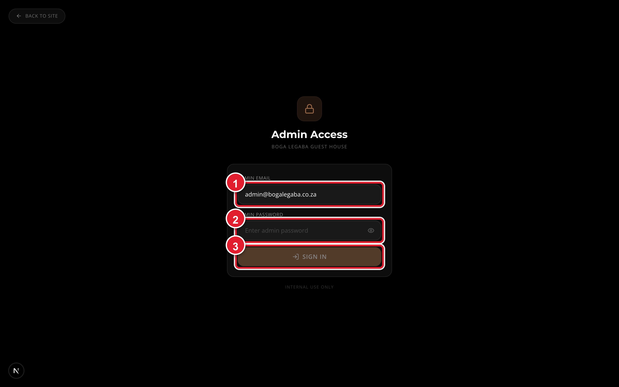
Fig. 2.2 The staff sign-in screen
Marker 1 is the email box, already completed. Marker 2 is where you type your password. Marker 3 is the Sign in button.
IF SOMETHING GOES WRONG: “Invalid email or password”
This red message means the password was mistyped. Check that Caps Lock is off, click the eye symbol to see what you have typed, and try again. If it still fails, the password may have been changed — ask whoever manages the website.
IMPORTANT: Everyone shares one password
There are no individual staff accounts on this website — everybody who manages the site uses the same password. That means it should be changed whenever someone leaves, and it should never be sent by email or written on a note near the computer.
TIP: Getting back to the public website
The link marked “Back to site” in the top-left corner of the sign-in screen returns you to the normal guest website.

Step 17: Understanding the dashboard
The Admin Dashboard is the first screen after signing in. It gives you the overall picture before you go into any individual booking.
1. Read the summary figures at the top of the page for an at-a-glance view of activity.
2. Scroll down through the panels. Each panel has a small gold heading telling you what it contains.
3. Use the navigation on the dashboard to move to Bookings, Images, Guest Registrations, Reviews, or the data audit.
4. The dashboard also links out to the reservation system's own Dashboard, Transactions, Calendar and Booking widget screens.
IMPORTANT: Fig. 5.1 — screenshot not available
The Admin Dashboard This picture could not be captured automatically. Ask your website administrator to add it.

Step 18: Managing guest registrations
This is where the digital check-in forms arrive. It is the closest thing the website has to a list of guest accounts.
1. From the dashboard, open Guest Registrations.
2. The list is a table. The columns are Submitted, Name, Contact, Ref, Nationality, Vehicle and Guests.
3. Read across a row to see everything one guest has told you before arrival.
4. Use the Ref column to match a registration to its booking.
5. Use the Vehicle column to check a car against the parking area.
IMPORTANT: Fig. 5.2 — screenshot not available
The Guest Registrations list This picture could not be captured automatically. Ask your website administrator to add it.
IMPORTANT: Guest registrations contain identity documents
This screen holds passport and identity numbers. Treat it as confidential, and never export or forward it without a good reason.

Step 19: Managing bookings
The Bookings screen has two separate lists, and understanding the difference matters.
- The main list shows every booking in the reservation system, however it was made — by phone, by an agent, or on the website.
- The website list shows only bookings made on this website, and adds whether the guest actually paid.

Viewing and filtering bookings
1. From the dashboard, open Bookings.
2. Use the tabs to narrow the list: All bookings, Arriving, In-house, Departing, or Provisional.
3. Arriving shows guests due to check in. In-house shows guests currently staying. Departing shows guests due to check out.
4. Provisional shows bookings that are not yet certain, so you can chase them.
5. Read the coloured status label on each booking. The meaning of every label is in the Glossary in Section 8.
IMPORTANT: Fig. 5.3 — screenshot not available
The Bookings screen This picture could not be captured automatically. Ask your website administrator to add it.

Checking that a website booking went through
A booking made on the website has to travel from the payment provider into the reservation system. Occasionally it does not arrive, and this is the screen where you catch that.
1. Scroll to the website bookings list.
2. Use the tabs All, Paid and Unsuccessful.
3. Open Paid and check every booking there also shows as being in the reservation system.
4. If a booking is marked as paid but has not reached the reservation system, use the retry action on that row to send it through again.
5. Open Unsuccessful to see guests whose payment failed or who abandoned the payment screen. These people did not pay and do not have a room.
IMPORTANT: Fig. 5.4 — screenshot not available
Website bookings, showing payment status This picture could not be captured automatically. Ask your website administrator to add it.
IF SOMETHING GOES WRONG: A paid guest who is not in the reservation system
This is the one situation to act on immediately: the guest has been charged and believes they have a room, but the room is not held. Use the retry action, and if it fails again, add the booking manually and telephone the guest to reassure them.

Adding a booking by hand
1. On the Bookings screen, open the form for adding a booking.
2. Fill in First name and Surname.
3. Enter the guest's Phone, including the country code.
4. Enter the guest's Email address.
5. Choose the room and the dates.
6. Save the booking, then confirm it appears in the main list.
IMPORTANT: Refunds are not issued from this website
There is no refund button in the management area. Refunds are processed in the payment provider's own system by whoever holds that account. Record the reason for any refund separately.

Step 20: Managing rooms and photographs
Room names, bed types and prices come from the reservation system, so they are changed there. What you control on this website is the photographs.
1. From the dashboard, open Images.
2. Choose whether you are working on room photographs or on general site photographs, using the tabs.
3. To add a photograph, choose the room it belongs to and upload the picture file.
4. Photographs appear in the order you set, so put the best picture first — it becomes the main image on the room card.
5. To remove a photograph, use the delete control beside it.
IMPORTANT: Fig. 5.5 — screenshot not available
The Images screen This picture could not be captured automatically. Ask your website administrator to add it.
TIP: Rooms without photographs look empty to guests
A room with no picture shows a grey “No image available” box on the Stay page. At the time this guide was written, fewer than half the rooms had photographs loaded. Adding pictures is the single easiest improvement to the guest experience.
IMPORTANT: Prices and availability are not edited here
Nightly rates, room descriptions and which rooms are free all come from the reservation system. Changing them on this website is not possible — they must be changed at source, and the website will follow automatically.

Step 21: Managing page content
Most wording on the public pages — the FAQs, the property descriptions, the conference details — is built into the website and is changed by whoever maintains it. What you can change yourself is the imagery.
1. From the dashboard, open Images.
2. Switch to the site images tab.
3. Upload a replacement picture for the page area you want to change.
4. Open the public page in a separate browser tab and refresh it to check the result.
TIP: Always look at the public page afterwards
The management area shows you the file you uploaded, not how it will be cropped on the real page. Checking the live page takes ten seconds and avoids an awkwardly cropped photograph sitting there for weeks.

Step 22: Managing reviews
The guest reviews on the home page are pulled from the guest house's Google listing. They are not written or edited on this website.
1. From the dashboard, open Reviews.
2. You will see the reviews currently displayed on the home page, under the heading “Homepage guest reviews”.
3. Click the refresh action to fetch the latest reviews from Google.
4. Check the home page afterwards to confirm the new reviews are showing.
IMPORTANT: Fig. 5.6 — screenshot not available
The Reviews screen This picture could not be captured automatically. Ask your website administrator to add it.
IMPORTANT: A bad review cannot be deleted here
Because reviews come from Google, they can only be responded to on Google. Reply to it there, politely and factually — future guests read the replies as closely as the reviews.

Step 23: Checking data and producing reports
The data audit screen exists to answer one question: does what the website shows match what the reservation system actually holds?
1. From the dashboard, open the NightsBridge data audit.
2. Read through the comparison it presents.
3. Investigate anything flagged as a mismatch before it affects a guest.
4. For financial reporting, use the reservation system's own Transactions screen, linked from the dashboard.
IMPORTANT: Fig. 5.7 — screenshot not available
The data audit screen This picture could not be captured automatically. Ask your website administrator to add it.
TIP: Make this a weekly habit
Five minutes on this screen once a week catches problems while they are still small — a room shown as free when it is not, or a booking that never arrived.

Step 24: Notifications and emails
Two automatic emails are sent by the website. Neither is written by hand.
- A confirmation email to the guest, sent as soon as payment succeeds.
- An alert to Boga Legaba, sent on every successful payment, so staff know a booking has come in.
1. After any test booking, check that both emails arrived.
2. If guests report that confirmations are not arriving, tell them their room is still booked, and report the problem to whoever maintains the website.
3. Ask guests to check their spam folder before you escalate — that is the cause most of the time.
IF SOMETHING GOES WRONG: Confirmation emails depend on outside services
Email delivery relies on services configured outside this website. If confirmations stop arriving for everyone at once, it is almost always one of those services rather than a fault in the booking system — bookings will still be recorded correctly.

Step 25: Managing who has access
1. Understand the position: this website has one shared password, not individual staff accounts.
2. Keep a written list of who currently knows the password.
3. Have the password changed whenever a member of staff leaves, or whenever you suspect it has been shared.
4. Never send the password by email, WhatsApp or text message.
5. Sign out when you have finished, especially on a computer other people use.
IMPORTANT: Anyone with the password sees everything
There are no limited or read-only staff logins. Whoever has the password can see every guest's contact details and every booking. Treat it as you would a key to the building.

5. Quick reference
The ten things people do most often. Each line tells you where to go and what to click.
I want to… | Do this
See what rooms exist | Menu → Stay → scroll down the list of room cards
Find a specific kind of room | Menu → Stay → type in the filter box, or click + TWIN, + DOUBLE, + FAMILY and so on
Check if a room is free on my dates | Menu → Stay → Book Now → read the Status column of the Available rooms table
Book and pay for a room | View & Book → Book This Room → fill in the form → tick the terms box → Confirm Booking
Check in before I arrive | Go to the /register page → fill in Full name and your details → submit
Change or cancel a booking | WhatsApp or phone +27 82 875 7018 with your booking reference — this cannot be done on the website
Ask a question fast | Tap the green WhatsApp button at the bottom-right of any page
(Staff) See today's arrivals | Go to /admin → sign in → Bookings → Arriving tab
(Staff) Check a guest actually paid | Bookings → website list → Paid tab
(Staff) Add a room photograph | Dashboard → Images → choose the room → upload the picture

6. Picture index
Every screenshot in this guide, in the order it appears.
Figure | What it shows
Fig. 1.1 | The home page, with the two things you use most marked
Fig. 2.1 | The digital check-in form
Fig. 3.1 | The Stay page, showing rooms grouped by property
Fig. 3.2 | The room search box and filter buttons
Fig. 3.3 | The top of a room's own page
Fig. 3.4 | Room facts, amenities and the nightly rates
Fig. 3.5 | The Check Availability & Rates screen
Fig. 3.6 | The complete booking form, with every section numbered
Fig. 3.7 | A closer look at the personal details section
Fig. 3.8 | The screen while your room is being held
Fig. 4.1 | The Payment Confirmed screen
Fig. 4.2 | The contact form
Fig. 2.2 | The staff sign-in screen
Fig. 5.1 | The Admin Dashboard (not captured)
Fig. 5.2 | The Guest Registrations list (not captured)
Fig. 5.3 | The Bookings screen (not captured)
Fig. 5.4 | Website bookings, showing payment status (not captured)
Fig. 5.5 | The Images screen (not captured)
Fig. 5.6 | The Reviews screen (not captured)
Fig. 5.7 | The data audit screen (not captured)

7. Troubleshooting
Find your problem in the left-hand column, and try the fix on the right.
I see this problem | Try this
The page will not load at all | Check you are connected to the internet by opening any other website. Then reload the Boga Legaba page. If it still fails, wait five minutes and try again — and phone +27 82 875 7018 if you need to book urgently.
I cannot sign in to the staff area | Check Caps Lock is off. Click the eye symbol beside the password box to see what you typed. If “Invalid email or password” keeps appearing, the password has probably been changed — ask whoever manages the website.
The list of available rooms is empty | Your dates may be fully booked, or too far ahead. Try dates a week either side. If every date is empty, the connection to the reservation system may be down — phone the guest house.
A room I wanted has disappeared | Someone else booked it while you were deciding. Availability is live. Go back, refresh the page, and choose another room.
“Room at full capacity — maximum 2 guests” | You have added more people than the room sleeps. Lower the adult or child count, or choose a Family or Triple room instead.
“Booking could not be completed” | The room was taken during the few seconds you were confirming, or the connection dropped. Click Try again. If it fails twice, use the WhatsApp button — do not keep retrying.
The “Reserving your room…” screen is taking ages | This is normal and can take a minute or two. Do not close the tab or press back — doing so may leave the booking half-finished. Wait at least three minutes before giving up.
My payment failed | No money has been taken and no room is held. Check your card details and available balance, then book again. If your bank declined it, phone them — they often block first-time online payments.
I paid but got no confirmation email | Check your spam or junk folder. Wait fifteen minutes. If it has still not arrived, phone +27 82 875 7018 — your room is booked, only the email is missing.
I cannot find my booking reference | It is in your confirmation email. Search your inbox for “Boga Legaba”. If you cannot find it, phone the guest house with your full name and arrival date instead.
I booked the wrong dates | Contact the guest house immediately on WhatsApp or by phone with your reference. The sooner you call, the more likely the change is free.
A room shows “No image available” | The photograph has not been uploaded yet. The room is real and bookable. Ask for pictures on WhatsApp.
The price looks different from what I expected | Rates are per room per night and include VAT, and they vary by night and by season. Check the meal plan you selected — Bed & Breakfast and Dinner, Bed & Breakfast cost more than Room Only.
The WhatsApp button does nothing | WhatsApp must be installed. On a computer, it opens WhatsApp Web and you may need to scan a code. Otherwise phone +27 82 875 7018 instead.
The digital check-in form will not submit | Full name is required — check it is filled in. Also check the date of birth is in the format the box shows. Scroll up to look for a red message beside a field.
(Staff) A booking is not showing in the list | Check which tab you are on — Arriving and In-house hide bookings outside those dates. Use All bookings. If it is a website booking, check the website list too.
(Staff) A guest paid but has no room in the system | Open Bookings, find the row in the website list, and use the retry action. If that fails, add the booking manually and phone the guest to reassure them.
(Staff) Reviews are not showing on the home page | Open the Reviews screen and refresh the review list. If nothing appears, the connection to Google may need attention from whoever maintains the website.

8. Glossary
Words you will see on the screen, in plain English.

Words guests will see
Word on screen | What it means
Available | This room is free for the dates you chose and can be booked now.
Live | The information was read from the reservation system just now, not saved from earlier.
Booking reference | The number that identifies your booking. Quote it whenever you contact the guest house.
Room Only | The price covers the room and no meals.
Bed & Breakfast | The price covers the room and breakfast.
Dinner, Bed & Breakfast | The price covers the room, breakfast and an evening meal.
Room type | The category of room, such as Double Room (Bath) — not one specific bedroom.
Room name | The name of one specific bedroom, such as Beads or Blue Clouds.
EFT | Electronic Funds Transfer — paying straight from your bank account instead of by card.
VAT | Value Added Tax. Rates shown on the website already include it.
Paystack | The South African company that securely handles the card and EFT payment.
Non-smoking | Smoking is not permitted in this room.
Tier | The grade of room, for example Standard.

Words staff will see
Word on screen | What it means
Dashboard | The first screen after signing in, summarising current activity.
Confirmed | The booking is certain and the room is held.
Provisional | The booking is being held but is not yet certain. It may need chasing.
Awaiting Dep | Awaiting deposit — the room is held pending payment of a deposit.
Paid | Payment has been received for this booking.
Reserved | The room is set aside, usually for an internal reason.
Outstanding | Money is still owed on this booking.
Unavailable | The room cannot be booked for these dates.
Pending | The guest started a booking but nothing has happened yet.
Awaiting pay | The guest reached the payment screen but has not completed payment.
Payment failed | The guest's card or transfer was declined. No room is held.
Arriving | Guests due to check in.
In-house | Guests currently staying at the guest house.
Departing | Guests due to check out.
NightsBridge | The reservation system that holds all rooms, rates and availability.
Data audit | A screen that checks the website and the reservation system agree with each other.
Digital check-in | The guest registration form completed before arrival.
Per diem | A fixed daily allowance that government departments pay for staff accommodation.

9. Contact and support

How to reach Boga Legaba
Method | Details
Telephone | +27 82 875 7018 — reception is staffed 24 hours a day
WhatsApp | +27 82 875 7018, or the green button on any page of the website
Email | info@bogalegaba.co.za
Website | www.bogalegaba.co.za
In person | Riviera Park, Mahikeng, 2745, North West Province — about five minutes from Mmabatho CBD

What to have ready when you ask for help
Giving these details in your first message will usually get your problem solved in one reply.
- Your full name, spelled as you entered it when booking.
- Your booking reference, if you have one.
- Your arrival and departure dates.
- Which property you booked — Chababa, Interlaken A or Lantana.
- Exactly what you see on screen, including any message in red, word for word.
- What you were doing just before the problem appeared.
- Whether you are on a phone or a computer, and which browser you are using.

If it is urgent
IF SOMETHING GOES WRONG: Anything affecting a stay within 24 hours
Telephone +27 82 875 7018 directly. Do not use email or the website contact form for anything urgent — those are not monitored minute by minute. Reception answers 24 hours a day.
TIP: For everything else
WhatsApp is the fastest written channel and gives you a record of what was agreed. Email suits longer requests such as corporate quotes, purchase orders or invoices.

Check-in and check-out
Item | Detail
Check-in | From 14:00
Check-out | By 10:00
Reception | Open 24 hours
Children 0–5 | Stay free
Children 6–12 | R150 per night
Parking | Secure on-site parking at each property
Wi-Fi | Free throughout all properties

End of guide.

