HW模型辨识算法研究

国内外研究现状：

**An Improved Hammerstein-Wiener System Identification with Application to Virtualized Software System——2015 IEEE Conference on Control Applications (CCA) Part of 2015 IEEE Multi-Conference on Systems and Control**

| Model Order | **6** | **7** | **8** | **9** |
| --- | --- | --- | --- | --- |
| MSE | 0.0236 | 0.0198 | 0.0061 | 0.0039 |

**Set-Membership identification of Hammerstein-Wiener systems——2011 50th IEEE Conference on Decision and Control and European Control Conference (CDC-ECC)**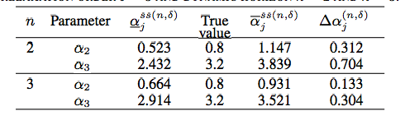

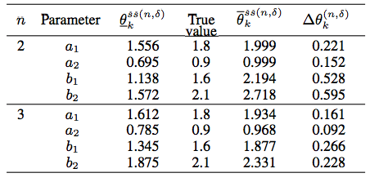

model_order = 6, mean_squared_error = 0.04455

**Parameter Estimation of Hammerstein-Wiener ARMAX Systems Using Unscented Kalman Filter——Proceeding of the 2nd RSI/ISM International Conference on Robotics and Mechatronics October 15-17, 2014, Tehran, Iran**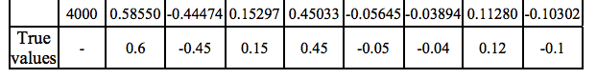

效果很好，但是假设了非线性模块函数f(·)，G(·)是已知的

**多变量 Hammerstein － Wiener 模型的参数辨识——东 北 大 学 学 报 ( 自 然 科 学 版 )**

MSE = 0.0547

综上

针对识别问题，生成大量数据，x 调频信号采样1000点 ,B,b,h HW模型参数,y 经过模型后的信号序列,将其作为训练数据

Train_x = [x,y] //变换前和变换后信号的排列

Train_y = [B,b,h]//此次变换的参数,损失函数为MSE（估计参数，真实参数）则辨识过程为



|  | 国外1 | 国外2 | 国内1 | 网络 |
| --- | --- | --- | --- | --- |
| MSE | 0.0236 | 0.04455 | 0.0547 | 0.0116 |

参数总MSE: 0.011621573000221048,MSE由5万组测试数据得到，取其前五组(6个估计参数)

|  |  |  |  |  |  |  |  |  |  |  |  |
| --- | --- | --- | --- | --- | --- | --- | --- | --- | --- | --- | --- |
|  | **B1** | **B2** | **B3** | **b1** | **b2** | **b3** | **h1** | **h2** | **h3** | **参数MSE** | **曲线MSE** |
| **真实1** | 1.0000 | -0.8018 | 0.8907 | 1.0000 | 0.7936 | 0.4376 | 1.0000 | 0.7259 | -0.5546 | 0.002410 | 0.000595 |
| **估计1** | 1.0000 | -0.8108 | 0.9122 | 1.0000 | 0.7125 | 0.3988 | 1.0002 | 0.7995 | -0.5346 |
| **真实2** | 1.0000 | 0.3494 | 0.3022 | 1.0000 | 0.1865 | 0.1201 | 1.0000 | 0.7068 | -0.0110 | 0.004417 | 0.000014 |
| **估计2** | 1.0000 | 0.4931 | 0.3562 | 1.0000 | 0.1390 | 0.1416 | 0.9999 | 0.7037 | -0.0258 |
| **真实3** | 1.0000 | -0.2297 | -0.9344 | 1.0000 | 0.7964 | 0.6452 | 1.0000 | -0.2351 | 0.4397 | 0.019178 | 0.000004 |
| **估计3** | 1.0000 | -0.4548 | -0.7574 | 1.0000 | 0.9666 | 0.5855 | 1.0000 | -0.2291 | 0.4631 |
| **真实4** | 1.0000 | 0.2949 | -0.1680 | 1.0000 | -0.6329 | -0.5452 | 1.0000 | 0.9340 | 0.8129 | 0.001518 | 0.000899 |
| **估计4** | 1.0000 | 0.3483 | -0.1891 | 1.0000 | -0.6931 | -0.5566 | 0.9997 | 0.9340 | 0.7674 |
| **真实5** | 1.0000 | -0.5062 | -0.3108 | 1.0000 | -0.5340 | 0.5549 | 1.0000 | 0.5334 | 0.0580 | 0.006096 | 0.000387 |
| **估计5** | 1.0000 | -0.5417 | -0.3800 | 1.0000 | -0.6142 | 0.7094 | 0.9998 | 0.5363 | 0.0430 |

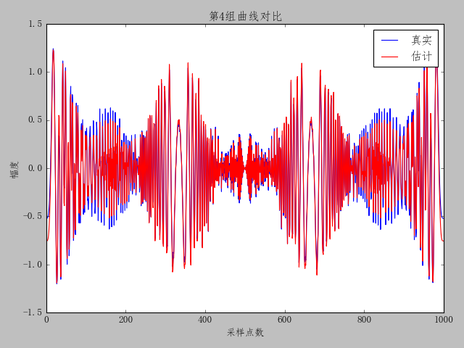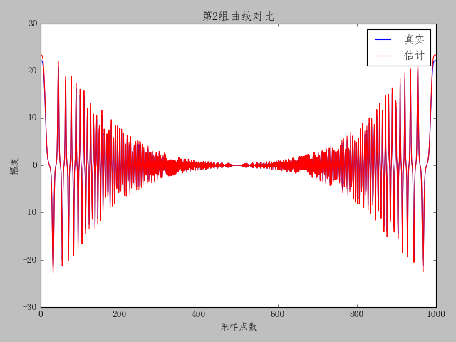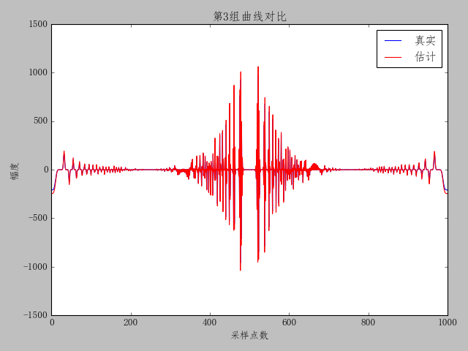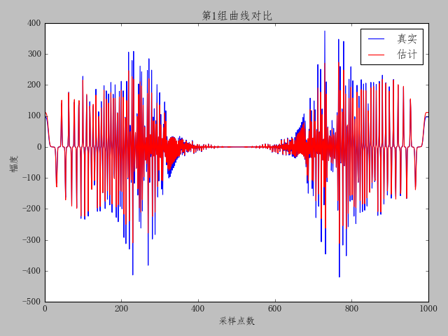

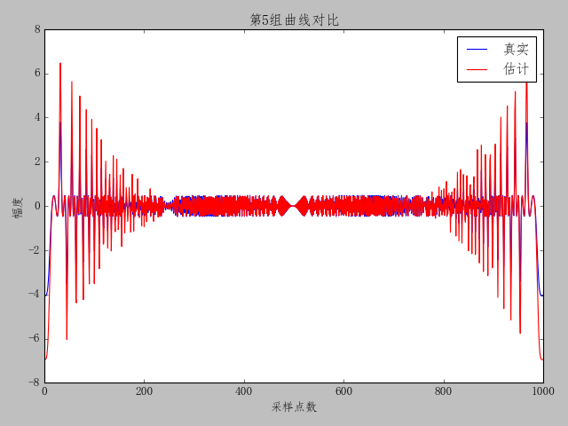

虽然没有特意去降低曲线的MSE，但是当参数估计准确的时候，曲线MSE自然也会下。目前国内有用BP神经网络来做HW参数的辨识，但是并没有给出参数的MSE，无法比较，而IEEE上并没有深度学习来做参数辨识，大多为迭代法，也有一些智能算法如自适应粒子群，虽然其给出的结果还不错，但是只是单纯的使用粒子群，我也写过这样的算法，但是效果其实并没有说的那么好。

By using PSO, the estimated values of parameters are found and the results are recorded in Table II. **The sum of squared error (SSE) equals to 0.1056**

而其共有8个参数，所以其MSE为0.0132

