fastdfs安装部署
下载示意图

nginx1
10.76.238.66:8888
nginx2
10.76.238.67:8888

tracker2
10.76.238.67:22122
tracker1
10.76.238.66:22122

stroage1
10.76.238.66
stroage2
10.76.238.67

安装准备

1.1安装包目录
/data/soft

1.2安装部署目录
/data/eask

1.3安装包准备
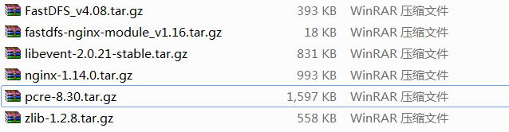
6个

部署

2.1安装基础环境

openssl
openssl version
yum -y install openssl openssl-devel

libevent
mkdir /data/eask/libevent
cd /data/soft
tar -zxvf libevent-2.0.21-stable.tar.gz
cd /data/soft/libevent-2.0.21-stable
./configure --prefix=/data/eask/libevent
make
make install

pcre
// 卸载默认安装的pcre
rpm -qa |grep pcre
// pcre-7.8-3.1.el6.x86_64

mkdir /data/eask/pcre8.30
cd /data/soft
tar -zxvf pcre-8.30.tar.gz
cd /data/soft/pcre-8.30
./configure --prefix=/data/eask/pcre8.30
make
make install

zlib
// 卸载默认安装的zlib
rpm -qa |grep zlib
// zlib-devel-1.2.3-27.el6.x86_64
// zlib-1.2.3-27.el6.x86_64

mkdir /data/eask/zlib1.2.8
cd /data/soft
tar -zxvf zlib-1.2.8.tar.gz
cd /data/soft/zlib-1.2.8
./configure --prefix=/data/eask/zlib1.2.8
make
make install

2.2安装fastdfs

2.2.1新建安装目录
mkdir -p /data/eask/apps/fastdfs/datas/tracker
mkdir -p /data/eask/apps/fastdfs/datas/storage
chmod 777 /data/eask/apps/fastdfs/datas

2.2.2安装
切换目录
cd /data/soft
tar -xf FastDFS_v4.08.tar.gz
cd FastDFS

修改make文件
vi make.sh
# 修改 /etc/fdfs 为/oncon/fastdfs
# 修改全部/etc/fdfs为/oncon/fastdfs/conf

grep '/etc/fdfs' make.sh
grep 'TARGET_PREFIX=/usr/local' make.sh

sed -i 's#/etc/fdfs#/data/eask/apps/fastdfs/conf#g' make.sh
sed -i 's#TARGET_PREFIX=/usr/local#TARGET_PREFIX=/data/eask/apps/fastdfs#g' make.sh

执行安装脚本
./make.sh C_INCLUDE_PATH=/data/eask/libevent/include LIBRARY_PATH=/data/eask/libevent/lib
./make.sh install

以root用户执行下面软连接
ln -s /data/eask/apps/fastdfs/lib/libfastcommon.so /usr/lib64/libfastcommon.so
ln -s /data/eask/apps/fastdfs/lib/libfdfsclient.so /usr/lib64/libfdfsclient.so

2.2.3修改配置文件
修改tracker配置文件
vi /data/eask/apps/fastdfs/conf/tracker.conf
port=22122
base_path=/data/eask/apps/fastdfs/datas/tracker

修改数据节点配置文件
vi /data/eask/apps/fastdfs/conf/storage.conf
port=23000
base_path=/data/eask/apps/fastdfs/datas/storage
store_path0=/data/eask/apps/fastdfs/datas/storage
tracker_server=10.76.238.66:22122
tracker_server=10.76.238.67:22122

修改测试的客户端配置
vi /data/eask/apps/fastdfs/conf/client.conf
base_path=/data/eask/apps/fastdfs/datas
tracker_server=10.76.238.66:22122

上面的修改可以使用命令进行快捷操作
cd /data/eask/apps/fastdfs/conf/

sed -i 's#base_path=/home/yuqing/fastdfs#base_path=/data/eask/apps/fastdfs/datas/tracker#g' tracker.conf

sed -i 's#base_path=/home/yuqing/fastdfs#base_path=/data/eask/apps/fastdfs/datas/storage#g' storage.conf

sed -i 's#store_path0=/home/yuqing/fastdfs#store_path0=/data/eask/apps/fastdfs/datas/storage#g' storage.conf

sed -i 's#tracker_server=192.168.209.121:22122#tracker_server=192.168.30.131:22122 tracker_server=192.168.30.131:22122#g' storage.conf 这个注意你的tracker是几个

sed -i 's#base_path=/home/yuqing/fastdfs#base_path=/data/eask/apps/fastdfs/datas#g' client.conf

sed -i 's#tracker_server=192.168.209.121:22122#tracker_server=192.168.30.131:22122#g' client.conf

2.2.4部署10.76.238.67节点

2.3启动fastdfs

2.3.1启动文件系统
启动两个节点10.76.238.66和10.76.238.67
注意点:先启动tracker，后启动storage
/data/eask/apps/fastdfs/bin/fdfs_trackerd /data/eask/apps/fastdfs/conf/tracker.conf

/data/eask/apps/fastdfs/bin/fdfs_storaged /data/eask/apps/fastdfs/conf/storage.conf

如果报错
/oncon/fastdfs/bin/fdfs_trackerd: error while loading shared libraries: libevent-2.0.so.5: cannot open shared object file: No such file or directory
执行
root@[/oncon/tools/FastDFS]$ export LD_LIBRARY_PATH=/data/eask/libevent/lib/

停止命令

2.3.2测试
查看服务运行
ps -ef|grep dfs

当前目录上传文件
/data/eask/apps/fastdfs/bin/fdfs_test /data/eask/apps/fastdfs/conf/client.conf upload test.txt
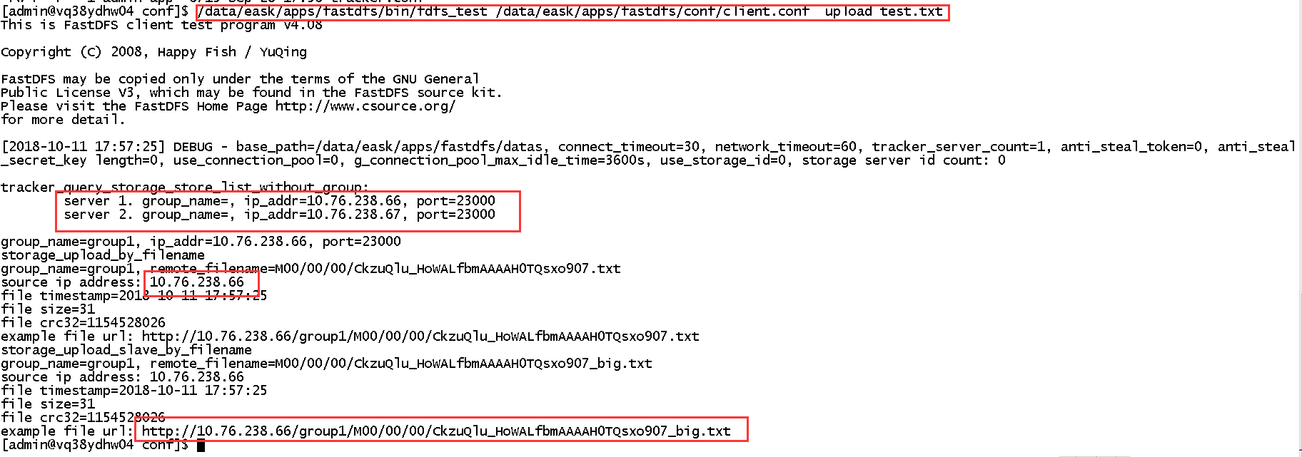

查看两个数据节点相应的目录
cd /data/eask/apps/fastdfs/datas/storage/data/00/00/
