NGINX部署

环境准备

独立部署

1.1.1安装包目录
/data/soft

1.1.2安装部署目录
/data/eask

1.1.3安装包准备
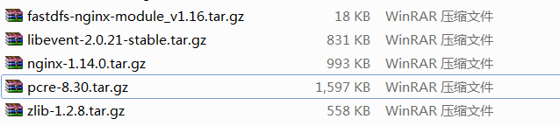

1.1.4安装基础环境

1.1.4.1openssl
openssl version
方案一:
yum -y install openssl openssl-devel

方案二:(推荐)
./config --prefix=/data/eask/openssl-1.0.2p
make
make install

1.1.4.2libevent
mkdir /data/eask/libevent
cd /data/soft
tar -zxvf libevent-2.0.21-stable.tar.gz 不要v，不显示详情
cd /data/soft/libevent-2.0.21-stable
./configure --prefix=/data/eask/libevent
make
make install

1.1.4.3pcre
// 卸载默认安装的pcre
rpm -qa |grep pcre
// pcre-7.8-3.1.el6.x86_64

mkdir /data/eask/pcre8.30
cd /data/soft
tar -zxvf pcre-8.30.tar.gz
cd /data/soft/pcre-8.30
./configure --prefix=/data/eask/pcre8.30
make
make install

1.1.4.4zlib
// 卸载默认安装的zlib
rpm -qa |grep zlib
// zlib-devel-1.2.3-27.el6.x86_64
// zlib-1.2.3-27.el6.x86_64

mkdir /data/eask/zlib1.2.8
cd /data/soft
tar -zxvf zlib-1.2.8.tar.gz
cd /data/soft/zlib-1.2.8
./configure --prefix=/data/eask/zlib1.2.8
make
make install

和文件系统一起部署
基础环境和文件系统一样

2部署

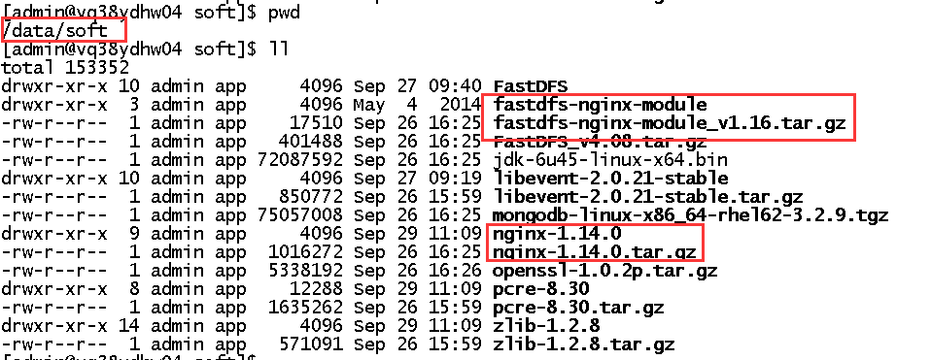

2.1编译fastdfs-nginx-module
[admin@vq38ydhw04 /]$ cd /data/soft/
[admin@vq38ydhw04 soft]$ tar xf fastdfs-nginx-module_v1.16.tar.gz
[admin@vq38ydhw04 soft]$ cd fastdfs-nginx-module
[admin@vq38ydhw04 fastdfs-nginx-module]$ vi src/config

使用下面的替换原内容
ngx_addon_name=ngx_http_fastdfs_module
HTTP_MODULES="$HTTP_MODULES ngx_http_fastdfs_module"
NGX_ADDON_SRCS="$NGX_ADDON_SRCS $ngx_addon_dir/ngx_http_fastdfs_module.c"
CORE_INCS="$CORE_INCS /data/eask/apps/fastdfs/include/fastdfs /data/eask/apps/fastdfs/include/fastcommon/"
CORE_LIBS="$CORE_LIBS -L/data/eask/apps/fastdfs/lib -lfastcommon -lfdfsclient"
CFLAGS="$CFLAGS -D_FILE_OFFSET_BITS=64 -DFDFS_OUTPUT_CHUNK_SIZE='256*1024' -DFDFS_MOD_CONF_FILENAME='\"/data/eask/apps/fastdfs/conf/mod_fastdfs.conf\"'"

2.2安装nginx

2.2.1安装
[admin@vq38ydhw04 soft]$ mkdir -p /data/eask/apps/nginx
[admin@vq38ydhw04 soft]$ tar xf nginx-1.14.0.tar.gz
[admin@vq38ydhw04 soft]$ cd nginx-1.14.0
编译，挂载的目录是安装包目录
./configure --prefix=/data/eask/apps/nginx --with-pcre=/data/soft/pcre-8.30/ --with-zlib=/data/soft/zlib-1.2.8/ --with-stream --with-stream_ssl_module --with-http_ssl_module --add-module=/data/soft/fastdfs-nginx-module/src
安装
make
make install

2.2.2修改配置文件
[admin@vq38ydhw04 ~]$ cd /data/eask/apps/nginx/conf/
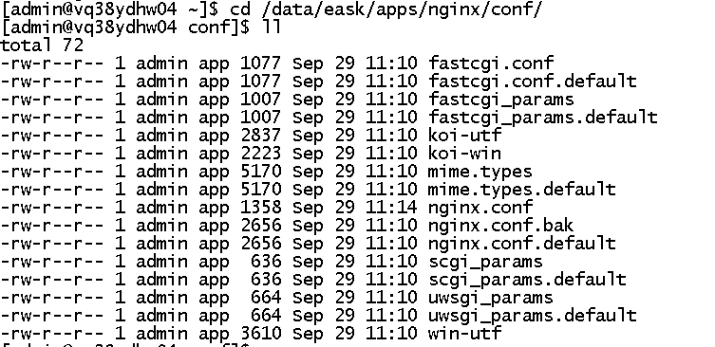

修改默认的配置文件
[admin@vq38ydhw04 conf]$ cp nginx.conf{,.bak}
[admin@vq38ydhw04 conf]$ grep -vE "#|^$" nginx.conf.default >nginx.conf

修改nginx.conf,在后面添加红色部分，修改80为8080
[admin@vq38ydhw04 conf]$ vi nginx.conf

worker_processes 1;
events {
worker_connections 1024;
}
http {
include mime.types;
default_type application/octet-stream;
sendfile on;
keepalive_timeout 65;
server {
listen 8080;
server_name localhost;
location / {
root html;
index index.html index.htm;
}
error_page 500 502 503 504 /50x.html;
location = /50x.html {
root html;
}
}
server {
listen 8888;
server_name localhost;

#charset koi8-r;

#access_log logs/host.access.log main;

location ^~ /group1/M00 {
root /data/eask/apps/fastdfs/datas/storage/data;
index index.html index.htm;
ngx_fastdfs_module;
}

location ^~/M00 {
proxy_set_header Host $host;
proxy_set_header X-Real-IP $remote_addr;
proxy_set_header X-Forwarded-For $proxy_add_x_forwarded_for;
rewrite ^/(.*)$ /group1$request_uri? last;
}

location / {
proxy_set_header Host $host;
proxy_set_header X-Real-IP $remote_addr;
proxy_set_header X-Forwarded-For $proxy_add_x_forwarded_for;
rewrite ^/(.*)$ /group1/M00$request_uri? last;
}
}

2.3配置模块
拷贝fastdfs-nginx-module配置文件

[admin@vq38ydhw04 conf]$ cp /data/soft/fastdfs-nginx-module/src/mod_fastdfs.conf /data/eask/apps/fastdfs/conf/

修改配置
vi /data/eask/apps/fastdfs/conf/mod_fastdfs.conf
进行修改
base_path =/data/eask/apps/fastdfs/datas/storage

log_filename=/data/eask/apps/nginx/logs/mod_fastdfs.log 这个文件要有权限,对log授权

url_have_group_name = true

group_name = group1

tracker_server=10.76.238.66:22122 或者是tracker_server=10.76.238.67:22122 看当前主机

store_path0=/data/eask/apps/fastdfs/datas/storage

2.4启动测试
查看部署状态
[admin@vq38ydhw04 ~]$ /data/eask/apps/nginx/sbin/nginx -t
[admin@vq38ydhw04 ~]$ ps -ef|grep nginx

启动
[admin@vq38ydhw04 ~]$ /data/eask/apps/nginx/sbin/nginx
/data/eask/apps/nginx/sbin/nginx -c /data/eask/apps/nginx/conf/nginx.conf

重启
/data/eask/apps/nginx/sbin/nginx -c /data/eask/apps/nginx/conf/nginx.conf -s reload
停止
/data/eask/apps/nginx/sbin/nginx -c /data/eask/apps/nginx/conf/nginx.conf -s stop
kill pid

3测试

3.1访问首页
10.76.238.66:8080
10.76.238.67:8080
正常说明通过

3.2下载文件测试
先上传文件获取路径
/data/eask/apps/fastdfs/bin/fdfs_test /data/eask/apps/fastdfs/conf/client.conf upload test.txt
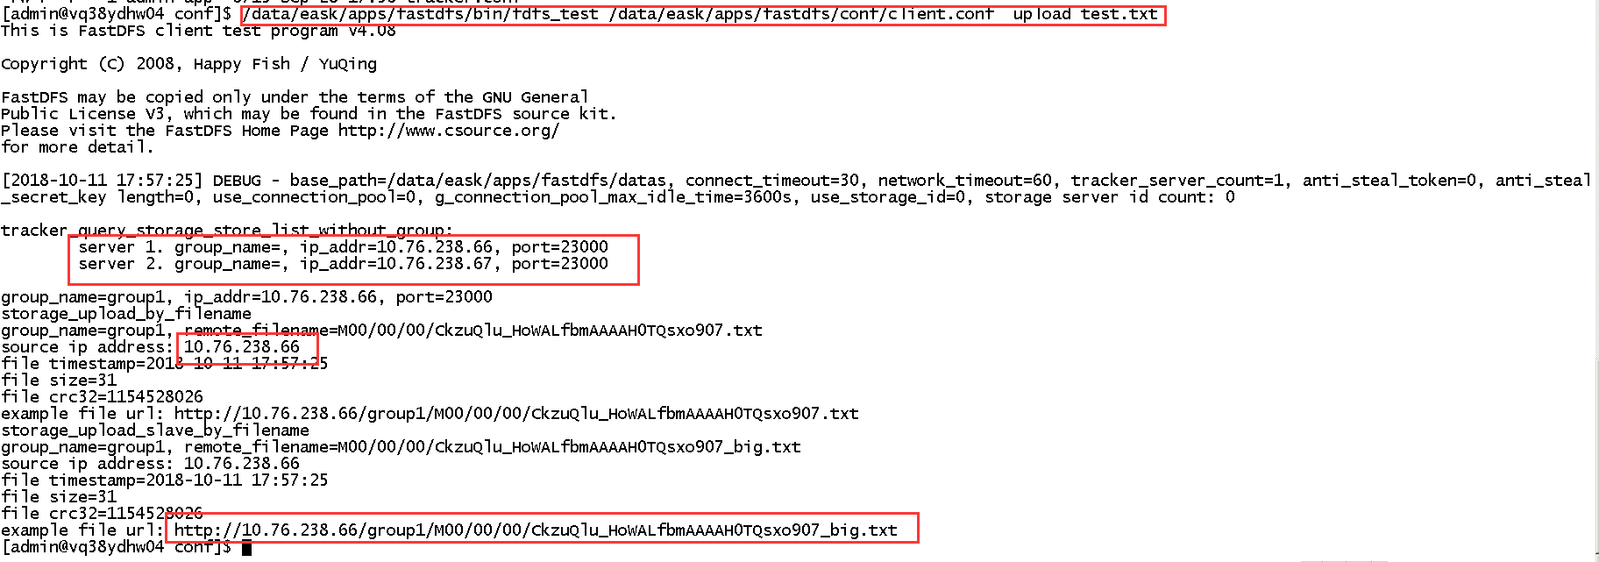
访问路径
http://10.76.238.66:8888/group1/M00/00/00/CkzuQlu_HoWALfbmAAAAH0TQsxo907_big.txt
http://10.76.238.67:8888/group1/M00/00/00/CkzuQlu_HoWALfbmAAAAH0TQsxo907_big.txt

