CprE 381, Computer Organization and

Assembly Level Programming

Lab 1 Report

Student Name ______Preston Gaskill____________________

Submit a typeset pdf version of this on Canvas by the due date. Refer to the highlighted language in the lab document for the context of the following questions.

[Part 1.c] Think of three more cases and record them in your lab report.
iW = Weight data input
iLdW = Associated weight load control signal
iY = Partial sum input
iX = Activation input
oY = output (birthday value)
oX = output

Case 3: Initialize weight with maximum value
1. Set weight value register input signal (iW) to maximum value.
2. Set weight value register load signal (iLdw) to desired value (1 to update iLdw’s register with each clock cycle positive edge)
(Test checks if register values hold correctly before positive edge of clock)
3. During the process the internal signal (s_W) will take on the desired value of the input register (max value).
(Test checks if registers values are maintained correctly and if s_W is correct)
4. Internal signal (s_W) will hold value indefinitely, unless, you re-input a value to register load signal (iLdw) or the register input changes (iW).
(Test prob checks indefinitely for problems)

Case 4: Initialize weight with minimum value
1. Set weight value register input signal (iW) to minimum value.
2. Set weight value register load signal (iLdw) to desired value (1 to update iLdw’s register with each clock cycle positive edge)
(Test checks if register values hold correctly before positive edge of clock)
3. During the process the internal signal (s_W) will take on the desired value of the input register (min value).
(Test checks if registers values are maintained correctly and if s_W is correct)
4. Internal signal (s_W) will hold value indefinitely, unless, you re-input a value to register load signal (iLdw) or the register input changes (iW).
(Test prob checks indefinitely for problems)

Case 5: Produce a oY value to be 29 (my birthday)
- With the above weight initialization for iW set to 5, I set the activation input, iX, to 4 and the partial sum input, iY, to 9.
- I expect that after two positive clock edges oX will be 4, and oY will be 29.

1. Set weight value register input signal (iW) to desired value (5).
2. Set weight value register load signal (iLdw) to desired value (0 to never update iLdw’s register even if there is a new register input signal (iW))
3. Set activation input signal (iX) to 4
4. Set the partial sum input signal (iY) to 9
(Test checks if register values hold before positive edge of clock)
5. activation input signal (iX) and partial sum input signal (iY) are only stored after first positive clock edge.
(Test check values againn)
6. Calculate partial sum output (oY), oY=iW×iX+iY, or oY=5×4+9=29
(Test prob checks indefinitely for problems)

[Part 1.e] For labels 1, 7, 22, and 28, specify where (VHDL file and line number) these values are located – some will be found in more than one place. Also attempt to explain the functionality of each label as it occurs in the code

(22) is the oQ output of
the g_Weight module, which is defined as an std_logic output on Line 30 of regld.vhd and set on Line
50.
For this specific instance of the g_Weight module, the output oQ is connected to a signal
called s_W on line 86, and another signal called s_X1 on line 106, and another signal called s_Y1 on line 112, and an output called oX on line 129, all in TPU_MV_Element.vhd. In this instance it is feeding its output back into the input.

(28) is the iD input of
the g_Delay3 module, which is defined as an std_logic input on Line 28 of Reg.vhd and ?set on Line
39?. For this specific instance of the g_Delay3 module, the input iD is connected to a signal
called iX on line 105 of TPU_MV_Element.vhd.

(7) is the g_Add1 module in adder.vhd. For this specific instance of the adder module, the output oC is connected to oY on line 138 of TPU_MV_Element.vhd. Input iA to signal s_WxX on line 136 and input iB to signal s_Y1 on line 137 both in TPU_MV_Element.vhd.

(1) is TPU_MV_Element.vhd this is the whole system.
It and it’s components are declared on line 24 and instantiated in structural VHDL on line 38 onward.

[Part 1.g.v] In your lab report, include a screenshot of the waveform. Describe, in plain English, any differences between what you expected and what the simulation showed.
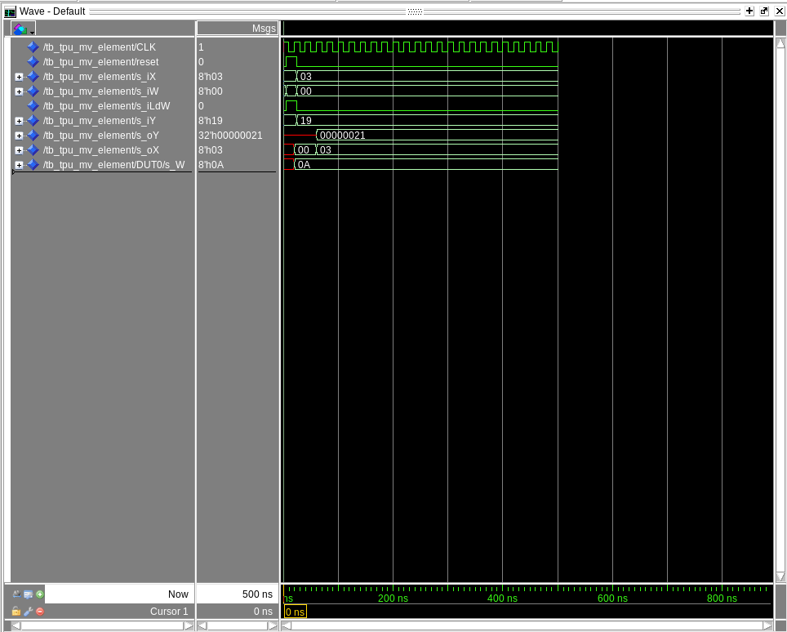

Test case 1 behaves correctly.
Test case 2 does not, outputting 33 instead of the desired 55.
[Part 1.h] In your lab report, include a screenshot of the waveform. Describe, in plain English, how your waveform matches the expected result (e.g., reference the specific cycles and times). In your submission zip file, provide the completed TPU_MV_Element.vhd file in a folder called ‘MAC’.
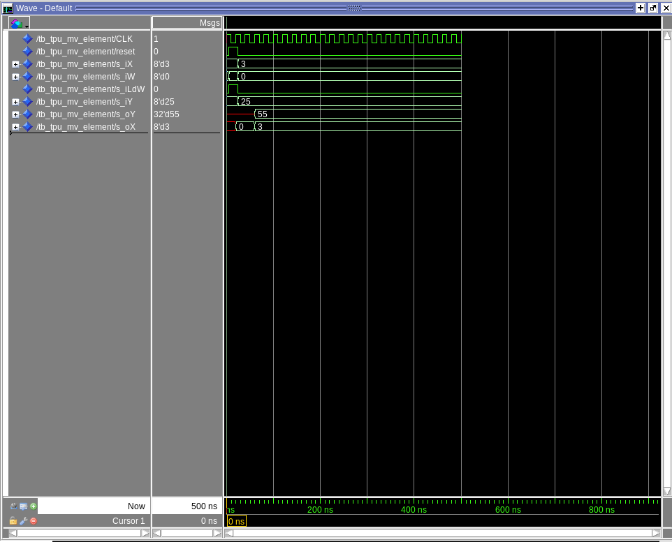

My waveform matches the expected results by first setting up the clock to move up and down every 10 ns. Then after waiting for 5 ns (to ensure clarity), the first test case sets x”00” to iX, then x”0A” to iW, then 1 to iLdW and x”00” to iY. The process then waits for 20 ns, and all this causes s_W to be 10 after the positive clock edge.
After that test case 2 then assigns ”03” to iX, then x”00” to iW, then 0 to iLdW and x”19” to iY. The process then waits for 40 ns before out all this causes o_Y to output 55.

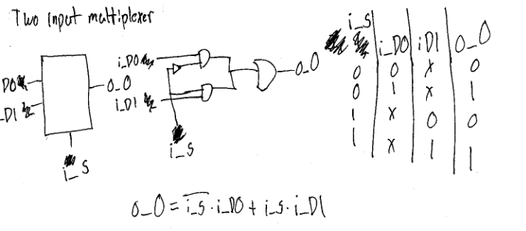
[Part 3.a] Draw the truth table, Boolean equation, and Boolean circuit equivalent (using only two-input gates) that implements a 2:1 mux. Include this in your lab report.

[Part 3.d] In your lab report, include a screenshot of the waveform. Make sure to label the screenshot with which module it is testing.
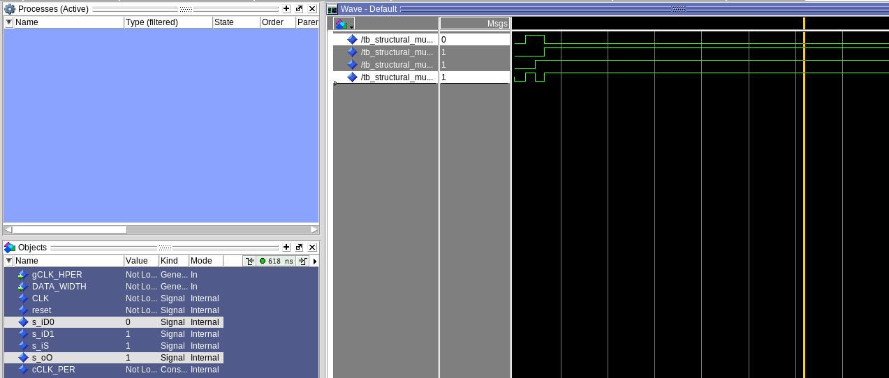
Structural 2:1 Mux

[Part 3.e] Again, in your lab report, include a labeled screenshot of the waveform showing the dataflow mux implementation working.
Dataflow 2:1 Mux
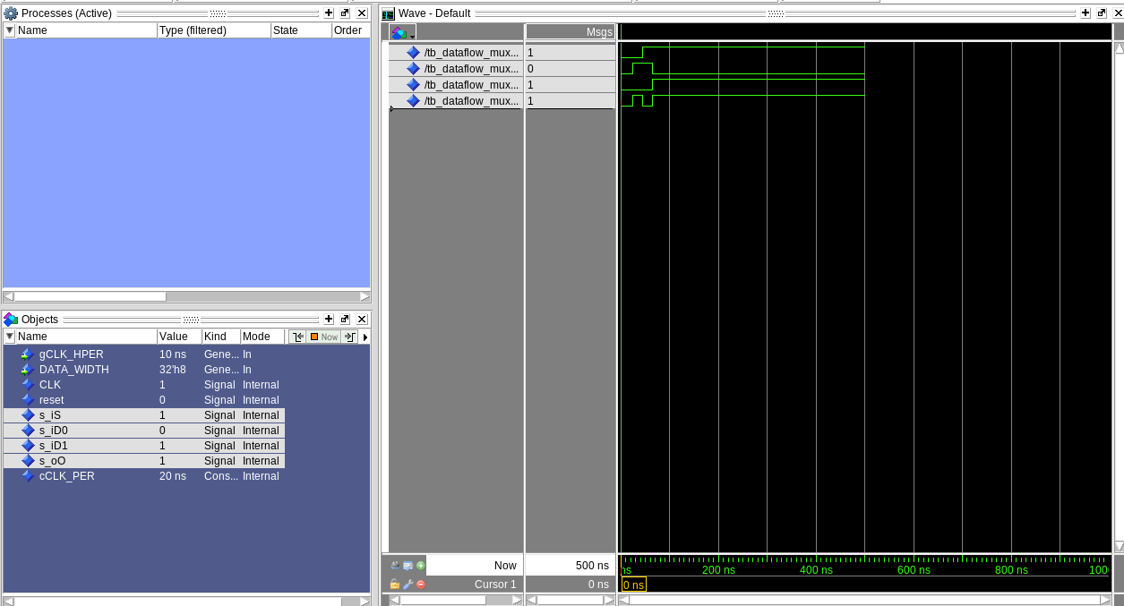

[Part 4] Include a waveform screenshot and corresponding description demonstrating it is working correctly.

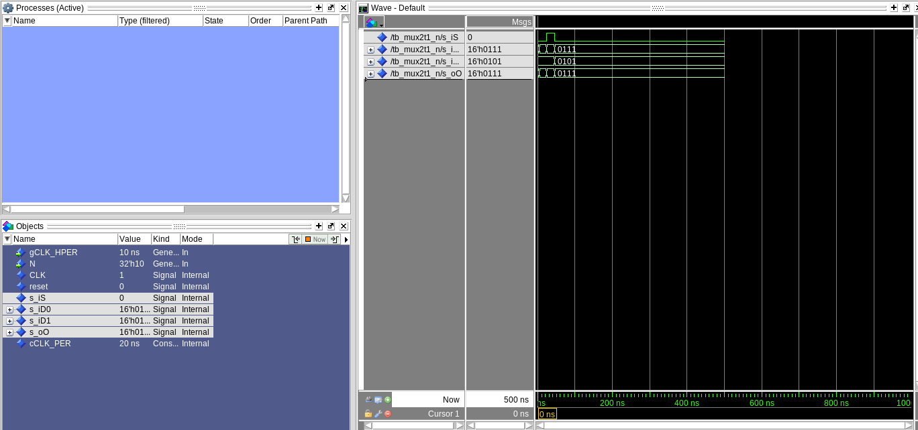

[Part 5.b] Include a waveform screenshot and description in your lab report.

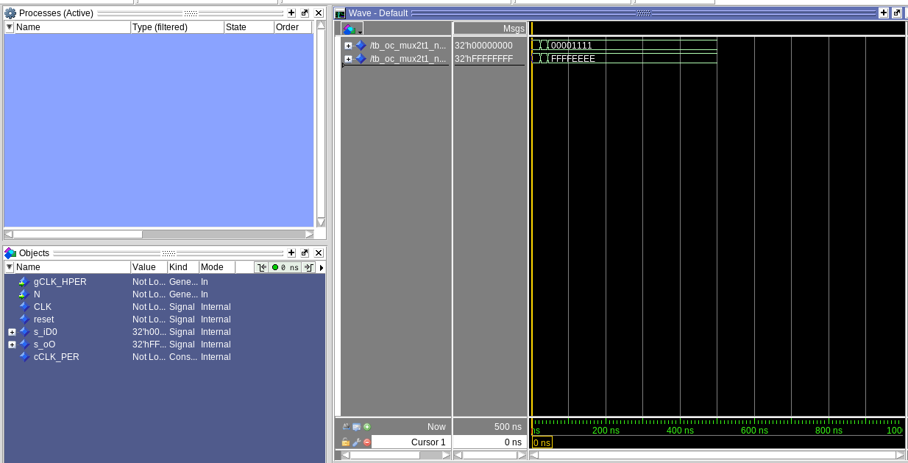

[Part 6.a] A full adder takes three single-bit inputs and produces two single-bit outputs – a sum and carry for the addition of the three input bits. Draw the truth table, Boolean equation, and Boolean circuit equivalent (using only two-input gates) that implements a 1-bit full adder. Include this in your report.
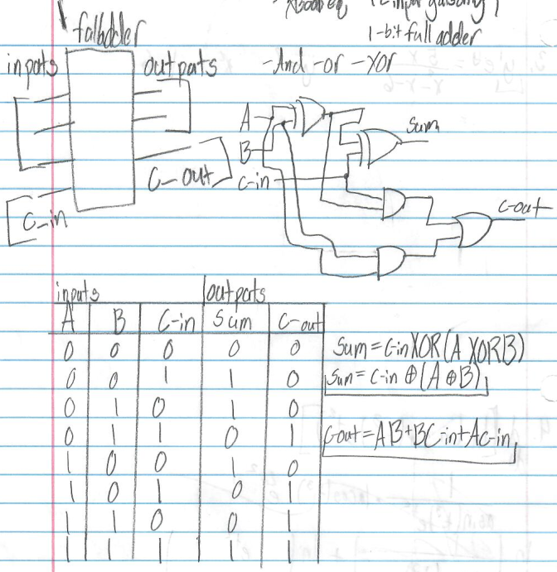

[Part 6.c] Then draw a schematic of the intended design, including inputs and outputs and at least the 0, 1, N-2, and N-1 stages. Include this in your report.

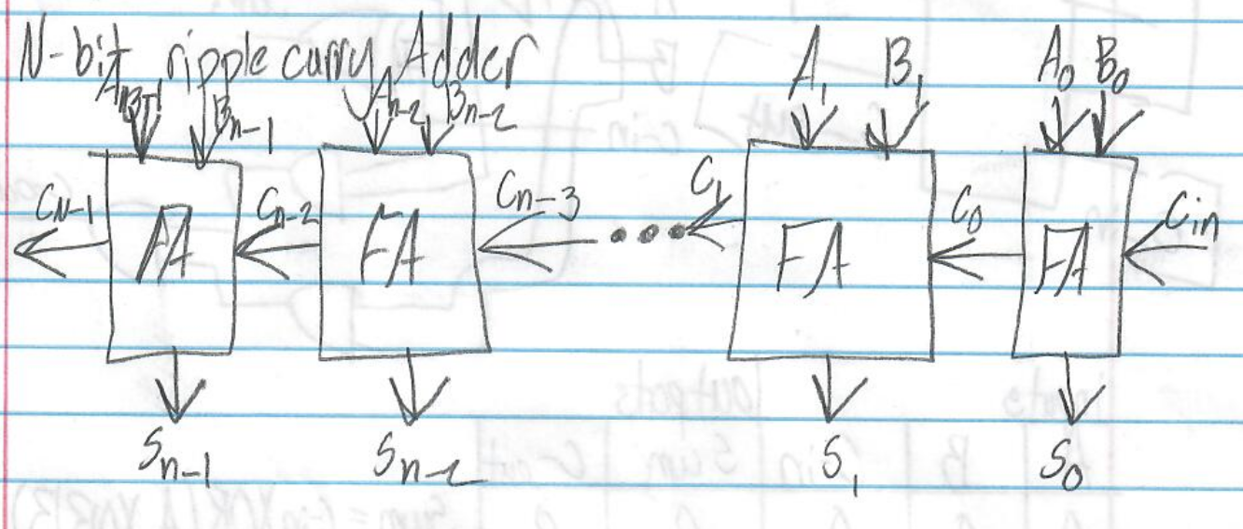

[Part 6.d] Include an annotated waveform screenshot in your write-up.
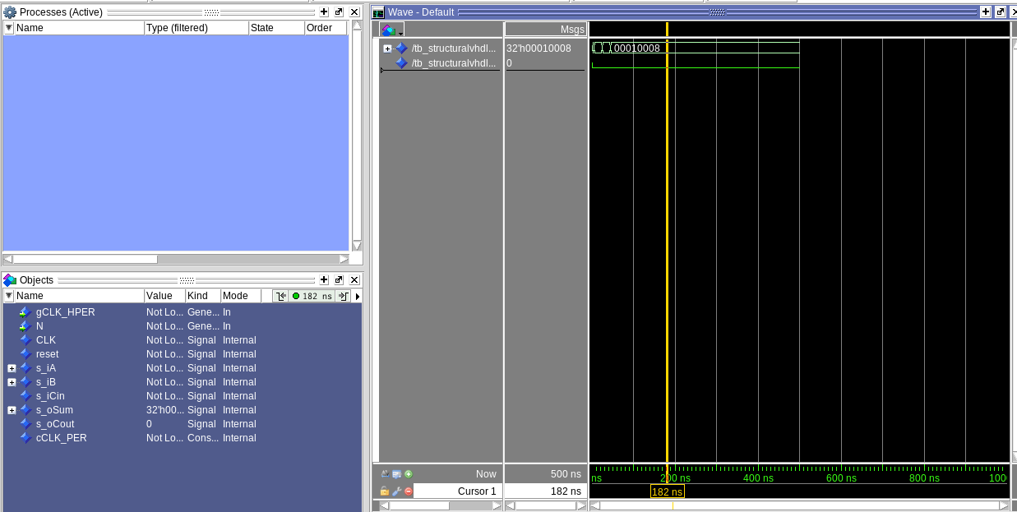

Part 7.a] Draw a schematic (don’t use a schematic capture tool) showing how an N-bit adder/subtractor with control can be implemented using only the three main components designed in earlier parts of this lab (i.e., the N-bit inverter, N-bit 2:1 mux, and N-bit adder). How is the ‘nAdd_Sub’ bit used? Include this in your report.

The nAdd_Sub is used in declaring whether the adder is adding or subtracting, I called it the control in the drawn schematic.

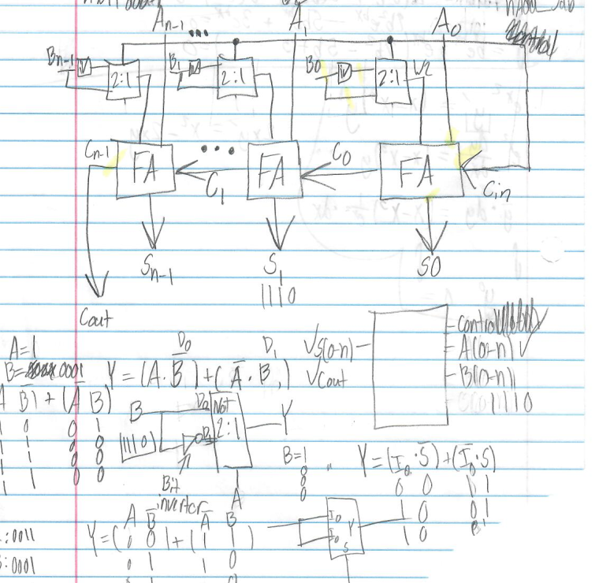

[Part 7.c] Provide multiple waveform screenshots in your write-up to confirm that this component is working correctly. What test-cases did you include and why?

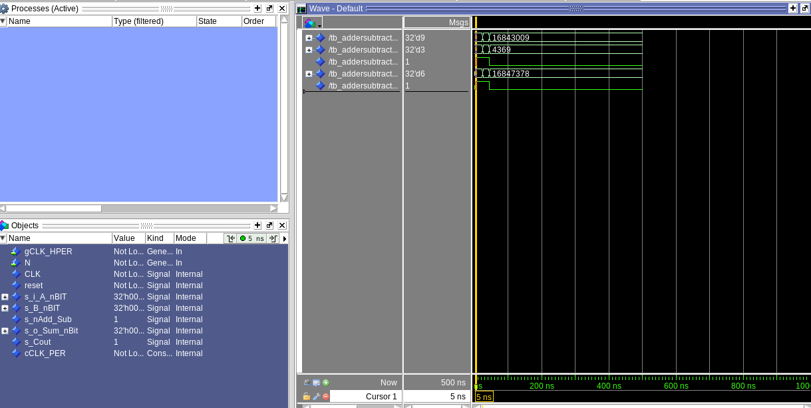
I primary tested the adding and subtracting of the Adder in my test cases. I did this because both a crucial in parts in the functionality of an adder/subtractor

