CprE 381, Computer Organization and

Assembly-Level Programming

Lab 2 Report

Student Name ___Preston Gaskill______________

Submit a typeset pdf version of this on Canvas by the due date. Refer to the highlighted language in the lab document for the context of the following questions.

[Part 1 (a)] Draw the interface description (i.e., the “symbol” or high-level blackbox) for the MIPS register file. Which ports do you think are necessary, and how wide (in bits) do they need to be?
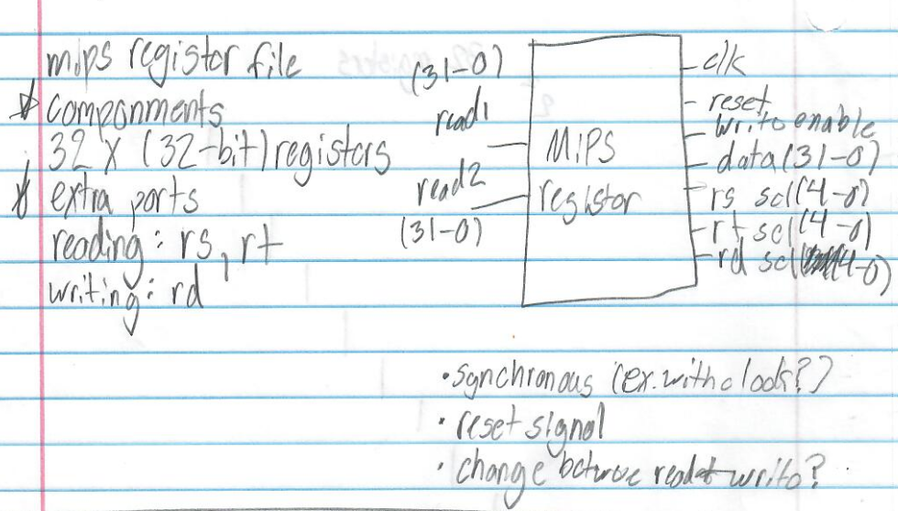

[Part 1 (b)] Create an N-bit register using this flip-flop as your basis.
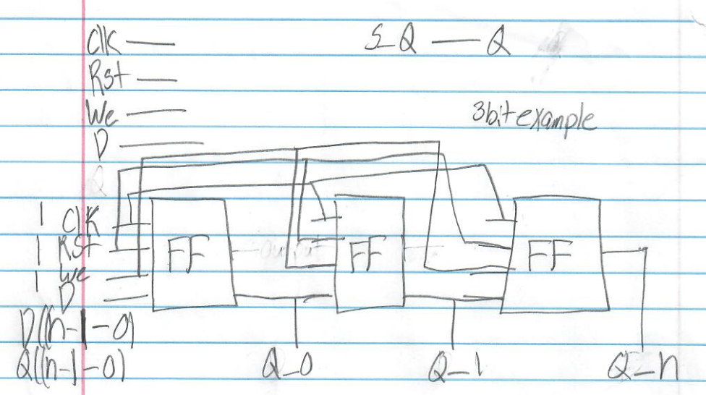

[Part 1 (c)] Waveform.
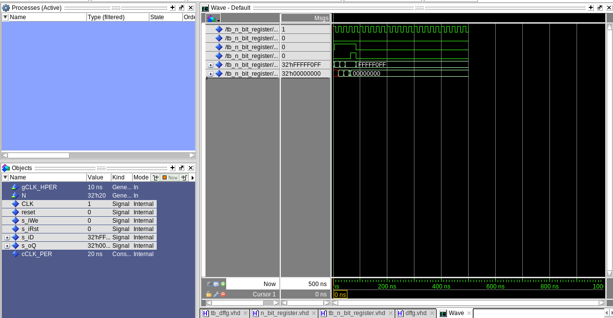

[Part 1 (d)] What type of decoder would be required by the MIPS register file and why?

There are 32 registers, you need to be able to select 1 of them at a time. That means there are going to be 32 outputs and so we need 2^5 inputs to cover all of this (5 being the amount of incoming bits). Given all this the decoder is going to be a 5to32 decoder.

[Part 1 (e)] Waveform.

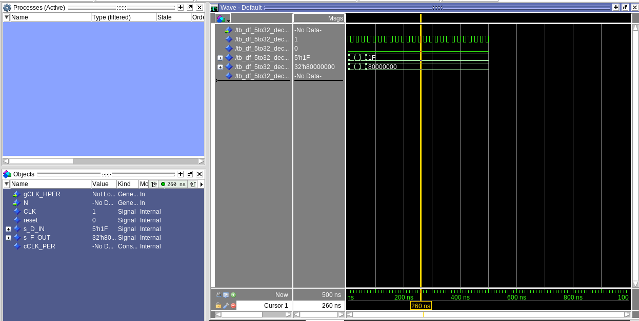

[Part 1 (f)] In your write-up, describe and defend the design you intend on implementing for the next part.

Using structural I am going to create a 32-bit 32:1 mux. This means that we are going to have 32 32:1 muxs and we want to select and output a SINGLE one of these muxs.
I am going to do this by setting each data input port to 32 bits then processing it and using another input 5-bit input called select with the command when to pick one of these as my data output.

[Part 1 (g)] Waveform.

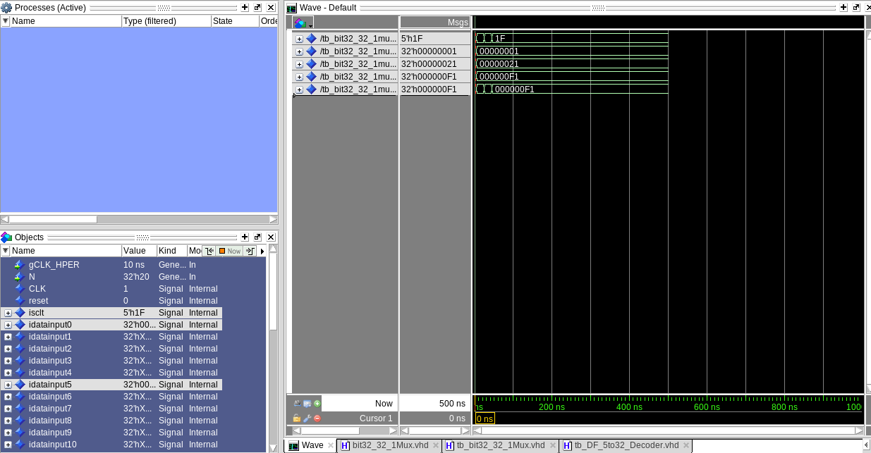

[Part 1 (h)] Draw a (simplified) schematic (i.e., components within the high-level blackbox) for the MIPS register file, using the same top-level interface ports as in your solution describe above and using only the register, decoder, and mux VHDL components you have created.

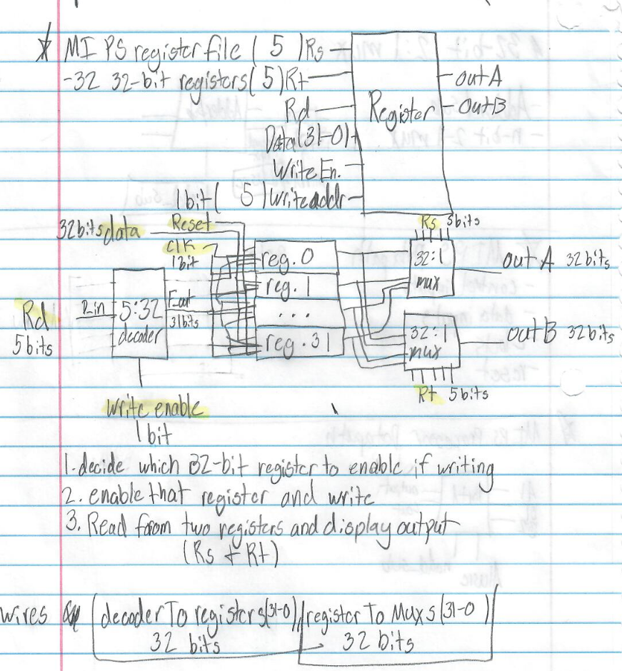

[Part 1 (i)] Waveform.

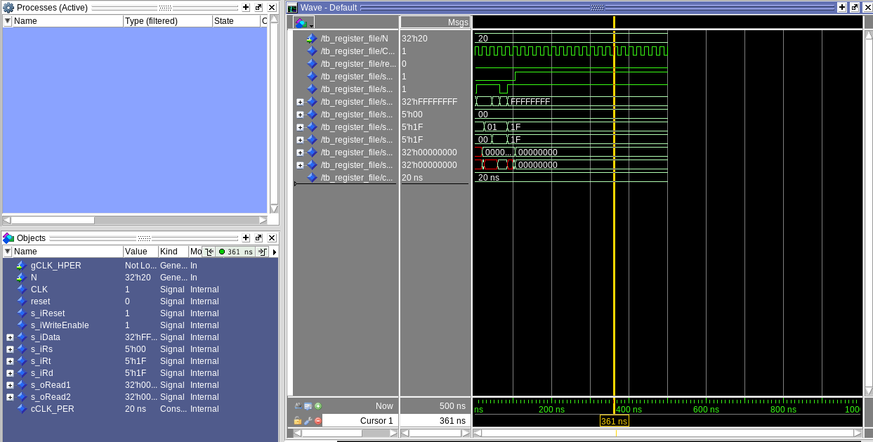

[Part 2 (b)] Draw a symbol for this MIPS-like datapath.

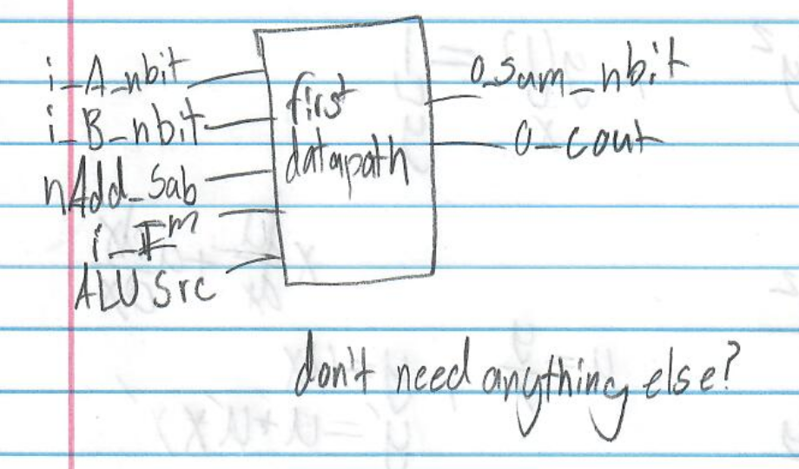

[Part 2 (c)] Draw a schematic of the simplified MIPS processor datapath consisting only of the component described in part (a) and the register file from problem (1).

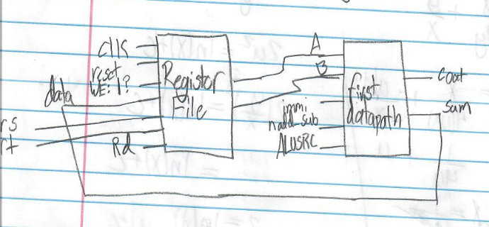

[Part 2 (d)] Include in your report waveform screenshots that demonstrate your properly functioning design. Annotate what the final register file state should be.

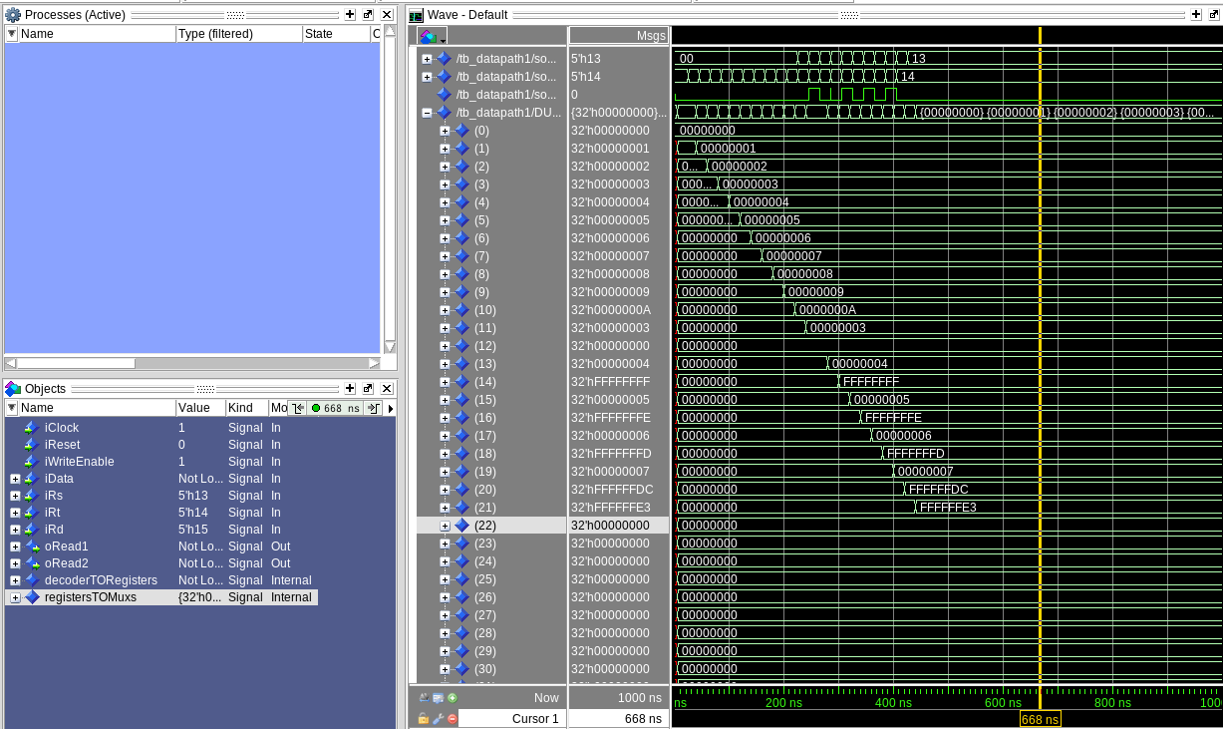

The final register modified state if FFFFFFE3

[Part 3 (a)] Read through the mem.vhd file, and based on your understanding of the VHDL implementation, provide a 2-3 sentence description of each of the individual ports (both generic and regular).

DATA_WIDTH: Holds a default value of 32, and defines how many bits each memory location holds.
ADDR_WIDTH: Holds a default value of 10, and defines the width of address bus and total number of memory locations.
Clk: Clock signal.
Addr: Specifies the memory location for reading and writing operations.
data: The data that is going to be written to a specific memory location. (Width of this port is determined by data width)
We: Write enable, if 1 will write to register, if 0 will only read.
Q: Output of the data stored in the memory location from Addr.

[Part 3 (c)] Waveforms.

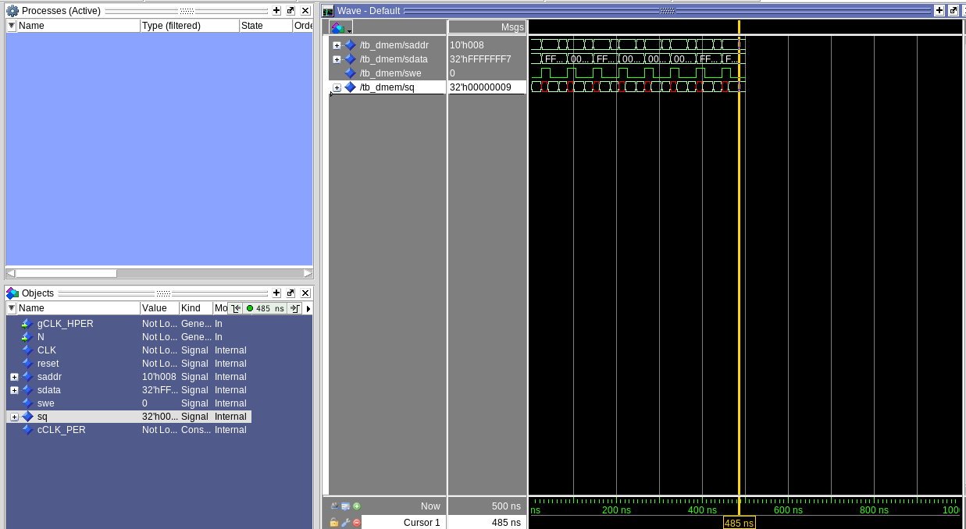

[Part 4 (a)] What are the MIPS instructions that require some value to be sign extended? What are the MIPS instructions that require some value to be zero extended?

Instructions involving immediate’s require a sign extension to treat the immediate as a signed number, and need a 0 extension to treat the number as an unsigned number.

[Part 4 (b)] what are the different 16-bit to 32-bit “extender” components that would be required by a MIPS processor implementation?

I think that the extender would need a sign extender and a zero extender and some way to flip between them. My idea is that I can describe the zero extender and sign extender and won’t have to make separate files describing them and then I can use some conditional or a mux if I have to so I can flip between them.

[Part 4 (d)] Waveform.

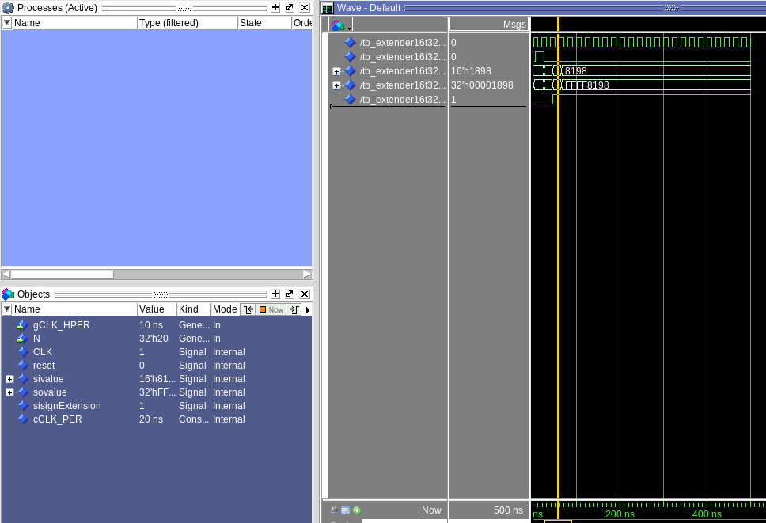

[Part 5 (a)] what control signals will need to be added to the simple processor from part 2? How do these control signals correspond to the ports on the mem.vhd component analyzed in part 3?

We will need to add two more control signals, one indicates whether we are writing into the memory, and the other will indicate whether we are reading from the memory.
MemoryWrite will be attached to port ‘we’ on mem, so if we are writing it will be able to change the stored memory values.
MemoryRead will be attached to a 2t1 mux where if it is reading (select line = 1) it will output the output of the mem to the registers dataline.

[Part 5 (b)] Draw a schematic of a simplified MIPS processor consisting only of the base components used in part 2, the extender component described in part 4, and the data memory from part 3.

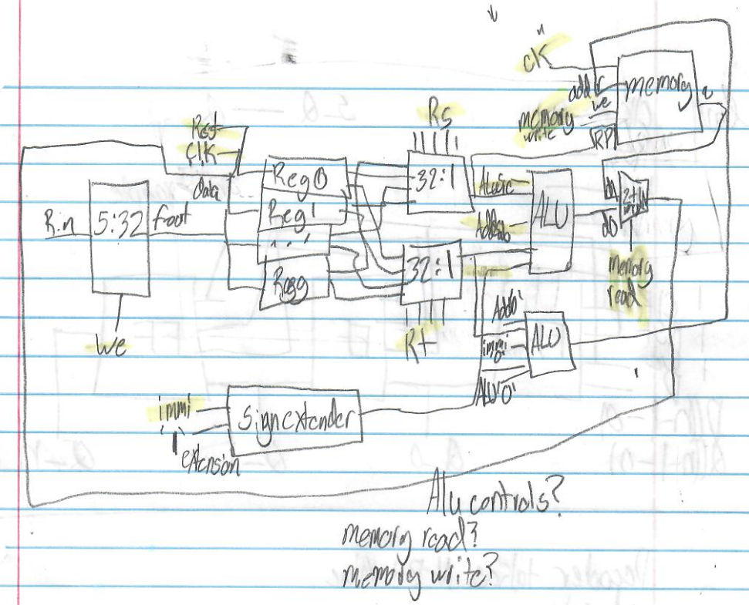

[Part 5 (c)] Waveform.

I think test/simulation is only worth 10 points of the second data path section? Honestly this lab is already late and I’m worried I won’t have time to finish this as is, I’ll just take the point lose and if I need to for a future lab I can come back and rework this.

