## 查找旅游目录

http://localhost//travel/category/findAll

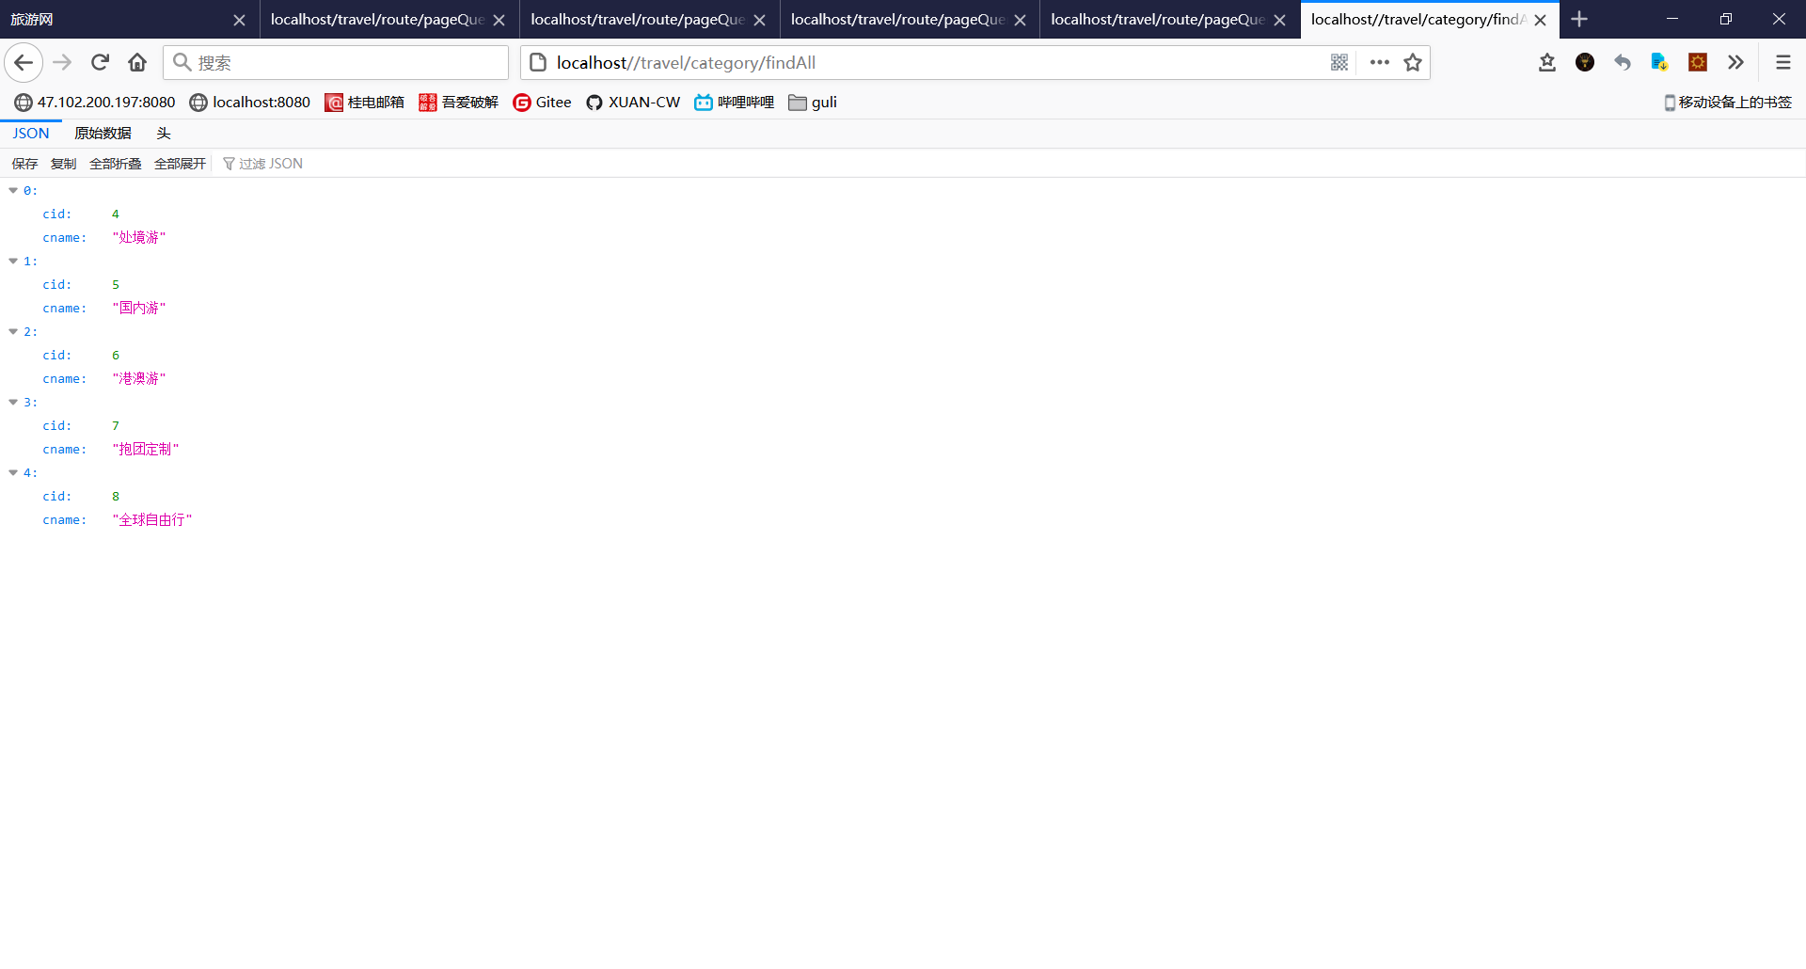

## 查找用户

http://localhost/travel/user/findOne

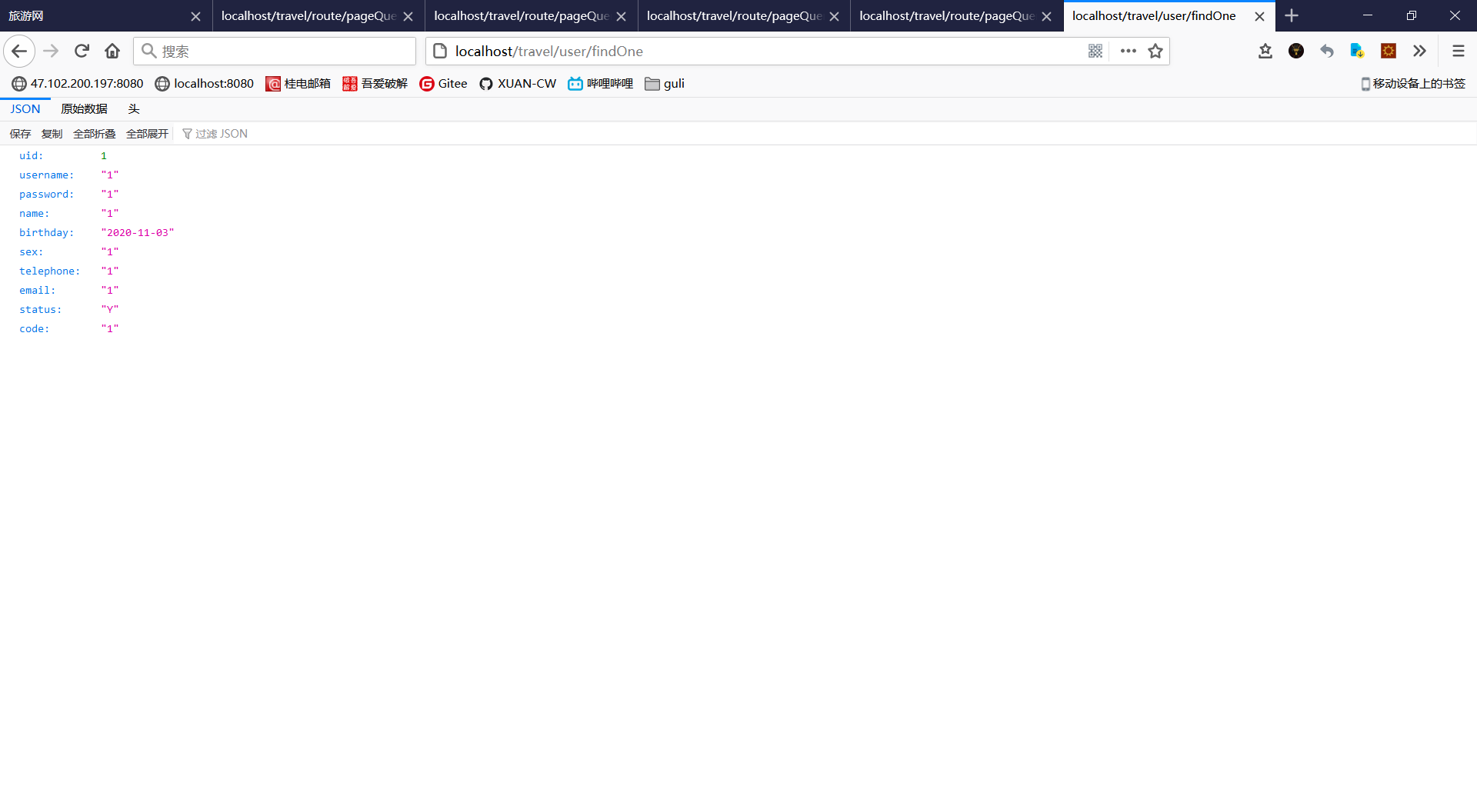

## 查找我的收藏

http://localhost/travel/user/myFavorite?currentPage=1

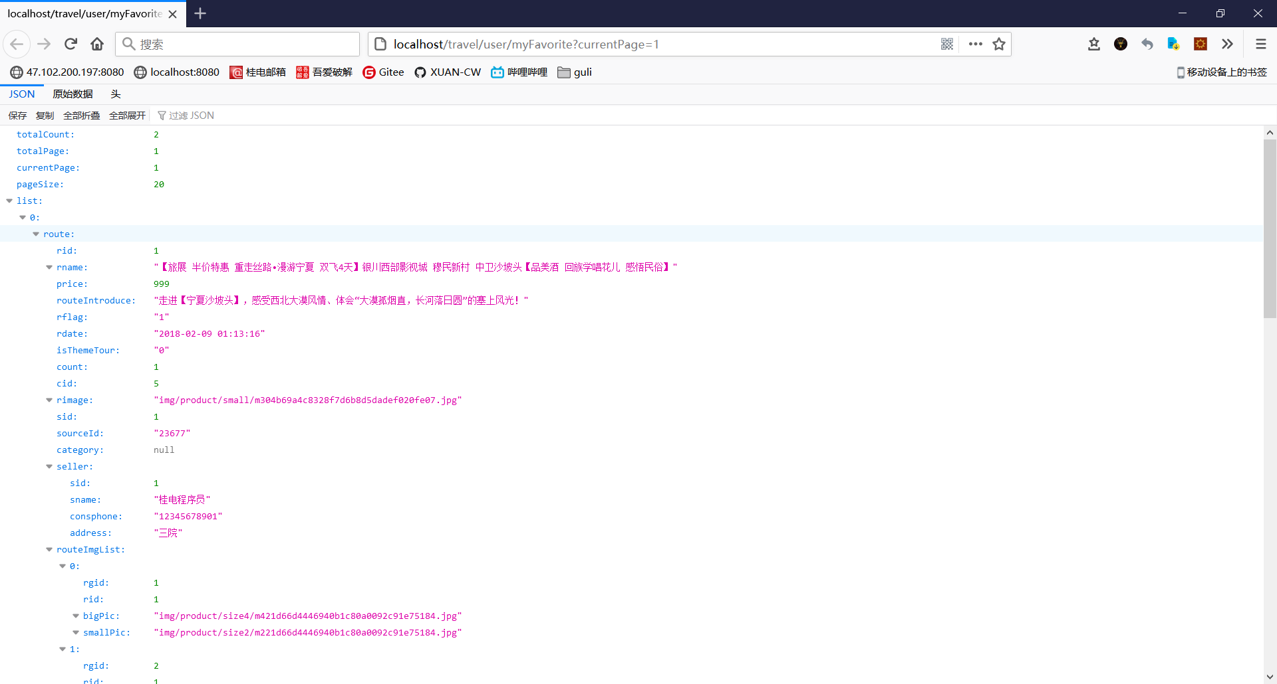

## 查询路线

### 出境游

http://localhost/travel/route/pageQuery?cid=4&currentPage=1

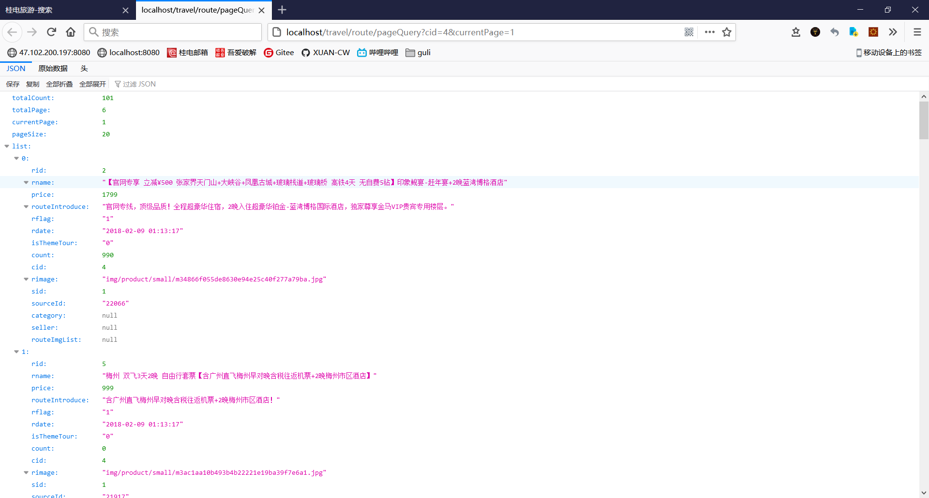

### 国内游

http://localhost/travel/route/pageQuery?cid=5&currentPage=1

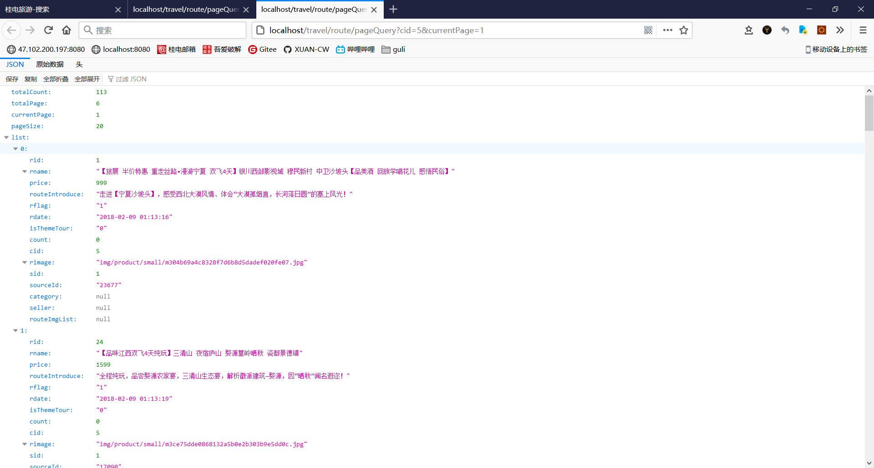

### 港澳游

http://localhost/travel/route/pageQuery?cid=6&currentPage=1

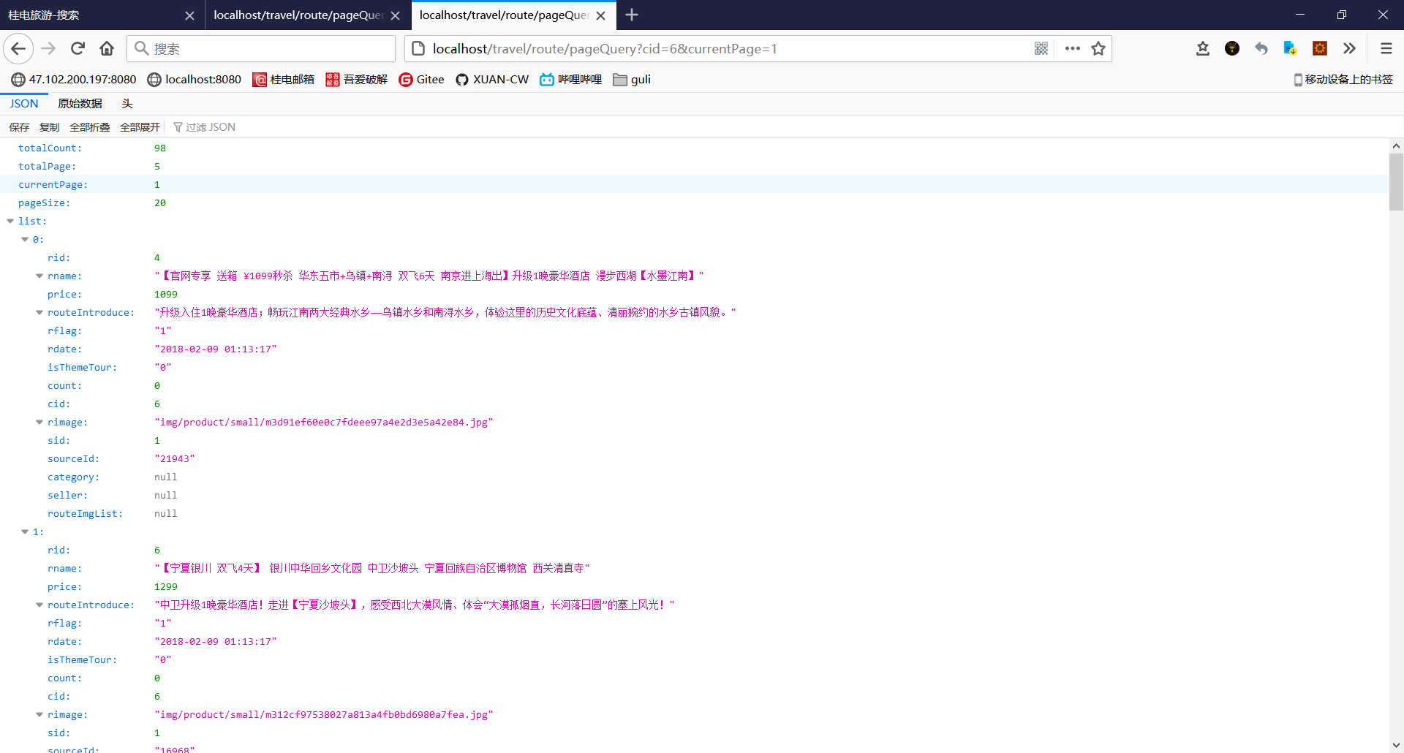

### 抱团定制

http://localhost/travel/route/pageQuery?cid=7&currentPage=1

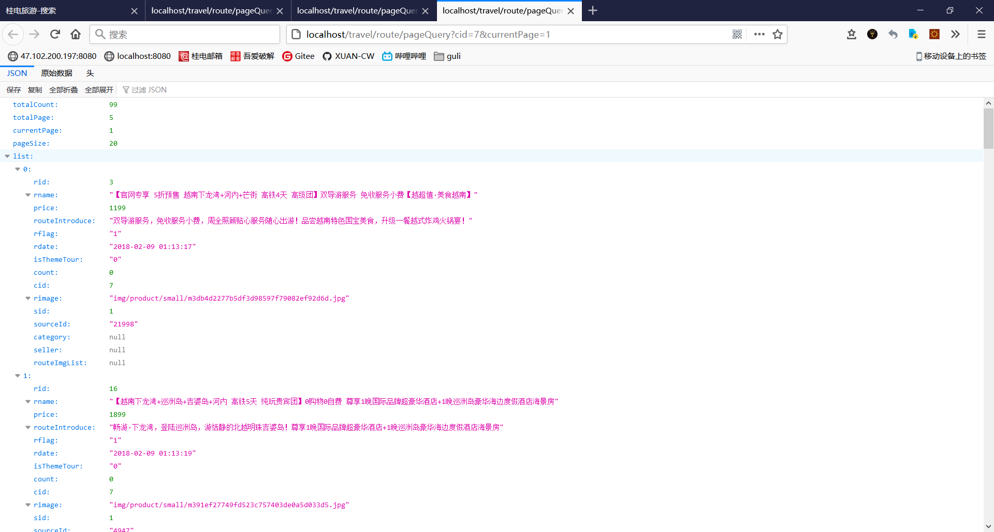

### 全球自由行

http://localhost/travel/route/pageQuery?cid=8&currentPage=1

