**Brief Documentation**

**Student name：Xuanhao Wang**

**Content**

* Project description
* The usage of this project
* Data Source
* Design
* Story board

**Project description**

The purpose of this project is to investigate the activity traces and frequency of great white sharks in the waters surrounding New Zealand, so as to further understand the marine environment and living habits of great white sharks in the waters surrounding New Zealand. This project will introduce different types of relevant data, such as the location, gender and time when great white sharks have been found in the waters around New Zealand in recent years. The project is based on python and will build an application program that displays specified types of data to help related researchers and interested users understand the trajectory and area of the great white shark.

**The usage of this project**

This app allows you to view signs of great white shark activity around New Zealand. This App will write a python function to read the file to obtain the activity data of the great white sharks in the surrounding waters, including the time of sighting, location and gender. This type of data will be displayed on the map of the app, which can help users view relevant data and understand the trajectory of the great white shark. For researchers, this is a software for data recording and searching for great white sharks. In addition, ordinary tourists such as diving and surfing enthusiasts can also use this software if they don't want to have a meeting with great white sharks. What's more, this app has a data addition function, which can help more and more data be entered into this app to ensure that the data is constantly updated.

**Data Source**

This project will use csv type data, which can be easily read and stored by the app. CSV is a common data, it is a form. In this project, this App will import csv data.

**Final Design**

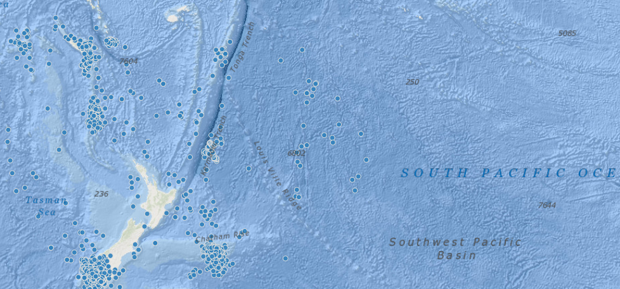

As shown in the figure, the final presentation of this App will show the location of the Great White Shark in the form of a map, and this App includes a search function. Users can find more accurate data through the search bar, such as a specific event or location. In addition, the App will also use different colors according to the activity frequency of the great white shark to highlight areas of frequent activity.

**SDV602 Storyboard**

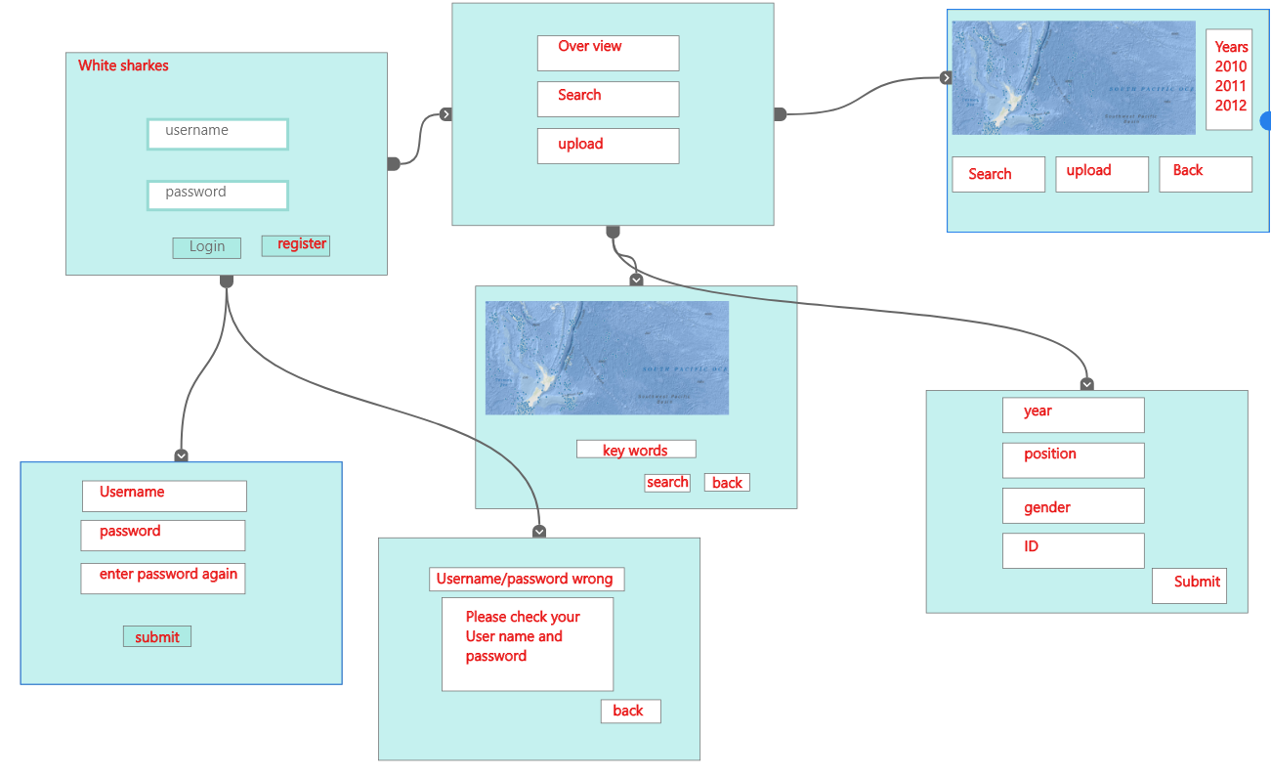

1.Login page

This APP will show the data of white sharks in New Zealand recent years. The first page is Login function, which customers can use this APP doing login, seeing the data and uploading new data.

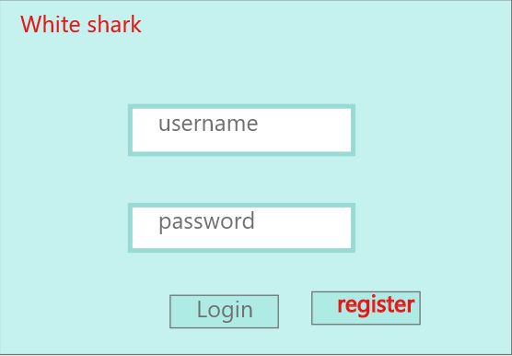

2.register

This page is to allow users who first time use the app creating a new account as formal user. The first text is username that will check new account available or not .And the fallowed two text is to ensure customer creating a password that they want.

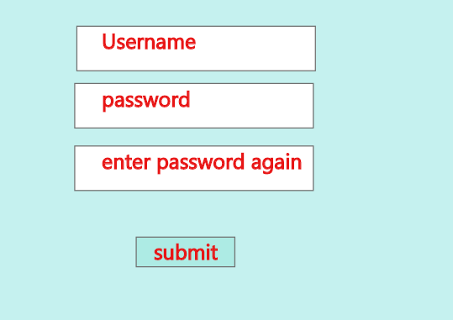

3.Username or password wrong

If users input a wrong username or password, the window will jump to this page and ask users to check their account information.

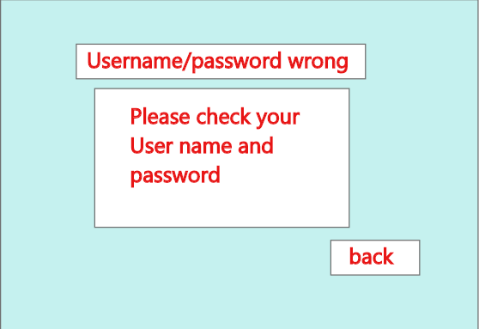

4.After login the App, there are three options can be clicked by customers, first button is to see the overall data of white sharks. Second button is a searching function, that users can search more specific information by this. Finally, the third button is for users to upload new data.

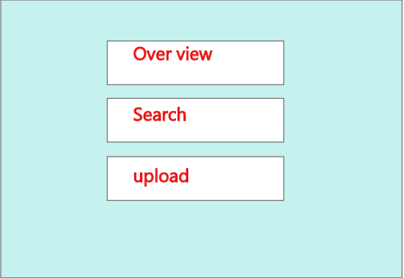

5.this is how the APP looks when users see the overall data, which shows a map with all white sharks appeared around New Zealand, including location, time, gender.

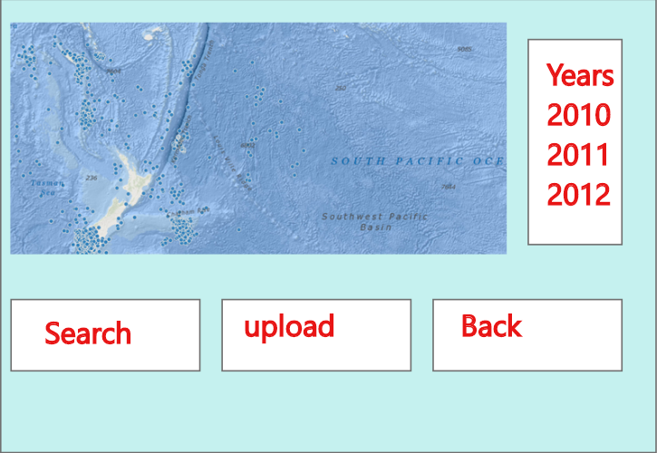

6.Searching data

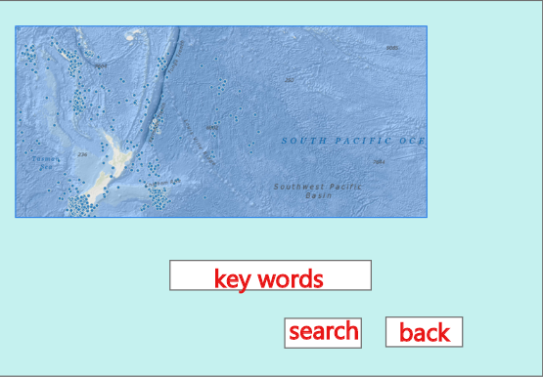

7.This is how users use the uploading function, So users can use this App to upload new data of white sharks.



