**SDV602 Storyboard**

1. Login page

This APP will show the data of white sharks in New Zealand recent years. The first page is Login function, which customers can use this APP doing login, seeing the data and uploading new data.

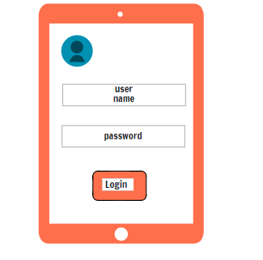

2.After login the App, there are three options can be clicked by customers, first button is to see the overall data of white sharks. Second button is a searching function, that users can search more specific information by this. Finally, the third button is for users to upload new data.

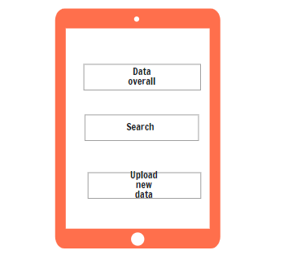

3.this is how the APP looks when users see the overall data, which shows a map with all white sharks appeared around New Zealand, including location ,time , gender.

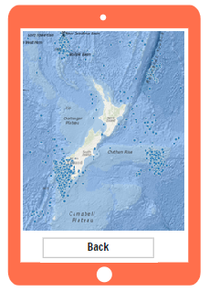

4.This is a simple framework of how users use the uploading function, So users can use this App to upload new data of white sharks.

