EBU6304 Software Engineering Group Project

2025-26
Group number | 101
Member 1 | QM no: 231223793 | Name: LeyanLi (Li Leyan)
Member 2 | QM no: 231223748 | Name: Lar-me-s (Fu Mingyi)
Member 3 | QM no: 231224033 | Name: lylybay (Meng Yuehan)
Member 4 | QM no: 231224044 | Name: LingyueYang (Yang Lingyue)
Member 5 | QM no: 231223519 | Name: Aurora050214 (Xu Shiqi)
Member 6 | QM no: 231223782 | Name: XUChenyou0216 (Xu Chenyou)

Final short report

Design

Architecture
The TA Recruitment System follows the Model-View-Controller (MVC) architectural pattern implemented with Java Servlet/JSP technology, as specified by the project requirements. The architecture comprises four distinct layers:
- Model Layer: Five data classes (User, Job, Application, TAProfile, Notification) encapsulate domain entities with CSV serialisation methods (toCsvRow/fromCsvRow) for persistence.
- DAO Layer: Five Data Access Object classes (UserDAO, JobDAO, ApplicationDAO, TAProfileDAO, NotificationDAO) provide CRUD operations through a centralised FileManager utility with synchronised thread safety.
- Controller Layer: Over 20 Servlet classes annotated with @WebServlet handle HTTP request/response cycles, each responsible for a specific user action (e.g., ApplyServlet, PostJobServlet, AdminUserServlet).
- View Layer: JSP pages organised by role (/ta/, /mo/, /admin/) with shared layout components (header.jsp providing sidebar navigation, footer.jsp closing layout tags).
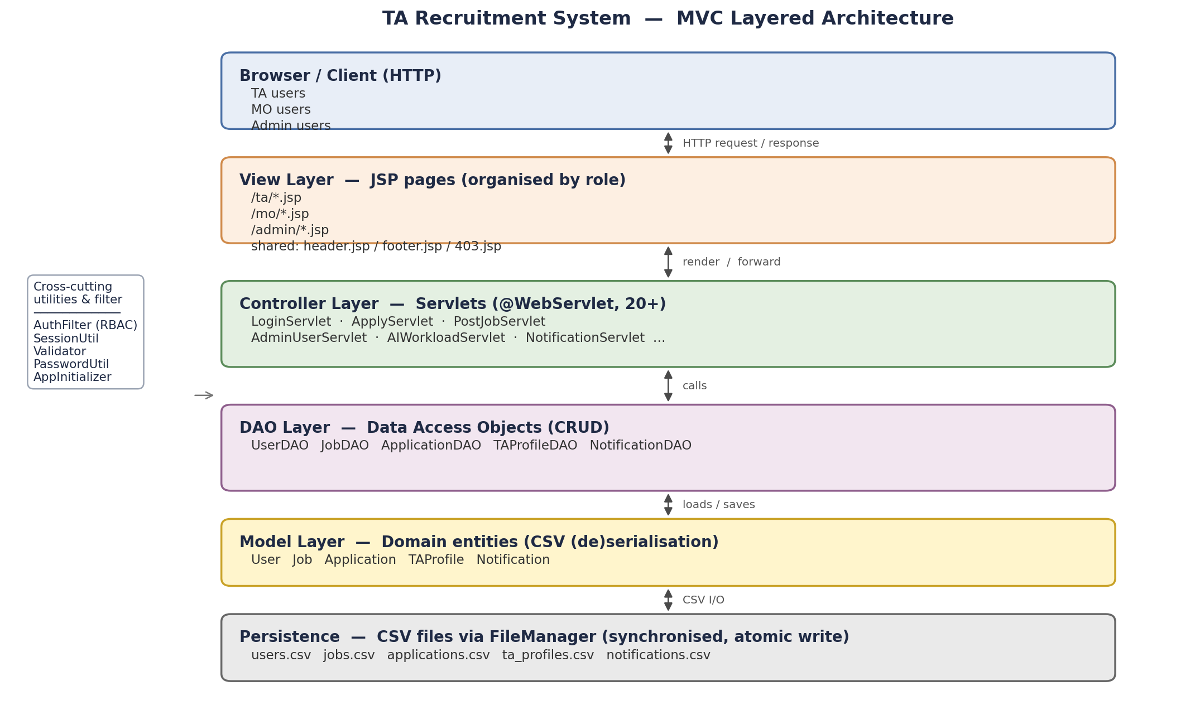
Figure 1. MVC Layered Architecture

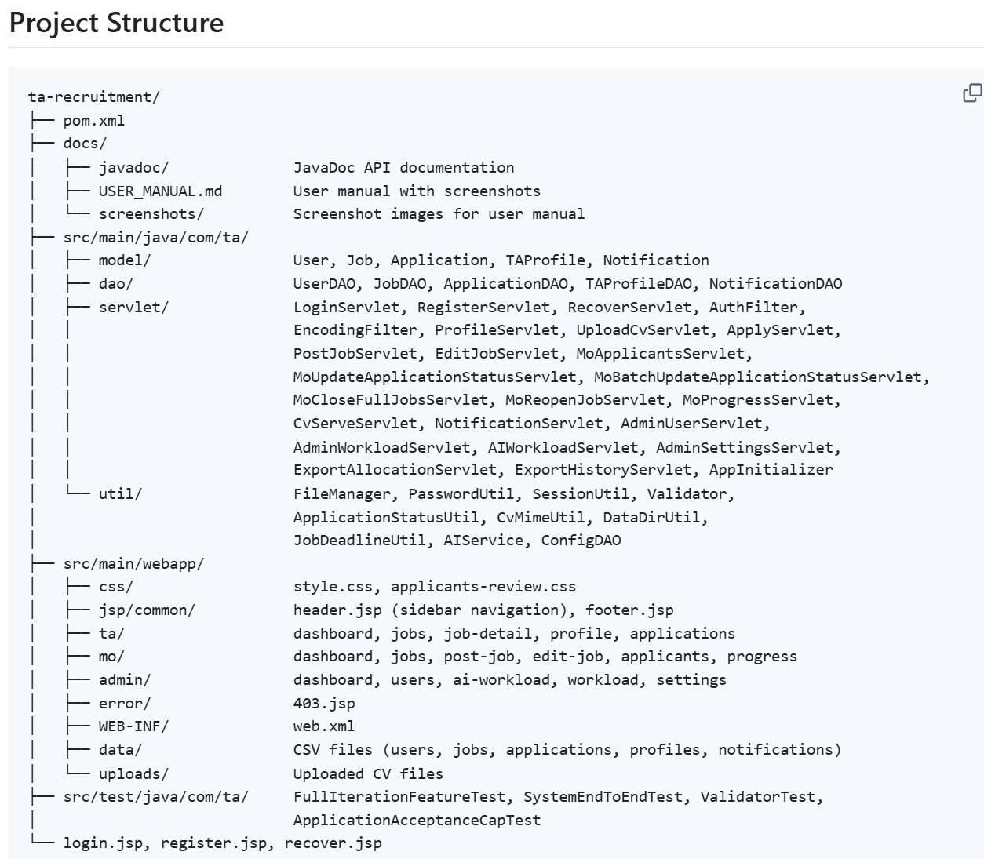
Figure 2. Project Structure

Design Principles
- Separation of Concerns: Each layer has a single responsibility — models hold data, DAOs handle persistence, servlets contain business logic, and JSPs render views.
- DRY (Don't Repeat Yourself): Common functionality is centralised in utility classes (FileManager for all file I/O, Validator for all input validation, SessionUtil for session management).
- Role-Based Access Control: AuthFilter implements the Intercepting Filter pattern, checking every HTTP request against the user's session role and URL prefix before forwarding to the target servlet.
- Convention over Configuration: @WebServlet annotations eliminate the need for verbose web.xml mappings, while @WebListener on AppInitializer enables automatic data initialisation.
- Human-in-the-Loop AI: The AI workload balancing feature follows a suggest-then-approve pattern, ensuring all automated recommendations require explicit administrator confirmation.

Key Design Decisions
- CSV Storage with Synchronised Access: All data is stored in CSV files as mandated by the specification. FileManager uses Java synchronized methods and atomic write operations to ensure thread safety within a single JVM deployment.
- AppInitializer for Zero-Configuration Setup: A @WebListener automatically creates data directories and sample CSV files on Tomcat startup, solving deployment inconsistencies across different development environments.
- Password Security: SHA-256 hashing via PasswordUtil ensures passwords are never stored in plaintext. Sprint 4 added strong password enforcement and 5-attempt login lockout.
- Notification System: A cross-cutting notification mechanism with a bell icon badge in the shared header.jsp, triggered by key business events (application submission, status change, workload anomaly).

Implementation

Implementation Strategy
The project was developed over four two-week sprints using Agile (Scrum) methodology, with incremental delivery of working software at each stage:
- Sprint 1 (Mar 23-30): Core infrastructure — MVC skeleton, authentication, role-based access, TA job browsing, input validation. Tag: v1.0
- Sprint 2 (Apr 1-8): Core business workflow — TA profile/CV management, job application, MO job posting/editing, applicant review. Tag: v2.0
- Sprint 3 (Apr 13-28): Advanced features — admin user management, workload monitoring, notification system, recruitment progress. Tag: v3.0
- Sprint 4 (Apr 29-May 10): Polish and robustness — AI workload balancing, settings, security hardening, batch operations, concurrency safety. Tag: v4.0
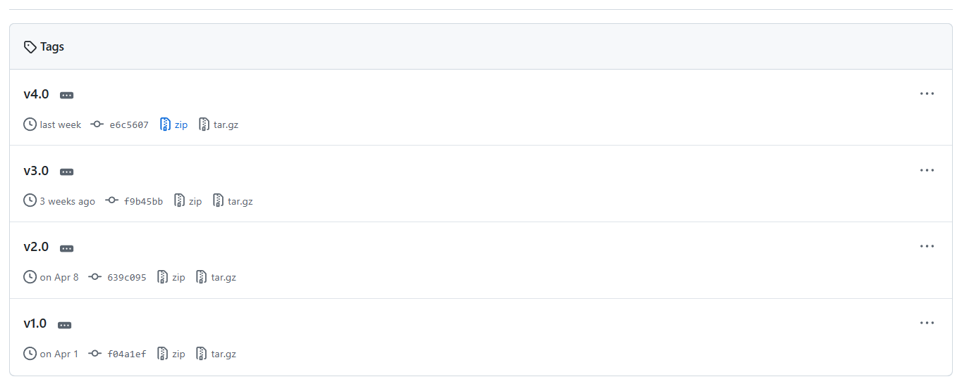
Figure 3. Sprint‑Plan‑Agile‑Scrum‑v1‑v4

Version Control and Collaboration
The team used GitHub with a feature-branch workflow. Each of the six members maintained their own development branch and submitted pull requests for code review. The Sprint leader reviewed every PR by checking out the branch locally, running the application, and systematically testing features before merging to main. Version tags (v1.0-v4.0) were created at each sprint completion.
Merge conflicts were resolved through several strategies: direct PR merges for clean branches, selective cherry-picking for branches with excessive conflicts (extracting only new files while preserving the existing codebase), and git merge -s ours for incorporating branch history into the network graph. A detailed Development Guide was created for each phase, specifying exact file paths and code templates for each team member.
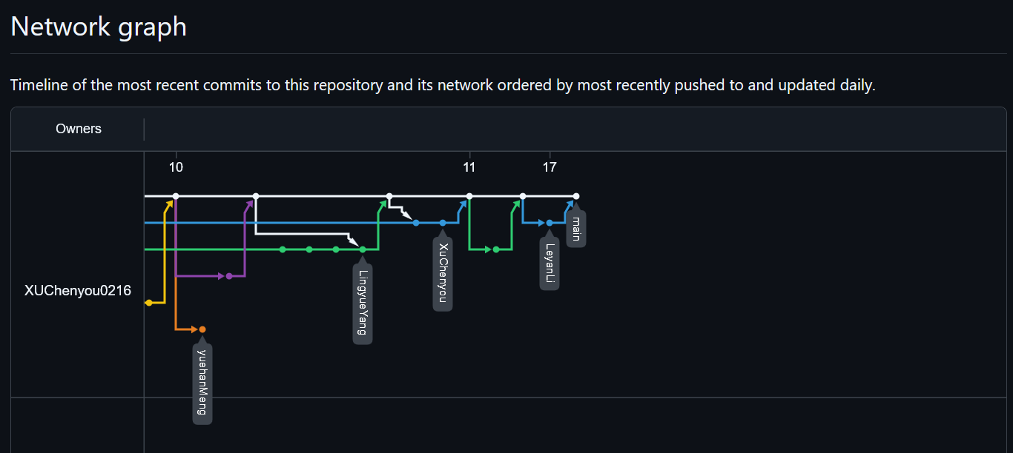
Figure 4. GitHub Feature-Branch Workflow (Branch Network)

Technology Stack
- Backend: Java 11, Servlet 4.0, JSP 2.3, embedded Tomcat 7 via Maven plugin
- Frontend: HTML5, CSS3, JavaScript ES5 with inline SVG icons, responsive sidebar layout
- Data: CSV file storage with synchronised FileManager, atomic write operations
- AI: Rule-based workload analysis engine with optional Claude/OpenAI API integration
- Security: SHA-256 password hashing, HttpSession management, Servlet Filter RBAC
- Build: Apache Maven 3.6+, JUnit 4.13.2, Gson 2.10.1

Testing

Testing Strategy
The project employed a multi-layered testing approach combining automated unit tests, integration tests, and systematic manual testing for every pull request.

Unit Testing
ValidatorTest provides comprehensive boundary-case coverage for all input validation methods: email format (valid/invalid patterns), password strength (length, character requirements), phone number format, date format (yyyy-MM-dd), file type restrictions (PDF/DOCX allowed, EXE/SH blocked), and file size limits (10MB maximum). Example test cases:
- testPasswordBoundary: Verifies 5-character passwords are rejected while 6-character passwords are accepted.
- testCvFileValidation: Confirms virus.exe is blocked, resume.pdf is allowed, and files exceeding 10MB are rejected.
- testDateValidation: Ensures yyyy-MM-dd format is accepted while dd-MM-yyyy is rejected.
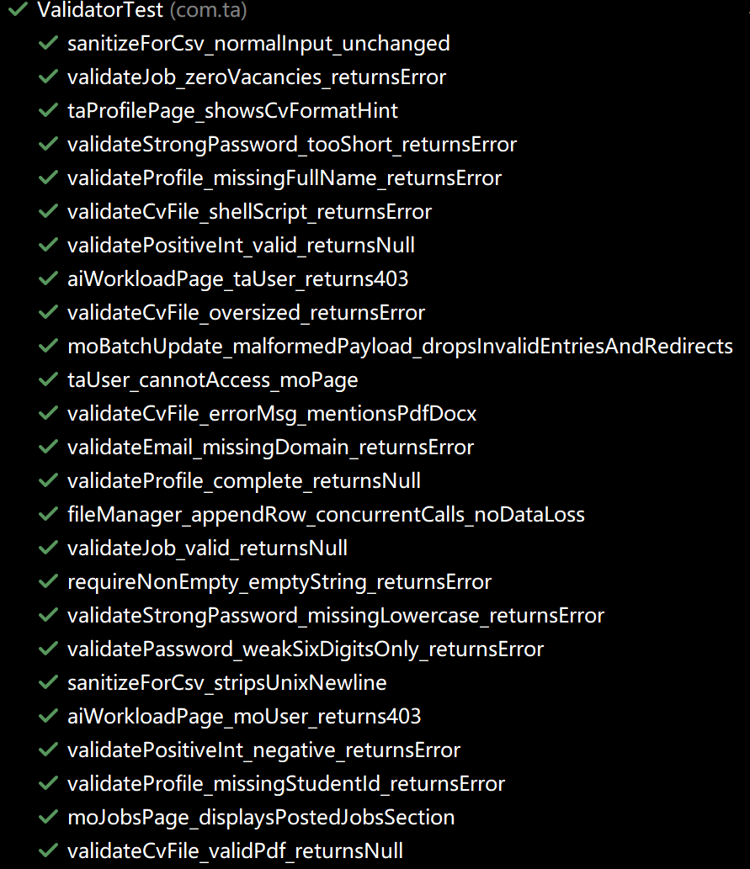
Figure 5. Example Test Case of ValidatorTest

Integration Testing
FullIterationFeatureTest simulates the complete recruitment workflow programmatically: user registration with password hashing verification, profile creation, job posting, application submission, status updates, and data persistence verification. SystemEndToEndTest extends this with cross-module interaction testing. ApplicationAcceptanceCapTest verifies the vacancy cap enforcement — ensuring that accepting applications beyond the job's vacancy count is correctly blocked.
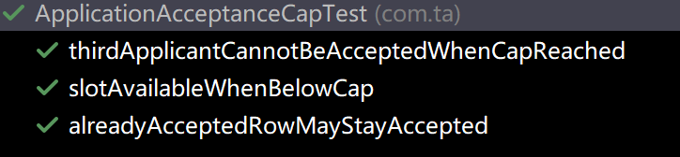
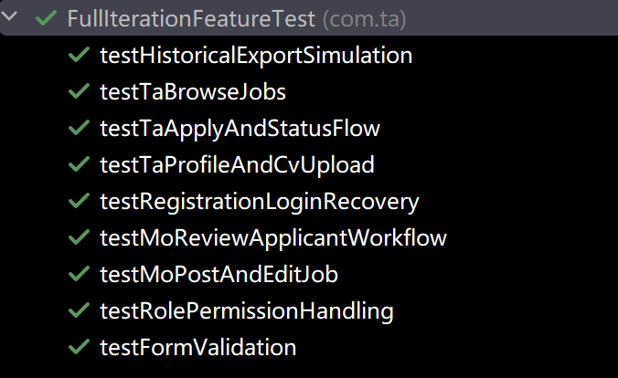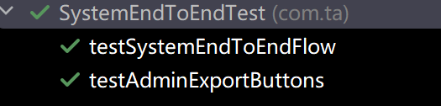
Figure 6. Some Test Case Example

Concurrency Testing
Sprint 4 introduced concurrent file access tests simulating 20 threads simultaneously writing to CSV files, verifying that all records are preserved without data loss or corruption under concurrent load.

Manual Integration Testing
For every pull request, the Sprint leader performed manual testing: checking out the feature branch, running mvn clean tomcat7:run, logging in as all three roles, testing the new feature against acceptance criteria, and verifying that existing functionality was not broken. This caught several integration issues that automated tests could not detect, such as JSP compilation errors on Tomcat 7 and CSS layout conflicts.

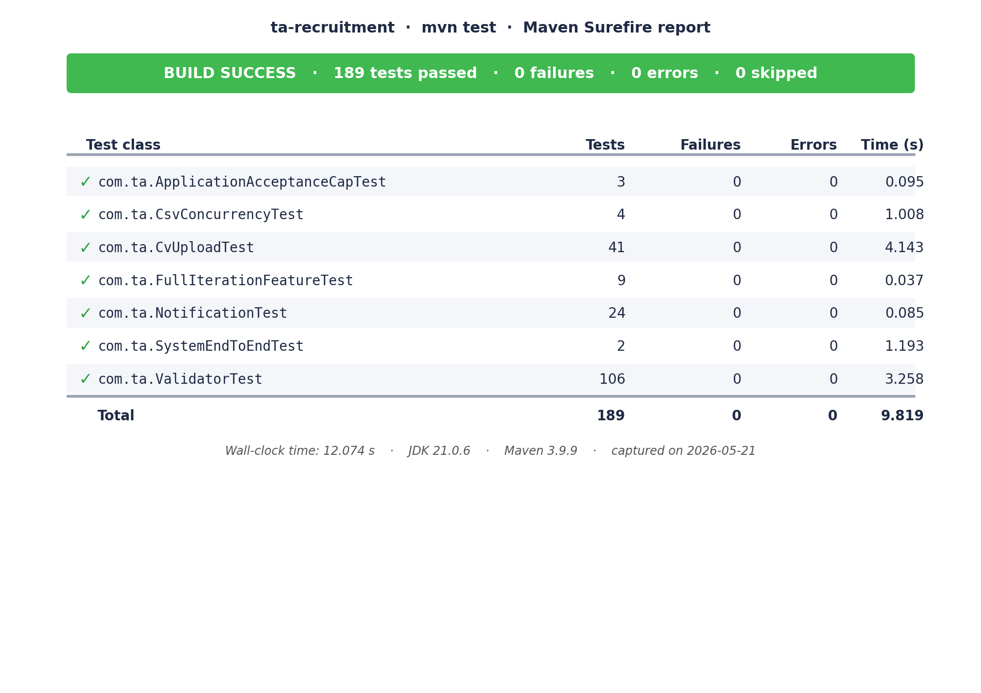
Figure 7. JUnit Test Suite — All Tests Passed

The use of Generative AI (GenAI)

AI Tools and Usage
The team primarily used the GenAI tool throughout the development process:
- Architecture Phase: AI assisted in designing the MVC project structure, Maven configuration, and base class templates. The initial project skeleton was AI-generated and then reviewed and customised by team members.
- Implementation Phase: AI generated code templates in the Development Guide for each sprint, providing each team member with specific file paths and starter code. Team members adapted these templates to implement their assigned features.
- Debugging Phase: AI diagnosed Tomcat 7 JSP compilation errors (diamond operator and lambda restrictions), CSV path separator issues causing the webappdata bug, and provided merge conflict resolution strategies.
- UI Design Phase: AI generated CSS stylesheets matching the Figma prototype.

Critical Evaluation
While AI significantly accelerated development, several limitations were identified:
- Tomcat 7 Compatibility: AI consistently generated Java 7+ syntax (diamond operators, lambdas, method references) in JSP files, which Tomcat 7's JSP compiler cannot process. Every AI-generated JSP required manual rewriting to Java 6 compatible syntax. This recurring issue demonstrated AI's lack of awareness of specific runtime constraints.
- Deployment Context: AI suggested standard file paths for data storage that did not account for Maven's build lifecycle (files in src/ are copied to target/ at build time). The AppInitializer solution was a designed fix we have created for a deployment problem AI could not anticipate.
- Over-generation Risk: One team member's use of Cursor AI regenerated the entire project with an incompatible Spring-style architecture (controllers, DTOs, repositories), requiring the leader to reject the bulk changes and cherry-pick only valid new files. This highlighted the risk of AI tools that operate at project level rather than file level.

AI-Powered Feature
The AI Workload Balancing feature (US-A02) implements responsible AI integration as required by the specification. It uses a rule-based engine that identifies overloaded TAs (>48 hours) and generates redistribution recommendations with confidence scores and explainable reasoning. The system supports optional API integration with Claude or OpenAI for enhanced recommendations, configurable via the Admin Settings page. All AI outputs are presented with a Human-in-the-Loop control banner, requiring explicit administrator approval before any changes are applied.

Individual contribution and reflection
Each group member provides their key contribution (agreed by the group) and a reflective statement on their learning experience.

QM no: 231223793
Name: Li Leyan (LeyanLi)
Main contribution:
As the Sprint 2 and 3 leader, I was responsible for the overall project architecture and integration management. I designed and implemented the complete MVC skeleton including all Model classes, DAO layer, utility libraries (FileManager, PasswordUtil, SessionUtil, Validator), and the initial Servlet/JSP framework. I created the AppInitializer that auto-generates data files on startup, solving a critical deployment issue that prevented team members from running the application after cloning. I built the entire UI framework with sidebar navigation matching our Figma prototype, and redesigned all Admin pages (dashboard, users, AI workload, settings). Throughout all four sprints, I reviewed and tested every pull request from all five team members before merging, resolving numerous integration conflicts including P5's 18-file conflict through selective cherry-picking. I fixed critical bugs including the CSV path separator issue, newline corruption in job postings, and missing DAO methods.
Reflective statement:
This project taught me that software engineering is fundamentally about managing complexity across people, not just code. The most challenging aspect was not writing features but integrating six developers' work into a coherent system. I learned that clear documentation (the Development Guide) and automated setup (AppInitializer) dramatically reduce onboarding friction. The experience with merge conflicts, especially when team members used AI tools that regenerated entire project structures, taught me the importance of establishing strict contribution guidelines early. I developed strong skills in Git workflow management, code review, and technical leadership that I will carry into future projects.

QM no: 231223748
Name: Fu Mingyi (Lar-me-s)
Main contribution:
I was responsible for the complete user authentication system across all four sprints. In Sprint 1, I implemented the password recovery feature (RecoverServlet) with security question verification. In Sprint 2, I built the TA profile management system (ProfileServlet) and CV upload functionality (UploadCvServlet) with file type validation supporting PDF and DOCX formats. In Sprint 3, I developed the Admin user management page (AdminUserServlet) enabling administrators to suspend, reactivate, and delete user accounts. In Sprint 4, I implemented security hardening including strong password enforcement (requiring uppercase, lowercase, and digits) and a login attempt limiter that locks accounts for 5 minutes after 5 consecutive failures.
Reflective statement:
Through this project, I gained practical experience in building a complete authentication and authorisation system from scratch. Working with Servlet sessions, password hashing, and file upload handling taught me the importance of security-first design. The iterative nature of Agile development meant my authentication module evolved significantly from a simple login form to a comprehensive security system with account management and lockout protection. I learned to write code that other team members could build upon, as my UserDAO and authentication infrastructure were used by nearly every other module in the system.

QM no: 231224033
Name: Meng Yuehan (lylybay)
Main contribution:
My primary responsibilities spanned access control, the job application workflow, and AI-powered features. In Sprint 1, I implemented role-based access control using AuthFilter and the 403 error page, ensuring TAs cannot access MO or Admin pages. In Sprint 2, I developed the ApplyServlet enabling TAs to submit job applications with duplicate prevention and profile completion checks, plus the application status tracking page. In Sprint 3-4, I built the AI Workload Balancing system (AIWorkloadServlet) featuring a rule-based engine with optional Claude/OpenAI API integration, explainable recommendations with confidence scores, and Human-in-the-Loop approval controls. I also implemented the functional Admin Settings page with configurable AI provider settings.
Reflective statement:
This project deepened my understanding of both traditional web development and AI integration in enterprise applications. Implementing the AuthFilter taught me how Servlet Filters work as cross-cutting concerns in web architecture. The most intellectually challenging task was designing the AI workload balancing engine to produce explainable results rather than black-box recommendations. I learned that responsible AI integration requires clear reasoning chains and human oversight mechanisms. The Agile workflow helped me prioritise features effectively — starting with essential access control before building advanced AI capabilities.

QM no: 231224044
Name: Yang Lingyue (LingyueYang)
Main contribution:
I focused on job management functionality and system robustness. In Sprint 1, I built the TA job browsing page with card-based layout showing status badges, deadlines, and vacancy counts. In Sprint 2, I implemented the MO job posting and editing system (PostJobServlet, EditJobServlet) with an enhanced Job model supporting module codes, working periods, key duties, and eligibility fields. In Sprint 3, I developed the MO Recruitment Progress dashboard (MoProgressServlet) displaying per-job statistics with fill rate calculations and progress indicators. In Sprint 4, I addressed concurrent file access safety by implementing atomic CSV write operations and FileLock mechanisms in FileManager, with corresponding concurrency tests to verify data integrity under multi-threaded conditions.
Reflective statement:
Working on this project gave me hands-on experience with the full lifecycle of a feature from design to deployment. Building the job management module taught me how to design extensible data models that can accommodate evolving requirements without breaking existing functionality. The concurrency challenge in Sprint 4 was particularly educational — I learned that thread safety in file-based systems requires careful coordination between read and write operations, and that automated testing is essential to verify correctness under concurrent load. The Git pull request workflow ensured my code was reviewed before merging, which caught several issues early.

QM no: 231223519
Name: Xu Shiqi (Aurora050214)
Main contribution:
I was responsible for the MO-facing application review pipeline and workload monitoring. In Sprint 1, I created the CvServeServlet for viewing applicant CVs inline. In Sprint 2, I built the MoApplicantsServlet and MoUpdateApplicationStatusServlet for reviewing applicants and updating their status, plus the MoBatchUpdateApplicationStatusServlet for bulk operations. In Sprint 3, I developed the AdminWorkloadServlet and workload table page showing per-TA assignment counts, estimated hours, and overload detection with red highlighting for TAs exceeding the 48-hour threshold. In Sprint 4, I implemented the MO close/reopen job workflow (MoCloseFullJobsServlet, MoReopenJobServlet) and auto-expiry logic via JobDeadlineUtil.
Reflective statement:
This project was a significant learning experience in collaborative software development. I initially struggled with Git workflow — my early submissions included unnecessary files from my IDE's code generation tool, causing merge conflicts. Through the team leader's guidance, I learned to create clean branches and submit only relevant files. This experience taught me that in team projects, code organisation and clean commits are as important as the code itself. On the technical side, building the workload monitoring system helped me understand data aggregation patterns and how to present complex information in an accessible UI format.

QM no: 231223782
Name: Xu Chenyou (XUChenyou0216)
Main contribution:
My work centred on testing infrastructure and the cross-cutting notification system. In Sprint 1, I created the Validator utility class with comprehensive input validation methods and the initial ValidatorTest covering boundary cases for email, password, phone, date, and file type validation. In Sprint 2, I developed FullIterationFeatureTest simulating the complete recruitment workflow end-to-end, plus the SystemEndToEndTest and ApplicationAcceptanceCapTest. In Sprint 3, I designed and implemented the notification system with a Notification model, NotificationDAO, and NotificationServlet, integrated a bell icon with unread count badge into the shared header, and added notification triggers in ApplyServlet (TA apply notifications to MO) and MoUpdateApplicationStatusServlet (status change notifications to TA). In Sprint 4, I extended notifications to include admin workload alerts and added regression test coverage.
Reflective statement:
Building the notification system taught me how cross-cutting features interact with multiple modules simultaneously. I had to modify servlets written by other team members to inject notification triggers, which required careful understanding of their code and coordination to avoid conflicts. The testing work gave me appreciation for both automated and manual testing — while my JUnit tests caught logic errors early, the team leader's manual PR testing caught integration issues that unit tests could not detect. I also served as the Phase 1 lead, which gave me early project management experience before transitioning to a specialist testing and feature development role.

