**ELEC2100 Lab Summary Sheet #4**

|  |  |  |  |  |  |  |  |
| --- | --- | --- | --- | --- | --- | --- | --- |
| 2 | 0 | 7 | 6 | 1 | 3 | 2 | 5 |

Name : Student ID :

Objectives

- To be familiar with modulation and demodulation

- To be familiar with sampling Deadline : 23 Nov (20:00)

**Part I** **(11)**

a) Download the audio file (**m1c.wav**) on Canvas. Notice that there are **TWO** modulated signals.

b) Use “**audioread**” to read the audio file and sampling frequency fs (in kHz).

**(1) The sampling frequency = 192kHz**

c) Define a frequency index from $-\frac{f_{s}}{2}$ to $\frac{f_{s}}{2}$.

d) Use **“subplot(311)”**, “**fft**”, “**fftshift**” and “**abs**”toplot the magnitude spectrum of the audio file versus frequency (Hz) in figure(1).

e) Observe the carrier frequency (in kHz) for each modulated signal.

**(2)** **Located at lower frequency band = 28kHz Located at higher frequency band = 55kHz**

f) Shift the spectrum located at **higher** frequency band back to the baseband using a **correct** carrier frequency.

g) Use **“subplot(312)”**, “**fft**”, “**fftshift**” and “**abs**”toplot the magnitude spectrum after frequency shifting in figure(1).

h) Design a Butterworth lowpass filter using “**butter**” and set **N = 16**.

i) Determine the cutoff frequencies (in kHz) and write down the corresponding value of Wn. Use “Datatip” to check the width of the passband.

**(1) Cutoff = 10kHz Wn = 2*10/192 = 0.1**

j) Use “**freqz**” to generate the frequency response and “**abs**”toplot the magnitude response in figure(2).

k) Use “**filter**” to perform lowpass filtering.

l) Use **“subplot(313)”**, “**fft**”, “**fftshift**” and “**abs**”toplot the magnitude spectrum of the output in figure(1).

m) Use “**soundsc**” and the sampling frequency to hear the audio file (**m1c**) and the output.

n) Describe the difference.

The change of tune is faster since the lower frequency is removed.

**(1)**

**(1) figure(2) with one “Datatip” to show the width of the passband**

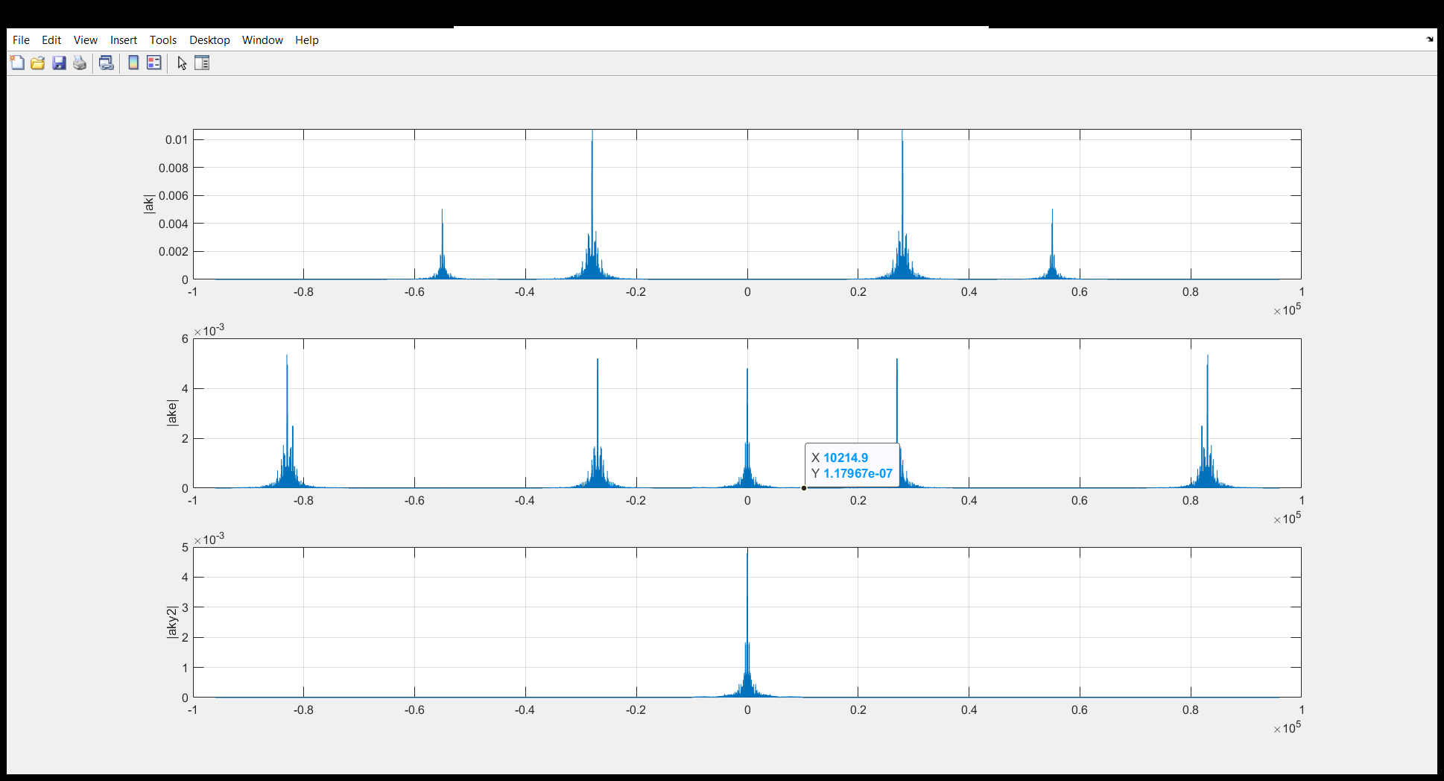

**(2) figure(1) including (311), (312) and (313)**

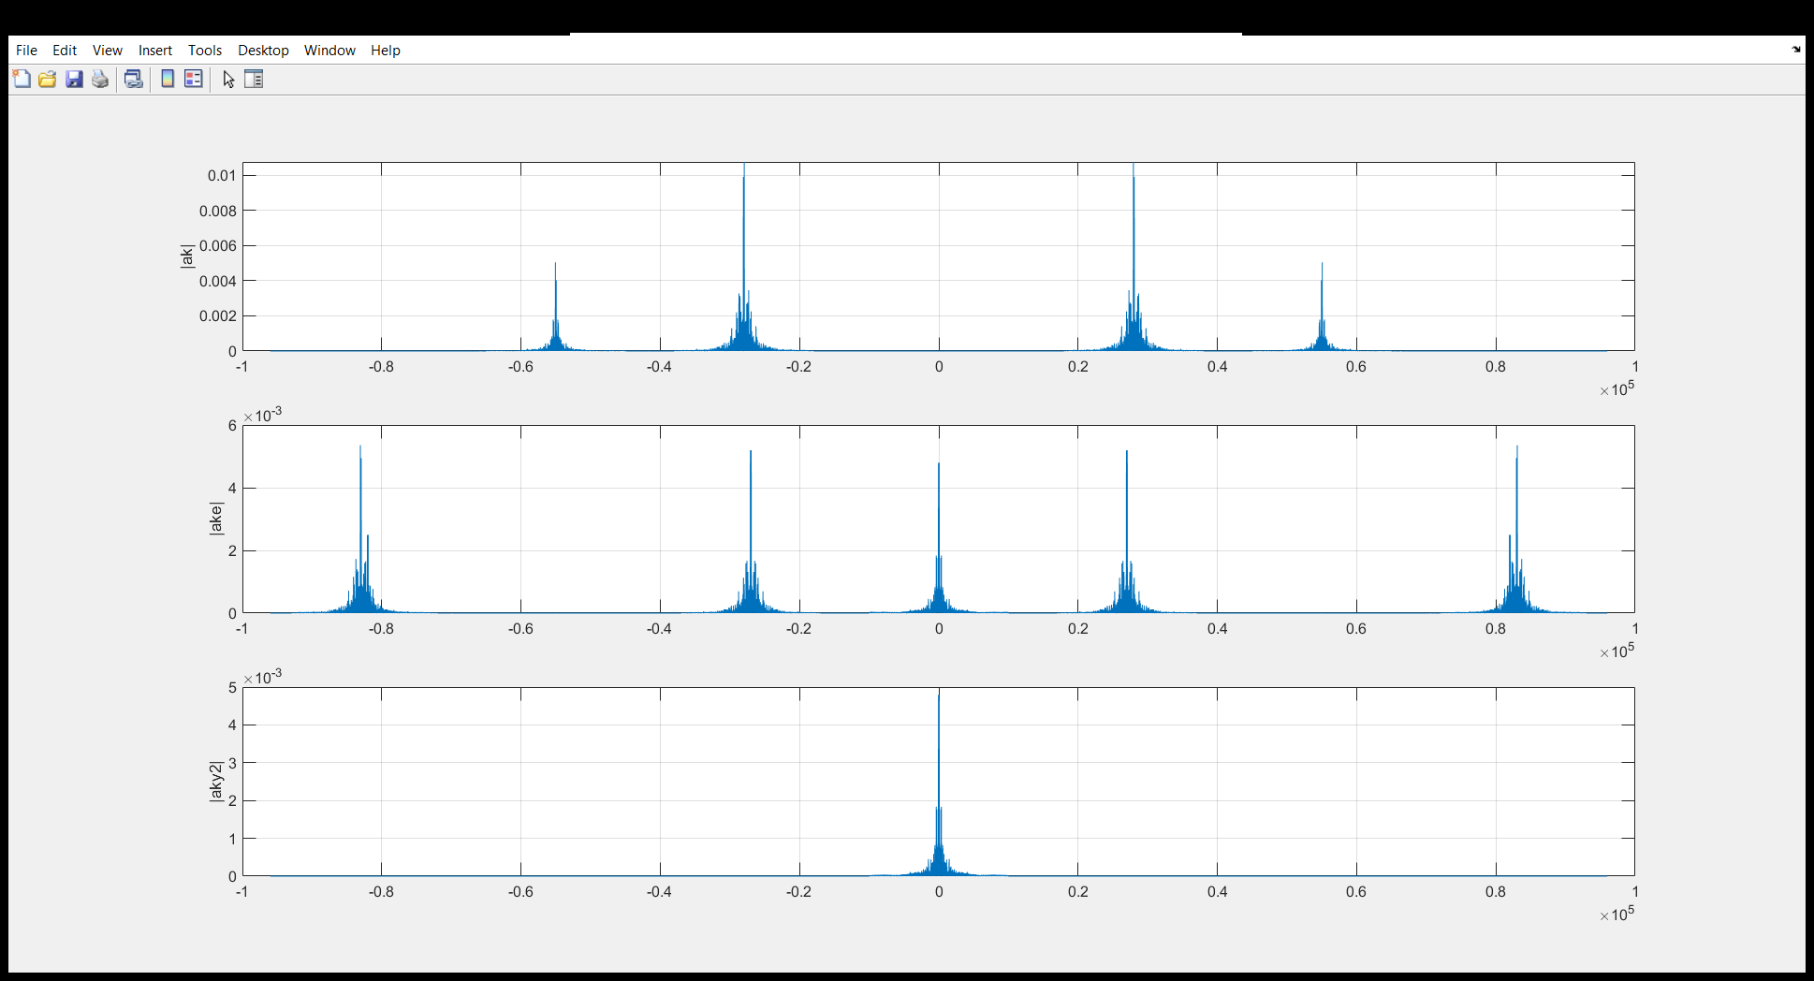

**(3) Screenshot of Matlab code for Part I**

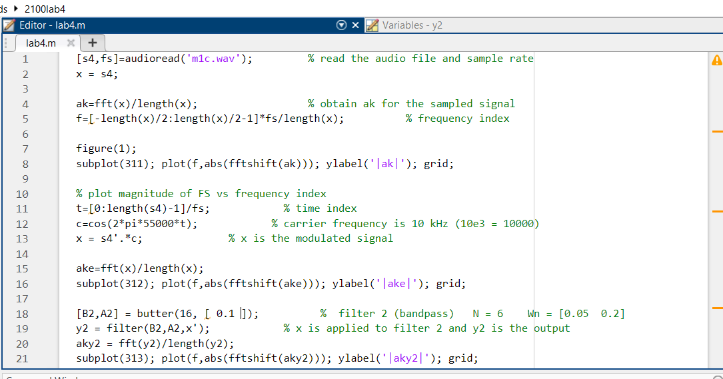

**Part II** **(9)**

A CT signal is given as $x\left(t\right)=4 cos\left(16π×{10}^{3}t\right)+13 cos\left(30π×{10}^{3}t\right)+7 cos\left(44π×{10}^{3}t\right)$.

a) What is the unilateral bandwidth (fm in kHz) of $x(t)$?

**(1)** **Unilateral bandwidth = 22kHz**

b) Define a DT sequence *x*1 if the sampling frequency (*f*s1) is 120 kHz and number of points is 30000.

c) Define a DT sequence *x*2 if the sampling frequency (*f*s2) is 12 kHz and number of points is 30000.

d) Define **actual** frequency index *f*1 according to the sampling frequency *f*s1.

e) Define **actual** frequency index *f*2 according to the sampling frequency *f*s2.

f) Use **“subplot”**, “**fft**”, “**fftshift**” and “**abs**” to plot the magnitude spectrum of *X*1 versus *f*1 and the magnitude spectrum of X2 versus *f*2 in figure(3).

**(1)** **figure(3)**

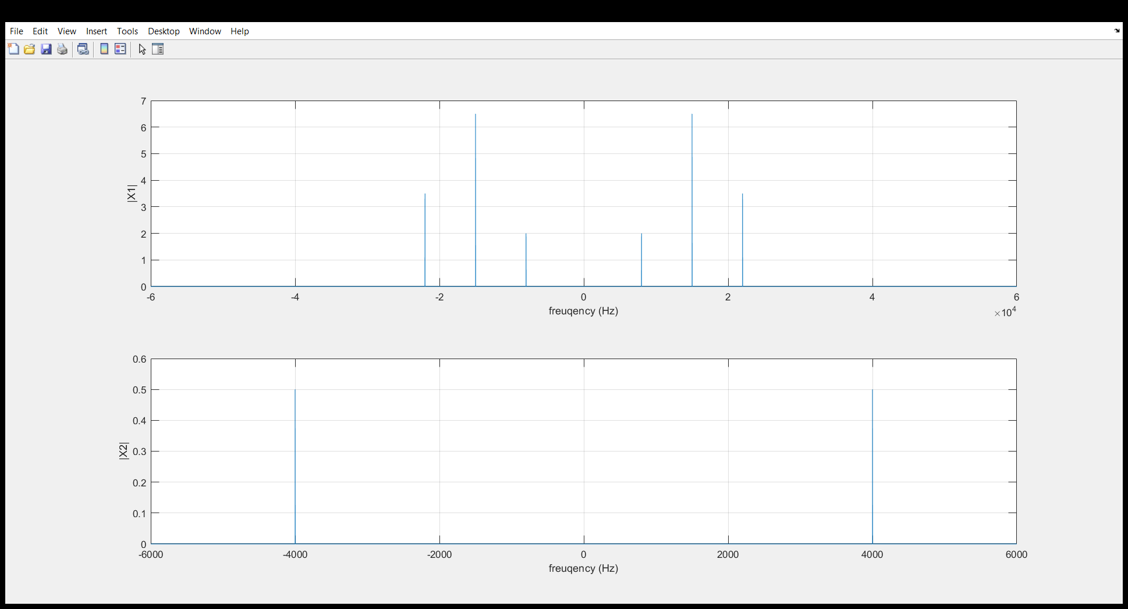

g) Fill in the following tables by looking at the positive frequency axis.

|  |  |  |
| --- | --- | --- |
| **Spectrum of $x_{1}[n]$** | **Frequency**  **(Hz)** | **Magnitude** |
| **1st component** | **8k** | **2** |
| **2nd component** | **15k** | **6.5** |
| **3rd component** | **22k** | **3.5** |

|  |  |  |
| --- | --- | --- |
| **Spectrum of $x_{2}[n]$** | **Frequency**  **(Hz)** | **Magnitude** |
| **1st component** | **4000** | **0.5** |
| **2nd component** |  |  |
| **3rd component** |  |  |

**(2)**

h) Which spectrum (*X*1 or *X*2) is the correct spectrum of $x\left(t\right)$?

**(1) X1 is the correct spectrum**

i) Explain your simulation result using **sampling theorem**.

**(2)**

**The sampling frequency of the second spectrum is 12kHz < 22KHz*2 = 44kHz. So aliasing appears.**

**(2) Screenshot of Matlab code for Part II**

