**ELEC2100 Labsheet #2**

|  |  |  |  |  |  |  |  |
| --- | --- | --- | --- | --- | --- | --- | --- |
| 2 | 0 | 7 | 6 | 1 | 3 | 2 | 5 |

Name : XUE Hongjia Student ID :

Objective

- To be familiar with impulse response and convolution Deadline : 19 Oct (20:00)

**Part I** **(7)**

**Let the value of A = the 8th digit of your student ID**

Let the input sequence to be the same as your student ID.

e.g. Student ID = 20345678 for n = A to A+7

The impulse responses of two LTI systems are shown below.

System 1 : System 2 :

Assume that System 1 and System 2 are connected **in series** to give the overall system .

The input sequence is applied to the overall system to give the output .

a) Write down the mathematical expression of the overall impulse response in terms of and .

**(1) h1[n] * h2[n] ( * means convolution )**

b) Define h1 and h2.

c) Use appropriate Matlab command to obtain the overall impulse response h according to the answer provided in (a).

d) Define nh index.

e) Fill in the following table after running your Matlab code.

**(1) Only show non-zero value of h and corresponding nh**

|  |  |  |  |  |  |  |  |  |  |  |  |  |
| --- | --- | --- | --- | --- | --- | --- | --- | --- | --- | --- | --- | --- |
| **nh** | **10** | **11** | **12** | **13** | **14** | **15** | **16** |  |  |  |  |  |
| **h** | **1** | **0** | **1** | **0** | **1** | **0** | **1** |  |  |  |  |  |

f) Use appropriate Matlab command to obtain the output y and define the corresponding index ny.

g) Fill in the following table after running your Matlab code.

**(1) Only show non-zero value of y and corresponding ny**

|  |  |  |  |  |  |  |  |  |  |  |  |  |
| --- | --- | --- | --- | --- | --- | --- | --- | --- | --- | --- | --- | --- |
| **ny** | **10** | **11** | **12** | **13** | **14** | **15** | **16** | **17** | **18** | **19** | **20** | **21** |
| **y** | **2** | **0** | **9** | **6** | **10** | **9** | **12** | **14** | **10** | **14** | **3** | **8** |

|  |  |  |  |  |  |  |  |  |  |  |  |  |
| --- | --- | --- | --- | --- | --- | --- | --- | --- | --- | --- | --- | --- |
| **ny** | **22** | **23** |  |  |  |  |  |  |  |  |  |  |
| **y** | **2** | **5** |  |  |  |  |  |  |  |  |  |  |

h) Plot the input in **BLUE**, the overall impulse response in **RED** and the output in **GREEN** using “**subplot**” and “**stem**”.

Label the axes. Place the screenshot of your simulation results in the space provided below.

**(2) figure(1)**

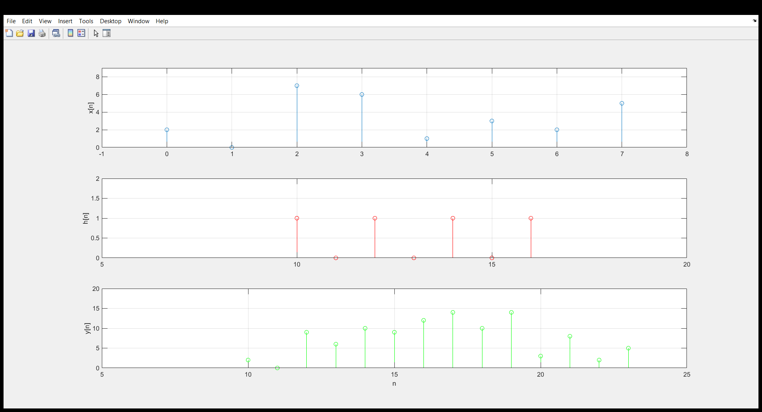

**(2) Screenshot of Matlab code for Part I**

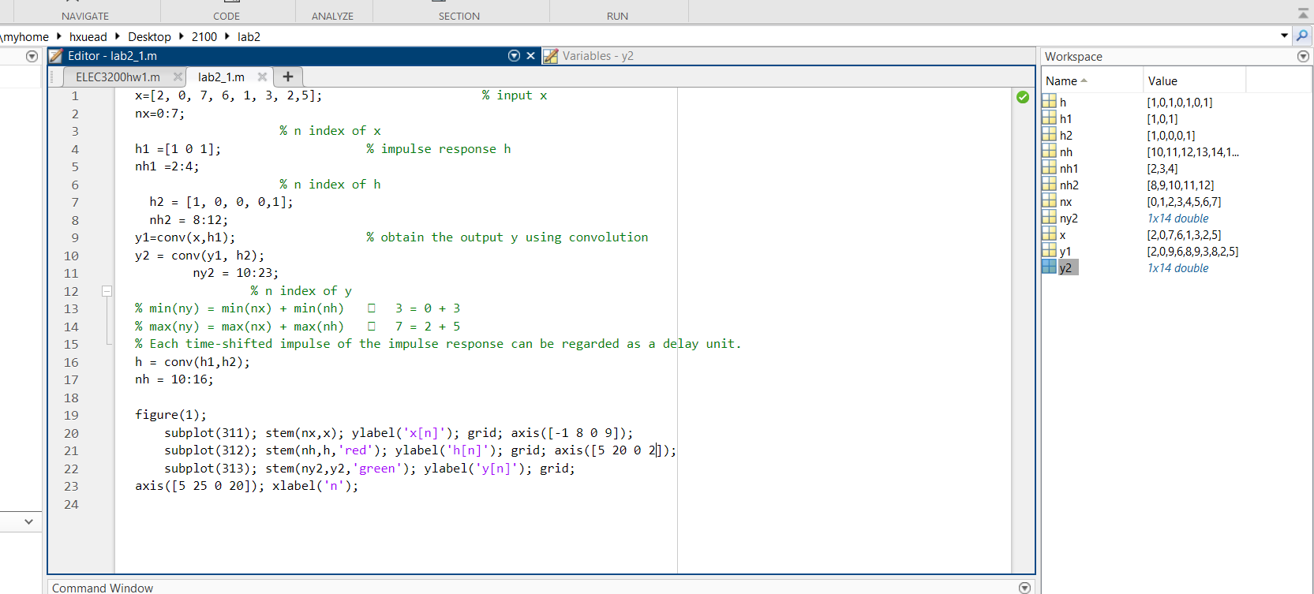

**Part II** **(7)**

Use “**audioread**” to read the audio file (**song2c.wav**) downloaded on Canvas.

a) What is the sampling frequency (*fs*) in Hz ?

**(1)** **The sampling frequency = 132300**

b) What is the time interval (in seconds) between two consecutive sample points ?

**(1)** **The time interval = 1/132300 = 0.00000756 (s)**

The impulse responses of two CT LTI systems are given below.

System 1 : System 2 :

If these two CT LTI systems are converted into DT representation using the sampling frequency (*fs*),

c) How many zeros are needed to represent a time delay of 0.35 seconds ?

**(1)** **Number of zeros = 0.35*132300 = 46305**

d) Write down the DT representations of System 1 and System 2.

**(1) [1] [ zeros(1,46305), 0.8 ]**

If these two DT LTI systems are connected **in parallel** and added together to give the overall system,

e) Write down the mathematical expression of the overall impulse response in terms of and .

**(1) h1 + h2 = [ 1, zeros( 1, 46304 ), 0.8 ]**

f) Define the overall DT impulse response h according to the answer provided in (e).

g) Apply the audio file to the overall DT system h to obtain the output y using “**conv**”.

h) Hear the original audio file and the output y using “**sound**”.

i) What is the sound effect introduced to the original audio file?

**(1)** there is an echo with decreased amplitude in addition to the original sound.

**(1)** **Screenshot of Matlab code for Part II**

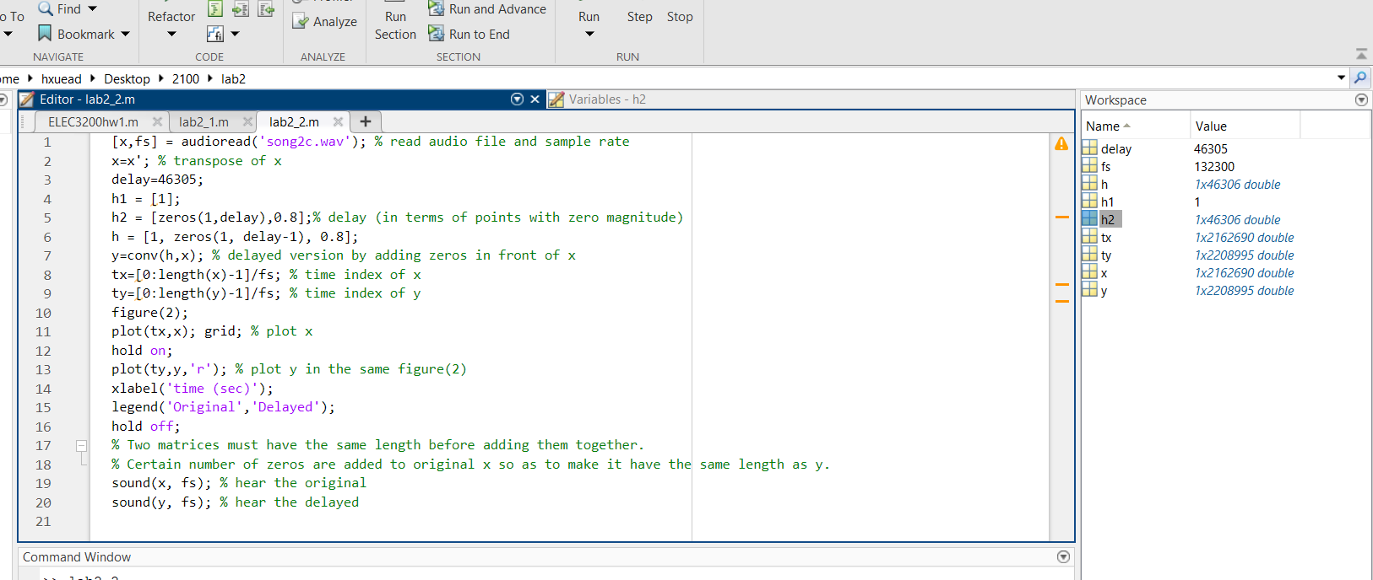

**Part III** **(6)**

a) Use “imread” to read the image file (**image2c.jpg**) downloaded on Canvas.

b) Display the image file using “**imshow**”. Place the screenshot in the space provided below.

**(1) figure(2)**

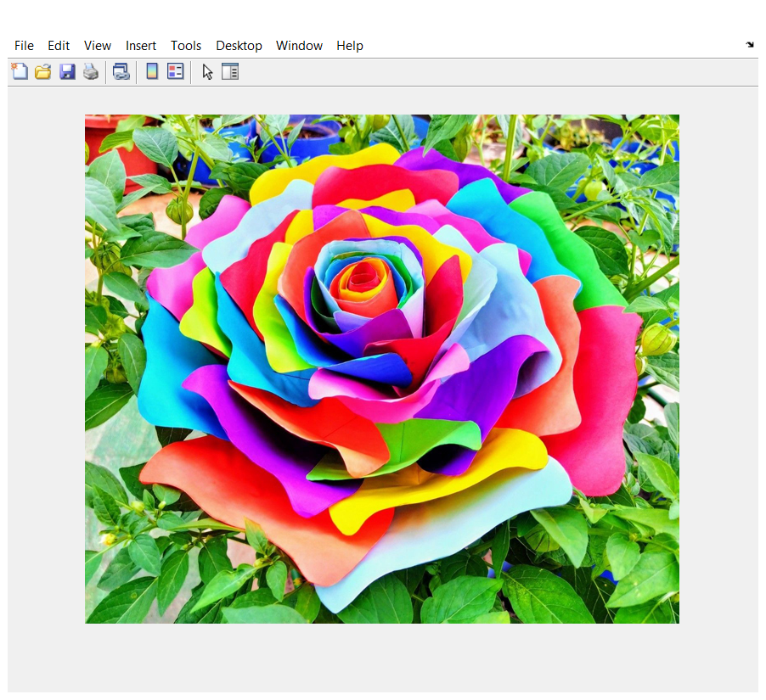

c) Apply the image file to a 2-D filter to obtain the output using “**convn**”.

d) Display the new image using “**uint8**” and “**imshow**”. Place the screenshot in the space provided below.

**(1) figure(3)**

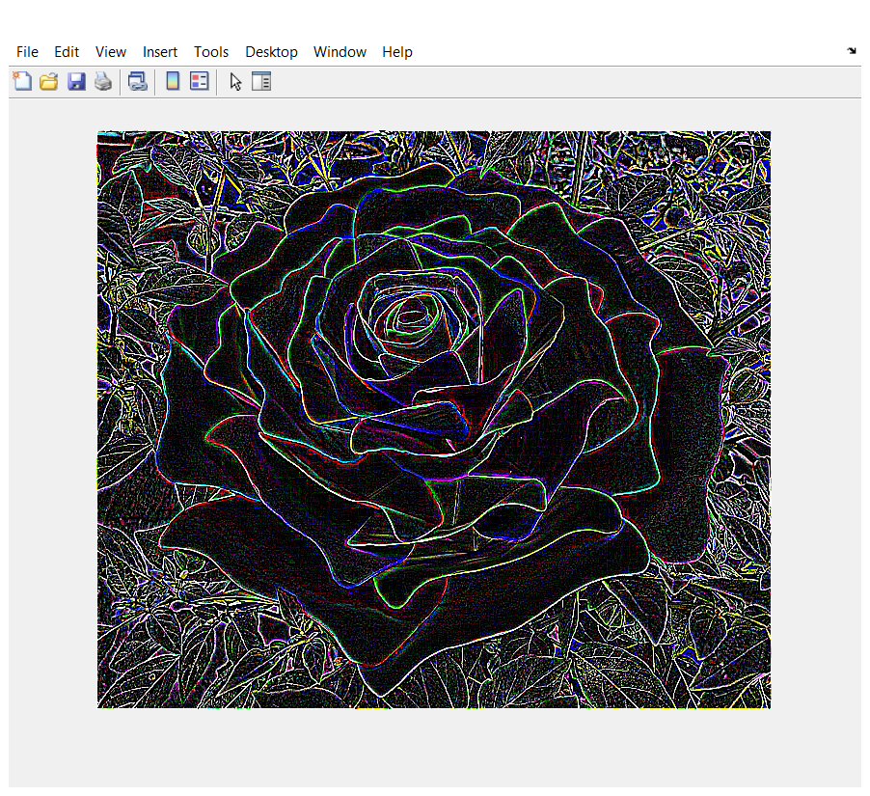

e) What does the 2-D filter do to the image ?

**(1)** sharpen the image to get its shape/contour

The impulse response of a 1-D filter is given below.

f) Use the above 1-D filter and proper **matrix operation** to define a **7-by-7** 2-D symmetric filter h2.

(i.e. Transpose of h2 is equal to h2)

g) Apply the image file to h2 to obtain the output using “**convn**”.

h) Display the new image using “**uint8**” and “**imshow**”. Place the screenshot in the space provided below.

**(1) figure(4)**

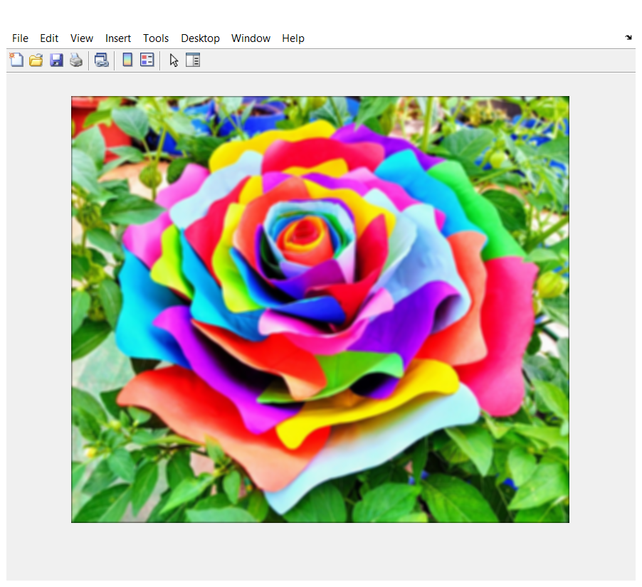

i) What does the 7-by-7 2-D symmetric filter h2 do to the image ?

**(1)** it makes the picture blurrer

**(1)** **Screenshot of Matlab code for Part III**

