1.Domain Class Diagram

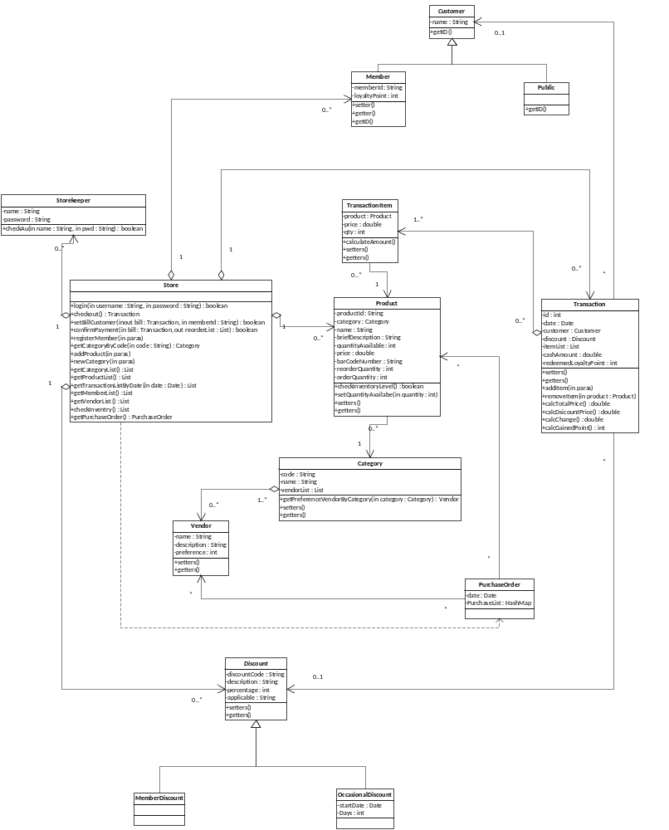

2. Assumption
- Save a snapshot of relevant product's price in [transaction.dat] file
- Load data in application initiation and save it in termination
- Every record has a unique primary key as identity, like for Product the primary key is [productId].
- when a object is associate with other objects, for instance, a product appears in some transaction, it should not be deleted or modified its primary key

