EMS MCDU Simulator
User Guide

This manual includes coverage of the following equipment:
Unit | Model | OEM Part No | EMS Part No | Software Version
 |  |  | 1252-SW-3801 | 100

EMS SATCOM  400 Maple Grove Road  Ottawa, ON  Canada  K2V 1B8 | Revision 1.0  November 7, 2026  Document number

PROPRIETARY NOTICE
This document contains information that is proprietary and confidential to EMS SATCOM (EMS Technologies Canada, Ltd.). Neither this document nor the information contained within may be disclosed or copied without the prior written permission of EMS SATCOM.
© COPYRIGHT 2007 EMS Technologies Canada Ltd. ALL RIGHTS RESERVED.

Document title
Document No. Document number
Revision: number
Printed in Canada
SOFTWARE COPYRIGHT NOTICE
© COPYRIGHT 2007 EMS Technologies Canada Ltd. ALL RIGHTS RESERVED. All software resident in this equipment is protected by copyright.
We welcome your comments concerning this manual. Although every effort has been made to keep it free of errors, some may occur. When reporting a specific problem, please describe it briefly and include the manual part number, the paragraph or figure number, and the page number.
Please send your comments to:
SATCOM Technical Documentation
EMS SATCOM
400 Maple Grove Road
Ottawa, Ontario, Canada K2V 1B8
Website: http://www.emssatcom.com
Email: techdocs@emssatcom.com
For product orders or for assistance, please contact
Repair and Overhaul Coordinator
1-800-600-9759 (North America) or +1-613-591-9064 (rest of the world)
SATCOM Product Support
1-888-300-7415 (North America) or +1-613-591-3086 (rest of the world)
Aeronautical Sales
1-800-600-9759 (North America) or +1-613-591-9064 (rest of the world) 0800 - 1700 EST

Record of Revisions
Revision | Sections Revised | Release Date | Comments
0.1

List of Effective Pages
Pages changed, added, or deleted by the current revision
Page No | Date of Issue | Comments

Applicable Service Bulletins
Service Bulletin Number | Subject
NA | NA
Table of Contents
1.1 Overview 3
1.2 Audience 4
2 Supported Connection options 4
2.1 ARINC 429 Connection 4
2.2 Maintenance Port Connection 4
3 Installation 5
3.1 Firewall 5
3.2 ARINC connection support 5
4 Launching EMS Mcdu Simulator 6
4.1 Shortcuts: 6
4.2 Command line options 7
5 CMC Simulator 8
6 Python Support 10
List of Tables
Error! No table of figures entries found.
List of Figures
Figure 1 - EMS MCDU Simulator 3
Figure 2 - McduSim UDP/Serial Connection 4
Figure 3 - Shortcuts 6
Figure 4 - Command Line 7
Figure 5 - CMC Simulator 8
Figure 6 - Periodic Words Window 9
INTRODUCTION
The EMS MCDU Simulator is a Graphic User Interface application which simulates a “Multi-purpose Control and Display Unit” as specified by the “ARINC characteristic 739A-1” ARINC document. Along this document EMS MCDU Simulator will be referenced as McduSim.

Overview
McduSim’s GUI shows a realistic MCDU panel where the user can interact with the SDU using the McduSim panel’s keyboard:
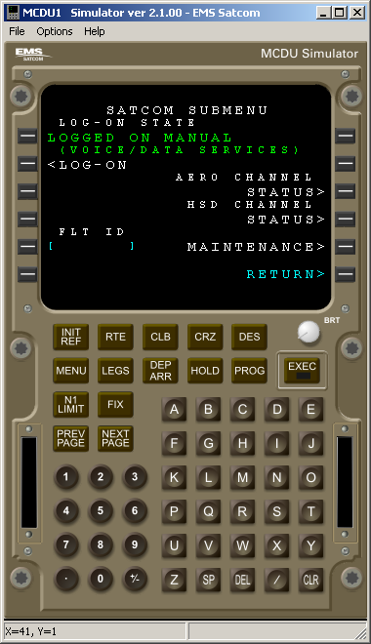
Figure 1 - EMS MCDU Simulator

Audience
This document is intended for SDU testers, test tool developers and product software developers. McduSim is currently an internal tool and must never be distributed or operated by any third party.

Supported Connection options
McduSim connects to EMS SDU’s in two possible ways: through a ARINC 429 Interface or through the SDU’s Maintenance Port.

ARINC 429 Connection
McduSim interfaces with third party ARINC 429 PCI cards or USB devices. The current McduSim version supports products from Data Device Corporation and TechSat.

Maintenance Port Connection
Support for McduSim was added for some EMS products. McduSim does not connect directly to EMS SDU’s. Instead, McduSim interfaces with mTerm, a modified VT-100 Terminal program, which acts as a bridge between SDU and McduSim:
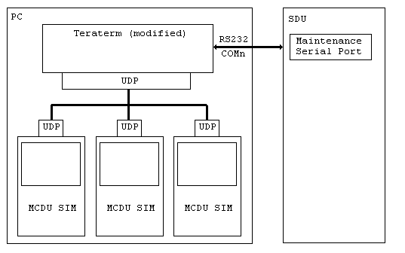
Figure 2 - McduSim UDP/Serial Connection

Installation
McduSim has a Windows compatible MSI installer file which simplifies the installation process to a simple “double click”.

Firewall
McduSim uses the following network ports depending which connection method is in use:
- ARINC 429: no ports used.
- Maintenance Port: UDP ports: 6000, 5001, 5002, 5003 and 5004.
- Python Support enabled: TCP ports 8000, 8001, 8002 and 8003.
Therefore, firewall should be set to allow local traffic for the above ports.

ARINC connection support
Proper device drivers are required to be installed before using McduSim for ARINC connection.
Mcdusim is integrated with the following DDC Libraries:
DD-42976S0: PCI Card Toolbox Version 1.4.3
DD-42992S0: ARINC 429 Multi-IO SDK Version 2.0.11
Refer to the proper Data Device Corporation’s documentation for further installation details about their products.
Mcdusim is integrated with the following TechSat Libraries:
usb32nh.dll (version 3.64)

Launching EMS Mcdu Simulator
After the installation is completed the following shortcuts will appear in the Windows desktop “Start” menu:
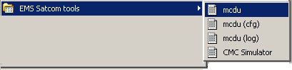
Figure 3 - Shortcuts

Shortcuts:
mcdu: launches McduSim with the same settings then the last instance of itself.
mcdu (cfg): launches McduSim displaying the configuration dialog (like command line option -c).
mcdu (log): launches McduSim displaying the log console (like command line option -l).
CMC Simulator: launches CMC Simulator.

Command line options
McduSim can be launched from a console window. The “Help->Command Line Help” menu option displays the following dialog:
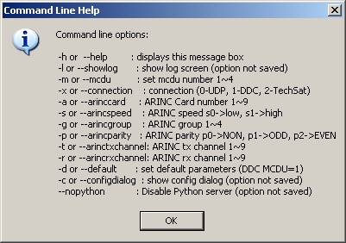
Figure 4 - Command Line
Command line options flagged as “option not saved” will not make effect when the McduSim starts again. All other options are “sticky” (saved). Options are saved every time an instance of McduSim is closed.

CMC Simulator
MCDU Simulator Installer also provides a CMC Simulator. Its mains screen provides a monitoring for ARINC Labels as following:
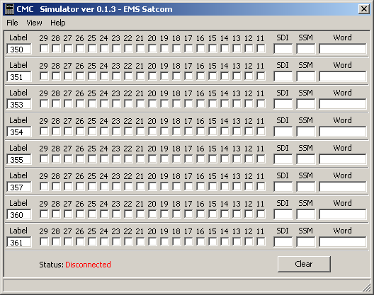
Figure 5 - CMC Simulator

Labels from 350~361 are defaults. Different labels can be provided by a file named “labels.txt”. Each label should be in a single line in octal, for example:
350
351
…
A Periodic Words Dialog can be visible by selecting View->Show Periodic Word:
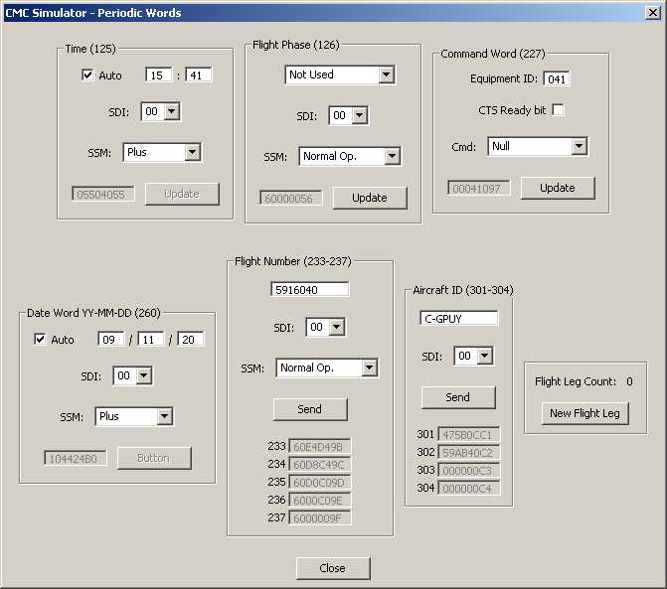
Figure 6 - Periodic Words Window

Python Support
The installer places an EMS python module called “emstools.py” that allows python scripts to interact with McduSim to simulate user actions. Key-strokes and screen text reading are the most used functions. A help file called PythonHelp.txt is also placed by the installer. The standard location for both files is under:
“C:\Program Files\EMS Satcom\MCDUSIM\Python” directory.

- x – x – x -

