1, copy the entire folder to your local drive;
2, Configure the machine to run this tool with automatic SAP login (able to double click and start SAP window without password input need); Skip this if already work that way;
Reference the SAP login profile configuration as below,
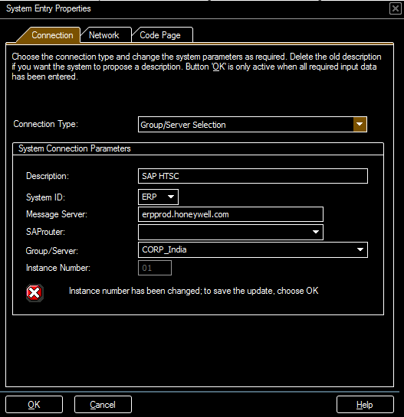
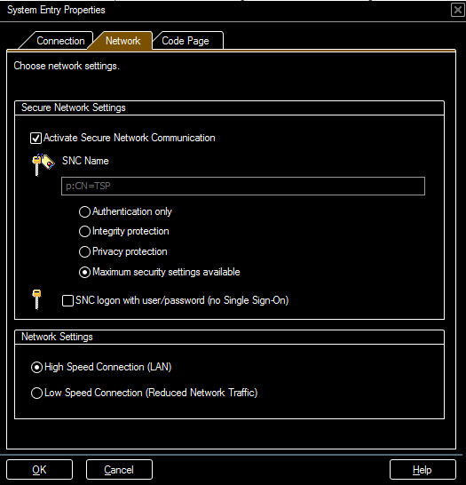

3, modify config.txt (Site, Work_Center, Mail Receiver, and SAP Login Profile) from your local folder to align with your group;
“SAP HTSC” is a SAP Login profile name as shown below,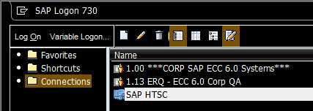
4, Configure SAP to avoid warning popup when running the SAP script (one time operation),
Enter SAP Option menu,
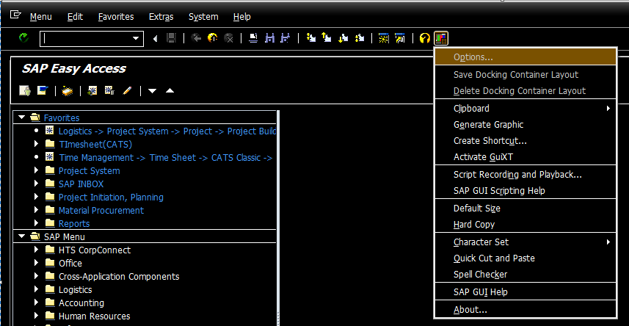
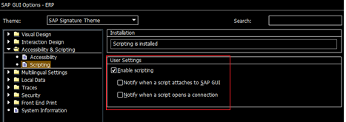

5, run the TimeSheetChecker.exe to start ( make sure you have privilege to run SAP t-Code ZHRDAYWISE and close SAP application before run );

6, Mail will send to receiver for the check result - anyone not fill in timesheet or timesheet not approved, otherwise if all ok, the mail
Will only contains the SAP effort report file path information;

