第七讲
一、课程简介
本讲主要讲授了第三部分（管理“事”的含义）中结构、艺术的相关概念，重点分析了案例“情人啤酒”。

二、课程目标：
- 说明绩效与个人特性和组织环境之间的关系
- 掌握结构影响行为的含义
- 理解系统思考的5种基本模式
- 了解人性的法则对人力资源管理的意义

三、要点提示：
成长上限模式、避重就轻模式、目标侵蚀模式、恶性竞争模式、强者越强模式、理性人、情绪人、社会人、经济人
四、课程预习：

- 阅读笔记

课程重点
_________________________________________________________________
_________________________________________________________________
_________________________________________________________________
_________________________________________________________________
_________________________________________________________________
_________________________________________________________________

课程难点
_________________________________________________________________
_________________________________________________________________
_________________________________________________________________
_________________________________________________________________
_________________________________________________________________
_________________________________________________________________

疑难问题:
_________________________________________________________________
_________________________________________________________________
_________________________________________________________________
_________________________________________________________________
_________________________________________________________________
_________________________________________________________________
_________________________________________________________________

体会:
_________________________________________________________________
_________________________________________________________________
_________________________________________________________________
_________________________________________________________________
_________________________________________________________________
_________________________________________________________________

五、课程学习
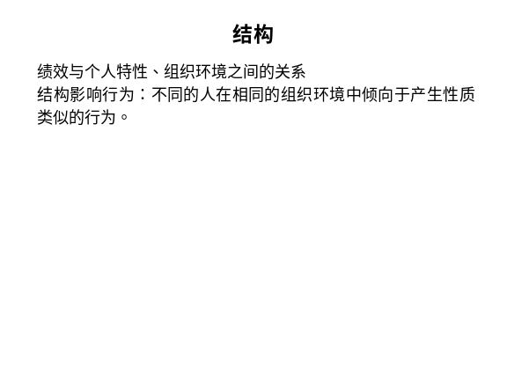 | Notes______________________________  ___________________________________  ___________________________________  Q&A______________________________  ___________________________________  ___________________________________  ___________________________________
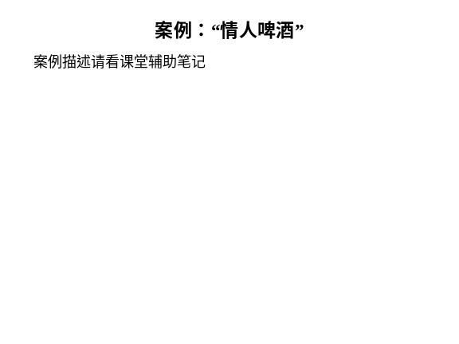 | Notes______________________________  ___________________________________  ___________________________________  Q&A_______________________________  ___________________________________  ___________________________________  ___________________________________
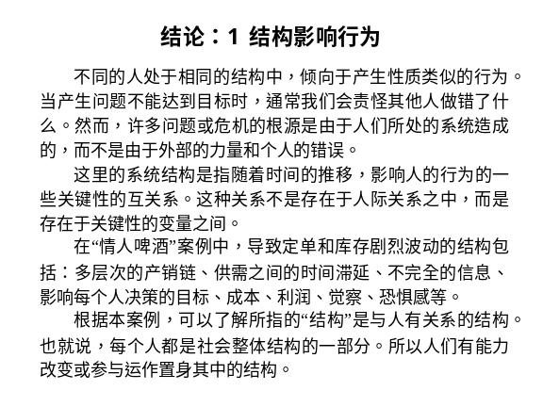 | Notes______________________________  ___________________________________  ___________________________________  Q&A_______________________________  ___________________________________  ___________________________________  ___________________________________
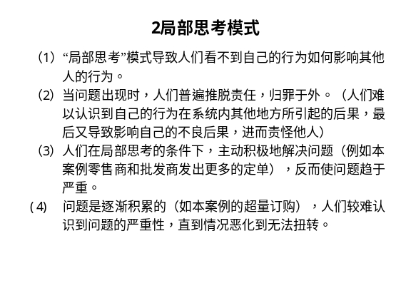 | Notes______________________________  ___________________________________  ___________________________________  Q&A_______________________________  ___________________________________  ___________________________________  ___________________________________
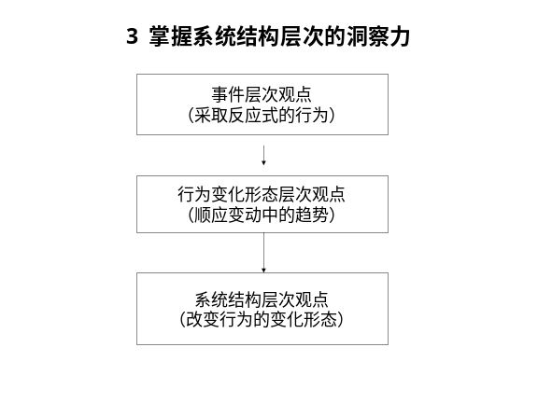 | Notes______________________________  ___________________________________  ___________________________________  Q&A_______________________________  ___________________________________  ___________________________________  ___________________________________
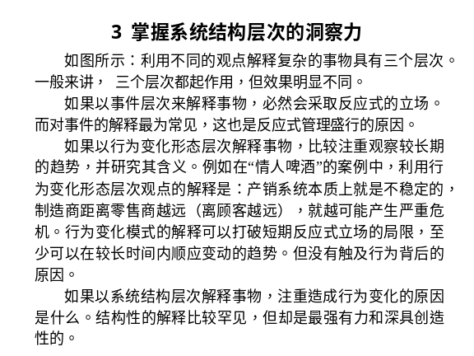 | Notes______________________________  ___________________________________  ___________________________________  Q&A_______________________________  ___________________________________  ___________________________________  ___________________________________
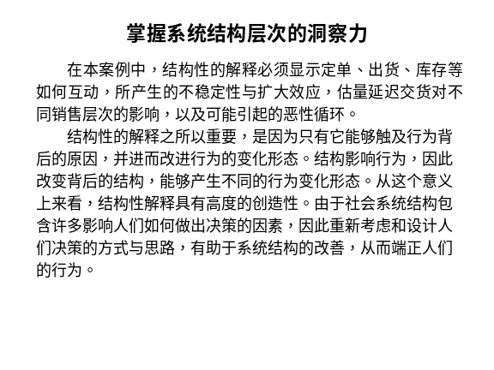 | Notes______________________________  ___________________________________  ___________________________________  Q&A_______________________________  ___________________________________  ___________________________________  ___________________________________
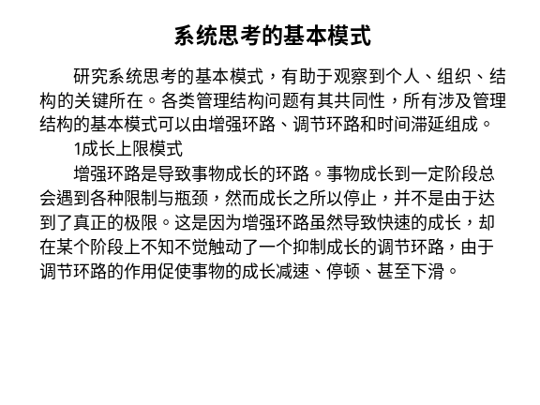 | Notes______________________________  ___________________________________  ___________________________________  Q&A_______________________________  ___________________________________  ___________________________________  ___________________________________
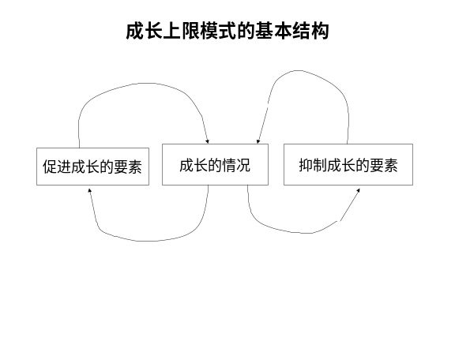 | Notes______________________________  ___________________________________  ___________________________________  Q&A_______________________________  ___________________________________  ___________________________________  ___________________________________
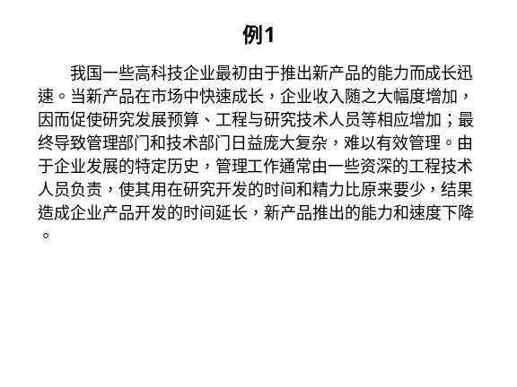 | Notes______________________________  ___________________________________  ___________________________________  Q&A_______________________________  ___________________________________  ___________________________________  ___________________________________
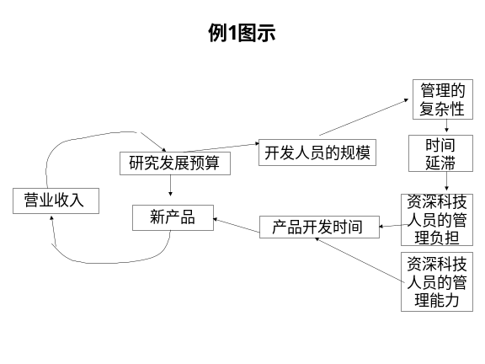 | Notes______________________________  ___________________________________  ___________________________________  Q&A_______________________________  ___________________________________  ___________________________________  ___________________________________
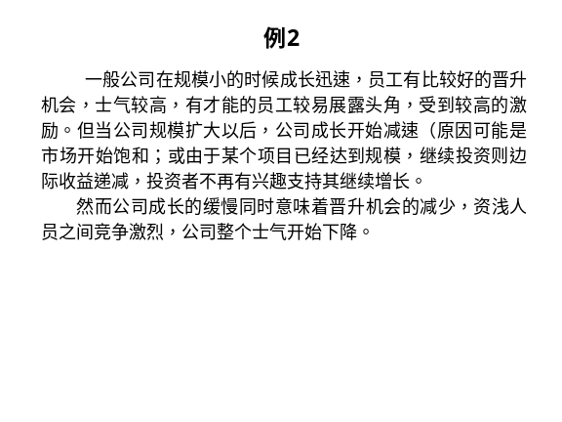 | Notes______________________________  ___________________________________  ___________________________________  Q&A_______________________________  ___________________________________  ___________________________________  ___________________________________
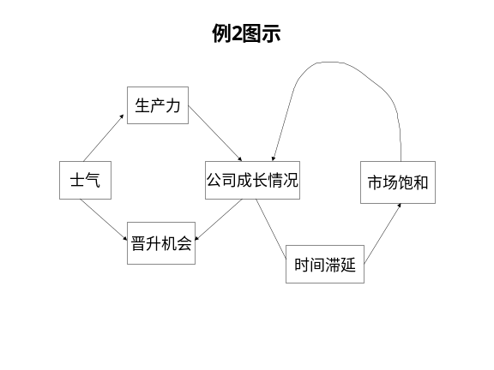 | Notes______________________________  ___________________________________  ___________________________________  Q&A_______________________________  ___________________________________  ___________________________________  ___________________________________
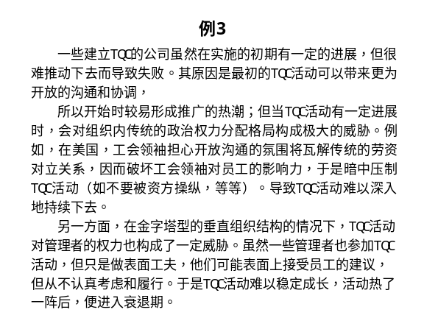 | Notes______________________________  ___________________________________  ___________________________________  Q&A_______________________________  ___________________________________  ___________________________________  ___________________________________
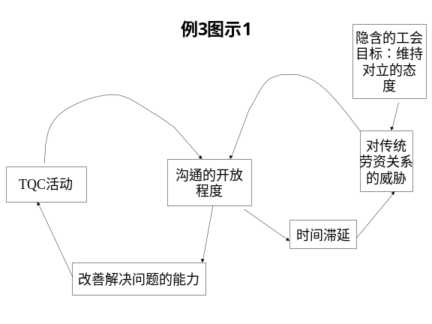 | Notes______________________________  ___________________________________  ___________________________________  Q&A_______________________________  ___________________________________  ___________________________________  ___________________________________
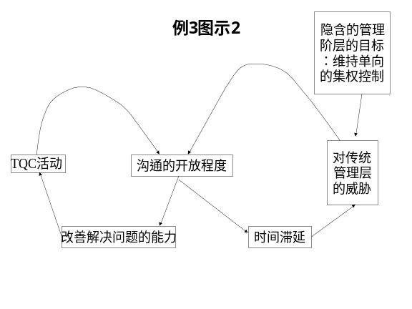 | Notes______________________________  ___________________________________  ___________________________________  Q&A_______________________________  ___________________________________  ___________________________________  ___________________________________
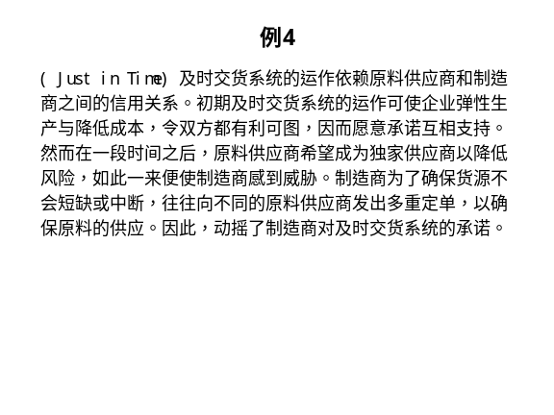 | Notes______________________________  ___________________________________  ___________________________________  Q&A_______________________________  ___________________________________  ___________________________________  ___________________________________
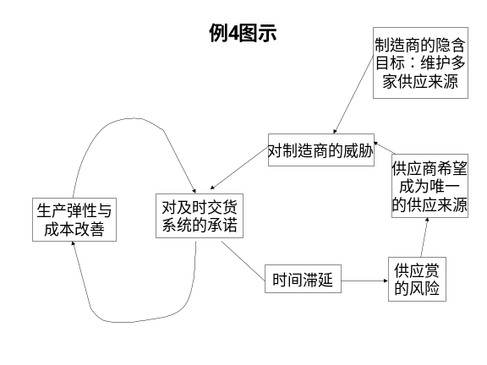 | Notes______________________________  ___________________________________  ___________________________________  Q&A_______________________________  ___________________________________  ___________________________________  ___________________________________
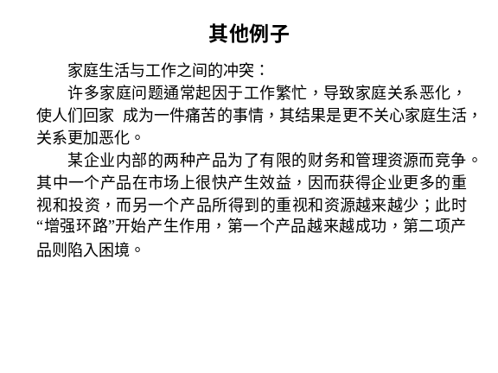 | Notes______________________________  ___________________________________  ___________________________________  Q&A_______________________________  ___________________________________  ___________________________________  ___________________________________
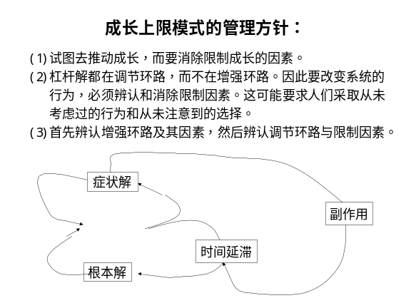 | Notes______________________________  ___________________________________  ___________________________________  Q&A_______________________________  ___________________________________  ___________________________________  ___________________________________
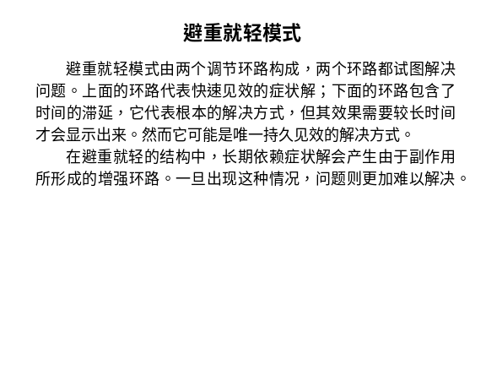 | Notes______________________________  ___________________________________  ___________________________________  Q&A_______________________________  ___________________________________  ___________________________________  ___________________________________
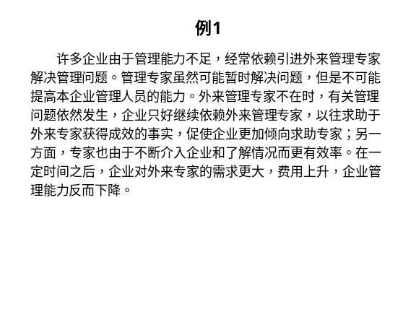 | Notes______________________________  ___________________________________  ___________________________________  Q&A_______________________________  ___________________________________  ___________________________________  ___________________________________
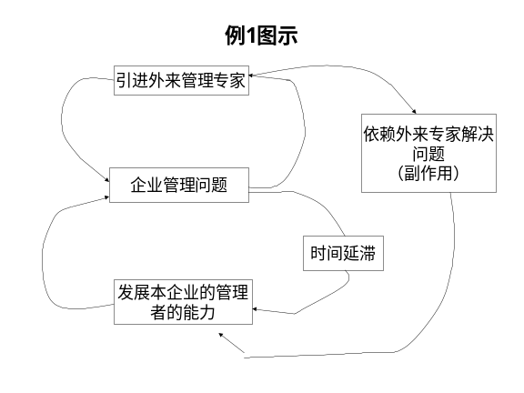 | Notes______________________________  ___________________________________  ___________________________________  Q&A_______________________________  ___________________________________  ___________________________________  ___________________________________
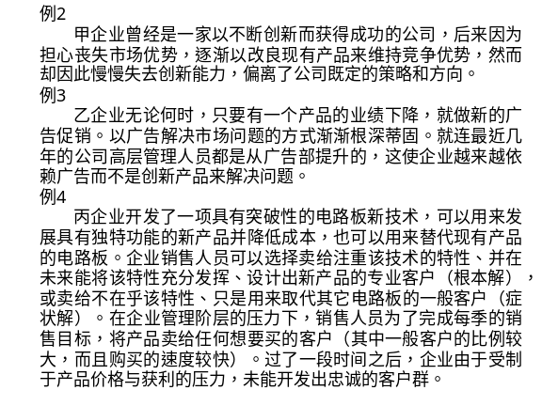 | Notes______________________________  ___________________________________  ___________________________________  Q&A_______________________________  ___________________________________  ___________________________________  ___________________________________
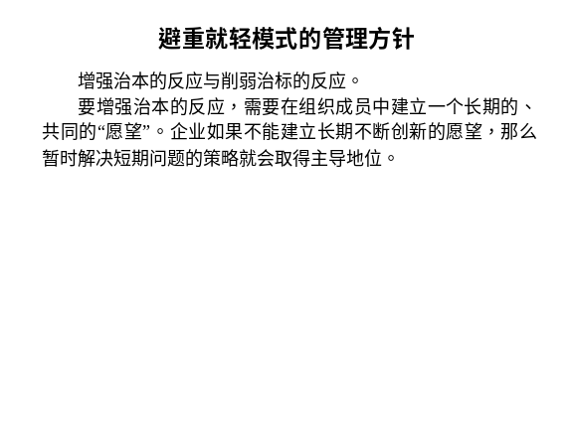 | Notes______________________________  ___________________________________  ___________________________________  Q&A_______________________________  ___________________________________  ___________________________________  ___________________________________
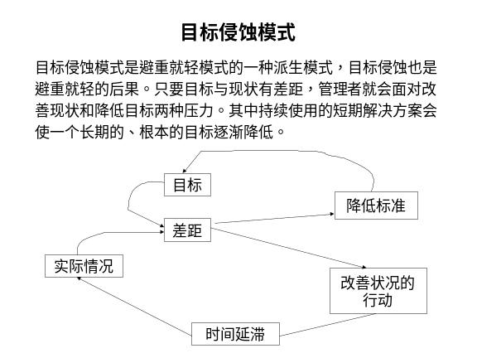 | Notes______________________________  ___________________________________  ___________________________________  Q&A_______________________________  ___________________________________  ___________________________________  ___________________________________
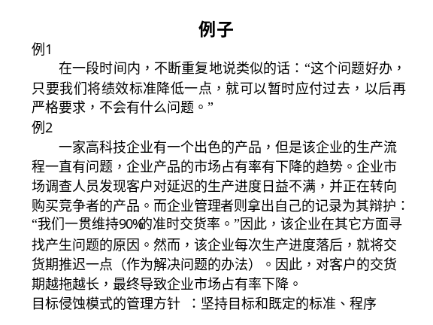 | Notes______________________________  ___________________________________  ___________________________________  Q&A_______________________________  ___________________________________  ___________________________________  ___________________________________
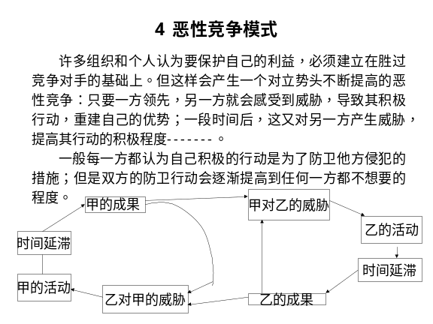 | Notes______________________________  ___________________________________  ___________________________________  Q&A_______________________________  ___________________________________  ___________________________________  ___________________________________
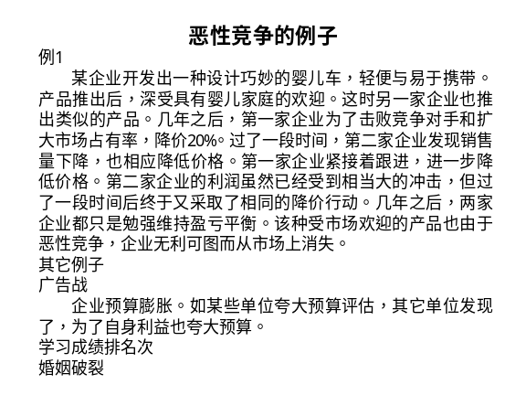 | Notes______________________________  ___________________________________  ___________________________________  Q&A_______________________________  ___________________________________  ___________________________________  ___________________________________
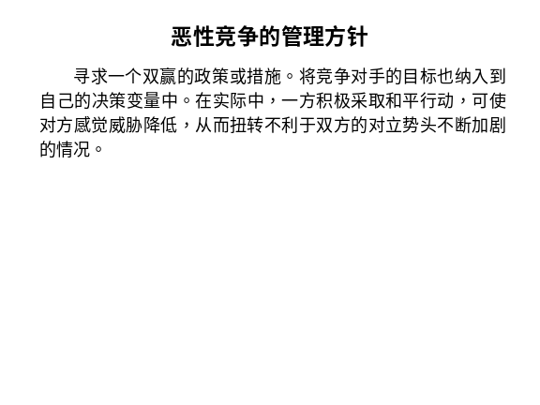 | Notes______________________________  ___________________________________  ___________________________________  Q&A_______________________________  ___________________________________  ___________________________________  ___________________________________
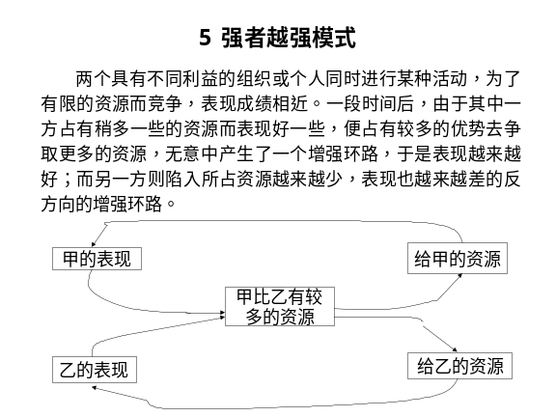 | Notes______________________________  ___________________________________  ___________________________________  Q&A_______________________________  ___________________________________  ___________________________________  ___________________________________
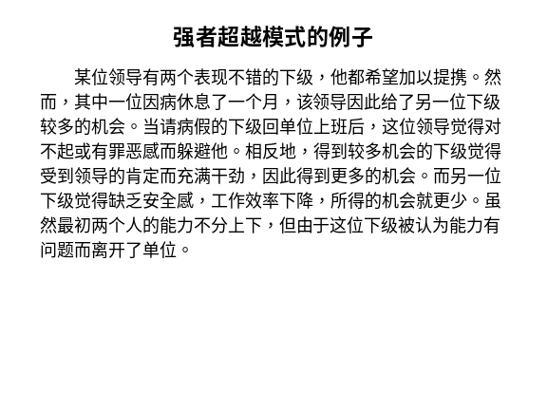 | Notes______________________________  ___________________________________  ___________________________________  Q&A_______________________________  ___________________________________  ___________________________________  ___________________________________
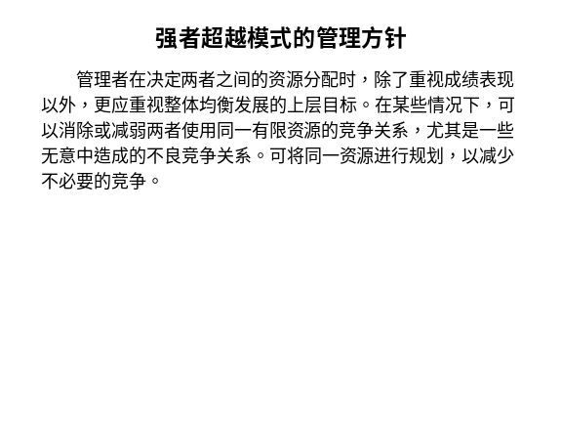 | Notes______________________________  ___________________________________  ___________________________________  Q&A_______________________________  ___________________________________  ___________________________________  ___________________________________
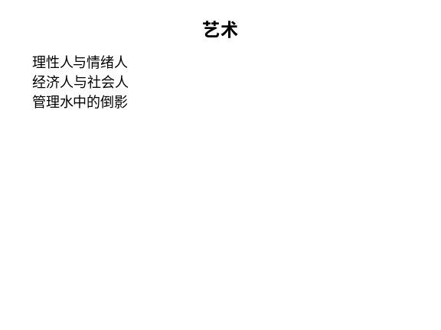 | Notes______________________________  ___________________________________  ___________________________________  Q&A_______________________________  ___________________________________  ___________________________________  ___________________________________
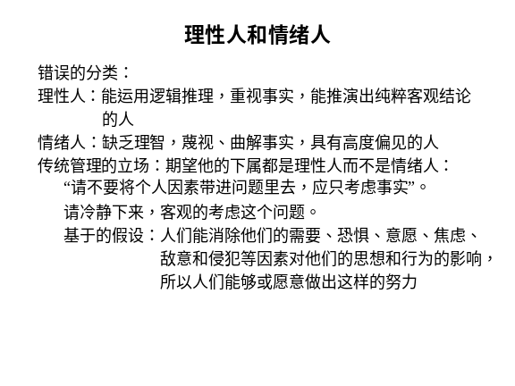 | Notes______________________________  ___________________________________  ___________________________________  Q&A_______________________________  ___________________________________  ___________________________________  ___________________________________
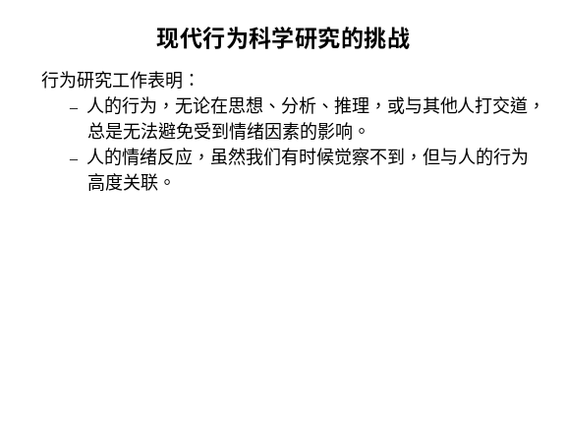 | Notes______________________________  ___________________________________  ___________________________________  Q&A_______________________________  ___________________________________  ___________________________________  ___________________________________
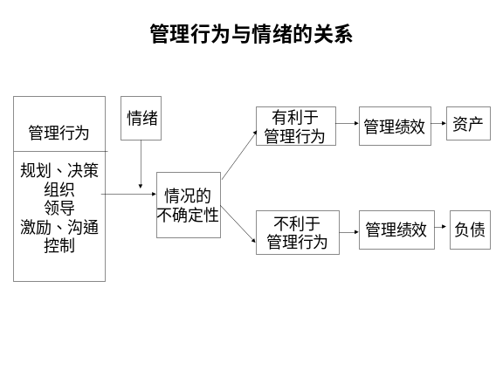 | Notes______________________________  ___________________________________  ___________________________________  Q&A_______________________________  ___________________________________  ___________________________________  ___________________________________
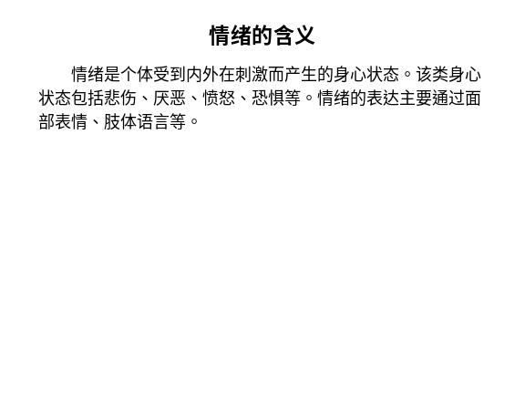 | Notes______________________________  ___________________________________  ___________________________________  Q&A_______________________________  ___________________________________  ___________________________________  ___________________________________
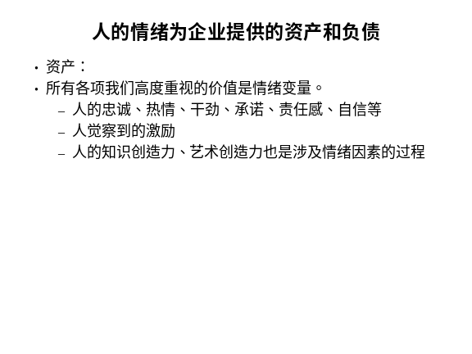 | Notes______________________________  ___________________________________  ___________________________________  Q&A_______________________________  ___________________________________  ___________________________________  ___________________________________
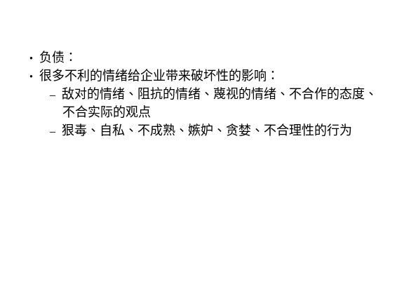 | Notes______________________________  ___________________________________  ___________________________________  Q&A_______________________________  ___________________________________  ___________________________________  ___________________________________
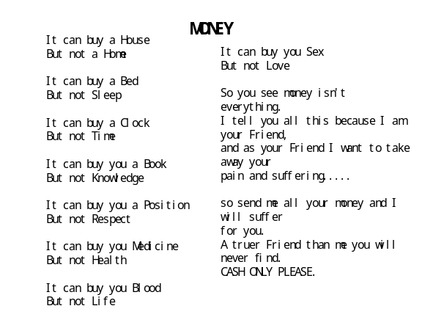 | Notes______________________________  ___________________________________  ___________________________________  Q&A_______________________________  ___________________________________  ___________________________________  ___________________________________
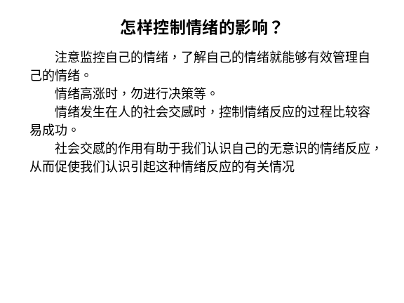 | Notes______________________________  ___________________________________  ___________________________________  Q&A_______________________________  ___________________________________  ___________________________________  ___________________________________
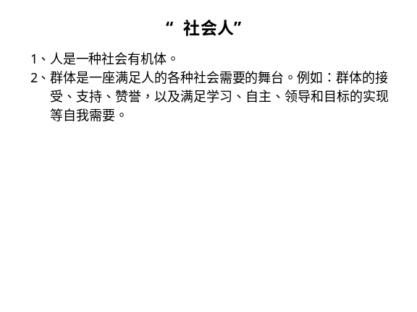 | Notes______________________________  ___________________________________  ___________________________________  Q&A_______________________________  ___________________________________  ___________________________________  ___________________________________
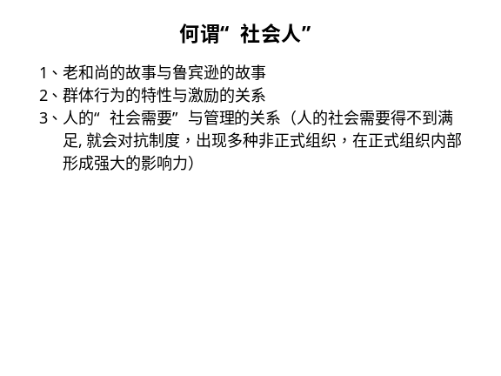 | Notes______________________________  ___________________________________  ___________________________________  Q&A_______________________________  ___________________________________  ___________________________________  ___________________________________
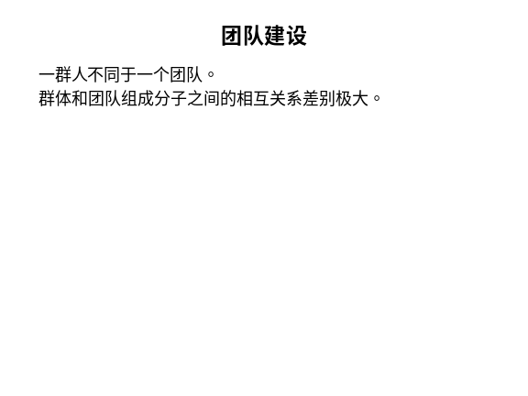 | Notes______________________________  ___________________________________  ___________________________________  Q&A_______________________________  ___________________________________  ___________________________________  ___________________________________

六、个人学习问题归纳
______________________________________________________________________________________________________________________________________________________________________________________________________________________________________________________________________________________________________________________________________________________________________________________________________

七、本讲思考题
请思考下列问题，并登陆网校，在“课程讨论室”参加讨论。
- 举例说明情绪对管理的影响，并说明如何有效地控制情绪对管理的不良影响。
- 举例说明绩效与个人特性、组织环境之间的关系。
- 学习提示：为了了解你对本讲基本内容的掌握情况，现在可以登陆网校，做一下本讲的自测习题。

本节课已经学习完毕。你可以进入下一个小节的学习。→

