第三讲
一、课程简介
本讲主要讲授了传统人事管理向现代人力资源管理转变的基础和过程，具体分析了人力资源管理的基本流程以及人力资源规划。
二、课程目标：
- 描述人力资源管理的基本流程
- 了解不同部门在人力资源管理中所扮演的角色
- 了解人力资源管理的战略性
- 掌握人力资源规划的基本问题和基本程序
- 掌握控制幅度和影响控制幅度大小的因素

三、要点提示：
晋升与肥胖症、外在报酬、战略人力资源管理、人力资源规划、控制幅度、
人员计划的内部一致性和外部一致性、趋势分析、散点分析、比率分析

四、课程预习：

- 阅读指导
- 人大出版社出版的«人力资源管理»第4、19章
- 机械工业出版社出版的«人力资源管理»第3章

- 阅读笔记

课程重点
_________________________________________________________________
_________________________________________________________________
_________________________________________________________________
_________________________________________________________________
_________________________________________________________________
_________________________________________________________________

课程难点
_________________________________________________________________
_________________________________________________________________
_________________________________________________________________
_________________________________________________________________
_________________________________________________________________
_________________________________________________________________

疑难问题:
_________________________________________________________________
_________________________________________________________________
_________________________________________________________________
_________________________________________________________________
_________________________________________________________________
_________________________________________________________________
_________________________________________________________________

体会:
_________________________________________________________________
_________________________________________________________________
_________________________________________________________________
_________________________________________________________________
_________________________________________________________________
_________________________________________________________________

五、课程学习
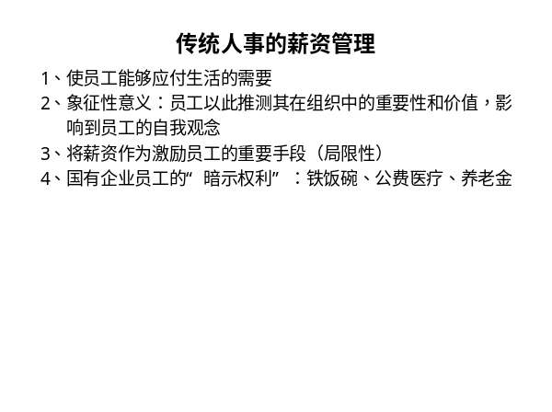 | Notes_________________________________________________________________  ___________________________________  ___________________________________  Q&A______________________________  ___________________________________  ___________________________________
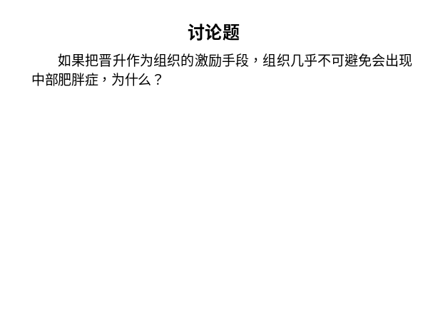 | Notes_________________________________________________________________  ___________________________________  ___________________________________  Q&A______________________________  ___________________________________  ___________________________________
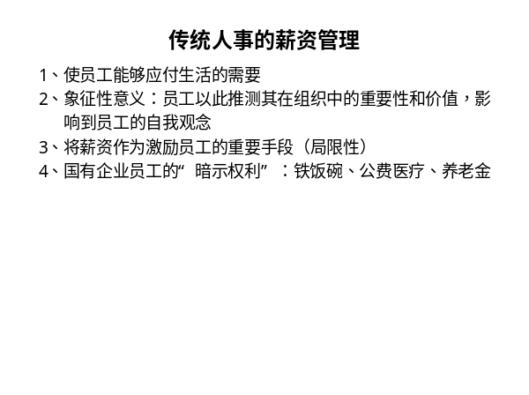 | Notes_________________________________________________________________  ___________________________________  ___________________________________  Q&A______________________________  ___________________________________  ___________________________________
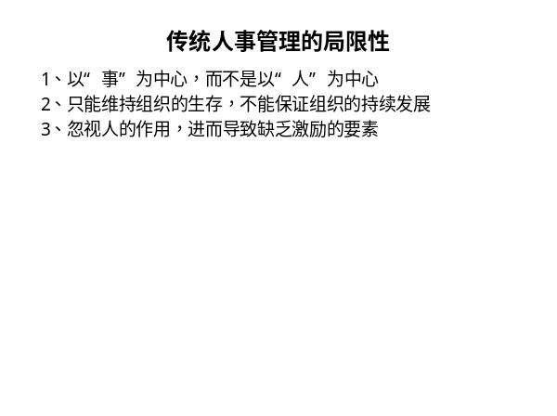 | Notes_________________________________________________________________  ___________________________________  ___________________________________  Q&A______________________________  ___________________________________  ___________________________________
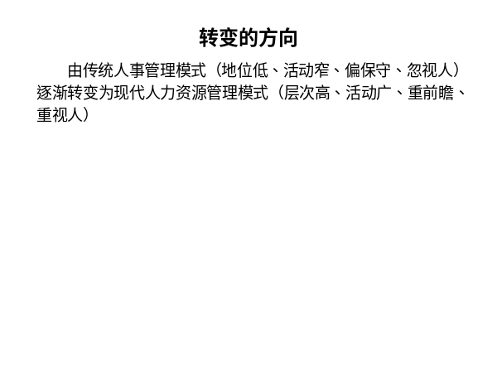 | Notes_________________________________________________________________  ___________________________________  ___________________________________  Q&A______________________________  ___________________________________  ___________________________________
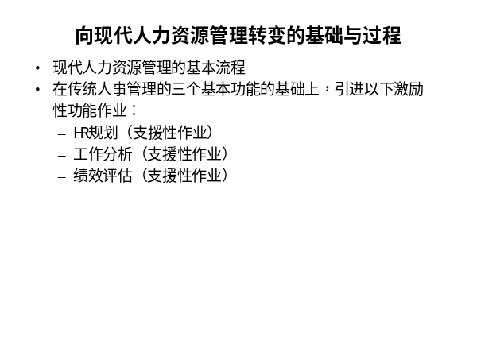 | Notes_________________________________________________________________  ___________________________________  ___________________________________  Q&A______________________________  ___________________________________  ___________________________________
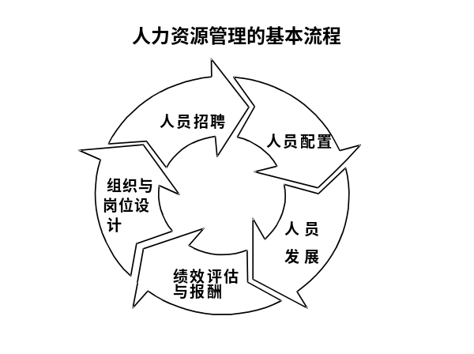 | Notes_________________________________________________________________  ___________________________________  ___________________________________  Q&A______________________________  ___________________________________  ___________________________________
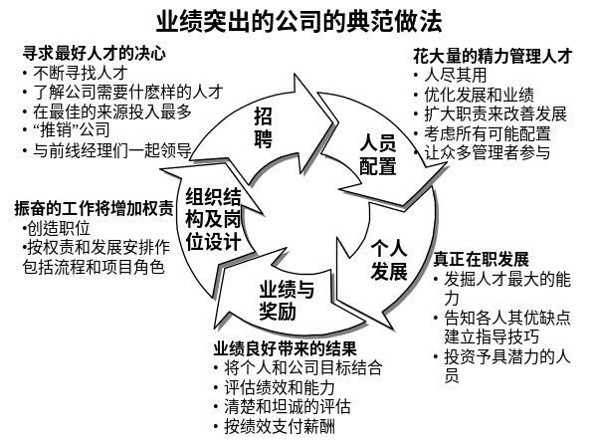 | Notes_________________________________________________________________  ___________________________________  ___________________________________  Q&A______________________________  ___________________________________  ___________________________________
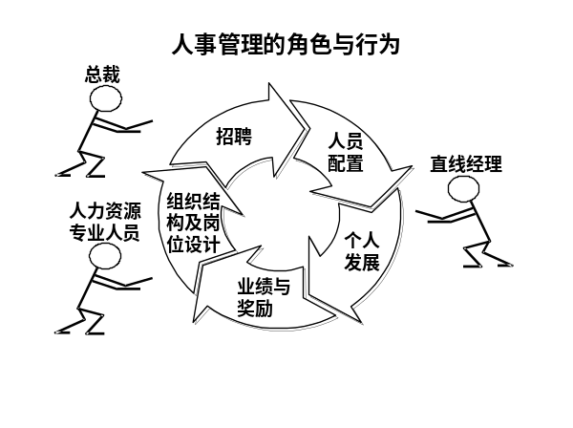 | Notes_________________________________________________________________  ___________________________________  ___________________________________  Q&A______________________________  ___________________________________  ___________________________________
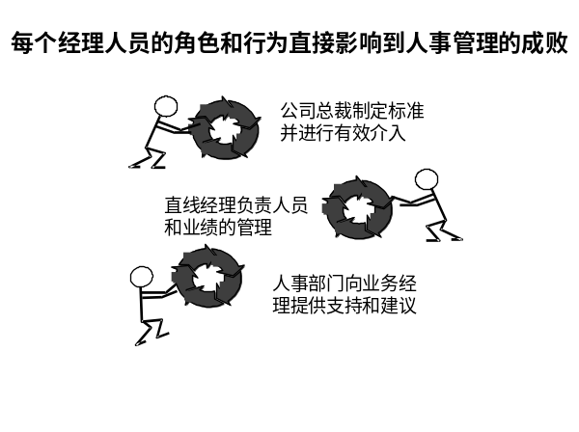 | Notes_________________________________________________________________  ___________________________________  ___________________________________  Q&A______________________________  ___________________________________  ___________________________________
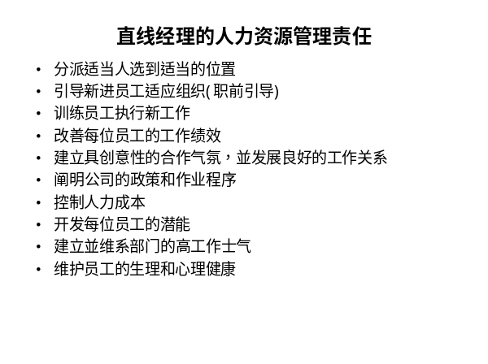 | Notes_________________________________________________________________  ___________________________________  ___________________________________  Q&A______________________________  ___________________________________  ___________________________________
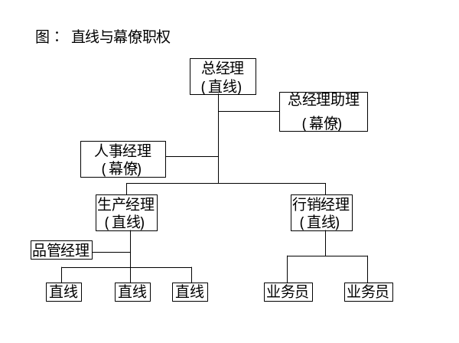 | Notes_________________________________________________________________  ___________________________________  ___________________________________  Q&A______________________________  ___________________________________  ___________________________________
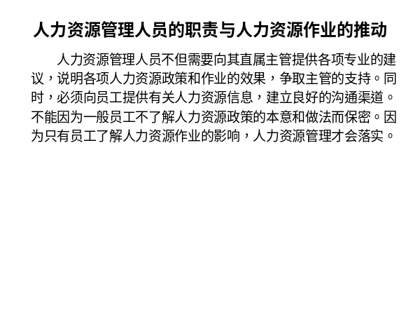 | Notes_________________________________________________________________  ___________________________________  ___________________________________  Q&A______________________________  ___________________________________  ___________________________________
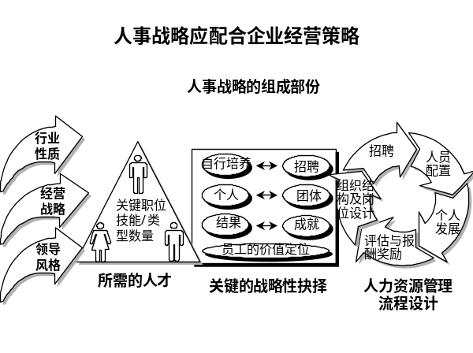 | Notes_________________________________________________________________  ___________________________________  ___________________________________  Q&A______________________________  ___________________________________  ___________________________________
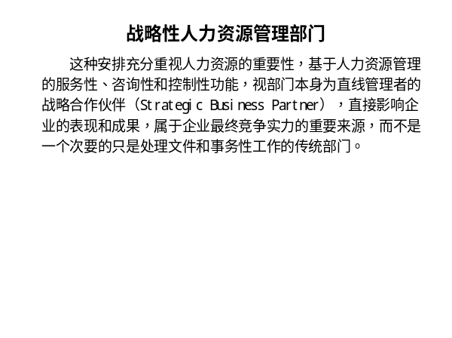 | Notes_________________________________________________________________  ___________________________________  ___________________________________  Q&A______________________________  ___________________________________  ___________________________________
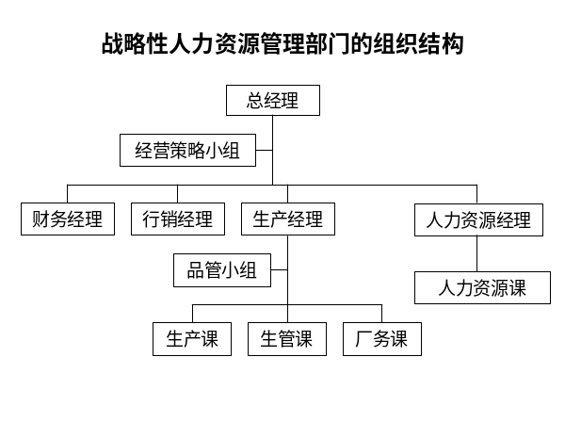 | Notes_________________________________________________________________  ___________________________________  ___________________________________  Q&A______________________________  ___________________________________  ___________________________________
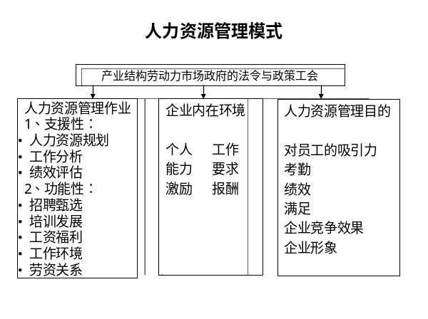 | Notes_________________________________________________________________  ___________________________________  ___________________________________  Q&A______________________________  ___________________________________  ___________________________________
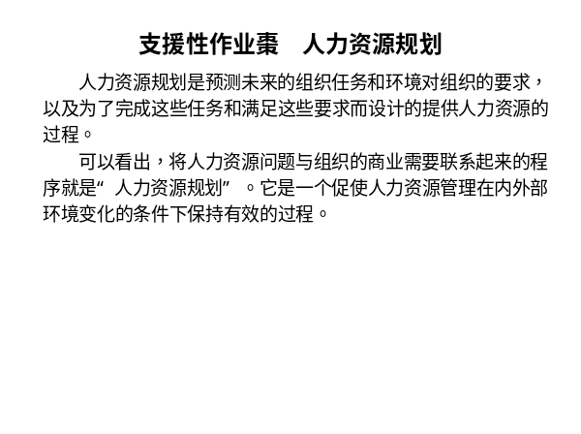 | Notes_________________________________________________________________  ___________________________________  ___________________________________  Q&A______________________________  ___________________________________  ___________________________________
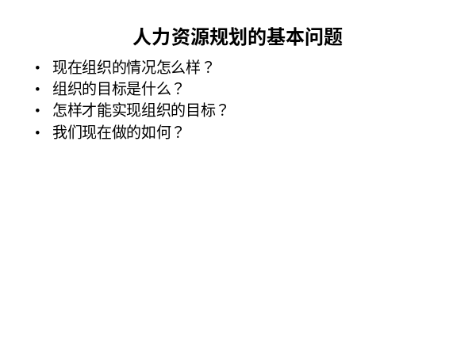 | Notes_________________________________________________________________  ___________________________________  ___________________________________  Q&A______________________________  ___________________________________  ___________________________________
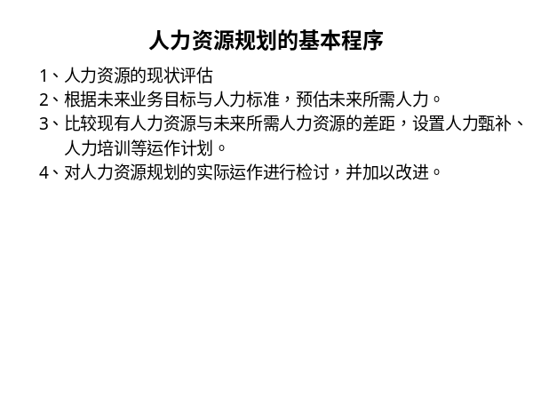 | Notes_________________________________________________________________  ___________________________________  ___________________________________  Q&A______________________________  ___________________________________  ___________________________________
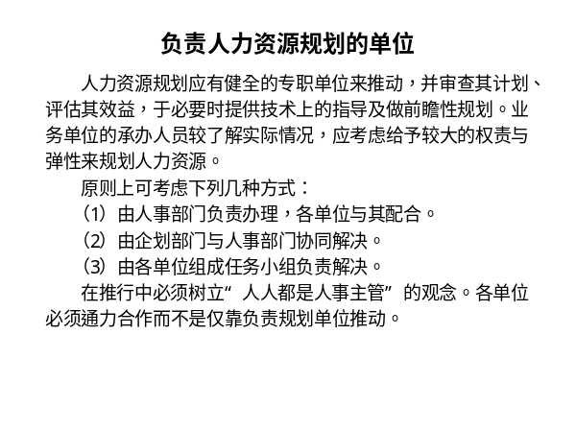 | Notes_________________________________________________________________  ___________________________________  ___________________________________  Q&A______________________________  ___________________________________  ___________________________________
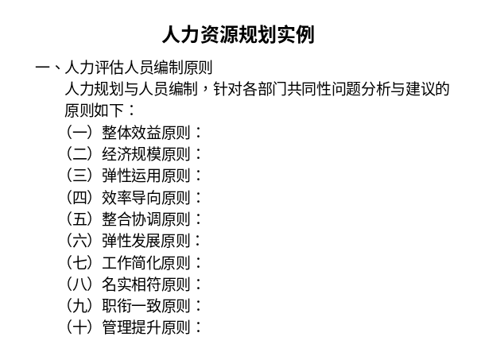 | Notes_________________________________________________________________  ___________________________________  ___________________________________  Q&A______________________________  ___________________________________  ___________________________________
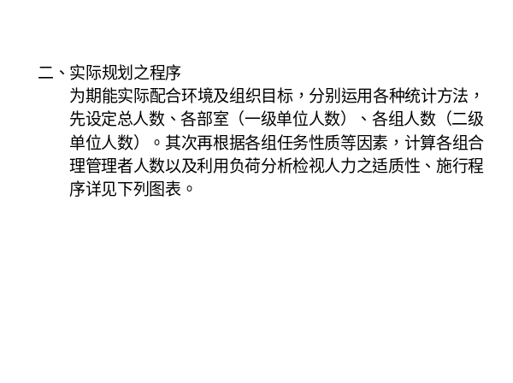 | Notes_________________________________________________________________  ___________________________________  ___________________________________  Q&A______________________________  ___________________________________  ___________________________________
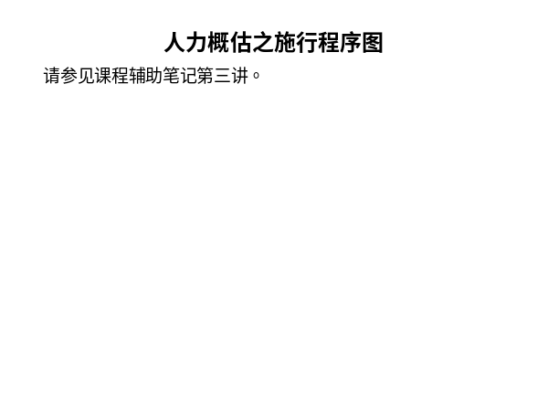 | Notes_________________________________________________________________  ___________________________________  ___________________________________  Q&A______________________________  ___________________________________  ___________________________________
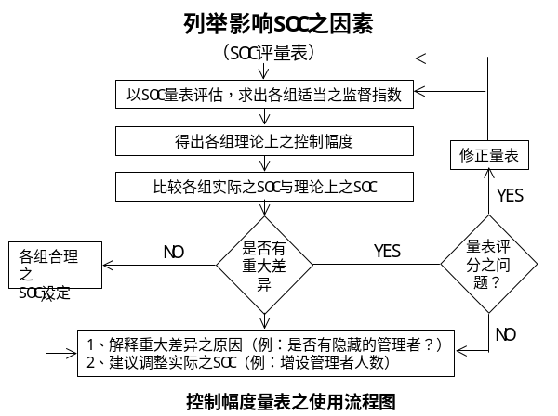 | Notes_________________________________________________________________  ___________________________________  ___________________________________  Q&A______________________________  ___________________________________  ___________________________________
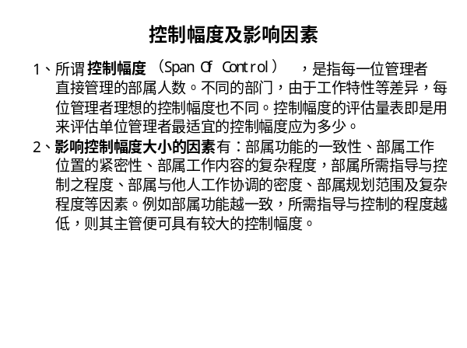 | Notes_________________________________________________________________  ___________________________________  ___________________________________  Q&A______________________________  ___________________________________  ___________________________________
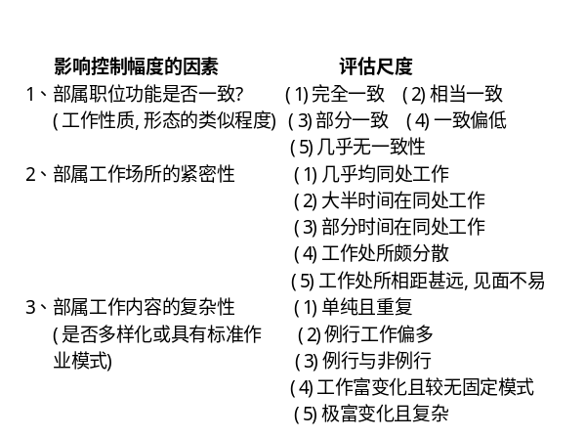 | Notes_________________________________________________________________  ___________________________________  ___________________________________  Q&A______________________________  ___________________________________  ___________________________________
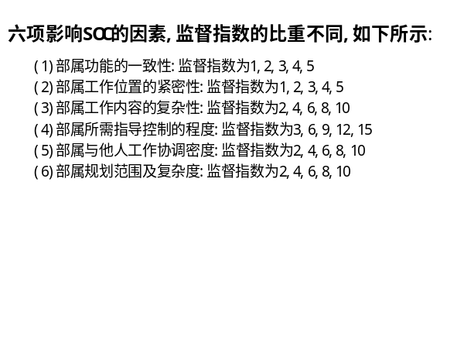 | Notes_________________________________________________________________  ___________________________________  ___________________________________  Q&A______________________________  ___________________________________  ___________________________________
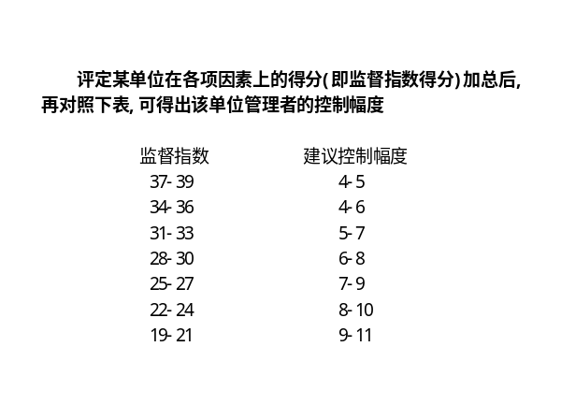 | Notes_________________________________________________________________  ___________________________________  ___________________________________  Q&A______________________________  ___________________________________  ___________________________________

六、个人学习问题归纳
______________________________________________________________________________________________________________________________________________________________________________________________________________________________________________________________________________________________________________________________________________________________________________________________________

七、本讲思考题
请思考下列问题，并登陆网校，在“课程讨论室”参加讨论。
    - 结合实际说明人员计划中内部一致性与外部一致性的含义？
    - 人力资源管理者的角色是什么？在实际工作中人力资源管理者如何才能演好自己的角色？

- 学习提示：为了了解你对本讲基本内容的掌握情况，现在可以登陆网校，做一下本讲的自测习题。

本节课已经学习完毕。你可以进入下一个小节的学习。→

