人力资源管理第二讲

一、课程简介
本讲主要讲授了管理团队有效作业的条件、外包的含义、传统人事管理的特征和基本职能，并进一步分析了传统人事招聘与现代人事招聘的区别、传统人事的级别管理和薪资管理。
二、课程目标
- 理解管理团队有效作业的条件
- 了解传统人事管理的特征和基本职能
- 区别传统人事与现代人事的招聘和甄选
- 了解传统人事的级别管理和薪资管理
三、要点提示
管理团队的有效作业条件、共同的目标、认同感、承诺感、坦诚沟通、信任关系、外包、传统人事管理、传统招聘、传统的级别管理、传统的薪资管理
工作分析、工作描述、职位说明书、访谈法、问卷法、观察法、日志法、人员需求预测、招聘方式

四、课程预习：

- 阅读指导
- 人大出版社出版的«人力资源管理»第3、4章
- 机械工业出版社出版的«人力资源管理»第4、5、6章

- 阅读笔记

课程重点
_________________________________________________________________
_________________________________________________________________
_________________________________________________________________
_________________________________________________________________
_________________________________________________________________
_________________________________________________________________

课程难点
_________________________________________________________________
_________________________________________________________________
_________________________________________________________________
_________________________________________________________________
_________________________________________________________________
_________________________________________________________________

疑难问题:
_________________________________________________________________
_________________________________________________________________
_________________________________________________________________
_________________________________________________________________
_________________________________________________________________
_________________________________________________________________
_________________________________________________________________

体会:
_________________________________________________________________
_________________________________________________________________
_________________________________________________________________
_________________________________________________________________
_________________________________________________________________
_________________________________________________________________

五、课程学习

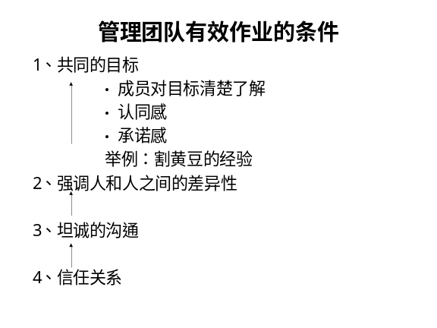 | Notes______________________________  ___________________________________  ___________________________________  Q&A_______________________________  ___________________________________  ___________________________________  ___________________________________
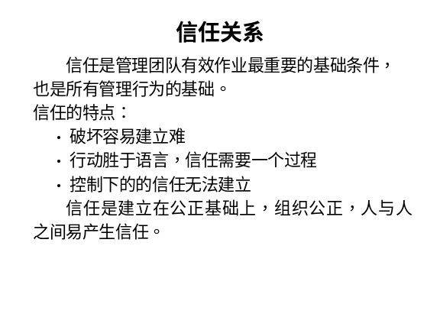 | Notes______________________________  ___________________________________  ___________________________________  Q&A_______________________________  ___________________________________  ___________________________________  ___________________________________
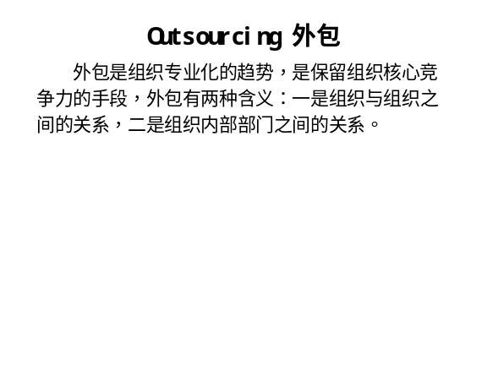 | Notes______________________________  ___________________________________  ___________________________________  Q&A_______________________________  ___________________________________  ___________________________________  ___________________________________
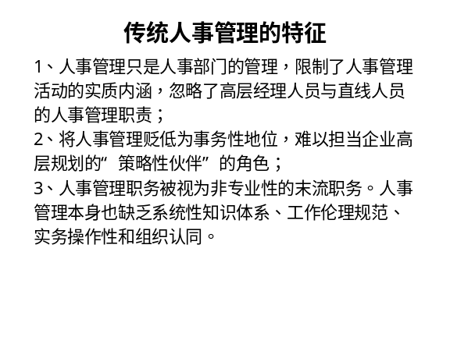 | Notes______________________________  ___________________________________  ___________________________________  Q&A_______________________________  ___________________________________  ___________________________________  ___________________________________
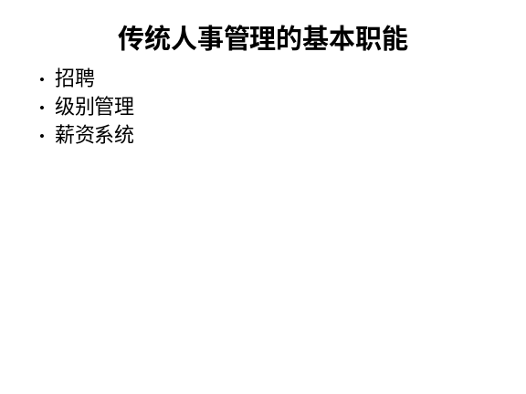 | Notes______________________________  ___________________________________  ___________________________________  Q&A_______________________________  ___________________________________  ___________________________________  ___________________________________
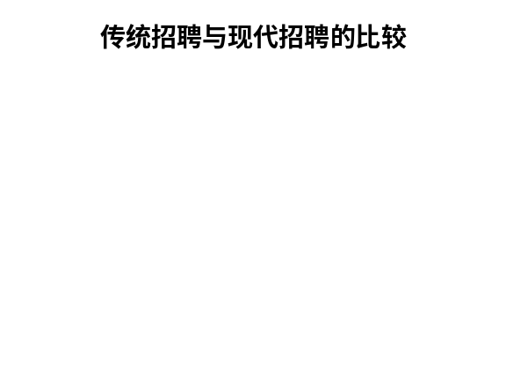 | Notes______________________________  ___________________________________  ___________________________________  Q&A_______________________________  ___________________________________  ___________________________________  ___________________________________
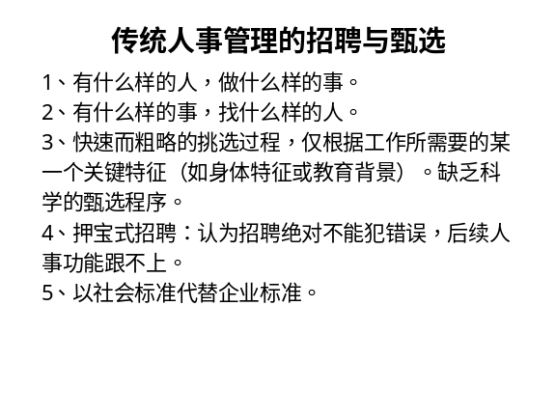 | Notes______________________________  ___________________________________  ___________________________________  Q&A_______________________________  ___________________________________  ___________________________________  ___________________________________
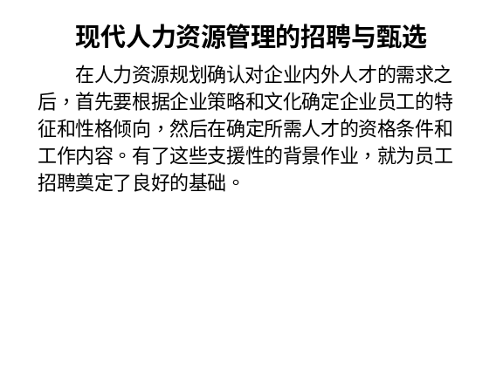 | Notes______________________________  ___________________________________  ___________________________________  Q&A_______________________________  ___________________________________  ___________________________________  ___________________________________
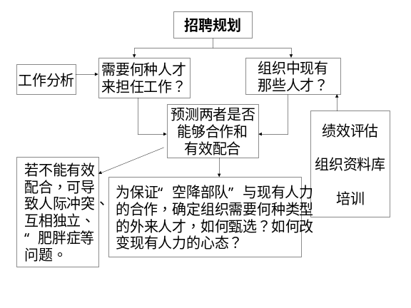 | Notes______________________________  ___________________________________  ___________________________________  Q&A_______________________________  ___________________________________  ___________________________________  ___________________________________
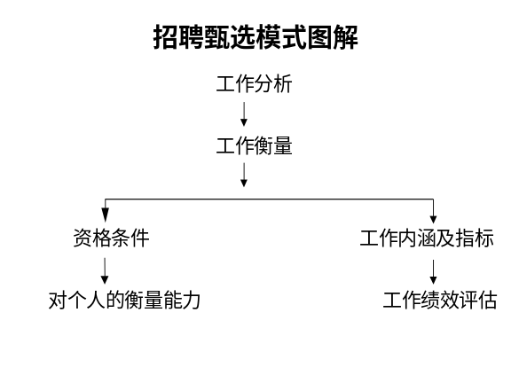 | Notes______________________________  ___________________________________  ___________________________________  Q&A_______________________________  ___________________________________  ___________________________________  ___________________________________
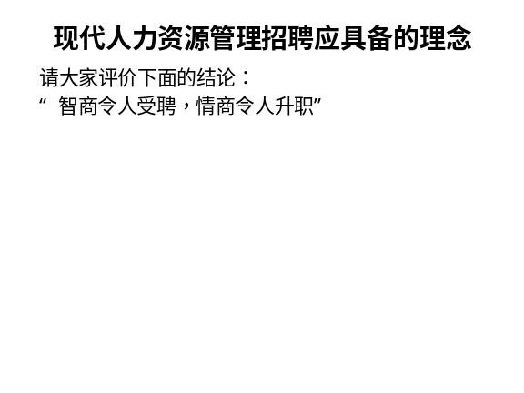 | Notes______________________________  ___________________________________  ___________________________________  Q&A_______________________________  ___________________________________  ___________________________________  ___________________________________
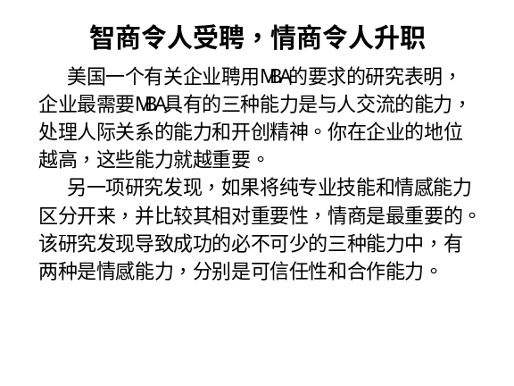 | Notes______________________________  ___________________________________  ___________________________________  Q&A_______________________________  ___________________________________  ___________________________________  ___________________________________
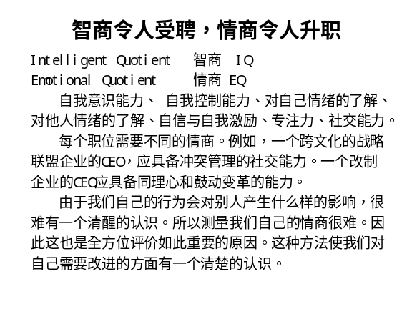 | Notes______________________________  ___________________________________  ___________________________________  Q&A_______________________________  ___________________________________  ___________________________________  ___________________________________
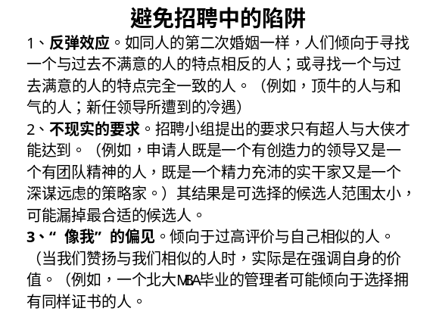 | Notes______________________________  ___________________________________  ___________________________________  Q&A_______________________________  ___________________________________  ___________________________________  ___________________________________
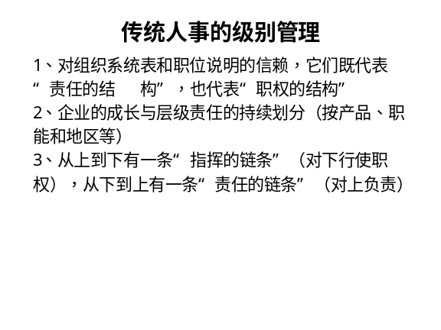 | Notes______________________________  ___________________________________  ___________________________________  Q&A_______________________________  ___________________________________  ___________________________________  ___________________________________
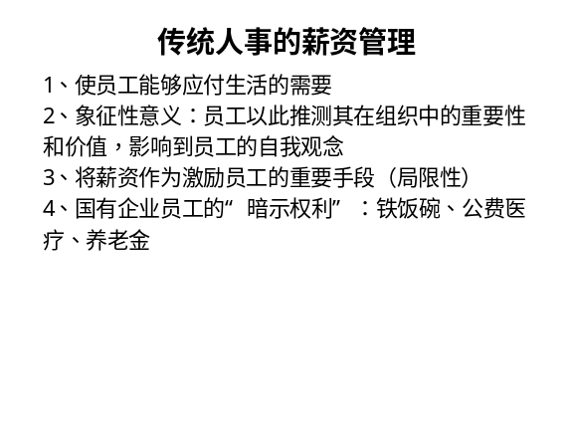 | Notes______________________________  ___________________________________  ___________________________________  Q&A_______________________________  ___________________________________  ___________________________________  ___________________________________

六、个人学习问题归纳
______________________________________________________________________________________________________________________________________________________________________________________________________________________________________________________________________________________________________________________________________________________________________________________________________

七、本讲思考题
请思考下列问题，并登陆网校，在“课程讨论室”参加讨论。
- 如果把晋升作为组织的激励手段，组织几乎不可避免会出现中部肥胖症，为什么？
- 现代人力资源管理面临的最大挑战是什么？
- 结合自己所在职位做一份工作分析的调查问卷。
- 如何根据公司的具体情况选择招聘方式？

- 学习提示：为了了解你对本讲基本内容的掌握情况，现在可以登陆网校，做一下本讲的自测习题。

本节课已经学习完毕。你可以进入下一个小节的学习。→

