第五讲
一、课程简介
本讲主要介绍了绩效评估的难点及人力资源管理中文化和理念的相关概念。

二、课程目标：
- 说明绩效评估信息的种类与绩效评估的内在矛盾
- 了解文化的概念和不同文化对管理的影响
- 区分自生秩序和创生秩序

三、要点提示：
评价性资料、发展性资料、归因理论、文化、管理种群、管理的旅客、文化层次、中西方文化价值对比、个人主义与集体主义、理念、价值观、权力差距、有机体与机械体、自生秩序、创生秩序

四、课程预习：

- 阅读指导
机械工业出版社出版的“人力资源管理”第14章p359
- 阅读笔记

课程重点
_________________________________________________________________
_________________________________________________________________
_________________________________________________________________
_________________________________________________________________
_________________________________________________________________
_________________________________________________________________

课程难点
_________________________________________________________________
_________________________________________________________________
_________________________________________________________________
_________________________________________________________________
_________________________________________________________________
_________________________________________________________________

疑难问题:
_________________________________________________________________
_________________________________________________________________
_________________________________________________________________
_________________________________________________________________
_________________________________________________________________
_________________________________________________________________
_________________________________________________________________

体会:
_________________________________________________________________
_________________________________________________________________
_________________________________________________________________
_________________________________________________________________
_________________________________________________________________
_________________________________________________________________

五、课程学习
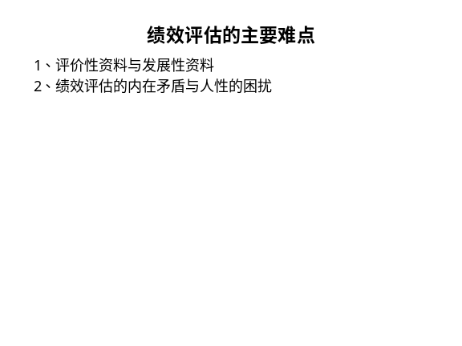 | Notes______________________________  ___________________________________  ___________________________________  Q&A_______________________________  ___________________________________  ___________________________________  ___________________________________
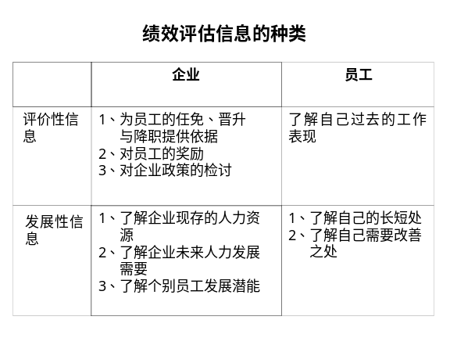 | Notes______________________________  ___________________________________  ___________________________________  Q&A_______________________________  ___________________________________  ___________________________________  ___________________________________
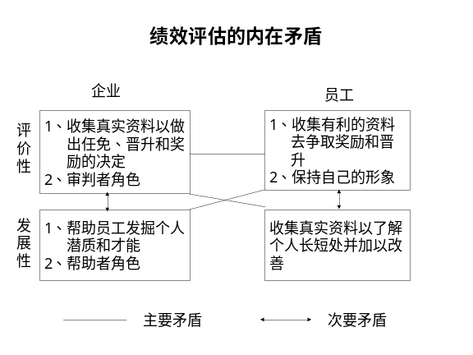 | Notes______________________________  ___________________________________  ___________________________________  Q&A_______________________________  ___________________________________  ___________________________________  ___________________________________
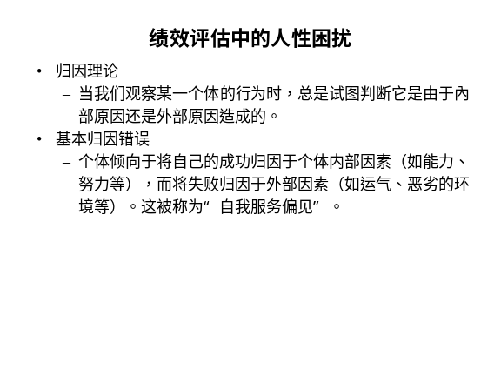 | Notes______________________________  ___________________________________  ___________________________________  Q&A_______________________________  ___________________________________  ___________________________________  ___________________________________
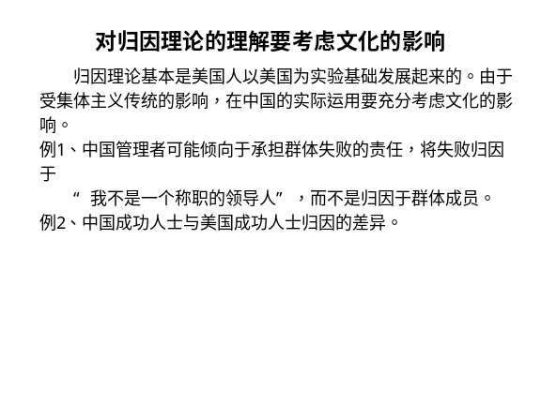 | Notes______________________________  ___________________________________  ___________________________________  Q&A_______________________________  ___________________________________  ___________________________________  ___________________________________
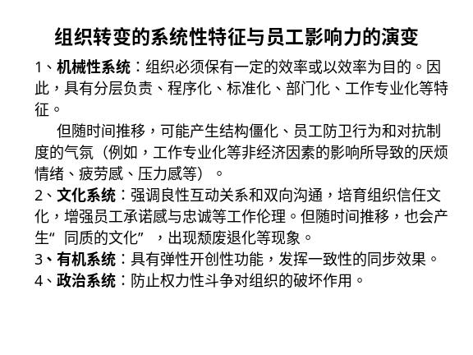 | Notes______________________________  ___________________________________  ___________________________________  Q&A_______________________________  ___________________________________  ___________________________________  ___________________________________
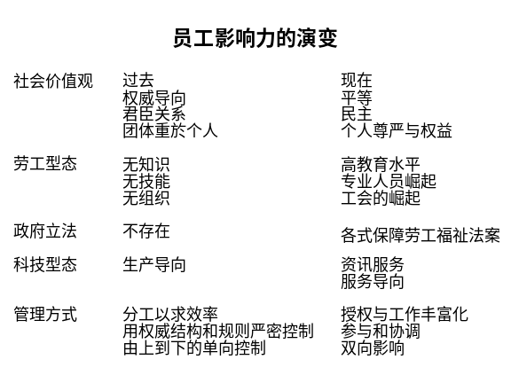 | Notes______________________________  ___________________________________  ___________________________________  Q&A_______________________________  ___________________________________  ___________________________________  ___________________________________
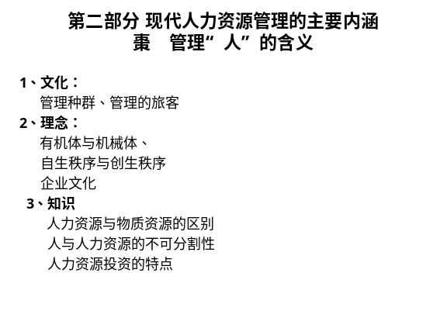 | Notes______________________________  ___________________________________  ___________________________________  Q&A_______________________________  ___________________________________  ___________________________________  ___________________________________
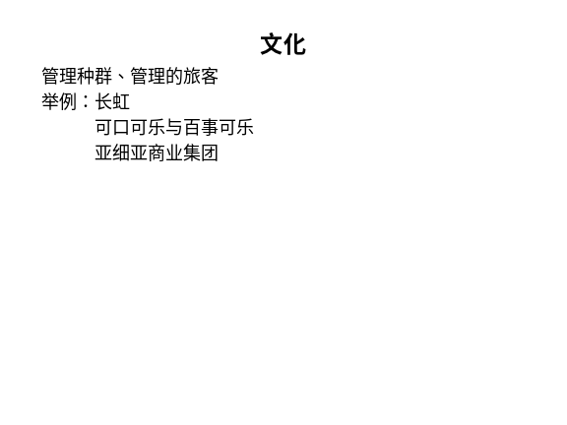 | Notes______________________________  ___________________________________  ___________________________________  Q&A_______________________________  ___________________________________  ___________________________________  ___________________________________
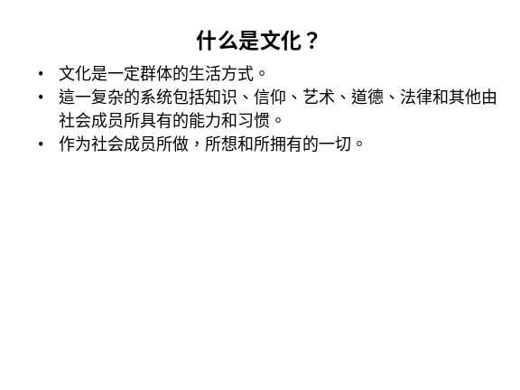 | Notes______________________________  ___________________________________  ___________________________________  Q&A_______________________________  ___________________________________  ___________________________________  ___________________________________
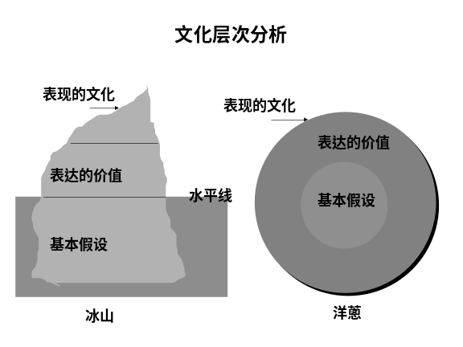 | Notes______________________________  ___________________________________  ___________________________________  Q&A_______________________________  ___________________________________  ___________________________________  ___________________________________
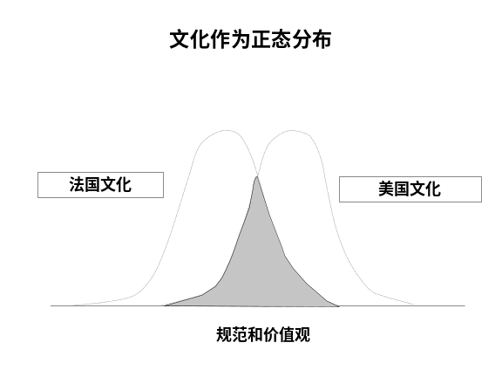 | Notes______________________________  ___________________________________  ___________________________________  Q&A_______________________________  ___________________________________  ___________________________________  ___________________________________
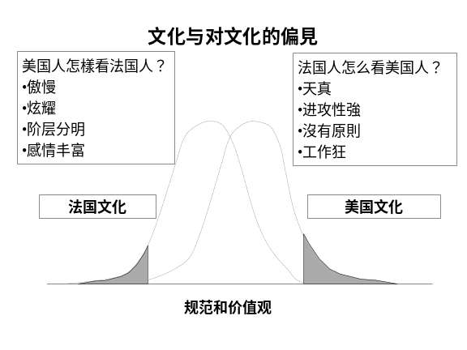 | Notes______________________________  ___________________________________  ___________________________________  Q&A_______________________________  ___________________________________  ___________________________________  ___________________________________
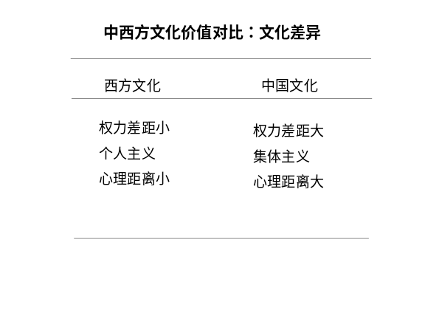 | Notes______________________________  ___________________________________  ___________________________________  Q&A_______________________________  ___________________________________  ___________________________________  ___________________________________
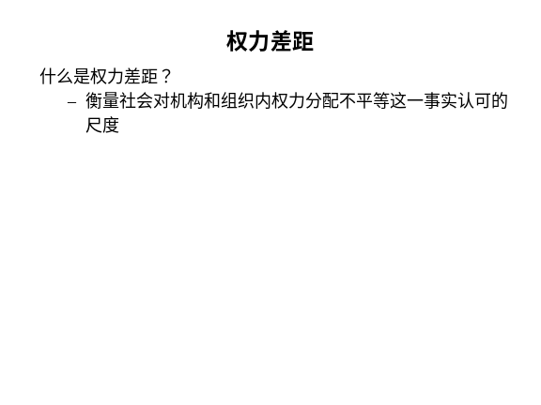 | Notes______________________________  ___________________________________  ___________________________________  Q&A_______________________________  ___________________________________  ___________________________________  ___________________________________
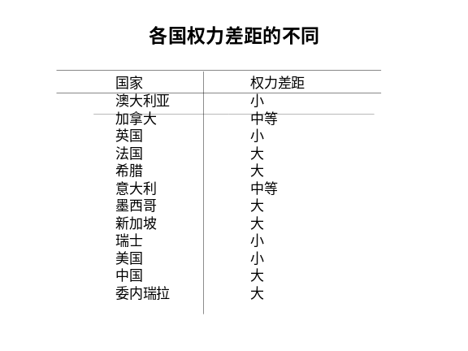 | Notes______________________________  ___________________________________  ___________________________________  Q&A_______________________________  ___________________________________  ___________________________________  ___________________________________
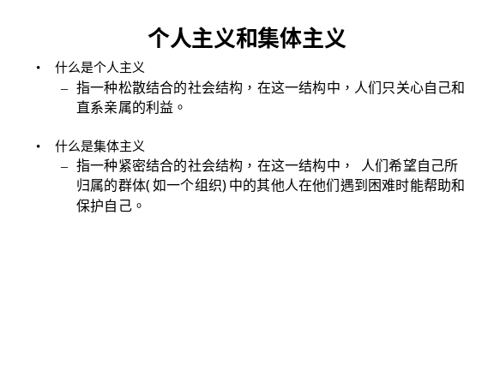 | Notes______________________________  ___________________________________  ___________________________________  Q&A_______________________________  ___________________________________  ___________________________________  ___________________________________
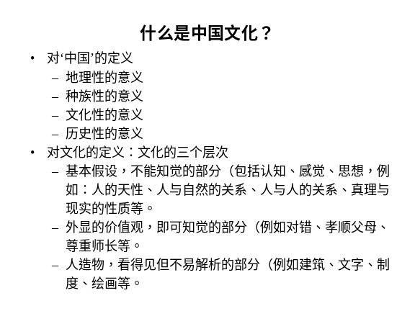 | Notes______________________________  ___________________________________  ___________________________________  Q&A_______________________________  ___________________________________  ___________________________________  ___________________________________
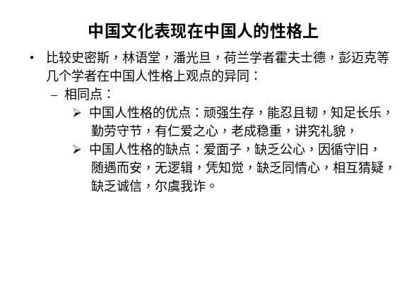 | Notes______________________________  ___________________________________  ___________________________________  Q&A_______________________________  ___________________________________  ___________________________________  ___________________________________
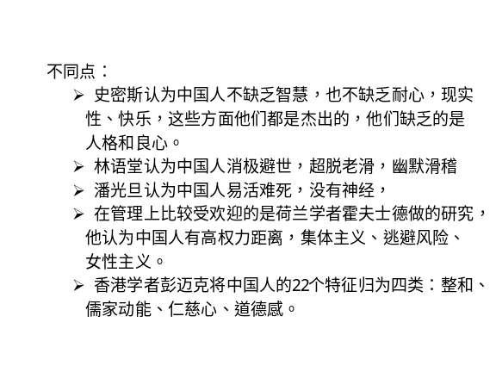 | Notes______________________________  ___________________________________  ___________________________________  Q&A_______________________________  ___________________________________  ___________________________________  ___________________________________
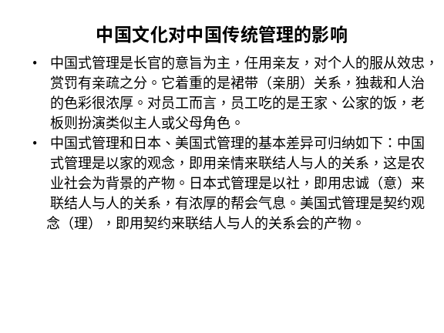 | Notes______________________________  ___________________________________  ___________________________________  Q&A_______________________________  ___________________________________  ___________________________________  ___________________________________
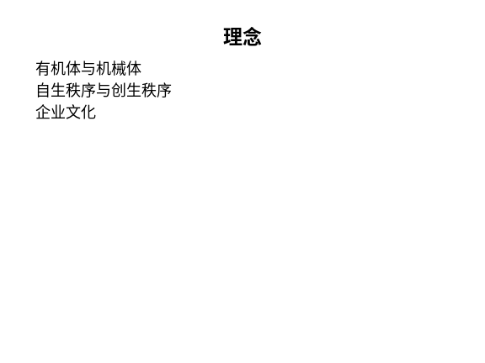 | Notes______________________________  ___________________________________  ___________________________________  Q&A_______________________________  ___________________________________  ___________________________________  ___________________________________
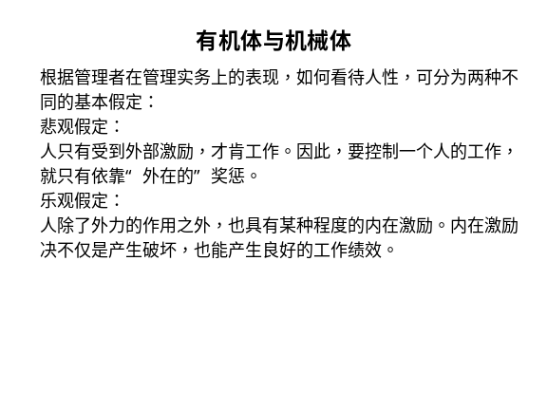 | Notes______________________________  ___________________________________  ___________________________________  Q&A_______________________________  ___________________________________  ___________________________________  ___________________________________
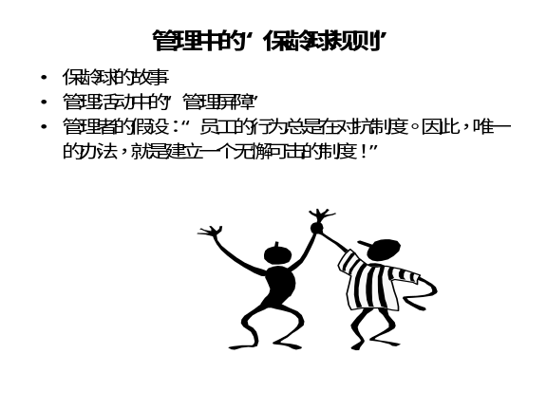 | Notes______________________________  ___________________________________  ___________________________________  Q&A_______________________________  ___________________________________  ___________________________________  ___________________________________
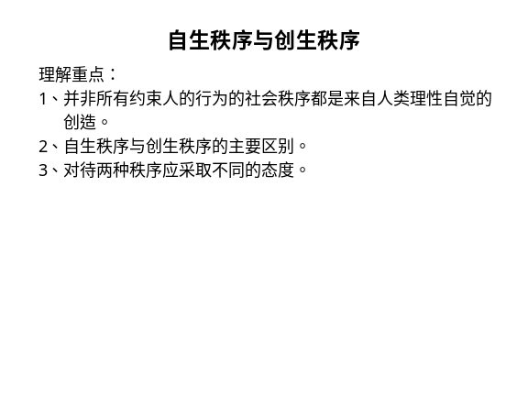 | Notes______________________________  ___________________________________  ___________________________________  Q&A_______________________________  ___________________________________  ___________________________________  ___________________________________
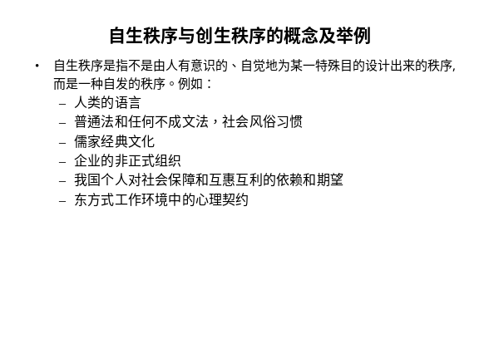 | Notes______________________________  ___________________________________  ___________________________________  Q&A_______________________________  ___________________________________  ___________________________________  ___________________________________

六、个人学习问题归纳
______________________________________________________________________________________________________________________________________________________________________________________________________________________________________________________________________________________________________________________________________________________________________________________________________

七、本讲思考题
请思考下列问题，并登陆网校，在“课程讨论室”参加讨论。
- 你认为绩效考核中的最大问题是什么？
- 自生秩序与创生秩序有何不同？试举例说明。
- 学习提示：为了了解你对本讲基本内容的掌握情况，现在可以登陆网校，做一下本讲的自测习题。

本节课已经学习完毕。你可以进入下一个小节的学习。→

