第八讲
一、课程简介
本讲主要讲授了三部分内容：工作团队、内在报酬的概念以及圈子文化。.

二、课程目标：
- 了解群体发展的阶段
- 了解群体行为模式
- 说明高绩效团队的特征
- 区别工作群体与工作团队
- 掌握外在报酬的特点
- 说明内在报酬与外在报酬的区别与关系
- 圈子文化的特点及对组织产生的影响

三、要点提示：
工作群体、工作团队、管理团队、动机、激励、公平理论、期望理论、马斯洛需要层次理论、内在报酬、外在报酬、圈子文化、承诺、认同、组织公正、社会交换理论
四、课程预习：
人大出版社出版的«人力资源管理»第12、13、14章
机械工业出版社出版的«人力资源管理»第9、10章

- 阅读笔记

课程重点
_________________________________________________________________
_________________________________________________________________
_________________________________________________________________
_________________________________________________________________
_________________________________________________________________
_________________________________________________________________

课程难点
_________________________________________________________________
_________________________________________________________________
_________________________________________________________________
_________________________________________________________________
_________________________________________________________________
_________________________________________________________________

疑难问题:
_________________________________________________________________
_________________________________________________________________
_________________________________________________________________
_________________________________________________________________
_________________________________________________________________
_________________________________________________________________
_________________________________________________________________

体会:
_________________________________________________________________
_________________________________________________________________
_________________________________________________________________
_________________________________________________________________
_________________________________________________________________
_________________________________________________________________

五、课程学习
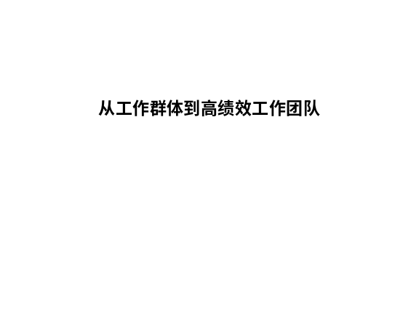 | Notes______________________________  ___________________________________  ___________________________________  Q&A_______________________________  ___________________________________  ___________________________________  ___________________________________
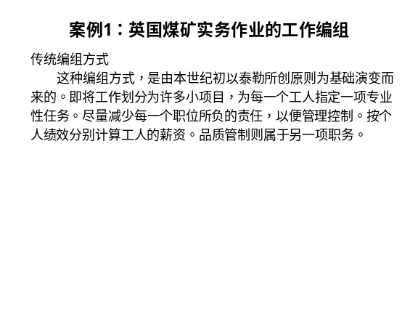 | Notes______________________________  ___________________________________  ___________________________________  Q&A_______________________________  ___________________________________  ___________________________________  ___________________________________
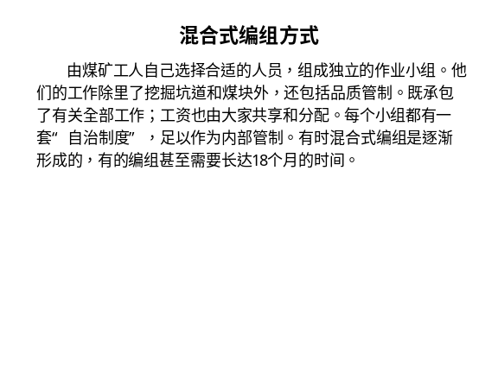 | Notes______________________________  ___________________________________  ___________________________________  Q&A_______________________________  ___________________________________  ___________________________________  ___________________________________
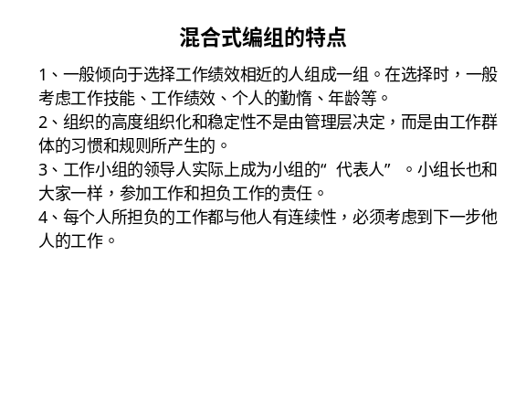 | Notes______________________________  ___________________________________  ___________________________________  Q&A_______________________________  ___________________________________  ___________________________________  ___________________________________
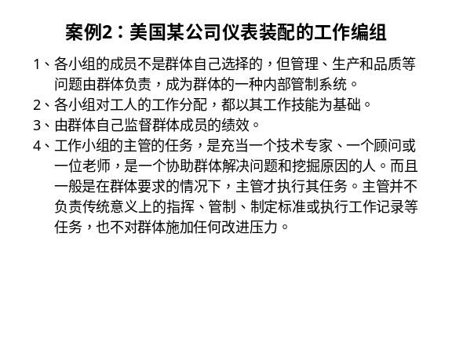 | Notes______________________________  ___________________________________  ___________________________________  Q&A_______________________________  ___________________________________  ___________________________________  ___________________________________
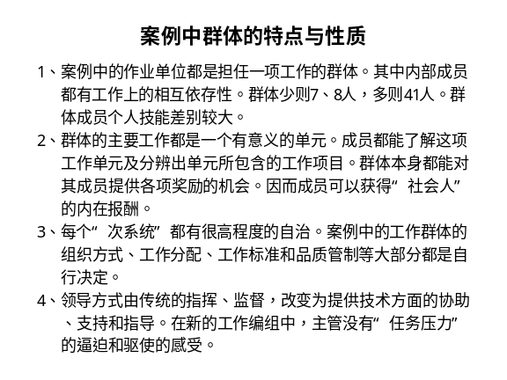 | Notes______________________________  ___________________________________  ___________________________________  Q&A_______________________________  ___________________________________  ___________________________________  ___________________________________
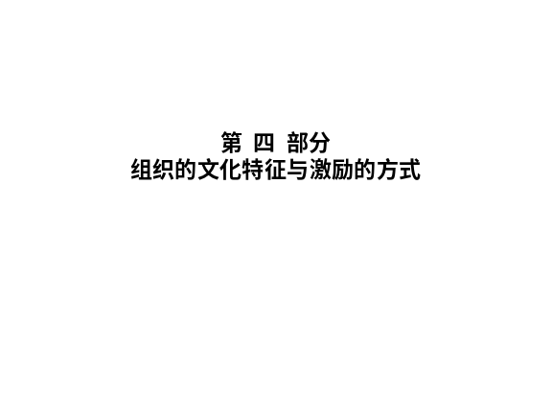 | Notes______________________________  ___________________________________  ___________________________________  Q&A_______________________________  ___________________________________  ___________________________________  ___________________________________
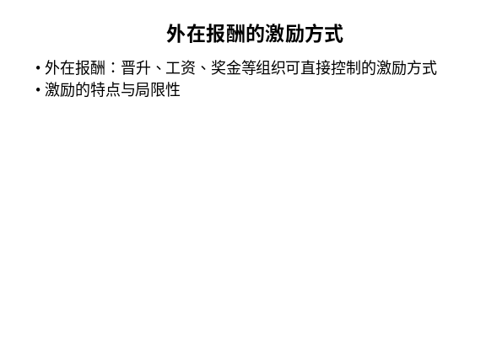 | Notes______________________________  ___________________________________  ___________________________________  Q&A_______________________________  ___________________________________  ___________________________________  ___________________________________
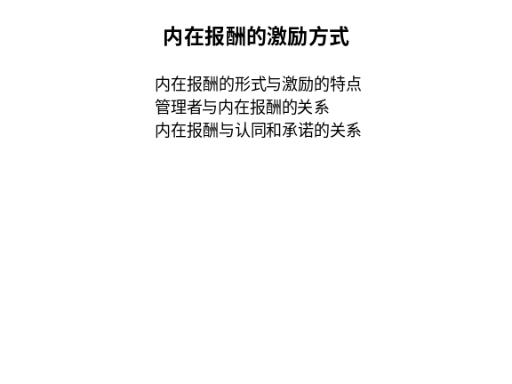 | Notes______________________________  ___________________________________  ___________________________________  Q&A_______________________________  ___________________________________  ___________________________________  ___________________________________
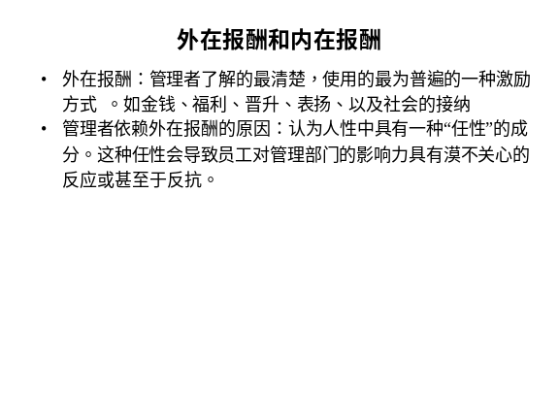 | Notes______________________________  ___________________________________  ___________________________________  Q&A_______________________________  ___________________________________  ___________________________________  ___________________________________
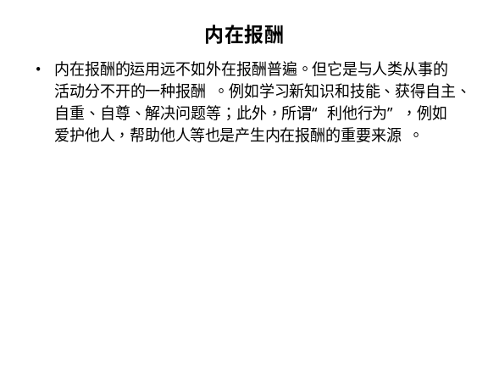 | Notes______________________________  ___________________________________  ___________________________________  Q&A_______________________________  ___________________________________  ___________________________________  ___________________________________

