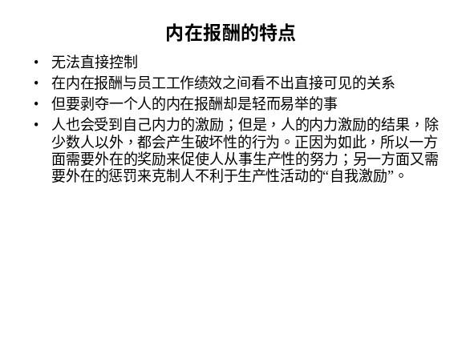 | Notes______________________________  ___________________________________  ___________________________________  Q&A_______________________________  ___________________________________  ___________________________________  ___________________________________
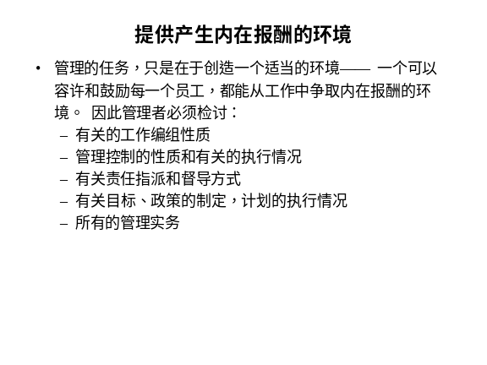 | Notes______________________________  ___________________________________  ___________________________________  Q&A_______________________________  ___________________________________  ___________________________________  ___________________________________
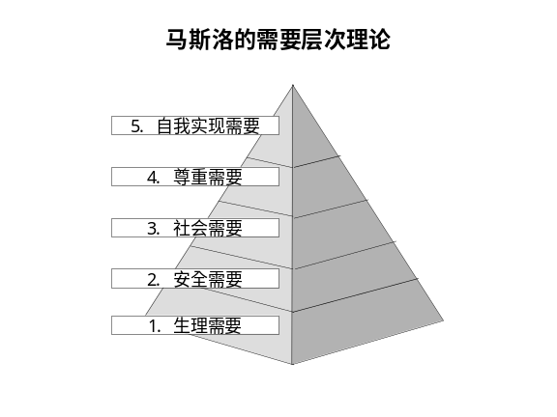 | Notes______________________________  ___________________________________  ___________________________________  Q&A_______________________________  ___________________________________  ___________________________________  ___________________________________
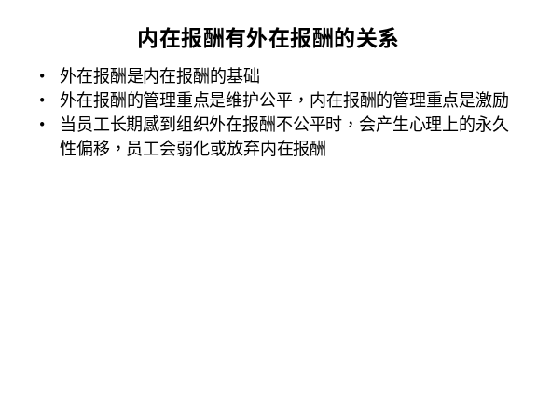 | Notes______________________________  ___________________________________  ___________________________________  Q&A_______________________________  ___________________________________  ___________________________________  ___________________________________
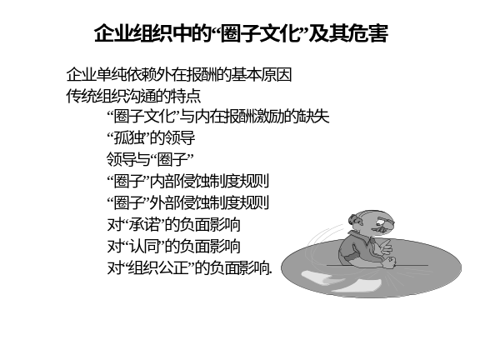 | Notes______________________________  ___________________________________  ___________________________________  Q&A_______________________________  ___________________________________  ___________________________________  ___________________________________
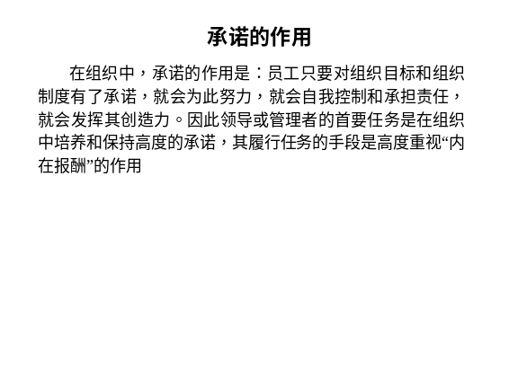 | Notes______________________________  ___________________________________  ___________________________________  Q&A_______________________________  ___________________________________  ___________________________________  ___________________________________
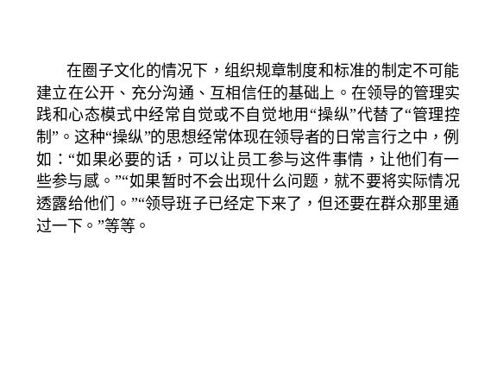 | Notes______________________________  ___________________________________  ___________________________________  Q&A_______________________________  ___________________________________  ___________________________________  ___________________________________
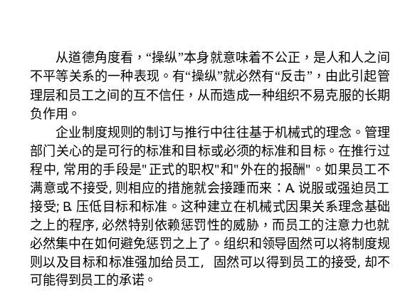 | Notes______________________________  ___________________________________  ___________________________________  Q&A_______________________________  ___________________________________  ___________________________________  ___________________________________
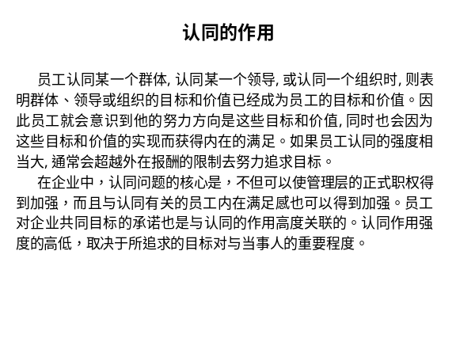 | Notes______________________________  ___________________________________  ___________________________________  Q&A_______________________________  ___________________________________  ___________________________________  ___________________________________
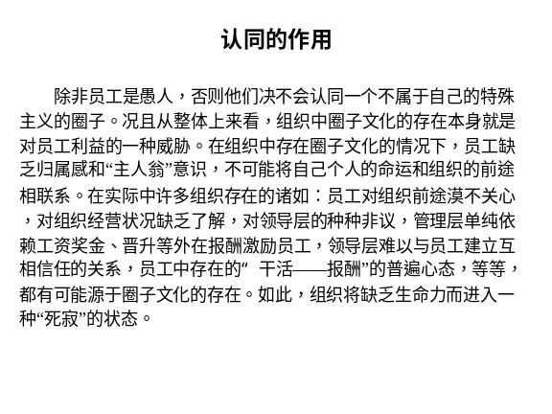 | Notes______________________________  ___________________________________  ___________________________________  Q&A_______________________________  ___________________________________  ___________________________________  ___________________________________
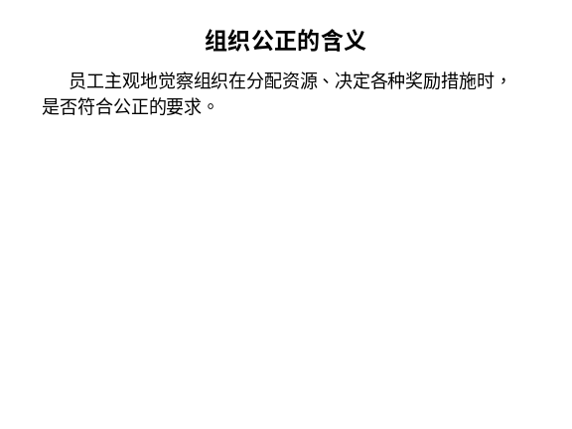 | Notes______________________________  ___________________________________  ___________________________________  Q&A_______________________________  ___________________________________  ___________________________________  ___________________________________
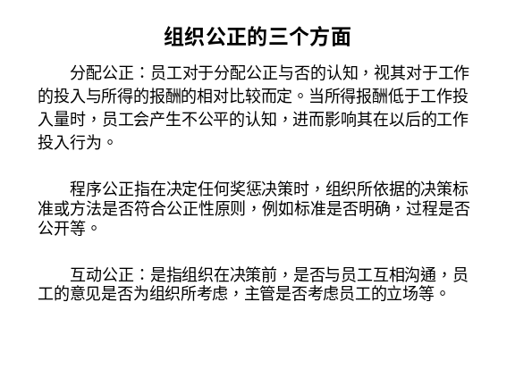 | Notes______________________________  ___________________________________  ___________________________________  Q&A_______________________________  ___________________________________  ___________________________________  ___________________________________
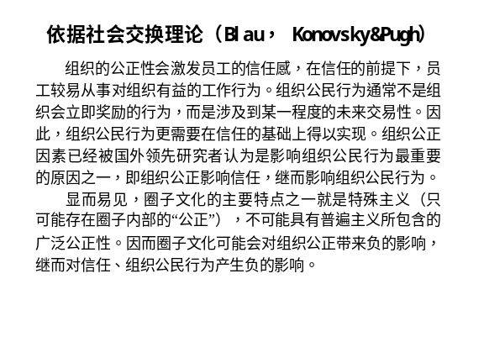 | Notes______________________________  ___________________________________  ___________________________________  Q&A_______________________________  ___________________________________  ___________________________________  ___________________________________

六、个人学习问题归纳
______________________________________________________________________________________________________________________________________________________________________________________________________________________________________________________________________________________________________________________________________________________________________________________________________

七、本讲思考题
请思考下列问题，并登陆网校，在“课程讨论室”参加讨论。
- 工作群体、工作团队和管理团队有哪些区别和联系？
- 举例说明内在报酬和外在报酬的关系。
- 圈子文化对组织有哪些方面的影响？
- 学习提示：为了了解你对本讲基本内容的掌握情况，现在可以登陆网校，做一下本讲的自测习题。

本节课已经学习完毕。你可以进入下一个小节的学习。→

