第六讲
一、课程简介
本讲继续讲授了自生秩序和创生秩序的区别，重点讲授了企业文化的相关内容。

二、课程目标：
- 区别自生秩序和创生秩序
- 说明企业文化的概念和层次
- 说明愿景、使命和核心价值的含义
- 理解企业的价值观与员工行为的关系
- 掌握如何培育适合的企业文化
- 理解关于人力资源的相关特性

三、要点提示：
自生秩序、创生秩序、企业文化、愿景、使命、核心价值、人力资源与物质资源的区别、人与人力资源的不可分割性、人力资源投资的特点
四、课程预习：

- 阅读笔记

课程重点
_________________________________________________________________
_________________________________________________________________
_________________________________________________________________
_________________________________________________________________
_________________________________________________________________
_________________________________________________________________

课程难点
_________________________________________________________________
_________________________________________________________________
_________________________________________________________________
_________________________________________________________________
_________________________________________________________________
_________________________________________________________________

疑难问题:
_________________________________________________________________
_________________________________________________________________
_________________________________________________________________
_________________________________________________________________
_________________________________________________________________
_________________________________________________________________
_________________________________________________________________

体会:
_________________________________________________________________
_________________________________________________________________
_________________________________________________________________
_________________________________________________________________
_________________________________________________________________
_________________________________________________________________

五、课程学习
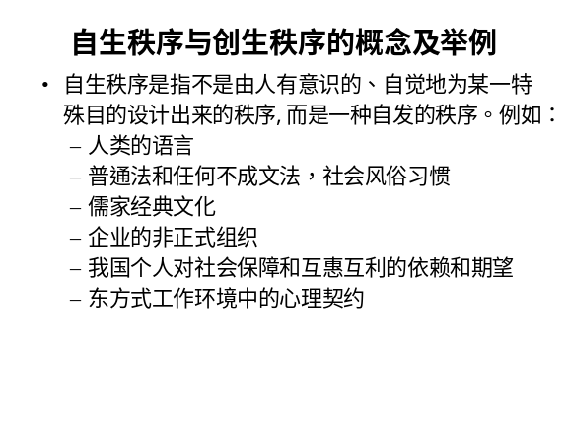 | Notes______________________________  ___________________________________  ___________________________________  Q&A_______________________________  ___________________________________  ___________________________________  ___________________________________
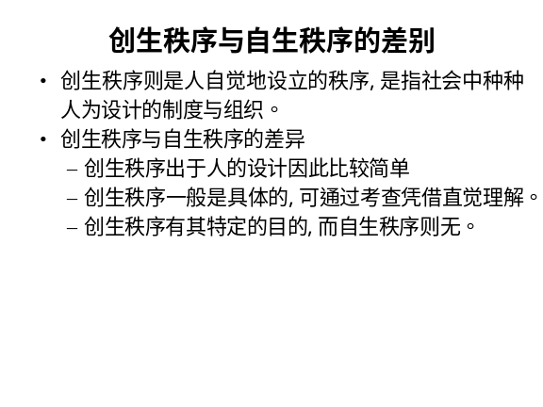 | Notes______________________________  ___________________________________  ___________________________________  Q&A_______________________________  ___________________________________  ___________________________________  ___________________________________
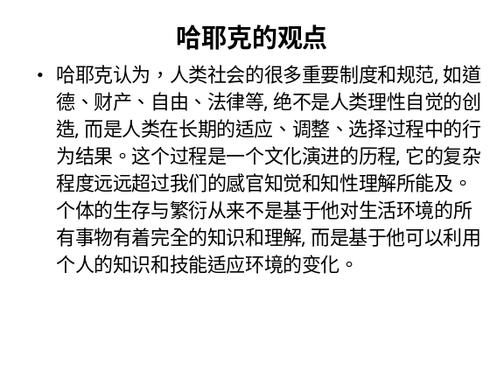 | Notes______________________________  ___________________________________  ___________________________________  Q&A_______________________________  ___________________________________  ___________________________________  ___________________________________
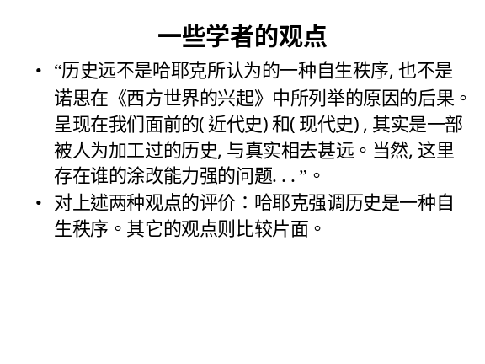 | Notes______________________________  ___________________________________  ___________________________________  Q&A_______________________________  ___________________________________  ___________________________________  ___________________________________
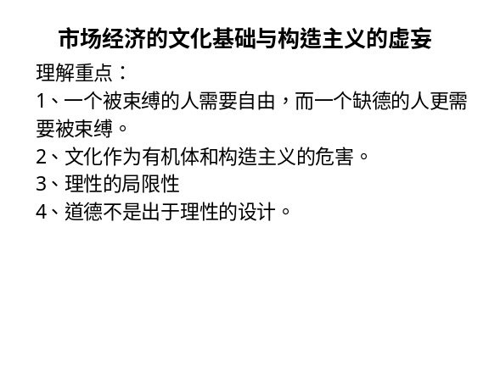 | Notes______________________________  ___________________________________  ___________________________________  Q&A_______________________________  ___________________________________  ___________________________________  ___________________________________
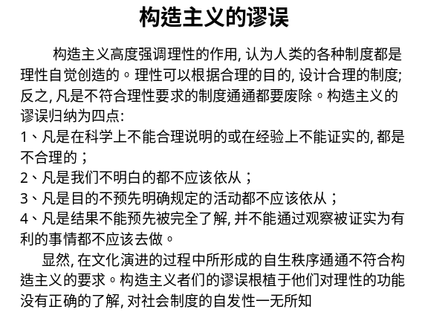 | Notes______________________________  ___________________________________  ___________________________________  Q&A_______________________________  ___________________________________  ___________________________________  ___________________________________
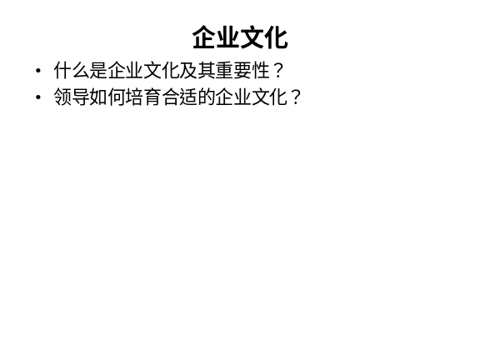 | Notes______________________________  ___________________________________  ___________________________________  Q&A_______________________________  ___________________________________  ___________________________________  ___________________________________
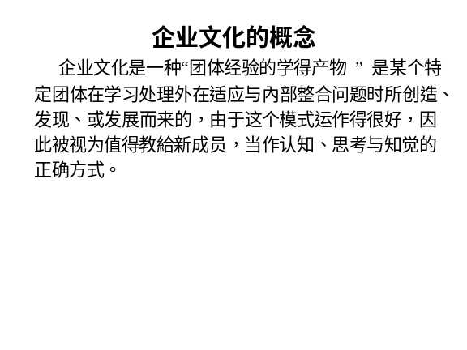 | Notes______________________________  ___________________________________  ___________________________________  Q&A_______________________________  ___________________________________  ___________________________________  ___________________________________
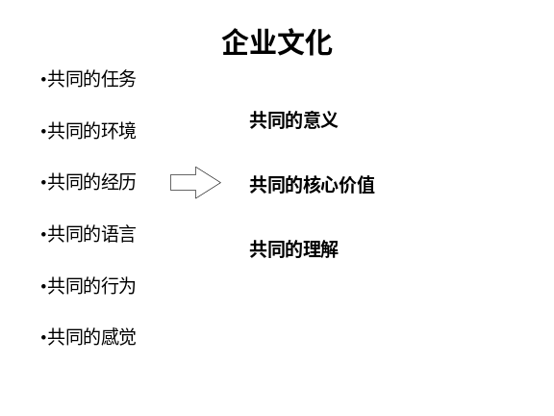 | Notes______________________________  ___________________________________  ___________________________________  Q&A_______________________________  ___________________________________  ___________________________________  ___________________________________
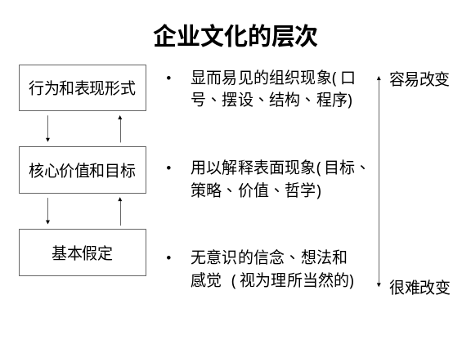 | Notes______________________________  ___________________________________  ___________________________________  Q&A_______________________________  ___________________________________  ___________________________________  ___________________________________
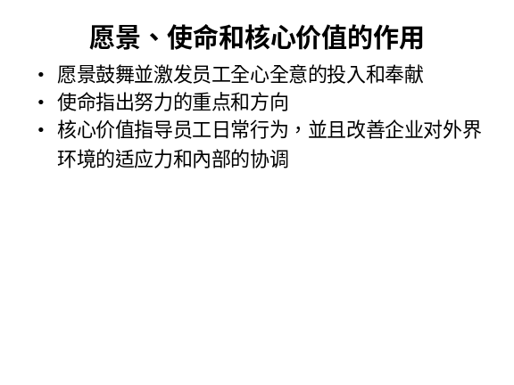 | Notes______________________________  ___________________________________  ___________________________________  Q&A_______________________________  ___________________________________  ___________________________________  ___________________________________
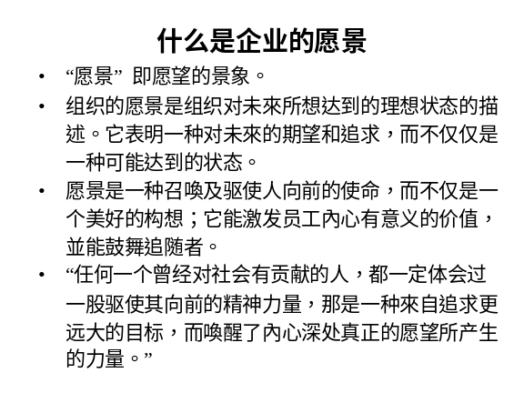 | Notes______________________________  ___________________________________  ___________________________________  Q&A_______________________________  ___________________________________  ___________________________________  ___________________________________
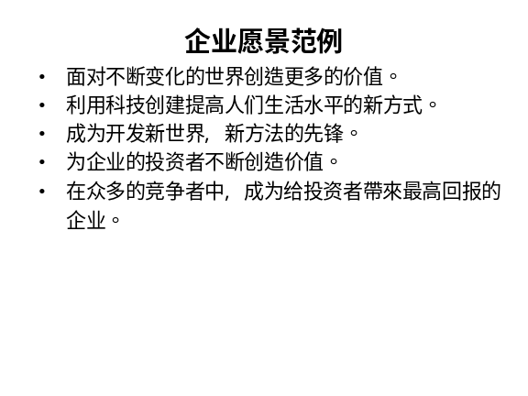 | Notes______________________________  ___________________________________  ___________________________________  Q&A_______________________________  ___________________________________  ___________________________________  ___________________________________
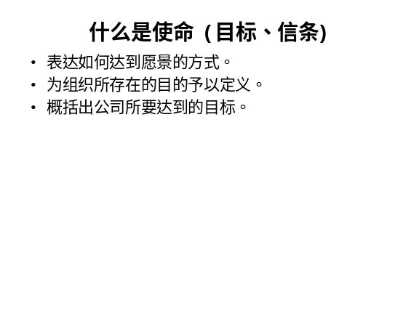 | Notes______________________________  ___________________________________  ___________________________________  Q&A_______________________________  ___________________________________  ___________________________________  ___________________________________
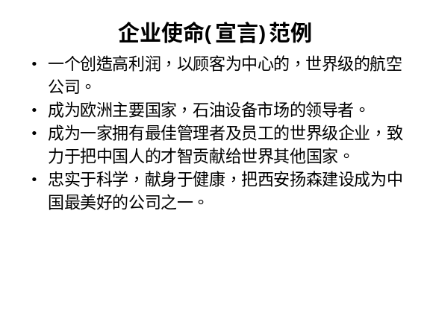 | Notes______________________________  ___________________________________  ___________________________________  Q&A_______________________________  ___________________________________  ___________________________________  ___________________________________
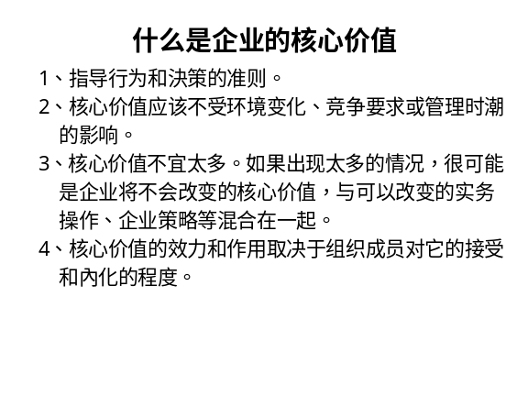 | Notes______________________________  ___________________________________  ___________________________________  Q&A_______________________________  ___________________________________  ___________________________________  ___________________________________
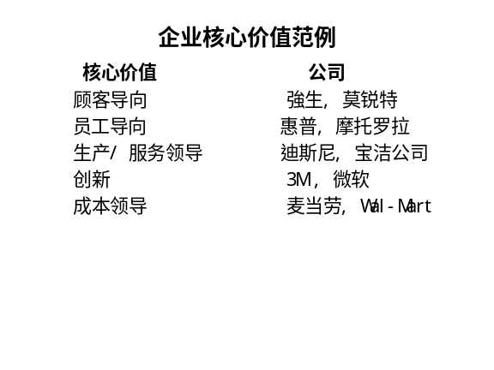 | Notes______________________________  ___________________________________  ___________________________________  Q&A_______________________________  ___________________________________  ___________________________________  ___________________________________
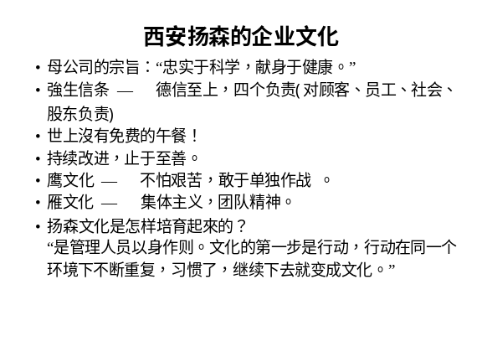 | Notes______________________________  ___________________________________  ___________________________________  Q&A_______________________________  ___________________________________  ___________________________________  ___________________________________
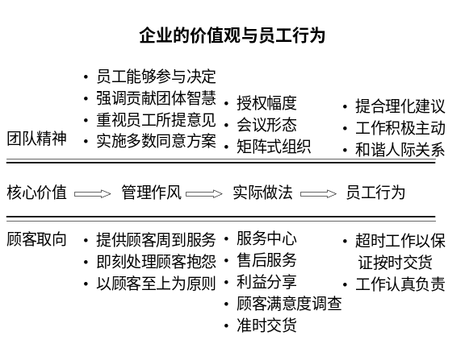 | Notes______________________________  ___________________________________  ___________________________________  Q&A_______________________________  ___________________________________  ___________________________________  ___________________________________
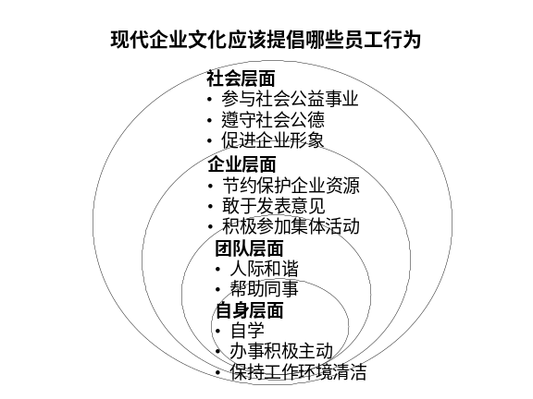 | Notes______________________________  ___________________________________  ___________________________________  Q&A_______________________________  ___________________________________  ___________________________________  ___________________________________
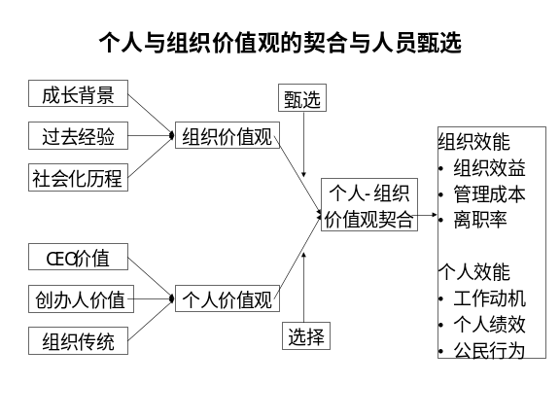 | Notes______________________________  ___________________________________  ___________________________________  Q&A_______________________________  ___________________________________  ___________________________________  ___________________________________
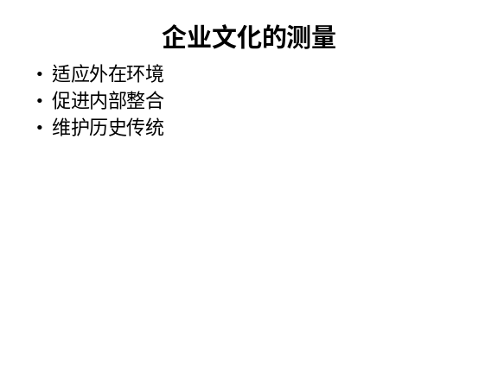 | Notes______________________________  ___________________________________  ___________________________________  Q&A_______________________________  ___________________________________  ___________________________________  ___________________________________
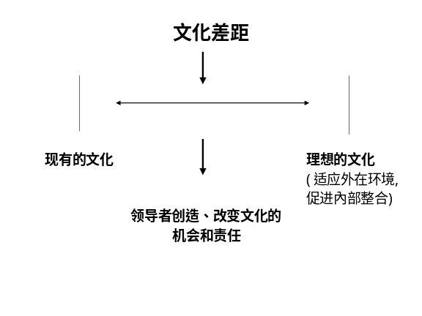 | Notes______________________________  ___________________________________  ___________________________________  Q&A_______________________________  ___________________________________  ___________________________________  ___________________________________
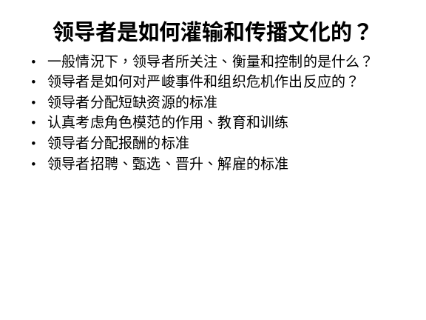 | Notes______________________________  ___________________________________  ___________________________________  Q&A_______________________________  ___________________________________  ___________________________________  ___________________________________
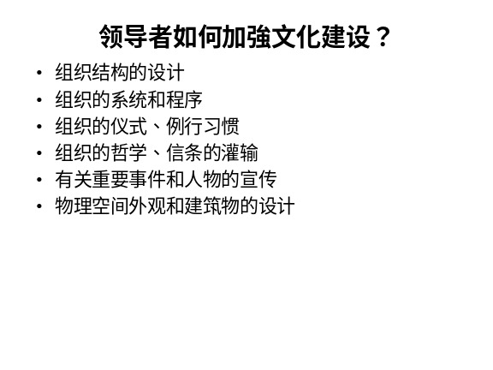 | Notes______________________________  ___________________________________  ___________________________________  Q&A_______________________________  ___________________________________  ___________________________________  ___________________________________
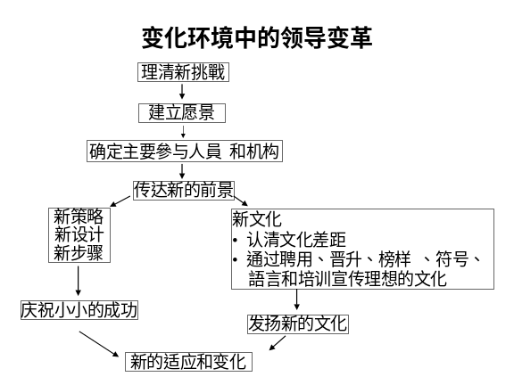 | ___________________________________  ___________________________________  ___________________________________  ___________________________________  ___________________________________  ___________________________________  ___________________________________
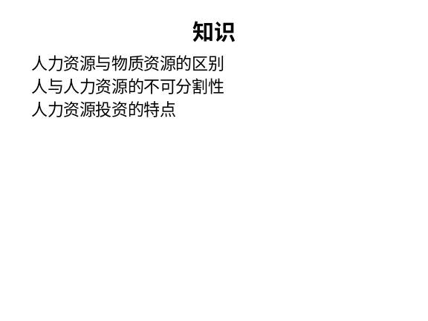 | Notes______________________________  ___________________________________  ___________________________________  Q&A_______________________________  ___________________________________  ___________________________________  ___________________________________
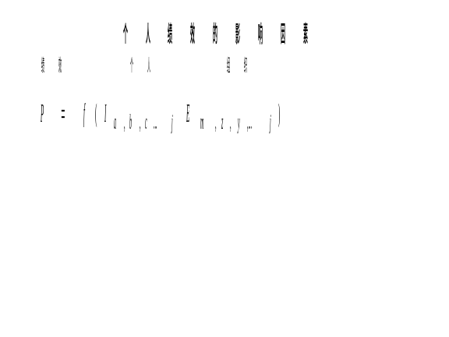 | Notes______________________________  ___________________________________  ___________________________________  Q&A_______________________________  ___________________________________  ___________________________________  ___________________________________
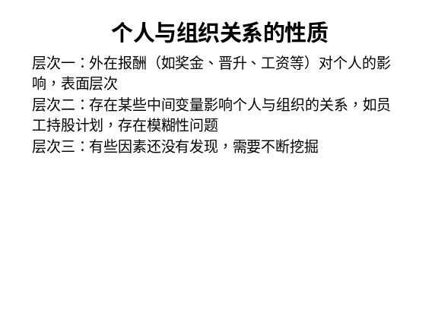 | Notes______________________________  ___________________________________  ___________________________________  Q&A_______________________________  ___________________________________  ___________________________________  ___________________________________

六、个人学习问题归纳
______________________________________________________________________________________________________________________________________________________________________________________________________________________________________________________________________________________________________________________________________________________________________________________________________

七、本讲思考题
请思考下列问题，并登陆网校，在“课程讨论室”参加讨论。
- 建设和谐的企业文化的基础是什么？
- 企业文化与人力资源管理的关系是什么？
- 学习提示：为了了解你对本讲基本内容的掌握情况，现在可以登陆网校，做一下本讲的自测习题。

本节课已经学习完毕。你可以进入下一个小节的学习。→

