第四讲
一、课程简介
本讲主要介绍了人力资源策略模式和两个支援性作业（工作分析和绩效评估），重点讲授了绩效评价概念和方法。
二、课程目标：
- 了解人力资源策略模式
- 掌握工作分析的概念、步骤和层次
- 掌握绩效评价的内容和程序
- 掌握绩效评价的测量方法
- 列举不同绩效评价方法的优缺点
- 了解工作中绩效评价容易出现的问题

三、要点提示：
人力资源策略模式、工作分析、绩效评估、相对标准法、绝对标准法、目标管理法、全方位业绩评价法、直接排列法、间隔排列法、配对比较法、强制分配法、特征评价表、行为定向评价法、
关键事件法、晕轮效应、居中趋势

四、课程预习：

- 阅读指导
- 人大出版社出版的«人力资源管理»第3、10章
- 机械工业出版社出版的«人力资源管理»第8章

- 阅读笔记

课程重点
_________________________________________________________________
_________________________________________________________________
_________________________________________________________________
_________________________________________________________________
_________________________________________________________________
_________________________________________________________________

课程难点
_________________________________________________________________
_________________________________________________________________
_________________________________________________________________
_________________________________________________________________
_________________________________________________________________
_________________________________________________________________

疑难问题:
_________________________________________________________________
_________________________________________________________________
_________________________________________________________________
_________________________________________________________________
_________________________________________________________________
_________________________________________________________________
_________________________________________________________________

体会:
_________________________________________________________________
_________________________________________________________________
_________________________________________________________________
_________________________________________________________________
_________________________________________________________________
_________________________________________________________________

五、课程学习

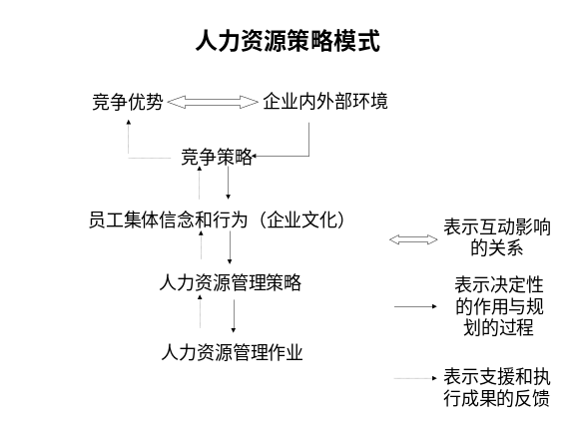 | Notes______________________________  ___________________________________  ___________________________________  Q&A_______________________________  ___________________________________  ___________________________________  ___________________________________
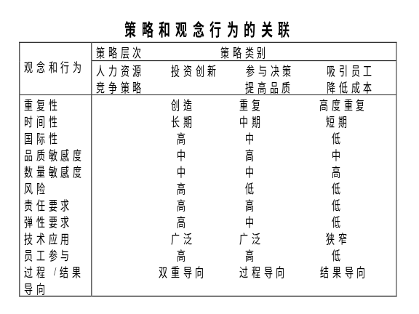 | Notes______________________________  ___________________________________  ___________________________________  Q&A_______________________________  ___________________________________  ___________________________________  ___________________________________
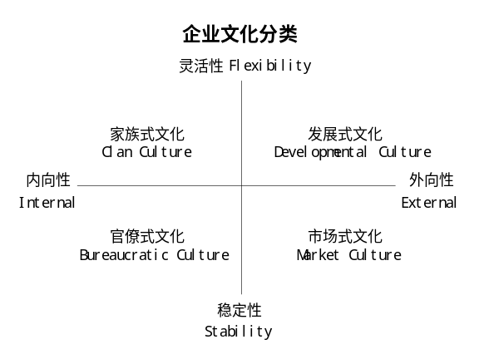 | Notes______________________________  ___________________________________  ___________________________________  Q&A_______________________________  ___________________________________  ___________________________________  ___________________________________
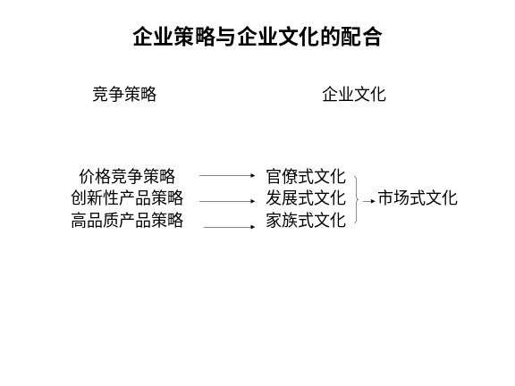 | Notes______________________________  ___________________________________  ___________________________________  Q&A_______________________________  ___________________________________  ___________________________________  ___________________________________
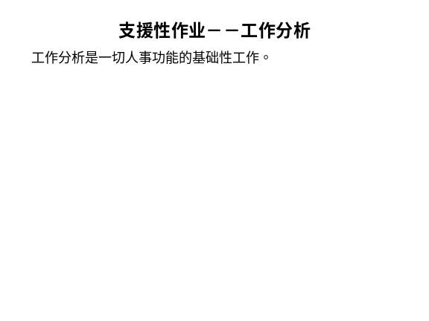 | Notes______________________________  ___________________________________  ___________________________________  Q&A_______________________________  ___________________________________  ___________________________________  ___________________________________
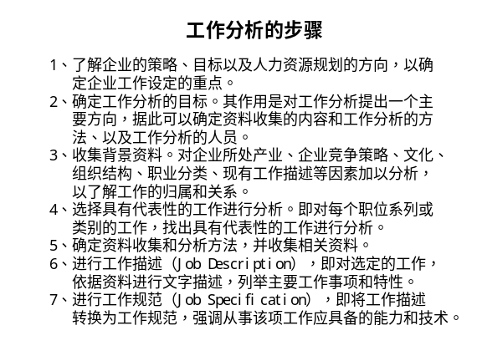 | Notes______________________________  ___________________________________  ___________________________________  Q&A_______________________________  ___________________________________  ___________________________________  ___________________________________
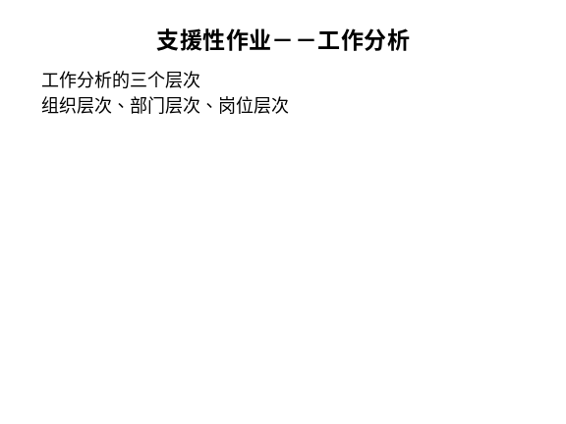 | Notes______________________________  ___________________________________  ___________________________________  Q&A_______________________________  ___________________________________  ___________________________________  ___________________________________
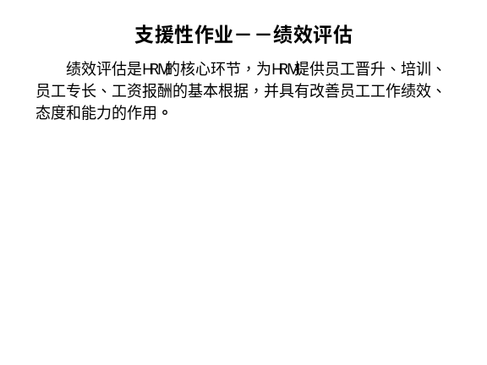 | Notes______________________________  ___________________________________  ___________________________________  Q&A_______________________________  ___________________________________  ___________________________________  ___________________________________
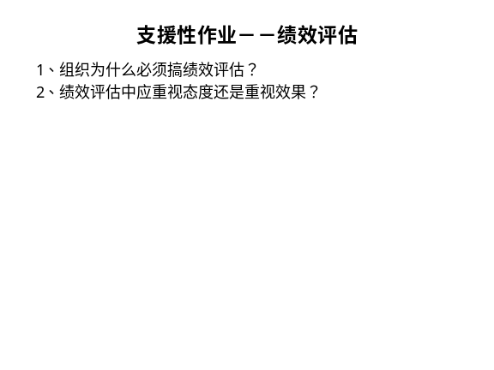 | Notes______________________________  ___________________________________  ___________________________________  Q&A_______________________________  ___________________________________  ___________________________________  ___________________________________
Notes______________________________
___________________________________
___________________________________
Q&A_______________________________
___________________________________
___________________________________
___________________________________

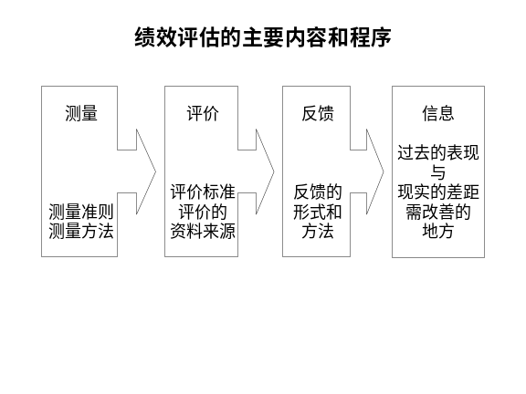 | Notes______________________________  ___________________________________  ___________________________________  Q&A_______________________________  ___________________________________  ___________________________________  ___________________________________
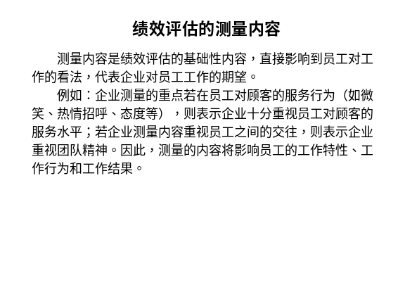 | Notes______________________________  ___________________________________  ___________________________________  Q&A_______________________________  ___________________________________  ___________________________________  ___________________________________
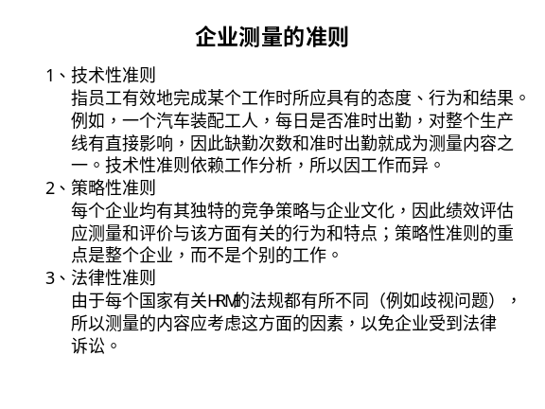 | Notes______________________________  ___________________________________  ___________________________________  Q&A_______________________________  ___________________________________  ___________________________________  ___________________________________
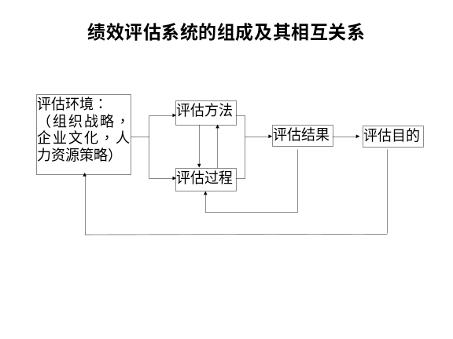 | Notes______________________________  ___________________________________  ___________________________________  Q&A_______________________________  ___________________________________  ___________________________________  ___________________________________
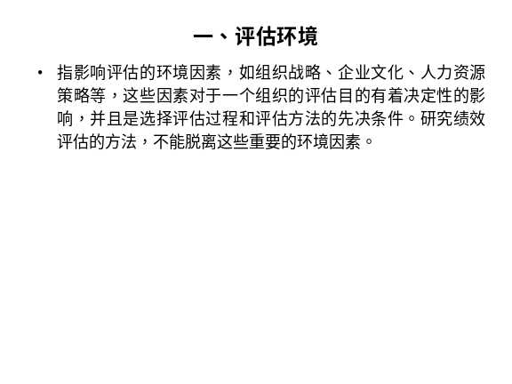 | Notes______________________________  ___________________________________  ___________________________________  Q&A_______________________________  ___________________________________  ___________________________________  ___________________________________
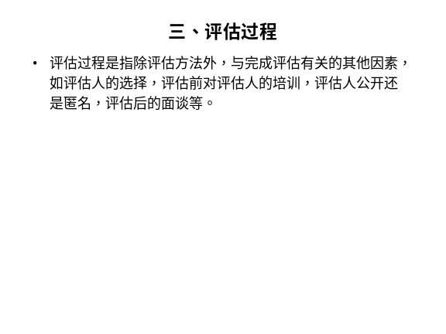 | Notes______________________________  ___________________________________  ___________________________________  Q&A_______________________________  ___________________________________  ___________________________________  ___________________________________

