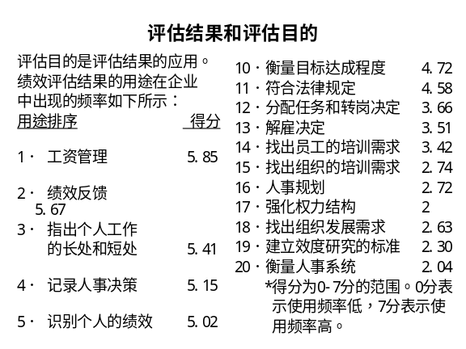 | Notes______________________________  ___________________________________  ___________________________________  Q&A_______________________________  ___________________________________  ___________________________________  ___________________________________
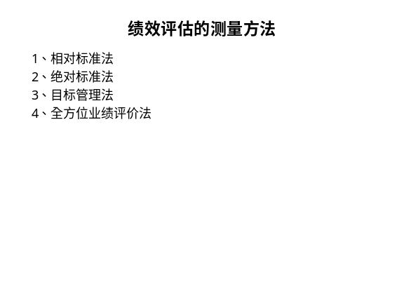 | Notes______________________________  ___________________________________  ___________________________________  Q&A_______________________________  ___________________________________  ___________________________________  ___________________________________
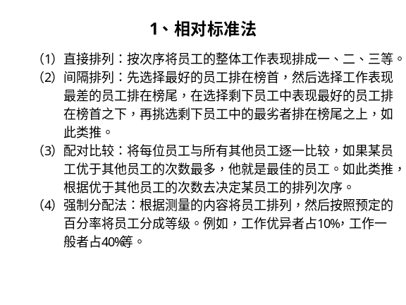 | Notes______________________________  ___________________________________  ___________________________________  Q&A_______________________________  ___________________________________  ___________________________________  ___________________________________
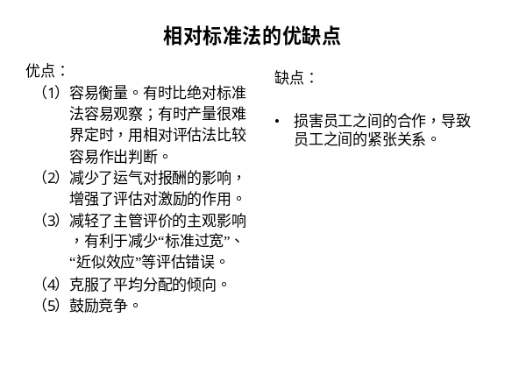 | Notes______________________________  ___________________________________  ___________________________________  Q&A_______________________________  ___________________________________  ___________________________________  ___________________________________
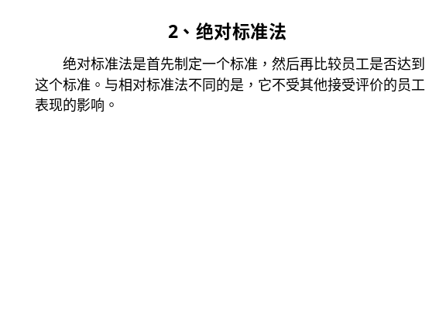 | Notes______________________________  ___________________________________  ___________________________________  Q&A_______________________________  ___________________________________  ___________________________________  ___________________________________
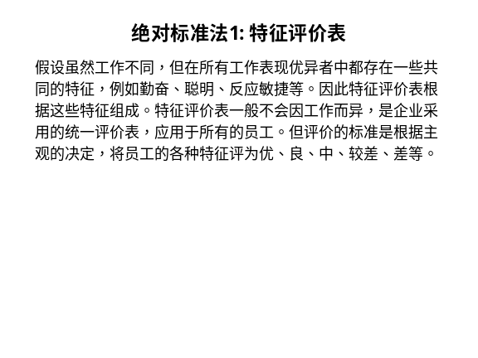 | Notes______________________________  ___________________________________  ___________________________________  Q&A_______________________________  ___________________________________  ___________________________________  ___________________________________
Notes______________________________
___________________________________
___________________________________
Q&A_______________________________
___________________________________
___________________________________
___________________________________

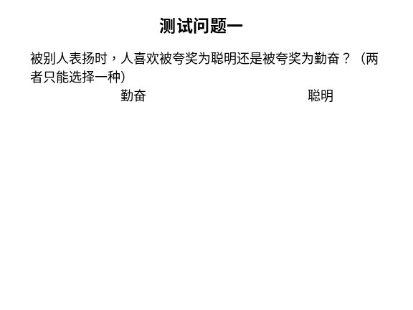 | Notes______________________________  ___________________________________  ___________________________________  Q&A_______________________________  ___________________________________  ___________________________________  ___________________________________
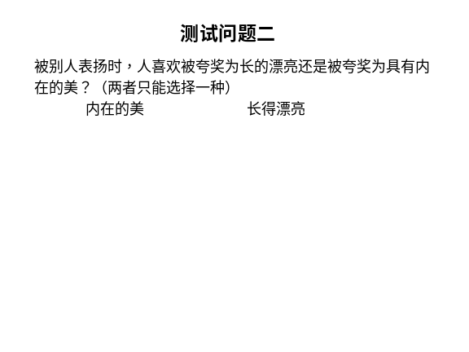 | Notes______________________________  ___________________________________  ___________________________________  Q&A_______________________________  ___________________________________  ___________________________________  ___________________________________
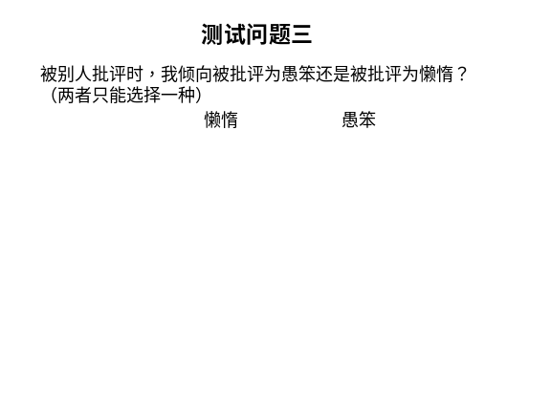 | Notes______________________________  ___________________________________  ___________________________________  Q&A_______________________________  ___________________________________  ___________________________________  ___________________________________
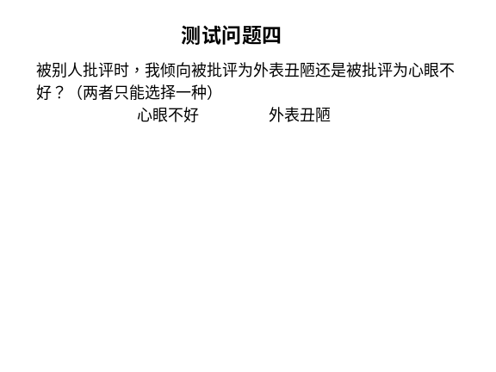 | Notes______________________________  ___________________________________  ___________________________________  Q&A_______________________________  ___________________________________  ___________________________________  ___________________________________
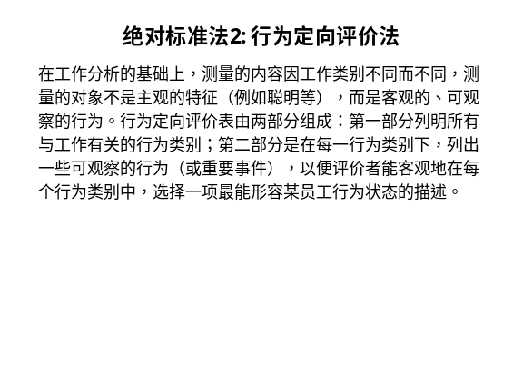 | Notes______________________________  ___________________________________  ___________________________________  Q&A_______________________________  ___________________________________  ___________________________________  ___________________________________
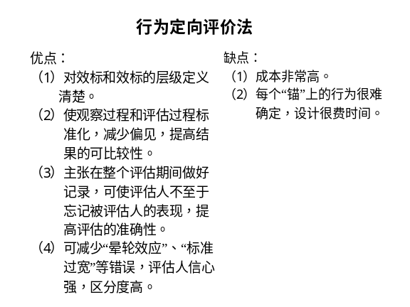 | Notes______________________________  ___________________________________  ___________________________________  Q&A_______________________________  ___________________________________  ___________________________________  ___________________________________
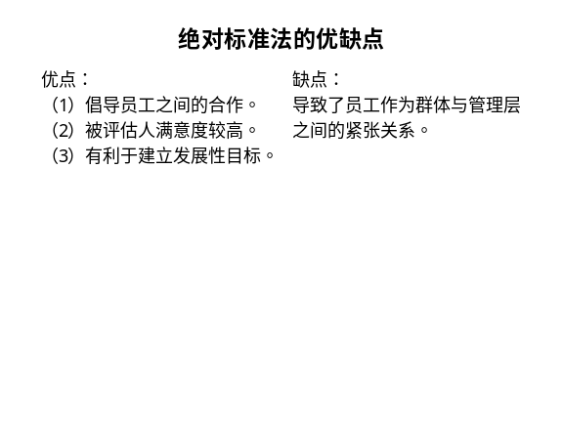 | Notes______________________________  ___________________________________  ___________________________________  Q&A_______________________________  ___________________________________  ___________________________________  ___________________________________
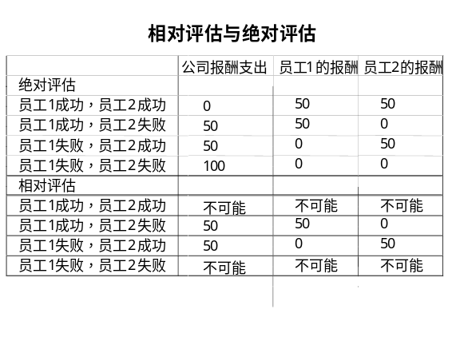 | Notes______________________________  ___________________________________  ___________________________________  Q&A_______________________________  ___________________________________  ___________________________________  ___________________________________
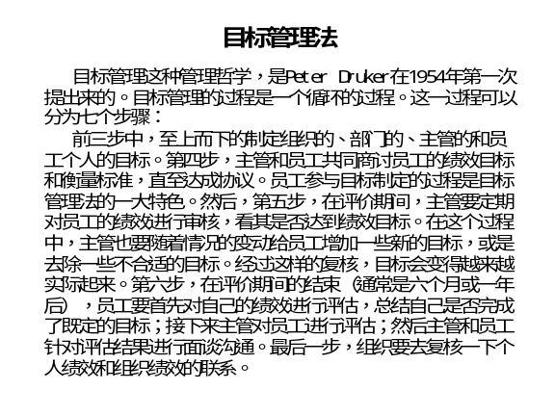 | Notes______________________________  ___________________________________  ___________________________________  Q&A_______________________________  ___________________________________  ___________________________________  ___________________________________
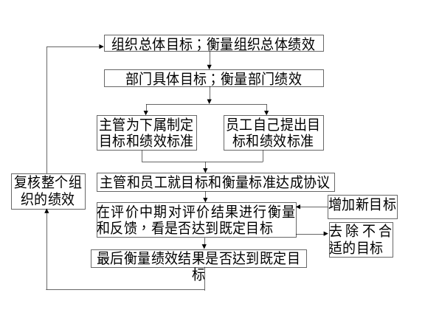 | Notes______________________________  ___________________________________  ___________________________________  Q&A_______________________________  ___________________________________  ___________________________________  ___________________________________
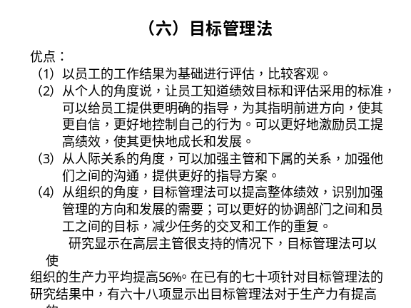 | Notes______________________________  ___________________________________  ___________________________________  Q&A_______________________________  ___________________________________  ___________________________________  ___________________________________
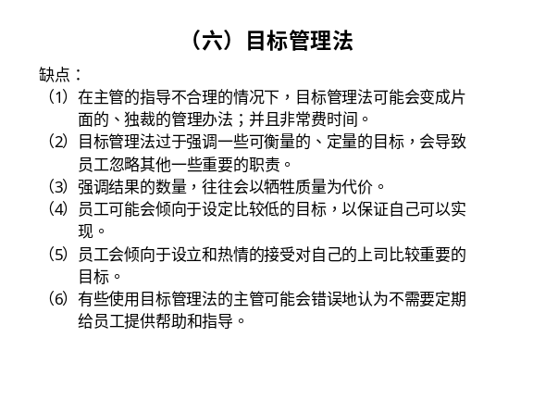 | Notes______________________________  ___________________________________  ___________________________________  Q&A_______________________________  ___________________________________  ___________________________________  ___________________________________
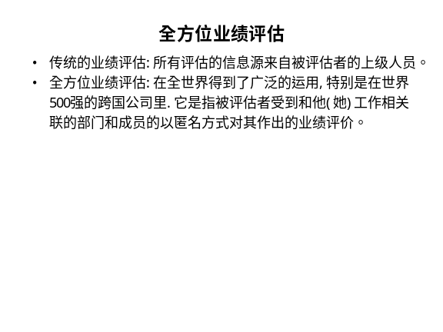 | Notes______________________________  ___________________________________  ___________________________________  Q&A_______________________________  ___________________________________  ___________________________________  ___________________________________
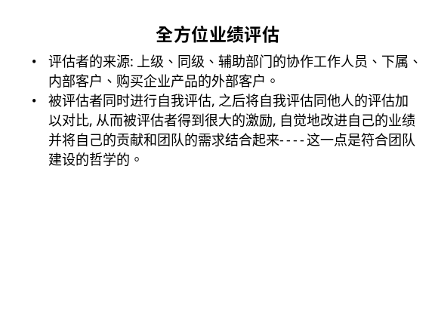 | Notes______________________________  ___________________________________  ___________________________________  Q&A_______________________________  ___________________________________  ___________________________________  ___________________________________

六、个人学习问题归纳
______________________________________________________________________________________________________________________________________________________________________________________________________________________________________________________________________________________________________________________________________________________________________________________________________

七、本讲思考题
请思考下列问题，并登陆网校，在“课程讨论室”参加讨论。
    - 强制分配法适用的条件是什么？其优缺点是什么？
    - 绝对标准法和相对标准法的区别是什么？判断一下你所在组织的绩效评估方法的种类并分析其优缺点。
    - 目标管理法的局限是什么？

- 学习提示：为了了解你对本讲基本内容的掌握情况，现在可以登陆网校，做一下本讲的自测习题。

本节课已经学习完毕。你可以进入下一个小节的学习。→

