|  |  |
| --- | --- |
| Document Reg ID: |  |
| Document Version: | 1.0 |
| Project Name: | KASM |

|  |  |
| --- | --- |
| Author | Team3 |
| Date | 2023-11-11 |
| Summary | This document provides an explanation of how to build and run an execution environment for a PWA project. |

PWA Work Project

Environment Setup

Contents

1 Install Neo4j 2

2 Run Backend Service 3

3 Run Frontend Service 3

# Install Neo4j

Neo4j is the world’s leading graph database. The architecture is designed for optimal management, storage, and traversal of nodes and relationships. The graph database takes a property graph approach, which is beneficial for both traversal performance and operations runtime. Neo4j offers dedicated memory management and memory-efficient operations.

In our project we use neo4j for backend database.

For installation we used neo4j docker image. You can establish neo4j docker environment with following steps:

* Install Ubuntu Server 20.04 to PC
* Install docker.io and docker-compose.
* Write in docker-compose.yml file:

version: '3.7'

services:

    neo4j:

      image: neo4j: neo4j:5.10.0-enterprise

      restart: unless-stopped

      ports:

        - 7474:7474

        - 7687:7687

      volumes:

        - [WorkPath]/neo4j/conf:/conf

        - [WorkPath]/neo4j/data:/data

        - [WorkPath]/neo4j/import:/import

        - [WorkPath]/neo4j/logs:/logs

        - [WorkPath]/neo4j/plugins:/plugins

      environment:

        # Raise memory limits

        - NEO4J_dbms_memory_pagecache_size=1G

        - NEO4J_dbms.memory.heap.initial_size=1G

        - NEO4J_dbms_memory_heap_max__size=1G

        - NEO4J_ACCEPT_LICENSE_AGREEMENT=yes

* + You just have to change [WorkPath] to the path that docker-compose.yml locates at.
* Make directories for docker volumes.

mkdir -p [WorkPath]/neo4j/conf

mkdir -p [WorkPath]/neo4j/data

mkdir -p [WorkPath]/neo4j/import

mkdir -p [WorkPath]/neo4j/logs

mkdir -p [WorkPath]/neo4j/plugins

* Pull down the docker image or load save one.

Table . KASM server docker images

|  |  |
| --- | --- |
| Offline | Online |
| docker load -i neo4j_5.13.0-enterprise.tar | docker pull neo4j:5.13.0-enterprise |

* Execute command to start docker container:

docker-compose up -d

* Now  you can access to neo4j through your browser at [http://localhost:7474](http://localhost:7474/).

username: neo4j

password: neo4j

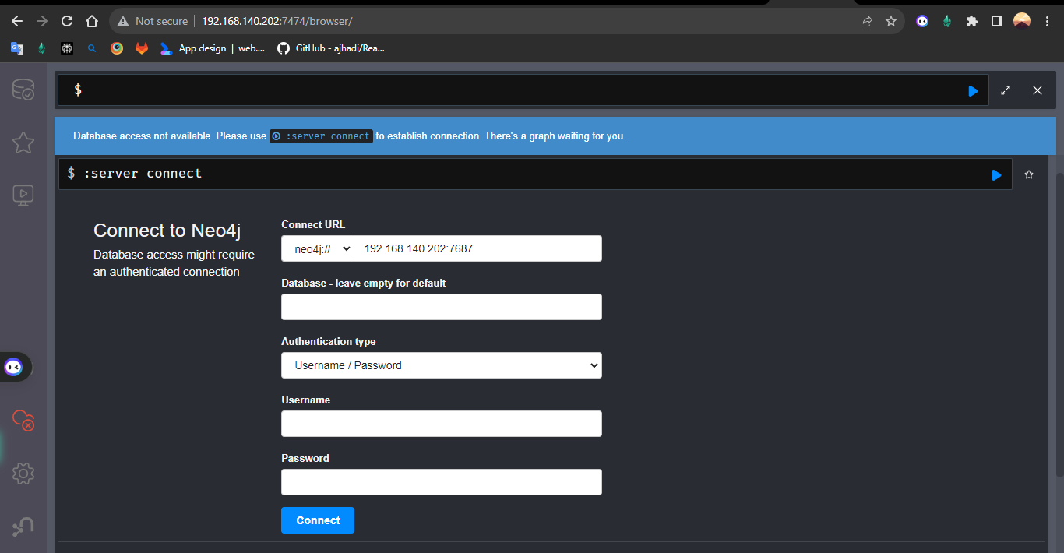

# Run Backend Service

* Before Running the backend service, install node-v18.18.2-x64 to your system.
* Copy and extract som-server-neo4j.7z to [WorkPath].
* Open project with IDE and change following code in index.js:

const driver = neo4j.driver(

  "bolt://192.168.140.202:7687",

  neo4j.auth.basic("neo4j", "asdfasdf"),

);

* + Change “192.168.140.202” to your host IP address.
* Move to the project directory and Open CMD then execute "node index".

# Run Frontend Service

* Copy and extract som-react-graphql.7z to [WorkPath].
* Move to the project directory and Open CMD then execute " npm run pwa".
* You can now connect to “Shipping” site via *http://localhost:3000*.