**Step 1: System Monitoring Setup:**

1. Install Monitoring Tools:

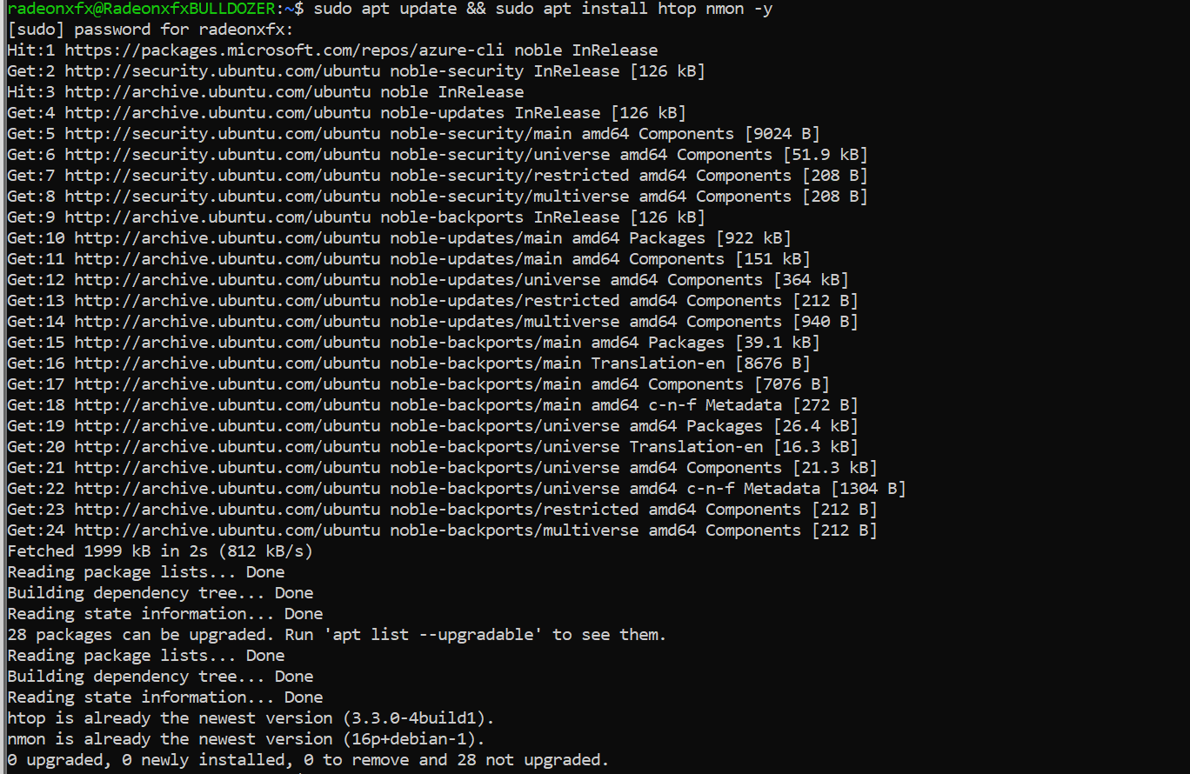

1. Create log directories and start monitoring disk usage:

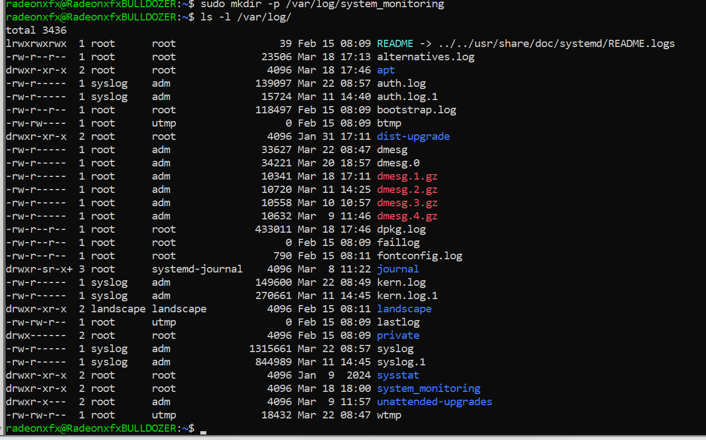

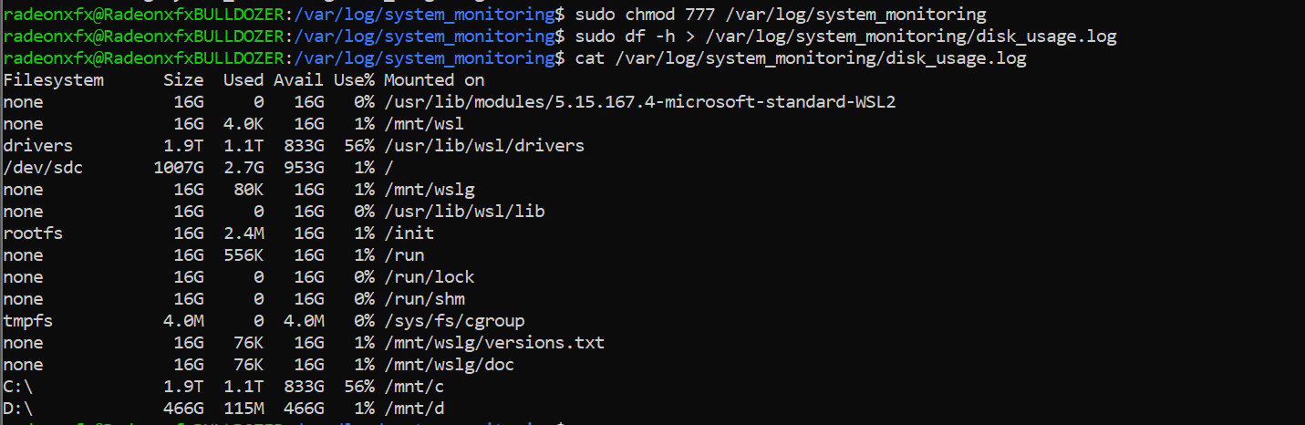

1. Create a disk monitoring script:

* I am usingfor creating a shell script **sudo vi /home/radeonxfx/monitor_disk.sh**