**Lab3**

**Q1.**

**Code(.aspx)**

<%@ Page Language="C#" AutoEventWireup="true" CodeBehind="WebForm1.aspx.cs" Inherits="WebApplication1.WebForm1" %>

<!DOCTYPE html>

<html xmlns="http://www.w3.org/1999/xhtml">

<head runat="server">

<title></title>

<style type="text/css">

#form1 {

height: 399px;

}

#TextArea1 {

height: 38px;

width: 172px;

}

.auto-style1 {

height: 459px;

}

</style>

</head>

<body style="height: 495px">

<form id="form1" runat="server" class="auto-style1">

<asp:DropDownList ID="DropDownList1" runat="server" Height="35px" OnSelectedIndexChanged="DropDownList1_SelectedIndexChanged" Width="125px">

<asp:ListItem>1.png</asp:ListItem>

<asp:ListItem>2.png</asp:ListItem>

<asp:ListItem>3.png</asp:ListItem>

<asp:ListItem>4.png</asp:ListItem>

</asp:DropDownList>

<asp:DropDownList ID="DropDownList2" runat="server" Height="35px" Width="125px" BackColor="White">

<asp:ListItem>Red</asp:ListItem>

<asp:ListItem>Orange</asp:ListItem>

<asp:ListItem>Purple</asp:ListItem>

<asp:ListItem>Yellow</asp:ListItem>

</asp:DropDownList>

<asp:DropDownList ID="DropDownList3" runat="server" Height="35px" Width="125px">

<asp:ListItem>10</asp:ListItem>

<asp:ListItem>20</asp:ListItem>

<asp:ListItem>30</asp:ListItem>

</asp:DropDownList>

<asp:DropDownList ID="DropDownList4" runat="server" Height="35px" Width="125px">

<asp:ListItem>Red</asp:ListItem>

<asp:ListItem>Blue</asp:ListItem>

<asp:ListItem>Green</asp:ListItem>

<asp:ListItem>Yellow</asp:ListItem>

</asp:DropDownList>

<br />

Image&nbsp;&nbsp;&nbsp;&nbsp;&nbsp;&nbsp;&nbsp;&nbsp;&nbsp;&nbsp;&nbsp;&nbsp;&nbsp;&nbsp;&nbsp;&nbsp;&nbsp;&nbsp;&nbsp;&nbsp;&nbsp;&nbsp; Background&nbsp;&nbsp;&nbsp;&nbsp;&nbsp;&nbsp;&nbsp;&nbsp;&nbsp;&nbsp;&nbsp; Font-Size&nbsp;&nbsp;&nbsp;&nbsp;&nbsp;&nbsp;&nbsp;&nbsp;&nbsp;&nbsp;&nbsp;&nbsp;&nbsp;&nbsp;&nbsp; Font-Colour<br />

<asp:TextBox ID="TextBox1" runat="server" Height="42px"></asp:TextBox>

<br />

Title<br />

<asp:Button ID="Button1" runat="server" OnClick="Button1_Click" Text="Generate" />

<br />

<br />

<asp:Panel ID="Panel1" runat="server" Height="321px" Width="223px">

&nbsp;&nbsp;&nbsp;&nbsp;&nbsp;&nbsp;&nbsp;&nbsp;&nbsp;&nbsp;&nbsp;&nbsp;&nbsp;&nbsp;&nbsp;&nbsp;

<asp:Label ID="Label1" runat="server" Text="Label"></asp:Label>

<br />

<br />

&nbsp;&nbsp;&nbsp;&nbsp;&nbsp;&nbsp;&nbsp;&nbsp;&nbsp;&nbsp;<asp:Image ID="Image1" runat="server" Height="167px" Width="99px" />

&nbsp;&nbsp;&nbsp;&nbsp;&nbsp;&nbsp;&nbsp;&nbsp;&nbsp;&nbsp;&nbsp;&nbsp;&nbsp;&nbsp;&nbsp;&nbsp;

</asp:Panel>

</form>

</body>

</html>

**Code(aspx.cs)**

using System;

using System.Collections.Generic;

using System.Drawing;

using System.Linq;

using System.Web;

using System.Web.UI;

using System.Web.UI.WebControls;

namespace WebApplication1

{

public partial class WebForm1 : System.Web.UI.Page

{

protected void Page_Load(object sender, EventArgs e)

{

}

protected void Button1_Click(object sender, EventArgs e)

{

Panel1.BackColor = Color.FromName(DropDownList2.SelectedItem.Text);

if (Int32.Parse(DropDownList3.SelectedItem.Text) > 0)

{

Label1.Font.Size =

FontUnit.Point(Int32.Parse(DropDownList3.SelectedItem.Text));

}

Label1.ForeColor = Color.FromName(DropDownList4.SelectedItem.Text);

Label1.Text = TextBox1.Text;

Image1.ImageUrl = DropDownList1.SelectedItem.Text;

Image1.Visible = true;

}

protected void DropDownList1_SelectedIndexChanged(object sender, EventArgs e)

{

}

}

}

**Output**

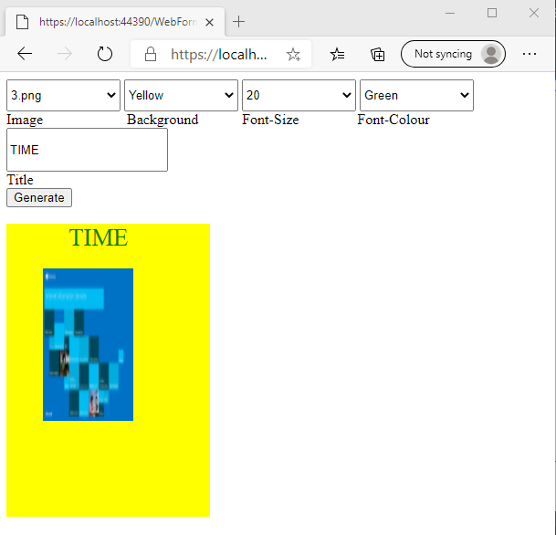

Q2.

Code(.aspx)

<%@ Page Language="C#" AutoEventWireup="true" CodeBehind="WebForm1.aspx.cs" Inherits="EmpEligibility.WebForm1" %>

<!DOCTYPE html>

<html xmlns="http://www.w3.org/1999/xhtml">

<head runat="server">

<title></title>

</head>

<body>

<form id="form1" runat="server">

<div>

Choose Employee Id<asp:DropDownList ID="DropDownList1" runat="server" OnSelectedIndexChanged="DropDownList1_SelectedIndexChanged">

<asp:ListItem>101</asp:ListItem>

<asp:ListItem>102</asp:ListItem>

<asp:ListItem>103</asp:ListItem>

</asp:DropDownList>

<br />

<asp:Image ID="Image1" runat="server" Height="204px" Width="183px" />

<br />

Name of the Employee <asp:TextBox ID="TextBox1" runat="server"></asp:TextBox>

<br />

Date of Joining

<asp:TextBox ID="TextBox2" runat="server"></asp:TextBox>

<br />

&nbsp;&nbsp;&nbsp;&nbsp;&nbsp;&nbsp;&nbsp;&nbsp;&nbsp;&nbsp;&nbsp;

<asp:Button ID="Button1" runat="server" OnClick="Button1_Click" Text="Am I eligible" Width="112px" />

</div>

<p>

&nbsp;&nbsp;&nbsp;&nbsp;&nbsp;&nbsp;&nbsp;&nbsp;&nbsp;&nbsp;&nbsp;&nbsp;&nbsp;&nbsp;&nbsp;&nbsp;

<asp:Label ID="Label1" runat="server" Text="Label"></asp:Label>

</p>

</form>

</body>

</html>

**Code(aspx.cs)**

using System;

using System.Collections.Generic;

using System.Linq;

using System.Web;

using System.Web.UI;

using System.Web.UI.WebControls;

namespace EmpEligibility

{

public partial class WebForm1 : System.Web.UI.Page

{

protected void Page_Load(object sender, EventArgs e)

{

}

protected void ImageMap1_Click(object sender, ImageMapEventArgs e)

{

}

protected void DropDownList1_SelectedIndexChanged(object sender, EventArgs e)

{

Image1.ImageUrl = int.Parse(DropDownList1.Text) % 100 + ".png";

Image1.Visible = true;

}

protected void Button1_Click(object sender, EventArgs e)

{

DateTime now = DateTime.Now;

DateTime joined = Convert.ToDateTime(TextBox2.Text);

if (now.Subtract(joined).TotalDays >= 5 * 365)

{

Label1.Text = "Eligible";

}

else

Label1.Text = "Not Eligible";

}

protected void FetchImage(object sender, EventArgs e)

{

Image1.ImageUrl = int.Parse(DropDownList1.Text) % 100 + ".png";

Image1.Visible = true;

}

}

}

**Output**

