Lab5

Q1.

Code(.aspx)

<%@ Page Language="C#" AutoEventWireup="true" CodeBehind="WebForm1.aspx.cs" Inherits="Validator1.WebForm1" %>

<!DOCTYPE html>

<html xmlns="http://www.w3.org/1999/xhtml">

<head runat="server">

<title></title>

</head>

<body>

<form id="form1" runat="server">

<div>

Choose candidate<br />

<asp:DropDownList ID="DropDownList1" runat="server">

<asp:ListItem>Butcher</asp:ListItem>

<asp:ListItem>Frenchie</asp:ListItem>

<asp:ListItem>MM</asp:ListItem>

<asp:ListItem>Hughie</asp:ListItem>

</asp:DropDownList>

<asp:RequiredFieldValidator ID="RequiredFieldValidator1" runat="server" ControlToValidate="DropDownList1" ErrorMessage="Candidate Empty"></asp:RequiredFieldValidator>

<br />

House<asp:RequiredFieldValidator ID="RequiredFieldValidator3" runat="server" ControlToValidate="RadioButtonList1" ErrorMessage="House Not Chosen"></asp:RequiredFieldValidator>

<br />

<asp:RadioButtonList ID="RadioButtonList1" runat="server">

<asp:ListItem>Red</asp:ListItem>

<asp:ListItem>Blue</asp:ListItem>

<asp:ListItem>Green</asp:ListItem>

</asp:RadioButtonList>

Class<br />

<asp:TextBox ID="TextBox1" runat="server"></asp:TextBox>

<asp:RequiredFieldValidator ID="RequiredFieldValidator2" runat="server" ControlToValidate="TextBox1" ErrorMessage=" Class field empty"></asp:RequiredFieldValidator>

<asp:RangeValidator ID="RangeValidator1" runat="server" ControlToValidate="TextBox2" ErrorMessage="Class Not in Range" MaximumValue="12" MinimumValue="6" Type="Integer"></asp:RangeValidator>

<br />

Email Id<asp:RequiredFieldValidator ID="RequiredFieldValidator4" runat="server" ControlToValidate="TextBox2" ErrorMessage="Email Id Field Empty"></asp:RequiredFieldValidator>

<asp:RegularExpressionValidator ID="RegularExpressionValidator1" runat="server" ControlToValidate="TextBox2" ErrorMessage="Incorrect email" ValidationExpression=".+@.+"></asp:RegularExpressionValidator>

<br />

<asp:TextBox ID="TextBox2" runat="server"></asp:TextBox>

<br />

<br />

Contact Number<asp:CustomValidator ID="CustomValidator1" runat="server" ControlToValidate="TextBox3" ErrorMessage="Invalid phone number" OnServerValidate="CustomValidator1_ServerValidate1" ValidateEmptyText="True"></asp:CustomValidator>

<br />

<asp:TextBox ID="TextBox3" runat="server"></asp:TextBox>

<br />

<br />

<asp:Button ID="Button1" runat="server" OnClick="Button1_Click" Text="Vote" />

<br />

<asp:ValidationSummary ID="ValidationSummary1" runat="server" ShowMessageBox="True" />

<br />

</div>

</form>

</body>

</html>

Code(aspx.cs)

using System;

using System.Collections.Generic;

using System.Linq;

using System.Web;

using System.Web.UI;

using System.Web.UI.WebControls;

namespace Validator1

{

public partial class WebForm1 : System.Web.UI.Page

{

protected void Page_Load(object sender, EventArgs e)

{

}

protected void CustomValidator1_ServerValidate(object source, ServerValidateEventArgs args)

{

int val = Int32.Parse(args.Value.Substring(0, 2));

if (val > 50)

{

args.IsValid = true;

}

else

args.IsValid = false;

}

protected void Button1_Click(object sender, EventArgs e)

{

}

protected void CustomValidator1_ServerValidate1(object source, ServerValidateEventArgs args)

{

try

{

int val = Int32.Parse(args.Value.Substring(0, 1));

if (val > 50 && args.Value.Length == 10)

{

args.IsValid = true;

}

else

args.IsValid = false;

}

catch

{

args.IsValid = false;

}

}

}

}

Output

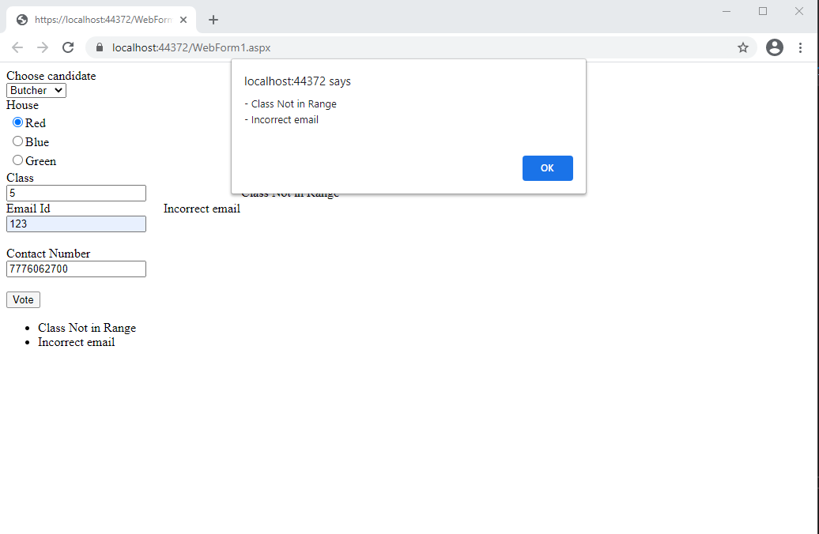

Q2.