**Lab6**

**Q1.**

**Code(.aspx)**

<%@ Page Language="C#" AutoEventWireup="true" CodeBehind="WebForm1.aspx.cs" Inherits="HouseKeeping.WebForm1" %>

<!DOCTYPE html>

<html xmlns="http://www.w3.org/1999/xhtml">

<head runat="server">

<title></title>

</head>

<body>

<form id="form1" runat="server">

<div>

</div>

Select StaffID:

<asp:DropDownList ID="DropDownList1" runat="server" OnSelectedIndexChanged="DropDownList1_SelectedIndexChanged">

</asp:DropDownList>

<br />

Name: <asp:Label ID="Label1" runat="server"></asp:Label>

<br />

Dno:

<asp:Label ID="Label2" runat="server"></asp:Label>

<br />

Current City:

<asp:Label ID="Label4" runat="server"></asp:Label>

<br />

<asp:Button ID="Button2" runat="server" OnClick="Button2_Click" Text="Show" />

<br />

<asp:ListBox ID="ListBox1" runat="server">

<asp:ListItem>Pune</asp:ListItem>

<asp:ListItem>Mumbai</asp:ListItem>

<asp:ListItem>Varanasi</asp:ListItem>

<asp:ListItem>Bangalore</asp:ListItem>

</asp:ListBox>

<br />

<asp:Button ID="Button1" runat="server" OnClick="Button1_Click" Text="Update" />

<br />

<asp:Label ID="Label3" runat="server"></asp:Label>

</form>

</body>

</html>

**Code(aspx.cs)**

using System;

using System.Collections.Generic;

using System.Data;

using System.Data.SqlClient;

using System.Linq;

using System.Web;

using System.Web.UI;

using System.Web.UI.WebControls;

namespace HouseKeeping

{

public partial class WebForm1 : System.Web.UI.Page

{

DataSet ds = new DataSet();

protected void Page_Load(object sender, EventArgs e)

{

if (!IsPostBack)

{

SqlConnection con = new SqlConnection();

con.ConnectionString = @"Data Source=(localdb)\MSSQLlocalDB;Initial Catalog=HouseKeeping;Integrated Security=True";

try

{

con.Open();

SqlCommand comm = new SqlCommand("select distinct StaffID from Staff", con);

SqlDataReader reader = comm.ExecuteReader();

while (reader.Read())

{

DropDownList1.Items.Add(reader["staffID"].ToString());

}

}

catch

{

}

finally

{

con.Close();

}

}

}

protected void DropDownList1_SelectedIndexChanged(object sender, EventArgs e)

{

}

protected void Button1_Click(object sender, EventArgs e)

{

SqlConnection con = new SqlConnection();

con.ConnectionString = @"Data Source=(localdb)\MSSQLlocalDB;Initial Catalog=HouseKeeping;Integrated Security=True";

try

{

//con.Open();

SqlCommand comm = new SqlCommand("update Staff set City = @param1 where StaffID = @param2", con);

comm.Parameters.AddWithValue("@param1", ListBox1.SelectedValue);

comm.Parameters.AddWithValue("@param2", DropDownList1.SelectedItem.Text);

con.Open();

comm.ExecuteNonQuery();

}

catch

{

Console.WriteLine("err");

}

finally

{

con.Close();

}

}

protected void Button2_Click(object sender, EventArgs e)

{

SqlConnection con = new SqlConnection();

con.ConnectionString = @"Data Source=(localdb)\MSSQLlocalDB;Initial Catalog=HouseKeeping;Integrated Security=True";

SqlCommand comm = new SqlCommand("select FirstName,LastName,DNo,City from Staff where StaffID = @staffID", con);

comm.Parameters.AddWithValue("@staffID", DropDownList1.SelectedItem.Text);

SqlDataAdapter adapter = new SqlDataAdapter(comm);

adapter.Fill(ds, "Staff_Details");

Label1.Text = (string)ds.Tables["Staff_Details"].Rows[0]["FirstName"] + " " + (string)ds.Tables["Staff_Details"].Rows[0]["LastName"];

Label2.Text = ds.Tables["Staff_Details"].Rows[0]["DNo"].ToString();

Label4.Text = (string)ds.Tables["Staff_Details"].Rows[0]["City"];

}

}

}

Output

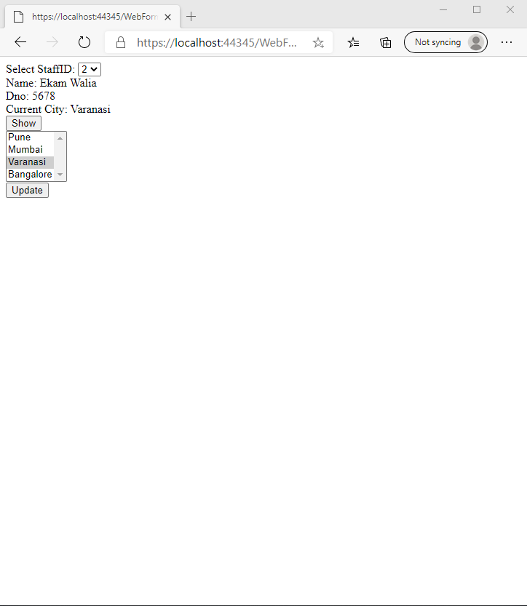

**Q2.**

**Code**