**Lab1**

Q1

**Code (ConsoleApp)**

using System;

using System.Collections.Generic;

using System.Linq;

using System.Text;

using System.Threading.Tasks;

namespace ArithmeticOps

{

class Program

{

static void Main(string[] args)

{

Console.WriteLine("Enter first number");

string sa = Console.ReadLine();

Console.WriteLine("Enter second number");

string sb = Console.ReadLine();

int a, b;

int.TryParse(sa, out a);

int.TryParse(sb, out b);

int sum = a + b;

int sub = a - b;

int mul = a * b;

float div = (float)a / (float)b;

//int rem = a % b;

Console.WriteLine("Addition of {0} and {1} is = {2}", a, b, sum);

Console.WriteLine("Subtraction of {0} and {1} is = {2}", a, b, sub);

Console.WriteLine("Multiplication of {0} and {1} is = {2}", a, b, mul);

Console.WriteLine("Division of {0} and {1} is = {2}", a, b, div);

//Console.WriteLine("Remainder of {0} and {1} is = {2}", a, b, rem);

//hit ENTER to exit the program

Console.ReadLine();

}

}

}

**Output**

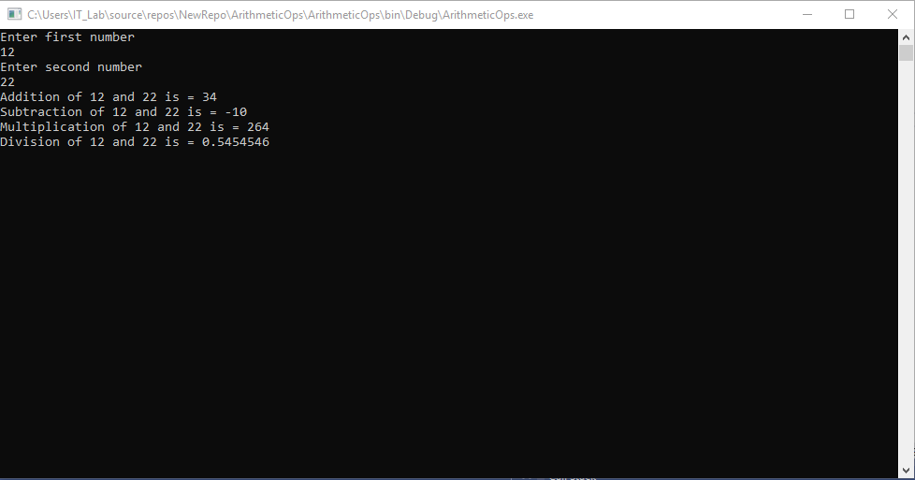

**Q2**

**Code(ConsoleApp)**

using System;

using System.Collections.Generic;

using System.Globalization;

using System.Linq;

using System.Text;

using System.Threading.Tasks;

namespace DateTime1

{

class Program

{

static void Main(string[] args)

{

Console.WriteLine("Enter Date Time");

string a = Console.ReadLine();

CultureInfo provider = CultureInfo.InvariantCulture;

DateTime d1;

int[] temp = new int[6];

String[] temp1 = a.Split(':');

int i = 0;

foreach(string str in temp1)

{

int.TryParse(str,out temp[i++]);

}

d1 = new DateTime(temp[2], temp[1], temp[0], temp[3], temp[4], temp[5]);

Console.WriteLine("Enter the number of ticks");

string b = Console.ReadLine();

int n;

int.TryParse(b, out n);

TimeSpan t = new TimeSpan(n);

DateTime d2 = d1.Add(t);

Console.WriteLine("The new Date Time is {0}",d2.ToString("hh:mm:ss"));

Console.Read();

}

}

}

**Output**

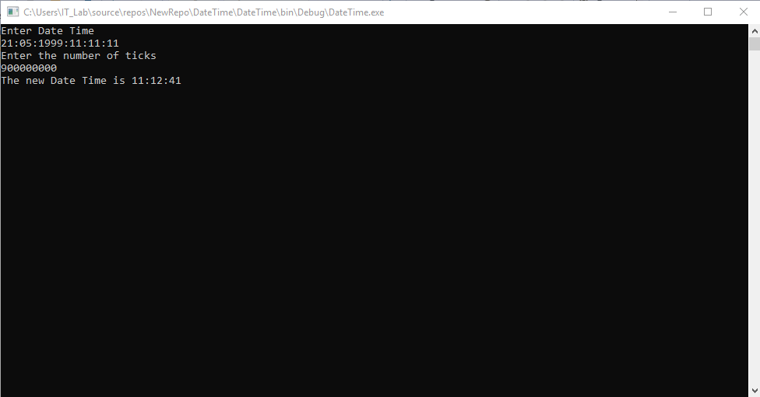

**Q3**

**Code(WebForm)**

using System;

using System.Collections.Generic;

using System.ComponentModel;

using System.Data;

using System.Drawing;

using System.Linq;

using System.Text;

using System.Threading.Tasks;

using System.Windows.Forms;

namespace SalaryCalculation

{

public partial class Form1 : Form

{

public Form1()

{

InitializeComponent();

}

private void label2_Click(object sender, EventArgs e)

{

}

private void radioButton3_CheckedChanged(object sender, EventArgs e)

{

}

private void button1_Click(object sender, EventArgs e)

{

double n2;

double.TryParse(textBox1.Text, out n2);

if (comboBox1.SelectedItem.ToString() == "Level 1")

{

MessageBox.Show("The bonus to be paid is " + (n2 * 0.1).ToString());

}

else if (comboBox1.SelectedItem.ToString() == "Level 2" || comboBox1.SelectedItem.ToString() == "Level 3" || comboBox1.SelectedItem.ToString() == "Level 4")

{

MessageBox.Show("The bonus to be paid is " + (n2 * 0.09).ToString());

}

else if (comboBox1.SelectedItem.ToString() == "Level 5" || comboBox1.SelectedItem.ToString() == "Level 6" || comboBox1.SelectedItem.ToString() == "Level 7")

{

MessageBox.Show("The bonus to be paid is " + (n2 * 0.07).ToString());

}

else if (comboBox1.SelectedItem.ToString() == "Level 8" || comboBox1.SelectedItem.ToString() == "Level 9" || comboBox1.SelectedItem.ToString() == "Level 10")

{

MessageBox.Show("The bonus to be paid is " + (n2 * 0.05).ToString());

}

}

}

}

**Output**

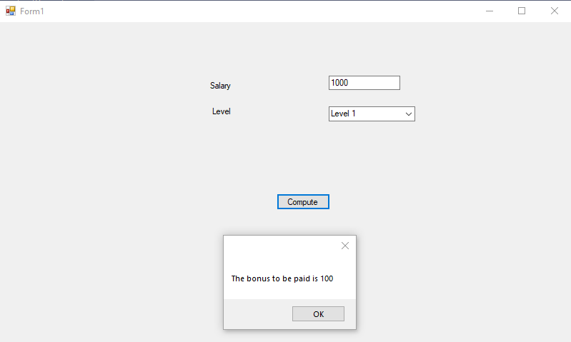

**Q3**

**Code(WebForm)**

using System;

using System.Collections.Generic;

using System.ComponentModel;

using System.Data;

using System.Drawing;

using System.Linq;

using System.Text;

using System.Threading.Tasks;

using System.Windows.Forms;

namespace CarBuy

{

public partial class Form1 : Form

{

public Form1()

{

InitializeComponent();

}

private void button1_Click(object sender, EventArgs e)

{

if (comboBox1.SelectedItem.ToString() == null || comboBox2.SelectedItem.ToString() == null)

{

MessageBox.Show("Sorry, Car or colour not selected");

}

else

MessageBox.Show("Thank you for purchasing");

}

private void button2_Click(object sender, EventArgs e)

{

comboBox1.Text = "";

comboBox2.Text = "";

}

}

}

**Output**

