**Lab4**

**Q1.**

**Code(.aspx)**

**Page1**

<%@ Page Language="C#" AutoEventWireup="true" CodeBehind="WebForm1.aspx.cs" Inherits="CarQuery.WebForm1" %>

<!DOCTYPE html>

<html xmlns="http://www.w3.org/1999/xhtml">

<head runat="server">

<title></title>

</head>

<body>

<form id="form1" runat="server">

<div>

Model:

<asp:TextBox ID="TextBox1" runat="server"></asp:TextBox><br />

Manufacturer<br />

<asp:DropDownList ID="DropDownList1" AutoPostBack="true" OnSelectedIndexChanged="DropDownList1_SelectedIndexChanged" runat="server"></asp:DropDownList>

</div>

</form>

</body>

</html>

Page2

<%@ Page Language="C#" AutoEventWireup="true" CodeBehind="WebForm2.aspx.cs" Inherits="CarQuery.WebForm2" %>

<!DOCTYPE html>

<html xmlns="http://www.w3.org/1999/xhtml">

<head runat="server">

<title></title>

</head>

<body>

<form id="form1" runat="server">

<div>

<asp:Label ID="Label3" runat="server" Text="Model : "></asp:Label><asp:Label ID="Label1" runat="server" Text="Label"></asp:Label><br /><br />

<asp:Label ID="Label4" runat="server" Text="Manufacturer : "></asp:Label><asp:Label ID="Label2" runat="server" Text="Label"></asp:Label>

</div>

</form>

</body>

</html>

**Code(aspx.cs)**

**Page1**

using System;

using System.Collections.Generic;

using System.Linq;

using System.Web;

using System.Web.UI;

using System.Web.UI.WebControls;

namespace CarQuery

{

public partial class WebForm1 : System.Web.UI.Page

{

protected void Page_Load(object sender, EventArgs e)

{

DropDownList1.Items.Add(new ListItem("--Select--"));

DropDownList1.Items.Add(new ListItem("BMW"));

DropDownList1.Items.Add(new ListItem("AUDI"));

DropDownList1.Items.Add(new ListItem("MARUTI"));

DropDownList1.Items.Add(new ListItem("HYUNDAI"));

DropDownList1.Items.Add(new ListItem("HONDA"));

}

protected void DropDownList1_SelectedIndexChanged(object sender, EventArgs e)

{

string url = "WebForm2.aspx?";

url += "Model=" + HttpUtility.UrlEncode(TextBox1.Text.ToString()) + "&";

url += "Make=" + HttpUtility.UrlEncode(DropDownList1.SelectedItem.ToString());

Response.Redirect(url);

}

}

}

**Page2**

using System;

using System.Collections.Generic;

using System.Linq;

using System.Web;

using System.Web.UI;

using System.Web.UI.WebControls;

namespace CarQuery

{

public partial class WebForm2 : System.Web.UI.Page

{

protected void Page_Load(object sender, EventArgs e)

{

Label1.Text = Request.QueryString["Model"];

Label2.Text = Request.QueryString["Make"];

}

}

}

**Output**

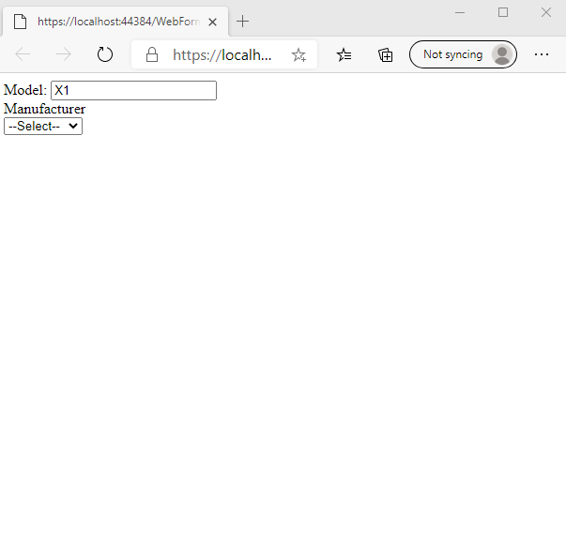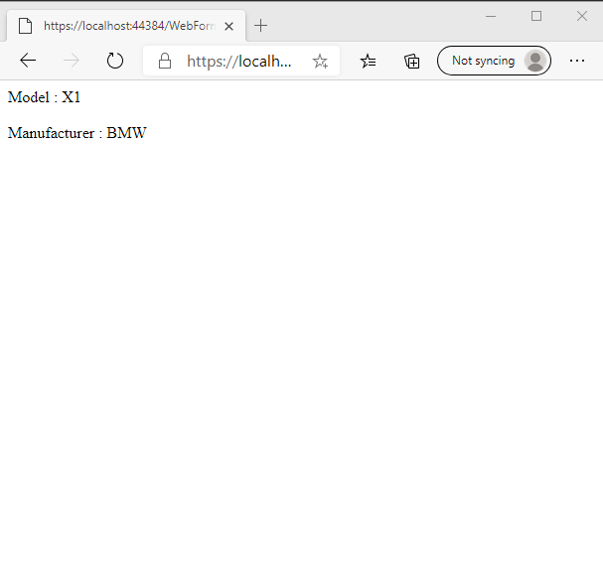

**Q2.**

**Code(.aspx)**

**Page1**

<%@ Page Language="C#" AutoEventWireup="true" CodeBehind="WebForm1.aspx.cs" Inherits="CookieCounter.WebForm1" %>

<!DOCTYPE html>

<html xmlns="http://www.w3.org/1999/xhtml">

<head runat="server">

<title></title>

</head>

<body>

<div>

<div >

<div>

<form id="form1" runat="server">

<div>

<asp:Label ID="Label2" runat="server" Text="Name"></asp:Label>

<asp:TextBox ID="name_tb" runat="server"></asp:TextBox>

</div>

<div class="form-group">

<asp:Label ID="Label3" runat="server" Text="Registration Number"></asp:Label>

<asp:TextBox ID="regno_tb" runat="server"></asp:TextBox>

</div>

<div class="form-group">

<asp:Label ID="Label1" runat="server" Text="Subjects"></asp:Label>

<asp:DropDownList ID="sub_ddl" runat="server"></asp:DropDownList>

</div>

<asp:Button ID="Button1" runat="server" Text="Next" OnClick="Button1_Click" />

</form>

</div>

</div>

</div>

</body>

</html>

**Page2**

<%@ Page Language="C#" AutoEventWireup="true" CodeBehind="WebForm2.aspx.cs" Inherits="CookieCounter.WebForm2" %>

<!DOCTYPE html>

<html xmlns="http://www.w3.org/1999/xhtml">

<head runat="server">

<title></title>

</head>

<body>

<form id="form1" runat="server">

<div>

<div>

<div id="main" style="width: 18rem" runat="server">

<p id="name_holder" runat="server"></p>

<p id="regno_holder" runat="server"></p>

<p id="subject_holder" runat="server"></p>

<div class="text-center">

Counter = <asp:Label id="_counter_holder" runat="server">0</asp:Label>

<asp:Button ID="Button1" runat="server" Text="Increment" OnClick="Button1_Click" />

</div>

</div>

</div>

</div>

</form>

</body>

</html>

**Code(aspx.cs)**

**Page1**

using System;

using System.Collections.Generic;

using System.Linq;

using System.Web;

using System.Web.UI;

using System.Web.UI.WebControls;

namespace CookieCounter

{

public partial class WebForm1 : System.Web.UI.Page

{

protected void Page_Load(object sender, EventArgs e)

{

if (!IsPostBack)

{

sub_ddl.Items.Add("Maths");

sub_ddl.Items.Add("Physics");

sub_ddl.Items.Add("Biology");

}

}

protected void Button1_Click(object sender, EventArgs e)

{

string name = name_tb.Text;

string regNo = regno_tb.Text;

string selectedSubject = sub_ddl.SelectedItem.Text;

Session["name"] = name;

Session["regNo"] = regNo;

Session["subject"] = selectedSubject;

Response.Redirect("WebForm2.aspx");

}

}

}

**Page2**

using System;

using System.Collections.Generic;

using System.Linq;

using System.Web;

using System.Web.UI;

using System.Web.UI.WebControls;

namespace CookieCounter

{

public partial class WebForm2 : System.Web.UI.Page

{

int _Counter = 0;

HttpCookie curr;

protected void Page_Load(object sender, EventArgs e)

{

curr = Request.Cookies.Get("counter_cookie");

if (curr != null)

{

int temp;

int.TryParse(curr["counter"], out temp);

_Counter = temp;

}

else

{

_Counter = 0;

}

_counter_holder.Text = _Counter.ToString();

if (IsPostBack) return;

name_holder.InnerText = string.Format("Name: {0}", (string)Session["name"]);

regno_holder.InnerText = string.Format("RegNo: {0}", (string)Session["regNo"]);

subject_holder.InnerText = string.Format("Subject: {0}", (string)Session["subject"]);

}

protected void Button1_Click(object sender, EventArgs e)

{

_Counter += 1;

if (curr == null)

{

curr = new HttpCookie("counter_cookie");

}

curr["counter"] = _Counter.ToString();

Response.Cookies.Add(curr);

_counter_holder.Text = _Counter.ToString();

}

}

}

**Output**

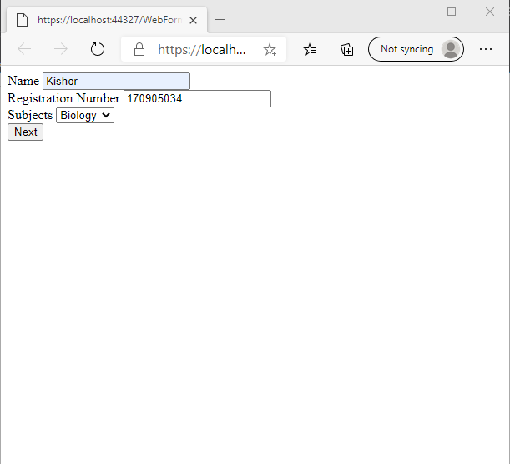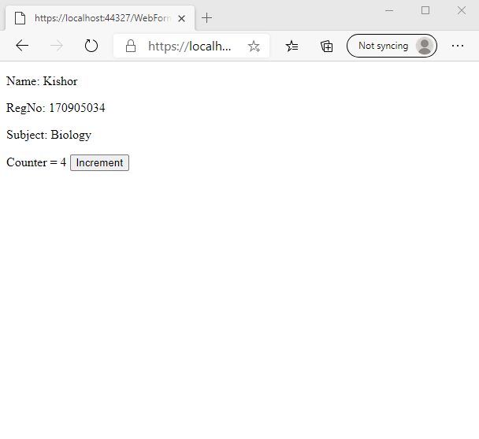

**Q3.**

**Code(.aspx)**

<%@ Page Language="C#" AutoEventWireup="true" CodeBehind="WebForm1.aspx.cs" Inherits="ShoppingCart.WebForm1" %>

<!DOCTYPE html>

<html xmlns="http://www.w3.org/1999/xhtml">

<head runat="server">

<title></title>

</head>

<body>

<div class="container">

<div>

<div style="width: 25em;">

<div>

<form id="form1" runat="server">

<div class="form-group">

<asp:Label ID="Label2" runat="server" Text="Enter Name"></asp:Label>

<asp:TextBox ID="name_tb" runat="server"></asp:TextBox>

</div>

<div class="form-group">

<asp:Label ID="Label3" runat="server" Text="Item "></asp:Label>

<asp:TextBox ID="i1" runat="server"></asp:TextBox>

</div>

<div class="form-group">

<asp:Label ID="Label4" runat="server" Text="Item "></asp:Label>

<asp:TextBox ID="i2" runat="server"></asp:TextBox>

</div>

<div class="form-group">

<asp:Label ID="Label5" runat="server" Text="Item "></asp:Label>

<asp:TextBox ID="i3" runat="server"></asp:TextBox>

</div>

<asp:Button ID="Button1" runat="server" Text="Continue Shopping" OnClick="Button1_Click" />

</form>

</div>

</div>

</div>

<div id="status" class="jumbotron" runat="server">

<h3>Items Saved in the cart</h3>

</div>

<div id="items_list" runat="server">

<h2 runat="server" id="welcome_msg"></h2>

<p runat="server" id="item1"></p>

<p runat="server" id="item2"></p>

<p runat="server" id="item3"></p>

</div>

</div>

</body>

</html>

**Code(aspx.cs)**

using System;

using System.Collections.Generic;

using System.Linq;

using System.Web;

using System.Web.UI;

using System.Web.UI.WebControls;

namespace ShoppingCart

{

public partial class WebForm1 : System.Web.UI.Page

{

private HttpCookie coki;

protected void Page_Load(object sender, EventArgs e)

{

status.Visible = false;

items_list.Visible = true;

coki = Request.Cookies.Get("cookie_cart");

if (coki != null)

{

items_list.Visible = true;

welcome_msg.InnerText = "Welcome, " + coki["_cust_name"].ToString()+" Here's Your Cart";

item1.InnerText = "Item1: " + coki["_item_1"];

item2.InnerText = "Item2: " + coki["_item_2"];

item3.InnerText = "Item3: " + coki["_item_3"];

}

}

protected void Button1_Click(object sender, EventArgs e)

{

coki = new HttpCookie("cookie_cart");

coki["_cust_name"] = name_tb.Text;

coki["_item_1"] = i1.Text;

coki["_item_2"] = i2.Text;

coki["_item_3"] = i3.Text;

Response.Cookies.Add(coki);

status.Visible = true;

}

}

}

**Output**

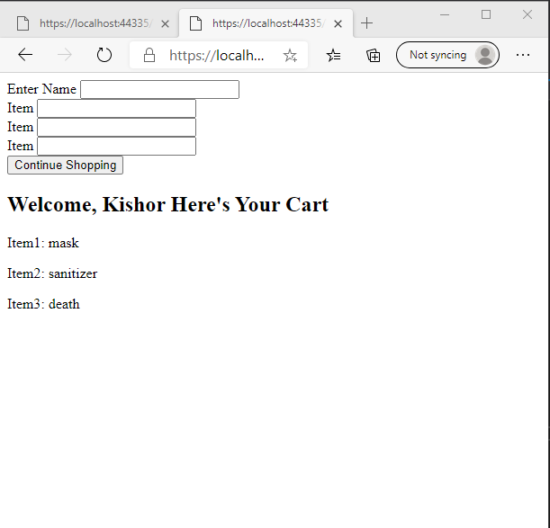

**Q4.**

**Code(.aspx)**

<%@ Page Language="C#" AutoEventWireup="true" CodeBehind="WebForm1.aspx.cs" Inherits="LogValidation.WebForm1" %>

<!DOCTYPE html>

<html xmlns="http://www.w3.org/1999/xhtml">

<head runat="server">

<title></title>

</head>

<body>

<div class="container">

<div>

<div>

<div>

<form id="form1" runat="server">

<div>

<asp:Label ID="Label2" runat="server" Text="Username"></asp:Label>

<asp:TextBox ID="name_tb" runat="server"></asp:TextBox>

</div>

<div class="form-group">

<asp:Label ID="Label1" runat="server" Text="Password"></asp:Label>

<asp:TextBox ID="pw_tb" runat="server" TextMode="Password"></asp:TextBox>

</div>

<div class="text-center">

&nbsp;&nbsp;&nbsp;&nbsp;&nbsp;&nbsp;&nbsp;&nbsp;&nbsp;&nbsp;&nbsp;&nbsp;&nbsp;&nbsp;&nbsp;&nbsp;&nbsp;

<asp:Button CssClass="btn btn-dark" ID="btn_login" runat="server" Text="Login" OnClick="btn_login_Click"/>

</div>

</form>

</div>

</div>

</div>

<div class="row">

<div class="col-6 text-center">

<span class="h3 text-uppercase">Attempts succesfull : </span>

<strong id="_success_count_holder" class="display-4" runat="server">-</strong></div>

<div class="col-6 text-center">

<span class="h3 text-uppercase">Failed attempts : </span>

<strong id="_failure_count_holder" class="display-4" runat="server">-</strong>

</div>

</div>

<div class="text-center">

<h2 id="status" runat="server"></h2>

</div>

</div>

</body>

</html>

**Code(aspx.cs)**

using System;

using System.Collections.Generic;

using System.Linq;

using System.Web;

using System.Web.UI;

using System.Web.UI.WebControls;

namespace LogValidation

{

public partial class WebForm1 : System.Web.UI.Page

{

int _s = 0;

int _f = 0;

private readonly string userName = "User";

private readonly string pwd = "Password";

protected void Page_Load(object sender, EventArgs e)

{

//initialize props

if (Application["_s"] != null && Session["_f"] != null)

{

_s = (int)Application["_s"];

_f = (int)Session["_f"];

updateCounters();

}

else

{

_s = _f = 0;

Application["_s"] = _s;

Session["_f"] = _f;

}

}

protected void btn_login_Click(object sender, EventArgs e)

{

if (pwd == pw_tb.Text && userName == name_tb.Text)

{

_s += 1;

}

else

{

_f += 1;

}

Application["_s"] = _s;

Session["_f"] = _f;

updateCounters();

}

private void updateCounters()

{

_success_count_holder.InnerText = _s.ToString();

_failure_count_holder.InnerText = _f.ToString();

if (_f > 3)

{

pw_tb.Enabled = false;

_failure_count_holder.Style["color"] = "red";

status.InnerText = "Login Attempts Failed! Contact Admin";

status.Style["color"] = "red";

}

}

}

}

**Output**

